Field study on the use of Artemisia cina (Sheih Baladi) and Humates ( Humapol-Fis) in the control of Saprolegniosis in fingerlings of Nile tilapias and Mugal cephalus in lower Egypt fish farms

Noor El Deen , A. I.E. *, Mona, S.Zaki * , Razin, A.M.** and Shalaby, S.I.

*Hydrobiology Department, Veterinary Division, National Research Centre
**Medicinal and Aromatic Plants Department (MAP), National Research Centre
*** Reproduction Department, Veterinary Division, National Research Centre
dr_ahmednoor2002@yahoo.com

Abstract: Saprolegniosis is a fungal disease and it is one of the most causes of economic loss in fish farming industry, affecting all developmental stages. This study was carried out on 300 cultured fingerlings of Nile tilapias and Mugal cephalus from earthen ponds in lower Egypt fish farms suffered from Saprolegniosis . Diseased fish were subjected to full clinical and postmortem examination . Artemisia cina (Sheih Baladi) and Humates (humic and fulvic acid ) were tested for the control of Saprolegniosis affecting fingerlings of Nile tilapias and Mugal cephalus. Artemisia cina L. (A.cina) was used in the form of 5% and 25% stock solutions prepared by pouring boiling water on the herb in a piece of gauze and soaked for 2 hours. The doses were 0.25, 0.5 and 1 ml/l 3 times every an hour for 3 days in fingerlings of Nile tilapias and twice for 2days in fingerlings of Mugal cephalus in earthen ponds. Humates was used as HUMAPOL-FIS dry stock solution in the rates of 5, 10 and 15 g/1000 liter in earthen ponds. Three replicates were used per each treatment and 3 earthen ponds served as control where malachite green or formalin were applied for comparison. Results revealed that A. cina and humates gave the best estimates of viability percentages among the Nile tilapia and Mugal cephalus fingerlings and were safe for fingerlings in the rates of 5% and 25% for A. cina and 5 and 15 gm/1000 liter for humates. [Life Science Journal 2010;7(3):125-128]. (ISSN: 1097-8135).

Keywords: Saprolegniosis, Nile tilapias, Mugal cephalus, Artemisia cina and humates

1. Introduction
Saprolegniosis is a continuing problem for aquatic animal culturist causing severe losses of fingerlings fish in earthen ponds and considered as single largest cause of economic losses (Shaheen,1986, Meyer,1991 and El-Ashram, 1997) where it is generally restricted to chronic, steady losses and affected on fingerlings stages (Aly and El Ashram,2000). The control of fungi of the genus saprolegnia has long been a major objective of aquaculturists. Once a fungal infection starts, it can spread rapidly from infected to healthy fish (Pipper et al., 1982 and El-Ashram, 1997). Antifungal are essential for the maintenance of healthy stocks of fish. However, chemical treatment is costly and can itself cause mortality (Jimenez, 1986 and El-Ashram, 1997).For these reasons many researchers have been investigating the use of safer compounds that have no harmful effect on fish and their ecosystem (Hatai, and Hoshiai,1992 and Hussein et al., 2001). Malachite green treated 0.5 mg/l and Formalin (0.1 ml/l) were superior in vitro tests in controlling Saprolegnia in tilapia and mullet fingerlings fish ponds (Fitzpatrick et al.,1995, Laszlo et al., 2002 and Khodabandeh and Abtahi (2006) and Abou El Atta,2008). Malachite green and Formalin are the most potent fungicides that have been prohibited due to their toxicity and persistence in the environment (Meyer and Jorgenson, 1983 and Schreck et al., 1992). Some medicinal plants have a powerful biological effect against fungi, bacteria and even some harmful insects (Diab, A.S. (2002). On the other hand, Humates is considered a potential natural compound used for external fish diseases, fungicide and parasiticide on fish ( Hussien, et al., 2010 and Noor El Deen et al., 2010). This study was established to detect the effect of Artemisia cina and humates in preventing Saprolegniosis in fingerlings of Nile tilapia and Mugal cephalus as well as investigating the toxicity or side effects induced by the experimental substances on the treated fingerlings of Nile tilapia and Mugal cephalus.

2. Materials and Methods
2-1-Materials
2-1-1-Fish:
A total number of 150 fingerlings of Nile tilapia and 150 fingerlings of Mugal cephalus were needed. Fingerlings obtained from several earthen ponds were cultured in Lower Egypt fish farms, during the period of October 2008 and November 2009, with average 10 gm body weight and length 5 cm. The diseased fingerlings were transported in ice box to Lab. of hydrobiology department, Vet. Div. National Research Centre, Egypt.
2-1-2-The experimental substances:
Artemisia cina and Humapol-Fis; (humic and fulvic acid) were tested against malachite green, formalin and sodium hypochlorite. They were all applied for three successive days on fingerlings of Nile tilapia and Mugal cephalus.
2-1-3-Media:
Sabouraud dextrose agar (SDA) was used for isolation of fungus and was prepared according to (Fent.,1998).
2-1-4-Stain:
Lactophenol cotton blue stain was prepared according to (Shaheen,1986).
2-1-5-Experimental design:
LC50 and safety of both wormseed plants and humates solutions were detected by adding 20 ml of Sheih in the rates of 5% and 25% as well as of humates solutions in the rates of 5, 10, 15 and 20 g/100 liter in 6 earthen ponds. One pond contained 24 meter of fresh water and served as a control. Fifty fingerlings were added to each of the earthen ponds.Artemisia cina solution (Sheih Baladi) was prepared in the rates of 5% and 25% by adding 1 liter of boiling distilled water to beakers containing 50 and 250 g respectively of the herb, wrapped in a piece of gauze. The mouth of the beaker was covered and the herb was left for an hour for proper soaking. The used rates in vitro were 0.25, 0.5 and 1 ml of sheih, 25% per liter of water of fingerlings fish ponds. Artemisia cina solution was added (0.25, 0.5 and 1 ml of sheih, 25% per liter water in the ponds were tested and compared with malachite green treated with malachite green 0.5 mg/l (Laszlo et al., 2002)1 ml/l of freshwater fish ponds). Humapol-Fis was added (5, 10,15 and 20 gram/ 100 liter of water in the ponds were tested and compared with 1 treatment of formalin (0.1 ml/l of freshwater fish ponds).

2-2-Methods:
2-2-1-Clinical examination:
Three hundred naturally infested Nile tilapia and the same Mugal cephalus were examined for abnormal behaviors and external lesions on the skin, fin according to the method described by Easa and Amin (1987).
2-2-2- Postmortem examination:
Postmortem examination was done on living and freshly dead fish and examination of internal organs.
2-2-3-Mycological examination:
Isolation of fungi was carried out from naturally infected fish, samples were taken from fish showing skin and fin lesions and isolate were collected and inoculated into SDA medium plates and incubated at 20+_2 C for 3-4 days, subculture on the same media was done for purification. Identification of the positive culture was discussed according to Bruno and wood (1994).

3. Results
3-1-Clinical examination:
The main characteristic lesions of Saprolegniosis were in the form of appearance of cotton wool like tufts on the dorsal, tail (caudal, pectoral fins) Plate 1.

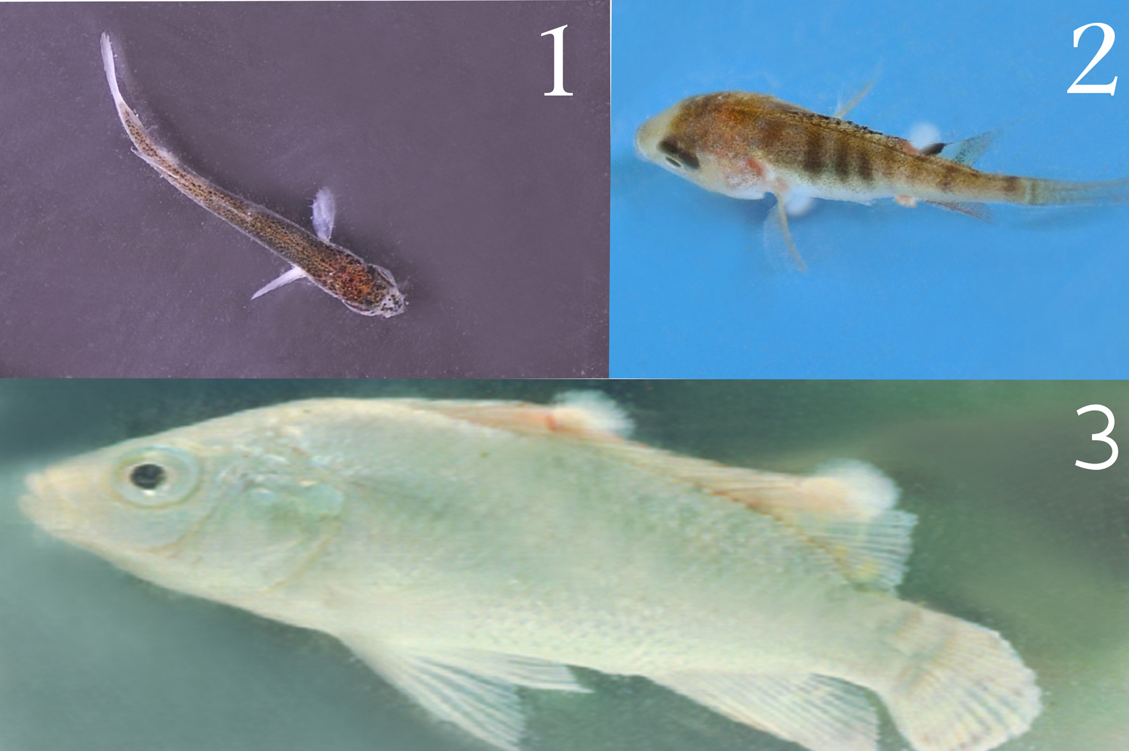
Plate 1: Showing cotton wool like tufts on the dorsal, tail of fingerlings of Mugal cephalus (1), small fingerling of Nile tilapia (2) and large fingerlings of Nile tilapia (3).

3-2-Postmortem examination:
The main postmortem lesions were in the form of cotton wool tufts on skin and caudal fin with erosion in tail and pale to grayish gills as well as serious fluid in the body cavity. In addition, intestine was free from any food particles, with dark enlarged liver and distend gall bladder with bile, spleenomegaly and congested kidney.
3-3-Mycological examination:
As shown in table (1); the mycological examination showed an isolation of 164 isolates from 450 samples obtained from 150 infected fish (100 Nile tilapia fingerlings and 50 fingerlings of Mugal cephalus ) and different trail of treatment as well as morality rate as showed in table (2).

Table 1: Artemisia cina and humates compared with Malachite green and formalin on Nile tilapia fingerlings and fingerlings Mugal cephalus.

fish | number | organs | Artemisia cina  skin |  | humates  gills |  | Malachite green  fins |  |  | formalin  total |  | %
No.  Nile tilapia fingerlings | 100 | No of samples | 100 | 66.7% | 100 | 66.7% |  | 100 | 66.7% |  | 100 | 66.7%
No.  Nile tilapia fingerlings | 100 | No of isolate | 80 | 68.6 % | 85 | 100% |  | 75 | 100% |  | 75 | 10%
fingerlings Mugal cephalus | 50 | No of samples | 50 | 33.3 % | 50 | 33.3 % |  | 50 | 33.3 % |  | 50 | 33.3 %
fingerlings Mugal cephalus | 50 | No of isolate | 35 | 34.4 % | 45 | 100% |  | 40 | 100% |  | 120 | 100%
 |  | Total No of samples | 150 | 100% | 150 | 100% |  | 150 | 100% |  | 450 | 100%
 |  | Total No of isolates | 115 | 100% | 130 | 100% |  | 115 | 100% |  | 360 | 100%
The positive colonies on SDA at 20 ºC for 3-4 days started with cysts of long hairs with cottony color after that become grayish then black after 96 hs. incubation.
Table (2): Showing mortality rate of fingerlings after different trail of treatments.
No Of fish | Artemisia cina  (0.5 mg/l) |  | Humates  (0.5 g/l) |  | Malachite green  (0.5 mg/l) |  | Formalin  (0.1 ml/l)
No Of fish | Mortality after  treatment |  | Mortality after  treatment |  | Mortality after  treatment |  | Mortality after  treatment
No Of fish | No. | % | No. | % | No. | % | No. | %
100 of Nile tilapia  Fingerlings for each | 5 | 5 | 4 | 4 | 25 | 25 | 34 | 34
50 of Fingerlings  Mugal cephalus for each | 2 | 4 | 1 | 2 | 20 | 40 | 28 | 56
Total | 7 | 4.5 | 5 | 3 | 45 | 32.5 | 62 | 45

3- 4-Trials of control:
3-4-1- LC50 and safety of Artemisia cina solution and humates were estimated on diseased fingerlings of Nile tilapia and Mugal cephalus sp. Artemisia cina solution in the rate of 5% and 25% was found to be safe on fingerlings of Nile tilapia and Mugal cephalus sp, which tolerated and lived for 48 hours in the stock solution of 25% and for 6 days in 5% Sheih solution.
3-4-2-Examination the rate of Artemisia cina and humates on fingerlings of Nile tilapia and Mugal cephalus sp was done. Results of Table (1) revealed that Artemisia cina solution and humates in the rate of 0.5 ml/l and applied on fingerlings of Nile tilapia and Mugal cephalus sp than malachite green, and formalin (1gm/10 liter) gave significantly higher figures of survivability% than other doses of Sheih . In addition to results of Table (2) revealed that Artemisia cina solution and humates decrease mortality rate than malachite green, and formalin.

4. Discussions
In Egypt, saprolegnia is considered one of the most important disease causing troubles in freshwater cultured fishes resulting in several economical losses (Easa and Amin, 1987 and Noga, 1996). The clinical signs appear on fish suffered from Saprolegniosis were in the form of grayish white cotton like tufts on dorsal fins, emaciation and death occurred due to secondary infection, toxicity and eye blindness, the fish unable to feed. These results agreement with (Neish and Hughes1980 and El Ashram et al., 2007). The main postmortem lesions were enlargement of liver, spleen and gall bladder which may be due to systemic bacterial infection , these results agree with Hatai,1980 ,Aly et al.,1996 and Abou El Atta,2008.The results of fungal examination showed that isolation of saprolegnia which was isolated with high percentage from gallbladder, kidney and spleen, these results agree with (Marzouk et al., 2003 and Abou El Atta, 2008). Thus, no LC50 was detected for Artemisia cina solution .Humates in a concentration of 15 g/ 100 liter killed all examined parasites after 1h with no deaths of diseased fishes when used in the rate of 5 g/ 100 liter for 4days this agree with El-Ashram,(1997). On the other hand, humates (0.5 g/l) and malachite green (0.5 mg/l) applied on fingerlings of Nile tilapia and Mugal cephalus sp on fingerlings of Nile tilapia and Mugal cephalus, showed relatively higher mortility than Artemisia cina and humates and survivability%. While in case of fingerlings of Nile tilapia and Mugal cephalus sp humates (0.5 g/l) and formalin (0.1 ml/l) revealed significantly higher estimates of survivability% than other doses of humates (0.25 and 1 g/l) .These results were is agreement with those reported by Gupte et al., (2002), Giesekes et al., (2005), El-Ashram et al., (2007) (Table 2). It could be concluded that, Artemisia cina in the rate of 0.5 ml/l of 25% solution gave the best estimates of survivability% among the examined Mugal cephalus and Nile tilapia fingerlings and recommended for practical application in earthen ponds to replace the currently used chemicals; malachite green and formalin with their well known environmental and public health hazards. Although humates used in the dose of 5 g/100 liter resulted in relatively good results regarding the same measured parameters.

References
- Abou El Atta,M.E. (2008): Saprolegniosis in freshwater cultured tilapia nilotica (O.niloticus)) and trial for control by using Bafry D 50/500.8th international symposium on tilapia aquaculture .1408-1414.
- Aly, S.M. and El Ashram,A.M.m (2000): Some factors contributing to the development of Saprolegniosis in Nile tilapia (O. niloticus) .Alex.J.Vet. science ,Vol.16. No.1:165-174.
- Aly, S.M. and Maberry,L.F. and El-Meleigy, M I..(1996):Pathological studies on Saprolegniosis among Nile tilapia (O.niloticus). Zag. Vet. J. Vol. 24,. No.3:pp 51-56.
- Bruno,D.W. and wood B.P.,( 1994): Saprolegnia and other Oomycetes.In fish disease and disorder,volume 3,viral,bacterial and fungal infections.Edited by P.T.K. Woo and D.W.Bruno.CABI publishing, walling ford, Oxon,U.K. pp:599-659.
- Diab, A.S. (2002). Antibacterial and antifungal effects of Allium sativum (Garlic), Hibiscus. subdariffa (Karkade) and Nigella sativa (Black seed) extract on some bacterial and fungal isolates from Abbassa hatchery”. 6th Vet. Med. Zag. Conference, 7-9th Sept. 2002, Hurghada, Egypt
- El-Ashram, M.M (1997). Some reproductive studies on some freshwater fish with regard to some pathological and toxicological factors. Ph.D. thesis, Zag. Univ., Egypt.
- El-Ashram, M.M, Abd El Rhman,A.M and Sakr,S.F. (2007):Contribution to Saprolegniosis in cultured Nile tilapia (O. niloticus) with special reference to its control.Egypt.J.Aquat.Biol. and fish. Vol.11, No, 2:943-955.
- Easa,M.E. and Amin,N.E.1987: Natural and experimental Saprolegniosis of tilapia, O. niloticus. Alex.J.Vet.Science.Vol.16,No.1:1165-1174.
- Fitzpatrick, M.S.,C.B. Schreck R.L. Chitwood et al.,(1995).Evaluation of three candidate fungicides for treatment of adult spring Chinook salmon.Prog.Fish Cul. 57:153-155.
- Giesekes,C.M.,Serfling,S.G.and Reimschuessel. R.,(2005):Formalin treatment to reduce mortality associated with saprolegnia parasitica in Rain bow Trout, J.aquaculture, 10.1016:pp7-39.
- Gupte, M., Kulkarmi, Ganguli, B.N., (2002): Antifungal antibiotics.Appl.microbial biotchnol 58, 46-57.
- Hatai, K (1980): Studies on pathogenic agent of saprolegnosis in freshwater fishes.special report of Nagasaki perfectural institute of fishers 8, Nagasaki,1-95.
- Hatai,K.; Hoshiai,G.,(1992): Saprolegniasis in in cultured cocho salmon.Gyobyo Kenkyu (fish pathol.,27:233-234.
- Hussein, M. M., Hata, K and Nomura,( 2001): Saprolegniosis in salmonids and their eggs in Japan.J.wild; Dis.37:204-207.
- Hussien, A.M. O; Ahmed, I.E. Noor El Deen1; Waled, S.E. Solman and Omima, A. Aboud(.2010): A trial for Induction of saprolegniosis in Mugel cephalus with special reference to biological control. Journal of American scince, 6. 6:203-209.
- Khodabandeh.S. and Abtahi.B(2006): Effects of sodium chloride, formalin and iodine on the hatching success of common carp, Cyprinus Carpio,eggs.J.Appl..Ichthyol. 22, pp: 54-56.
- Laszlo. H., Gizella, T. and Chris S. (2002): Carp and pond fish, second Edition. Fishing News Books, An imprint of Blackwell Science. UK: MPG Books Ltd.
- Jimenez, G. (1986). Effect of disinfectants on the hatching and survival of Tilapia nilotica eggs and fry. M.D. thesis, Auburn Univ., USA.
- Marzouk,M.S.M.,Rezeka.samira and El Gamal, M.H,2003:Some mycological investigations on cultured tilapia in Kafr El Sheik governorate. Kafr El Sheik Vet.Med.J.Vol.1 No.2, 97-114.
- Meyer,F.P (1991) : Aquaculture disease and health management.J.Anim.Sci.69:4201-4208.
- Meyer,F. P. and Jergenson,F.A.(1983):Teratological and other effects of malachite green on development of Rain bow trout and rabbit.trans Am fish Soc.112:818-824.
- Neish, G. A. and Hughes, G. C., (1980): Fungal diseases of fishes. T.F.H. publication, Neptune, New jersey
- Noga,E. J.,(1996):fish diseases. Diagnosis and treatment Mosby yearbook Inc. St. Louis.
- Noor El- Deen, A.E., Mona M. Ismaiel, Mohamed A. E. and Omima A.A.El-Ghany, (2010) : Comparative studies on the impact of Humic acid and formalin on ectoparasitic infestation in Nile tilapia Oreochromis niloticus, Nature and Science;8(2):121-125]. (ISSN: 1545-0740).
- Pipper, R.G., McElwain, I.B., Orme, L.E., McCraren, J.P.L., Fowler G. and Leonard, J.R.(1982). Fish hatchery management. S. Fish and wildlife Service. Washington, D.C.
- Schreck,C.B.;Fitzpatrick marking, L . L.,Rach, J.J. and Schreier,T.M., (1992) :Research to identify effective antifungal agent.Bonneville power administration, US Department of energy, Portland,OR,USA,30pp.
- Shaheen,A.A.M. (1986). Mycoflora of some fresh water water. M.V. Sc. Thesis, Zag. University.

7/7/2010

