The Protective Role of Alpha Lipoic Acid Against pesticides Induced testicular toxicity. (Histopathological and Histochemical Studies)

Azza M. Gawish

Department of Zoology, Faculty of Science, Cairo University, Giza, Egypt
azzagawish@ymail.com

Abstract: The present study aimed to investigate the efficiency of alpha-lipoic acid (ALA) as natural antioxidant in ameliorating some of changes induced by intoxication with a mixture of well known pesticides used in our agricultural media. Four groups of male rats were treated as follows untreated control animals, (p-mix, consists of 1/60LD50 chloropyrifos (2mg/Kg b.wt) 1/200 LD50 of fenitrothion (2.5 mg/km b.wt) as used in agriculutural environment and ALA 200mg/animal of alpha lipoic acid, (P-mix+ALA). Histological observation of the intoxicated rats revealed significant alterations in the testis tissue of P mix. treated group including focal mild testicular damage, blood hemorrhage and hypospermatogensis, necrosis and atrophy. The degree of fibrosis was encountered using masson-trichrome stain technique which revealed various fibrosis grades between the control and treated testes tissues upon the exposure to the insecticides. TUNEL technique showed an increase in the incidence of positive apoptotic cells between the spermatogonial and germ cells. Also complete depletion of the level of acid phosphatase enzyme which involved in the testosterone biosynthesis. The treatment with alpha lipoic acid showed many degrees of improvements in the seminiferous tubules, spermatogenic germ cells and the interstitial cells. Also decrease in the grades of fibrosis between testes tissues. Conclusion: The biochemical, hiopathological, reports supported that the pesticides have many implicated toxic changes on the testes tissues and the antioxidants like alpha lipoic acid obtained many trials to get ameliorative effects on the toxicity of pesticides. [Life Science Journal 2010;7(3):117-124]. (ISSN: 1097-8135).

Key Words: Pesticides – Reproduction - Apoptosis - Fibrosis – Antioxidants

1. Introduction:
Chlorpyrifos, first introduced into the marketplace in 1965, has been widely used globally as an insecticide to control crop pests in agriculture, reduce household pests such as termites, reduce insect damage, and for mosquito control. Fenitrothion is approved as a broad-spectrum organophosphorus pesticide. Its toxicity was first evaluated by the 1969. Problems associated with pesticides hazards to man and environment are not confined to the developing countries, but extended to developed nations and still facing some problems in certain locations (Nuckols et al., 2007 and Suresh, 2007). It has many structural actions of insecticides as the inhibition of the release of the acetylcholonesterase at the synaptic junction (Roy et al., 2004). Several studies showed that organophosphorous as malathion and chlorpyrifose induced various physiological, biochemical, immunological and histological changes in experimental animals (Tamura et al., 2001 and Selvakumar et al., 2004). The widespread usage of organophosphates has stimulated research to the existence of effects related with their reproductive toxic activity (Pajoumand et al. 2002).
Hileman, (1994) reported that fenitrithione have the potential to cause reproductive toxicity in animals, affect human reproduction. Okamura et al., 2005 and Presibella et al., 2005). were showed some pathological effects of pesticides on the reproductive system of experimental animals. Chlorpyrifose had been obtained testicular damage, damage to sperm production, and reduction in testosterone levels when fed to adult male rats (Afifi et al., 1991). There is growing concern that pesticide as chlorpyrifose, had estrogenic property may be causing a variety of reproductive disorders in wildlife and human population (Chitra et al., 1999).
Gangadharan et al. (2001) was reported that organophosphorous have been shown to produce reactive oxygen species (ROS) in both intra and extra cellular spaces, resulting in decline of sperm count and infertility in wildlife and human. Chlorpyrifos was showed severe testicular damage and results in reduction in sperm count affecting fertility (Ibrahim and ElGamal, 2003). Chlorpyrifos (CPF) and Fenitrothion, are organophosphorous insecticides, have postulated a possible role for the generation of free radicals and induction of oxidative stress (Tuzmen et al., 2008). Suskind et al. (2007) was reported that a significant correlation between increased fibrosis and both reduced tubular diameter and fewer germ cells.
Apoptosis or programmed cell death is an active process controls cell numbers in a variety of tissues and at various phases of germ cell development (Bartke, 1995). Many studies reported that many organophosphorous as chlorpyrifose caused withdrawal of gonadotropins and/or testosterone which enhances the germ cell degeneration and apoptosis of germ cells in the testes (Billig et al., 1995; Henriksen et al., 1995; Hikim et al., 1995; Kangasniemi et al., 1995).
Lipoic acid is an organ sulfur compound, which is an essential cofactor for many enzyme complexes and the amount of lipoic acid present is very low. Naturally occurring lipoic acid is always covalently bound and not immediately available from dietary sources. Studies are generally dealing with the biological consequences of lipoic acid administration and its derivatives in cases associated with oxidative stress (Han et al., 1997 and Henriksen, 2006). An attempt was made to elucidate the possible protective effect of-lipoic acid treatment on pesticides-induced physiological and histopathological alterations in rats with testicular toxicity. Chlorpyrifos exposed rats showed abnormal levels of antioxidants enzymes In contrast, rats pretreated with lipoic acid showed normal lipid peroxidation and antioxidant defenses. These findings indicate a cytoprotective role of lipoic acid in this experimental model of testicular toxicity (Selvakumar et al., 2004). Present study was taken to assess the effects of chlorpyrifos and fentrithion on testes, the main organ of male reproduction and the possible ameliorative effect of naturally occurring antioxidants like alpha lipoic acid.

2. Materials and methods
Animals and experimental design:
Animals:
Male albino rats Rattus norvegicus (3–4) month's age, weighing between 150–180 g were used. Animals were supplied by the breeding unit of the Egyptian Organization for the Biology and Vaccine Production, Egypt. The animals were housed in plastic cages, fed ad libitum and allowed to adjust to the new environment for two weeks before starting the experiment. The rats were housed at 23 ± 2 ºC dark/light cycle.

Chemicals:
Chlotpyrifos:
Pyriban (chlorpyrifos 48%EC) (O,O–Diethyl-O(3,5,6-trichloro-2-pyridyl phosphorothioat) was supplied by El Help company for pesticide industry- Egypt.

Fenitrothion:
Sumithion (Fenitrothion 50% EC) (O,O-dimethyl O-4-nitro-m-tolyl phosphorothioate) was purchased from Kaffer Elzayat Co. for Insecticide Ind. Kaffr Elzayat, Egypt.
Antioxidant used: Alpha lipoic acid

Experimental Design:
All animals were treated according to the standard procedures laid down by OECD guidelines 407 (1992) repeated dose 28 days oral toxicity study in rodents. Animals were randomly divided into six experimental groups, five animals each as follows:
Group I (control): each animal in this group was given distilled water (1ml/animal) by gastric incubation every day for 28 days.
2- Group (P-mix): rats were orally treated via gastric intubation with mixture of pesticides mixture contain (1/60LD₅₀ chloropyrifos (2mg/Kg b.wt, 1/200 LD₅₀ of fenitrothion =2.5 mg/k gm b.wt every day for 28 consecutive days.
3- Group (ALA): rats were orally supplemented with 60mg /Kg for 28 days and served as +ve control. 4-Group (P-mix + ALA): rats were orally supplemented with (60 mg /kg) ALA 1 hour after intoxication with pesticides mixture.

Sampling
Blood samples collected from the retro-orbital plexus vein according to Schermer (1967). On heparinzed tubes at 28 days of treatment periods, plasma samples were separated by centrifugation of the blood samples at 3600 rpm for 15 min. Plasma samples were kept at -20 Cº for subsequent use. At the end of the experiment, animals were dissected and samples of the testes were subjected to the histopathological and histochemical studies.

Biochemical assay
Malondaldehyde (MDA) enzyme was measured according to Ohkawa et al, (1979) in the plasma after incubation at 95°C with thiobarbituric acid in aerobic conditions (pH 3.4). Testosterone hormone level was measured in the plasma according to Tremblay, (2001).

Histological studies:
Animals were sacrificed after 24 hour of treatment. The testis was dissected and fixed immediately in neutral buffered formalin (10%) and paraffin sections were prepared and stained with hematoxylin and eosin. and Masson-trichrome stain was used showing collagen and elastic fibers changes according to Bancroft and Stevens, (2002).

2- Assessment of apoptosis.
Evaluation of apoptosis in testis tissue homogenate was achieved by quantification of cytoplasmic histone-associated DNA fragments using cell death Detection ELISA plus kit (Roche). One ml of testis tissue was transferred into 1 volume incubation buffer (7% paraformaldehyde) and homogenized. According to the kit manufacturer's guidelines (Roche), homogenized samples were centrifuged at 13000 rpm for 10 min at 4ºC, the supernatant was removed carefully, and the pellet was resuspended in 200 µl incubation lysis buffer, and incubated for 30 min at room temperature. It should be noticed that several dilutions of testis tissue were assayed to determine the appropriate concentration required for ELISA as a preliminary test. Then the lysate was centrifuged at 200x g for 10 min, the supernatant (cytoplamic fraction) 20µl/well was transferred carefully into the streptavidin-coated micro-titer plate (MTP) for analysis; samples were added in duplicates. Positive, blank and background controls were treated similarly as the samples. The immunoreagent was prepared by mixing 1/20 volume antihistone-biotin with 1/20 volume anti-histone with 18/20 volume incubation buffer (v:v:v), then 80µl/well of the prepared reagent were added to MTP. The plate was incubated (covered with adhesive foil) on MTP shaker under gentle shaking for 2 hrs at room temperature. Then, the solution was well rinsed in 250 µl incubation buffer. The reaction was visualized by adding 100 µl/well of the freshly prepared substrate ABTS, incubated for 15 min on a plate shaker at 250 rpm until the colour development is sufficient for photometric analysis. The absorbance was recorded at 405 nm against ABST as a blank (reference wave length approx. 490 nm). Unless otherwise stated, all reagents and supplements were supplied with the kit. The concentration of nucleosomes in the sample reflects the amount of cell death. Increases in DNA fragmentations over control values (blank and background) were measured and expressed as OD₄₀₅₋₄₉₀.

TUNEL staining.
To detect cells undergoing apoptosis, the tissue sections were stained according to the TUNEL procedure (Gavrieli et al., 1992), with some modifications. Briefly, the testes tissues was immediately fixed in 4% paraformaldhyde at 4ºC for 20 – 22 h and embedded in paraffin. The tissue was sectioned at 4µm, dewaxed, rehydrated, and digested with 20µg/ml of proteinase K (Sigma). Endogenous peroxidase was blocked by treatment in 0.3 % hydrogen peroxide. The sections were then rinsed in water and incubated with 50µl of terminal deoxynucleotidyl transferase buffer in a moist chamber at 37ºC for 60 min. The sections were then rinsed and 50µl converter-POD was added on each tissue sample, covered, and incubated for 30 min at 37ºC. For colour development the slides were rinsed in PBS, then 50µl DAB-substrate (Roche) solution were added, incubated in dark for 10 min at room temperature, washed, counterstained with haematoxylin, dehydrated and finally coverslips were mounted.

Histochemical study:
The specimens were subjected to the fixation with froml – calcium and acid phosphatase was detected due to Gomori-lead method in which acid phosphatase activity acquire black colour and the nuclei acquired green colours according to Bancroft and Stevens, (2002).

3. Results:
The expressed data in Table (1) declared that in addition to the classical mechanism of pesticides there is an enhancement for the free radicals that expressed by significant elevation in oxidative stress biomarker malondialdehyde (MDA) versus control at p< 0.05. On the other hand, consecutive supplementation with ALA for 28 days alone or in combination with pesticides induced observable significant reduction in plasma MDA level, this significant was versus control and P-mix treated groups at p< 0.05. As regards to plasma testosterone level repeated intoxication with p mix induced remarkable significant reduction versus control in plasma testosterone level at p<0.05. However, supplementation with ALA improves the toxic effect of p mix that was significant versus control and P- mix groups.

Histopathological Observations
(A) Examination of sections of the testes with haematoxylin and eosin stain revealed normal architecture of seminiferous tubules, normal arrangement of spermatogenic cells germ cells and well arranged and distributed interstitial cells in the peritubular areas (Fig1). The second group of rats was treated with (60mg/kgm b.wt.) of alpha-lipoic acid served as positive control showed nearly normal appearance of the seminiferous tubules and Leydig cells (Fig. 2). Upon the toxicity with (P-mix, consists of, 1/60LD50 chloropyrifos (2mg/Kg b.wt)1/200 LD50 of fenitrothion (2.5 mg/kgm b.wt) of pesticides mixture, the testes tissues appeared with many foldings of the basement membrane of the seminiferous tubules, highly degeneration of the interstitial cells (Fig. 3). Also, severe disorganized and atrophy of tubules and complete blood hemorrhage (Fig. 4), some giant and necrotic cells appeared between the interstitial cells (Fig. 5). When the rats treated with alpha- lipoic acid after the toxicity with the pesticides mixtures, the testis tissues revealed some degeneration between the germ cells of the tubules and well arranged interstitial cells (Fig. 6) and well organized.
(B) Fibrosis: Staining of the testes sections with Masson-trichrome stain showed normal thickening of the walls surrounding the testis tissues (Tunica albuginea)(Fig. 8). The testis tissue of the animals treated with (60mg/kg b.wt.) of lipoic acid showed mild fibrosis around the testis section (Fig. 9). The pesticides mixture treatment obtained higher grades of fibrosis surrounding the testis section (tunica albuginea) and in the peritubular areas (Fig. 10, 11). Supplementation of alpha lipoic acid after the toxicity of pesticides mixture showed testis tissues with minimal fibrosis (Fig. 12).

Table (1): Effect of Alpha Lipoic Acid supplementation on Different biochemical parameters in plasma of male albino rats intoxicated with mixture of pesticides(cpf+fn)
ALA+ P-mix | ALA (+ ve C) | P-Mix | Con. | Parameter  Groups
21.96 + 2.99 | 19.97 + 3.57 | 31.71 + 1.66 ª | 17.22 + 1.77 | MDA (µmol/dl)
192.779 + 19.27^{ab} | 207.699 +16.22 | 143.043+ 11.16 ª | 211.699+20.11 | Testosterone (ng/dl)
All data were expressed as mean + SE.
ª significance difference versus control at P<0.05. ^{b} significance difference versus control at P<0.05.
^{c} significance difference versus control at P<0.05. MAD = malondialdehyde

Immunohistochemical results:
Testes sections of all groups were subjected to terminal deoxynucleotidyl transferase-mediated dUTP nick end labeling of tissue sections TUNEL for the detection of apoptosis. The testis tissue of the untreated control rats showed normal significant positive cells (Fig. 13). Upon supplementation with alpha lipoic acid alone the testis tissue revealed mild increase in the positive cells between their germ cells (Fig. 14). The testis section of the animals intoxicated with pesticides mixture obtained significant highly positive cells between all the stages of spermatogenesis cells (Fig. 15). Mild improvement of the apoptotic positive cells was recorded within the testis tissue of the rats treated with alpha lipoic acid after the intoxication with pesticides mixture (Fig. 16).
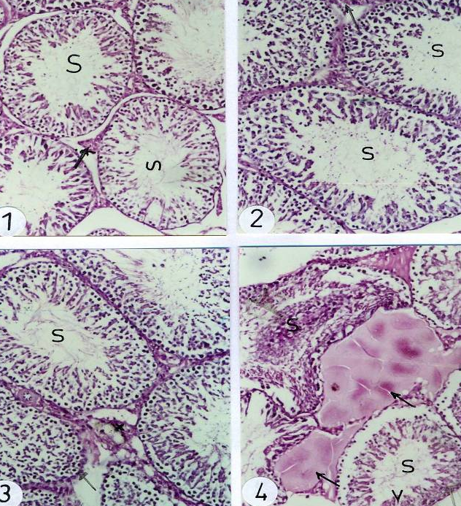

Fig. (1): Photomicrograph of testis section of untreated rat showed normal appearance of testis structure (Arrows) and smeiniferous tubules (S).
Fig. (2) Photomicrograph of testes section of rat treated with (60mg/kg) alpha lipoic acid showed nearly normal architecture of seminiferous tubules and interstitial cells (arrows).
Fig. (3, 4): Photomicrographs of testes sections of rats treated with insecticide mixture of (1/60 of LD50 of chlorpyrifose and 1/200 LD50 of fenitithione) showed infoldings of the membranes of seminiferous tubules, degeneration of the spermatogenesis process and hemorrhage between the seminiferous tubules (arrows).

Histochemical observations:
Acid phosphatase enzyme was detected in all testes sections of the animals using Gomori lead method. Untreated animals recorded the distribution of acid phosphatase in the primary and secondary spermatocytes as brown granules (Fig. 17). The animals treated with alpha-lipoic acid (served as+control group) showed nearly normal level of the brown granules of acid phosphatase enzyme (Fig. 18).

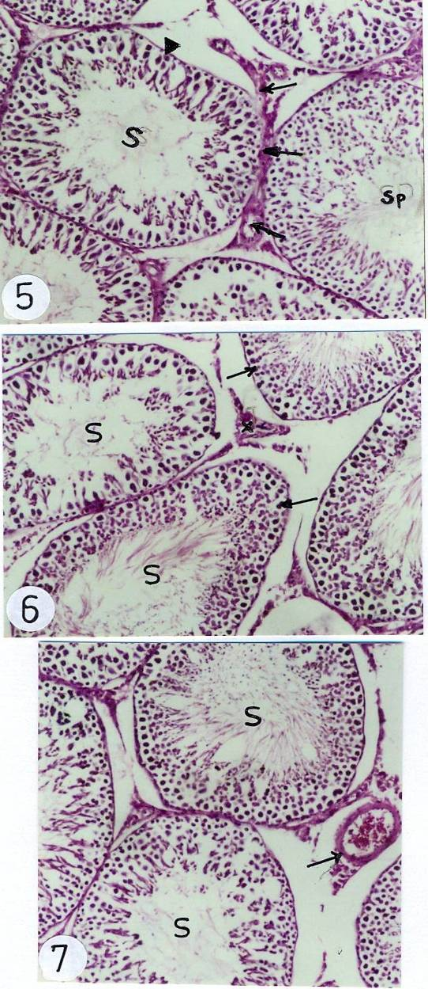

Fig. (5): Photomicrograph of testes sections of rats also treated with pesticide mixture obtained more proliferation within the interstitial cells (arrows).
Fig. (6,7): Photomicrograph of testes sections of rats intoxicated with the pesticide mixture and treated with ALA revealed some amelioration of the hypospermatogonia in the seminiferous tubules (S6) and giant cells between the Leydig cells (arrows 7). Fig. (8): Photomicrograph of testis section of untreated rat stained with masson trichrome stain showed the tunica albuginea normally arranged (arrows).
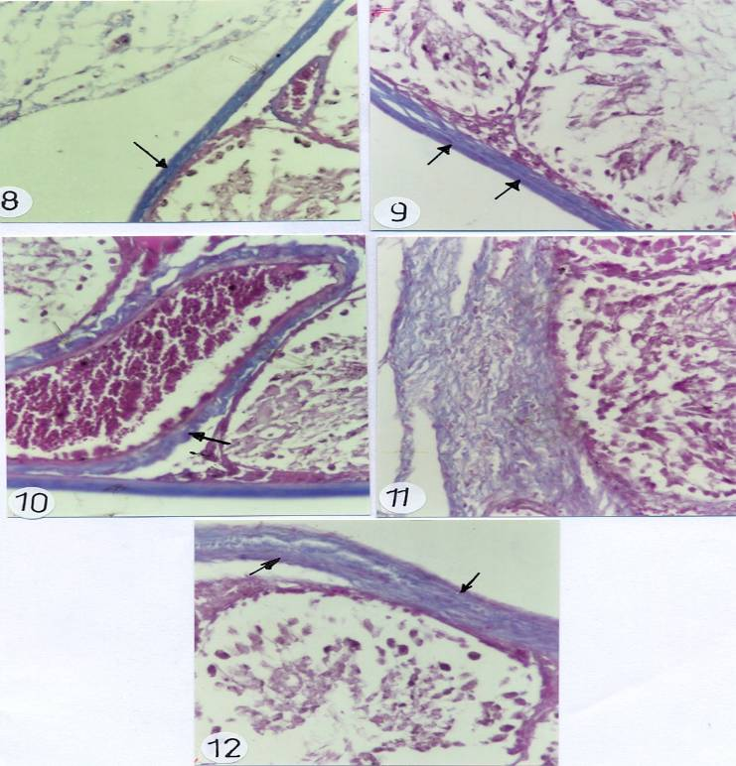

Fig. (9): Photomicrograph of testes section of rat treated with (60mg/kg) alpha lipoic acid showed nearly normal architecture of seminiferous tubules and interstitial cells (arrows).
Fig. (10, 11): Photomicrographs of testes sections of rats treated with insecticide mixture of (1/60 of LD50 of chlorpyrifose and 1/200 LD50 of fenitithione) showed high degree of fibers around the seminiferous tubules (arrows 10) and around the testis (arrows 11).

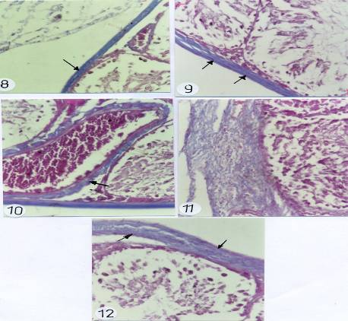

Fig. (12): Photomicrograph of testes sections of rats intoxicated with the pesticide mixture and treated with ALA revealed nearly normal appearance of the fibers with minimal increase comparing to untreated control animals.

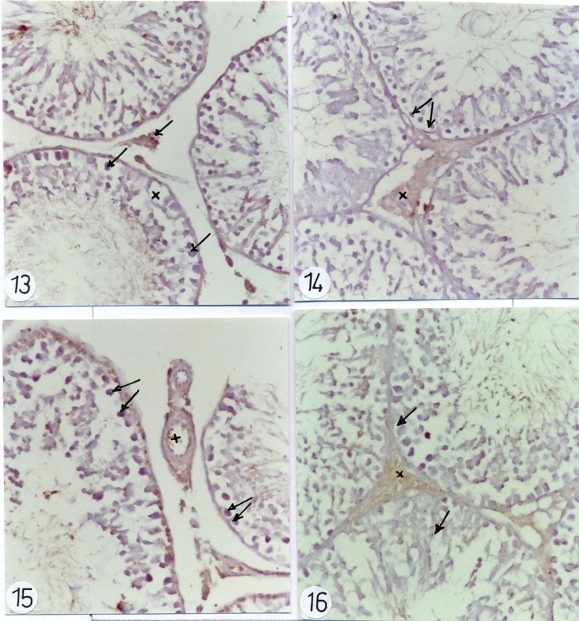

Fig. (13): Photo graph of testis section tissue of untreated rat showed normal positive cells between the spermatogenesis cells (arrows).
Fig. (14): Photomicrograph of testes section of rat treated with (60mg/kg) alpha lipoic acid showed some positive cells within germ cells (arrows).
Fig (15): Photomicrographs of testes sections of rats treated with insecticide mixture of (1/60 of LD50 of chlorpyrifose and 1/200 LD50 of fenitithione) showed significant increase in the brown positive cells within the primary stages of germ cells (arrows).
Fig. (16): Photomicrograph of testes sections of rats intoxicated with the pesticide mixture and treated with ALA revealed nearly decrease of the positive cells (arrows).

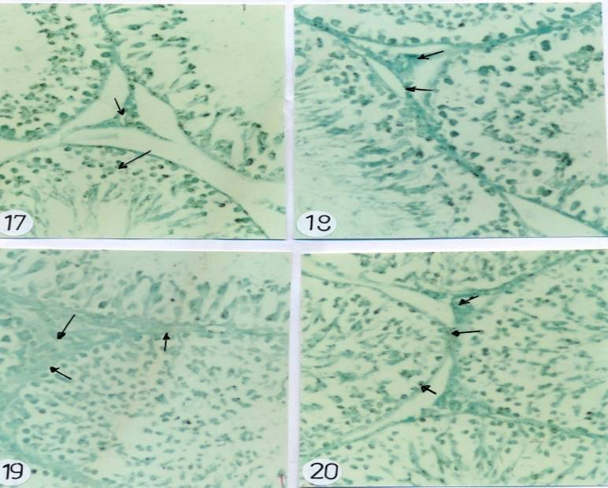
Fig. (17): Photo graph of testis section tissue of untreated rat showed normal distribution of the brown granules of the acid phosphatase enzyme within primary stages of spermatogonia (arrows).
Fig. (18): Photomicrograph of testes section of rat treated with (60mg/kg) alpha lipoic acid showed normal content of the brown granules within germ cells (arrows).
Fig. (19): Photomicrographs of testes sections of rats treated with insecticide mixture of (1/60 of LD50 of chlorpyrifose and 1/200 LD50 of fenitithione) showed significant depletion in the brown granules within the primary stages of germ cells (arrows).
Fig. (20): Photomicrograph of testes sections of rats intoxicated with the pesticide mixture and treated with ALA revealed nearly normal view of the acid phosphatase enzyme (arrows).

4. Discussion:
The testicular toxicity of insecticides was proven and alternative harmless control strategies should be applied. Insecticides were proven to be induced sever testicular toxicity as shown in the histopathological results which coupled with marked changes of biochemical results. Our results obtained spermatogonial depletion and atrophy due to pesticides toxicities in the seminiferous tubules. We detected desquamated cells in the lumen of seminiferous tubules and vacuolization within germ cells and some tubules contain apoptotic bodies, at the end of treatment, Leydig cells are strongly regressed and spermatozoa are less present in the luminal aspect of the seminiferous tubules. Also thickened basement membrane accompgnied by disappearance of interstitial cells and Leydig cells were proven.
There are several possible mechanisms for the antigonadal actions of organphosphorous in which they may exert a direct inhibitory action on the testis; they may affect the pituitary causing changes in gonadotropin concentration, and may change the concentration of the neurotransmitter acetylcholine (Sarkar et al., 2000; Serin, 2007). The hazardous effect of these pesticides on semen quality continued during the post treatment period, and was dose-dependent (Cakir and Sarikaya, 2005). Therefore Roy et al. (2004) showed that chlorpyrifos may exert a suppressive effect on the functional activity of accessory sex glands by decreasing testicular testosterone production following inhibition of pituitary gonadotrophins release (Parashanti et al., 2006). Exposure to low level organophosphorous is known to produce a variety of biochemical changes, some of which may be responsible for the adverse biological effects reported in humans and experimental animals (Sutatos, 1994).
As we shown that, fibrosis correlates with these histological finding, and implicated with the pathological changes. Fibrosis is probably the end result of an inflammatory process. Cell death also occurs spontaneously at various phases of germ cell development and morphological studies have implicated apoptosis in spermatogonial death appears to play a major role during spermatogenesis (Bartke, 1995). The spermatogenesis in mammals depends on testosterone production by Leydig cells in response to stimulation by FSH and LH. FSH increases Sertoli cell synthesis of an androgen binding protein needed to maintain high concentrations of testosterone. LH stimulates testosterone production by the interstitial cells of the testis (Kackar et al. 1997).
Sugar (1997) was obtained that acid phospatase enzyme plays an important role in the process of cell metabolism, autolysis, differentiation and many related processes and the dilatation of blood capillaries in between seminiferous tubules obtained upon the result of acid phosphatase enzyme activity. The increase in acid phospahatase enzyme activity could be explained on the bases of enhancement of cell membrane permeability with disturbance in the transphosphorylation process as a result of cellular degeneration (Linder et al.1997 and Ibrahim et al., 2003).
The depletion of the enzymatic antioxidative system strengthens the oxidative damage of membranes plays a significant role in cellular damage into the testes (Parasmthi et al., 2005 and Qu et al., 2008). Pesticides may induce oxidative stress, leading to generation of free radicals and alteration in antioxidants, oxygen free radicals, the scavenging enzyme system, and lipid peroxidation (Banerjee et al. 1999, Etemadi et al. 2002).
Lipoic acid was first postulated to be an effective antioxidant (Biewenga et al., 1997 and Packar et al., 1997). It is able to scavenge reactive species in vitro, though there is little or no evidence that this actually occurs in vivo. Alpha Lipoic Acid works both inside the cell and at the membrane level, thereby giving dual protection. Cronan et al. (2005) obtained the ability of ALA to create a robust shield on the cell membrane of sperm, along with the liquid that surrounds the sperm indirectly enhance the ability of the sperm to tolerate higher volumes of free radical attack. ALA has also been reported to assist the mitochondria’s citric cycle; this in turn will increase the level of reduced glutathione, ATP, TCA cycle enzyme and electron transport chain complex activities (Reddy, 2001 and Henriksen, 2006). ALA regulation of metabolism, increased availability of mitochondrial co-enzymes and improvement of protection of free radicals are thought to eventually lead to a reduced incidence of mitochondria dysfunction, thus ensuring sufficient ATP for sperm movement. (Ibrahim et al., 2008). In conclusion, the toxicity of the pesticides mixture was shown atrophy, fibrosis and increase the incidence of the apoptosis on the testes tissues then, on the fertility and spermatogenesis process. Also, alpha lipoic acid treatment revealed mild ameliorative effect on the pathology of testes.

Corresponding author
Azza M. Gawish
Department of Zoology, Faculty of Science, Cairo University, Giza, Egypt
azzagawish@ymail.com

5. References:
- Afifi NA, Ramadan A, El-Aziz, M.I., Saki EE. (1991). Influence of dimethoate on testicular and epididymal organs, testosterone plasma level and their tissue residues in rats. Dtsch Tierarztl Wochenschr.; 98(11):419-23.

- Bartke, A. (1995). Editorial: Apoptosis of male germ cells, a generalized or a cell type-specific phenomenon? Endocrinology, 136: 3-4.
- Bancroft J. D. and Stevens. H. (2002): Theory and Practice of Histological Techniques. Fourth Edition, Queen's Medical Center, Notingham, University Hospital NHS Trust.
- Banerjee, B; D., Seth, V., Battacharya, A., Pasha, S.T. and Chakrabory, A.K.(1999). Biochemical effects of some pesticides on lipid peroxidation and free radical scavengers. Toxicol. Lett.; 107: 33-47.
- Biewenga, G.P.; Haenen, G.R. and Bast, A. (1997)."The pharmacology of the antioxidant lipoic acid". Gen Pharmacol; 29: 315–331.
- Billig, H., Furuta, I., Rivier, C., Tapanainen, J., Parvinen, M. and Hsueh, J. W. (1995). Apoptosis in testis germ cells: developmental changes in gonadotropin dependence and localization to selective tubule stages. Endocrinology; 136: 5-12.
- Cakir, S. and Sarikaya, R., (2005).Genotoxicity testing of some organophosphate insecticides in the Drosophila wing spot test. Food Chem. Toxicol.; 43: 443-450.
- Chitra, K.C., Latchoumycandane, C. and Mathur, P.P. (1999). Chronic effect of endosulfan on the testicular functions of rat. Asian J. Andro.; 1: 203-206.
- Cronan, J.E., Zhao, X., Jiang, Y. (2005). "Function, attachment and synthesis of lipoic acid in Escherichia coli." Adv. Microb. Physiol; 50: 103–46.
- Etemadi-Aleagha, A., Khgari, M. and Abdollahi, M. A. (2002). A brief review on oxidative stress and cardiac diseases. Mid. East Pharma., 10; 10: 8-9. Henriksen, K., Hakovirta, H. and Parvinen, M. (1995). Testosterone inhibits and induces apoptosis in rat seminiferous tubules in a stage-specific manner: in situ quantification in squash preparations after administration of ethane dimethane sulfonate. Endocrinology; 136, 3285-3289.
- Gangadharan, B.; urugan, M.A. and Mathur, P.P. (2001). Effect of methoxychlor on antioxidant system of goat epididymal sperm in vitro. Asian J. Androl; 3: 285-288.
- Gotz, M. E., A. Dirr, R. Burger, B. Janetzky, M. Weinmuller, W. W. Chan, S. C. Chen, H. Reichmann, W. D. Rausch, and P. Riederer. (1994). Effect of lipoic acid on redox state of coenzyme Q in mice treated with 1-methyl-4- phenyl-1,2,3,6-tetrahydropyridine and diethyldithiocarbamate. Eur. J. Pharmacol.; 266: 291–300.
- Han, D., G. Handelman, L. Marcocci, C. K. Sen, S. Roy, H. Kobuchi, H. J.Tritschler, L. Flohe, and L. Packer, L. (1997). Lipoic acid increases de novo synthesis of cellular glutathione by improving cystine utilization. Biofactors.; 6: 321–338.
- Henriksén K, Hakovirta H, Parvinen M. (1995); In-situ quantification of stage-specific apoptosis in the rat seminiferous epithelium: effects of short-term experimental cryptorchidism. Int J Androl. ; 18(5):256-62.
- Henriksen, E.J (2006). "Exercise training and the antioxidant alpha-lipoic acid in the treatment of insulin resistance and type 2 diabetes". Free Radic. Biol. Med; 40 (1): 3–12.
- Hileman, B., (1994). Environmental estrogens linked to reproductive abnormalities and cancer. Chem. Eng. New, 31: 19–23.
- Hikim, A. P. S., Wang, C., Leung, A., and Swerdloff, R. S. (1995). Involvement of apoptosis in adult rats after gonadotropin-releasing hormone antagonist treatment. Endocrinology. 136, 2770-2775.
- Ibrahim, S. F., Khairul, O., Srijit, D.,, Abas, M. O., Norzaiti, A., and Mohd, P. AA(2008). Study of the Antioxidant Effect of Alpha Lipoic Acids on Sperm Quality Clinics.; 63(4): 545–550.
- Ibrahim, N.A. and El-Gamal, B.A. (2003). Effect of diazinon, as organophosphate insecticide, on plasma lipid constituents in experimental animals. J. Biochem Mol Biol.; 36: 499-504.
- Kackar, R., Srivastara, M. K. and Raizada, R. B. (1997). Induction of gonadal toxicity to male rats after chronic exposure to mancozobe. Ind. Health; 35: 104-111.
- Kangasniemi M, Wilson G, Huhtaniemi I, Meistrich ML. (1995). Protection against procarbazine-induced testicular damage by GnRH-agonist and antiandrogen treatment in the rat. Endocrinology.; 136(8):3677-80.
- Linder RE, Klinefelter GR, Strader LF, Suarez JD, Roberts NL. (1997). Spermatotoxicity of dichloroacetic acid. Reprod Toxicol.; 11(5):681-8.
- Nuckols, J.R.; Gunier, R.B.; Riggs, P (2007): Linkage of California pesticide use reporting data-base spatial land use for exposure assessment. Environ. Health Perspect; 115 (5): 684-689.
- Okamura, A., M. Kamijima, E. Shibata et al. A comprehensive evaluation of the testicular toxicity of dichlorvos in Wistar rayts.Toxicology, 2005; 213: 129–37
- Packar, L., Witt, E. H. and Tritschler, H. J. (1997). Alpha-lipoic acid as a biological antioxidant. Free Radic. Biol. Med.; 19:227–250.
- Pajoumand, A., Jalali, N., Abdollahi, N. and Shadnia S. (2002). Survival following severe aluminium phosphide poisoning. J Pharm. Pract. Res; 32: 297-299.
- Parasmthi, K., Muralithara, J. and Rajini, P. (2005). Fenvalerate induced oxidative damage inrat tissue and its attenuation by dietary sesame oil. Food Chem. Toxicol.; 43: 299- 306.
- Prashanthi, N., Narayana, K., Nayanatara, A., Chandra, K. H., Bairy, K.L. and D'Souza, U.J. (2006): The reproductive toxicity of the organophosphate pesticide 0, 0-dimethyl 0-4- nitrophenyl phosphorothioate (methyl parathion) in the male rat. Folia Morphol; 65: 309-321.
- Presibella, K.M., D.H. Kita, C.B. Carneiro, A.J.M. Andrade and P.R. Dalsenter, (2005). Reproductive evaluation of two pesticides combined (deltamethrine and endosulfan) in female rats. Reproductive Toxicology, 20: 95–101.
- Qu, J. H., Hong, X., Chem, J. F., Wang, Y. And Sun, H. (2008). Fenvalerate inhibits progesterone production through cAMP- dependent signal pathway. Toxicol. Lett. ; 176, 31 – 39.
- Reddy, L.J. (2001). "A Trail of Research from Lipoic Acid to alpha-Keto Acid dehydrogenase Complexes". J Biol. Chem.; 276 (42): 38329–36.
- Roy, T.S., Seidler, F.J., and Slotkin, T.A. (2004). Morphologic effects of subtoxic neonatal chlorpyrifos exposure in developing rat brain: Regionally selective alterations in neurons and glia. Brain Res. Dev. Brain Res.; 148:197–206.
- Sarkar R, Mohanakumar KP, Chowdhury M.( 2000). Effects of an organophosphate pesticide, quinalphos, on the hypothalamo–pituitary–gonadal axis in adult male rats. J. of Reprod. and Ferti.; 118: 29–38.
- Selvakumar E, Prahalathan C, Mythili Y, Varalakshmi P. (2004). Protective effect of DL-alpha-lipoic acid in cyclophosphamide induced oxidative injury in rat testis. Reprod. Toxicol.;19(2):163-7.
- Serin M, Gülbaş H, Gürses I, Erkal HS, Yücel N. (2007).The histopathological evaluation of the effectiveness of melatonin as a protectant against acute lung injury induced by radiation therapy in a rat model. Int. J. Radiat. Biol.; 83(3):187-93.
- Sugár J, Tóth K, Csuka O, Gáti E, Somfai-Relle S. (1997) . Role of pesticides in epatocarcinogenesis. J. Toxicol. Environ. Health; 5(2-3):183-91.
- Sultatos, L.G.: (1994). Mammalian toxicology of organophosphorous pesticides. J. Toxicol. Environ. Health.; 43: 271–289.
- Suresh, C. J. (2007): Testicular toxicity of chlorpyrifos (an organophosphate pesticide) in albino rat. Toxicology and Industrial Health; 23: 439—444.
- Suskind, A., Hayner-Buchan, A. and Feustel, P. J (2007). Analysis of human undescended testes. B J U International 101: 1 4 4 1 – 1 4 4 5
- Tamura, H., Maness, S.C., Reishman, K., Dorman, D.C., Gray, L.E., Gaido, K.W. (2001). Androgen Receptor antagonism by the organophosphate insecticide fenitrothion. Toxic. Scien.; 60: 56–62.
- Tremblay R R. (2001); Practical consequences of the validation of a mathematical model in assessment of partial androgen deficiency in the aging male using bioavailable testosterone. The Aging Male 4:23-9.
- Tuzmen, N.; Candan, N.; Kays, E. and demiryas, N.: Biochemical effects of chlorpyrifos and deltamethrin on altered antioxidative defense mechanisms and lipid peroxidation in rat liver. Cell Biochem. Funct. (2008); 26:119-124.

7/23/2010

