Subconjunctival bevacizumab, a potential therapeutic strategy for treatment of corneal neovascularization.

Hisham A. Hashem¹, Iman M. A. Zaki², Mohamed Ramzy¹.

¹ Ophthalmology Dept, Research Institute of Ophthalmology.
² Pathology Dept, Research Institute of Ophthalmology.
hisham_hashem@hotmail.com

Abstract: Purpose: feasibility of local application of bevacizumab for inhibition and treatment of corneal angiogenesis. Materials and Methods: 20 pigmented rabbits with average weight 3.7±0.4 kg were numbered and two groups were made, Group A: the rabbits of this group were subjected to corneal sutures application to induce corneal vascularization. Group B: rabbits of this group were subjected to corneal sutures with concomitant bevacizumab application. The rabbits were kept under observation and were examined and photographed after one week of taking the deep corneal suture for assessment of the corneal vessels. Then rabbits of group B were anaesthetized and bevacizumab was injected. At the end of the experiment, the rabbits were killed with an intravenous overdose of thiopentone, and histopathological studies were done. All histopathological analyses were performed by investigators blinded to medicine injected and the group of bevacizumab injection. Results: Corneal neovascularization disappeared in all rabbits of the group of bevacizumab injection. Conclusion: Data presented in this study effectively demonstrates the potential feasibility and safety of local application of bevacizumab for inhibition and treatment of corneal angiogenesis in an animal model. [Life Science Journal 2010;7(3):112-116]. (ISSN: 1097-8135).

Keywords: Subconjunctival, bevacizumab, corneal neovascularization.

1. Introduction
Neovascular diseases of the cornea and other parts of the eye represent a major public health problem. A wide range of inflammatory, infectious, degenerative, or traumatic disorders may induce corneal neovascularization. (1) Corneal neovascularization is a major challenge following chemical burns and corneal inflammation. Corneal neovascularization is a sequela of several inflammatory diseases of the anterior segment, such as infections, reactions to corneal transplantation and extended contact lens wear. The potential of antiangiogenic therapy has been greeted with great hope in ophthalmology. The tight regulation of corneal neovascularization helps maintain the transparency and immune privilege of the cornea. (2)
Corneal avascularity requires low levels of angiogenic factors and high levels of anti-angiogenic factors under basal conditions. Rupture of this homeostasis may occur in the pathogenesis of corneal neovascularization.(1) The data supporting a causal role for VEGF in corneal neovascularization are extensive. (3 - 13)
During corneal neovascularization, an up-regulation of angiogenic factors must be present, most likely in association with a down-regulation of anti-angiogenic molecules. It was recently shown that VEGF was up-regulated in inflamed and vascularised corneas in humans and in animal models. (11, 12, and 14) Angiogenesis is controlled by several mediators, including VEGF and basic fibroblast growth factor.
VEGF promotes several steps of angiogenesis, including proteolytic activities (dissolution of the membrane of the original vessel), endothelial cell proliferation, migration, and capillary tube formation. (1)
Hypothesis
Taken together, these data indicate that an anti-VEGF therapeutic approach may limit the visual loss associated with conjunctivalization of the corneal surface. Therefore, we propose the hypothesis that local administration of new anti-VEGF compounds such as pegaptanib sodium, bevacizumab and ranibizumab may be safe and an effective therapeutic option in corneal neovascularization.
To test this hypothesis the effects of a subconjunctival injection of bevacizumab (Avastin) tested in an animal model of corneal neovascularization.

2. Material and Methods
This protocol was approved by the Research Institute of Ophthalmology Medical Committee and was conducted in accordance with regulatory guidelines for the care of laboratory animals. We used 20 rabbits with average weight 3.7±0.4 kg.
All rabbits were examined by slit lamp to exclude any eye pathology or corneal neovascularization.
Deep corneo-limbal stitch were done in all rabbits to induce corneal neovascularization, the rabbits were anaesthetized and 8 0 vicryl sutures were taken under surgical microscope.
All rabbits were examined and photographed after one week of the application of the deep corneo-limbal suture, and the area of neovascularization was assessed according to the size (objectively the area of neovascularization was measured by ruler) and density (subjectively by the examiner)
The rabbits were numbered and two groups were made each contain 10 rabits:

Group A: rabbits of this group were taken as control, saline (2, 5 mg) were injected sub-conjunctively near the area of neovascularization.
Group B: rabbits of this group were injected by bevacizumab (2, 5 mg 0,1ml.) sub-conjunctively near the area of neovascularization.
Then rabbits of both groups were anaesthetized and saline and bevacizumab was injected (1 week after corneal sutures) in each group. For local delivery of saline & bevacizumab we used the insulin syringe for subconjunctival injection near the area of neovascularization.
Rabbits in the 2 groups were kept under observation and were re-examined and photographed after one week of injections, (2 weeks after deep corneal sutures) for assessment of the area of neovascularization (both objectively and subjectively) and grading scale were fashioned.

Table 1. Change in size of area of neovascularization

Grade | Change in size of area of neovascularization
0 | No change
I | 25 % Reduction
II | 50 % Reduction
III | 75 % Reduction
IV | Complete resolution

At the end of the experiment, the rabbits were killed with an intravenous overdose of thiopentone, the eye were enucleated and immediately bisected and fixed in 2, 5 % buffered glutaraldehyde for 6 hours, then sections from the cornea were taken, washed in phosphate buffer, post fixed in 1 % osmium tetroxide, dehydrated in a series of graded ethanol and lastly embedded in Araldite cy212. Semi thin sections of one micron thickness were obtained and stained with Toluidine blue (TB) stain for light microscopic examination.
All histological analyses were performed by investigators blinded to medicine injected and the group of bevacizumab injection.

3. Results and Discussion
In all 20 rabbits, the deep corneal sutures induced corneal vascularization (Fig. 1-2); the average area of neovascularization was 2 x 1 mm. (Table 1).
The results after the injections are summarized in Table 2.
In animals of group A; the area of neovascularization did not regress after saline injection, no change in the size or density occurred. (Table 2)
In group B; the area of neovascularization was considerably reduced both in size and density in all rabbits. Disappearance of the corneal neovascularization occurred in 7 rabbits (70 %). (Fig. 3) In 2 of injected rabbits (20 %), the area of neovascularization were reduced by more than 75 % in size with marked reduction in density and caliber of the blood vessels, in 1 of the injected rabbits (10 %) the area of neovascularization reduced to more than 50 %, with marked reduction in density of the neo-vessels. (Table 2).

Histopathologic Assessment
Light microscopic examination of the prepared corneal sections in the current stud included the following:
Group A: rabbits of this group were subjected to corneal sutures application to induce corneal vascularization with saline injection. Microscopic examination of corneal sections revealed multiple vascular spaces with disarranged surrounding collageneous lamellae (Fig 4, 5).
Group B: rabbits of this group were subjected to corneal sutures with concomitant bevacizumab application Microscopic examination showed different stages of occlusion of the induced neovascularization. This was in the form of narrowing, partial obliteration and subsequent complete occlusion of the luminae (Fig 5, 6, 7, 8, 9)

Table 2. Clinical evaluation of the 2 groups

 | No. of rabbits | Area of neovascularization 1 W after suture | Size 1 W after injection | Grade | Percentage  Of rabbits improved
Group A | 10 | 2 X 1 mm | 2 X 1 mm | 0 | 0 %
Group B | 7 | 2 X 1 mm | Complete resolution | IV | 70 %
Group B | 2 | 2 X 1 mm | Reduction in size more than 75 % | III | 20 %
Group B | 1 | 2 X 1 mm | Reduction in size more than 50 % | II | 10 %

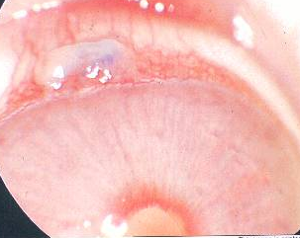

Fig. (1)

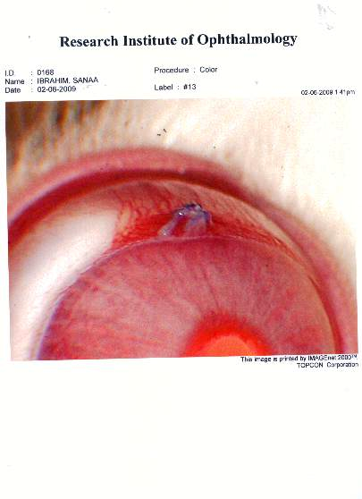
Fig. (2)

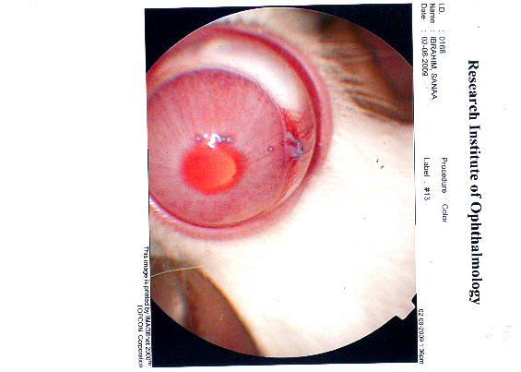
Fig. (3)

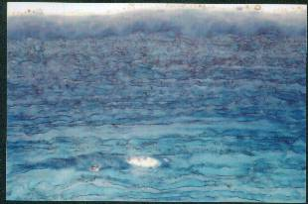
Fig. (4)

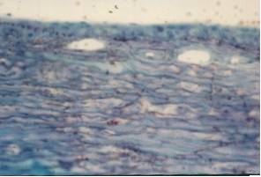
Fig. (5)

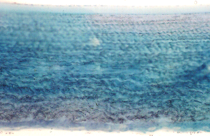
Fig. (6)

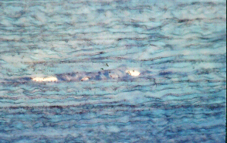

Fig. (7)

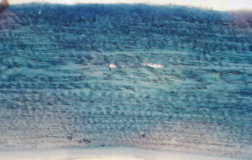
Fig. (8)

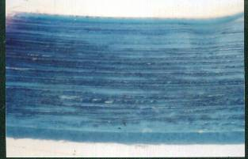

Fig. (9)

4. Discussion
Corneal neovascularization is a serious complication that can occur following keratoplasty and predispose to graft rejection. It is characterized by the growth of new capillaries from the limbal blood vessels and is often accompanied by an inflammatory response. The neovascularization starts in the recipient corneal bed, then extends to the graft–host interface and finally to the graft itself. Corneal neovascularization is a high risk for graft rejection after corneal transplantation because of the associated high levels of inflammatory cells and inflammatory mediators within the graft, which eventually provoke rejection and failure. (25).
Prevention and control of corneal neovascularization is thus a critical step in stopping graft rejection and failure.
Corneal neovascularization appears to be controlled by 2 opposing mechanisms: angiogenic stimulators such as vascular endothelial growth factor (VEGF) and angiogenic inhibitors such as angiostatin. (15, 16, 17).
Under normal conditions, the balance is toward the endogenous angiogenic inhibitors, keeping the cornea avascular. An insult to the cornea, may enhance the production of angiogenic stimulators, disturbing the balance and resulting in capillary endothelial cell proliferation and neovascularization.(15).
Vascular endothelial growth factor is a potent and highly selective mitogen for vascular endothelial cells, as well as a modulator of vascular permeability (vascular permeability factor), and is thought to play a key role in the pathogenesis of corneal neovessels. (20, 21)
Several methods to treat corneal neovascularization have been tried, argon laser photocoagulation and photodynamic therapy with different photosensitizers. However, such therapies are associated with thermal damage to the cornea and a high rate of vessel recanalization. Pharmacological treatment of corneal neovascularization using angiogenic inhibitors has evolved as a new way to manage corneal neovascularization. Lately, the success of monoclonal antibodies against VEGF such as bevacizumab and ranibizumab (Lucentis) in the treatment of retinal and choroidal neovascularization has encouraged the use of these antibodies to treat corneal neovascularization. (22, 23)
An important question is how to achieve therapeutic concentrations of such antibodies in the cornea.
Because there is little knowledge of the rate of absorption of the drug through the subconjunctival route and the required therapeutic dose, the answer to this question is uncertain. For most drugs, the recommended subconjunctival dose is 10 to 100 times the intravitreal dose. It seems logical that for control of corneal neovascularization, higher doses of bevacizumab than the classic 2.5 mg given in intravitreal injections are needed for subconjunctival injections (repeat injections may also be needed).
However, further studies are needed to establish the exact dose needed. This study may point to a possible role for VEGF inhibitors in the management of corneal neovascularization and, possibly, graft rejection. Topical application is another possible route. (24)

5. Conclusion:
Data presented in this study effectively demonstrates the potential feasibility of local application of bevacizumab for inhibition and treatment of corneal angiogenesis in an animal model.

References
- Chang JH, Gabison EE, Kato T, Azar DT. Corneal neovascularization. Curr Opin Ophthalmol 2001; 12(4): 242–9.
- Huang AJ, Watson BD, Hernandez E, Tseng SC. Induction of conjunctival transdifferentiation on vascularized corneas by photothrombotic occlusion of corneal neovascularization. Ophthalmology 1988; 95(2):228–35.
- Davidorf FH, Mouser JG, Derick RJ. Rapid improvement of rubeosis iridis from a single bevacizumab (Avastin) injection. Retina 2006; 26(3):354–6.
- Gan L, Fagerholm P, Palmblad J. Vascular endothelial growth factor (VEGF) and its receptor VEGFR-2 in the regulation of corneal neovascularization and wound healing. Acta Ophthalmol Scand 2004; 82(5):557–63.
- Lai CM, Spilsbury K, Brankov M, Zaknich T, Rakoczy PE. Inhibition of corneal neovascularization by recombinant adenovirus mediated antisense VEGF RNA. Exp Eye Res 2002; 75(6):625–34.
- Joussen AM, Poulaki V, Mitsiades N, Stechschulte SU, Kirchhof B, Dartt DA, et al. VEGF-dependent conjunctivalization of the corneal surface. Invest Ophthalmol Vis Sci 2003; 44(1):117–23.
- Zhou LH, Xing YQ, Chen CL, Wang DW. [Antisense vascular endothelial growth factor suppressed corneal neovascularization in rats]. Zhonghua Yan Ke Za Zhi 2006; 42(5): 426–30.
- Murata M, Takanami T, Shimizu S, Kubota Y, Horiuchi S, Habano W, et al. Inhibition of ocular angiogenesis by diced small interfering RNAs (siRNAs) specific to vascular endothelial growth factor (VEGF). Curr Eye Res 2006; 31(2): 171–80.
- Singh N, Amin S, Richter E, Rashid S, Scoglietti V, Jani PD, et al. Flt-1 intraceptors inhibit hypoxia-induced VEGF expression in vitro and corneal neovascularization in vivo. Invest Ophthalmol Vis Sci 2005; 46(5):1647–52.
- Kim B, Tang Q, Biswas PS, Xu J, Schiffelers RM, Xie FY, et al. Inhibition of ocular angiogenesis by siRNA targeting vascular endothelial growth factor pathway genes: therapeutic strategy for herpetic stromal keratitis. Am J Pathol 2004; 165(6):2177–85.
- Chen J, Liu W, Liu Z, Chen L, Huang T, Zhen H. [Expression of vascular endothelial growth factor and its receptors (flt-1) in morbid human corneas and investigation of its clinic importance]. Yan Ke Xue Bao 2002; 18(4):203–7.
- Zheng M, Deshpande S, Lee S, Ferrara N, Rouse BT. Contribution of vascular endothelial growth factor in the neovascularization process during the pathogenesis of herpetic stromal keratitis. J Virol 2001; 75(20): 9828–35.
- Philipp W, Speicher L, Humpel C. Expression of vascular endothelial growth factor and its receptors in inflamed and vascularized human corneas. Invest Ophthalmol Vis Sci 2000; 41(9):2514–22.
- Cursiefen C, Rummelt C, Kuchle M. Immunohistochemical localization of vascular endothelial growth factor, transforming growth factor alpha, and transforming growth factor beta1 in human corneas with neovascularization. Cornea 2000; 19(4):526–33.
- Amano S, Rohan R, Kuroki M, Tolentino M, Adamis AP. Requirement for vascular endothelial growth factor in wound- and inflammation-related corneal neovascularization. Invest Ophthalmol Vis Sci 1998; 39(1):18–22.
- Cursiefen C, Ku¨chle M, Naumann GOH. Angiogenesis in corneal diseases: histopathologic evaluation of 254 human corneal buttons with neovascularization. Cornea 1998; 17: 611–613.
- Dawson DW, Volpert OV, Gillis P, et al. Pigment epithelium derived factor: a potent inhibitor of angiogenesis. Science 1999; 285:245–248.
- Chang J-H, Gabison EE, Kato T, Azar DT. Corneal neovascularization. Curr Opin Ophthalmol 2001; 12:242–249.
- Miller J. Vascular endothelial growth factor and ocular neovascularization. Am J Pathol 1997; 151:13–23.
- Phillips GD, Stone AM, Jones BD, et al. Vascular endothelial growth factor (rhVEGF165) stimulates direct angiogenesis in the rabbit cornea. In Vivo 1994; 8:961–965.
- Amano S, Rohan R, Kuroki M, et al. Requirement for vascular endothelial growth factor in wound- and inflammation-related corneal neovascularization. Invest Ophthalmol Vis Sci 1998; 39:18–22.
- Isaacs TW, Barry C. Rapid resolution of severe disc new vessels in proliferative diabetic retinopathy following a single intravitreal injection of bevacizumab (Avastin) [letter]. Clin Exp Ophthalmol 2006; 34:802–803.
- Costa RA, Jorge R, Calucci D, et al. Intravitreal bevacizumab for choroidal neovascularization caused byAMD(IBeNA Study): results of a phase 1 dose-escalation study. Invest Ophthalmol Vis Sci 2006; 47:4569–4578.
- Awadein A. Subconjunctival bevacizumab for vascularized rejected corneal grafts. J Cataract Refract Surg. 2007; 33:1991–1993.

List of figures:
Fig (1-2): Colored photos of induced corneal neovascularization by deep corneo-limbal 8 0 vicryle suture.
Fig (3): Colored photo after I week of bevacizumab injection.
Fig (4): light photomicrograph of semi thin section of control rabbit cornea with induced neovascularization showing an empty oval vascular space (v) inbetween the stromal collageneous lamellae (c) (TB stain X 500).
Fig (5): light photomicrograph of semi thin section of control rabbit cornea with induced neovascularization showing multiple oval to round empty vascular spaces (v) with surrounding disarrayed collageneous lamellae (c) (TB stain X 500).
Fig (6): light photomicrograph of semi thin section of control rabbit cornea with induced neovascularization with bevacizumab application showing partial occlusion of newly formed vessels (v) (TB stain X 250).
Fig (7): light photomicrograph with higher magnification showing partial occlusion of the newly formed vessels (v) (TB stain X 250).
Fig (8): light photomicrograph of semi thin section of control rabbit cornea with induced neovascularization with bevacizumab application showing almost completely occluded slit-like vascular space (arrow) (TB stain X 250).
Fig (9): light photomicrograph of semi thin section of control rabbit cornea with induced neovascularization with bevacizumab application showing evidence of completely occluded vascular space (arrow) (TB stain X 250).

7/7/2010

