Skin abnormalities，female reproductive disorders and shorter life span with a mutation in the hairless gene

Kui-cheng Zhu,Jin-tao Zhang,and Chun-yao Wang
Laboratory Animal Center, Zhengzhou University, Zhengzhou -450052,Henan, China
jtzhang@zzu.edu.cn

Abstract: A spontaneous recessive mutation named rhinocerotic and short-lived（symbol：hr^{rhsl}） arose in a breeding colony of Chinese Kunming mice.Mutant hr mouse strains show skin and hair abnormalities and shorter life span.The present study analysed the skin，thymus and ovary of young（2 mo）and adult（6 mo）wild type and mutant mice.The mutant mice showed the disintegration of hair folliciles and formation of utriculi and dermal cystic structures in the dermis by histology and electron microscopy.The thymus of mutant mice underwent the accelerated atrophy and the decreased number of CD4⁺CD8⁻ and CD8⁺CD4⁻ were examined，and the increased apoptosis in the ovarian granulosa cells were observed in the mutant mice compared with the age-matched wild type by hematoxylin-eosin staining and flow cytometry.Taken together，present results strongly suggest accelerated age-dependent regression of thymus and increased apoptotic cells of ovary in mutant mice compared with the age-matched wild type，which could explain at least in part the immunodeficiency，shorter life span and reproductive disorder. [Life Science Journal 2010;7(3):105-111]. (ISSN: 1097-8135).

Key words: hairless mouse, ovary, thymus, hair follicle, skin

1. Introduction
The hairless gene（hr）is one of the molecules that regulates the hair follicle cycling and is found to be associated with a recessively inherited complete loss of body hairs（Panteleyev et al,1999）.A mutation in the hr（hairless）gene is responsible for the typical cutaneous phenotype of hairless mice (Panteleyev et al,1998c).The first mutation，hr，was collected in a British aviary in 1926（Brooke,1926）.After this，a number of mutation causing generalized hair loss occurred in the laboratory.The most widely studies include the hairless（hr），rhino（hr/^{rh}）and nude（Hfh11^{nu}）mutations.The hr mutation was found to be autosomal recessive allelic pattern,and mapped to mouse Chrosome 14（Sundberg,1994）.Several such mutations have prove to be homologous to specific human disease and represent useful animal models，for example，melanoma，interleukin-12-deficient，and asthma.Hairless mouse was first proposed as a mouse model for human popular atrichia in 1989（Sundberg,1989）.Mice carrying a mutation in hr,or in one of its alleles，typically show immune defects，as well as an aged-related immunodeficiency，consistently these animals are more sensitive to chemical carcinogens and UV-induced skin neoplasma.Moreover，these mutants have a decreased antibody response to thymus-dependent antigens with increasing age.Taken together,these findings indicate a thymic defect（Kawajih et al,1980；Shultzld, 1987）.The long duration of the estrous cycle，the absence of the ovulated oocytes was observed in histopathological studies of estrous cycles and ovaries in mutant B10-hr^{rhY} mice strain.The absence of mutation division，ovulation and corpora luteum in ovaries was found in contrast to normal isogenic B10 females（Ignatieva E L et al,1988）.
Several mice lacking hair arose spontaneously in a closed colony of Chinese Kunming mice in our lab，Which was isolated and established a mutant mouse strain termed “Yuyi hairless mice（YYHL）”.The inheritance mode of this phenotype was revealed，by testcross，to have resulted from an autosomal recessive mutation（Zhang et al,2002）. In homozygous YYHL mice，the first hair coat grows normally for the first 12 days after birth.Progressive hair loss was initiated around the eyes，and progresses caudally，resulting in a completely hairless condition within 2 wk with the exception of the vibrissae.As affected mice aged，the skin becomes progressively thickened，loose and redundant as schematically shown Figure 1（Zhang et al,2005）.Of interest，the life span in YYHL mice significantly decreased in contrast to normal Chinese Kunming mice and the hairless homozygous females have reduced reproductive capabilities（Li et al,2002;Du et al,2003）.The present study was designed to analyse the changes in the morphology of mutant mouse skin，thymus and ovary，and thymocytes subpopulation and ovarian granulosa cell were analysed by flow cytometer in mutant mice，which were compared with wild type mice.

2. Materials and methods
Animals and tissues
The skin, thymus and ovary of YYHL homozygous mice aged 2（n=5）and 6（n=5）mo，and of age-matched wild type mice (n=5 and n=5，respectively) were used in this study.Mutant mice strains and normal littermates were obtained from the colony of the Laboratory Animal Center of Zhengzhou University. All mice were cared for according to the Guide for the Care and Use of Laboratory Animals，and the study was approved by the Medical Ethical Committee of Zhengzhou University. The animals were killed by decapitation after deep ether anaesthesia，and the skin from the upper back，thymus and ovary quickly removed.

Histology and transmission electron microscopy
The dorsal skin were removed immediately and biopsies were taken both for TEM and histology studies.For TEM，samples were washed in 5% sucrose cacodylate buffer，postfixed with 1% osmium tetroxide，dehydrated and embedded in epoxy resin after 4h in Karnovsky,s fixative.Ultrathin sections were cut，collected on formvar coated grids and examined in an electron microscope.For histology，the skin，thymus and ovary were fixed in 10% neutral buffered formalin overnight，embedded in paraffin，sectioned at 5 microns,and stained with hematoxylin and eosin.
Thymocytes were prepared from mice (2-mo and 6-mo old) and stained with both FITC-conjugated mouse-specific CD4 and PE-conjugated mouse-specific CD8 monoclonal antibodies for two-color staining. Analysis was performed with a FACScan and the Cell Quest program.
Ovaries from mice were harvested after cervical dislocation and immediately placed in ice-cold saline. The granulose cells of follicle were separated using the method described earlier（Gilbert，1977）.The harvested cells were washed in PBS twice and then incubated with 200 μL RNase A (100μg/mL) at 37ºC for 30 min. The cells were stained with Propidium Iodide at 4 ºC for 30 min and immediately analyzed by flow cytometry.

Statistical analysis
The data obtained from each mouse was averaged per group and standard deviation of the mean values was calculated. Mean values were compared by nonparametric Mann–Whitney test using SPSS 10 for Windows software package. The results were expressed as the mean value ± SD，and differences at p < 0.05 were accepted as the level of significance.

3. Result
Histology
YYHL skin displayed obvious differences to the skin of wide type mouse.The histopathological feature of the YYHL mice was the disintegration of hair folliciles and formation of utriculi and dermal cystic structures in the dermis and the dermal cysts grows progressively larger with increasing age，example are showed at 2 month and at 6 months（figure 2），which was believed to be the main pathomechanism of skin wrinkling，folding and thickening in YYHL mice.
The absolute weight and the growth index between the thymus of wild-type mice and the age-matched YYHL mice were significantly reduced. Histological examination showed cortical atrophy，which had a marked disappearance of lymphocytes from the thymic cortex in the thymus of YYHL mice when compared with the wild-type mouse of the same age.Interestingly, the alterations increased in an age-dependent manner. Morphologically, the granulosa cells in ovarian tissue of YYHL mice demonstrated marked apoptosis characterized by cell shrinkage, membrane blebbing and nuclear condensation，some of which were lost from the granulosa cell layer when compared with the wild type mice.

Skin Ultrastructure
By electron microscopy，the number of cells had increased in the epithelial islets by 14 days after birth, and a centripetal arrangement was seen.In the central part of the cysts，a fibrillar material was observed suggesting degeneration of the central cells.The cysts progressively enlarged and a central cavity had come evident by the age of 28 days（Figure 3）.

Change of the weights and growth index，hispathology and lymphocyte subpopulations in the thymus
As can be seen in Table 1，the weights and relative weights of thymus decreased significantly，and histological examination revealed a marked disappearance of lymphocytes from the thymic cortex in 6 mo YYHL mice as compared to 2 mo YYHL mice and the wild type mice.
The distribution of T-cell subsets in the thymus was analyzed by flow cytometry.In 6 mo YYHL mice，the percentage of CD4⁺CD8⁻ and CD8⁺CD4⁻ thymocytes was lower and the ratio between CD4⁺CD8⁻ and CD8⁺CD4⁻ cells increased as cpmpared to the wide-type mice of the same age. The percentages of CD8⁺CD4⁻ and CD4⁺CD8⁻ thymocytes also decreased both 2 and 6 mo in YYHL mice.There was no difference in the percentage of CD4⁺CD8⁻ and CD8⁺CD4⁻ between 2 and 6 mo wide-type mice（Figure 4）.

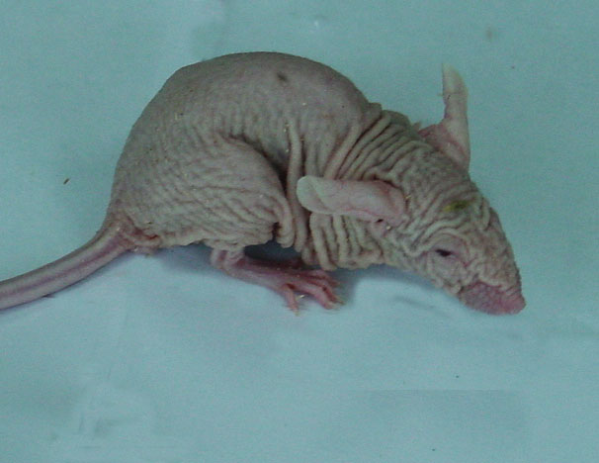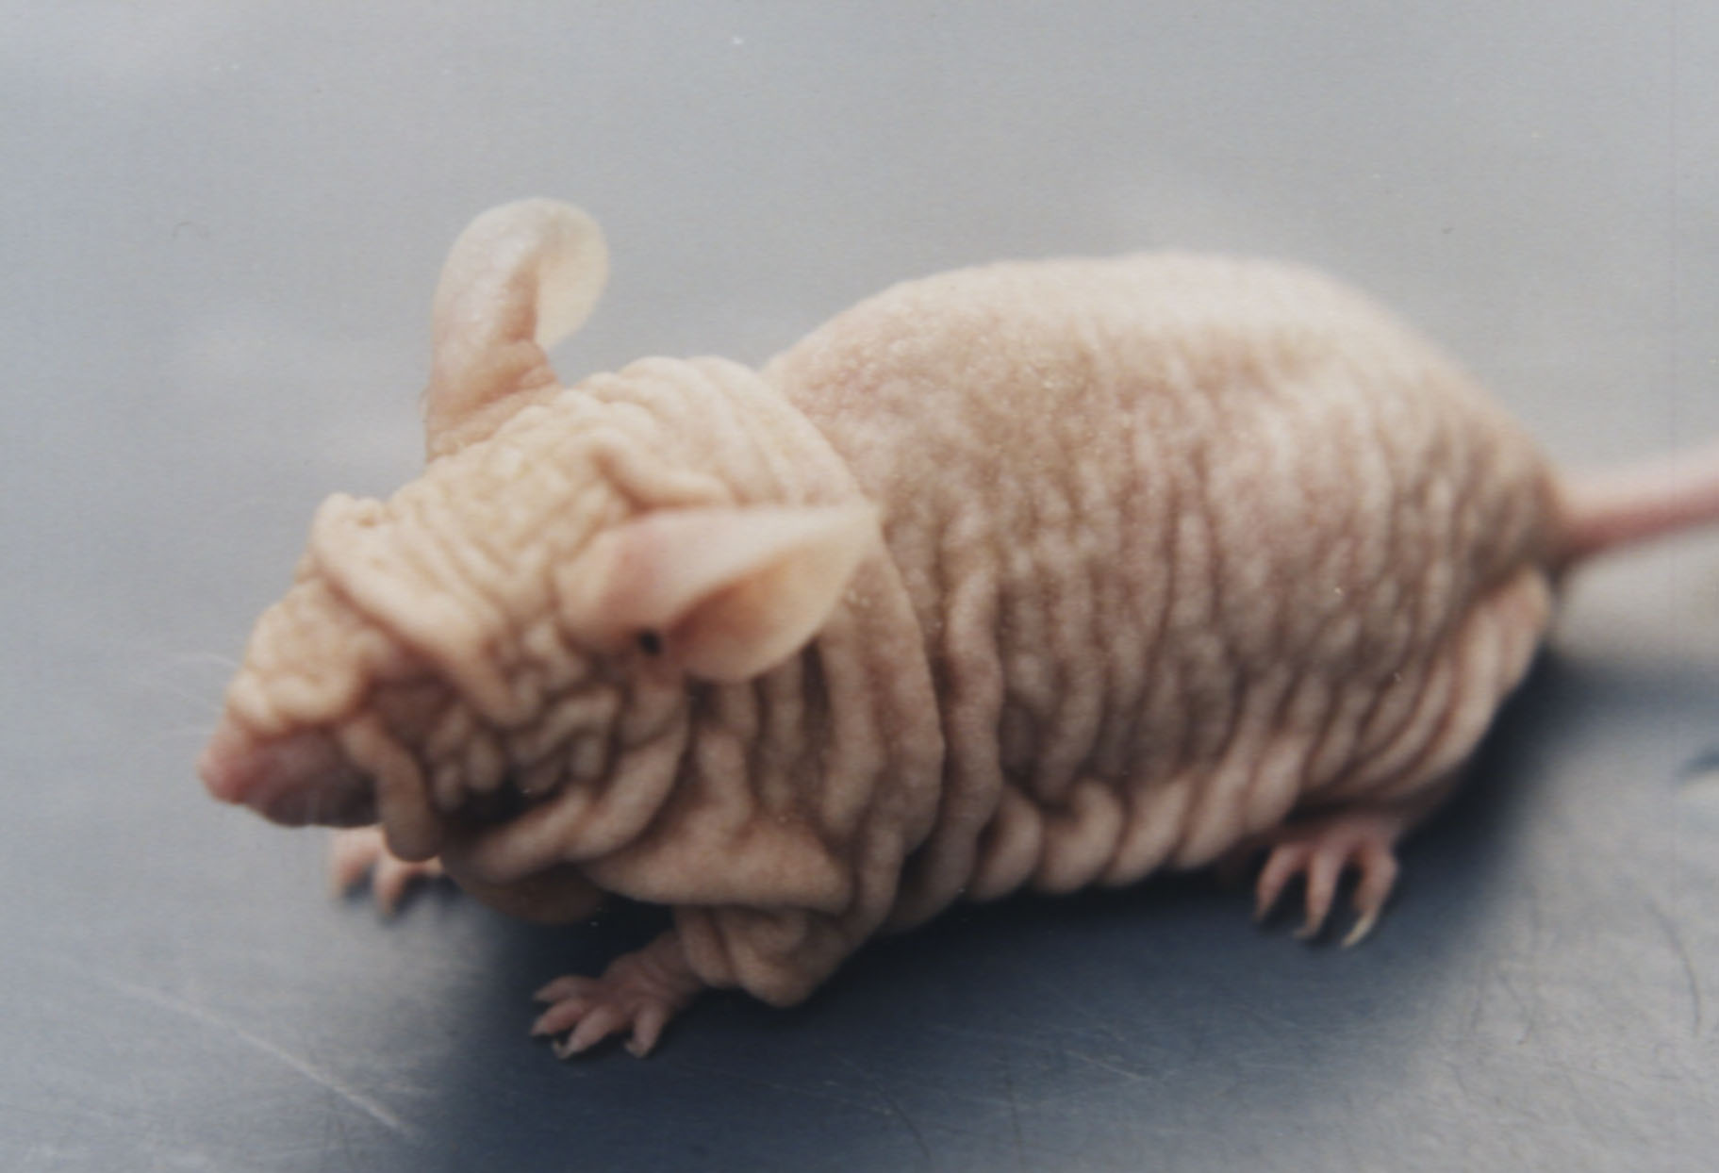
B
A
Figure 1. Appearance of YYHL mutant mice.A：The 2-month-old YYHL mouse on the left demonstrates the characteristic hair loss with loose and redundant skin.B：The 6-month-old YYHL mouse with severe thickening and wrinkling of the skin.
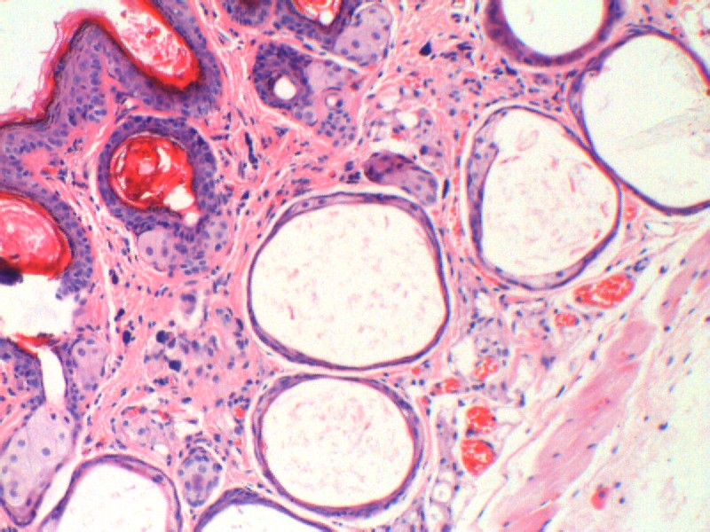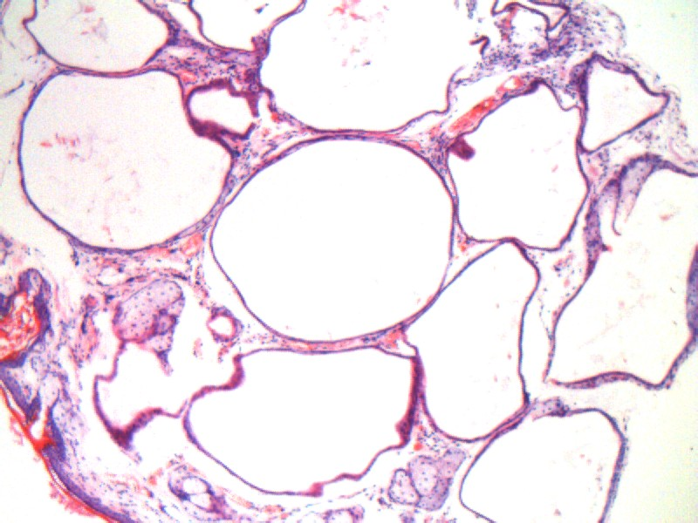
C
D
Figure 2. Progressive degeneration of hair follicles in Cross-section of dorsal skin of mutant mice.C：mutant mice at 2 months of age；D：mutant mice at 6 months of age.Solid arrow，enclosed dermal cysts.

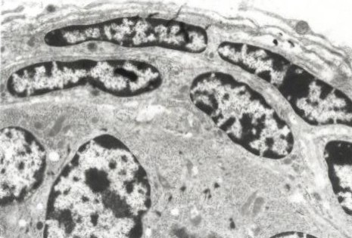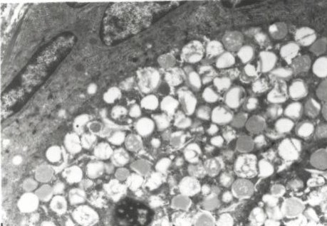
E
F
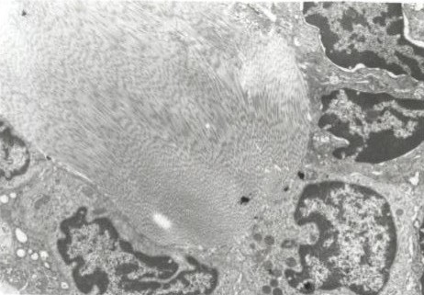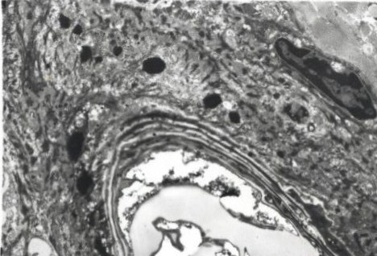
G
H
Figure 3. Ultrastructural aspects of dermal cysts. At 12 days（E），dermal cysts are formed by epithelial cells which cluster in islets.Sebocyte-like cells in the cysts of a 16-day-old YYHL mouse（F）.At 20 days（G），the central part of the cyst is characterized by an accumulation of fibrillar material from degenerative cells. At 28 days（H），The central cavity is formed from degenerative cells.

Table 1. Weight and growth index and lymphocytes subpopulations in the thymus of wild type and mutant mice
Wild type mice rhsl-hr-mice
2mo 6mo 2mo 6mo
Thymus weight 110.20±7.51 72.50±4.63 85.30±4.65 33.80±1.64ª
Thymus weight
index mg/g body weight（%） 3.18±0.32 1.75±0.09^{b} 2.96±0.22 0.74±0.05ª
CD4⁺CD8⁻ 14.33±1.59 13.83±1.63 14.02±1.27 8.85±0.83ª
CD8⁺CD4⁻ 7.81±0.65 8.04±1.12 8.22±1.03 4.22±0.51ª
CD4⁺CD8⁻/ CD8⁺CD4⁻ 1.84±0.25 1.74±0.29 1.71±0.14 2.13±0.41^{c}
a，＜0.01 vs all the other groups；b,＜0.05 vs young wild type and young mutated mice；c，＜0.05 vs young wild type,young mutated mice and adult mutated mice.

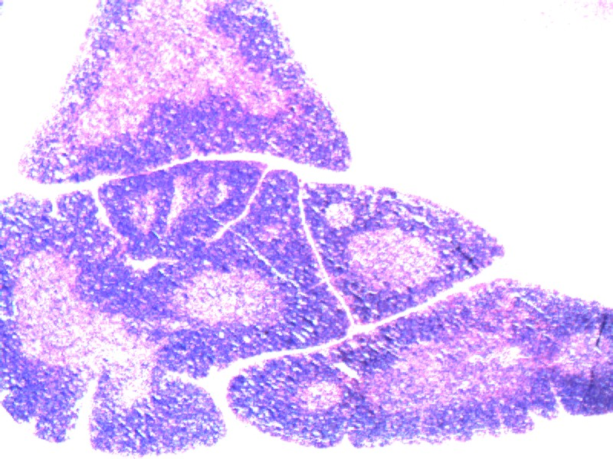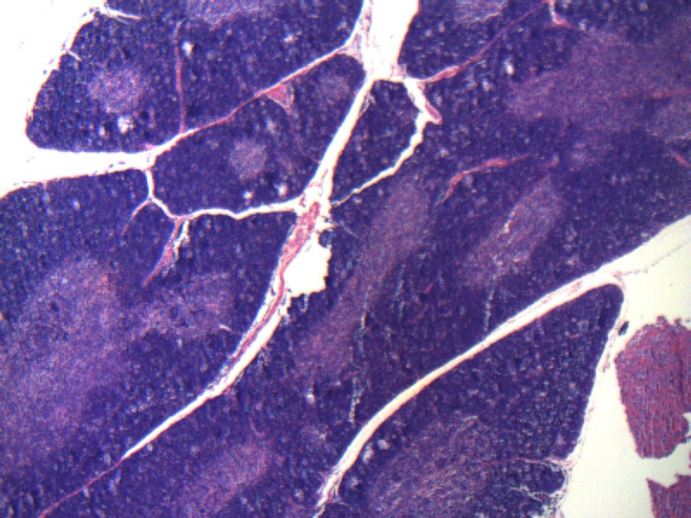
I
J

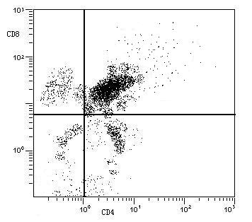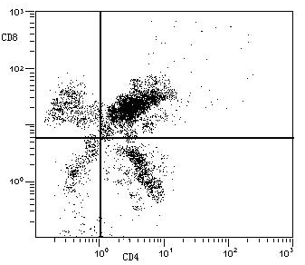
K
L

Figure 4. Thymus from 6-month-old mutant and wild type mice. I：Severe thymus atrophy from a mutant mouse showing substantial reductions in the thickness of the cortex and depletion of cortical lymphocytes. J：Normal appearance of the thymus from a wild type mouse showing a thick zone of densely staining cortex and a narrow zone of lightly staining medulla. HE (bar=100μm).Representative flow cytometry profiles of CD4 and CD8 expression on thymocytes both 6 mo YYHL mice（K） and wild type mice（L）.Subset percentages were indicated in Table 1.

Analysis of cell cycle and apoptosis on the ovarian granulose cells
The ﬂow cytometric analyzed that 70.34% and 44.96% of the ovarian granulose cells in 6 and 2 mo mutant mice respectively were in the G1 phase，which were 28.93% and 32.91% in age-matched wild type mice respectively. 54.89% of the cells in the S phase in 6-mo wild type mice，17.45% in the S phase in 6-mo mutant mice，indicating the accumulation of cells in the G1 phase of cell growth in 6-mo mutant mice as compared to the wild type mice. In the cells undergoing apoptosis，DNA was degraded to fragments of low molecular weight and subsequently leaked out from the cells，and when the DNA content was stained with a DNA-specific fluorochrome，propidium iodide (PI)，a special DNA peak (usually called sub-G1 peak) appeared. Significant apoptosis was present in ovarian granulose cells of YYHL mice（23.93%）at 6 months compared with YYHL mice at 2 months（7.40%）and 2 and 6 mo wild type mice，which were 3.06% and 2.84% respectively（Table 2）.Histologically，Ovarian granulose cells demonstrated marked apoptosis characterized by cell shrinkage，membrane blebbing，and nuclear condensation（Figure 5）.The subG1 population and the apoptotic fraction of ovarian granulose cells was increased significantly in 6 mo mutant mice compared with 2 mo mutant mice and wild type mice（Figure 5）.

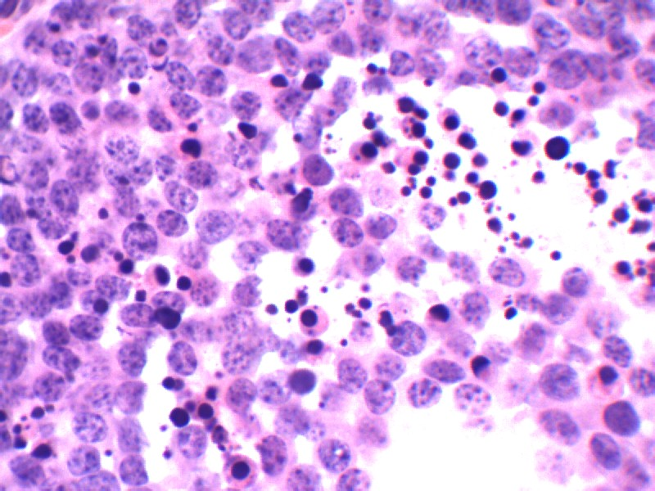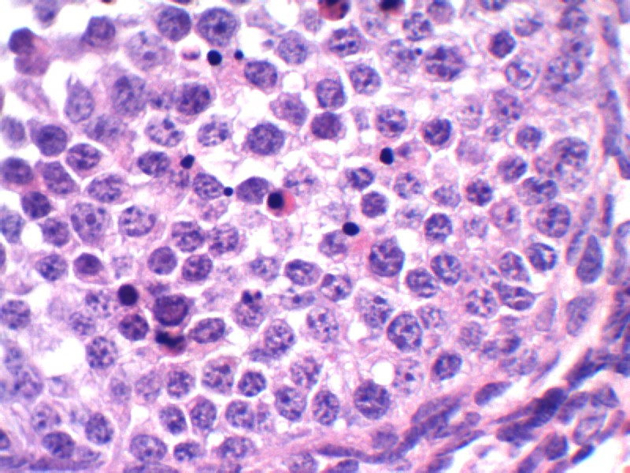
M
N

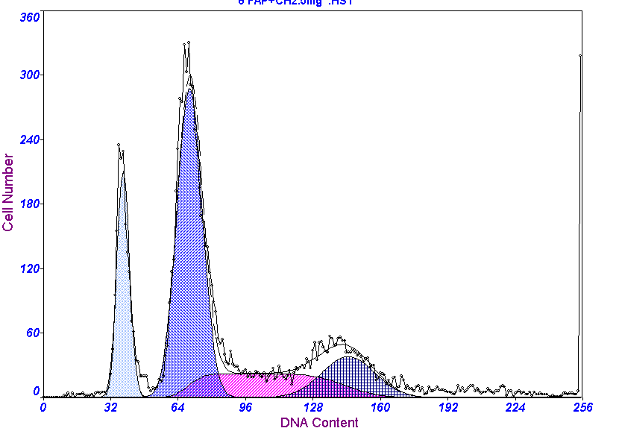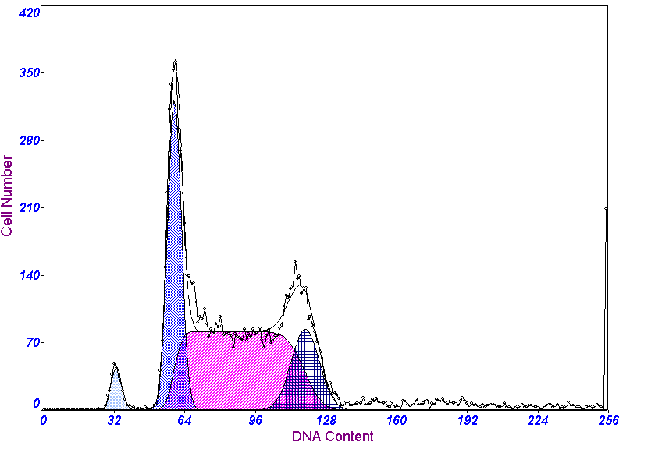
O
P
Figure 5. Ovarian granulosa cells were analysed by histology and flow cytometry in the ovaries both mutant mice and wild type mice.Ovarian granlosa cells demonstrated marked apoptosis characterized by cell shrinkage,membrane blebbing，and nuclear condensation in 6 mo YYHL mice （M） compared with the 2 mo YYHL mice and 2 and 6 mo wild type mice（N）.The subG1 population，the apoptotic fraction of ovarian granulosa cells (arrow：d) was increased significantly in 6 mo YYHL mice（O）compared with the 2 mo YYHL mice and 2，6 mo wild type mice（P）.

Table 2. Cell cycle and and apoptosis of ovarian granulosa cells in wild type and mutant mice
Wild type mice rhsl-hr-mice
2mo 6mo 2mo 6mo
G1 32.91±3.86 28.93±2.18 44.96±3.91^{b} 70.34±3.70ª
S 56.24±2.90 54.89±3.24 45.78±2.62^{b} 17.45±2.53ª
G2/M 10.85±2.04 16.18±2.77 9.26±1.01^{c} 12.21±2.14
Apoptotic（%） 3.06±0.51 2.84±0.39 7.40±1.20^{b} 23.93±2.35ª
a，＜0.01 vs all the other groups；b,＜0.01 vs young wild type mice and wild type mice；c,＜0.01 vs adult wild type mice and adult mutated mice,young mutated mice and adult mutated mice.

4. Discussion
In this study，we reported that a newly found mutant mouse（YYHL）has histological and Ultrastructual features in the skin.Histologically，the main reason for the abnormal skin was the various sizes of dermal cysts occupied the lower dermis and subcutaneous tissue.It was worth noting that dermal cysts in the skin of aged hairless mice undergo a slow enlargement process，which resulted in the abnormality of skin.The TEM study showed the characteristics of cysts that developed in the deep dermis of hairless mice.Early development of dermal cysts was primarily characterized by an increase in the number of cells in the islets.Simultaneously the central part of the cyst is characterized by an accumulation of fibrillar material from degenerative cells. At later stages of development，a central cavity formed which derived from degeneration of the central cells.Our results ruled out the possibility that these cells might correspond to cells originating from the follicular dermal papilla which are mesenchymal cells（Roth,1965;Montagna,1974）.
The study analyzed the thymus of 2 mo and 6 mo mice carrying a mutation in the hr gene.Here we described for the first time structural changes as well as T-cell subsets of thymus in YYHL mice .The result revealed the reduction both the weight and the weight index of the thymus at 6 mo YYHL mice compared with the wide type mice of the same age.The main structural change in the thymus of mutated mice was the atrophy，which showed substantial reduction in the thickness of the cortex and the depletion of cortical lymphocytes.A previous study reported atrophy of the thymus of hr-rh-j mice with aging（San Jose et al，2001）.In the thymus，functionally mature SP thymocytes derive from immature DP cells through negative and positive selections (Penit and Vasseur，1989； Nossal，1994) mediated by complex cellular interactions，and a variety of cytokines，hormones，neuropeptides，and growth factors (Takayama et al，1998). In turn，DP thymocytes derive from immature DN cells，and then express the TCRb polypeptide chain on their membrane (Wurch et al，1999).Our results showed that a decrease in CD4⁺CD8⁻ and CD8⁺CD4⁻ thymocytes and the ratio between CD8⁺CD4⁻ and CD4⁺CD8⁻ at 6 mo YYHL mice compared with the wide-type mice of the same age. Several of the mouse mutations with abnormalities of the integument associated with more or less severe immunological defects have been reported previously（Shultz LD et al,1978）.Our findings suggested an age-dependent degeneration and accelerated regression of the thymus in YYHL mice，which might be correlated with the impaired function of cellular immunity and shorten life span.
In this study，we examined the apoptosis and the cell cycle of ovarian granulosa cell both mutanted mice and wild type mice by flow cytometry.The present results showed that a G1-phase to S-phase cell cycle block was accompanied by increased apoptosis cells in 6 mo mutated mice compared with 2 mo mutated mice and young and adult wide type mice. In addition，histological analysis also demonstrated the increased granulosa cell apoptosis by hematoxylin-eosin staining and the presence of apoptosis was associated with decreased ovarian weight in mutant mice.Previous studies describing the reproductive defects in hr^{rhY}/hr^{rhY} mice. It was proposed that the reason for hr^{rhY}/hr^{rhY} female infertility was not the dysfunction of the ovary itself，but the impaired perception of any external regulatory factors，most likely，luteinizing hormone of the anterior pituitary，which played an important role in the regulation of ovulation（Garcia and Jones,1981）.Our study revealed it was possible that mutation induced apoptosis of ovarian granulosa cell caused reproductive disorders in Yuyi hairless female mice.
Taken together，our findings strongly suggest accelerated age-dependent regression of thymus and increased apoptotic cells of ovary in mutant mice compare with the age-matched wild type，which could explain at least in part the immunodeficiency，shorter life span both YYHL male and female mice，and the reduced reproductive capabilities in YYHL female mice.More studies are necessary in order to elucidate the true origin of these in mutated mice.

Acknowledgements:
Authors are grateful to the Laboratory Animal Center of Zhengzhou University，Government of China for financial support to carry out this work.

Coresponding Author：
Dr. Jin-tao Zhang
Laboratory Animal Center, Zhengzhou University, Zhengzhou-450052,China.
E-mail: jtzhang@zzu.edu.cn

References
1. Panteleyev AA,Botchkareva NV,Sunderg JP,Christiano AM，Paus R.The role of the hairless（hr）gene in the regulation of hair follicle catagen transformation.Am J Pathol 1999;155:159-71.
2. Panteleyev AA,Van der Veen C,Rosenbach T，Muller-Rover S，Sokolov VE，Paus R：Towards defining the pathogenesis of the hairless phenotype.J Invest Dermatol 1998c;110:903-07.
3. Brooke HC.Hairless mice.J Hered 1926;17:173-74.
4. Sundberg JP. Handbook of Mouse Mutations with Skin and Hair Abnormalities: Animal Models and Biomedical Tools .CRC Press, Boca Raton 1994; 291–312.
5. Sundberg JP, Dunstan RW, Compton JG. Hairless Kunming use. HRS/J hr/hr. In: Jones T C, Mohr U, Hunt R, eds,1989.
6. Kawajih T,sukuda R, Nakaguchi T.Immunopathology of rhino mouse, an autosomal recessive mutant with murine Lupus-like disease. Acta Pathologica Japonica 1980;30:515–30.
7. Shultzld.Pleiotropic mutations causing abnormalities n the murine immune system and the skin.Current Problems in Dermatology 1987;17: 236–50.
8. Ignatieva E L,Malashenko A M,Blandova Z K. Morphofunctional characteristic of reproductive system in females of mutant B10-hr^{rhY} mice strain. Bull Exp Biol Med 1988;11: 602-03.
9. Zhang JT, Wang CY, Kang QZ, Du XT, Xue JL.Establishment of segregating inbred strain of Yuyi hairless mice and its monitoring of genetic characteristics. Acta Genet Sin 2002;29:221–25.
10. Zhang JT, Sheng GF,Wang CY. A novel nonsense mutation and polymorphisms in the Mouse hairless gene. J Invest Dermatol 2005;124:1200 –205.
11. Li HT,Du CY, Zhang JT,Wang CY. Study on procreation and mamary gland of Yuyi hairless mice. Journal of Zheng zhou University（Medical sciences）2002;11:198-99.
12. Du CY,Li HT,Zhang JT,Wang CY,Du XT. Investigation on life span of Yuyi hairless mice. Journal of Zheng zhou University（Medical sciences）2003;2:196-97.
13. Gilbert AB,Evans AJ,Perry MM,Davidson MH.A method for separating the granulosa cells，the basal lamina and the theca of the preovulatory ovarian follicle of the domestic fowl (Gallus domesticus).J Reprod Fertil 1977;50:179−81.
14. Roth S.The cytology of the murine resting (telogen) hair follicle. In: Lyne AG, Short BF (eds) Biology of the skin and hair growth. Angus and Robertson, Sydney 1965;233-50.
15. Montagna W, Parakkal P.The structure and function of the skin.The pilary unit. Academic Press, London 1974;172–258.
16. SAN JOSE I,Garcia-Suarez O,Hannestad J,Cabo R,Gauna L,Represa J and Vega JA. The thymus of the hairless rhino-j (hr/hr-j) mice. J. Anat. 2001;198:399–406.
17. Penit C，Vasseur，F.Cell proliferation and differentiation in the foetal and early postnatal mouse thymus. J. Immunol 1989;142:3369–377.
18. Nossal GJ.Negative selection of lymphocytes. Cell 1994;76:229–239.
19. Takayama E,Kina T,Katsura Y,Tadakuma T.Enhancement of activation-induced cell death by ﬁbronectin in murine CD4⁺CD8⁺ thymocytes. Immunology 1998;95:553–58.
20. Wurch A, Biro J, Falk I, Mossmann H. Eichmann K.Reduced generation but efﬁcient TCR betachain selection of CD4⁺CD8⁺ double-positive thymocytes in mice with compromised CD3 complex signaling. J Immunol,1999;162:2741-747.
21. Shultz LD, Heiniger HJ, Eicher EM.Immunopathology of streaker mice: a remutation to nude in the AKR/J strain. In: Gershwing ME, Cooper EL (eds) Animal models of comparative and developmental aspects of immunity and disease. Pergamon Press 1978;211–22.
22. Garcia J E,Jones GS,Wright GL. murine of the time of ovulation. Fert Steril 1981;36:308–15.

9/16/2010

