GCMS Prediction of Organochlorine Herbicide Sorption Rate: A
Batch kinetic studies.
Itodo A.U.¹, Abdulrahman F.W.², Hassan L.G³, Maigandi S.A.⁴, Itodo H.U⁵
¹Department of Applied Chemistry, Kebbi State University of Science and Technology, Aliero, Nigeria
²Department of Chemistry, University of Abuja, Nigeria
³Department of Pure and Applied Chemistry, Usmanu Danfodiyo University, Sokoto, Nigeria
⁴Faculty of Agriculture, Usmanu Danfodiyo University, Sokoto, Nigeria
⁵Department of Chemistry, Benue State University, Makurdi, Nigeria
itodoson2002@yahoo.com
Abstract: Viable adsorption technique based on sorbate removal by phosphoric acid (H₃PO₄) poultry droppings (PD) was proposed to improve the ecological system. Two ways activation schemes generated activated carbons was applied to herbicide uptake and evaluated with three (3) kinetic models. GC/MS quantitation experiment based on external standard method was performed to demonstrate up to 89.216% atrazine removal. The kinetic equilibrium study showed that a 300 minute sorbate – sorbent interaction gave 19.293 out of 25 gdm³ adsorption (being a 77.172% adsorption). This is only 5.140, 1.992, 1.432 and 0.632% higher than the 60, 120, 180 and 240 minutes interaction with 72.032, 75.180, 75.740 and 76.540% atrazine removal respectively .The pseudo-second order kinetics was observed to be more suitable in predicting the adsorption rate by the sorbate wherein the initial adsorption rate, h was estimated as 0.3646 g.mg⁻¹ min⁻¹. A time dependent physisorption phenomenon was evidenced. The major results support the conclusion that the sorted agro-waste has the potential to serve as extractants adsorbents in remediation process. [Life Science Journal 2010;7(3):64-72]. (ISSN: 1097-8135).
Keywords: Adsorption kinetics, Rate, Poultry droppings, GCMS

- Introduction
Triazines and organophosphorus pesticides are considered as priority pollutants since they are harmful to organism even µgL⁻¹ levels. These pesticides or herbicides constitute a diverse group of chemical structures exhibiting a wide range of physiochemical properties (Agdi et al., 2000). Atrazine (2-chloro-4-, amino-6-isopropylamino-s-triazine) and related substituted chlorotriazine compound,2-chloro-4,6-bis(ethylamino)-s-triazine) finds extensive use as herbicides (Shimabukoro,1967).They are widely used for the control of broadleaf and grassy weeds. Contrary to expectations, these compounds reduce the rate of CO₂ fixation in plants and act as inhibitors of hill reaction during photosynthesis. Unfortunately too, it is also widely detected in water supplies (Itodo et al., 2009a).
Among the conventional techniques for removing dissolved sorbates (heavy metals,dyes,organics etc.) include electrodialysis, phytoextraction (Myroslav et al.,2006).Others include ultrafilteration, reverse osmosis, chemical precipitation, ion exchange, carbon adsorption, evaporation and membrane adsorption.Most of this methods are expensive and ineffective when applied to low strength wastes with heavy metal concentration less than 100mgL⁻¹ (Wong et al.,2000).Non conventional methods, studied for sorbate uptake include the use of wood, fullers earth, fired clay, fly ash, biogas waste slurry, waste orange peels, chitin, silica etc (Maria and Virginia, 2009).
Adsorption is the adhesion of a chemical substance (adsorbate) onto the surface of a solid (adsorbent). The most widely used adsorbent is activated carbon (Itodo et al., 2009a).
Activated carbon can be prepared either by physical or chemical means, using a variety of starting material such as coconut shells, shell hull palm tree, apricot stones, almond shells etc with the most popular being wood charcoal or coal (Yoshiyuki and Yukata,2003).
Agricultural by – product is currently a major economic and ecological issue, and the conversion of these Agro products to adsorbent, such as activated carbon represents a possible outlet. This measure, to some extent, agrees with the concept of zero emission” as proposed to be an idea of reducing environmental impact produced by discarded waste products and increase the effective and repeated utilization of resources ( Yoshiyuki and Yukata, 2003). About 9100 million tons of domestic animal manure was generated in Japan in 2001. The average number of cattle and poultry wastes has increased by 56% and 176% in the world since 1978. These Poultry manure such as wastes and litters, in the absence of suitable disposal methods may pose a threat to the public health and the environment because of potential contamination of air, and ground and surface water sources via running off from the manure sites, and odor releases (Isabel et al., 2005).
To access adequately the feasibility of activated carbon for normal removal of contaminant, and to design the most effective manner in which it can be used ,it will be necessary to qualitatively and quantitatively predict the expected adsorption performance, using adsorption isotherms.(Dinesh and Charles,2007). Knowledge of adsorption kinetics (i.e. the rate of solute uptake, which dictates the residence times of sorbed solute at the solid-liquid interface) is important in carbon adsorption process.
Equilibrium is a phenomenon when the rate of adsorption and the rate of desorption are equal (Cooney, 1999). This is also the case when the effluent exiting an adsorption column contains pollutants at greater concentrations than is allowed. With a column system the adsorbent is said to be “spent.”The relationship between the amount of adsorbate adsorbed onto the adsorbent surface and the equilibrium concentration of the adsorbate in solvent at equilibrium at a constant temperature may be estimated by various adsorption isotherm models. The amount of Dye at equilibrium, q_{e} was calculated from the mass balance equation given in equation 1 by Hameed et al.,(2006).
q_{e} = (C_{O} –C_{e}) V/W ………..(1)
where C_{o} and C_{e} are the initial and final Dye concentrations (mg/L) respectively. V is the volume of dye solution and M is the mass of the acid catalyzed Poultry waste sorbent (g). while t is the equilibrium contact time, when q_{e} = qt, equation 1 will be expressed as equation 2 below:
q_{t} = (C_{o} - C_{t})v/w …… - (2)
where q_{e} = q_{t} and C_{t} is the concentration at time t. The percent dye removal (RE %) was calculated for each equilibration by the expression presented as equation 3
R E(%) = (C₀ ₋ C_{e} )/Co x 100 …… (3)
Where R (%) is the percent of dye adsorbed or removed. The % removal and adsorption capacities were used to optimize the activation condition.(Maryam et al., 2008). The test were done at a constant temperature of 25±2⁰C.(Rozada et al.,2002).
Adsorption dynamic and mechanism (Batch kinetic studies): Kinetics of adsorption is one of the important characteristics defining the efficiency of adsorption .According to Demirbas et al., (2004), the study of adsorption dynamics describes the solute uptake rate and evidently the rate control the resident time of adsorbate uptake at the solid-solution interface. The adsorption rate constant can be used to compare the performance of activated carbons (Demirbas et al.,2004).Several models have been used by a number of authors to ascertain the kinetics and mechanism of adsorption onto activated carbon surface.
Experimental results were fitted to pseudo- First and pseudo-second order kinetic model. The integrated and linearized pseudo-first order kinetic model expression was given by Lagergren, (1898) in Ho and Mckay,(1999) as equation 4
Log (q_{e} - q_{t}) = log q_{e} – (k₁/2.303) t - - - - - - - (4)
On the other hand, Ho and McKay, (1999) presented the second-order kinetic model, integrated and linearized as 5
t/q = 1/k₂q_{e}² + (1/q_{e)} t - - - - - - - (5)
Where k₁ and k₂ stands for the pseudo first and second order rate constants respectively and were determined by regression analysis by fitting on a number of experimental data point, plotting log (q_{e} - q_{t}) versus t and t/q against t From equation 4 and 5 respectively. q_{e} was calculated for each model and compared with its experimental value for precision validity test (Reuben and Miebaka, 2008 ; Itodo et al., 2009b,)
Validity tests: Accepted kinetic model for a given adsorption is characterized by three common validity test;
- A good and high correlation coefficient, R² indicating the applicability and reliability of a given model.
- A close agreement between the calculated and experimental q_{e} values.
- The accepted model must have the least values for the sum of error squares (% SSE), which is determined as equation 6
SS E (%) =√ ∑ (q_{e}.exp. - q_{e} cal.)²/N ------------ (6)
Where N is the number of data points. (Hameed et al., 2006; Itodo et al;2009b).
Standardization for GC/MS: Quantitative analysis in gas chromatography is to convert the size of the peak into some measure of quantity of the particular material of interest. This involves chromatographing known amount of the material to be analyzed and measuring their peak sizes. Then, the composition of the unknown is determined by relating the unknown peaks to the known amounts through peak size. Standards are made from a matrix to be close to the unknown sample as possible not only in the amount of material to be analyzed, but also in the matrix of the sample itself. This standard was prepared, used and discarded within a short period of time owing to evaporation of most of the solvent and stability of standard (Robert and Eugene, 2004).
External standardization for GC/MS: Techniques of external standardization entails the preparation of standards at the same levels of concentration as the unknown in the same matrix with the known. These standards are then run chromatographically under ideal conditions as the sample. A direct relationship between the peak size and composition of the target component is established and the unknown was extrapolated graphically. This technique allows the analysis of only one component in the same sample. Peak size is plotted against absolute amount of each component or its concentration in the matrix (Robert and Eugene, 2004).
2. Materials and Methods
Brand name herbicide (atrazine® presumably 2-chloro-4-ethylamino-6-isopropyl amino-1,3,5-trazine) with assay of 50% atrazine was procured from a retailer’s stand of the Agro-chemical wing of Sokoto central market, Nigeria. Stock standard solution (25g/L) was prepared and from which ranges of working standard were prepared in chloroform and stored in the dark. This was employed as adsorbate, used in this analysis. Zinc Chloride (98+ %) and Ortho Phosphoric acid obtained from prolabo chemicals were used as chemical activants while Chloroform was used as solvent. Hydrochloric acid (0.1M) and distilled water were used as washing agents.
Sample collection and preparation of activated carbon: Poultry droppings, PD (as the raw material for the production of activated carbon) were collected from Labana farms, Aliero in Kebbi state. The raw materials were pretreated as earlier described elsewhere (Zahangir et al.,2008;Itodo et al .,2009a and b). For thermo chemical (heat/chemical) activation, methods by Itodo et al., 200a and 2009b;Turoti et al.,2007 were used after slight modifications. The samples (activated carbon produced) were crushed and sieved using <2mm aperture size sieve.
Preparation of Atrazine standard :5g of substrate was diluted to the mark of 100cm³ volumetric flask. This concentration of 50g/L herbicide is equivalent to 25g/L or 25,000ppm atrazine stock.
Batch equilibrium kinetic studies: Accurately 0.1g of home based activated carbon was mixed with 10cm³ of the 25g/L atrazine solution. The residual concentration of atrazine in solution (C_{e} in g/L) was measured after different stirring and interaction times (60, 120, 180, 240, and 300mins). The equilibrium phase herbicide was analyzed using a GC/MS. External standard method was used to calibrate the machine beforehand (Min and Yun,2008;Agdi et al.,2000).
GC/MS Conditioning: gas chromatography equipped with a mass spectrophotometer detector (with a model GCMS QP2010 plus Shimadzu, Japan) was used in this analysis. The column was held at 60ºC in injection volume of 1µL and then programmed to 250ºC. it was set at a start m/z of 40 and end m/z of 420.The detector (mass spectrophotometer) was held at 250ºC above the maximum column temperature. The sample size was 1µL, which was split 100⁻¹ onto the column and so the total charge on the column was about 1. Helium was used as the carrier gas at a linear velocity of 46.3cm/sec and pressure of 100.2kPa. Ionization mode is electron ionization (EI) at a voltage of 70eV. In this analysis, Amplification and resolution for test herbicide was achieved by adjusting the threshold to 6000. Thus, worse interference and solvent peaks were screened out leaving majorly the deflection of target compound (atrazine) as it was made pronounced on the chromatogram. Baseline disturbance was linked to either hydrocarbon impurities. Impure carrier gas can also cause baseline instability (Robert and Eugene, 2004).It can be corrected by changing the purifier when pressure drops reaches 10 – 15 pSi routinely monitoring the pressure. Sorption efficiency of an adsorption process was defined based on the fractions of extracted and unextracted sorbates (Robert and Eugene, 2004).
Calibration curve for GC/MS analysis: A three point calibration curve was made from 1.0, 5.0 and 10.0g/L atrazine solution. These standards were run chromatographically under ideal conditions. A direct relationship between the peak height or size and concentration of target was established. The unknown was extrapolated graphically (Robert and Eugene, 2004).
This work was aimed at evaluating Poultry Droppings as a substrate for removing atrazine (herbicide) from aqueous solutions or water environment. The specific objectives include; Generation of activated carbon thereby adding values to the wastes. Testing the experimental data with3 different kinetic models viz; (i) First order kinetics ,(ii) Second order kinetics and (iii) Apparent first order kinetics. Beside adding value to the waste and arriving at a more ecofriendly environment, contribution by this work was also hoped for its scholarly knowledge in areas like prediction of kinetic models, transport models, sorption energies and their evaluations.
- Results
Experimental results were fitted to pseudo- First and pseudo-second order kinetic model. The integrated and linearized pseudo-first order kinetic model expression were given earlier by Lagergren, (1898) as equation 4

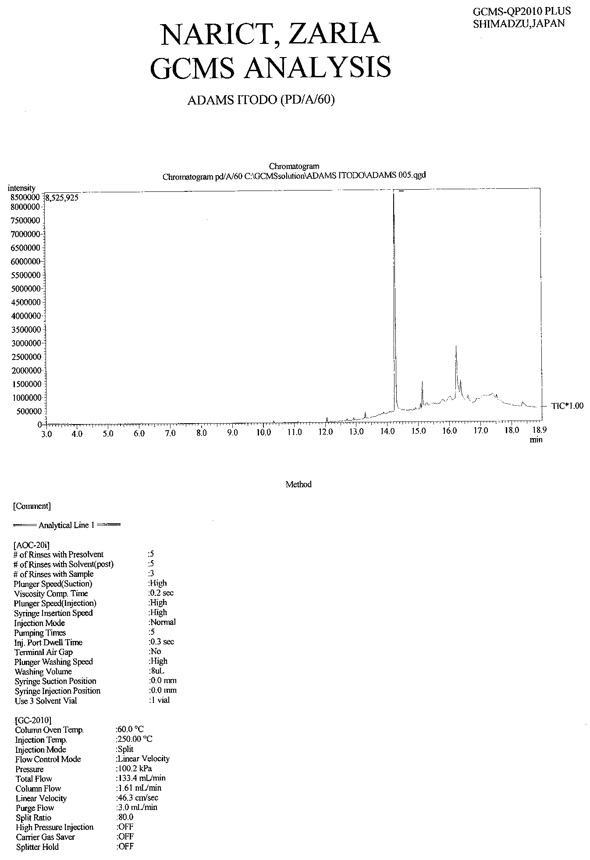
Figure 1: GC/MS chromatogram of equilibrium concentration atrazine after adsorption onto PD/A/60min. sorbent (Carrier gas-Helium 100.2kpa,Column temperature –60ºc,Injection temperature-250ºc,Injection volume—1µL,Flow rate-1.61mL/min, Injection method- split, Linear velocity- 43.6cm/sec.)
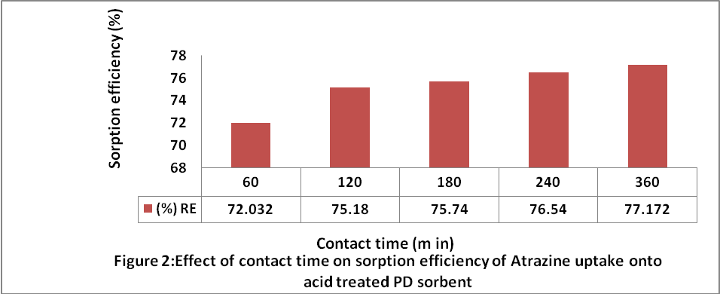

The results from Figure 2 showed that the equilibrium phase concentration at any time C_{t}. the mass of the unadsorbed sorbates reduces (from 0.0693 – 0.0571) as contact time increases from 60 – 300 minutes. This implies that the removal efficiency increases (from 72.032% - 77.1325%) with time. Table I shows the effects of sorbate –sorbent contact time on the sorption efficiency.

Table 1: Adsorption experimental data of atrazine uptake by fixed mass of PD-Sorbents at different contact time, using GC/MS.
Biosorbent | Co(g/dm³) | Ct (g/dm³) | Ca (g/dm³) | % RE | Ads mass (mgx10⁻³) | q_{t} (mg/g) | Kc= Ca/Ct | F = q_{t}/q_{e}
PD/A/60 | 25 | 6.925 | 18.008 | 72.032 | 0.1801 | 1.801 | 2.600 | 0.9385
PD/A/120 | 25 | 6.205 | 10.795 | 75.180 | 0.1879 | 1.879 | 3.029 | 0.9740
PD/A/180 | 25 | 6.065 | 18.935 | 75.740 | 0.1894 | 1.894 | 3.122 | 0.9819
PD/A/240 | 25 | 5.865 | 19.135 | 76.540 | 0.1914 | 1.914 | 3.263 | 0.9922
PD/A/300 | 25 | 5.707 | 19.293 | 77.172 | 0.1929 | 1.929 | 3.381 | 1.000
PD/A/60 – Poultry droppings, treated with, H₃PO₄interacted with Atrazine solution for 60 minute. PD/A/300 – Poultry droppings, treated with, H₃PO₄interacted with Atrazine solution for 300 minute.

Chromatograms presented as Figures 3 to 7 were typical of charts obtained for the equilibrium phase concentration analyzed using GC/MS. Analysis was carried out after filtration at the 60,120,180,240 and 300th minutes contact time. As interaction time increases, equilibrium concentration reduces. This implies an increase in adsorbed sorbate concentration with time.

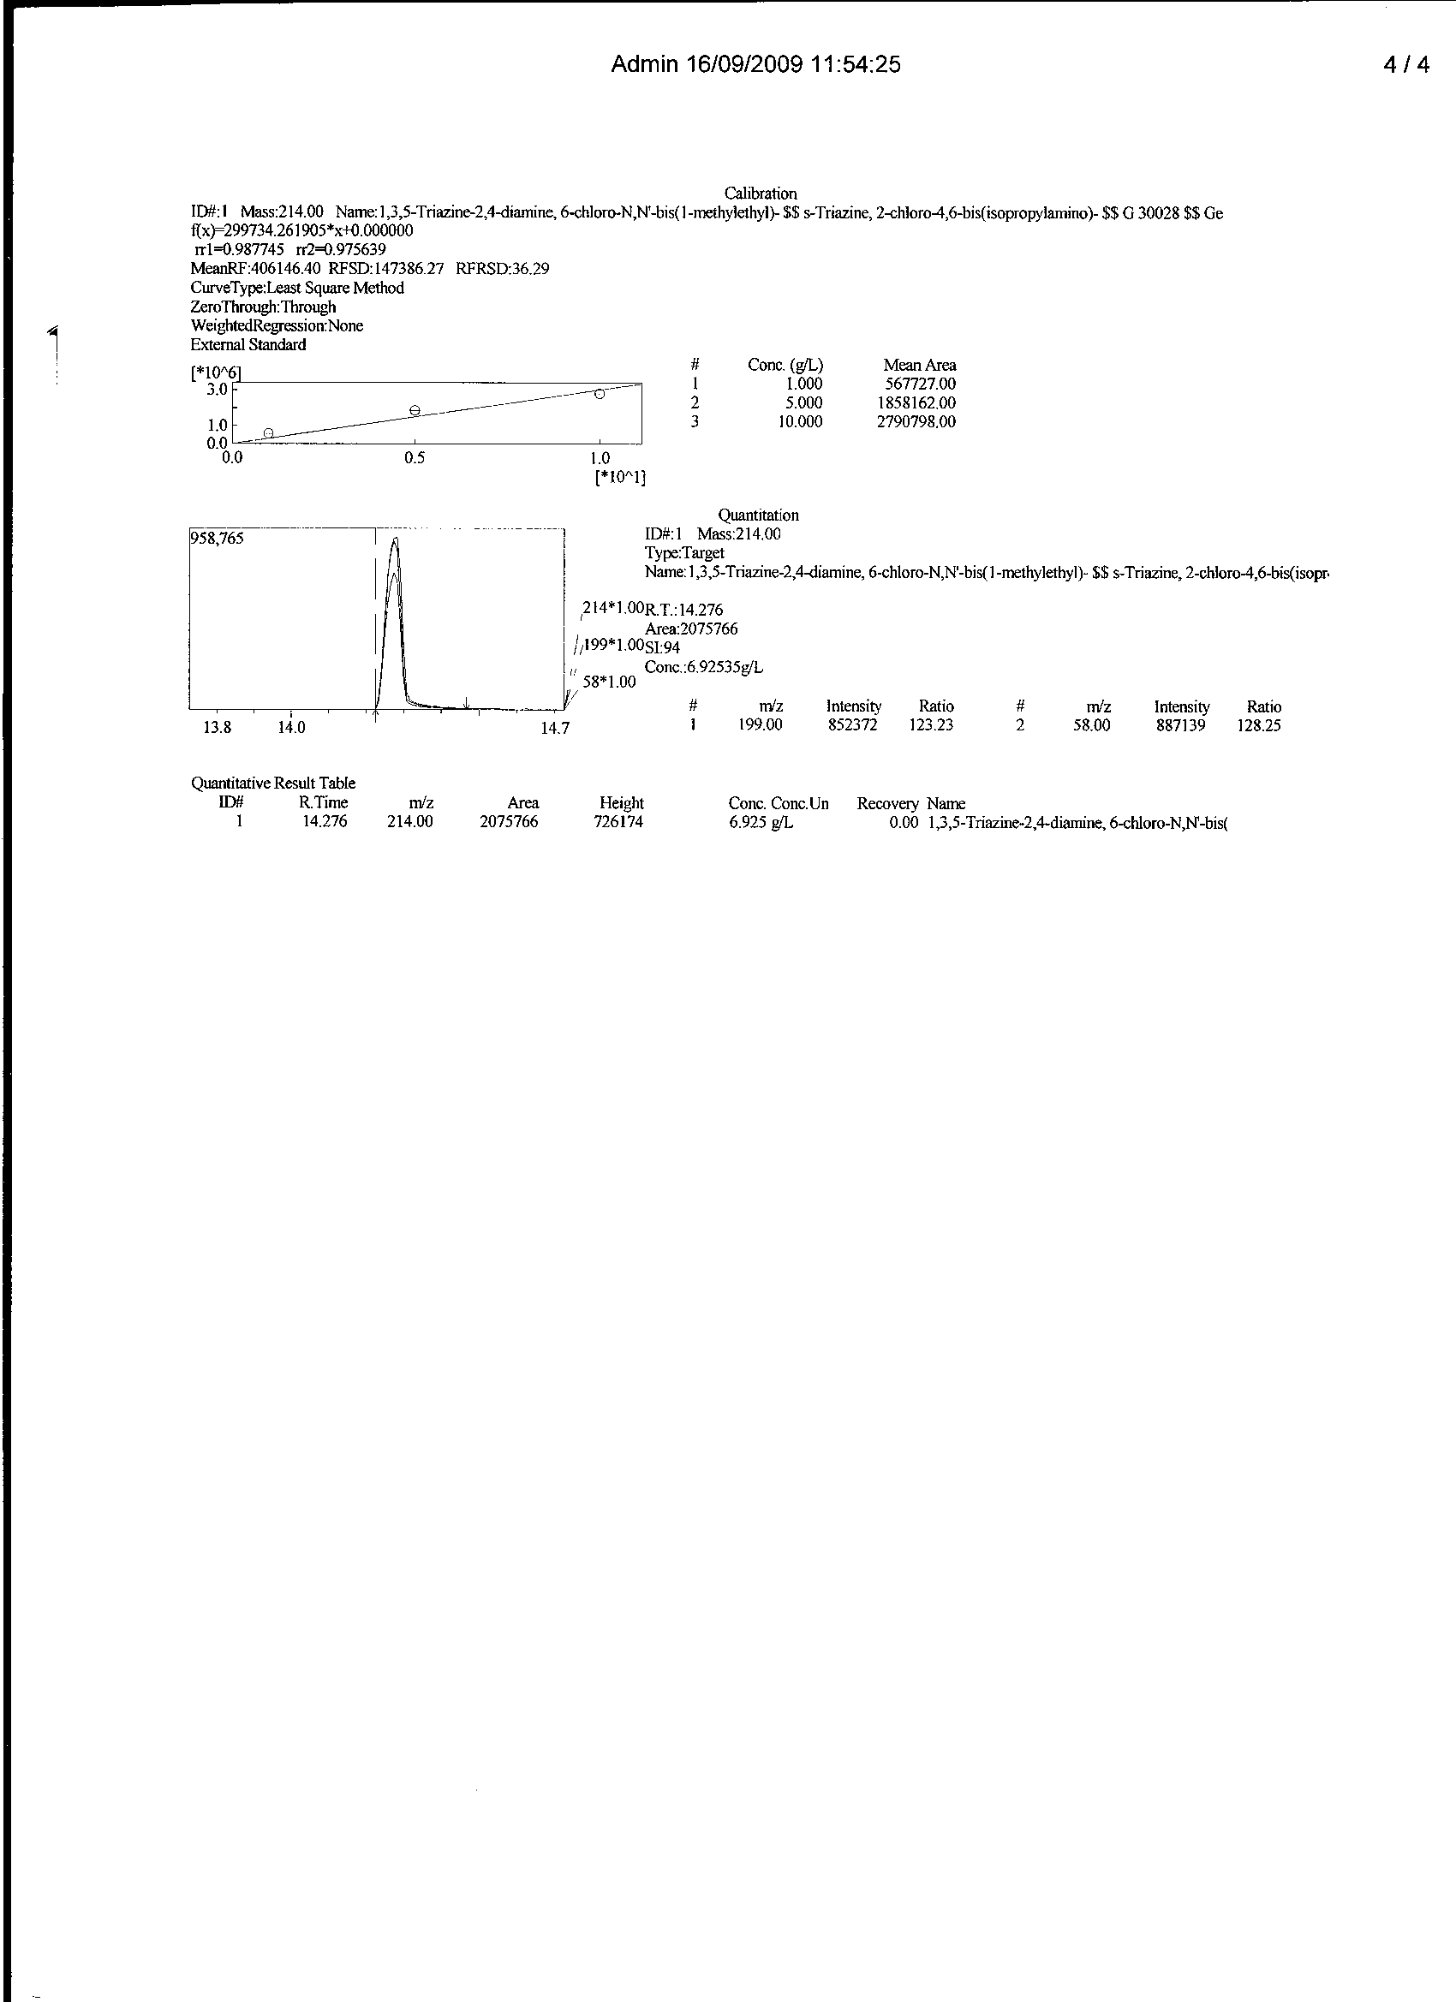
Figure 3: GC/MS chromatogram, quantitative measurement and spectral information of equilibrium phase atrazine after adsorption onto PD/A/60min sorbent
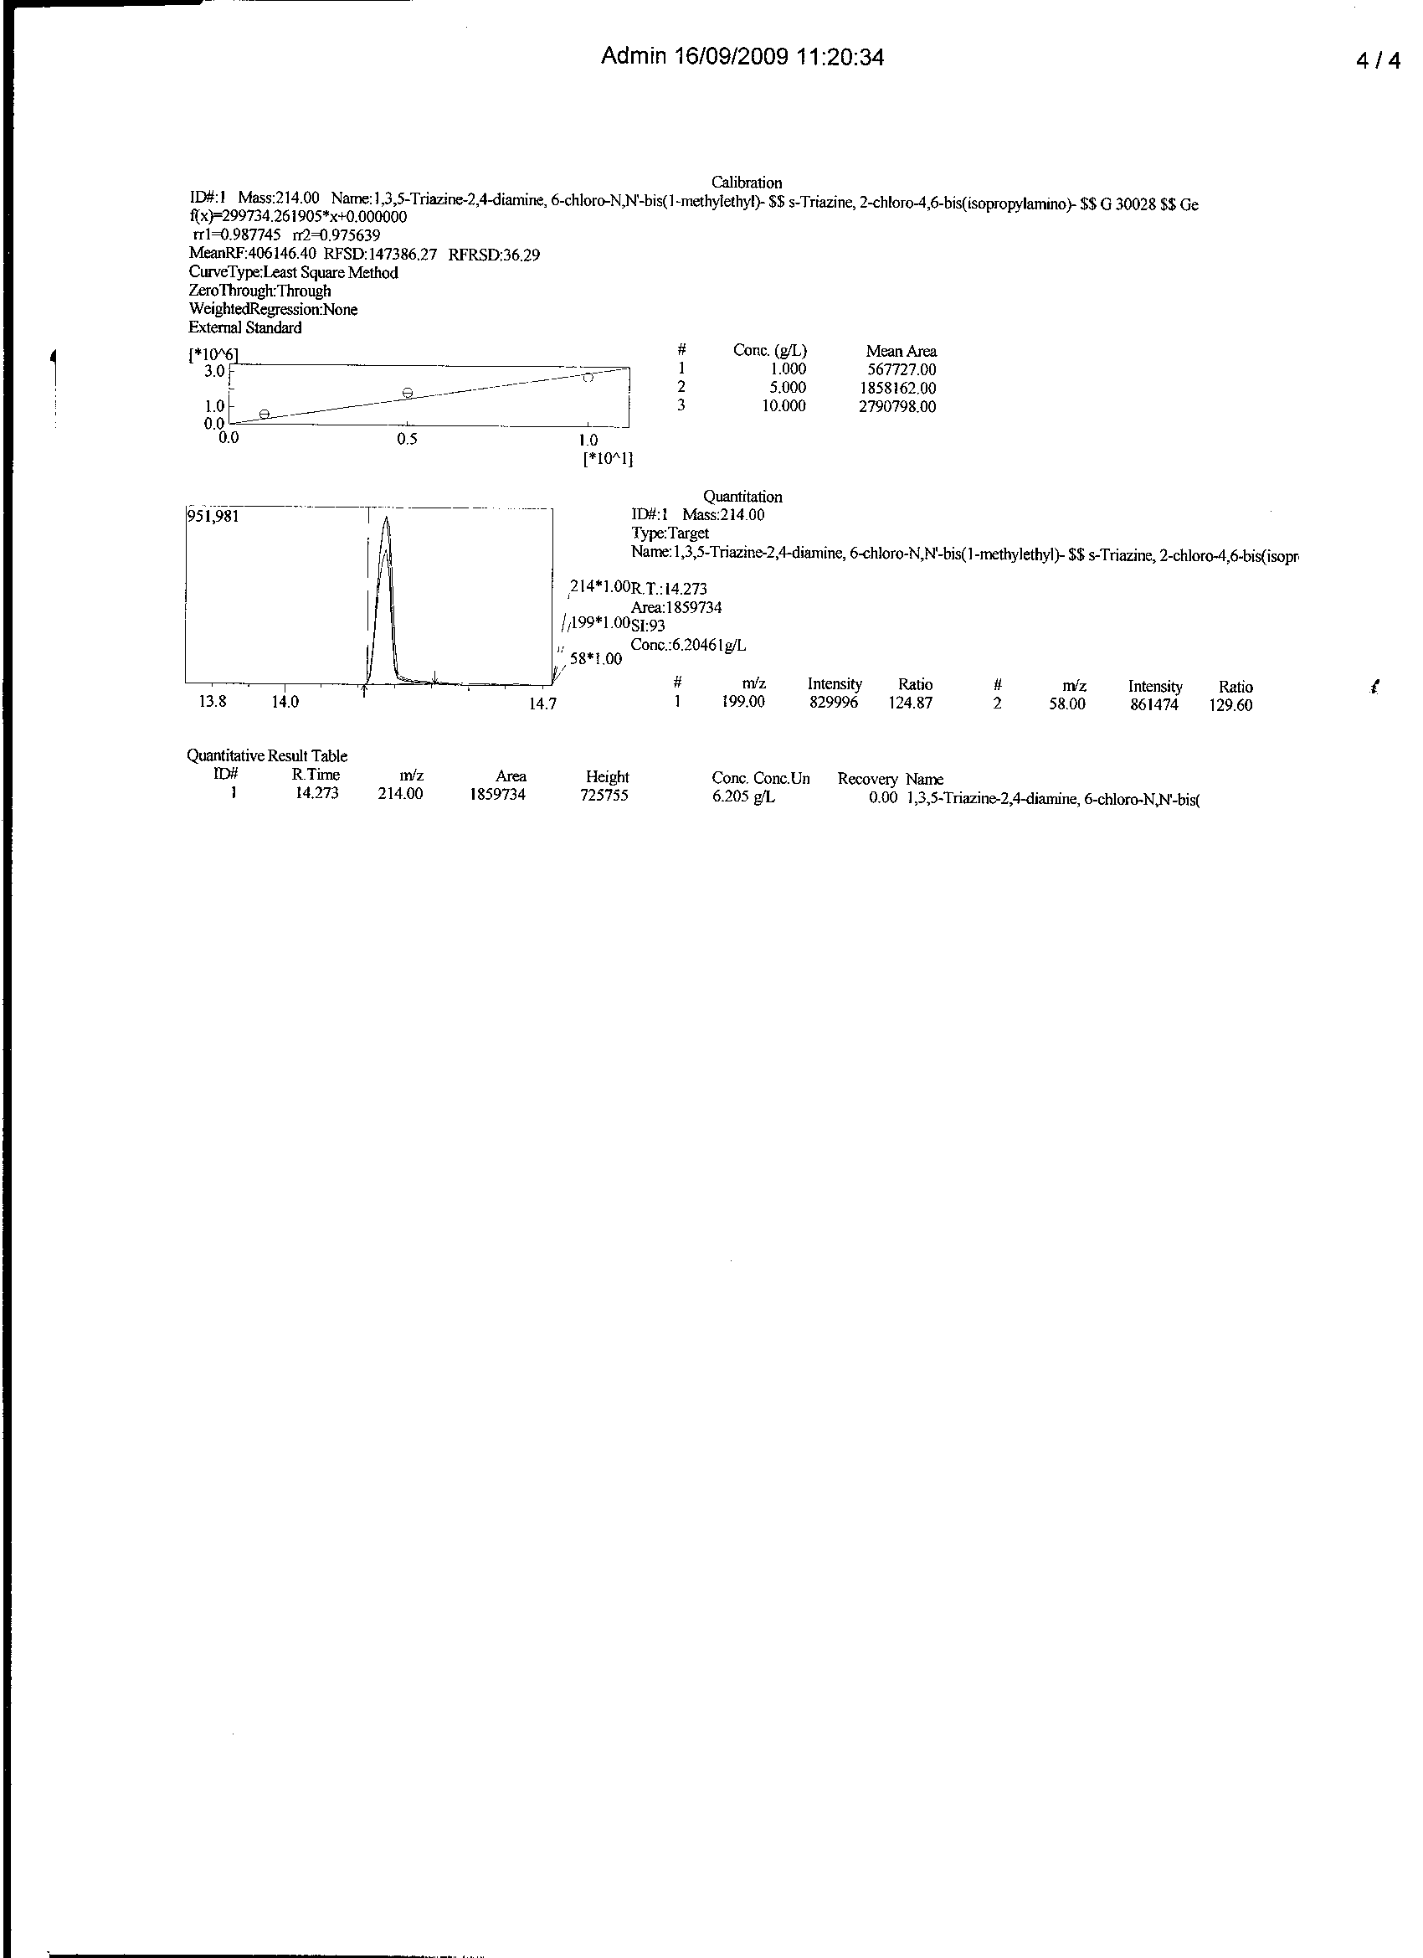
Figure 4: GC/MS chromatogram, quantitative measurement and spectral information of equilibrium phase atrazine after adsorption onto PD/A/120min sorbent

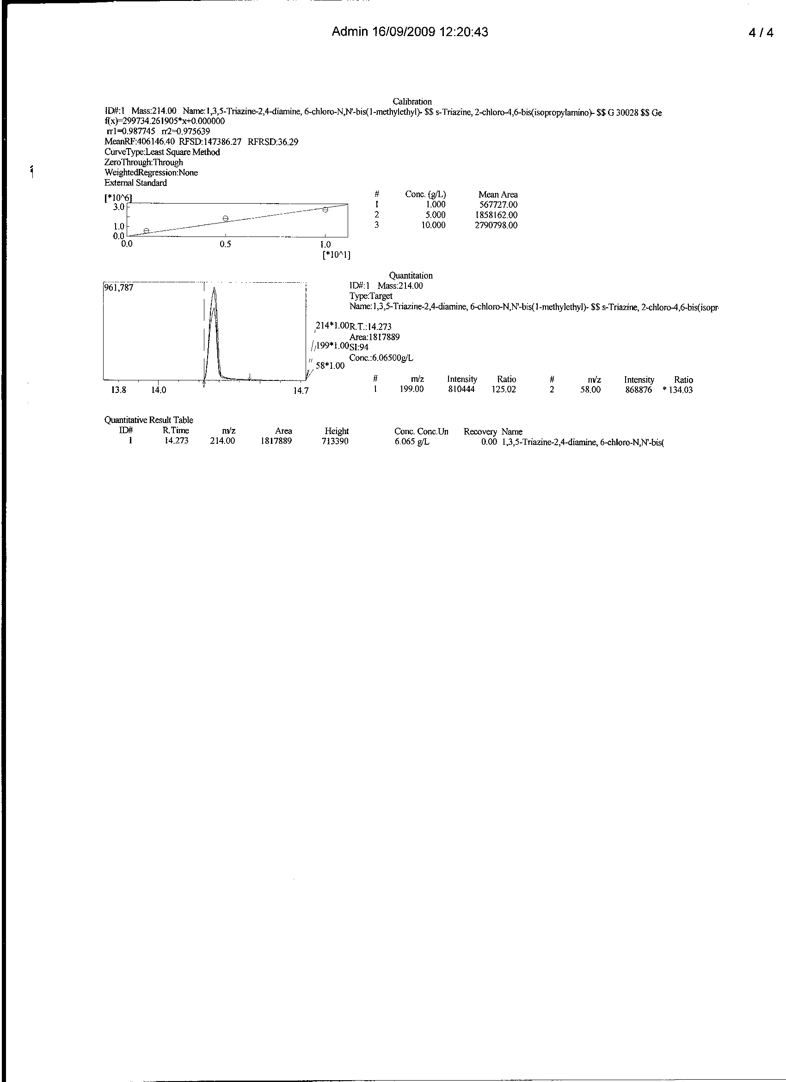
Figure 5: GC/MS chromatogram, quantitative measurement and spectral information of equilibrium phase atrazine after adsorption onto PD/A/180min sorbent

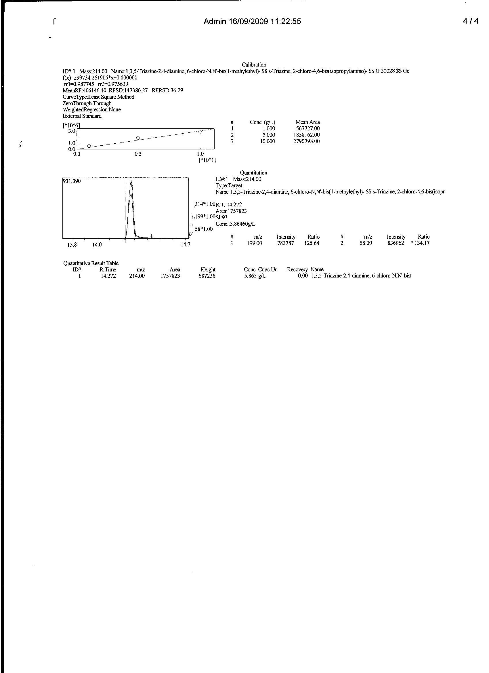
Figure 6: GC/MS chromatogram, quantitative measurement and spectral information of equilibrium phase atrazine after adsorption onto PD/A/240min sorbent

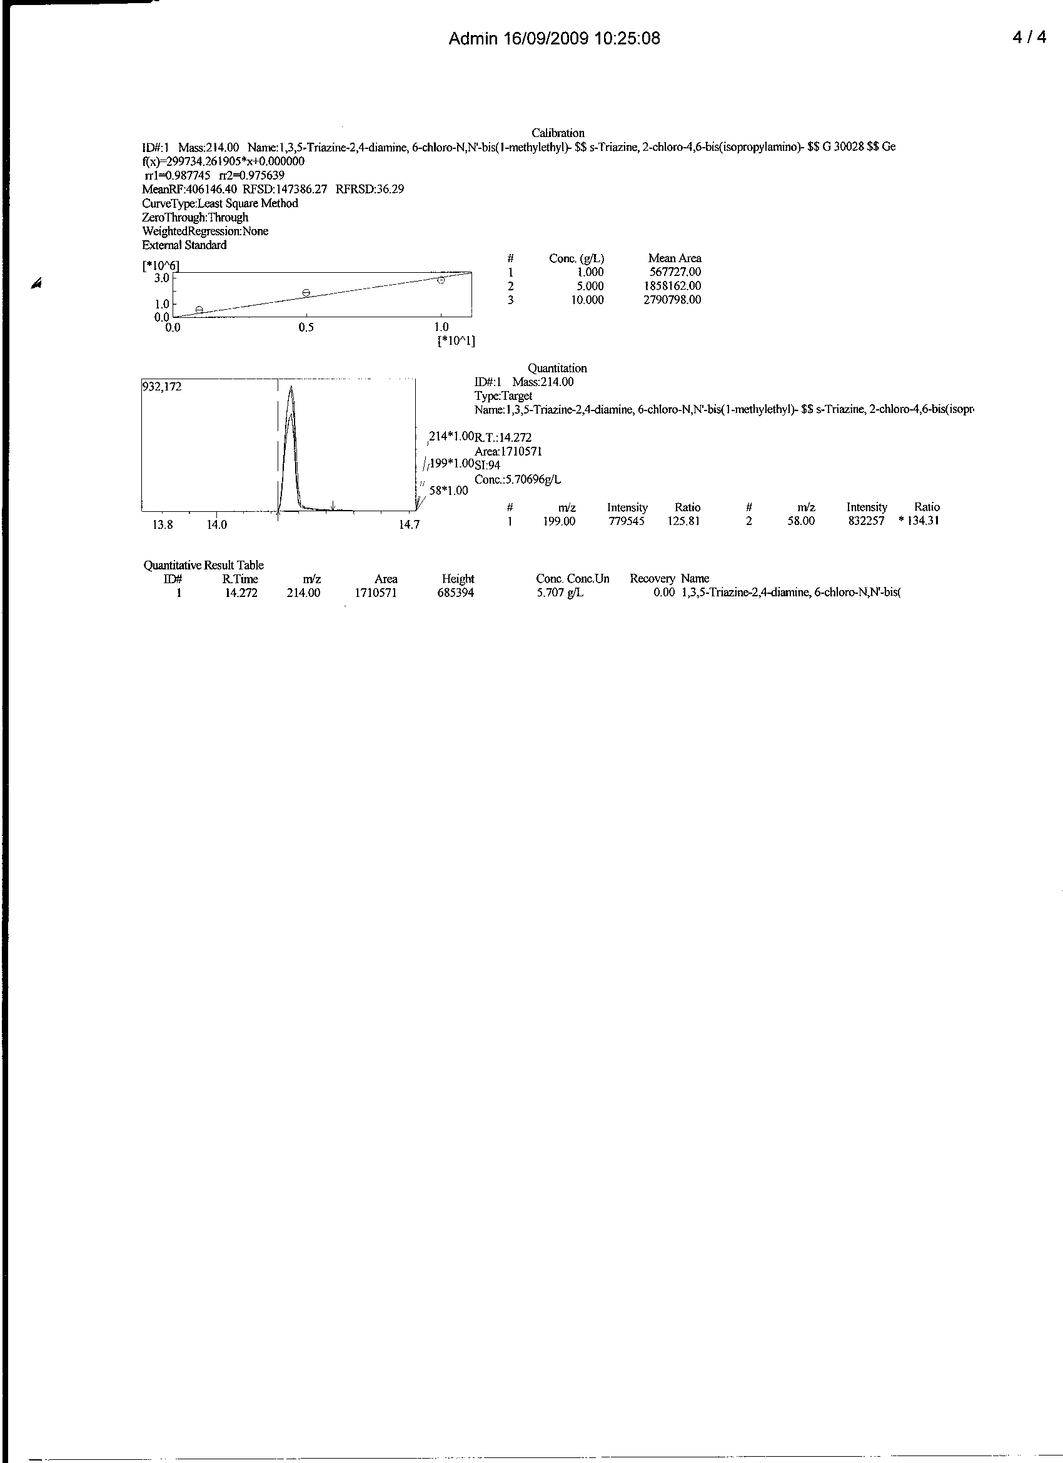
Figure 7: GC/MS chromatogram, quantitative measurement and spectral information of equilibrium phase atrazine after adsorption onto PD/A/300min sorbent

- Discussion
The extent at which contact time affect adsorption is non monotonical in multiplicity. At such, a 300 min sorbate – sorbent interaction gave 19.293 adsorption (being a 77.172% adsorption). This is only 5.140, 1.992, 1.432 and 0.632% higher than the 60, 120, 180 and 240 mins interaction with 72.032, 75.180, 75.740 and 76.540% atrazine removal respectively. Summarily, over 72% of atrazine removal was attained within the selected 60 – 300mins timing.
Effect of contact time on rate studies: Result clearly indicates that sorption by PD/A sorbents presents good uptake > 70% along the series (60-300 minutes contact time). However, Table 1 gave results which revealed that the sorption efficiency by PD/A/300 (77.00%) > PD/A/240 (96.540%) … while the least was by PD/A/60 (72.032%). The initial adsorption rate, h was estimated from the second order kinetic model as 0.3646 g.mg⁻¹ min⁻¹ while the fractional attainment at equilibrium was calculated as F = q_{t}/q_{e} (Juliade et al., 2008). F is a measure of the diffusion coefficient, D (cm²/s). In this analysis, the F (Table 2) values tend to unity as the interaction time increases. Equilibration is attained at 300 minutes with F value of 1 while 60, 120, 180 and 240 contact time gave value of 0.934, 0.974, 0.982 and 0.992 respectively.

Table 2: kinetic experimental data of atrazine uptake onto PD/A-sorbent by fixed mass Sorbents at different contact time, using GC/MS.
t(min) | lnt | t^{1/2} | Ct | q_{t} x10⁻³ | 1/q_{t} x10⁻³ | t/q_{t} x10⁻³ | log(q_{e}- q_{t}) | F= q_{t}/q_{e} | ln (Ca/Ct)
60 | 4.094 | 7.746 | 6.925 | 1.801 | 0.555 | 33.315 | -0.893 | 0.934 | 0.9755
120 | 4.787 | 10.954 | 6.205 | 1.879 | 0.532 | 63.864 | -1.301 | 0.974 | 1.108
180 | 5.193 | 13.416 | 6.065 | 1.894 | 0.528 | 95.037 | -1.456 | 0.982 | 1.138
240 | 5.481 | 15.492 | 5.865 | 1.914 | 0.522 | 125.392 | -1.824 | 0.992 | 1.183
300 | 5.704 | 17.321 | 5.707 | 1.929 | 0.518 | 155.521 | - | 1.000 | 1.218

Where F = fractional attainment at equilibrium. Adsorption tends to equilibrium as F values approaches unity (1.0). F can be used to measure effective diffusibility. This behavioral trend is corroborated by the findings of Ho and McKay, (1999) that sorption is influenced by contact time, pH, sorbent concentration, nature of solute and its concentration as re-emphasized by Reuben and Miebaka, 2008 ; Itodo et al., 2009d). In this study, it was evidence that equilibrium time for the chosen concentration (25g/L) and sorbent dose (0.1g) in 10cm³ aliquot is 300 minutes, wherein 19.293g/L out of 25g/L atrazine was adsorbed. Cossich, (2002) reported equilibrium time to range between 15 min and 10 days.

Table 3: First order, Second order and Apparent first order kinetics experimental constants of atrazine uptake onto PD/A-sorbent by fixed mass of Sorbents at different contact time, using GC/MS
Kinetic model | Relationship (y = ) | R² | Constants | Values
First order | -0.004x – 0.630 | 0.974 | k₁(min⁻¹)  q_{e}(cal)(mgg₋₁)  q_{e}(exp)(mgg⁻¹)  %SSE | 0.00921  0.234  1.929  0.758
Second order | 0.510x – 2.743 | 1.00 | k₂(mgg⁻¹min⁻¹)  h(g mg⁻¹min⁻¹)  q_{e}(cal)(mgg⁻¹)  q_{e}(exp)(mgg⁻¹)  %SSE | 0.0948  0.3646  1.9607  1.929  0.014
Apparent first order | 0.001x + 0.940 | 0.876 | Ka(min⁻¹)  C | 0.001  0.940

In line with the aforementioned validity tests, It was observed that the value of the equilibrium concentration deduced with the pseudo-first-order kinetics is q_{e} = 1.929 mg/g while its experimental value is 0.234 mg/g (low precision).Estimated value of the correlation coefficient (R²=0.974). This is also comparably low while the statistical sum of error is higher (%SSE=0.758) for the first order kinetics. On the other hand, calculated q_{e} value for the pseudo-second-order kinetic (q_{e} = 1.920) is of high precision to the experimental q_{e} (1.9607) units in mg/g. A perfect correlation of 1.00 and extremely low statistical sum of error was evaluated and reported (Table 3).This results shows that the pseudo-second order kinetic model is more suitable in predicting atrazine sorption from aqueous medium. Similar result was reported by Hameed et al., (2006).
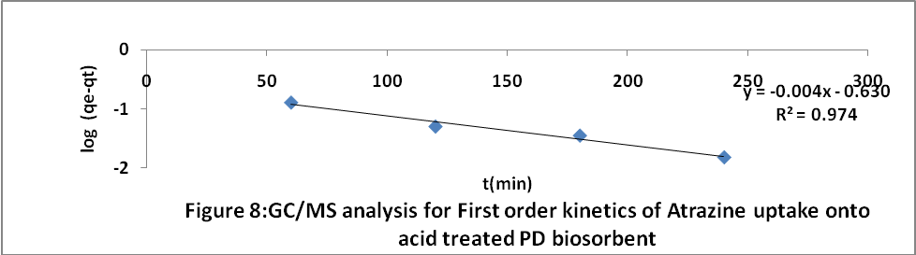

Generated data were also fed into the apparent first order equation, as described (Ana et al., 2009) in equation 7.
ln (C_{o}/C_{e}) = K_{a}t - - -- (7)

The wide range of apparent first order rate constant (0.001) as compared to that of the pseudo first order kinetics (0.00921) is also an indication that the sorption of atrazine onto PD sorbent does not follow the first order kinetics.

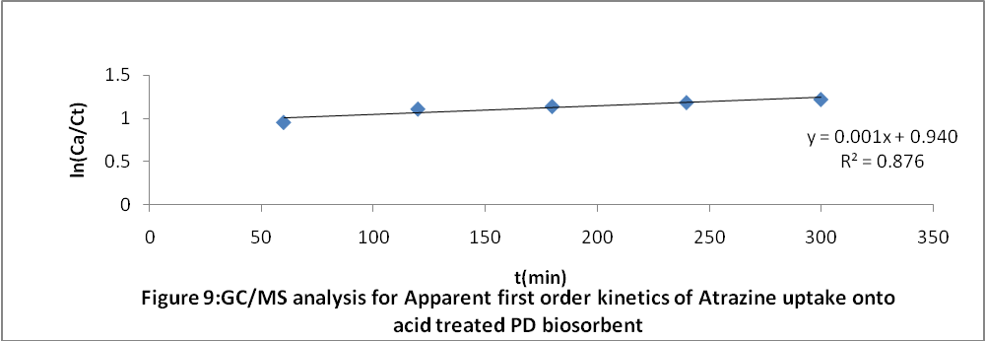
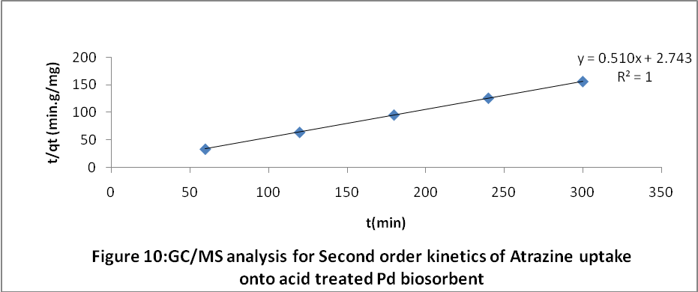

Conclusion:
The PD activated carbon matrices generated, using the two ways activation scheme with acid (H₃PO₄) and salt (Zncl₂) as activating agents was successfully prepared and reported to provide over 70% atrazine adsorption for a kinetic study of 60min-300min. Contact time. A second order kinetic process was reported. An external standard preparation, followed by GC/MS quantitation proves a good option for analyzing the quantity of single analyte from a multicomponent system such as atrazine from either herbicide or pesticide.

Acknowledgements:
Authors are grateful to the instrumental unit of NARICT, Zaria for the GCMS analysis

Corresponding Author: Itodo Udoji Adams
Department of Applied Chemistry,
Kebbi state University of Science and Technology,
P.M.B 1144, Aliero, Kebbi state
Nigeria
E-mail: itodoson2002@yahoo.com
TEL: +2348073812726, +2348039503463

REFERENCES
1. Agdi K, Bouaid A, Martin E, Fernandez H, Azmani A, Camara C. Removal of atrazine from environmental water by diatomaceous earth remediation method. Journal of Environmental monitor 2000; 2: 420-423.
2. Ana S, Joao P, José M, Jose B, Carvalho C, Ania O.Waste-derived activated carbons for removal of ibuprofen from solution: Role of surface chemistry and pore structure. Bioresource Technology.2009; 100 : 1720–1726.
3. Cooney DO. Adsorption Design for Wastewater Treatment. First Edn. Lewis. Publishers, CRC Press LLC, Boca Raton, Florida,1999
4. Dermibas, E; Kobya, M; Senturk, E. and Ozkan, T. (2004). Adsorption kinetics for the removal of Cr (vi) from aqueous solutions on the activated carbon prepared from agricultural wastes. Journal of water. 30 (4): 533-539.
5. Dinesh M, Charles U, and Pittman T. Arsenic removal from waste water using adsorbent;A critical review.2007 Elsevier B.V, 2007:16-42
6. Hameed BH, Din AM, Ahmad AL. Adsorption of methylene blue onto Bamboo based activated carbon: kinetics and equilibrium studies. Hazardous materials. 2006;137(3):695- 699.
7. Ho YS, John D A, Foster CF.Water Resources, 1995; 29: 1327.
8. Isabel M, Wayne, M. The ultimate trash to treasure: poultry waste into toxin – grabbing char. Agricultural research . 2005; 306 (1): 127-43.
9. Itodo AU, Abdulrahman FW, Hassan LG, Dogonyaro AI, Sadiq IS, Happiness UO. Biosorption of Heavy metals and herbicides onto poultry based activated carbon animalis. Conference paper presented at CSN, 7th Chemclass conference on 11/06/2009 at NARICT, Zaria 2009a
10. Itodo AU, Abdulrahman FW, Hassan LG, Maigandi SA, Happiness UO . Thermodynamic equilibrium, kinetics and adsorption mechanism of industrial dye removal by chemically modified poultry droppings activated carbon.Nigerian Journal of Basic and Applied Science 2009b;17(1):38-43.
11. Maria p, Virginia M. Guava seed as adsorbent for adsorption of dye. Bioresource technology 2009; 100 (2): 2111-2117.
12. Min C, Yun Z. Rapid method for analysis of organophosphorus pesticide in water:Bulletin application note. Agilent Technology, USA 2008;19-21.
13. Robert, L. and Eugene, F. Modern practice of chromatography. 4th Edn. Wiley interscience. John Wiley and sons Inc. New Jersey, 2004; 425
14. Rozada F, Calvo F, Garcia A., Martin V, Otaro M. Dye adsorption by sewage sludge based activated carbon in batch and fixed bed system. Bioresource technology 2003; 87 (3): 221 – 230.
15. Shimabukoro R.H. Atrazine metabolism and herbicidal selectivity. plant physiol. 1967;42:1269-1276.
16. Turoti M, Gimba C, Ocholi O, Nok A. Effect of different Activation Methods on the Adsorption Characteristics of Activated Carbon from Khaya Senegalensis Fruits and Delonix Regia pods. Chemclass Journal 2007; 4 : 107 – 112.
17. Wong J, Wong S, Tan N. Nickel biosorption by two Chlorella species. Bioresource Technology 2000; 73 (1):133-137
18. Yoshiyuki S, Yutaka K. Pyrolysis of plant, animal and human waste: Physical and chemical characterization of the pyrolytic product. Bioresource Technology 2003;90 (3): 241-247.
19. Zahangir A, Suleyman A, Noraini K. Production of activated carbon from oil palm empty fruit Bunch for Zn removal. Bul.conference proceedings 12th int.water Tech conf. IWTC12 Egypt. 2008; 373-383.

Received February 8, 2010

