Black mulberries (Morus nigra) as natural dyes for animal whole mount staining
Ehab Tousson¹ and Bahija Al-Behbehani²
¹Department of Zoology, Faculty of Science, Tanta University, Egypt
²Science Department, College of Basic Education, PAAET, Kuwait
toussonehab@yahoo.com bshm7000@yahoo.com

ABSTRACT: Natural dyes have been used for staining wool, silk, carpet and cotton. Black mulberry (Morus nigra) has strong staining activity and a distinct flavor with juicy and acidic characteristics making them attractive for use in the processing industry in products such as fruit juice, ice cream, jelly, and jam. Aim of this study was to investigate a new staining method using black mulberry as natural source of dye for whole mount staining in the parasitological studied. Whole mount of adult liver flukes (Fasciola sp.) were collected from the livers of naturally infected cows at slaughterhouse, washed with physiological saline solution and then stained by the new method (dye extracted form black mulberry). By using the dye extracted from black mulberry, zoologists and parasitologists can make identification and differentiation between different parasites. This dye method can be an alternative to cost and time consuming current chemical staining methods. [Life Science Journal 2010;7(2):98-101]. (ISSN: 1097-8135).

Keywords: Natural dyes; Black mulberry; Whole mount staining; Liver flukes.

1. Introduction
Dyes have been defined as intensely coloured substances used for colouration (1; 3). They are retained in substances by physical adsorption, mechanical retention, the formation of covalent chemical bonds or of complexes with salts or metals, or by solution. Stains are characterized by their ability to absorb visible part of the electromagnetic spectrum (380-780 nm). For good staining property it has to have high enough absorption coefficient (10 000 to 40 000 l.mol-1.cm-1).
Natural dyes have been used for staining wool, silk, carpet and cotton (1; 4; 8; 13; 15). Until the late nineteenth century only natural dyes were used for coloring weaving yarns. There are three primary sources for natural dyes (plants, animals and minerals). The natural dyes come from roots, flowers, leaves, fruits and barks of plants, or from animal sources such as cochineal and or mineral sources such as red soils. Regardless of the source, natural dyes can be broken down into two categories (substantive and adjective). Substantive dyes also referred to as direct dyes, become chemically fixed to the fiber without the aid of any other chemicals or additives. Indigo and some lichens are substantive dyes. For “green” dyed garments it is preferable to use substantive natural dyes (11). Adjective dyes, also referred to as mordant dyes, require an added substance known as a mordant to make the dyes colorfast (13). Most natural dyes are adjective dyes and the type of mordant used in the dyeing process affects the color produced (1; 8; 11). Dyers are able to get a variety of colors and shades from the same source depending on the type of material used, the characteristic of local water, and the use of different mordants (3). For example, from pomegranate skin they can produce a range of colors from red to black by using different mordants. Also, as with a painter's palette, all the primary natural colors employed could be mixed to produce a wide variety of secondary hues.
The Black mulberry (Morus nigra) tree times throughout the Mediterranean region of are native from Egypt to Morocco in northern Africa, Asia, Europe, North America, and South America (2; 5; 7; 12). Black mulberry fruits have strong staining activity and become dark red–black at maturity. The fruit of M. nigra has a distinct flavor with juicy and acidic characteristics making them attractive for use in the processing industry in products such as fruit juice, ice cream, jelly, and jam (9).
Ercişli and Orhan (7) determined the total phenolic content, antioxidant activity, mineral content, and selected physicochemical properties of M. nigra genotypes. The main use of M. nigra in modern medicine is for the preparation of syrup obtained from the ripe fruit employed to flavour or colour other medicines (14). It is a dark violet or purple liquid, with a faint odour and a refreshing, sweet-acid taste (6).

2. Materials and Methods
Approximately 50 g of Black mulberry (Fig.1) were immersed in 200 ml water, heated to just below boiling point and simmered until the colour has been transferred from the dye solution. Concentrated juice of Black mulberry is cooled, and filtered. Adult liver flukes (Fasciola sp.) were collected from the livers of naturally infected cows at slaughterhouse and washed several times in physiological saline solution (approximately 0.8% saline NaCl) to clean the mucus and debris from it (Figs. 2, 3). Fix the specimens in 10% neutral buffered formalin for 4 hours. Stained the fixed specimens with the new dye extracted form black mulberry for 5-10 minutes (depending on size of specimens), then wash the specimens in distal water and dehydrated it in an alcohol series, clarified in clove oil and mounted in Canada balsam as permanent preparations. The stained adult worms were examined under dissecting microscope and a digital camera (Cannon 620) captured images.

3. Results and Discussion
Many staining methods in parasitology and histology use natural dyes. One of the most important natural dyes is hematoxylin that is extracted from the heart-wood of haemtoxylin campechamum, the logwood tree of south and Central America. In classification of dyes based on the methods of application, the extracted dye of mulberries fruits can be included in vat dyes, instance indigo in enzyme histochemistry. Also, based on combination of dyes with substrate, the dye is progressive (10). It is necessary for the histopathologist to have dyes that can be relied upon to give satisfactory and repeatable results. This new method can be used as an alternative method for whole mount and histological staining in parasitology department and in clinical pathology Laboratory for research and education.
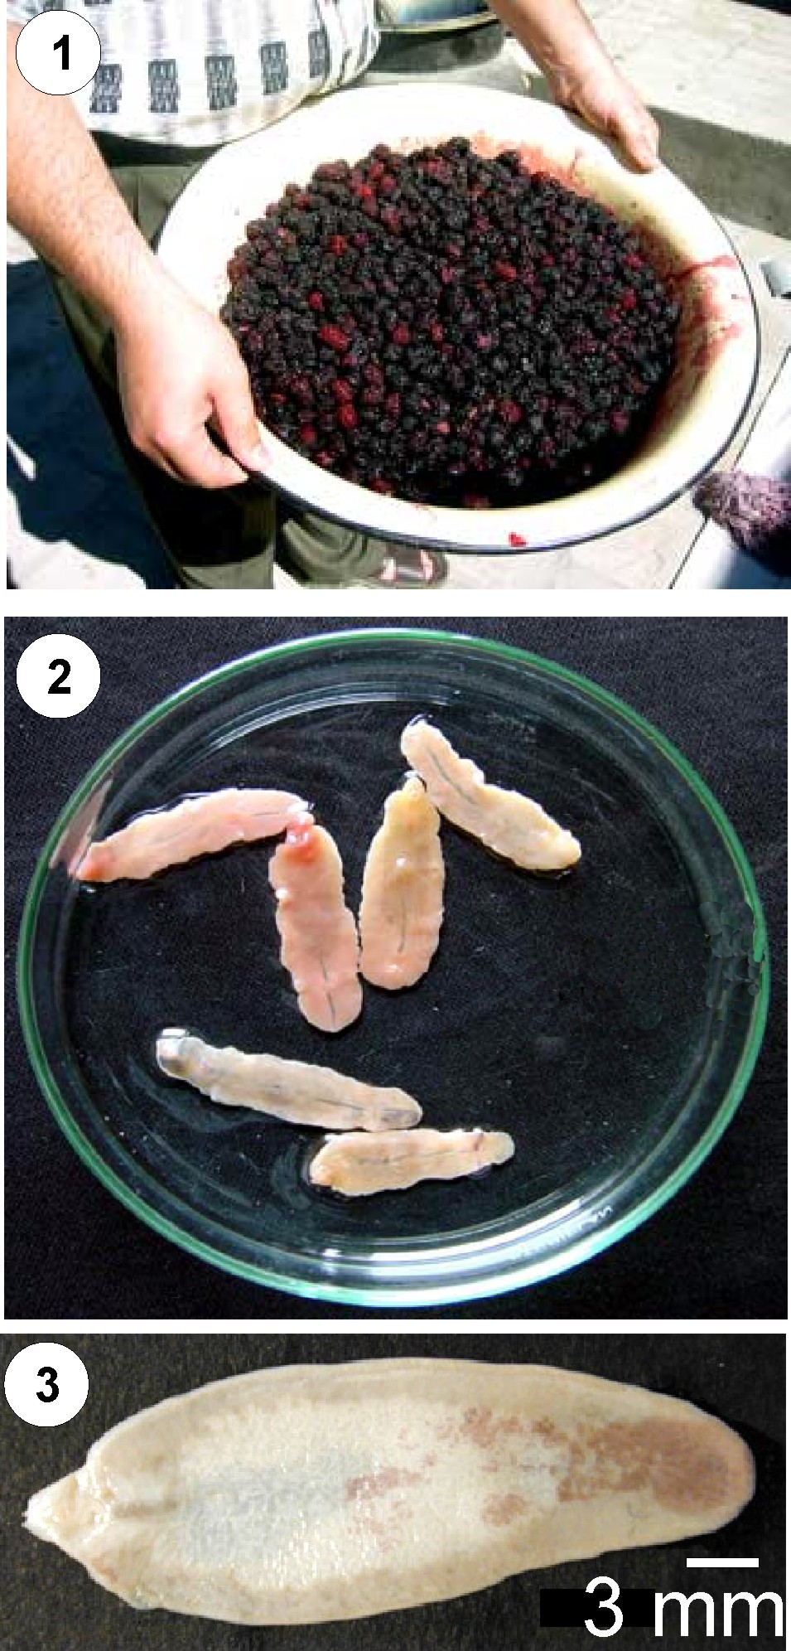

Figure 1: Photograph of collected black mulberry (Morus nigra).
Figure 2: Photograph of unstained adult liver flukes (Fasciola sp.).
Figure 3: Photograph of unstained whole mount of adult liver fluke (Fasciola sp.).

Adult flukes of fasciola are flattened and leaf-like in shape and measures approximately 3-5 cm in length, with narrowed anterior and posterior ends as shown in unstained whole mounts (Figs.2, 3). In specimens stained with black mulberry (Figs. 4-21), we can easy to identify all fluke organs. Figures 4-9 shown the oral and posterior suckers, at the anterior end the oral sucker occurs at its tip and surrounding the mouth (Figs. 4, 5, 7) while the ventral sucker is present at the oral conemain body junction (Figs. 6-9). Just posterior to the oral sucker is the pharynx that then branches off into the digestive cecae which has many branches (Figs. 5, 15). Just posterior to the intestinal bifurcation is the prominent ventral sucker, a unique muscular structure used for attachment. Posterior to this structure lays the female reproductive organs, ending in a common genital pore (Figs. 4, 9). We can easy to showing the common genital opening for the male and female reproductive systems just anterior to the ventral sucker; also, a small pinkish colour spot could be seen just behind the ventral sucker representing the Mehlis’ gland (Figs. 8, 11).

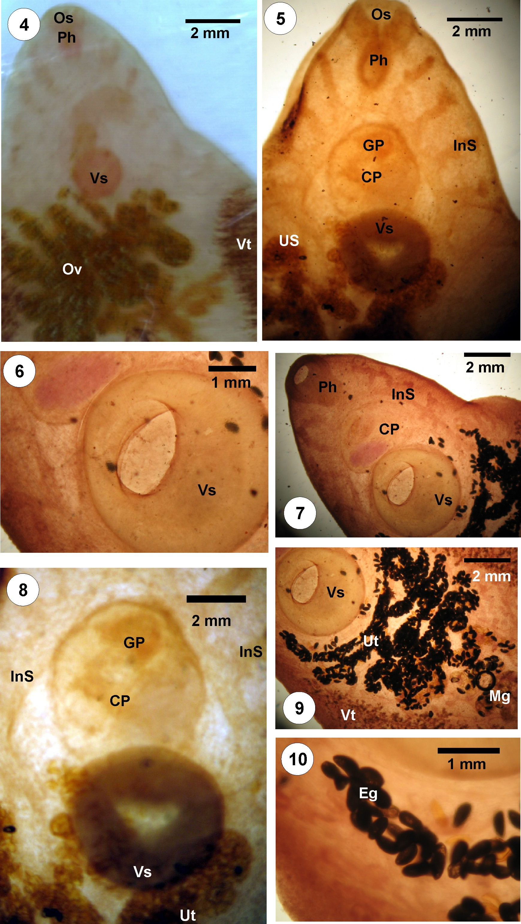

Figures 4-10: Photomicrographs of adult liver fluke stained with black mulberry showing the stained organs in the head region. (Os, Oral sucker; Vs, Ventral sucker; Ph, Pharynx; Ov, Ovary; Ins, Intestine; Gp, Genital pore; Cp, Cirrus pouch; Ut, Uterus; Eg, Eggs).

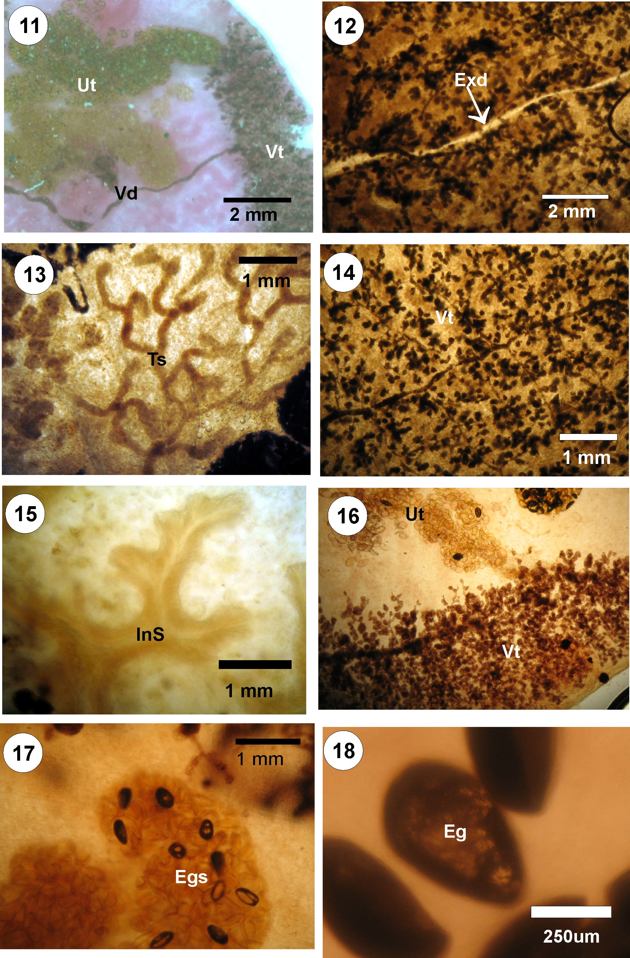

Figures 11-18: Photomicrographs of adult liver fluke stained with black mulberry showing the stained organs in the middle region. (Ov, Ovary; Vt, vitelline; Ts, Testis; Ins, Intestine; Ut, Uterus; Exd, Excretory duct; Eg, Egg; Egs, Eggs)

Also we can see the acetabulum is the dark circle just behind the intestinal bifurcation (Figs. 7, 8). The lighter circle just ahead of the acetabulum is the cirrus pouch, and the curved cirrus is visible inside it (Fig. 8). Posterior to the acetabulum are the dark coils of the uterus, filed with tiny eggs (Figs. 9, 11, 17). The black lateral bands of vitelline follicles drain their contents by two curving vitelline ducts which unite near the midline and form a small vitelline reservoir (Figs. 12, 14, 16, 21). The vitelline reservoir are overlays the larger seminal receptacle. You should be able to observe the dark, much-branched ovary and the sinuous uterus, completely packed with eggs (Figs. 4, 9, 11) also posterior to the female systems, between the 2 intestinal branches in the middle of the animal, are the branched testes from easy to seen it after used the new stain (Figs. 13, 19, 20).
Utilizing the new dye from black mulberry to impart stain onto fluke whole mount has a number of advantages over other conventional biological staining. Black mulberry dye not as other natural dyes has limited availability. Almost all natural dyes as black mulberries are free of azo compounds which are carcinogenetic and are more eco-friendly than synthetic dyes. Synthetic dyeing procedures can be polluting and certain diazo dyes are carcinogenetic. Black mulberry produce bright colors in a variety of shades and not fade quicker as another natural dyes when exposed to light. Mulberries dye have some disadvantages where unlike synthetic dyes that are created in a laboratory, Black mulberry dyes are obtained from plants and are dependent on growing seasons. The binding of dyes to textile products has been studied for many years, but is still not fully understood. Less is known about the interaction between dye and tissues. We recommend further studies to detect effective chemical dye extracts of mulberries
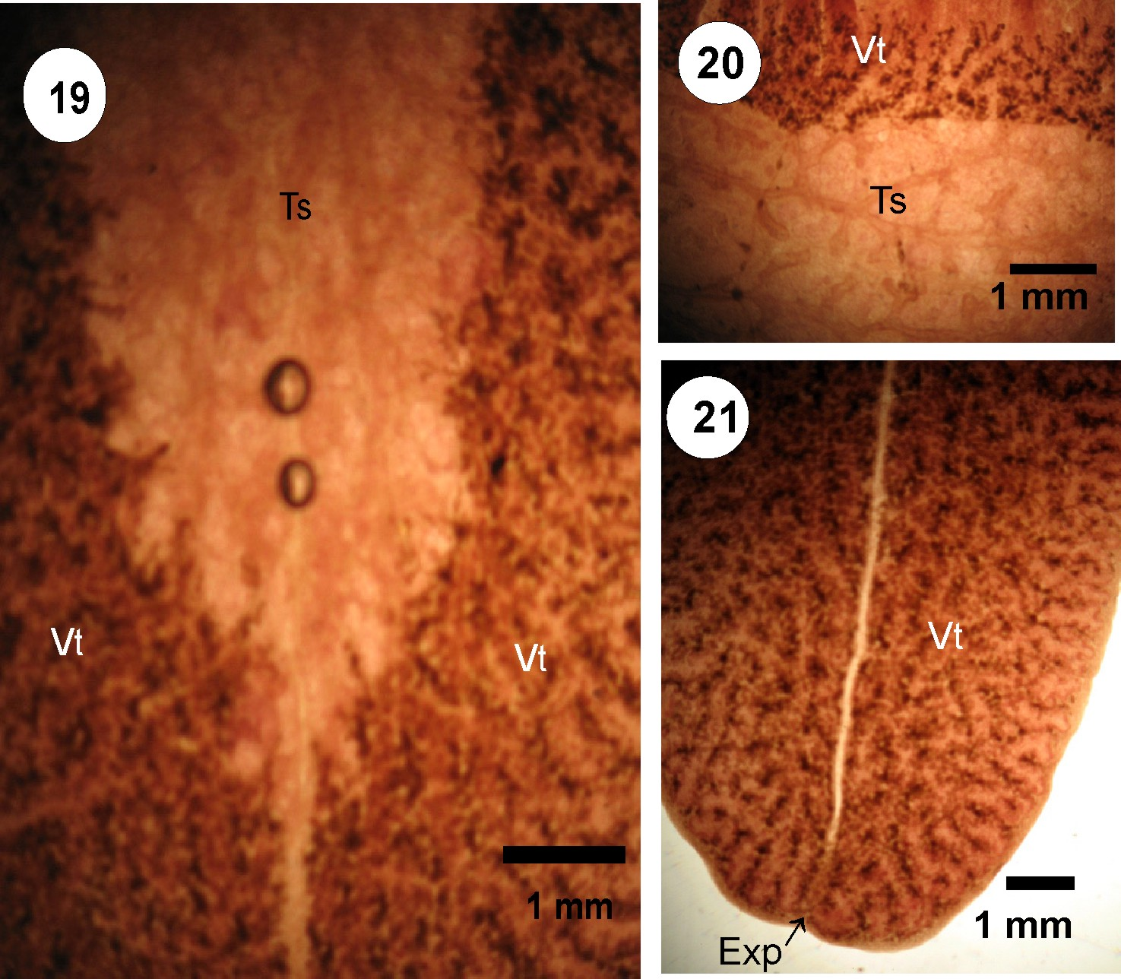

Figures 19-21: Photomicrographs of adult liver fluke stained with black mulberry showing the stained organs in the tail region. (Vt, vitelline; Ts, Testis; Exp, Excretory pore)

References
- Angelini, L G,., Pistelli, L., Belloni, P. and Bertoli, A. (1996). Quantitative determination and technological assays of natural dyes from Rubia tinctorum L. and Reseda luteola L. Abstracts, Third European Symposium on Industrial crops and Products, Reims, France, 22-24 April 1996.
- Berg, C.C. (2001). Moreae, Artocarpeae, and Dorstenia (Moraceae), New York Botanical Garden Press, New York, NY, USA
- Cannon, J. and Cannon, M. (1994). Dye plants and dyeing. The Herbert Press Ltd, London, published in association with The Royal Botanic Gardens, Kew. pp 128.
- Dyer, A. (1977). Dyes from natural sources. Charles T. Branford Company, Newton, Massachusetts, US.
- Ercisli, S. (2004). A short review of the fruit germplasm resources of Turkey. Genet. Resour. Crop Evol., 51: 419–435.
- Ercisli, S. and Orhan, E. (2007). Chemical composition of white (Morus alba), red (Morus rubra) and black (Morus nigra) mulberry fruits. Food Chem., 103: 1380–1384.
- Ercisli, S. and Orhan, E. (2008). Some physico-chemical characteristics of black mulberry (Morus nigra L.) genotypes from Northeast Anatolia region of Turkey. Sci. Hort., 116: 41-46.
- Jacobson, G.. and Wasileski, J. (1994). Production of Food Colorants by Fermentation. In Bioprocess Production of Flavor, Fragrance, and Color Ingredients. Ed. A. Gabelman, John Wiley & Sons, Inc, 205-237.
- Kafkas, S., Ozgen, M., Dogan, Y., Ozcan, B., Ercisxli, S. and Sercxe, S. (2008). Molecular Characterization of Mulberry Accessions in Turkey by AFLP Markers. J. Amer. Soc. Hort. Sci.,. 133(4): 593–597.
- Kiernan, J.A. (1999). Histological & Histochemical method, 3 rd Ed, Pergamon Perss .; pp 31-114
- Kirk, R.E., Othmer, D.F., Grayson, M. and Eckroth, D. (1978). Eds. Kirk-Othmer Encyclopedia of Chemical Technology, 3rd edition. John Wiley and Sons, New York. Koyuncu, F. 2004. Morphological and agronomical characterization of native black mulberry (Morus nigra L.) in Sutculer, Turkey. Plant Genet. Res. Newsl., 138: 32-35.
- Koca, I., Ustun, N.S., Koca, A.F. and Karadeniz, B. (2008). Chemical composition, antioxidant activity, and anthocyanin profiles of purple mulberry (Morus rubra) fruits. J. Sci. Food Agr., 6: 39-42.
- Mangan, C., Kerckow, B. and Flanagan, M. (1995). Catalogue of contracts. AIR (Agriculture and Agro-industry, including Fisheries) 1991-1994. Non-food, bio-energy and forestry. European Commission, Brussels. pp 449.
- Özgen, M., Güneş, M., Akça, M., Türemiş, N., Ilgin, M., Kizilci, G., Erdoğan, U. and Serçe, S. (2009). Morphological Characterization of Several Morus Species from Turkey. Hort. Environ. Biotechnol., 50(1): 1-5.
- Watson, J. (1991). Textiles and the Environment, Special Report No 2150. The Economist Intelligence Unit, 40 Duke Street, London W1A 1DW. pp 117.

5/2/2010

