The Effects of 17β-estradiol on Neuronal PC12 Cells Injuried by OGD-R

and NO/iNOS System Mechanism

Yu Wang¹, ZhengTang², Xiufang Chen ³, Jing Zhang ⁴, Guanxun Zhang⁵
1 Department Of Neurosurgery Of the First People’s Hospital Of Zhengzhou, Zhengzhou, Henan, China，nice2836@sina.com; 2 Xinxiang Medical University, Xinxiang, Henan, China; 3 Modern Medical Research Institute Of Henans, Zhengzhou, Henan, China; 4 Zhengzhou Children's Hospital, Zhengzhou, Henan, China; 5 Emergency Center of Zhengzhou Xinzheng International Airport Management Co., Ltd., Xinzheng, Henan, China.

Received Jun 20, 2009

Abstract
Estrogen also plays an important role in normal development or differentiation of the brain. It's found recently that estrogen can not only affect reproductive activity through the regulation of serving Gn-RH inferior colliculus neurons, but also affect the other neurons of the brain in electrophysiology, neurological nutrition and metabolism. And, what concern most is the protection to central neuron of it. Through establishing the model of PC12 cells injuried by OGD-R, investigating the effect of Estrogen receptor antagonist ICI182780 Intervention on 17β-estradiol of PC12 cells injuried by OGD-R and ON/iNOS system. [Life Science Journal. 2010; 7(1): 34– 40] (ISSN: 1097 – 8135).

Key words: ICI182780; estradiol; PC12 cell; neuron; oxygen-glucose deprivation; iNOS

1. Objectives
Through establishing the model of PC12 cells injuried by OGD-R, investigating the effect of Estrogen receptor antagonist ICI182780 Intervention on 17β-estradiol of PC12 cells injuried by OGD-R and ON/iNOS system. For more, explore further the neuro-protective mechanism of 17β-estradiol on PC12 cells injuried by OGD-R, so as to provide the theoretical basis for clinical therapeutic application of 17β-estradiol in acute brain injuries induced by ischemia or reperfusion injury.

2. Methods
PC12 cells were cultured in DMEM medium, and then were induced to differentiate in DMEM medium containing 50ng/ml NGF for 5 days. These cells were named neuronal PC12 cells after exhibiting characteristic neuronal morphology. These neuronal PC12 cells which grew well and were well induced, and were dissected into suspension and then were inoculated on well plates with the cell concentration according to the necessity of different experiments. After induced to differentiate with NGF for 48 hours, they attached the wall and completely expanded. These cells were randomly divided into five groups（Table 1）: the normal control group, the OGD-R group, the 17β-estradiol group, the ICI182780 Intervention group and the ICI182780 control group. PC12 cells in the normal group did not receive OGD-R and were cultured in DMEM medium recovered glucose as usual during oxygen-glucose deprivation and during reperfusion. While PC12 cells in OGD-R group were cultured in medium without glucose. Cells in 17β-estradiol group containing 10ng/ml 17β-estradiol and medium without glucose during OGD-R. The ICI182780 intervention group containing 10ng/ml 17β-estradiol and medium without glucose during OGD-R. adding 100ng/ml ICI182780. The ICI182780 control group was cultured in 100ng/ml ICI182780 DMEM without glucose. Then were put into the chamber in which oxygen was driven off, after receiving oxygen-glucose deprivation for 30 minutes, PC12 cells in the groups were taken out and were changed into medium with glucose, 10ng/ml 17β-estradiol and medium with glucose, 10ng/ml 17β-estradiol and 100ng/ml ICI182780 DMEM with glucose and 100ng/ml ICI182780 DMEM with glucose respectively. They were put back to cells culture incubator and cultured successively during reperfusion. Cellular morphological changes were observed after oxygen-glucose deprivation. The viability of cells and the concentration of NO in the culture medium were measured at each time point of 2h, 4h, 8h, 16h, and 24h after reperfusion. Cell apoptosis and cell death were detected with flow cytometry 24 hours after oxygen-glucose deprivation. The expression level of iNOS and protein were examined by Western Blotting 24 hours after oxygen-glucose deprivation. The expression level of iNOS mRNA and protein were examined by RT-PCR analysis 24 hours after oxygen-glucose deprivation.

Table 1: group experiments and the experimental process
groups | period of oxygen-glucose deprivation（30min） | period of reperfusion
normal control group | were cultured in DMEM medium and did not receive OGD-R in the chamber | were cultured in DMEM medium
OGD-R group | were cultured in medium without glucose and receive OGD-R in the chamber | were cultured in DMEM medium
17β-estradiol group | containing 10ng/ml 17β-estradiol and medium without glucose during OGD-R in the chamber | 10ng/ml 17β-estradiol and medium with glucose
ICI182780 Intervention group | containing 10ng/ml 17β-estradiol and medium without glucose during OGD-R, adding 100ng/ml ICI182780 | 10ng/ml 17β-estradiol and 100ng/ml ICI182780 DMEM with glucose
ICI182780 control group | were cultured in 100ng/ml ICI182780 DMEM without glucose | 100ng/ml ICI182780 DMEM with glucose and receive OGD-R in the chamber

3. Results

(1) The morphological observation of PC12 cells after oxygen- glucose deprivation for 30 minutes
The PC12 cells in normal control group grew well as usual（Figure 1）. After oxygen-glucose deprivation for 30 minutes, the PC12 cells in OGD-R group（Figure 2） and the ICI182780 control group （Figure 5）became round because of serious edema and their prominence completely disappeared.

The PC12 cells in 17β-E₂ group（Figure 3） reserved the neuron-like characteristics, but the cell body of them had slighter edema and their prominence became thinner and shorter. the PC12 cells in the ICI182780 Intervention group（Figure 4） seem similar with that in 17β-E₂ group. The PC12 cells in five different groups had a very different appearance.

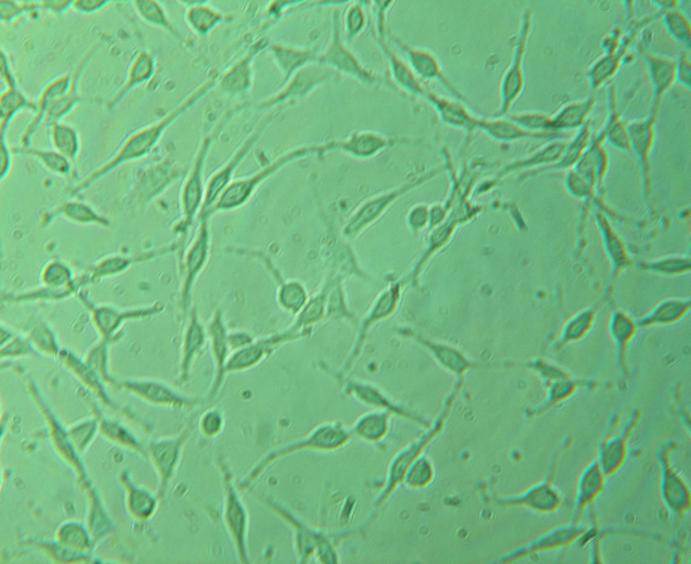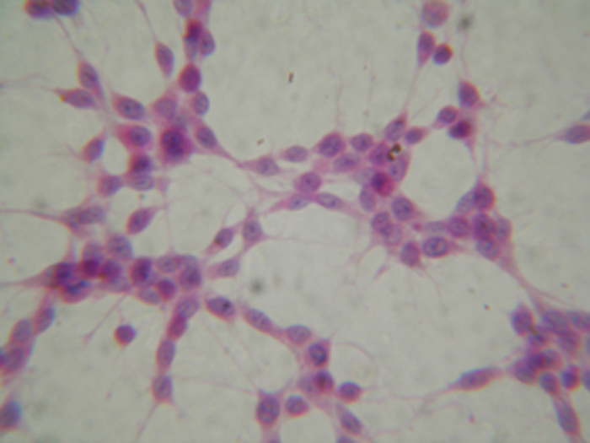
Figure 1: The characteristics of PC12 cells in normal control group are very similar to these of neurons. The right figure is HE staining. (Observed under the microscope 10×40)
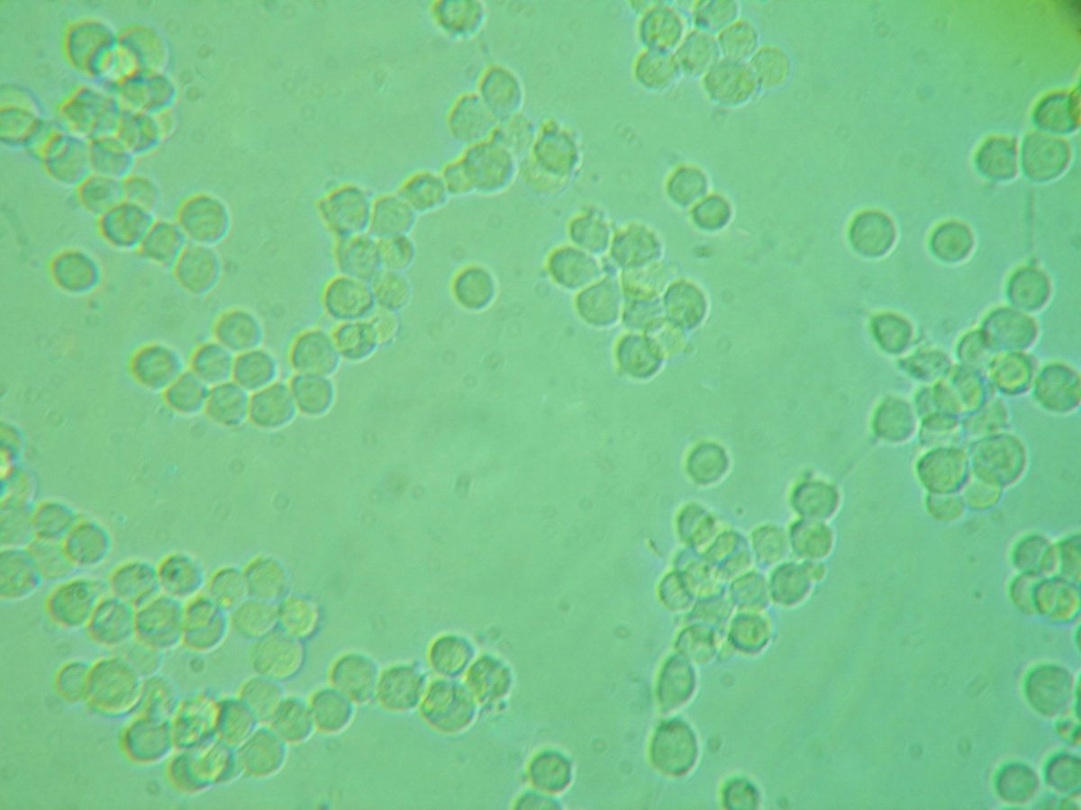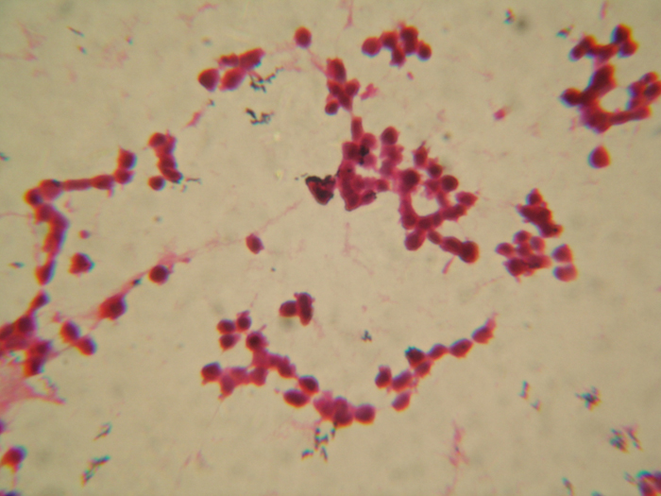
Figure 2: After oxygen-glucose deprivation for 30 minutes, the PC12 cells in OGD-R group became round because of serious edema and their prominence completely disappeared. They group gathered. The right figure is HE staining. (Observed under the microscope 10×40)
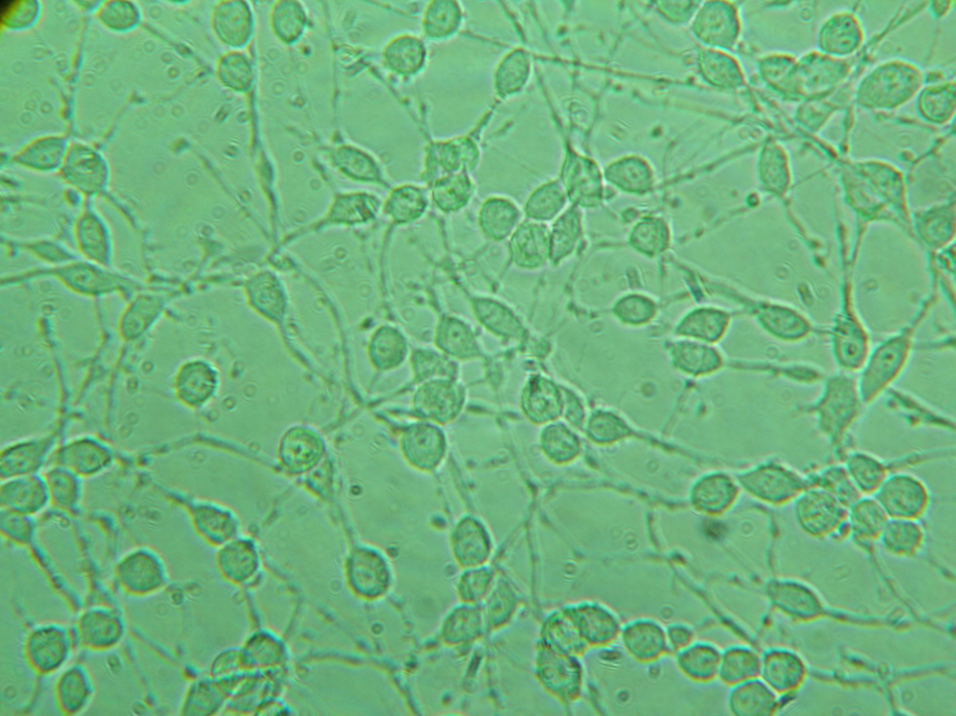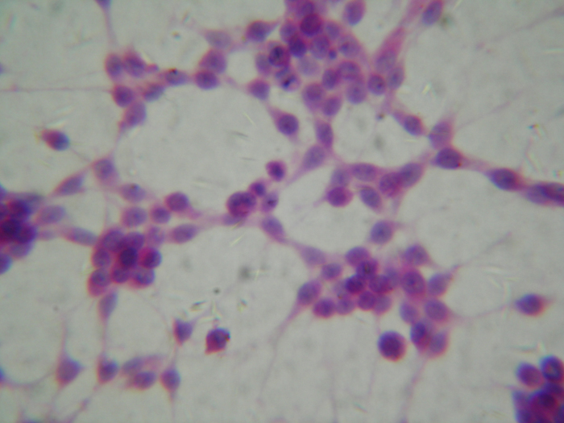
Figure 3: After oxygen-glucose deprivation for 30 minutes, most PC12 cells in 17β-E₂ group retained the spindle-shaped cells, but the cell body of them had slighter edema and their prominence became thinner and shorter. Small number of cells became round and their prominence disappeared; the group gathered is not obvious. The right figure is HE staining. (Observed under the microscope 10×40)
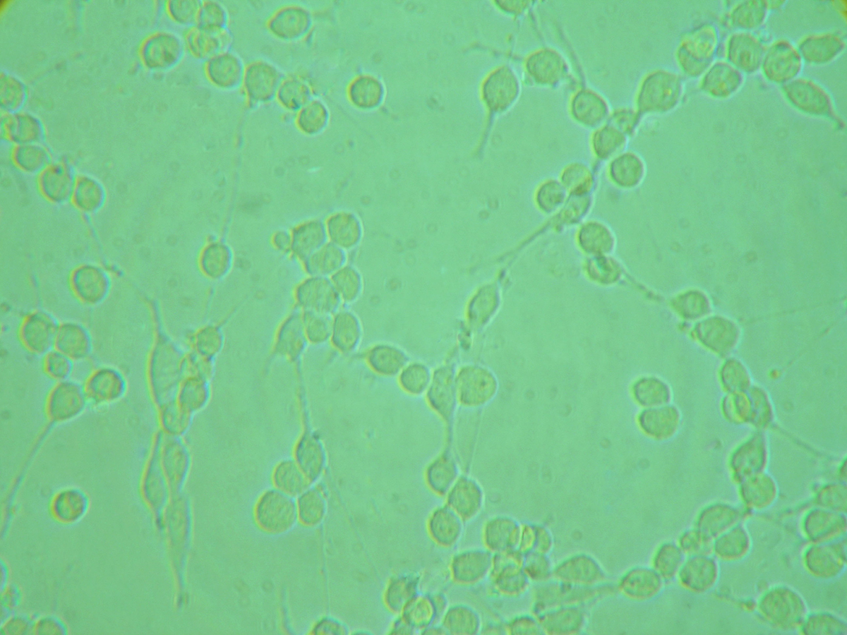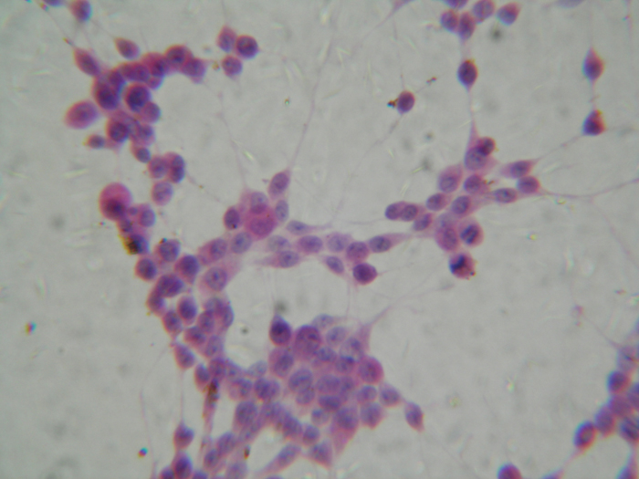
Figure 4: After oxygen-glucose deprivation for 30 minutes, most PC12 cells in the ICI182780 Intervention group retained the spindle-shaped cells, but the cell body of them had slighter edema and their prominence became thinner and shorter. Small number of cells became round and their prominence disappeared, the group gathered is not obvious. A small number of cells floated. The right figure is HE staining. (Observed under the microscope 10×40)
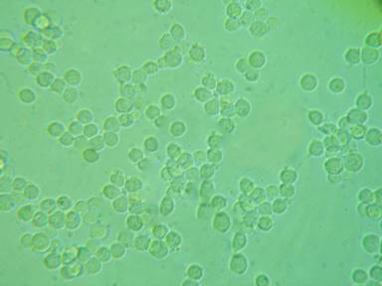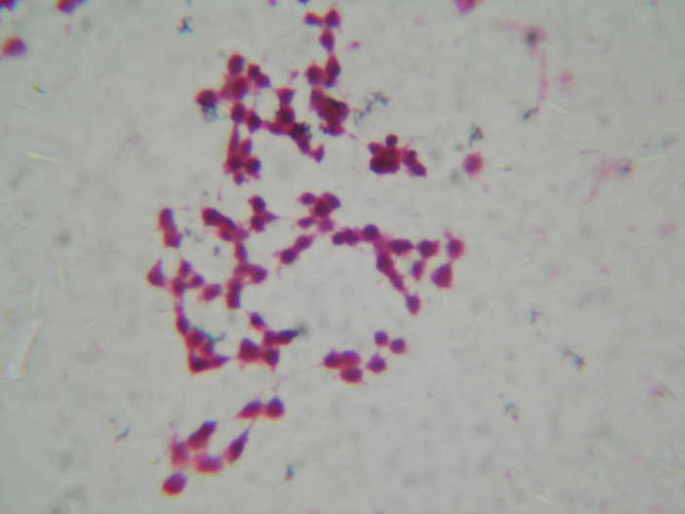
Figure 5: After oxygen-glucose deprivation for 30 minutes, the PC12 cells in the ICI182780 control group became round because of serious edema and their prominence completely disappeared. They group gathered. Their characteristics are very similar to these of OGD-R group. The right figure is HE staining. (Observed under the microscope 10×40)

(2) The determination of NO in cell medium
The concentration of NO in cell medium was measured respectively at each time point of 2h, 4h, 8h, 16h, and 24h after reperfusion. At each time point, the concentration of NO was highest in OGD-R group or Fulvestrant control group, and lowest in normal control group, and the concentration of NO in 17β-E₂ group and ICI182780 Intervention group was between the two. The differences among five groups were obvious (P<0.01). Along with the reperfusion time, the differences of the concentration of NO among five groups changed more significantly. （Table 2）

Table 2: The concentration of NO in cell medium of every group in each time ($\bar{x}±s$)
groups | n | The concentration of NO （μM）
groups | n | 2h | 4h | 8h | 16h | 24h
the normal control group | 6 | 0.566±0.212 | 0.605±0.178 | 0.606±0.178 | 0.645±0.122 | 0.685±0.130
OGD-R group | 6 | 1.830±0.415△ | 2.027±0.277△ | 2.146±0.193△ | 2.303±0.245△ | 2.422±0.178△
17β-E₂ group | 6 | 1.080±0.178△★＃ | 1.159±0.130△★＃ | 1.238±0.178△★＃ | 1.356±0.245△★＃ | 1.435±0.193△★＃
the ICI182780 Intervention group | 6 | 1.372±0.156△★＃ | 1.405±0186△★＃ | 1.532±0.179△★＃ | 1.631±0.185△★＃ | 1.746±0.253△★＃
the ICI182780 control group | 6 | 1.790±0.451△ | 1.998±0.321△ | 2.120±0.213△ | 2.259±0.241△ | 2.389±0.117△
Annotate: Compare with the normal control group, △P<0.01；compare with OGD-R group ★P<0.01；compare with the ICI182780 control group, ＃P<0.01.

(3) Detecting the expression of iNOS protein in neuronal PC12 cells after 24 hours of reperfusion
The iNOS protein in the cytoplasm of PC12 cells after 24 hours of reperfusion was showed by Western Blotting method, and then was measured by computer picture analysis software. The expression of iNOS protein was lowest in normal control group and highest in OGD-R group and ICI182780 control group, but the expression of iNOS protein in 17β-E₂ group and ICI182780 Intervention group was between the two（Figure6.7）. The differences of the expression of iNOS protein among five groups were obvious (P<0.05)（Table 3）.

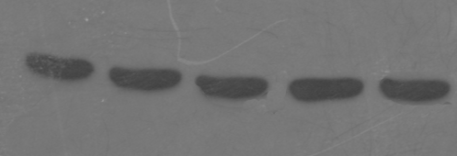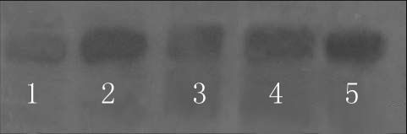
Figure 6 Figure 7
Figure 6: After oxygen-glucose deprivation for 30 minutes and after 24 hours of reperfusion, the expression of protein. (β-action). Figure 7: After oxygen- glucose deprivation for 30 minutes and after 24 hours of reperfusion, the expression of iNOS protein in five groups. In the figure, 1 is for the normal control group, 2 is for the OGD-R group, 3 is for the 17β-estradiol group, 4 is for the ICI182780 Intervention group, 5 is for the ICI182780 control group.

Table 3: Comparison of iNOS protein gray level ($\bar{x}±s$)
groups | n | iNOS
normal control group | 3 | 0.31±0.01
OGD-R group | 3 | 0.62±0.01△
17β-E₂ group | 3 | 0.45±0.02△★＃
the ICI182780 Intervention group | 3 | 0.39±0.01△★＃
the ICI182780 control group | 3 | 0.61±0.02△
Annotate: Compare with the normal control group, △P<0.05; compare with OGD-R group ★P<0.01; compare with the ICI182780 control group, ＃P<0.01.

(4) The expression of iNOS mRNA examined by RT-PCR after 24 hours of reperfusion.（Figure 8, 9）
The level of iNOS mRNA was expressed as ratio expression rate of iNOS gene/β-actin according to RT-PCR. The level of iNOS gene expression was 0.640±0.028 in normal control group, 1.322±0.094 in OGD-R group, 1.361±0.065 in ICI182780 control group, 0.772±0.032 in 17β-E₂ group and 0.764±0.0453 in ICI182780 Intervention group. The expression of iNOS mRNA was different among five groups (P<0.05). The difference between OGD-R group and normal control group was more significant (P<0.01)（Table 4）.

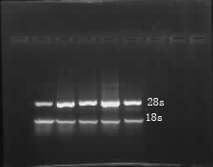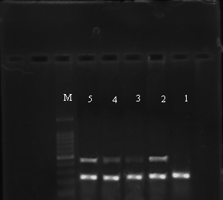
iNOS
β-action

Figure 8 Figure 9

Figure 8: The expression of iNOS mRNA examined by RT-PCR after 24 hours of reperfusion. Figure 9: After oxygen- glucose deprivation for 30 minutes and after 24 hours of reperfusion, the expression of iNOS mRNA in five groups. In the figure, M is for mark, 1 is for the normal control group, 2 is for the OGD-R group, 3 is for the 17β-estradiol group, 4 is for the ICI182780 Intervention group, 5 is for the ICI182780 control group.

Table 4: Comparison of iNOS mRNA gray level ($\bar{x}±s$)
groups | n | iNOS mRNA
the normal control group | 3 | 0.630±0.028
the OGD-R group | 3 | 1.342±0.094△  Annotate: Compare with the normal control group, △P<0.05；compare with the OGD-R group, ★P<0.01；compare with the ICI182780 control group, ＃P<0.01.
the 17β-estradiol group | 3 | 0.772±0.032△★＃
the ICI182780 Intervention group | 3 | 0.869±0.029△★＃
the ICI182780 control group | 3 | 1.361±0.065△

4. Discussions and Conclusions
In the experiment, oxygen glucose deprivation and reperfusion injury of PC12 cells model is more realistic than a simple lack of oxygen, or lack of sugar, and even oxygen-glucose deprivation period of application of sugar-free Earle's solution in the simulation of cerebral ischemia-reperfusion in which nerve cells ischemic perfusion environment ^{[1]}. After numerous pre-tests we found that the model repeatability and stability. It can meet the needs of this experiment ^{[2]}. Through inhibiting NO / iNOS system, 17β-estradiol can reduce the injury of PC12 cells in oxygen-glucose deprivation and reperfusion, also, it reduce their early apoptosis as a neuroprotective role ^{[3]}. However, the exact mechanism of action and role of the target is not clear ^{[4]}. In order to further understand the mechanism of estrogen action, we introduced estrogen receptor (ER) of the specific antagonist ICI182780 (Faslodex) ^{[5]} to interfere in the 17β-estradiol treatment, with its observation of the object as a control study was to investigate estrogen receptor ER ^{[6, 7]}, in the cerebral protective effect of estrogen in the meaning. In this experiment, five groups, in the oxygen-glucose deprivation and reperfusion 2h, 4h, 8h, 16h, 24h of each time point. We found NO concentration in the supernatant of the cells in the experimental group; the cell activity was reduced reverse. We can see that high concentrations of NO have obvious cytotoxicity^{[8]}. So NO / iNOS system activation may lead to oxygen-glucose deprivation-reperfusion injury in PC12 nerve cell injury and early apoptosis ^{[9, 10]}. It's one of the important reasons ^{[11, 12]}. Detection of RNA and protein expression levels of the test results also prompted that iNOS gene and protein expression have a consistency in all experimental groups^{[3]}, and directly related to the measured NO concentrations; compared with the normal group, the iNOS gene and protein expression of PC12 cells in the 24h oxygen-glucose deprivation-reperfusion model group is the highest. The cell activity in microscopic observation is the worst. ICI182780 followed by the group below. While the iNOS gene and protein expression of estrogen-treated PC12 cells is the lowest, activity of microscopic cells is the closest to the

normal group. The ICI182780 Intervention group is between model group and treatment group. So we can see through inhibiting NO / iNOS system, 17β-estradiol can reduce the injury of PC12 cells in oxygen-glucose deprivation and reperfusion, and reduce their early apoptosis as a neuroprotective role ^{[13]}. In this experiment, the iNOS gene, protein expression, NO concentration and cell activity observations of PC12 cells have shown that the ICI182780 intervention groups still have a certain protection to PC12 cells on oxygen-glucose deprivation and reperfusion ^{[14]}. Using enough high-purity of estrogen receptor antagonist can not make an effective rivalry to the protection of estrogen. So, we speculate that the neuroprotective effect of estrogen is multipath. We point out it may play a neuroprotective effect through means other than its receptor ^{[15]}.
This experiment was successfully prepared by oxygen-glucose deprivation-reperfusion injury model PC12 cells, the application interfere with estrogen receptor antagonist^{[16.17]}, estrogen treatment, compared to observe the protective effect of estrogen, and further explored 17β-estradiol on the oxygen-glucose deprivation and then reperfusion injury in PC12 cells^{[18.19]}, and NO / iNOS system, the impact mechanism, draw the following conclusions:
(1) High concentrations of NO has a strong cytotoxic, NO / iNOS system activation is the important cause of PC12 cells injuried by OGD-R.
(2) 17β-E2 can effectivly inhibit NO/iNOS system from activating and performing in PC12 cells of OGD-R. It can relieve cell edema, preserve cell morphous and enhance cell activity.
(3) Estrogen receptor antagonist ICI182780 could not effectively block the 17β-estradiol inhibited NO / iNOS system in neuroprotection.
(4) The protective effects of estrogen are probably many ways, and 17β-E₂ can exert neuroprotective effects and relieve injuries on neuronal PC12 cells injuried by OGD-R through other means other than receptor.

References
- Plaschke K, Yun SW, Martin E, et al. Linear relation between cerebral phosphocreatine concentration and memory capacities during permanentbrain vesselocclusions in rats [J]. Ann N Y Acad Sci. 2000; 903:299-306.
- Al-Abdulla NA, Martin LJ. Apoptosis of retrogradely degenerating neurons occurs in association with the accumulation of perikaryal mito-chondria and oxidative damage to the nucleus [J]. American Journal of Pathology. 1998; 153:447-456.
- Neil Howell; James Dykens; Walter H Moos. Estrogens and Neuroprotection: Desperate Housewives, Lost, and Survivor [J]. Drug Development Research, 2005, 66(2):51-52.
- Mattson MP. Presenilin-1 mutation increases neuronal vulnerability to focal ischemia in vivo and to hypoxia and glocuse deprivation in cell culture: involvement of perturbed calcium homeostasis [J]. The Journal of Neuroscience, 2000, 20: 1358.
- Varshochi R, Halim F, Sunters A, et al. ICI182,780 induces P21 waf 1 gene transcription through realeasing histone deacytylase1 and Eralpha from SP1 sites to induce cell cycle areest in MCF-7 breast cancer cellline [J].JBiolChem, 2005, 280(5): 3185-3196.
- Shughrue P J, Merchenthaler I. Estrogen is more than just a “sex hormone”: novel sites for estrogen action in the hippocam-pus and cerebral cortex [J]. Front Neuroendocrinol, 2000; 21(1):95-101.
- Osuka K, Feustel PJ, Mongin AA, Tranmer BI, Kimelberg HK. Tamoxifen inhibits nitrotyrosine formation after reversiblemiddle cerebral artery occlusion in the rat [J]. J Neurochem, 2001; 76(6):1842-50.
- Dawson VL, Dawson TM, Bartley DA, et al. Mechanisms of nitric oxide- mediated neurotoxicity in primary brain cultures [J]. J Neurosci, 1993, 13(6): 2651-2661.
- Iadecola C, Zhang F, Casey R, et al. Inducible nitric oxide synthase gene expression in vascular cells
after transient focal cerebral ischemia[J]. Stroke, 1996, 27(8):1373-1380.

- Ikeno S, Nagata N, Yoshida S, et al. Immature brain injury via peroxynitrite production induced by inducible nitric oxide synthase after hypoxia-ischemia in rats[J]. J Obstet Gynaecol Res, 2000, 26(3):227-234.
- Jiang H, Koubi D, Zhang L, et al. Inhibitors of iNOS protect PC12 cells against the apoptosis induced by oxygen and glucose deprivation [J]. Neurosci Lett, 2005, 375(1):59-63.
- Tehranian R, Rose ME, Vagni V, et al. Disruption of baxprotein prevents neuronal cell death but produces cognitive impairment in mice following traumatic brain injury [J].J Neurotrauma, 2008, 25(7):755-767.
- Chen Z, Yuhanna IS, Galcheva-Gargova Z, et al. Estrogen receptor alpha mediates the nongenomic activation of endothelial nitric oxide synthase by estrogen [J]. J Clin Invest, 1999, 103(3):401-406.
- Liaudet L, Soriano FG, Szabo C. Biology of nitric oxide signaling [J]. Crit Care Med, 2000, 28(Suppl 4):37-52.
- Toran-Allerand CD, Guan X, MacLusky NJ, et al. ER-X: a novel, plasma membrane-associated, putative estrogen receptor that is regulated during development and after ischemic brain injury [J]. J Neurosci, 2002, 22(19): 8391-8401.
- Kim HP, Lee JY, Jeong JK, et al. Nongenomic stimulation of nitric oxide release by estrogen is mediated by estrogen receptor alpha localized in caveolae[J]. Biochem Biophys Res Commun, 1999, 263(1):257-262.
- Hurn PD, Macrae IM. Estrogen as a neuroprotectant in stroke [J]. J Cereb Blood Flow Metab, 2000, 20(4):631-652.
- McCullough LD, Alkayed NJ, Traystman RJ, et al. Postischemic estrogen reduces hypoperfusion and secondary ischemia after experimental stroke [J]. Stroke, 2001, 32(3):796-802.
- Shafer TJ, Atchison WD. Transmitter, ion channel and receptor properties of pheochromocytoma (PC12) cells: a model for neurotoxicological studies [J]. Neurotoxicology, 1991, 12(3):473-492.

