Study of the Expressions of level of sex hormones and their receptors
for Lung Cancer Patients

Xiufang Chen
Henan XianDai Medical Research Institutation, Zhengzhou, Henan, PRC
Received February 2, 2008
____________________________________________________________________
Abstract
Most of lung cancer patients are with disorder expressions of estrogenic and androgen as well as their receptors ER and AR. In this study, a mechanism is proposed by testing Testosterone (T) and Estradiol (E2) levels and to look into the expressions of ER and AR for male non-small cell lung cancer patients to clarify the influence of sex hormones and their receptors. [Life Science Journal. 2009; 6(4): 78 – 86] (ISSN: 1097 – 8135).

Keywords: Testosterone, Estradiol, Sex Hormone ________________________________________________________________________________________________

- Introduction
Pr1marybronehogenic Carcinoma can be referred as lung cancer, typically originated in bronchia mucose. Lung cancer is constantly malignant and seriously threat to people's health and life. In the United States, lung cancer accounts for most of the cancer deaths [1]. It is expected that by the year 2020, cases of cancer all over the world will reach 15 million. Most of these cases are Lung cancer which shall be the highest morbidity and mortality of diseases [2].
Presently, pathogeny of lung cancer is not yet fully understood. The epidemiology survey shows that smoking is the most possible for lung cancer in etiology. About 85% of lung cancer patients have smoking history [3]. Air pollution, employment, nutrition, diet, ionizing radiation, chronic lung disease is by closely related to biological factors of lung cancer. In recent years, animal experiments and clinical data indicate that, in certain non-malignant tumor, the expression of sex hormones receptors' can be also found in target organs like liver cancer, colon cancer, throat cancer, lymphoma etc. [4-6]. The growth of lung cancer is affected by sex hormones and its receptor. Sex hormone regulates the differential of the lung and its development. The lung should be involved in the metabolism of estrogen and progesterone procedure; estrogen and progesterone have their own receptor-binding to play their role as well as estrogen and progesterone receptors. The high expression of estrogen causes the organ of lung cancer to change endocrinic micro environment. The cells of lung cancer originate the estrogen and progesterone receptor protein synthesis genes.
Correspondence: fang1518@126.com
Dr. Xiufang Chen

The synthesis of lung cancer cell with binding activity of receptor protein basically tells the characteristics of the female and male hormone receptors as well as the origination of the lung cancer and its growth [7]. Especially in advanced stage, patients with lung cancer can be found the hormone disorder in the expression of ER and AR [8, 9]. In this report, we use immunohistopathologic assay to detect the expression of the estrogen receptor (ER) and androgen receptor (AR). Meanwhile, we also use radiant immunological assay to detect T and E2 levels for checking the possible etiological mechanisms for male non-small cell lung cancer patients.

2. Materials and methods
2.1 Materials and Samples
All cases obtained since July 2007 through July 2008 were from Department of thoracic surgery in Zhengzhou University first affiliated Hospital. Patients, a total of 56 cases, with the histological classification of lung cancer WHO1999, 34 patients with squamous cell carcinoma, 22 cases of adencarcinoma were pathological confirmed in diagnosis as male non-small cell lung cancer. 29 cases were classified as in stage I, 17 cases in phase II, 10 patients in stage III. The youngest is 34-year-old, by averagely with the eldest 75-year-old, is 59.2 years old. Non of them were been in chemotherapy or radiotherapy and have not been prescribed sexual hormone-disrupting medicine in one month before operation. The control group was 30 healthy male volunteers selected through carefully physical examination.
Serum preparation: Collecting blood 3 ml from patients in the morning before surgery, put into 3,000 r/min centrifugation, taking the serum saved at -20ºC.
Tissue specimen’s preparation: Taking the fresh surgical resection with diseased tissue and adjacent tissues from patients fixed with 4% formaldehyde solution for more than 24h and then after ethanol gradient dehydration, using paraffin embedding at low melting point paraffin, cut in as 3 ~ 4μm slices. The experimental Testosterone (T) reagent was purchased from DPC biotechnology company; estradiol (E2) reagent was purchased from Beijing North Biotechnology Institute products. And both AR monoclonal antibody and ER monoclonal antibody were produced by the United States Santa Cruz Inc.. S-P immunohistochemical reagent was purchased in Beijing Jinqiao Bio Co., Ltd.

2.2 Methods

2.2.1 Method to determine serum testosterone (T) and estradiol (E2)
With radioimmunoassay (RIA) kit, testosterone can be determined by using coated tube method, meanwhile, E2 can be determined by using pairs of anti-method.

2.2.2 AR, ER immunohistochemical staining
By using of Streptavidin-biotin-peroxidase immunohistochemical method (referred to http://www.kpl.com/catalog/), we checked from microscope by view of films to compare experimental group and the cancer adjacent tissue (from cancer tissue more than 5cm) group which was used the control group. Positive control including ER, c-myc, c-fos and AR photos was referred to the photos provided by Beijing Chungshan Company.

2.2.3 The assessment of immunohistochemistry assays
The assessment of the immunohistochemical staining was referred to the literature [10] to develop criteria for immunohistochemical. The ER, AR can be cataloged by the number of plasma brown granules appeared as positive in nuclei of tumor cells shown in high-powered microscope. Every slice selected needed five horizons, each horizon counting 100 cells. If the positive plasma brown granules appeared more than 25% was recorded as positive. High-powered microscope could take four different points for each view and each count has 200 cells. The percentage of cells, according to the degree of positive was marked as one (+) to three (+). In contrary, no positive cells, we marked it as negative (-). When the positive cells were around 30%, we gave it marked as +, if positive cells accounted for 30% to 50%, we gave it marked as + +, meanwhile, if positive cells were over 50% , we gave it marled as + + +. The percentage of positive cells referred to the reference [10] under (100 times) microscope view, we randomly selected four viewing fields to calculate the percentage of positive cells in tumor and defined that the percentage of positive cells between 0% -5% as 0 point, 5% -25% as 1 point, 26% -50% as 2 points ,51-75% as 3 points and more than 76 as 4 points. Comparatively, staining index points of 0-2 is defined as the negative,3-7 is defined as positive expression.

2.2.4 Statistical Methods
The count information was based upon mean ± standard deviation. All statistical analysis was used by SPSS13.0 statistical software.

3. Results
3.1 The relationship between the clinical pathology and the serum sex hormone levels
In comparison of non-small cell lung cancer group to the normal control group, we found that the T level was significantly lower (P <0.01). However, the E2 level was significantly higher (P <0.01). The E2-T ratio was significantly higher (P <0.01). The serum sex hormone level of 60-year-old and elder senior group patients were significantly higher than others (P <0.05). The T level was negatively correlated with age (P <0.05). As the age reduces, the level T and E2 were positively correlated (P <0.05), namely, E2 levels increased with age rising. The lung cancer patients with high, medium, poorly differentiated levels of serum E2 level between the two groups was statistically significant difference (P <0.05), which differentiated the serum E2 level was significantly lower than the poorly differentiated group, the differentiation of serum E2 was significantly lower than the poorly differentiated group (P <0.05).

Table 1. The serum sex hormone levels of Lung cancer group and normal control group comparison ($\bar{x}±s$)
group | samples | serum sex hormone level
group | samples | T (ng/mL) | E₂ (pg/mL) | E₂/T
Patient | 56 | 3.87±1.45 | 59.90±26.67 | 3.48±2.01
Control | 30 | 6.72±1.43 | 87.00±23.54 | 1.48±1.00
P <0.01
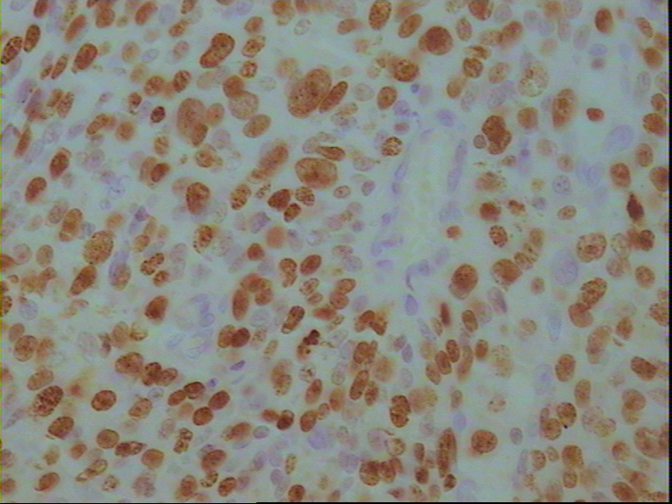
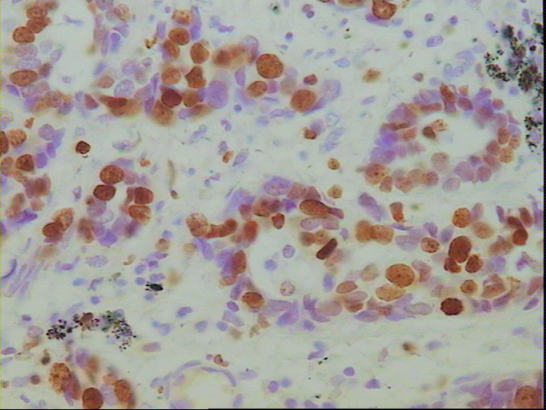

Figure 1. AR expression in lung adenocarcinoma（IHC×400）
Figure 2. AR expression in squamous cell carcinoma（IHC，×400）
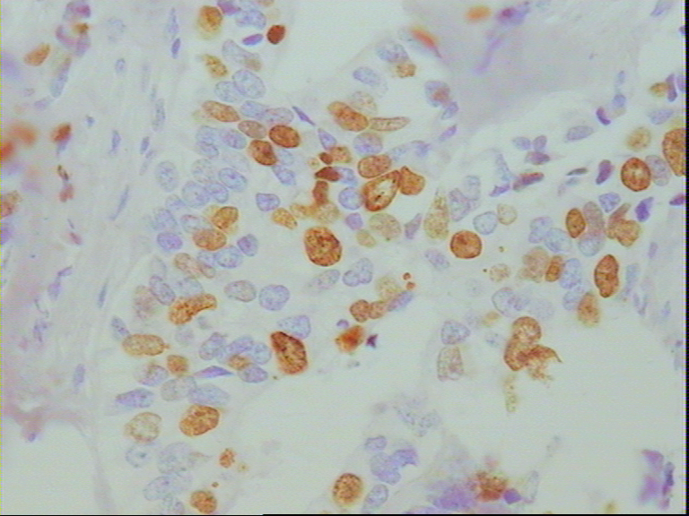
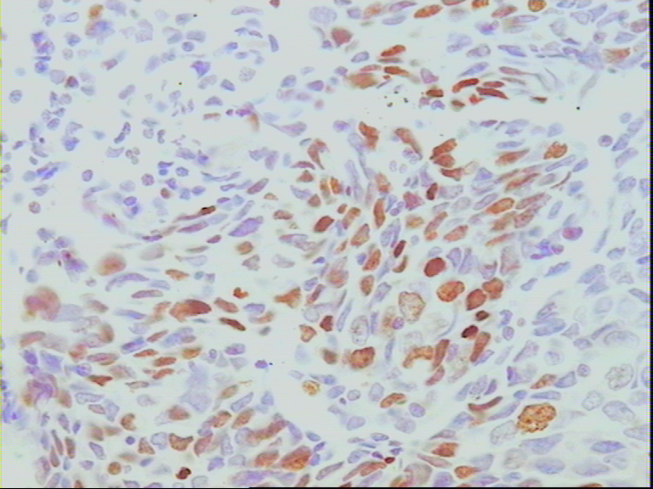

Figure 3. ER expression in lung adenocarcinoma（IHC×400）
Figure 4. ER expression in squamous cell arcinoma（IHC，×400）

Table 2. Relationship between sex hormones levels
and clinicopathological characteristics of lung cancer patients
Characteristic | samples | sex hormones levels
Characteristic | samples | T (ng/mL) | E₂ (pg/mL)
Tatals | 56 | 3.87±1.45** | 59.90±26.67**
Age(y)
≥60 | 27 | 3.38±1.14* | 94.78±20.30*
<60 | 29 | 4.32±1.56 | 79.76±24.35
Histology
Squamous cell | 34 | 2.67±1.47 | 91.29±25.88
Adenocarcinoma | 22 | 3.61±2.33 | 96.32±26.66
Grade
I | 29 | 4.36±1.5* | 75.93±22.06**
II | 17 | 3.49±1.06* | 92.82±19.50**
III | 10 | 3.08±1.18 | 109.20±13.76*
Metastasis (TNM) Stage
I | 33 | 3.27±1.80* | 93.10±19.98
II | 12 | 3.32±2.57 | 103.00±27.94
III | 11 | 2.023±0.80 | 91.55±25.145
T Stage
1-2 | 52 | 3.11±1.95 | 93.02±22.48
3-4 | 11 | 2.08±0.05 | 119.50±10.38
N Stage
0 | 34 | 3.05±2.00 | 98.15±19.90
1 | 10 | 3.04±1.49 | 86.31±23.11
2 | 12 | 3.01±2.02 | 92.92±29.65

Table 3. Relationship between expression of AR, ER and clinicopathological characteristics of lung cancer patients

Characteristic | n | expression of AR |  | P value | expression of ER |  | P value
Characteristic | n | Positive | Positive(Rate) | P value | Positive | Positive(Rate) | P value
Tatals | 56 | 13 | 23.21 |  | 12 | 21.43
Age(y) |  |  |  | 0.865 |  |  | 0.523
≥60 | 27 | 6 | 22.22 |  | 7 | 25.93
<60 | 29 | 7 | 24.14 |  | 5 | 17.24
Histology |  |  |  | 0.240 |  |  | 0.111
Squamous cell | 34 | 8 | 23.53 |  | 5 | 14.71
Adenocarcinoma | 22 | 5 | 22.72 |  | 7 | 31.82
Grade |  |  |  | 0.751 |  |  | 0.301
I | 29 | 7 | 24.14 |  | 6 | 20.69
II | 17 | 4 | 23.53 |  | 4 | 23.53
III | 10 | 2 | 20.00 |  | 2 | 20.00
TNM Stage |  |  |  | 0.906 |  |  | 0. 231
I | 33 | 7 | 21.21 |  | 4 | 18.18
II | 12 | 4 | 33.33 |  | 2 | 16.67
III | 11 | 2 | 18.18 |  | 6 | 36.36
T Stage |  |  |  | 0.227 |  |  | 0.401
1-2 | 52 | 11 | 21.15 |  | 9 | 21.15
3-4 | 4 | 2 | 50.00 |  | 3 | 25.00
N Stage |  |  |  | 0.760 |  |  | 0.193
0 | 34 | 7 | 20.59 |  | 6 | 17.65
1 | 10 | 4 | 25.00 |  | 4 | 25.00
2 | 12 | 2 | 16.67 |  | 2 | 33.33

3.2 The relationship of the clinical pathology for the ER and AR expression
ER and AR in lung cancer the overall positive were 23.21% (13/56) and 21.43% (12/56). ER positive expression in lung cancer do not correlate with age, tumor histological type, histological grade, TNM stage. Meanwhile, AR an positive expression in lung cancer do not correlate with age, tumor histological type, histological grade, TNM stage either. But TNM stag of lung cancer patients in Phase III were significantly higher than in phase I lung cancer. Lymph node metastasis, there are no difference (X2 = 5.2032, P <0.05) between N2 group and N0 group.

4. Discussion and Conclusion
It is reported in the literature [11] that 40% to 60% of human cancers are related with endogenous or exogenous sex hormone effects. In recent years, sex hormone disorders and the relationship between the occurrence and development of lung cancer are concerned by scientists specifically about the relationship between sex hormones and lung cancer which have a complex duality, being with carcinogenic and on the other hand role of tumor suppressor. Hormonal environment of the body imbalance, sex hormone deficiency and excess could lead to cancer. Hormone itself is not carcinogenic substances, but it can through the proliferation of target cells, so that to play a role in promoting the carcinogenic process to start. The roles of sex hormones also have a mechanism of catalyst to promote the start-up phase in the proliferation of cancer cells. In addition, sex hormones can promote the rapid proliferation of the cells to the malignant cell transformation. As early in 1977, Fairlamb et al. [12] have found that men with breast development may associate with lung cancer with increasing the level of estradiol and drawing down the testosterone level [13-14].
David et al. [15] has studied 39 cases of male patients with lung cancer. They reported that blood testosterone level was lower (<12nmol / L) than the positive control. Low level of testosterone can be used as an indicator of lung cancer metastasis. The results of our study has show that serum T level of male patient with lung cancer in comparison to the normal control group was also significantly lower (P <0.01). Serum E2 level compared with normal control group significantly increased (P <0.01). E2 / T ratio increased may mean that comparing with lymph node metastasis group and no lymph node metastasis group revealed T at significantly lower that indicating the patients with lung cancer in serum sex hormone level presented in disorder. But there are also opposite findings from Chen Ming-wei [16]. The sex hormone levels were correlated with the pathological type of tumor, cell differentiation; clinical staging and tumor size with no significant relationship between the sizes of tumor. David [17] reported that leading to a lower level of serum T may be the effect caused by reducing and increasing consumption jointly; peripheral blood level of estrogen increase was mainly attributable to increase in estrogen or metabolic disorder. In normal male, 50% to 70% female hormone was produced by testosterone in fat, muscle and skin tissue transforming with aromatase from the secretion of cortex. The reason why the male obesity patient appears peripheral blood reduction of androgen and increasing estrogen is due to the aromatase in adipose tissue transforming the androgen into estrogen-induced [18]. Some studies suggested that [19] the androgen aromatase catalytic in lung tissues converted to estrogen and the release into the blood may result in male patients with lung cancer with elevation of estrogen but reducing testosterone. Estrogen, androgen and their receptors are correlated with the occurrence, development and prognosis of cancers not only in target organs such as the uterus, breast, prostate cancer organs but also non-target organs. Chaudhuri et al. reportwd on 1982 that the frequency of ER was 14.29% (15/105) that revealed the lung cancer may be estrogen-dependent [20]. Our study supported that the frequency of expression of ER-positive at 23.21%. However, some other studies have shown [21] ER in non-small cell lung cancer cases was in negative expression. Radzikowska et al [22] suggested the opposite outcomes might be the applications of the error in different technology and the effect of polyclonal antibodies, such as the operation of antigens hot fix, non-standardized operation of the process and monoclonal antibodies Clone. The morbidity and mortality for male lung cancer patients were much higher than females. The reason may be the occurrence of AR in the development of lung cancer. ER relatively to the AR of lung cancer, is much less expressed varied (0-76%). such as Liang Peng et al [23] using immunohistochemical SP method detected 47 cases of lung cancer tissues in AR expression, AR-positive rate was 61.7%, Yan-ming [8] using immunohistochemical staining of 105 cases of lung cancer tissue specimens AR expression, AR-positive rate of 20%. This study showed that AR was negative in normal lung tissue expression of AR in lung cancer tissues positive rate of 21.43%. For lung cancer patients, the expressions of AR and ER are highly related to the characteristic of Clinical and pathological features as well the degree of differentiation and clinical stages and the age of the patients. Due to these differences, it is believed that the expression of ER may be related with histological types of lung cancer, accordingly, the positive expression frequency of adenocarcinoma was publicized significantly higher than squamous cell carcinoma, and adenocarcinoma, and this is also possibly the reason that the observed incidence of female was higher than male [24-31]. However, in our study, we did not find the expressions of ER and AR being significant different between squamous cell carcinoma and adenocarcinoma. Our study has demonstrated that the experimental group of male with non-small cell lung cancer patients being observed serum sex hormone disorders and high expressions in cancer tissues of ER as well as AR, which suggested that the abnormal sex hormone disorders and its receptor expression may be the initiation factor in the development of lung cancer. Despite the ambiguities of the statistical results, study of sex hormone and its receptors ER, AR expressions in origination for lung cancer and metastasis should be further investigated in depth.

References
- Jemal A, Siegel R, Ward E, et al. Cancer statistics, 2008[J]. CA Cancer J Clin, 2008, 58: 71–96.
- Jemal A, Siegel R, Ward E et al. Cancer statistics, 2007[J]. CA Cancer J Clin, 2007, 57:43– 66.
- Peto R, Darby S, Deo H et al. Smoking, smoking cessation, and lung cancer in the UK since 1950: Combination of national statistics with two casecontrol studies [J]. BMJ, 2000, 321:323–329.
- Lindahl B, Alm P, Fetto M, et al. Prognostic value of steroid receptor concentration and flow cytometrical DNA measurement in stage I-II endometrial carcinoma [J]. Arta Oncol, 1989, 28(4):595.
- Harrison JD, Watson S, et al. The effect of sex hormones and tamoxifen on the growth of human gastric and colorectal cancer cell lines [J]. Cancer (Philadelphia), 1989, 63: 2148-2151.
- Schwartz MR, Randolph RL, et al. Steroid hormone binding macromolecules in meningiomas: failure to meet riteria of specific receptors [J]. Cancer (Philadelphia), 1984, 53:922-927.
- Oliaycsl CW, Riordan GP, Rushin JM. Estrogen receptor detection in paraffin sections of adenocarcinoma of the colon, pancreas, and lung [J]. Arch Pathol LabMed, 1994, 118:630.
- Yan M, Chen XB, Wang SL, et al. The expression of AR and ER in lung cancer [J]. Chinese Journal of Lung Cancer, 2008, 1 (11):126-129.
- Li QS, Zhao XM, Jin XP, et al. Expression and significance of estrogen and progesterone receptor in lung cancner[J]. Chinese Journal of Lung Cancer, 2003, 8(3):192-194.
- Fang N, Shao R, Chen DY. Expression of PTTG, c-myc and p53 Protein in Non-Small Cell Lung Carcinoma and Its Significance. Journal of Jiangsu University, 2008, 2(18):131-134.
- Li JJ, Mueller GC, Sekely LI. Workshop report from the Division of Cancer Etiology, National Cancer Institute, National Institutes of Health. Current perspectives and future trends in hormonal carcinogenesis [J]. Cancer Res, 1991, 51(13):3626- 3629.
- Fairlamb D, Boesen E. Gynaecomastia associated with gonadotrophin secreting carcinoma of lung cancer [J]. Postgrad Med J, 1977, 53 (619): 269-271.
- Shu QJ, Chen JG, Wang YN, et al. On Sex Hormones in Male Patients with Lung Cancer. Military Medical Journal of South China, 2007, 21(6):13-14.
- Wang NH, XU L. The study of serum sex hormone levels changes in male malignant tumors patients [J]. Journal of Modern Laboratory Medicine, 2007, 22(3):79-80.
- David PT, Christina G, Kenneth Gd. Low serum testosterone as indicator of metastic bronchial carcinoma [J]. Thorax, 1987, 42:661.
- Chen MW, Hu GY, Li ZM et al. Using Double antibody radioimmunoassay detected serum sex hormone levels change in lung cancer. Xi'an Med Univ, 1999, 20(2):202-204.
- David PT, Christina G, Kenneth GD. Low serum testosterone as an indicator in metastatic bronchila [J]. Thorax, 1987, 42: 661.
- Xu B, Zhou L, Zhang J. Sex hormones and obesity [M]. China Science &Technology Press, 1997,189-198.
- Zhou XD, Cao WQ, Cai HW. Study on the relationship between estrogen receptor expression and level of serum sexual hormones in male patients with lung cancer. Chinese Journal of Lung Cancer, 2002, 5(5):349-351.
- Chaudhuri PK, Thoms PA, Walker MT, et al. steroid receptor in human lung cancer cyetoslos. Cancer Lett, 1982, 16(3):327-332.
- Li JL, Zhu HY, Chen TX, et al. Expressions of BRCA2, ER, PR and c-erbB-2 in Non-small cell lung carcinoma [J]. Chinese J. of Histochemistry and Cytochemistry, 2008,17(4):306-310.
- Radzikowska E, Langfort R, Giedronowicz D. Estrogen and progesterone receptors in non small cell lung cancer patients [J]. Ann Thorac Cardiovasc Surg, 2002, 8(2):69-73.
- Liang P, Liu ZH, Wang Q, et al. The significance of detect sex hormone receptors in Primary lung cancer [J]. Chinese Journal of Clinical Oncology and Rehabilitation, 1998, 5(2):16-17.
- Mollerup S, Jorgensen K, Berge G, et al. Expression of estrogen receptors alpha and beta in human lung tissue and cell lines [J]. Lung Cancer, 2002, 37(2):153-159.
- Li QS, Gao XH, Lv XY, et al. Expression and Clinical Significance of ER, PR in NSCLC. Clinical Focus, 2003, 18(24):1390-1392.
- Mao WH, Xun JP, Mao JL. Expression and Clinical Significance of ER, PR in lung cancer tissue [J]. Zhejiang Practical Medicine, 2005, 10(4):225-245.
- Chen DY, Hu YX, Bi JB, et al. Expression of estrogen and Progesterone Receptors in Non small cell Lung Cancer and its Clinical Significance［J］.China Medical Univ, 1998, 27(2):161-163.
- Zhou JJ, Chen HJ, GaoY, et al. Expression of Estrogen and Progesterone Receptors in Non-Small Cell Lung Carcinoma [J]. Chin J Clin Oncol, 2004, 31(9):1108-1110.
- Lu ZH. Expression of Estrogen and Progesterone Receptors in Pulmonary Carcinoma and Its Correlation of Clinical Significance and Prognosis [D]. Jiangxi Medical College, 2003

- Peng AM, Yin SJ, Fu PF, et al. P53 Protein, Estrogen/Progesterone Receptor Expression and DNA Ploidyin Lung Cancer. Journal of Tongji University, 2005, 26(3):16-18.
- Peng AM, Cang LQ, Liu DF, et al. A study on the expression of estrogen receptor and the effect of Tamoxifen treatment in lung cancer [J]. Journal of Shanghai Tiedao University, 2000, 21(1):59-62.

