Synchronous TBI and ABI measurement Scheme for Diabetes Patients
Synchronous Sphygmomanometer of Four Limbs
Sung-Tsun Shih
Department of Electronic Engineering, Cheng Shiu University, Kaohsiung , Taiwan

Received November 18, 2009
__________________________________________________________________________________________________________________________________________________
Abstract: Measurement of ankle blood pressure is a simple method of assessing lower limb arterial blood supply. It has been found through a large amount of experimental measurements that the differences of blood pressure among the four limbs and great toe are highly correlated with hyperlipemia, thrombosis blood vessel hardening and high density of blood on supine position. In this study, a synchronous TBI and ABI measurement scheme is built with six electronic sphygmomanometers work concurrently. We utilize six general electronic sphygmomanometers adding with transmission interface and an embedded microprocessor to build the brachial and great toe blood pressure synchronous measurement equipment. Then, the ABI and TBI reports are automatic calculated and displayed to guide clinicians make decision. Also we adopt the RFID system in the measurement scheme to identify user identity and as a user login mechanism. [Life Science Journal. 2009;6(4):62- 68] (ISSN: 1097 – 8135)
Keywords: Toe brachial index (TBI), Ankle brachial index (ABI), Diabetes, Blood pressure, RFID
________________________________________________________________________________________________

1. Introduction
Macrovascular disease is common in diabetes and is the major cause of morbidity and mortality in this condition. The increase in vascular disease is not restricted to the coronary circulation but also occurs to the cerebrovascular and peripheral vascular systems. It has been estimated that > 30% of patients with diabetes have evidence of peripheral vascular disease (PVD). Assessment of the circulation in the lower limbs is not only important for patients with symptoms of ischemia, but also helpful in classifying foot ulcers and predicting the chance of healing. Clinical examination is the first step in this process but in many patients non-invasive vascular tests are required to confirm clinical judgment and to assess more quantitatively the degree abnormalities. Measurement of the ankle brachial index (ABI) by Doppler ultrasound is a simple and commonly used method for this purpose. However, the applicability of this technique to patients with diabetes is in some doubt because diabetic patients often develop ___________________________________________*Corresponding Author: Sung-Tsun Shih, PhD
E-mail: stshih@csu.edu.tw
calcifications of the lower limb arteries. The presence of calcification may invalidate the ABI as the arterial wall becomes stiffer and resists compression, giving a falsely high ankle systolic pressure. As a result, measurement of great toe artery pressure for calculation of toe brachial index (TBI) is commonly advocated in diabetic patients. However, before accepting this approach it should be borne in mind that toe arteries might also be calcified. Moreover, measurement of toe pressure is technically more demanding and requires expensive equipment beyond the scope of most clinicians. It would be worthwhile to have some clinical data to guide clinicians as to when pressure measurements should be taken at the toe rather than at the ankle.
Measurement of ankle blood pressure is a simple method of assessing lower limb arterial blood supply. However, its use in diabetes has been questioned due to the presence of medial artery calcification. Measurement of toe blood pressure has been advocated as an alternative but it is technically more difficult.
In this study, we try to build a concurrent TBI and ABI measurement scheme with six electronic sphygmomanometers. We utilize six general electronic sphygmomanometers adding with transmission interface to build the brachial and great toe blood pressure concurrent measurement equipment. Then, the ABI and TBI reports are automatic calculated and displayed by the embedded microprocessor. Also we adopt the RFID system to identify user identity and as a user login mechanism.
A remotely physiological reporting system in accordance with the present utility model senses and identifies a unique entity, collects measured data, transmits and stores parametric data sensed by measurement apparatus, can be used in medical monitoring. The automatic matching and recording system comprises a Radio Frequency Identification (RFID) reader, a measurement apparatus, a local recording device and a remote monitoring device.

2. Methodology
The ankle-arm pressure index (also known as the Ankle / Brachial Index or ABI) compares the systolic blood pressure of the ankle to that of the arm (brachial). These measurements are useful in the assessment, follow-up and treatment of patients with peripheral vascular disease (PVD). ABI's provide an objective baseline to follow the progression of the disease process and evaluate the effectiveness of the treatment plan.
The ABI results are usually combined with Doppler or pulse volume waveform analysis (PVR). Significant changes in arterial systolic pressure between sites indicate reduced blood flow caused by obstruction of blood vessels. The effects of obstructions can be emphasized by increasing blood flow, either by exercise testing or by inducing reactive hyperemia with an occlusive cuff.
Patients, such as diabetics, with calcified vessels may show falsely elevated ankle pressures. In this case, pressure measurements can be made on the foot or toes by Photo Plethysmography (PPG) for more accurate results. Diagnostic information is obtained both from the waveform of the arterial flow when displayed on a chart recorder and from using the PPG sensor to determine the blood pressure in the digit.

ABI Interpretation Levels:
>1.3 Non-compressible
1.00 – 1.29 Normal
0.91 – 0.99 Borderline (equivocal)
0.41 – 0.90 Mild-to-moderate P.A.D.
0.00 – 0.40 Severe P.A.D.

Figure 1. Normal artery and atherosclerotic artery
Figure 2. Normal ABI measurement result with manually recording
.
Figure 3. Severe ABI measurement result with manually recording

3. Experiment Scheme
Figure 4. Synchronous TBI and ABI measurement scheme
Embedded MCU Controller
Right Sphygmomanometer for Arm, Ankle, toe.
Left Sphygmomanometer for Arm, Ankle, toe.

Blood
Pressure
Cuffs

Blood
Pressure
Cuffs

The proposed system consists of signal acquisition, radio frequency (RF) transmission; signal processing, internet communication and database modules. The signal is amplified and filtered in the signal acquisition module. The bio-signal is digitized by the built-in analog-to-digital converter (ADC) in the micro- controller and organized into a data package. As soon as the package is established, it is sent by the transceiver using the high-frequency band. On the receiver side, it utilizes the same communication protocol to extract signals from the received package. Data is then passed to the personal computer (PC) through the RS232 interface, on the receiving side, for signal processing, analysis and storage. In addition to waveforms display, the PC processes the acquired signals and obtains biological parameters such as heart rate for evaluating user’s physical condition. At the same time, the application program on the PC can establish internet connection with the remote server in the hospital. After processing, data is saved in the Access database for long-term physical condition monitoring.
The embedded microprocessor is used to stimulate the six sphygmomanometers concurrently, and collect the systolic blood pressure, diastolic blood pressure and beat pulse from each cuff. Only the bigger value of each systolic blood pressure in arm, ankle, and toe are used to calculate the ABI (Ankle Brachial Index ) and TBI(Toe Brachial Index) index.

Right ABI = (Right Ankle systolic pressure ) / (bigger one of right and left Brachial systolic pressure) (1)
Left ABI=(Left Ankle systolic pressure)/(bigger one of right and left Brachial systolic pressure) (2)
Right TBI = (Right great Toe systolic pressure) / (bigger one of right and left Brachial systolic pressure) (3)
Left TBI = (Left great Toe systolic pressure) / (bigger one of right and left Brachial systolic pressure) (4)

4. Measurement of arterial pressures
The patient was asked to rest supine for 10 min and a 10-cm cuff was wrapped around the upper arm. The brachial pulse was then palpated and the Doppler probe placed at a 45º angle to the skin surface with the probe directed towards the patient's head. Once the best signal was obtained the cuff was inflated until the signal disappeared. The cuff was then slowly deflated, and the point at which the signal returned was taken as the systolic blood pressure. This process was then repeated for the other arm and the higher of the two pressures taken as the brachial artery pressure.
The same cuff was placed around the ankle immediately above the malleoli. The dorsalis pedis pulse was palpated and the pressure reading obtained as described for the brachial pressure. The process was repeated for the posterior tibial artery. The pressure of the artery with the higher reading was taken as the ankle pressure and the ABI was calculated from the ratio of the ankle systolic pressure to brachial systolic pressure. The cuff was not inflated beyond the pressure of 250 mmHg, even if the Doppler signal was not obliterated. In this situation, the ankle systolic pressure was arbitrarily taken as 250 mmHg. To measure toe pressure a 25-mm digital cuff was placed around the proximal phalanx of the hallux and the Doppler signal was recorded from the distal pad of the great toe. The cuff was inflated to a maximum of 200 mmHg and then slowly deflated. The point at which the arterial waveform reappeared was taken as the toe systolic blood pressure. If an adequate Doppler signal could not be obtained for technical reasons, the pressure was measured using a photoplethysmograph (PPG). This method detects light reflected from blood flow in superficial tissues. It requires specialized equipment and a darkened room. Our controlled studies showed that the Doppler and PPG methods yielded the same toe pressure result.
Commonly used in patients with diabetes and peripheral arterial disease, a toe brachial pressure index (TBI) is a noninvasive way of determining arterial perfusion in feet and toes. You determine the TBI by using a sphygmomanometer to measure systolic pressure in the arm and the great toe. The TBI is a ratio of these two readings. (See Calculating Toe Brachial Pressure Index.)

What are the pros and cons of TBI compared with traditional techniques?
A disadvantage of TBI is that it may not reveal an arterial occlusion in the tip of the toe because the sphygmomanometer cuff is placed at the base of the toe. And because TBI is an indirect assessment of perfusion, it can't pinpoint the location of arterial occlusion.

How to measure TBI?
First, ensure the patient has avoided tobacco and caffeine for 30 minutes before the procedure; both can increase blood pressure. Next, gather the equipment: a handheld embedded system (PDA, ARM), a sphygmomanometer with an arm cuff 5 inches (12.5 cm) wide and 9 inches (22.5 cm) long, and a toe cuff 1 inch (2.5 cm) wide and 5 inches (12.5 cm) long.
Place the patient supine with her toes level with her heart. Cover her with a blanket if the room is cool. Have her rest there for 10 minutes. While she's resting, explain the procedure to her. Then, follow the steps shown in these photographs.

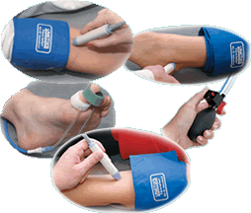
Fig. 5. Arm cuff, ankle cuff and toe cuff for sphygmomanometer

Peripheral arterial disease, or P.A.D., develops when your arteries become clogged with plaque—fatty deposits that limit blood flow to your legs. Just like clogged arteries in the heart, clogged arteries in the legs mean you are at risk for having a heart attack or stroke. Plaque buildup in the legs does not always cause symptoms, so many people can have P.A.D. and not know it. People who do experience symptoms, such as pain or cramping in the legs, often do not report them, believing they are a natural part of aging or due to another cause. In all, P.A.D. affects 8 to 12 million people in the United States, especially those over 50.

5. Conclusions
The ABI was calculated as the highest ankle systolic pressure divided by the highest brachial systolic pressure. For the purpose of this study, an ABI < 0.9 was taken as denoting the presence of PVD, those ≥ 0.9 and < 1.3 as normal, and ≥ 1.3 as evidence of medial wall calcification. The TBI was calculated as the toe systolic pressure divided by the brachial pressure. Synchronous TBI and ABI measurement scheme from both legs, great toes and arms are developed in this paper.
Measurement of ankle blood pressure is a simple method of assessing lower limb arterial blood supply. Measurement of toe blood pressure has been advocated as an alternative but it is technically more difficult. In this study, we try to build a synchronous TBI and ABI measurement scheme with six electronic sphygmomanometers. We utilize six general electronic sphygmomanometers adding with transmission interface to build the brachial and great toe blood pressure concurrent measurement equipment. Then, the ABI and TBI reports are automatic calculated and displayed by the embedded microprocessor. Also we adopt the RFID system to identify user identity and as a user login mechanism.

Acknowledgement
The clinical suggested measurement method by the Mackay Memorial Hospital Taitung Branch is gratefully acknowledged.

Sphygmomanometer
Personal Computer & Blood Pressure Recording
Upload ID &
Measurement data
Blood Pressure Received Interface
Blood Pressure Record Data Base
ID Matching
Personal Blood Pressure Record
ID Query
Record Report
Blood Pressure Trend Chart
User’s End
Server Terminal
USB&RS-232
Internet
Personal Blood Pressure Trend Chart
Community Blood Pressure Healthy Status

Figure 6. The Sphygmomanometer measurement and transmission block diagram

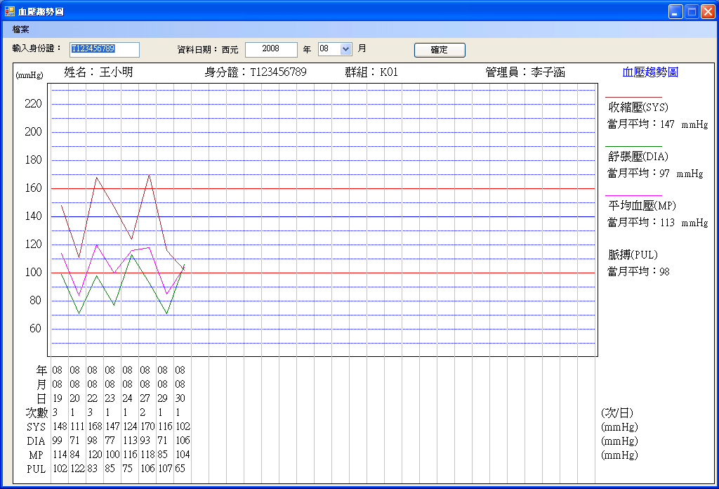
Figure 7. The blood pressure measurement trend graph

References
- Vale PR, McGrath MA. Peripheral vascular disease: a GP's guide to current management. Mod Med Australia 1996; August: 92-103.
- Vowden KR, Goulding V, Vowden P. Hand-held Doppler assessment for peripheral arterial disease. J Wound Care 1996; 5: 125-128.
- Mayfield JA, Reiber GF, Sanders LJ, Janisse D, Pogach LM. Preventive foot care in people with diabetes. Diabetes Care 1998;21: 2161-2179.
- Young MJ, Adams JE, Anderson GF, Boulton AJM, Cavanagh PR. Medial arterial calcification in the feet of diabetic patients and matched non-diabetic control subjects. Diabetologia 1993; 36: 615-621.
- Bland JM, Altman DG. Statistical methods for assessing agreement between two methods of clinical measurement. Lancet 1986; 8: 307-310.
- Bostrom K, Watson KE, Horn S, Wortham C, Herman IM, Demer LL. Bone morphogenetic protein expression in human atherosclerotic lesions. J Clinical Invest 1993; 91: 1800-1809.
- Goebel FD, Fuessel HS. Monckeberg's sclerosis after sympathetic denervation in diabetic and non-diabetic subjects. Diabetologia 1983; 24: 347-350.
- Brooks, B., et al.: "TBI or Not TBI: That Is the Question. Is It Better to Measure Toe Pressure than Ankle Pressure in Diabetic Patients?" Diabetic Medicine. 18(7):528-532, July 2001.
- Leskinen, Y., et al.: "The Prevalence of Peripheral Arterial Disease and Medial Arterial Calcification in Patients with Chronic Renal Failure: Requirement for Diagnostics," American Journal of Kidney Diseases. 40(3):472-479, September 2002.

