Nature of genetic variants in the BRCA1 and BRCA2 genes from breast cancer families in Taiwan

Yuan-Ping Lin ¹, Yi-Ling Chen¹, Hong-Tai Chang ² and Steven Shoei-Lung Li ^{1*}
¹ Institute of Biomedical Sciences, National Sun Yat-Sen University, Kaohsiung, Taiwan, ROC; ² Department of Surgery, Kaohsiung Veterans General Hospital, Kaohsiung, Taiwan, ROC; ³ Graduate Institute of Medicine, Kaohsiung Medical University, Kaohsiung, Taiwan, ROC
Received February 2, 2008
____________________________________________________________________
Abstract
A total of six families with two cases of breast cancer from southern Taiwan were identified, and the nature of genetic mutations was analyzed. One novel missense substitution of Gln1886Pro (A5885C), as well as one novel silent nucleotide change of A4806G at Thr1526, of the BRCA2 gene was found in a breast cancer family. Four missense substitutions of Pro871Leu (C2731T), Glu1038Gly (A3232G), Lys1183Arg (A3667G) and Ser1613Gly (A4956G), and two silent nucleotide changes of T2430C at Leu 771 and T4427C at Ser1436 of the BRCA1 gene, as well as one silent nucleotide change of T4035C at Val1296 of the BRCA2 gene, were identified in five other breast cancer families. All of the BRCA1 and BRCA2 variations identified thus far in Taiwan are compared with those reported from China. [Life Science Journal. 2009; 6(3): 93 – 97] (ISSN: 1097 – 8135).

Keywords: BRCA1, BRCA2, variants, breast cancer, Taiwan
________________________________________________________________________________________________

1. Introduction
Breast cancer is the most common malignancy among women. The BRCA1 (MIM#113705) [Miki et al., 1994] and BRCA2 (MIM#600185) [Wooster et al., 1995] genes are associated with inherited susceptibility to breast cancer, and the mutations in these two genes accounted for about 5-10% of all breast cancer cases [Szabo and King, 1997]. It is about twice as many have either a first-degree or a second-degree relative with breast cancer [Johnson et al., 1995]. The risk conferred by a family history of breast cancer has been assessed in both case-control and cohort studies, using volunteer and population-based samples, with generally consistent results [Pharoah et al., 1997]. Both males and females can inherit and transmit an autosomal dominant cancer predisposition. A male who inherits a cancer predisposition and shows no evidence of it can still pass the altered gene on to his sons and daughters.
BRCA1 and BRCA2 are involved in a myriad of functions within cells including homologous DNA repair, genomic stability, transcriptional regulation and cell cycle control [Gudmundsdottir and Ashworth, 2006]. Nearly 2,000 distinct mutations and sequence variations in BRCA1 and BRCA2 have already been described. _____________________________________________*Corresponding Author: Steven Shoei-Lung Li
e-mail: lissl@kmu.edu.tw
Approximately one in 400 to 800 individuals in the general population may carry a pathogenic mutation in BRCA1 and BRCA2 [Ford et al., 1995; Whittemore et al., 2004]. Our laboratory had previously reported the nature of mutations in the BRCA1 and BRCA2 genes from 18 breast cancer families in Taiwan [Li et al., 1999], and here we describe the nature of genetic variations in these two genes among six new breast cancer families in Taiwan.

2. Materials and methods
Samples
A total of six new families with two breast cancer cases from southern Taiwan were identified. The younger patients from each family were analyzed for the mutations at all exons and exon-intron junctions of the BRCA1 and BRCA2 genes, and the identified variations were confirmed from second patient and/or other members of each family.

DNA extraction/polymerase chain reaction
Genomics DNAs were isolated from peripheral blood lymphocytes by phenol/chloroform extraction method, and the DNA fragments were amplified using the previously published 48 and 58 PCR primer pairs for the BRCA1 and BRCA2 genes, respectively [Li et al., 1999].

Subcloning/DNA sequencing
The normal and variant alleles from the some heterozygotes were separately isolated by subcloning into the pUC19 vector (Fermentas, MD, USA). All fragments were sequenced on both strands. The sequencing reactions were performed with a dye-labeled terminators kit (Perkin-Elmer) using the cycle sequencing method. Both separation of DNA fragments and sequence analysis were performed in an ABI Prism 377 DNA sequencer.

3. Result
The clinical information of patients and the nature of genetic variations at the BRCA1 and BRCA2 genes from six new breast cancer families in Taiwan are summarized in Table 1 and Table 2.

Table 1. The clinical information of patients from six new breast cancer families in Taiwan
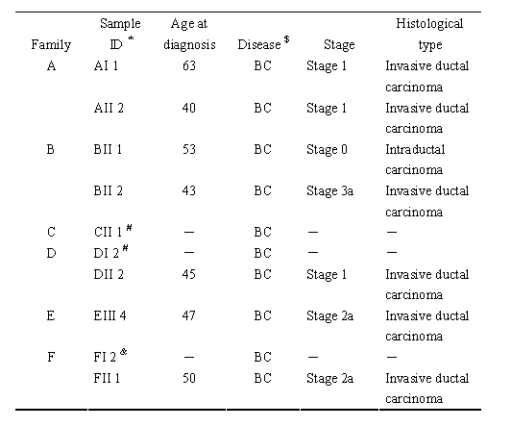
* Family: A－F; Generation: I－II; Age from oldest to youngest: 1－4. $ BC: breast cancer. # The patients were taken from external hospital, no information. & The patient was dead, no information.

Table 2. The nature of genetic variations at the BRCA1 and BRCA2 genes from 6 new breast cancer families in Taiwan
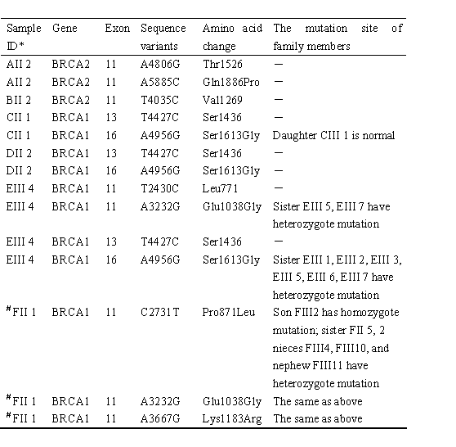
* Family: A－F; Generation: I－II; Age from oldest to youngest: 1－4. # These three BRCA1 mutations are on the same chromosome.

In the A family, the daughter had breast cancer diagnosed at age 40 years, and her mother had breast cancer diagnosed at age 63. Both patients had stage 1 invasive ductal carcinoma. One novel missense substitution of Gln1886Pro (A5885C), as well as one novel silent nucleotide change of A4806G at Thr1526, of the BRCA2 gene was found to be heterozygous. In the B family, the younger sister had stage 3a invasive ductal carcinoma diagnosed at age 43, and her elder sister had stage 0 intraductal carcinoma diagnosed at age 53. Only one previously reported silent nucleotide change of T4035C at Val1269 of the BRCA2 gene was detected. In the C family, the younger sister had breast cancer diagnosed at 51, and her elder sister also had breast cancer, but their pathological data were not available. In the D family, the daughter had stage 1 invasive ductal carcinoma diagnosed at age 45, and her mother also had breast cancer. In both C and D families, the previously reported missense substitution of Ser1613Gly (A4956G) and silent nucleotide change of T4427C at Ser1436 of the BRCA1 gene were found. However, the variant alleles in the C family are heterozygous, while those in the D family are either homozygous or hemizygous (loss of normal allele). In the E family, the patient had stage 2a invasive ductal carcinoma diagnosed at age 47, and her cousin also had breast cancer. Two previously reported missense substitutions of Glu1038Gly (A3232G) and Ser1613Gly (A4956G), as well as two silent nucleotide changes of T2430C at Leu771 and T4427C at Ser1436, of the BRCA1 gene were found to be heterozygous. Both normal and variant alleles were separately isolated by subcloning and sequenced to confirm these missense substitutions. In the F family, the daughter had stage 2a invasive ductal carcinoma diagnosed at age 50, and her mother died of breast cancer. Three previously reported missense substitutions of Pro871Leu (C2731T), Glu1038Gly (A3232G) and Lys1183Arg (A3667G) of the BRCA1 gene were found to be heterozygous, and different alleles were subcloned using the 5’ and 3’ primers to amplify these three variants (Figure 1). It is of interest that all three normal amino acids (Pro-Glu-Lys) are on one haplotype, whereas all three variant amino acids (Leu-Gly-Arg) are on another haplotype. A younger sister and two nieces were found to be heterozygous for these three missense substitutions, but thus far they are free of breast cancer.

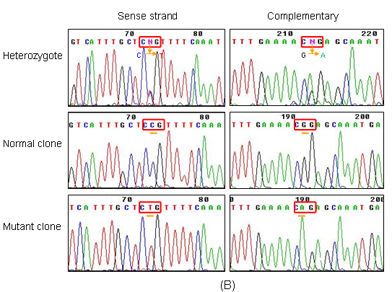
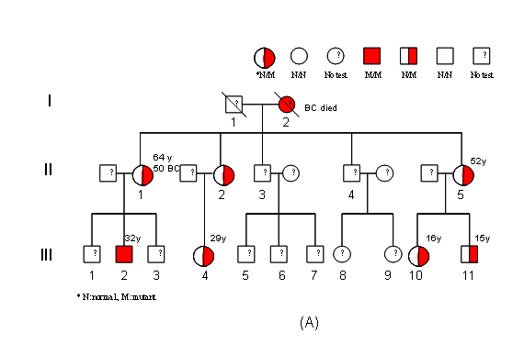

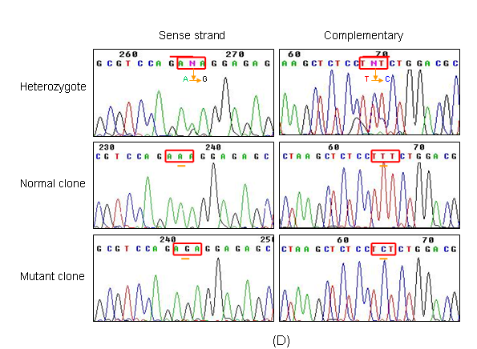
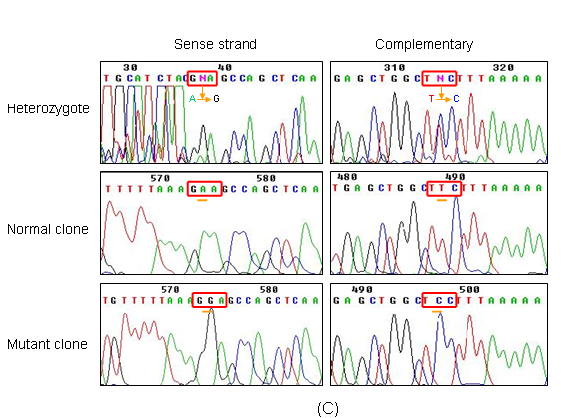

Figure 1. DNA sequence of exon 11 of the sense and complementary strand from a familial patient (designated as FII1) reveals three heterozygous mutation on the same allele. (A) The family F pedigree FII1 is a breast invasive ductal carcinoma patient and the detection of the (B) Pro871Leu (2731C→T), (C) Glu1038Gly (3232A→G) and (D) Lys1183Arg (3667A→G) missense mutation from exon 11 of BRCA1.

4. Discussion
Although the molecular nature of mutations in these two genes has been extensively analyzed among Caucasians, only some BRCA1 and BRCA2 mutations were reported among Asian populations (Table3), http://research.nhgri.nih.gov/bic/). In this investigation, the novel missense substitution of Gln1886Pro (A5885C) and silent nucleotide change of A4806G at Thr1526 of the BRCA2 gene were found in one of these six Taiwanese breast cancer families. The four missense substitutions of Pro871Leu, Glu1038Gly, Lys1183Arg and Ser1613Gly of BRCA1 gene which were detected in this investigation, as well as the substitutions of Pro346Ser of BRCA1 gene and Asn289His, His372Asn, Asn991Asp and Ile3412Val of BRCA2 gene, were previously reported among 18 Taiwanese breast cancer families [Li et al., 1999]. The pathological effect of these amino acid substitutions at BRCA1 and BRCA2 genes remain to be determined as either disease-associated mutations or benign polymorphisms (Table 4). Some of missense mutations at exon splicing enhancer sequences were shown to cause exon skipping, resulting in breast cancer [Fakenthal et al., 2002; Campos et al., 2003]. Among the 24 breast cancer families analyzed thus far in Taiwan, the same splicing mutation of BRCA1 gene observed in two unrelated families and three different deletions of BRCA2 gene are clearly associated with breast cancer [Li et al., 1999]. It may be noted that these breast cancer associated mutations deleted in Taiwan are different from those reported from Hong Kong [Khoo et al., 2000] and Tainjin (northern China) [Zhi et al., 2002].

Table 3. The BRCA1 and BRCA2 mutations were reported among Caucasians and Asian populations
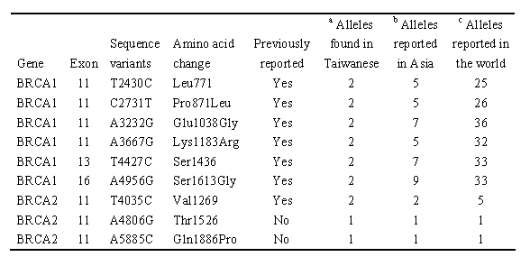
ª The mutations in Taiwanese from this study and Li, et al., (1999) ^{b} The mutations in Asia (including Taiwanese)
^{a, b, c} Breast cancer information core (Bic) http://research.nhgri.nih.gov/bic/

Table 4. The BRCA1 and BRCA2 amino acid mutation effect
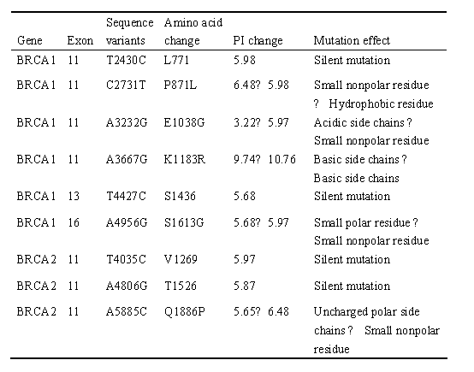

Acknowledgements
This investigation was supported by a grant from Kaohsiung Veterans General Hospital.

References
- Campos B, Díez O, Domènech M, Baena M, Balmaña J, Sanz J, Ramírez A, Alonso C, Baiget M. RNA analysis of eight BRCA1 and BRCA2 unclassified variants identified in breast/ovarian cancer families from Spain. Hum Mutat 2003; 22: 337.
- Fackenthal JD, Cartegni L, Krainer AR, Olopade OI. BRCA2 T2722R is a deleterious allele that causes exon skipping. Am J Hum Genet 2002; 71: 625-31.
- Ford D, Easton DF, Peto J. Estimates of the gene frequency of BRCA1 and its contribution to breast and ovarian cancer incidence. Am J Hum Genet 1995; 57: 1457-62.
- Gudmundsdottir K, Ashworth A. The roles of BRCA1 and BRCA2 and associated proteins in the maintenance of genomic stability. 2006; 25: 5864-74
- Johnson N, Lancaster T, Fuller A, Hodgson SV. The prevalence of a family history of cancer in general practice. Fam Pract 1995; 12: 287-9.
- Khoo US, Ngan HY, Cheung AN, Chan KY, Lu J, Chan VW, Lau S, Andrulis IL, Ozcelik H. Mutation analysis of BRCA1 and BRCA2 genes in Chinese ovarian cancer identifies 6 novel germline mutations. Hum Mutat 2000; 16: 88-9.
- Li SS, Tseng HM, Yang TP, Liu CH, Teng SJ, Huang HW, Chen LM, Kao HW, Chen JH, Tseng JN, Chen A, Hou MF, Huang TJ, Chang HT, Mok KT, Tsai JH. Molecular characterization of germline mutations in the BRCA1 and BRCA2 genes from breast cancer families in Taiwan. Hum Genet 1999; 104: 201-4.
- Miki Y, Swensen J, Shattuck-Eidens D, Futreal PA, Harshman K, Tavtigian S, Liu Q, Cochran C, Bennett LM, Ding W, Bell R, Rosenthal J, Hussey C, TranT, McClure M, Frye C, Hattier T, Phelps R, Haugen-Strano A, Katcher H, Yakumo K, Gholami Z, Shaffer D, Stone S, Bayer S, Wray C, Bogden R, Dayananth P, Ward J, Tonin P, Narod S, Bristow PK, Norris FH, Helvering L, Morrison P, Rosteck P, Lai M, Barrett JC, Lewis C, Neuhausen S, Cannon-Albright L, Goldgar D, Wiseman R, Kamb A, Skolnick MK. A strong candidate for the breast and ovarian cancer susceptibility gene BRCA1. Science 1994; 266: 66-71.
- Pharoah PD, Day NE, Duffy S, Easton DF, Ponder BA. Family history and the risk of breast cancer: a systematic review and meta-analysis. Int J Cancer 1997; 71: 800-9.
- Szabo CI, King MC. Population genetics of BRCA1 and BRCA2. Am J Hum Genet 1997; 60: 1013-20.
- Whittemore AS, Gong G, John EM, McGuire V, Li FP, Ostrow KL, Dicioccio R, Felberg A, West DW. Prevalence of BRCA1 mutation carriers among U.S. non-Hispanic Whites. Cancer Epidemiol Biomarkers Prev 2004; 13: 2078-83.
- Wooster R, Bignell G, Lancaster J, Swift S, Seal S, Mangion J, Collins N, Gregory S, Gumbs C, Micklem G. Identification of the breast cancer susceptibility gene BRCA2. Nature 1995; 378: 789-92.
- Zhi X, Szabo C, Chopin S, Suter N, Wang QS, Ostrander EA, Sinilnikova OM, Lenoir GM, Goldgar D, Shi YR. BRCA1 and BRCA2 sequence variants in Chinese breast cancer families. Hum mutat 2002; 20: 474.

