The artificial microRNA mediates GUS-GFP gene silencing using ath-miR169d precursor as backbone

Chong Liu^{1,2*}, Lan Zhang², Jie Sun^{1,2}, Yanzhong Luo², Ming-Bo Wang³, Yun-Liu Fan² , Lei Wang²
¹College of Agriculture, Key Laboratory of Oasis Ecology Agriculture of BINTUAN, Shihezi University, Shihezi, 832003, China; ^{2*}Biotechnology Research Institute/The National Key Facility for Crop Gene Resources and Genetic Improvement, Chinese Academy of Agricultural Sciences, Beijing 100081, China;

Received March 1 2009
_________________________________________________________________________________________
Abstract: Artificial microRNA (amiRNA) is becoming a powerful tool for silencing genes in plants, and several amiRNA vectors have recently been developed based on the natural precursor structures of ath-miR159a, ath-miR164b, ath-miR172a, ath-miR319a and osa-miR528. In this study we generated a simple amiRNA vector (pAmiR169d) based on the structure of Arabidopsis miR169d precursor (pre-miR169d). Two unique restriction sites were created inside the stem region of pre-miR169d, which allows for amiRNA sequences to be cloned as either ~80 bp synthetic oligonucleotides or PCR products. A β-glucuronidase (GUS):green florescent protein (GFP) fusion gene was efficiently silenced in transient assays using a pAmiR169d-derived construct targeting a GFP sequence. 5’RACE showed that the target GFP transcript was cleaved precisely at the expected position across nucleotides 10 and 11 of the artificial miRNA. Thus, pAmiR169d allows for both easy construction of artificial miRNA constructs and efficient silencing of target genes in plants. [Life Science Journal. 2009; 6(3): 86-95] (ISSN: 1097 – 8135)

Key words: miRNA, Hairpin RNA, artificial microRNA, silencing gene
___________________________________________________________________________________

1. Introduction
MicroRNAs (miRNAs) are 20-25 nt small RNAs that negatively regulate gene expression in plants and animals by base pairing with target mRNAs causing mRNA cleavage or translational repression. miRNAs are processed by RNaseIII-like enzyme Dicer from short hairpin-loop structures known as miRNA precursors (pre-miRNA) that are derived from longer primary miRNA transcripts (pri-miRNA). Single-stranded mature miRNAs are incorporated into RNA-induced silencing complex (RISC) containing Argonaute proteins to guide mRNA cleavage or translational repression. In animals, miRNAs are normally partially complementary to the target mRNA and cause translational arrest [1-6]. By contrast, in plants
Correspondence: Chong Liu
liu_chong02@163.com

miRNAs typically have few (zero to five) mismatches to their targets and induce transcript cleavage and subsequent degradation ^{[7]}.
Recent studies have shown that alteration of several nucleotides within a miRNA sequence does not affect its biogenesis as long as the initial base-pairing in the stem-loop structure of the precursor remain unaffected ^{[12]} . This makes it possible to modify natural miRNA sequences and generate amiRNA targeting any gene of interest ^{[13-15]} . The amiRNA technology was first used for silencing genes in human cell lines, and recently it was successfully employed to down-regulate individual genes or groups of endogenous genes in transgenic plants [16-17]. These plant amiRNAs are expressed from vectors derived from precursors of ath-miR159a, ath-miR164b, ath-miR172a, ath-miR319a and Osa-miR528. Genome-wide expression analyses in transgenic Arabidopsis thaliana shows that plant amiRNAs exhibit high sequence specificity similar to natural miRNAs [18] , so the amiRNA sequence can be easily optimized to knock down the expression of a single gene or several highly conserved genes without affecting the expression of other unrelated genes.
The MiR169 family is one of the highly conserved miRNA families in plants. The ath-miR169 family consists of 4 types from 14 chromosomal locations [19]. The size of ath-miR169 precursors ranges from 154 to 411 nt, of which miR169d was the shortest, comprising only 154 nt. In this study, we modified the precursor of ath-miR169d (accession number: MI0000987) into an artificial miRNA vector that allows for easy cloning of amiRNA sequences. Transient assays using the green florescent protein (GFP) gene as a target indicated that miR169d-based constructs are effective at conferring gene silencing in plants.

2 Materials and Methods
Vector construction
Artificial miRNA vector pAmiR169d

The backbone of pAmiR169d was directly assembled by annealing of the following eight sense and antisense overlapping oligonucleotides: oligo1 (5’- gatccGTATCATAGAGTCTTGCATGGA-3’),
oligo2 (5’- AAAATTAAAGaattcATTGAGCCAAGGATGACTTGCCGATGTT-3’),
oligo3 (5’- ATCAACAAATCTTAACTGATTTTGGTGTCCGGCAAGTTGACCTT-3’),
oligo4 (5’- GGCTCTGTCGACTTCTTTTCTTTTCAATGTCAAACTCTAGATATgagct -3’),
oligo5 (5’- cATATCTAGAGTTTGACATTGAA -3’),
oligo6 (5’- AAGAAAAGAAgtcgacAGAGCCAAGGTCAACTTGCCGGACACCA -3’),
oligo7 (5’- AAATCAGTTAAGGATTTGTTGATAACATCGGCAAGTCATCCTTGGC-3’)
and oligo8 (5’- TCAATCGAATTCTTTAATTTTTCCATGCAAGACTCTATGATACg -3’).

These oligonucleotides were phosphorylated and annealed as previously described ^{[2}0] , forming double-stranded DNA with 4 nt overhangs ready for ligation with BamHI and SacI-digested DNA.
To obtain a promoter-terminator cassette for expressing the amiRNA, the ~3000 bp 35S-GUS-Nos fragment was excised by HindIII/EcoRI digestion from pBI121 and gel-purified using a Qiagen agarose gel purification kit. The fragment was ligated to the binary vector pCAMBIA1303 at the Hind III/ EcoR I sites, generating the plasmid pCAMBIA-35S. To remove the EcoRI site from pCAMBIA-35S, the plasmid was digested with EcoR I, the sticky ends were blunted with T4 DNA polymerase, and the linearized DNA was self-ligated to form pCAMBIA-35SE. The annealed products (~100 ng) described above were cloned into pCAMBIA1303-35SE at the BamH I and SacI sites, generating the artificial miRNA vector pAmiR169d.

Artificial miRNA construct targeting GFP, pAmiR-gfp
The following four oligonucleotides were synthesized and annealed as described above to form an EcoRI-SalI fragment containing the AmiR-gfp sequence.

oligo9 (5’- aattcGATtTGTATTCCAaCTTGTGGCCGatgtTAT -3’),
oligo10 (5’- CAAcaAATCttAActGATTTTGGTGtccggccacaagatggaatacatGTcgac -3’), oligo11 (5’-AAAATCagTTaaGATTtgTTGATAacatCGGCCACAAGtTGGAATACAaATCg -3’), and oligo12 (5’ -tcgagtcgACatgtattccatcttgtggccggaCACC -3’).

The annealed products were ligated with pAmiR169d pre-digested with EcoRI and SalI, generating pAmiR-gfp, in which the ath-miR169d sequence was replaced by the sequence “tTGTATTCCAaCTTGTGGCCG”, targeting the GFP sequence in the GUS-GFP fusion gene of pCAMBIA-35SE.

Transient expression analysis in Nicotiana benthamiana leaves using Agrobacterium infiltration
pAmiR-gfp was introduced into Agrobacterium tumefaciens strain GV3101 by electroporation. pCAMBIA1303 was also introduced into GV3101 for use as control. Growing of wild-type Nicotiana benthamiana and Agrobacterium infiltration of N. benthamiana leaves were carried out as previously described ^{[21]}: 0.5 ml of Agrobacterium containing pAmiR-gfp was infiltrated into leaves of N. benthamiana that had been grown to 6-8 leaves in pots at ~24°C under a photoperiod of 16h light/8h dark. Similarly, 0.5 mL of Agrobacterium containing pCAMBIA1303 was infiltrated into leaves of N. benthamiana for use as a control. After infiltration, plants were kept under the constant conditions and grown for 48h. The infiltrated leaves (~150mg) were then excised from the plants and used for GUS expression and RNA analysis. GUS enzyme assays were measured as previously described ^{[2}1] .

RT-PCR analysis
Total RNA was isolated using the RNAgents Total RNA Isolation System (Promega). Portions (2μg) of total RNAs were used for the reverse transcription using the SuperScript First-Strand Synthesis System (Invitrogen). The following primers were used to detect the GUS-GFP transcript: forward 5′-CGATGCGGTCACTCATTA
C-3′ and reverse
5′-TTCACACGTGGTGGTGGTGGT-3′. The PCR reaction was denatured at 94 °C for 2 min, followed by 35 cycles of 20sec at 94 °C, 20sec at 53 °C and 20sec at 72 °C, with a final extension for 10 min at 72 °C. The predicted size for the PCR product is ~2600 bp. For use as loading reference, a ~441bp fragment of the tobacco Actin1 (GenBank: AB158612) RNA was amplified using the following primers: NAcfw,
5′-atgagcaagagttggagactg-3′ (forward) and NAcrv,
5′-CAATGGAAGGACCAGATTCAT-3′ (reverse). The reaction was denatured at 94 °C for 2 min, followed by 25 cycles of 20sec at 94 °C, 20sec at 53 °C and 40sec at 72 °C, with a final extension for 10 min at 72 °C.

5’ RACE (rapid amplification of cDNA ends)
The 5’RACE assay was performed using version 2.0 of the 5’RACE System available from GIBCO BRL Life Technologies following the manufacturer’s instructions. Basically, 2μg of total RNA was reverse-transcribed using a GFP-specific primer (GFP RV:5’ TTCACACGTGGTGGTGGTGGT). The resulting cDNA was purified to remove unincorporated dNTPs and GFP RV primer and treated with TdT (Terminal deoxynucleotidyl transferase) to add homopolymeric C tails to the 3’ end. The tailed cDNA was then amplified by PCR using the anchor primer T7-G (5’ TAATACGACTCACTATAGGGGGGGGGG) and GFP RV. The reaction was denatured at 94 °C for 2 min, followed by 30 cycles of 20sec at 94 °C, 20sec at 65 °C and 45sec at 72 °C, with a final extension for 10 min at 72 °C. Nested PCR was performed using a T7 primer
(5’TAATACGACTCACTATAGGG) and GFP RV2 (5’ GTGGTGGTGGTGGCTAGCTTT). The reaction was denatured at 94 °C for 2 min, followed by 30 cycles of 20sec at 94 °C, 20sec at 55 °C and 45sec at 72 °C, with a final extension for 10 min at 72 °C. The PCR products were separated in 1% agarose gel. The ~300 bp DNA fragment was excised and purified using a Qiagen agarose gel purification kit. The sample was ligated to pGEM-T vector, and five individual clones were selected for sequencing.
2. Results
Construction of the artificial microRNA vector pAmiR169d
The construction of artificial microRNA vectors in the previous reports often involved cloning of relatively long DNA fragments generated by multiple PCRs. To select for a better amiRNA backbone, we screened all Arabidopsis miRNA precursors in the miRBase/Rfam database. We found that the ath-miR169d precursor (pre-miR169d) consists of only 154 nt and forms a simple stem-loop (Fig.1A), and the sequences can be easily modified into two restriction endonuclease sites for EcoRI and Sal I in the stem. Furthermore, ath-miR169d is expressed in several Arabidopsis tissues including leaves, roots and panicles, indicating that pre-miR169d can be efficiently processed by Dicer in these tissues.

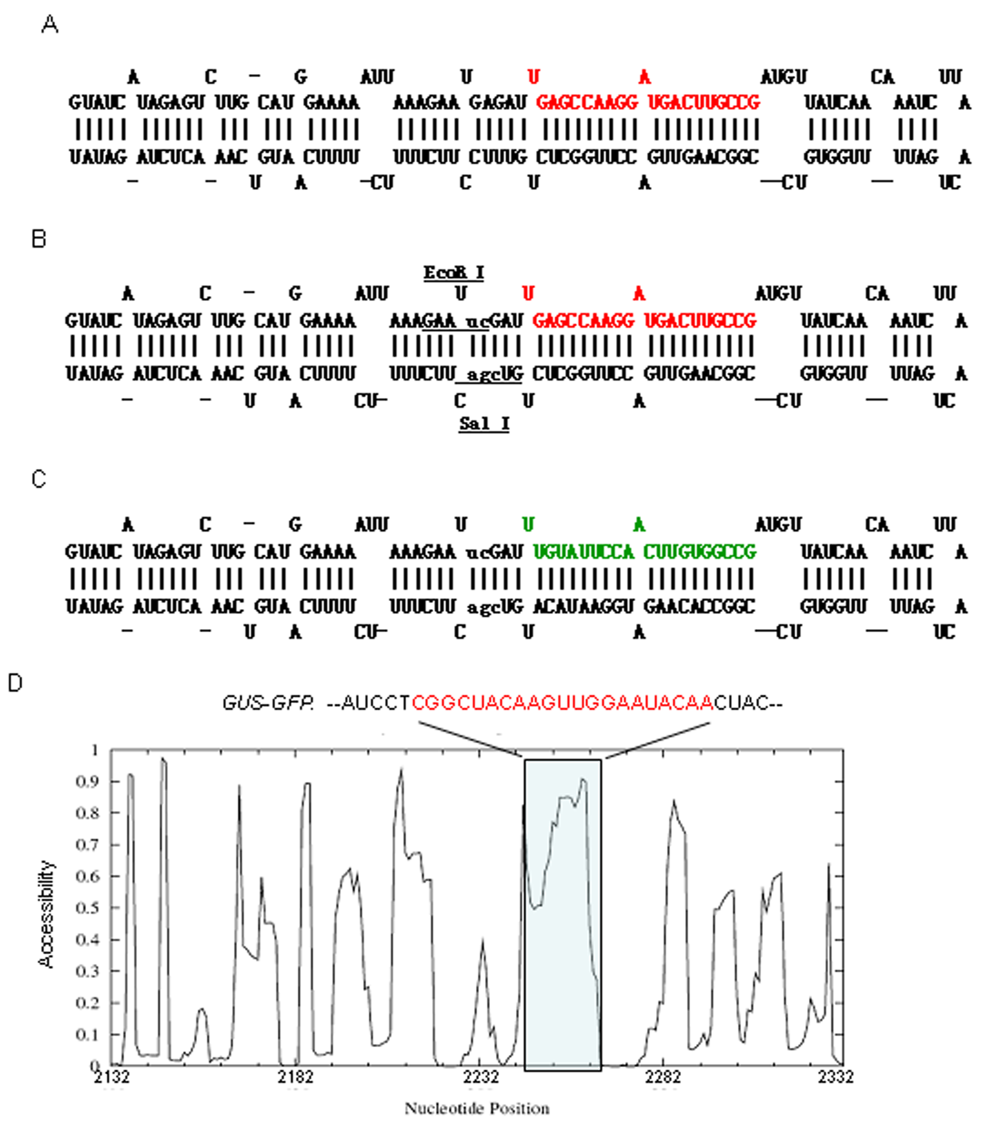
Figure 1: Predicted structure of the native Ath-miR169d precursor (A), the modified amiR169d precursor (B) and the GFP artificial miRNA amiR-gfp (C). The ath-miR169d and amiR-gfp sequences are shown in red and green, respectively, and the modified nucleotides in the stem-loop are shown in lowercase. D. Target accessibility profiling by Sfold for part of the GUS-GFP sequence (from nt. 2132 to nt. 2332) containing the region targeted by amiR-gfp. Note that the amiR-gfp–binding site (shaded) is highly accessible for small RNA.

The modified ath-miR169d precursor sequence was directly assembled by annealing of eight synthetic oligonucleotides, in which five nucleotides of the original pre-miR169d sequence were altered to produce the EcoRI and SalI sites but with the secondary structure of pre-miR169d being maintained (Fig. 1B). The anneal products had 4 nt overhangs in each ends, matching the BamHI and SacI sites, respectively. To clone this pre-miR169d sequence into an expression vector suitable for Agrobacterium-mediated plant transformation, the 35S-GUS-Nos cassette from pBI121 was inserted into pCAMBIA1303, generating pCAMBIA-35S (Fig. 2).

The EcoR I site of pCAMBIA-35S was subsequently removed giving rise to the intermediate plasmid pCAMBIA-35SE. The modified ath-miR169d precursor was then inserted at the BamHI and SacI sites downstream of the 35S promoter in pCAMBIA-35SE, forming the pAmiR169d vector (Fig. 2). The EcoR I and Sal I sites are unique in pAmiR169d, and the sequence between the two restriction sites, including the miRNA and miRNA* parts, is about 80 bp. Therefore, artificial miRNA sequences can be conveniently cloned into the vector either as annealed synthetic oligonucleotides or as PCR fragments.

pAmiR-gfp efficiently down regulates GFP expression at mRNA and protein levels
To validate the efficacy of pAmiR169d, we chose the fusion reporter gene GUS-GFP from the pCAMBIA1303 vector as a target. The artificial miRNA targeting GFP, amiR-gfp, was designed based on the characteristics of nucleotide compositions of natural Arabidopsis miRNAs, 5’ instability of miRNA/miRNA* duplexes, and target accessibility. The sequence, 5’-UUGUAUUCCAaCUUGUGGCCG-3’, contains a uridine residue at position 1 and an adenine residue at position 10, with a GC content of 48% (Fig 1C); all of these features are overrepresented in endogenous miRNAs [22]. This sequence also ensures the amiRNA/amiRNA* duplex to have 5’ instability allowing preferential loading of the amiRNA strand into RISC [26]. The structural accessibility to the GFP complementary sequence by amiR-gfp was examined using Sfold [23-25], which showed that amiR-gfp has high accessibility to its complementary target sequence, with nucleotides 10 and 11 the highest having the highest accessibility (Fig 1D).
Agrobacterium infiltration-mediated transient assays have been widely used to study transgene expression and transgene-induced silencing in plants [21,26]. We therefore chose Agrobacterium infiltration to investigate the silencing effect of pAmiR-gfp on the target GUS-GFP gene that is present in the same vector. As the GUS sequence is transcriptionally fused with the GFP sequence, targeting of the GFP sequence should result in the silencing of both the GFP and GUS genes. We therefore examined the silencing effect by measuring the GUS activity. As shown in Figure 3A, N. benthamiana leaves infiltrated with pAmiR-gfp expressed significantly lower levels of GUS activity than those infiltrated with the control vector pCAMBA1303; GUS activity was reduced by around 50%. RT-PCR of RNA isolated from infiltrated leaves showed a dramatic reduction in GUS-GFP mRNA levels in pAmiR-gfp-infiltrated leaves in comparison with pCAMBIA1303-infiltrated tissues (Fig. 3B). These results indicated that amiR-gfp was expressed and properly processed from pAmiR-gfp, resulting in efficient GFP silencing in N. benthamiana cells.

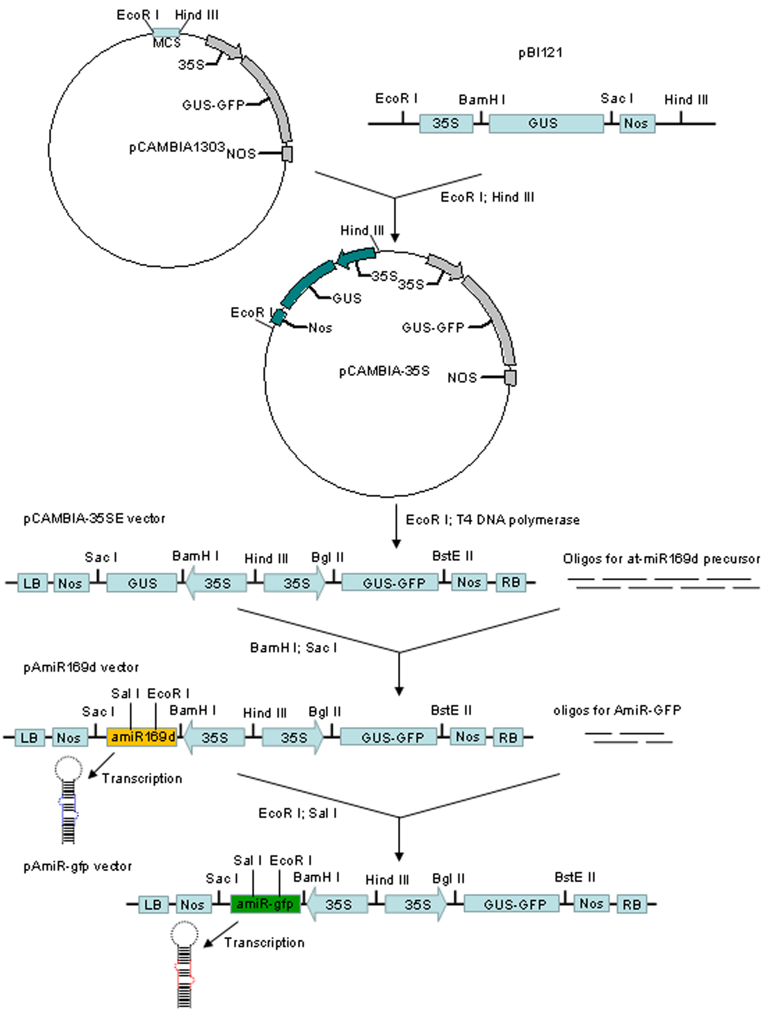
Figure 2: Flow chat for the construction of pAmiR169d and pAmiR-gfp. The 35S-GUS-Nos cassette is excised from pBI121 with EcoR I and Hind III digestion, and inserted into pCAMBIA1303, giving rise to pCAMBIA-35S. The EcoR I site in pCAMBIA-35S is abolished by treatment with T4 DNA polymerase to generate pCAMBIA-35SE. The Ath-miR169d precursor sequence was then assembled from 8 overlapping oligonucleotides by annealing and inserted into pCAMBIA-35SE at the BamHI/SacI site, forming the amiRNA vector pAmiR169d. To make the AmiR-gfp construct, 4 overlapping oligonucleotides were annealed and inserted into the SalI/EcoRI sites in pAmiR169d.

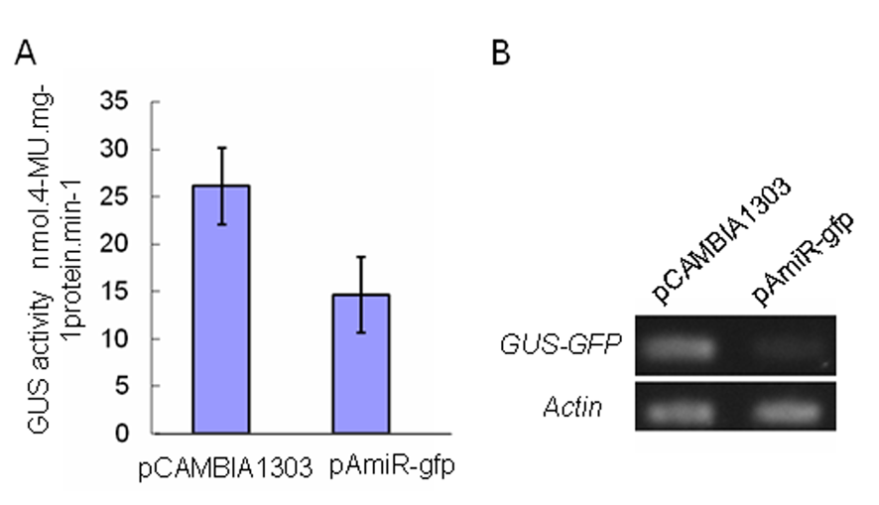
Figure 3. pAmiR-gfp induces target gene silencing in Agrobacterium-infiltrated N. benthamiana leaves. A. Analysis of GUS activity. B. Semi-quantitative RT-PCR of GUS-GFP transcripts.

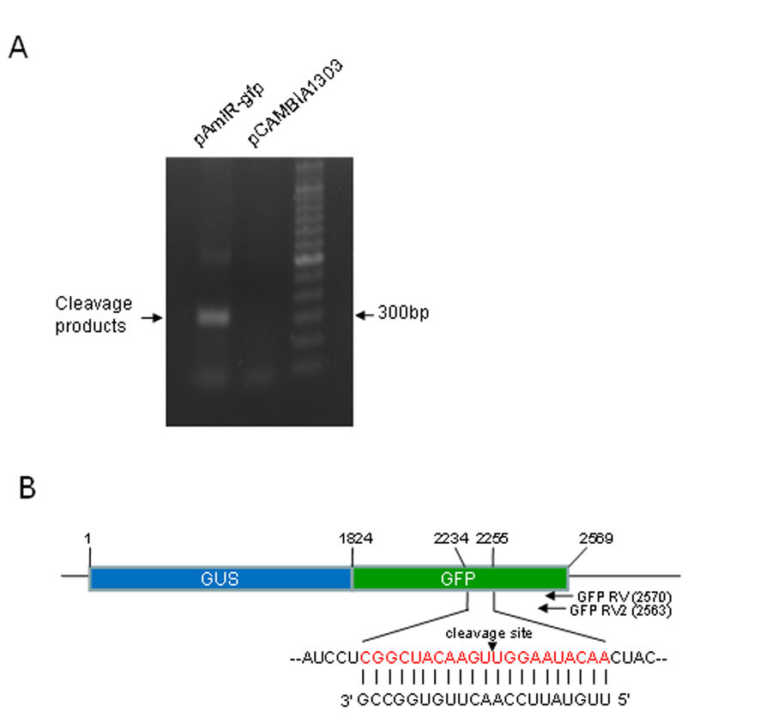
Figure 4. AmiR-gfp induces cleavage of the target GUS-GFP transcript at the predicted nucleotide position. A: 5’RACE-PCR. A distinct band of about 320 bp is present in the sample infiltrated with pAmiR-gfp but not the infiltrated with the control plasmid pCAMBIA1303. B: Target cleavage site by amiR-gfp as determined by sequencing of 5 RACE clones. The 21 nt target sequence is shown in red, and the cleavage site is indicated by an arrow head. The size of the cleavage fragment is predicted to be 317bp (from the cleavage site at nt 2245 to the 5’ end of the reverse primer GFP RV2 at 2563).

AmiR-gfp directs precise cleavage of GUS-GFP mRNA at the predicted position
To confirm proper processing and functioning of amiR-gfp, 5’ RACE-PCR was performed to detect the cleavage site in the target GUS-GFP RNA. Cleavage of GUS-GFP transcript by amiR-gfp at the predicted site should generate a 317 bp RACE-PCR fragment (Fig 4B). As shown in Figure 4A, a distinct band of about 320 bp was amplified from the sample infiltrated with pAmiR-gfp, but not from the pCAMBIA1303-infiltrated sample. This band was gel-purified and ligated into the pGEM T vector. Five clones were sequenced, and the result showed that this DNA fragment was the expected 317 bp cleavage product from the GUS-GFP transcript. All five clones had the same 5’ terminal nucleotide corresponding to the position located between the two nucleotides complementary to nucleotides 10 and 11 of amiR-GFP (Fig. 4B). This was consistent with miRNA- and siRNA-guided cleavage in plants that typically occurs across nucleotides 10 and 11 of the miRNA and siRNA sequences, and that even 24nt siRNAs also cleave at position 10 ^{[27]}.

Discussion
In this study, the Arabidopsis miR169d precursor was successfully used as the backbone for the expression of artificial miRNAs in plants. Preparation of amiRNA constructs in the previous reports using backbones from ath-miR159a, ath-miR164b, ath-miR172a, ath-miR319a and Osa-miR528 all involves cloning of longer DNA fragments that are normally generated through multiple PCRs ^{[13,16-17,26]}. With the pre-miR169d-based vector, artificial miRNA sequences can be directly synthesized as ~80 bp oligonucleotides and cloned by a single step ligation into the unique restrictions sites EcoR I and Sal I created in the middle of the stem. This should allow for rapid and high-throughput preparation of amiRNA constructs for silencing genes in plants. The GFP-targeting amiRNA construct, amiR169d-gfp, conferred efficient silencing to the GUS-GFP fusion transgene in transient assays, and this silencing was correlated with precise cleavage of the GUS-GFP transcript at the predicted position across nucleotides 10 and 11 of the designed GFP amiRNA. This suggests that amiRNAs expressed from the pAmiR169d vector is accurately processed by Dicer and efficiently loaded into RISC, indicating that the introduction of the restriction sites into the pre-miR169d stem did not affect Dicer processing. Creating restriction sites into pre-miRNA stems could therefore be used for constructing amiRNA vectors from on other miRNA precursors to allow for easy cloning of amiRNA sequences.
In order to design an effective artificial microRNA, we examined the sequence characteristics of all known Arabidopsis miRNAs and the base-pairing feature between the miRNAs and their targets. Initially, candidate 21-mer sequences were picked from the whole length of the reverse complements of the target GFP transcript, which had a nucleotide A at position 10 and displayed 5’instability (higher AU content at the 5’ end and higher GC content at the 3’ end around position 19). These candidate sequences were further screened based on the statistic analysis of base mismatches between microRNAs and their targets, which showed that mismatches occur frequently at position 1, 2 or 21, but almost never occur at position 3, 4, 16 or 17, and G:U pairing was the most frequent mismatch. Furthermore, target accessibility by the amiRNA was analysed using the Sfold program [23]. The finally chosen amiR-gfp sequence, 5’-UUGUAUUCCAaCUUGUGGCCG3’, therefore conforms with both the sequence features of microRNAs and their targeting rules. The transient assay data demonstrated that this amiR-gfp directed efficient and precise cleavage of the GUS-GFP mRNA at the predicted amiR-gfp recognition site, suggesting that this amiRNA selection pipeline is potentially applicable to the design of other amiRNAs.

Acknowledgments
This work was supported by the National Key Basic Research Program [Grant Numbers 2006CB101601]; and National High Technology Research and Development Program of China [Grant Number 2007AA10Z147].

References:
[1] Margis R, Fusaro AF, Smith NA et al (2006) The evolution and diversification of Dicers in plants. FEBS Lett 580:2242-2250.
[2]Hutvagne G. (2005) Small RNA asymmetry in RNAi: function in RISC assembly and gene regulation.Hutvagne. FEBS Lett 579:5850-5857.
[3] Brodersen P, Voinnet O. (2006) The diversity of RNA silencing pathways in plants. Trends Genetics 22:268-280.
[4] Allen E, Xie Z, Gustafson AM et al (2006) microRNA-directed phasing during trans-acting siRNA biogenesis in plants. Cell 121:207-221.
[5] Blevins T, Rajeswaran R, Shivaprasad P-V et al (2006) Four plant Dicers mediate viral small RNA biogenesis and DNA virus induced silencing. Nucleic Acids Res 34:6233–6246.
[6] Dang Long, Rosalind Lee, Peter Williams et al (2005) Principles of microRNA-target recognition. PLoS Biol 3:e85.
[7] Cesar Llave, Kristin D. Kasschau et al (2002) Endogenous and silencing-associated small RNAs in plants. Plant Cell 14:1605–1619.
[8] Mansoor S, Amin I, Hussain M et al (2006) Engineering novel traits in plants through RNA interference. Trends Plant Sci 11:559-565.
[9] Wesley SV, Helliwell CA, Smith NA et al (2001) Construct design for efficient, effective and high-throughput gene silencing in plants. Plant J 27:581–590.
[10] Chuang C-F, Meyerowitz E-M. (2000) Specific and heritable genetic interference by double-stranded RNA in Arabidopsis thaliana. Proc Natl Acad Sci USA 97:4985–4990.
[11] Xu P, Zhang Y-J, Kang L et al (2006) Computational Estimation and Experimental Verification of Off-Target Silencing during Posttranscriptional Gene Silencing in Plants. Plant Physiol 142:429–440.
[12] Vaucheret Hervé, Vazquez F, Patrice Crété et al (2004) The action of ARGONAUTE1 in the miRNA pathway and its regulation by the miRNA pathway are crucial for plant development. Genes Dev 18:1187-1197.
[13] Niu Q-W-, Lin S-S, Reyes J-L et al (2006) Expression of artificial microRNAs in transgenic Arabidopsis thaliana confers virus resistance. Nat Biotechnol 11:1420-1428.
[14] Zeng Y, Wagner EJ, Cullen BR. (2002) Both natural and designed microRNAs can inhibit the expression of cognate mRNAs when expressed in human cells. Mol Cell 9:1327-1333.
[15] Parizotto E-A, Dunoyer P, Rahm N et al (2004) In vivo investigation of the transcription, processing, endonucleolytic activity, and functional relevance of the spatial distribution of a plant miRNA. Genes Dev 18:2237-2242.
[16] Warthmann N, Chen H, Ossowski S et al (2008) Highly specific gene silencing by artificial miRNAs in rice. PLoS ONE 3:e1829.
[17] Schwab R, Ossowski S, Riester M et al (2006) Highly Specific Gene Silencing by Artificial MicroRNAs in Arabidopsis. Plant Cell 18:1121-1133.
[18] Schwab R, Palatnik JF, Riester M et al (2005) Specific effects of microRNAs on the plant transcriptome. Dev Cell 8:517-527.
[19] Wang L, Wang M-B, Tu J-X, Helliwell C-A et al (2007) Cloning and haracterization of microRNAs from Brassica napus. FEBS Letters 581:3848–3856
[20] Wang L, Zhao J, Fan Y-L (2002) Cloning and function analysis of ABP9 protein which specifically binds toABRE2 motif of maize Cat1 gene. Chinese Science Bulletin 47（22）：1871-1875
[21] Wang L, Luo Y-Z, Zhang L et al (2008) Rolling circle amplification-mediated hairpin RNA (RMHR) library construction in plants. Nucleic Acids Res. 22: e149
[22] Ossowski S, Schwab R, Weigel D (2007) Gene silencing in plants using artificial microRNAs and other small RNAs. the plant cell 53:674–690.
[23] Ding Y, Chan C-Y, Charles E, Lawrence (2004) Sfold web server for statistical folding and rational design of nucleic acids. Nucleic Acids Res 32:w135-w141.
[24] Long D, Lee R, Williams P et al (2007) Potent effect of target structure on microRNA function. nature structural and molecularbiology 4:1038-1226.
[25] Kertesz M, Iovino N, Unnerstall U et al (2007) The role of site accessibility in microRNA target recognition. Nature Genetics 39:1278-1285.
[26] Khraiwesh B, Ossowski S, Weigel D et al (2008) Specific gene silencing by artificial microRNAs in Physcomitrella patens: An alternative to targeted gene knockouts. Plant Physiology 148:684–693.
[27] Wang MB, Helliwell CA, Wu LM et al（2008）Hairpin RNAs derived from RNA polymerase II and polymerase III promoter-directed transgenes are processed differently in plants. RNA 14(5):903-13

