Study of Biomaterial Based on Saving Energy Technology of Rapid Thermal Annealing for Si⁺-implanted SiO₂ Thin Film

Jen-Hwan Tsai¹, Chih-Hsiung Liao^{2*} and Hsien-Chiao Teng³
¹Department of Mathematics and Physics, Air Force Academy, Kangshan, Kaohsiung, 820, Taiwan, R.O.C.; ²Department of Physics, Chinese Military Academy, Fengshan, Kaohsiung, 830, Taiwan, R.O.C.; ³Department of Electrical Engineering, Chinese Military Academy, Fengshan, Kaohsiung, 830, Taiwan, R.O.C.

Received March 20, 2009
______________________________________________________________________________________________
Abstract
Varying with the heating rate of rapid thermal annealing (RTA), room-temperature photoluminescence (PL) could be observed in the 310¹⁶ cm⁻² Si⁺-implanted 400-nm-thick SiO₂ films after RTA at 1150 ºC in dry nitrogen and the respective PL peak was located in the range between blue band to near-infrared band. At the heating rate of 100 ºC/s, the PL peaks was shifted from 2.6 eV to 1.7 eV for the isothermal RTA durations from 5 seconds to 20 seconds and no obvious shift was further found since the RTA duration of 20 seconds. However, after the heating rate was decreasing to 25 ºC/s, no significant shift of PL peak could be seen in the films after the isothermal RTA for the durations ≥1 second. Like the shift of PL peak, the average rate of the FTIR peak change at ~1100 cm⁻¹, reflecting the repaired condition of SiO₂ structure, from the as-implanted films after RTA for the durations ≤ 20 seconds were quicker than those for the durations ≥ 20 seconds at the heating rate of 100 ºC/s, and near a constant for the RTA durations ≥ 1 second at that of 25 ºC/s. The above PL and FTIR phenomena should be attributed to the Si⁺ re-crystals and the improvement of the broken structure in the RTA-treated as-implanted SiO₂ films In comparison with the isothermal conventional thermal annealing method, the RTA method saves vast dosages of Si⁺-implantation, thermal budget and the respective electrical energy under obtaining the same results. [Life Science Journal. 2009; 6(3): 68 – 73] (ISSN: 1097 – 8135)

Keywords: photoluminescence, Si⁺-implanted SiO₂ films, rapid thermal annealing, FTIR spectra, conventional thermal annealing
_______________________________________________________________________________________________

1 Introduction
Thermal annealing is a treatment that can recombine sample’s broken structure and let the structure be stable. For a Si⁺-implanted SiO₂ film, the stable structure after annealing treatment is that these implanted ions are re-crystallized and embedded in the groups of SiO₂ bonds. Hence, the method of silicon-implantation into SiO₂ films on Si substrate with subsequent thermal annealing treatment produces silicon crystals in a SiO₂ film and has the effect of luminescence emission. The emission bands between 1.5 and 2.6 eV have been observed by several research groups from Si⁺-implanted SiO₂ films after ≥ 1000 °C conventional thermal annealing (CTA) in vacuum, Ar or N_{2.}^{[1-9]} However, in those reports^{[4-9]}, the flux of implanted silicon was relatively high (≥1x 10¹⁷ cm⁻²) and the whole annealing process required several hours. The enormous consumption of electric and thermal energy for these CTA tests seriously goes against the tacit understanding of saving energy and environmental protection. Recently, single-wafer rapid thermal annealing (RTA), which has become indispensable in the present-day manufacture of ————————————————————*Corresponding Author Chih-Hsiung Liao, Ph.D.
liao550226@yahoo.com.tw integrated circuits, has replaced CTA (batch furnace) to satisfy device and production requirements for low manufacturing cost and low energy consumption. We have demonstrated that the light emission can be red-shifted by RTA method with the dose of Si⁺ implantation ≤3x10¹⁶ cm⁻² and the shorter whole annealing-time ≤30 minutes.^{[10~12]} By controlling the flux of the Si⁺-implantation between 4x10¹⁵ and 3x10¹⁶ cm⁻², the emission bands between 1.7 and 2.2 eV have been observed by us from the Si⁺-implanted 400 nm-thick SiO₂ film after RTA at the range between 950 and 1150 ºC for the durations between 5 and 20 seconds in N₂. The PL peak position from the above as-implanted SiO₂ films could shift with the varying of the Si⁺ concentration in oxide matrices and the thermal annealing temperature and duration, and is independent of hydrogen-related bonds. Because only the PL band due to the silicon nanocrystals in oxide matrix (nc-Si) has above properties, these emissions should be attributed to the Si⁺ re-crystal after RTA^{[4-9]}. Otherwise, the above 1.7 eV PL peak (near-infrared band) can also be produced by us from the 3x10¹⁶ cm⁻² Si⁺-implanted 400 nm SiO₂ film after CTA in N₂ for ~12 hours and the main difference between RTA and CTA method is the heating rate in additional to the thermal annealing duration. Thus, the correlation of Si⁺ re-crystal in Si⁺-implanted SiO₂ films with the heating rate of the annealing treatments is necessary to study.
In this study, the Si⁺-implanted 400-nm-thick SiO₂ films with the fixed flux of 3x10¹⁶ cm⁻² after RTA at 1150 ºC in 50 mbar dry nitrogen were continuously used as samples. As the RTA heating rate increasing from 25 to 100 ºC/s, the PL peaks shifted from blue-light of 2.6 eV to original light of 2.0 eV were observed from the film after RTA for the duration of 1 seconds and from 2.0 eV to near-infrared light of 1.7 eV after keeping the RTA duration at 20 seconds. In addition, when the heating rate was less than 10 ºC/s and the laser power was kept at ~5 mW, no PL sign could be seen in the 3x10¹⁶ cm⁻² Si⁺-implanted 400-nm-thick SiO₂ films after the isothermal RTA. On the other hand, fixing the heating rate at 100 ºC/s and varying the isothermal RTA duration from 1 to 20 seconds, the PL peaks shifted from ~2.6 eV to ~1.7 eV and no obvious shift of PL peak was found for the RTA duration greater than 20 seconds in the above as-implanted Si⁺-implanted films. Similar, the respective FTIR-peak positions around 1100 cm⁻¹ from the as-implanted RTA-treated samples shifted to higher wave-numbers with the increase of the duration and their rates for the RTA durations from 1 second to 20 seconds were faster than those for the durations ≥ 20 seconds. Furthermore, after the heating rate decreasing to 25 ºC/s, no obvious shift of PL peak from 2.0 eV was found and, in the respective FTIR spectra, the rates of the peak position shifting to higher wave-number were not obviously vary since the RTA durations ≥1 second. These implies that the shift of PL and FTIR peaks related closely to the varying of silicon cluster’s size after RTA was determined by the RTA heating rate for a given RTA temperature and duration. The heating rate shall make decision of the active-time of the Si⁺ re-crystal in the as-implanted films and so the Si⁺ re-crystal plays an important role for the repairing of the Si-O bonds in the films^{[13, 14]}, In final, isothermal RTA and CTA have the same effect of PL mechanism production and Si-O bonds repair in a Si⁺-implanted oxide matrix. But if the saves of Si⁺-implanted dosage, thermal annealing budget and its respective electrical energy are also compared, the RTA method is much superior to the CTA method.

2 Experimental Procedure
Samples were prepared by implantation of ²⁸Si⁺ onto a 400-nm-thick SiO₂ layer which was thermally grown on (100)-oriented p-doped Si substrates. The fluences of the Si⁺-implantation was 3x10¹⁶ cm⁻². The temperature of the samples during ion implantation was kept at liquid nitrogen temperature. The acceleration energy of ~ 160 keV was selected so that the maximum concentration was at a depth of ~250 nm below the surface and the standard deviation of the implanted region was 60 nm. In order to clarify the PL mechanism in the as-implanted films, the respective layers of 100 nm, 200 nm, and 250 nm were etched off from the top of the rapid-thermal-annealed films. The layer thickness removed by HF(10%) was monitored by ellipsometer. These samples were subjected to RTA system at substrate temperature of 1150 ºC under dry N₂. Furthermore, the heating rates were 25, 50 and 100 ºC /s, respectively and cooling rate of about 100 ºC /min were used for the RTA system. To detect the PL spectra, a He-Cd laser (3.8 eV) was used as the excitation and the lock-in technique were employed to improve the signal-to-noise ratio, in conjunction with a monochromator and cooled photomultiplier tube. Moreover, FTIR measurements were performed to examine the Si-O-Si bonding quality of the SiO₂ films in the samples according to the absorption peak position at ~1100 cm⁻¹ in the spectra. The absorption peak position was assigned to the anti-symmetric stretching mode (TO₃ mode) of Si-O-Si units^{[14]}. With the reference being the same silicon plate as the sample, the spectra were measured at room temperature in N₂ atmosphere at a 1 cm⁻¹ resolution with 100 scan accumulations.

3 Results and Discussion
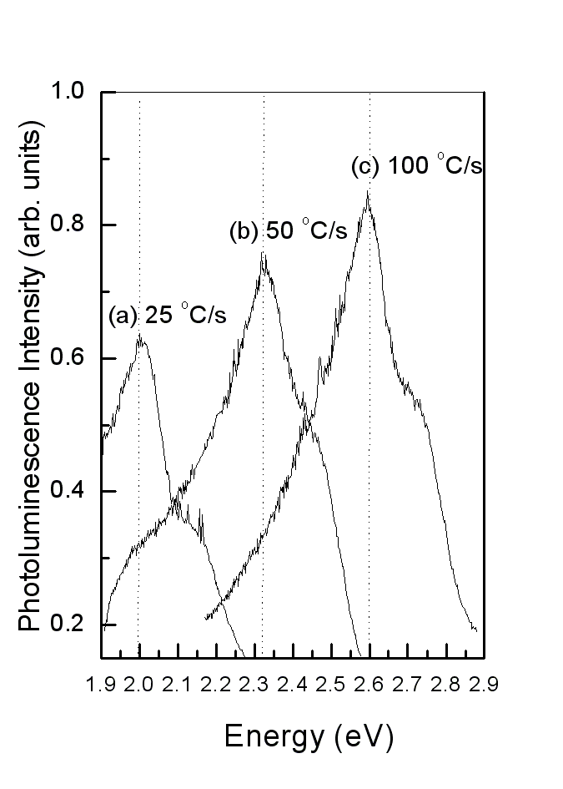
When a He-Cd laser (3.8 eV) was used as the excitation source to detect the PL spectra and operate at a power of ~5 mW, no PL sign could be found in the 3x10¹⁶ cm⁻² Si⁺-implanted 400-nm-thick SiO₂ films without RTA. Like a conventional thermal annealing (CTA), RTA includes three procedures as heating, holding, and cooling and the holding time in RTA calls RTA duration. The effect of heating rate on luminescence is presented in Fig.1 where three PL spectra of the 3x10¹⁶ cm⁻² Si⁺-implanted 400-nm-thick SiO₂ films after RTA at 1150 ºC for 1 second are shown. The PL spectrum with a peak at ~2.0 eV from the as-implanted films has the heating rate of 25 ºC/s and those with peaks at ~2.3 eV and ~2.6 eV from the films have the heating rate of 50 ºC/s and 100 ºC/s, respectively. The results shown in the figure imply that no PL sign could be seen in the films at the heating rate of RTA <10 ºC/s, then, a significant original light of 2.0 eV was not observed until the heating rate at 25 ºC/s and, finally, the PL peak shifted progressively from 2.3 eV to blue-light of 2.6 eV as the heating rate increased from 50 ºC/s to 100 ºC/s.

Figure 1. Room temperature PL spectra of Si⁺-implanted SiO₂ films after 1150 ºC RTA for 1 seconds at the heating rate of (a) 25 ºC/s, (b) 50 ºC/s, and(c) 100 ºC/s.
Furthermore, Figure 2 shows three PL spectra of the as-implanted 400-nm-thick SiO₂ films after the same RTA as above but for the duration of 20 seconds. As shown in this figure, when the RTA duration was increasing and kept at 20 seconds, a red shift of the PL peak from 2.0 eV to 1.7 eV would be found in the films as the heating rate of RTA was increasing from 25 ºC/s to 100 ºC/s. Hence, the two figures both imply that, for a given RTA duration and temperature, the bands of PL-peak in the as-implanted films were adjusted by the heating rate of RTA.
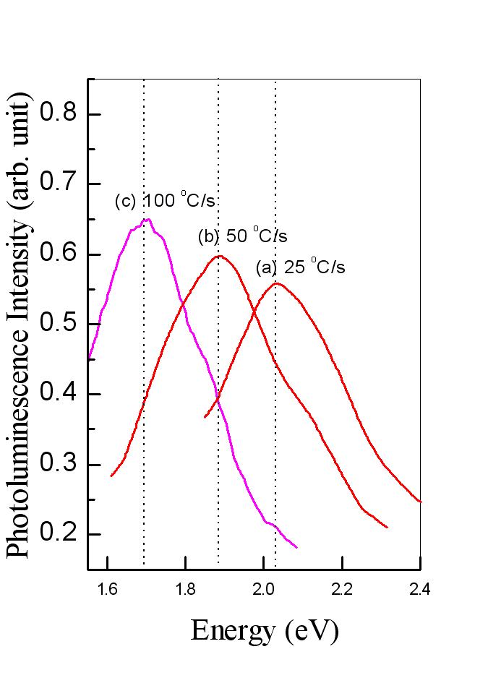
Figure 2. Room temperature PL spectra of Si⁺-implanted SiO₂ films after 1150 ºC RTA for 20 seconds at the heating rate of (a) 25 ºC/s, (b) 50 ºC/s, and(c) 100 ºC/s.

Moreover, Figs. 3-5 all show the PL spectra of the 3x10¹⁶ cm⁻² Si-implanted 400-nm-thick SiO₂ film after RTA for the duration of 20 seconds at 1150ºC and subsequently etching-off the 100-nm-thick and 200-nm-thick layer from the as-implanted films. But, the respective heating rate of RTA was the value of 100 ºC/s in Fig.3, 50 ºC/s in Fig.4 and 25 ºC/s in Fig.5. With the decreasing of the thickness of the films from 400 nm to 200 nm, Fig. 3 clearly shows that the PL spectrum declines and the peak position is shifted from ~1.7 eV to ~1.6 eV; Fig.4 shows that PL spectrum declines, too, but the peak position is shifted from ~1.9 eV to ~1.8 eV. Lastly, Fig.5 shows that the peak position of the declining PL spectrum is shifted from ~2.0 eV to ~1.88 eV. The PL phenomena in the three figures shall all be related closely to the Si⁺ concentration implanted in the films because the deeper layer of the as-implanted 400nm-thick films has the larger Si⁺ concentration before 150-nm-thick layer and led to the smaller PL band after the RTA treatment. Hence, the mechanisms in the RTA-treated Si⁺-implanted SiO₂ films are not related to the defects that has been investigated in the as-implanted films, such as an NBOHC, oxygen-deficient center (ODC) (~2.7 eV), ^{[15]} a weak oxygen bond (~3.0 eV)^{[16]}, neutral oxygen vacancies (NOVs) (~2.8 eV) ^{[16]} and so forth, but is similar to the nc-Si in an oxide matrix (1.5 eV~2.0 eV). Among these defects, only the nc-Si in the films can vary as the ion concentration in oxide matrices, at a fixed heating rate and thermal annealing duration and under the independent of hydrogen-related bonds^{[4-9]}. To sum up above points, we believe that the ion concentration shall be proportional to the average-size of nc-Si in the respective layer of the as-implanted film for a given RTA duration and temperature and heating rate. On the other hand, figure 6 shows that the band of PL peaks from the Si⁺-implanted SiO₂ films after the isothermal RTA was changed as a function of the RTA duration when the heating rate were 25 ºC/s, 50 ºC/s, and 100 ºC/s, respectively. As shown in the figure, when the heating rate of RTA was kept at 100 ºC/s, a red shift of the PL peak from 2.6 eV to 1.7 eV was observed from the films after the isothermal RTA at 1150 ºC for the duration from 1 seconds to 20 seconds and no obvious shift of the PL peak position was continuously found from the isothermal RTA-treated as-implanted films for the duration of >20 seconds.

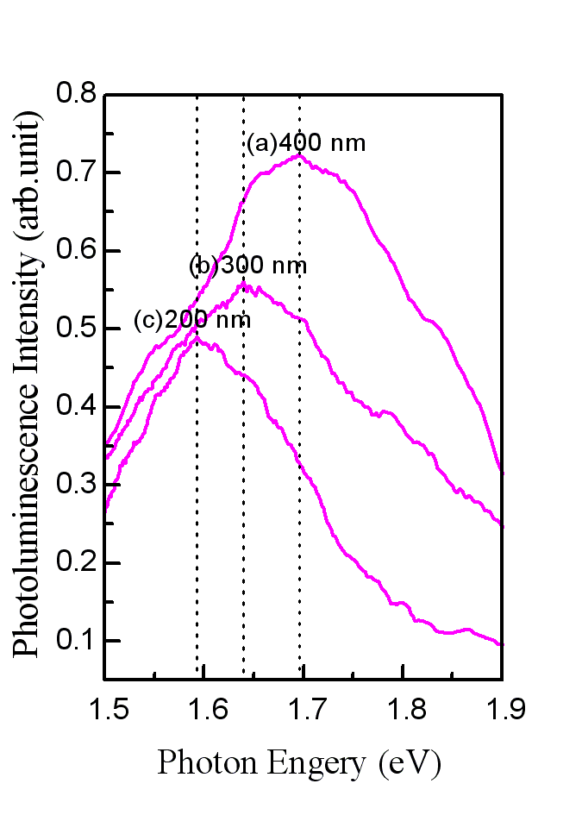
Figure 3. Room temperature PL spectra of the Si⁺- implanted 400-nm-thick SiO₂ film after RTA for the heating rate of 100 ºC/s and RTA duration of 20 seconds at 1150ºC (a) without HF etching, (b) with etched 100-nm-thick layer, and (c) with etched 200-nm-thick layer. The HF-etching procedure was performed after RTA.

Moreover, Figure 6 also shows a smaller shift of the PL peak from 2.3 eV to 1.9 eV was observed from the as-implanted films after the above isothermal RTA for the duration from 1 seconds to 5 seconds and no obvious shift of the PL peak position was continuously found from the films for the duration of >5 seconds at the heating rate of 50 ºC/s. Then, after the heating rate was decreasing and assigned to 25 ºC/s, no significant shift of the PL peak could be seen in the films after the isothermal RTA since the durations of 1 seconds and the PL peak position seems to be fixed at 2.0 eV. These results imply, for a given RTA temperature of 1150ºC, the maximum active-time about the PL mechanism’s production was
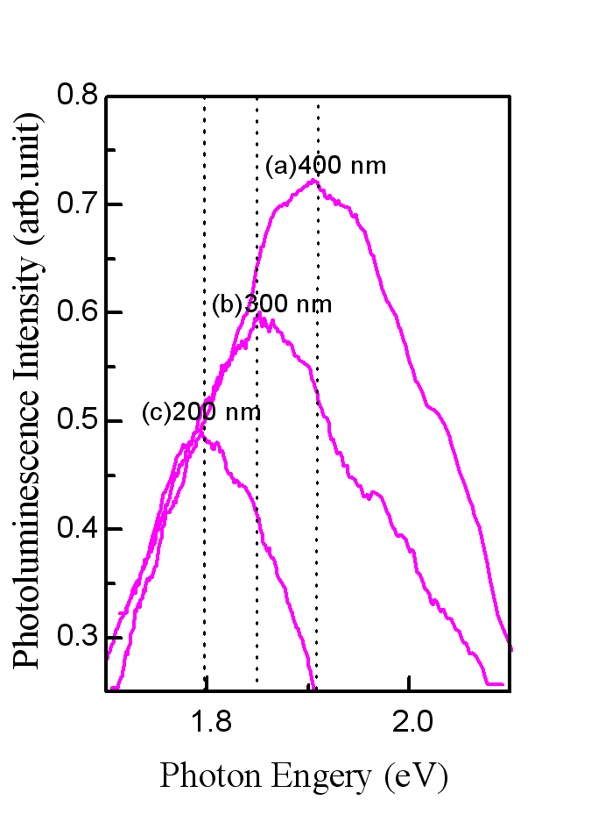
Figure 4. Room temperature PL spectra of the Si⁺-implanted 400-nm-thick SiO₂ film after RTA for the heating rate of 50 ºC/s and RTA duration of 20 seconds at 1150ºC (a) without HF etching, (b) with etched 100-nm-thick layer, and (c) with etched 200-nm-thick layer. The HF-etching procedure was performed after RTA.
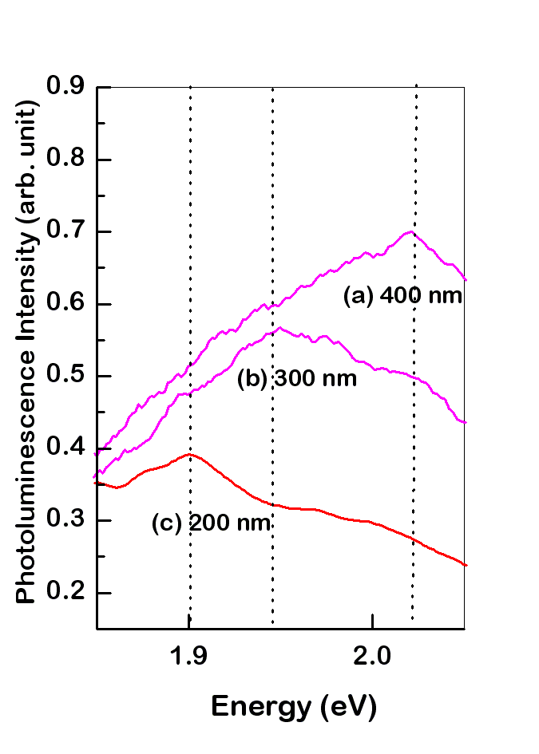
Figure 5. Room temperature PL spectra of the Si⁺- implanted 400-nm-thick SiO₂ film after RTA for the heating rate of 25 ºC/s and RTA duration of 20 seconds at 1150ºC (a) without HF etching, (b) with etched 100-nm-thick layer, and (c) with etched 200-nm-thick layer. The HF-etching procedure was performed after RTA.

about 20 seconds for the heating rate of 100 ºC/s, about 5 seconds for the heating rate of 50 ºC/s, and less than 1 seconds for 25 ºC/s. The maximum active-time was increasing with the increasing of heating rate of RTA. Anyway, for a given RTA duration, although the RTA temperature determining the average speed of Si⁺ re-diffusion plays an important role of Si⁺ re-crystal in the as-implanted film, the RTA heating rate determining the active-time plays the main role.

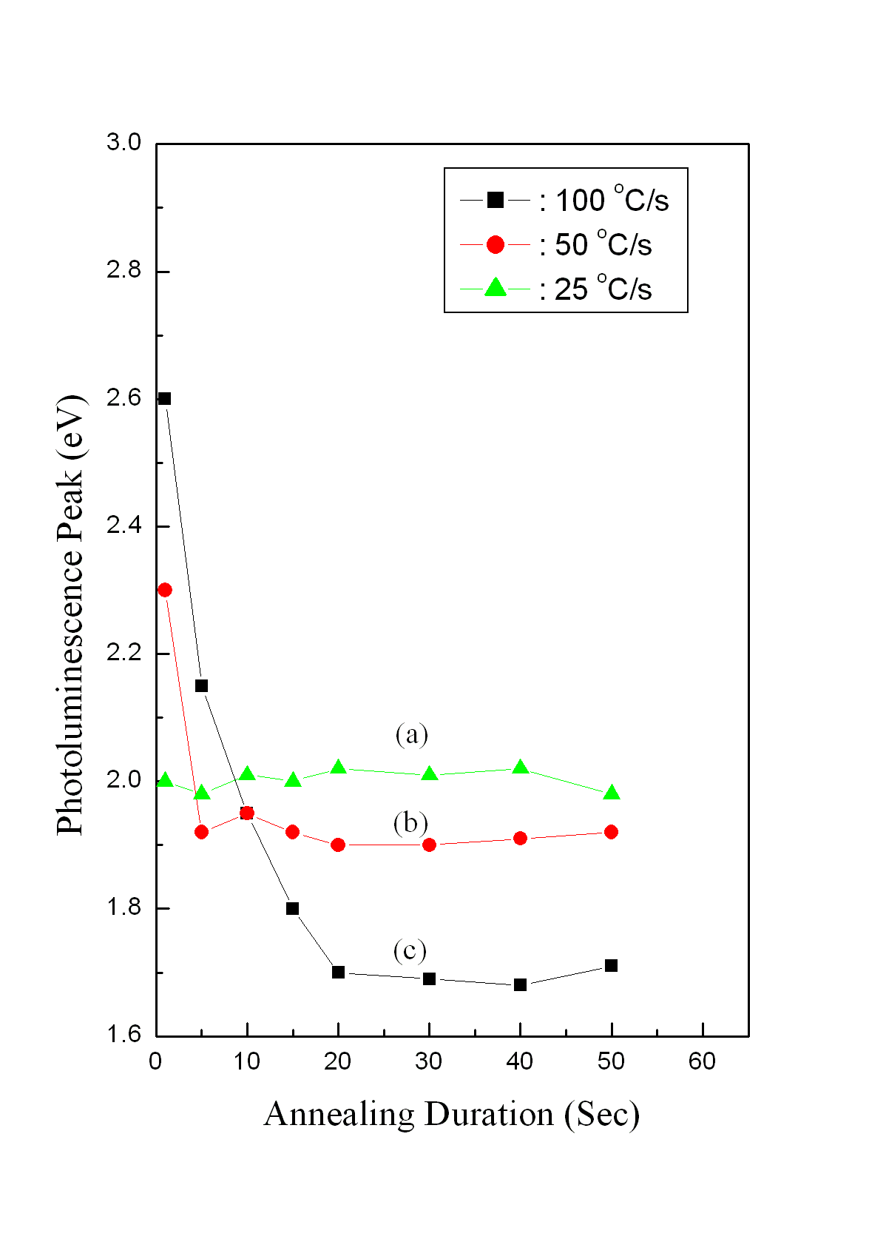
Figure 6. The change in the band of PL peaks from Si⁺- implanted SiO₂ films after 1150 ºC RTA at the heating rate of (a) 25 ºC/s, (b) 50 ºC/s, and(c) 100 ºC/s, as a function of the RTA duration.

Finally, the position of FTIR peak in the ~ 1100 cm⁻¹ range shows the anti-asymmetric stretching vibration of Si-O-Si unit in a SiO₂ film, which can reflects the repairing condition of Si-O bonds in the film. The shift of the FTIR peak to high wave-number, observed from the as-implanted SiO₂ films after RTA, represents the improvement of the broken SiO₂ structure and causes the relaxation of the Si-O bonding network in the films.^{[14, 17]} Fig. 7 shows that the FTIR absorption peak in the 1100 cm⁻¹ range from the Si⁺-implanted SiO₂ films after RTA at the heating rate of 25 ºC/s, 50 ºC/s, and 100 ºC/s for the duration of 1 second, respectively, changed as a function of the holding temperature in RTA. As shown in Fig. 7, under this short duration of RTA, the changes in the FTIR peak of the three heating rates were all slow until the holding temperature in RTA was above the dissociation temperature (~1000 ºC) of a-SiO₂ phase variance¹⁸ and the lower heating rate has the bigger change in the positions of FTIR peak. It implies that the lower RTA heating rate wasting more time from 1000 ºC to the holding temperature of 1150 ºC than the bigger heating rate has the better repairing effect for a damaged and substoichiometric oxide matrix where were due to the outcome of Si⁺-implantation.
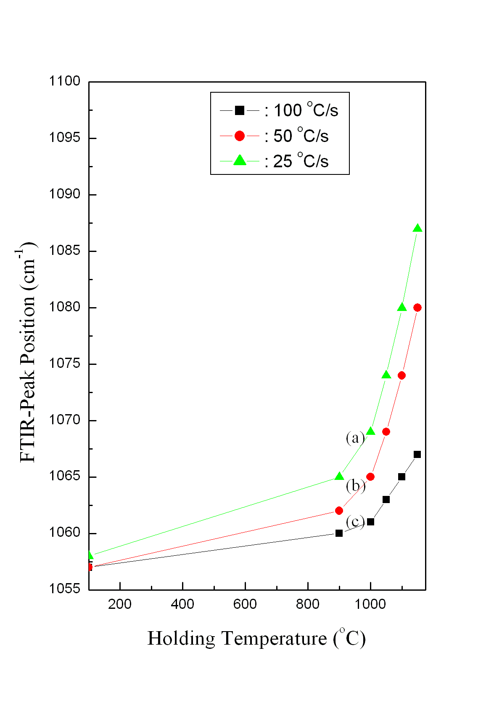
Figure 7. The changes in the FTIR peak positions around 1100 cm⁻¹ from the Si⁺-implanted SiO₂ films after RTA for the duration of 1 second for the heating rate of (b) 25 ºC/s, (c) 50 ºC/s, and(d) 100 ºC/s, as a function of the holding temperature in RTA.

Moreover, the FTIR absorption peak’s position at ~ 1100 cm⁻¹, observed from the original 400-nm-thick SiO₂ film without RTA and the 3x10¹⁶ cm⁻² Si⁺-implanted 400-nm-thick SiO₂ films after the 1150 ºC RTA but at the different heating rate, change as a function of RTA duration and are shown in Fig. 8. In the figure, at the RTA heating rate of 100 ºC/s, the wave-number of the Si-O-Si stretching mode from the as-implanted SiO₂ films was quickly increasing from 1067 cm⁻¹ to 1083 cm⁻¹ as the RTA duration changed from 1 second to 20 seconds, the average changed rate is about 0.83 cm⁻¹/s in this period of 19 seconds; then, the wave-number from the films progressively increased to only 1087 cm⁻¹ as the duration had increased up to 60 seconds, the average changed rate is decreasing to the value of 0.1 cm⁻¹/s in this period of 40 seconds. At the RTA heating rate of 50 ºC/s, the wave-number of the Si-O-Si stretching mode from the as-implanted SiO₂ films increased from 1080 cm⁻¹ to 1085 cm⁻¹ as the RTA duration changed only from 1 seconds to 5 seconds, the average changed rate is about 1.25 cm⁻¹/s in this period of 4 seconds; then, the wave number from the films progressively increased to 1092 cm⁻¹ after the duration increasing up to 60 seconds, the average changed rate is decreasing to the value of 0.18 cm⁻¹/s in this period of 40 seconds. After decreasing the RTA heating rate to 25 ºC/s, the wave-number of the Si-O-Si stretching mode from the films smoothly increased from 1087 cm⁻¹ to 1095 cm⁻¹ as the RTA durations changed from 1 second to 60 seconds. Clearly, the peak’s positions of ~ 1100 cm⁻¹, where were measured from the films treated at different RTA heating rate, all shift to higher wave-number as the RTA duration varying from 1 seconds to 1 min; besides, for a given RTA duration and temperature, the wave-number of FTIR peak from the as-implanted films was increasing with the decreasing of heating rate of RTA and never bigger than that from the original 400-nm-thick SiO₂ films without RTA. These imply that, for the RTA durations ≤ 20 seconds at the heating rate of 100 ºC, ≤ 5 seconds at the heating rate of 50 ºC/s, and ≤ 1 second at that of 25 ºC/s, the respective average rate of the FTIR-peak change from the RTA-treated as-implanted film was quicker than that for the other durations and so was the repairing rate of the Si-O bonds in the films. Certainly, the final repairing situation of the RTA-treated as-implanted SiO₂ film can not recover to the original situation of the SiO₂ film before implantation. Therefore, the heating rate of RTA determining the active-time of PL-mechanism production has an important contribution for the improvement of the broken structure in the RTA-treated as-implanted SiO₂ film.
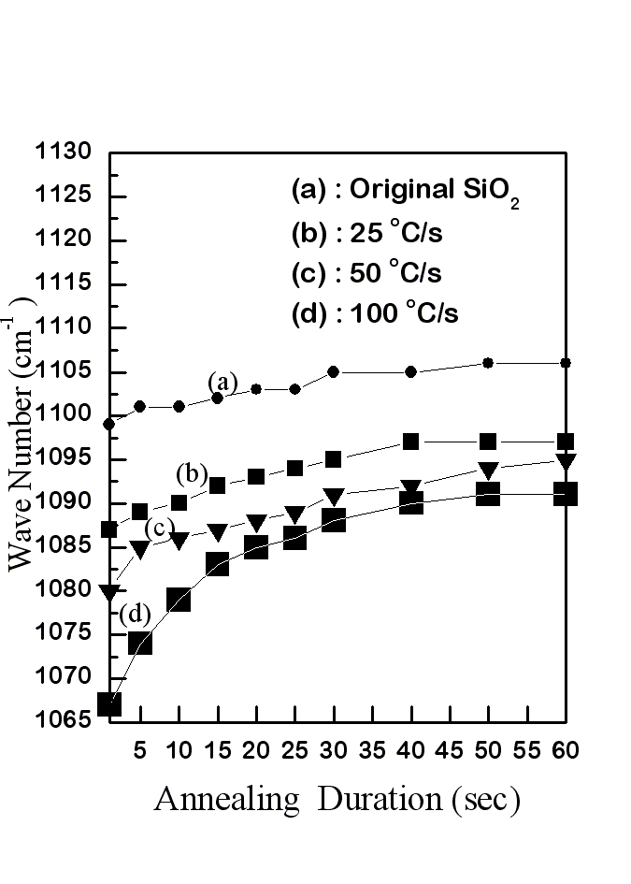
Figure 8. The changes in the FTIR peak positions around 1100 cm⁻¹ from the (a) original and Si⁺-implanted SiO₂ films after RTA at 1150 ºC and at the heating rate of (b) 25 ºC/s, (c) 50 ºC/s, and(d) 100 ºC/s, as a function of the RTA duration.

4 Conclusion
Room-temperature visible photoluminescence (PL) was observed in 3x10¹⁶ cm⁻² Si⁺-implanted 400-nm-thick SiO₂ films after RTA at 1150 ºC in dry nitrogen. For the RTA duration of 1 seconds, the PL peak at ~2.6 eV from the as-implanted films has the heating rate of 100 ºC/s and those with peaks at ~2.3 eV and ~2.0 eV from the films have the heating rate of 50 ºC/s and 100 ºC/s, respectively. Moreover, when the RTA duration was increasing from 1 s to 20 seconds, a broader shift of the PL peak from 2.6 eV to 1.7 eV would be found in the films as the RTA heating rate of 100 ºC/s. However, after the heating rate was decreasing to 25 ºC/s, no significant shift of the PL peak could be seen in the films after the isothermal RTA for the duration > 1 seconds. Similarly, the average rate of the FTIR-peak change at ~ 1100 cm⁻¹ from the as-implanted films after the isothermal RTA was quick for the RTA duration ≤ 20 seconds at the heating rate of 100 ºC, ≤ 5 seconds at the heating rate of 50 ºC/s, and not obviously vary for the RTA duration >1 s at that of 25 ºC/s. For these PL and FTIR phenomena should be related closely to the formation of nc-Si crystal and the improvement of the broken structure in the RTA-treated as-implanted SiO₂ films, the RTA heating rate really plays the main role of Si⁺ re-crystal and the repair of broken Si-O bonds in the as-implanted SiO₂ film for a given RTA temperature and duration.

References
1. Brus L, Semiconductors and Semimetals, edited by D. Lockwood (Academic, New York), Vol. 490 (1998) 303.

2. Qin GG, Li AP, Zhang BR and Li B, J. Appl. Phys. 78 (1995) 2006.
3. Lin GR and Lin CJ, J. Appl. Phys. 95(12) (2004) 8484.
4. Shimizu-Iwayama T, Nakao S and Saitoh K, Appl. Phys. Lett. 65 (1994) 1814.
5. Mutti P, Ghislotti G, Bertoni S, Bonoldi L., Cerfolini GF, Meda L, Grilli E and Guzzi M, Appl. Phys. Lett. 66 (1995) 851.
6. Zhu JG, White CW, Budai J D, Withrow P and Chen Y, J. Appl. Phys. 78 (1995) 4386.
7. Ghislotti G, Nielsen B, Asoka-Kumar P, Lynn KG, Gambhir A, DiMauro LF and Bottani CE, J. Appl. Phys. 79 (1996) 8660.
8. Min KS, Shcheglov KV, Yang CM and Atwater HA, Appl. Phys. Lett. 69 (1996) 2033.
9. Aidong Lan, Baixin Liu and Xinde Bai, Jpn. J. Appl. Phys. 36 (1997) L1019.
10. Chou ST, Tsai JH, and Sheu BC, J. Appl. Phys. 83(10) (1998) 5394.
11. Tsai JH, Yu AT, and Sheu BC, Jpn. J. Appl. Phys. 39 (2000) L107.
12. Tsai JH and Yu AT,, Jpn. J. Appl. Phys. 44(3) (2005) 1389.
13. Nakamura M, Kanzawa R, and Sakai K, Journal of Electrochemical Society 133(6), (1986) 1167.
14. Sano N, Sekiya M, Hara M, and Kohno A, Appl. Phys. Lett. 66(16) (1995) 798.
15. Trukhin AN, Jansons J, Fitting HJ, Barfels T, and Schmidt B: J. Non-Cryst. Solid 331 (2003) 91.
16. Lin GR and Lin CJ: J. Appl. Phys. 95 (2004) 8484.
17. Garrido Fernanedz B, Lopez M, Garcia C, Perez-Rodriguez A, and Morante JR, Jpn. J. Appl. Phys. 91(2) (2002) 798.
18. Sosman RB, Trans. Br. Ceram. Soc. 54, (1995) 655.

