The Novel Biomaterial of Visible Photoluminescence by Saving Energy Technology of Rapid Thermal Annealing
Jen-Hwan Tsai¹, Chih-Hsiung Liao² and Shen Cherng³
¹Department of Mathematics and Physics, Air Force Academy, Kangshan, Kaohsiung, 820, Taiwan ROC; ²Department of Physics, Chinese Military Academy, Fengshan, Kaohsiung, 830, Taiwan ROC; ³Department of Computer Science and Information Engineering, Chengshiu University, Niaosong, Kaohsiung, 833 Taiwan, ROC

Received March 20, 2009
_______________________________________________________________________________________________

Abstract
In this article, the novel biomaterial of visible photoluminescence by saving energy technology of rapid thermal annealing is presented. A shift in the photoluminescence (PL) peak from blue to near-infrared region was observed in the Si⁺-implanted 400-nm-thick SiO₂ film with the rapid thermal annealing (RTA) method only. As the Si⁺-fluence was 1x10¹⁶ ions/cm², a blue band was observed in the films after RTA at 1050ºC for 5 seconds in dry-N₂ atmosphere; then, the band shifted from blue to orange upon increasing the holding temperature of RTA to 1250 ºC in the films after the isochronal RTA in dry N₂. Furthermore, while the fluence was increased to 3x10¹⁶ ions/cm² and the holding temperature was at the same range between 1050ºC and 1250 ºC, the PL peak occurred between red and near-infrared regions. Although the RTA and conventional thermal annealing (CTA) methods produce the similar mechanism, the CTA method needs a much longer annealing-time and a higher Si⁺-implanted dose than the RTA method to observe the same range and intensity of PL peak from the as-implanted sample. Therefore, the RTA method can produce the mechanism in the Si⁺-implanted sample with the energy of PL peak between blue and near-infrared band in palce of the CTA method. [Life Science Journal. 2009; 6(3):61–67] (ISSN: 1097 – 8135)
Keywords: rapid thermal annealing (RTA), Si⁺ implantation, photoluminescence, SiO₂ films, FTIR spectra
________________________________________________________________________________

1 Introduction
With the advancement of Si technology for electronic integrated circuits and in view of the potential applications in optoelectronics and photonics, there has been a significant interest in the structures consisting of silicon nanocrystals embedded in SiO₂^{[1]}. Room temperature visible luminescence had been firstly observed from porous silicon (P-Si), however, several problems have been encountered in practical application ^{[2, 3]}. The plasma deposition technologies by using silane, gas evaporation, and termination of glass-melt reaction was used to produce visible light emission and silicon nanocrystals, but still none of them were appropriate for the manufacturing process of integrated device products. In addition to above methods, silicon-implantation into SiO₂ film on crystal Si with subsequent conventional thermal annealing (CTA) was another alternative method to fabricate Si-based luminescence structures. Broad emission bands between ~1.5 and ~2.5 eV had been observed by several research groups by implanting Si⁺ into the SiO₂ films and following CTA at a temperature higher than 1000°C in vacuum, in Ar, or in N₂^{[4-9]}. The 1x 10¹⁷ cm⁻² Si⁺-implanted films after the CTA in dry-N₂ at about 1000ºC emits visible blue-light and the PL peaks were shifted from the blue ~2.5 eV to _____________________________________________*Corresponding Author Chih-Hsiung Liao, Ph.D.
liao550226@yahoo.com.tw
yellow ~2.2 eV upon increasing the annealing temperature from 1000ºC to 1250ºC^{[5]}. The other light emission between red and near-infrared band was presented at the flux between 1x 10¹⁷ cm⁻² and 3x 10¹⁷ cm⁻² and were attributed to the quantum confinement effect in silicon nanocrystals that was confirmed by transmission electron microscopy ^{[5-6,8]}. In those reports^{[4-9]}, the flux of implanted silicon was relatively high and the whole annealing process required several hours. Although ion implantation of III-V compounds was routinely used in the production of optoelectronic integrated circuits, the methods using silicon implantation seem not suitable for applications in optoelectronics.
Recently, we successfully used the rapid thermal annealing (RTA) method only to observe the photoluminescence (PL) peak between blue and near-infrared regions in the Si⁺-implanted 400-nm-thick SiO₂ films. At the Si⁺-fluence of 1x10¹⁶ ions/cm², the light shifted from blue to orange band when the holding temperature of RTA was increased from 1050ºC to 1250 ºC in the films after RTA for 5 seconds in dry N₂. Furthermore, while the fluence was increasing to 3x10¹⁶ ions/cm² and the holding temperature was at the same range between 1050ºC and 1250 ºC, the ranges of PL peak were observed between red and near-infrared regions in the films after the RTA for 20 seconds. On the other hand, by means of RTA and CTA method, the PL peaks from the Si⁺-implant SiO₂ films were both shifted with the increase of the Si⁺ concentration in the oxide matrices and of the thermal annealing duration. However, the shifting affect using RTA method was much better than that using CTA method. In additional, the mechanisms achieved by RTA and CTA are both not dependent on hydrogen-related bonds and have similar existent ratio after isothermal and isochronal RTA test. The results show that the mechanisms in the Si⁺-implanted SiO₂ films after the RTA and CTA methods are similar. However, for the same range and intensity of PL peak from the as-implanted sample, the CTA method needs a much longer annealing-time and a higher dose of Si⁺-implantation than the RTA method. Therefore, using RTA method to produce the mechanisms in the Si⁺-implanted samples with the energy of PL peak between blue to near-infrared band is better than using CTA method.

2 Experimental Procedure
Samples were prepared by implantation of Si⁺ into a 400-nm-thick wet SiO₂ film which was thermally grown on (100)-oriented p-doped Si substrates. The respective fluences of the Si⁺-implantation are 1x10¹⁵, 4x10¹⁵, 1x10¹⁶, 2x10¹⁶, and 3x10¹⁶ ions/cm². The temperature of the samples during ion implantation was kept at liquid nitrogen temperature. The acceleration energy of ~ 160 keV was selected so that the maximum concentration was at a depth of ~250 nm below the surface and the standard deviation of the implanted region was 60 nm. These samples were subjected to RTA treatments at substrate temperature of 1050ºC, 1150ºC, and 1250ºC, respectively, under dry and wet N₂. The introduction of wet N₂ into the furnace was performed by heating liquid H₂O at 100 ºC in a cylinder, which was connected to the furnace through a guiding tube, and by mixing up with dry N₂ in the guiding tube. Furthermore, the atmospheric pressure of 50 mbar was provided into the furnace and a heating rate of 100ºC/s and the cooling rate of about 100ºC /min was used. On the other hand, in order to display the advantage of RTA system, we also annealed the samples at temperatures between 1050ºC and 1250ºC by using a conventional electric oven. The atmospheric pressure of 50 mbar was provided but a maximum heating rate of 10ºC /min and the cooling rate of 50ºC /min were used in the CTA system. It shall be noted that the two thermal annealing treatments both include three procedures as heating, holding, and cooling. On the other hand, to detect the PL spectra, a He-Cd laser (3.8 eV) was used as the excitation and a lock-in amplifier was employed to improve the signal-to-noise ratio, in conjunction with a monochromator and cooled photomultiplier tube. The excitation was operated at a small and fixed power of 5 mW to not detect any PL sign in the 3x10¹⁶ cm⁻² Si⁺-implanted 400-nm-thick wet SiO₂ films without RTA. Finally, the FTIR measurements were performed to examine the presence or absence of hydrogen-related species in samples of oxide film. With the reference being the same silicon plate as the sample, the spectra were measured at room temperature in N₂ atmosphere at a 2 cm⁻¹ resolution with 200 scan accumulations.

- Results and Discussion
In order to demonstrate that the RTA method is better than the CTA method for producing the mechanism in Si⁺-implanted SiO₂ films with the energy of PL peak between the blue and near-infrared band, the fluence of the silicon implantation in the films was kept at 1x10¹⁶ and 3x10¹⁶ ions/cm² and the experimental results are shown in Figs.1 and 2, respectively. From Fig. 1, when the holding temperature of RTA increases from 1050ºC to 1250ºC in the 1x10¹⁶ cm⁻² Si⁺-implanted 400-nm-thick films after the dry-N₂ RTA for 5 seconds, the PL peak shifted from the blue band of ~2.5 eV to the orange band around 2.1 eV. Furthermore, at the same range of holding temperature as in Fig.1, Fig. 2 shows that the PL peak shifted from the near-infrared band of ~1.85 eV to ~1.5 eV in the 3x10¹⁶ cm⁻² Si⁺-implanted 400-nm-thick films after the dry-N₂ RTA for 20 seconds. Keeping the holding temperature in the range between 1000 ºC and 1250 ºC, a similar shift of PL peak (~2.5 eV to ~2.3 eV) as shown in Fig. 1 was observed in the 160 Kev Si⁺-implanted 430 nm-thick SiO₂ films after CTA by the group of Mutti. et al.^{[5]}. However, the silicon fluence was 1 x 10¹⁷ ions/cm² and the duration at those high temperatures was 1 hr. On the other hand, a similar band of PL peak (~1.5 eV) as the result in Fig. 2 were observed in the 150 Kev Si⁺-implanted 800 nm-thick SiO₂ films after CTA at 1100 ºC by Garrido et al^{[8]}; but, the silicon fluence must be increased to ~3 x 10¹⁷ ions/cm² and the duration at the high temperatures was 8 hr. Besides, At the silicon fluece of 3 x 10¹⁷ cm⁻², Mutti. et al. can only produce the PL peak of ~1.65 eV in the 160 Kev Si⁺-implanted 430 nm-thick SiO₂ film after CTA at 1000 ºC for 5 hrs^{[5]}.
Figure 3 shows that the PL peak is shifted from ~2.1 eV to ~1.7 eV when the 3 x 10¹⁶ cm⁻² as-implanted films are treated by the dry-N₂ RTA at 1150ºC and the RTA duration is increased from 5 to 20 seconds,. At the same time, Fig. 4 shows that the PL peak is shifted from ~1.75 eV to ~1.7 eV in the 3 x 10¹⁶ cm⁻² as-implanted films after CTA at 1150ºC for the duration from 4 to 12 hrs. Referring to Fig.3, the results indicate that the band
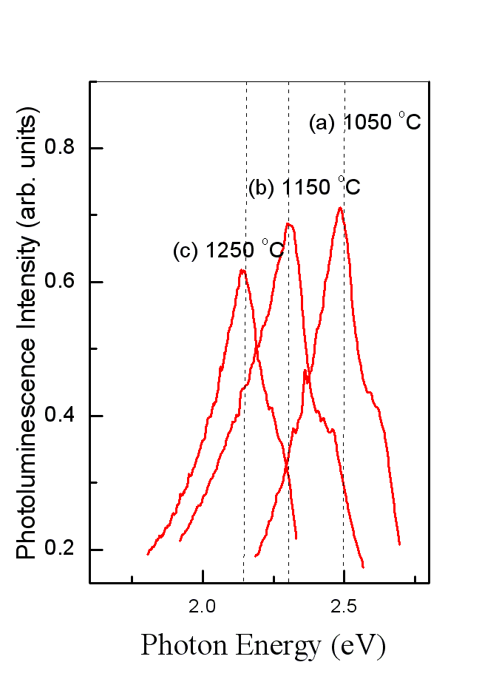
Figure 1. PL spectra of the Si⁺-implanted 400-nm-thick SiO₂ film grown on crystal Si at a fluence of 1x10¹⁶ ions/cm² after dry-N₂ RTA for 5 seconds at (a) 1050ºC, (b) 1150ºC, and (c) 1250ºC.
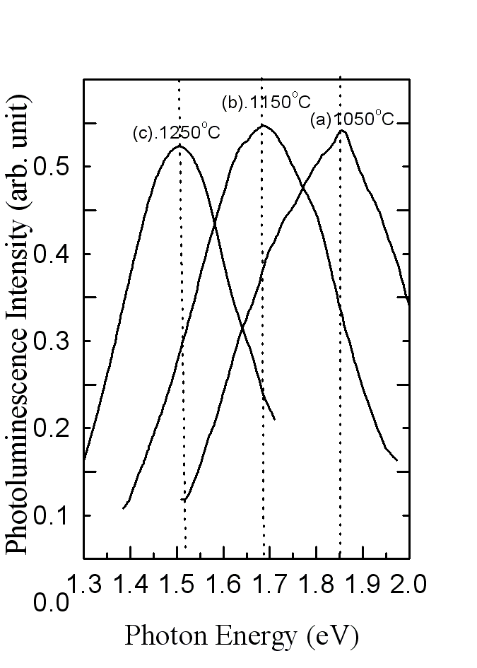
Figure 2. PL spectra of the Si⁺-implanted 400-nm-thick SiO₂ film grown on crystal Si at a fluence of 3x10¹⁶ ions/cm² after dry-N₂ RTA for 20 seconds at (a) 1050ºC, (b) 1150ºC, and (c) 1250ºC.

of PL peak can be decreased by increasing the RTA duration. However, the results in Fig. 4 indicate that the PL peak is weakly affected by the CTA duration although the intensity of PL spectra become large due to the increase in CTA duration,. The result agrees with that of the study by Shimizu-Iwayama et al.^{[6]}, in which the peak energy of the PL is found to be weakly dependent on annealing time, while the intensity of the luminescence increase as the annealing time increases. In addition, comparing Figs. 3 with 4, under the same Si⁺-flux of 3x10¹⁶ ions/cm⁻² and holding temperature of 1150 ºC, the intensity of PL-peak in the as-implanted film after the RTA method for the holding duration between 5 and 20 seconds as shown in Fig. 3 is always bigger than that after the CTA method for the duration between 4 and 12 hrs as shown in Fig.4.
Figure5 shows the effect of Si⁺ fluence on the luminescence in the RTA-treated film, where the PL spectrum of the Si⁺-implanted 400-nm-thick SiO₂ films grown on silicon crystal at three different fluences after RTA in dry N₂ at 1150ºC for 20 seconds. As the Si⁺ fluence into the as-implanted film was 1x10¹⁶ ions/cm², the PL spectrum has a peak at ~1.95 eV shown in Fig.5(a); as those films have the fluence of 2x10¹⁶ and 3x10¹⁶ ions/cm², the PL spectra have the peaks at ~1.8 eV and ~1.7 eV, shown in Figs. 5(b) and 5(c), respectively. The results indicate that the PL peak can be red-shifted with the increase of fluences. The peak energy of the PL spectra is obviously decided by the fluence of the Si⁺-implantation. Thus, the Si⁺ concentration plays the important role during the production of the respective mechanisms in the RTA-treated films. On the other hand, Fig.6 shows the effect of Si⁺ fluence on the luminescence
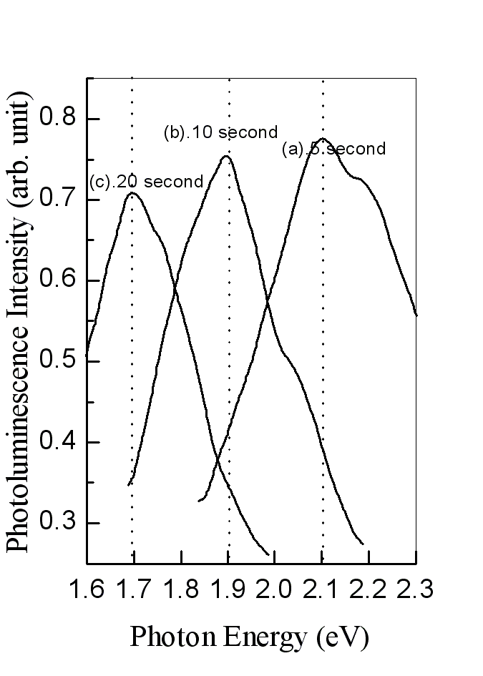
Figure 3. The PL spectra of the Si⁺-implanted 400-nm -thick SiO₂ film grown on crystal Si at a fluence of 3x10¹⁶ ions/cm² after dry-N₂ RTA at 1150 ºC for (a) 5 seconds, (b) 10 seconds, and (c) 20 seconds.

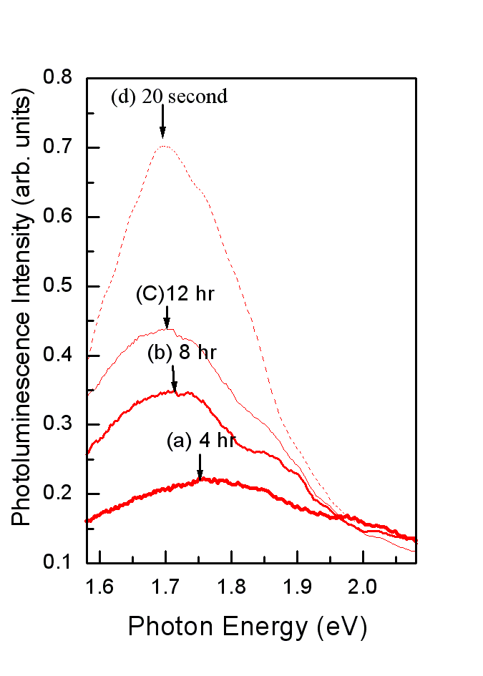
Figure 4. The PL spectra of the Si⁺-implanted 400-nm -thick SiO₂ film grown on crystal Si at a fluence of 3x10¹⁶ ions/cm² after dry-N₂ CTA at 1150 ºC for (a) 4 hours, (b) 8 hours, and (c) 12 hours and (d) after isothermal dry-N₂ RTA for 20 seconds.

in the CTA-treated film, where is also the PL spectrum of the Si⁺-implanted 400-nm-thick SiO₂ films grown on silicon crystal at three fluences as above but after CTA in dry N₂ at 1150ºC for 12 hrs. Referring to Figs.5 and 6, under the same holding temperature of 1150ºC and the Si⁺ -fluence between 1x10¹⁶ and 3x10¹⁶ ions/cm², the PL intensity of the as-implanted film by CTA has obvious increase upon increasing with the dose of implanted Si⁺ but the respective PL Peak shifts only from ~1.75 eV to~1.70 eV as shown in Fig.6, which are always weaker than that by RTA as shown in Fig.5. The results show that the intensity of the PL spectrum is obviously affected
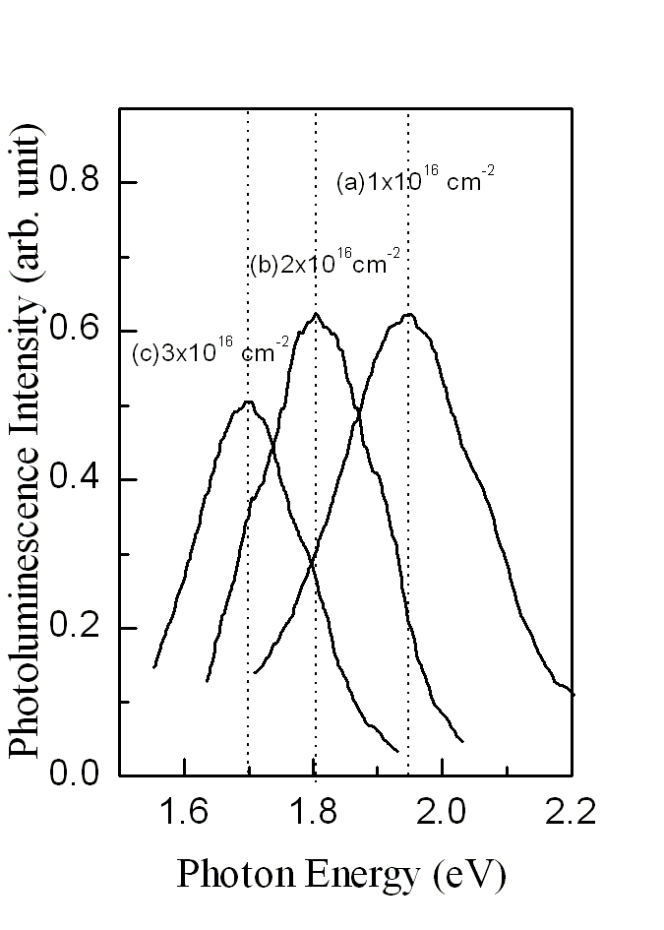
Figure 5. PL spectra of the Si⁺-implanted 400-nm-thick SiO₂ film grown on crystal Si at a fluence of (a) 1x10¹⁶ ions/cm², (b) 2x10¹⁶ ions/cm², and (c) 3x10¹⁶ ions/cm² after dry-N₂ RTA treatment for 20 seconds at 1150ºC.
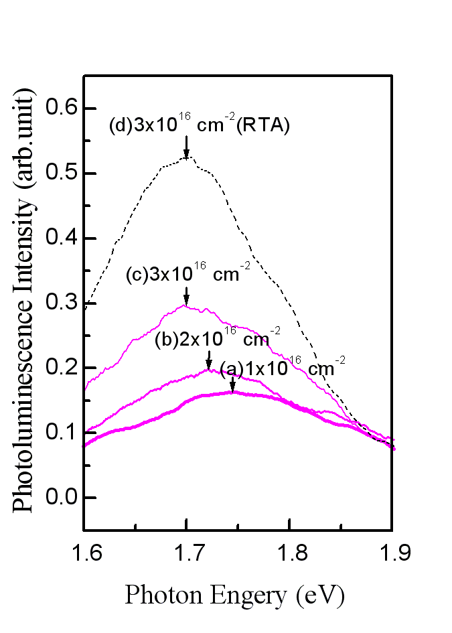
Figure 6. PL spectra of the Si⁺-implanted 400-nm-thick SiO₂ film grown on crystal Si at a fluence of (a) 1x10¹⁶ ions/cm², (b) 2x10¹⁶ ions/cm², and (c) 3x10¹⁶ ions/cm² after dry-N₂ CTA for 12 hours at 1150ºC and at a fluence of (d) 3x10¹⁶ ions/cm² after dry-N₂ isothermal RTA for 20 seconds.

by the concentration of implanted Si⁺, but the peak energy is weakly affected by the concentration of implanted Si⁺ in the CTA-treated film. Otherwise, the result shown in Fig.6 is consistent with the observation of several other research groups^{[6, 8, 14-15]}. According to the observation of Shimizu-Iwayama et al.^{[6]}, although the intensity of PL is strongly affected by the dose of implanted Si⁺, the peak energy of the PL that is weakly affected by the Si⁺-dose shifted from 1.75 eV to 1.7 eV as the Si⁺ -fluence implanted into the 600 nm-thick SiO₂ film with the energy of 180 KeV increases from 1x10¹⁶ to 2x10¹⁷ ions/cm⁻² and the thermal annealing was carried out by the CTA at 1050 ºC for 4 hrs. Furthermore, the shift of PL peak from 1.7 eV to 1.5 eV was obsedved by Fernandez et al.while the Si⁺ -fluence implanted into the 800 nm-thick SiO₂ film with the energy of 150 KeV increases from 1x10¹⁷ to 3x10¹⁷ ions/cm² and the thermal annealing was treated by the CTA at 1100 ºC for 8 hrs ^{[8]}. Anyway, the red-shifting phenomena of PL can be observed by RTA, which can decrease the fluence of the Si⁺- implantation and shorten the thermal annealing time as compared with CTA. Moreover, although the growth of PL mechanism in the as-implanted SiO₂ film treated by CTA is much slower than that treated by isothermal RTA, the mechanism in the film treated by the RTA or CTA method is dependent of Si⁺ concentration in the oxide matrices and of the thermal annealing temperature and duration.
Remarkably, besides of the enhanced diffusion and aggregation of Si⁺ implanted in oxide matrix during RTA ^{[21]}, we believe that the procedure of Si⁺-nanocrystals formation all be enhanced by using the RTA method but the effect is very sensitive to the heating rate of RTA. According to our initial observation, the PL intensity from the as-implanted film by RTA with the heating rate of 100 ºC/s was much stronger than that by RTA with the heating rate of 50 ºC/s and no significant intensity could be found after the heating rate of 25 ºC/s. At the same time, the shift of PL peak from the as-implanted film by RTA with the heating rate of 100 ºC/s could occur at the holding duration less than 20 seconds. However, after the heating rate decreasing to 50 ºC/s, the shifting phenomena could occur only at the holding duration less than 5 seconds. The results conform to the observation by Shimizu-Iwayama et al.. They found that, under the Si⁺ fluence of ≥5x10¹⁶ ions/cm⁻², the PL intensity of sample only after RTA at ≥ 1050 ºC for 5 min with the heating rate of 30 ºC/s was much weaker than that treated by the same RTA at first and achieved finally by CTA at ≥ 1050 ºC for ≥ 1 hr ^{[21]}.
On the other hand, Fig. 7 shows the FTIR spectra of the films with the different treated process. Figure 7(a) shows the FTIR spectrum in the 3750 cm⁻¹ range of original 400-nm-thick SiO₂ film grown on the Si crystal without RTA. Besides, for the Si⁺-implanted 400-nm-thick SiO₂ films with the same fluence of 3x10¹⁶ ions/cm², but proceeding the RTA in dry N₂ at 1150ºC for 20 seconds and the CTA at 1150ºC for 12 hours, the FTIR spectra in the 3750 cm⁻¹ range are show in Figs. 7(b) and 7(c), respectively. Moreover, in order to confirm the absence of Si-O-H structures in the as-implanted samples by the RTA and CTA, the spectra in the 3750 cm⁻¹ range of the Si⁺-implanted 400-nm-thick SiO₂ films with the respective fluences of 1x10¹⁵ and 4x10¹⁵ ions/cm² after the RTA but in wet N₂ are displayed in Figs. 7(d) and 7(e). According to these FTIR spectra in Figs.7(b) and 7(c), the absorption valleys of Si-O-H structures in the dry-N₂-annealed films after above RTA and CTA, which are indicated by the signature at ~ 3750 cm⁻¹ in the FTIR spectra^{[16-20]}, are both shallow as the sample of original wet SiO₂ films without RTA treatment shown as Fig. 7(a) and seem un- change with the increase of silicon implantation fluence. However, from Figs. 7(d) and 7(e), we observed that the absorption valleys of Si-O-H structures in the respective 1x10¹⁵ cm⁻² and 4x10¹⁵ cm⁻² Si⁺-implanted SiO₂ films after RTA in a wet N₂ are deepened with the increase of Si⁺-implantation fluence and so their respective mechanism in the films, that lead to the luminescence, are related closely to the Si-O-H structures^{[11, 12]}. In addition, no samples with the above mechanisms in this study display an FTIR signature at ~2100 cm⁻¹ and~1450 cm⁻¹ (or ~2300 cm⁻¹), related to the absorption of SiH_{x} (x=1,3) and CH_{x} structures, respectively^{[13, 16]}. Hence, the above mechanisms in the 3x10¹⁶cm⁻² Si⁺-implanted SiO₂ films after the above dry-N₂ RTA and CTA are all independent of the Si-O-H related bonds and the SiH_{x} or CH_{x} structures according to the FTIR spectra.
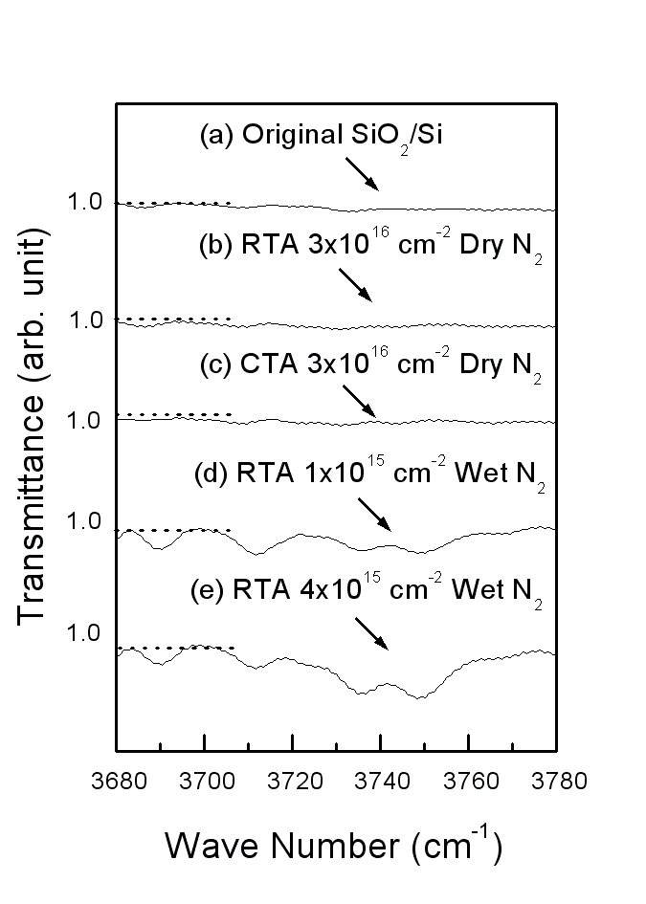
Figure 7. FTIR spectra in the 3750 cm⁻¹ range of (a) original 400-nm-thick SiO₂ film grown on Si crystal without RTA, the Si⁺-implanted 400-nm-thick SiO₂ film grown on crystal Si at a fluence of 3x10¹⁶ ions/cm² (b) after Dry-N₂ RTA at 1150ºC for 20 seconds and (c) after Dry-N₂ CTA at 1150ºC for 12 hours, and that at a fluence of (d) 1x10¹⁵ ions/cm² and (e) 4x10¹⁵ ions/cm² with RTA as in (b) but in wet N₂.

Otherwise, Fig. 8 shows the peak-intensity of the PL spectra as a function of the re-annealing temperature by RTA for 5 min in nitrogen. The PL peaks from the respective 1x10¹⁶ cm⁻² as-implanted films achieved by the CTA (shown as Fig. 8(a)) and RTA (shown as Fig. 8(b)) both decay nearly one-half intensities after isochronal re-annealing at the temperature of 1000 ºC and both disappear since the temperature of 1100 ºC. Furthermore, when the fluence is increased to 3x10¹⁶ ions/cm², the PL mechanism in the as-implant films achieved by the CTA (shown as Fig. 8(c)) and RTA (shown as Fig. 8(d)) can persist even after re-annealing at the temperature of >1100ºC and both disappear at 1200 ºC. The results of the above PL mechanism imply that the ratio of remainder number after the above re-annealing is ambiguously dependent of productive method (RTA or CTA) but depends on the Si⁺ dose implanted into the SiO₂ film. Hence, under the same dose of implanted Si⁺, the PL mechanism in the film achieved by RTA and CTA have similar existent ratio after isothermal and isochronal RTA test.
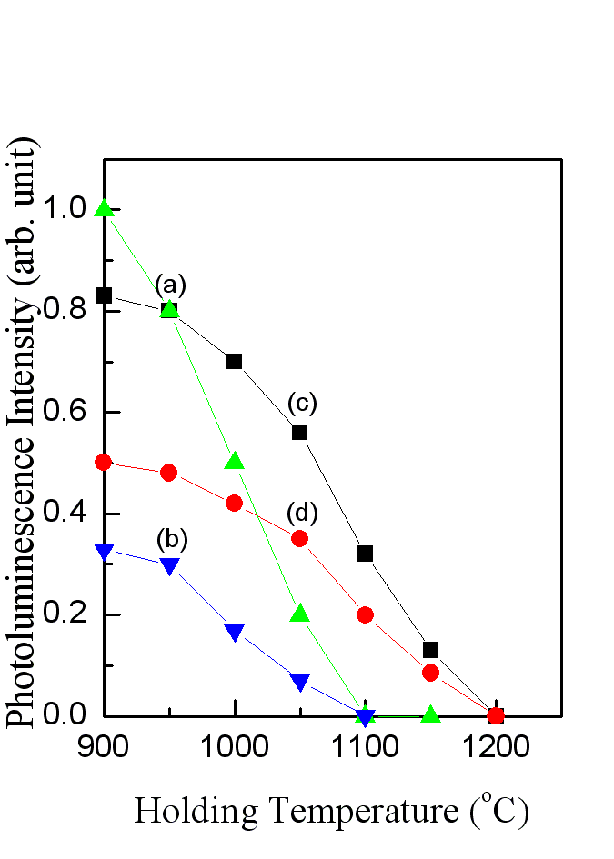
Figure 8. Changes in the PL intensity from the 1x10¹⁶ cm⁻² Si⁺-implanted 400-nm-thick SiO₂ film grown on crystal Si (a) after RTA at 1150ºC for 20 seconds and (b) after CTA at 1150ºC for 12 hrs and from the 3x10¹⁶ cm⁻² as-implanted sample (c) after RTA at 1150ºC for 20 seconds and (d) after CTA at 1150ºC for 12 hrs as a function of the re-annealing temperature, respectively. Re-annealing of the these groups of specimens was achieved by RTA for 5 min with heating rate of 30 ºC/s .

Finally, both the RTA and CTA methods can produce the mechanisms in the Si⁺-implant SiO₂ film with the energy of PL peak between blue and near-infrared band. In addition, their respective PL peaks are both shifted with the increase of Si⁺ concentration in the oxide matrices and of the thermal annealing temperature and duration. The two mechanisms are both independent of hydrogen-related bonds and have the similar existent ratio after the test of RTA at high temperature. Therefore, the respective mechanism in the Si⁺-implanted SiO₂ films after RTA and CTA are similar. It is well known that Si ion implanted into SiO₂ and subsequent high-temperature CTA induce the formation of embedded luminescence Si nanocrystals^{[4-9, 21]}. Hence, the mechanism in the as-implanted film,produced by RTA,was also attributed to silicon nanocrystals embedded in SiO_{2.}

4 Conclusion
The PL peak between ~2.5 eV and ~1.5 eV can be observed in the Si⁺-implanted 400 nm-thick SiO₂ film after dry-N₂ RTA only. The studies indicate that light emission in the lower dose Si⁺-implanted film with the ~30 minutes RTA has the similar shifting phenomena like that in the higher dose as-implanted film with the several-hours CTA method. Under the implanted Si⁺ dose between 1x10¹⁶ cm⁻² and 3x10¹⁶ cm⁻² and the holding temperature of 1150 ºC, the intensity of PL spectrum from the as-implanted film treated by the RTA method is always stronger than that treated by the CTA method. Furthermore, light emission from the as-implanted film by the two methods, in which the peak positions are both shifted with the variation of Si⁺ concentration in oxide matrices and the thermal annealing temperature and duration. The PL mechanisms in the film achieved by RTA and CTA are both independent of hydrogen-related bonds and have similar existent ratio after isothermal and isochronal RTA test. The phenomena imply that the two methods produce the similar PL mechanism in the oxide matrix, that were both attributed to silicon nanocrystals embedded in SiO₂. Therefore, using RTA method to produce the mechanisms in the Si⁺-implanted films with the energy of PL peak between blue and near-infrared band is better than using the CTA method.

References
- Brus L, Semiconductors and Semimetals, edited by D. Lockwood (Academic, New York, 1998), Vol. 490, p. 303.
- Sabet-Dariani R, McAlpine NS and Haneman D, J. Appl. Phys. 75 (1994) 8008.
- Qin G G, Li AP, Zhang BR and Li B, J. Appl. Phys. 78 (1995) 2006.
- Shimizu-Iwayama T, Nakao S and Saitoh K, Appl. Phys. Lett. 65 (1994) 1814.
- Mutti P, Ghislotti G, Bertoni S, Bonoldi L, Cerfolini GF, Meda L, Grilli E and Guzzi M, Appl. Phys. Lett. 66 (1995) 851.
- Shimizu-Iwayama T, Kurumado N, J. Appl. Phys. 83 (1998) 6018.
- Kenyon AJ, Chryssou CE, Pitt CW, Shimizu-Iwayama T, Hole DE, Sharma N and Humphreys CJ, J. Appl. Phys. 91 (2002) 367.
- Fernandez BG, Lopez M, Garcia C, Perez-Rodriguez A, Morante JR, Bonafos C, Carrada M and Claverie A, J. Appl. Phys. 91 (2002) 798.
- Chen T P, Lin Y, Tse M S, Fung S and Dong G, J. Appl. Phys. 95 (2004) 8481.
- Chou ST, Tsai JH, and Sheu BC, J. Appl. Phys. 83 (1998) 5394.
- Tsai JH, Yu AT, and Sheu BC, Jpn. J. Appl. Phys. 39 (2000) L107.
- Tsai JH, Yu AT, Jpn. J. Appl. Phys. 44 (2005) 1389.
- Allian G, Delerue C, and Lannoo M, J. Lumin. 57 (1993) 239.
- Bonafos C, Garrido B, Lopez M, Perez-Rodriguez A, Morante JR, Kihn Y, Ben Assayag G, and Claverie A, Mater. Sci. Eng. 69 (1999) 379.
- Agarwal M and Dunham ST, J. Appl. Phys. 78 (1995) 5313.
- Shim HW, Kim KCand Seo YH, Nahm K S, Suh E. K, Lee HJ, and Hwang YG, Appl. Phys. Lett. 70 (1997) 1757.

- Zvznut ME, Chen TL, Stahlbush RE, Steigerwalt ES, and Brown GA: J. Appl. Phys. 77 (1995) 4329.
- Zvznut ME, Chen T L, Appl. Phys. Lett. 69 (1996) 28.
- Weng YM, Fan ZN and Zong XF, Appl. Phys. Lett. 63 (1993) 168.
- Lin GR and Lin C J, J. Appl. Phys. 95 (2004) 8484.
- Iwayama TS, Hama T, Hole DE, Boyd IW, Vacuum , 81(2006) 179.

