Gustatory Afferents from the Locust Ovipositor: Integration at the Interneuron Level

Tousson, Ehab¹ and Hustert, Reinhold²

¹ Department of Zoology, Faculty of Science, Tanta University, Egypt.
² Institute of Zoology and Anthropology, Georg August Univ., Göttingen, Germany

Received March 25, 2009

Abstract
Sensory afferents from the ovipositors influence the behaviour of locusts before and during egg-laying. Their contact chemoreceptors have only one terminal porous (basiconic sensilla) and five sensory neurons at their base, with one responding to mechanical contact and the others to different classes of attractant or repellent chemicals. Responses to aqueous solutions of salts (NaCl), sugars (glucose), acids (citric acid), oviposition aggregation pheromones (veratrole and acetophenone), alkaloids (quinine and tomatine), and phenolic compounds (salicin) were seen. Higher order processing occurs in local and ascending interneurones of the terminal abdominal ganglion. They are excited or inhibited when purely aqueous solutions of a single chemical are applied to the ovipositor taste receptors. We focussed on a cluster of interneurons extending in the anterolateral region of the eighth abdominal neuromere. Several have ascending collaterals to more anterior abdominal ganglia. Projecting interneurons respond only to one or two chemical substances (sugars or salts, or salts and acids together). The physiological and morphological differences between the chemosensory interneurons suggest that there is no specific centre for processing taste information in the locust terminal ganglion. [Life Science Journal. 2009; 6(3): 37 – 45] (ISSN: 1097 – 8135).

Key words: Taste sensilla, locust ovipositor, local and ascending interneurons, chemical stimulants.

1 Introduction
Most insects have contact chemoreceptors on various surfaces of their body. This sense of taste can be involved in a number of behaviours, including avoidance ^{[1-11]}, detection and the selection of food^{[5, 12-14]}, and selection of egg-laying sites^{[4, 9, 10, 15-17]} . Suitable substrates for starting oviposition are detected first by the tarsal contact chemoreceptors of fore- and middle legs^{[1, 14, 18-20]}. Consecutively, further chemical cues are given for starting and maintenance of digging as well as egg-laying by the contact chemoreceptors of the genital segments and ovipositor valves of the abdomen.
Many locust contact chemoreceptors are distributed “randomly” on the body and extremities. Their central projections do not sort out or converge in specific glomeruli in the CNS according to typical sensory classes of taste (e.g. salts, acids, sugar, water and others). The afferents branch more or less position- specific like mechanosensory afferents even if they originate from areas of increased body contact with the substrate as the tarsi ^{[18, 21]} or genital segments of females ^{[6, 8, 9, 22-25]}. Chemosensory projections develop no specific gustatory centers with specific interneurons that might ease integration and extracting specific chemosensory information in the terminal ganglion.
Neural responses from the tips of insect taste sensilla were first recorded with the technique of Hodgson et al ^{[26]} that allows studying chemosensory specificity of the different afferents from single basiconic contact chemoreceptors. In the fly for example, different ---------------------------------------------------------------------
Email: ehabtousson@yahoo.com
chemosensory afferents in one sensillum respond selectively to water, anions, salts and sugars^{[12]}. Stimulation of their contact chemoreceptors on the tarsi leads to extension of the proboscis^{[12]}. In locusts, stimulation of tarsal chemoreceptors with an antifeedant (sodium nicotine tartrate) elicits aversive leg waving^{[1, 27]}. Natural stimuli, such as plant extracts, appear to be encoded in an across fibre pattern in the responses of many chemosensory afferents and elicit various feeding behaviours^{[4, 10, 28, 29]} .
Neuronal pathways for processing tastes are poorly understood in insects. We know little of how the taste of different chemicals is coded and represented in the central nervous system or which interneurones are responsible for their processing ^{[2, 3, 4, 9, 21, 30]}. Part of the underlying problem is the relative inaccessibility and small size of the taste cells, of the integrating neurones that process their signals ^{[31]} and their physiological properties. The contact chemoreceptors on the ovipositor of locusts are innervated regularly by five sensory afferent neurones that project intersegmentally in the terminal abdominal ganglion and further into the seventh abdominal ganglion ^{[9, 23, 25]}. This system offers the chance of understanding chemoreception systems at the level projecting interneurons by recording extracellularly from their ascending axons in connectives to preceding ganglia. Which chemical cues are extracted from environmental contacts of the locust ovipositor and which are required to select suitable oviposition sites and subsequently control oviposition before and during digging and egg laying. Intracellular recording and staining of several chemosensory integrating interneurons from the locust terminal ganglion gave an insight into the integrative properties, the morphology types and the distribution of local and ascending taste sensitive interneurons.

2 Material and Methods

All experiments were performed on sexually mature females of Locusta migratoria taken from our crowded laboratory culture reared at 25 °C under a 12h light / 12h dark regime and fed mainly with fresh wheat. Prior to the dissection locusts were anaesthetised by cooling to 2-4°C and experiments were performed at 22-25 °C.
In order to record from the anterior connectives of the terminal ganglion the 7th and the terminal abdominal ganglia were first exposed by dorsal dissection removing internal genitals, fat and viscera. All nerves from the terminal abdominal ganglion (TG) were cut except for the terminal branch of the eighth ventral abdominal nerve (8V) that innervates the ventral ovipositor valve. Locust saline at 22-25°C was exchanged regularly throughout an experiment in the terminal abdominal segments.
2.1 Recording afferent responses
Electrophysiological recording of the activity of chemosensory neurones were obtained from the terminal pore of basiconic sensilla using a modified version of the tip recording technique ^{[4]}. For simultaneous stimulation and recording, contact was made with the meniscus of the salt solution at the end of the fine tapering plastic tip of a suction electrode. The recording and stimulating electrodes for the basiconic sensilla contained different concentrations of salts as NaCl (0.01 M to 3.0 M), sugar as glucose (0.01 M to 3.0 M), acids as citric acid (0.01M, 0.1M and 1.0 M), oviposition aggregation pheromones as veratrole and acetophenone (1.0% and 0.1%), alkaloids as quinine and tomatine (0.1%) and phenolic compounds as salicin (0.1%).
For specific stimulation, different chemicals were applied to a distinct single basiconic sensillum (contact chemosensitive sensillum) in the ventral region of the ipsilateral ventral ovipositor valve. Mechanical stimulation of other sensory neurons was avoided by immobilising all other sensilla in the terminal abdominal segments and on the ovipositor valves with Vaseline. In addition, large mechanosensitive sensilla near the basiconic sensillum selected for recording were shaved off. A ring of a soft, low temperature melting wax was applied to surround the basiconic sensillum in which drops of different chemical stimulants could be applied selectively during recording. Sometimes application of the stimulant solution deflected the basiconic sensillum initially and elicited spikes phasically for up to 20ms in its mechanosensory afferent. Each stimulus was repeated 8-10 times for each stimulant chemical. For testing the specific response of stimulants all basic classes of stimulating chemicals (salts, acids, sugar, alkaloids) diluted in water with electrolyte (0.01M NaCl) were applied consecutively with interspersed pauses of several minutes in each experiment. In contrast to chemical stimulation and recording simultaneously at the terminal pore of the gustatory sensilla, stimulation with just the specific chemical in water for recording from interneurons had the great advantage of being unbiased by an additional electrolyte.
2.2 Interneuron recording and staining
For extracellular recording from the left or right abdominal connective between the 7th and the terminal abdominal ganglia large diameter suction electrodes were used. For intracellular recordings from neurons of the terminal ganglion while stimulating a basiconic sensillum on the ventral ovipositor the last abdominal ganglia were isolated except for their connection with the ventral ovipositor valves and fixed dorsal side down in a Petri dish on non-toxic plasticine. The ovipositor apodemes were pinned down. On a wax-covered stainless steel platform the terminal ganglion was mounted and its sheath was treated with a solution of about 1% (Wt / Vl) of protease (Sigma XIV) to facilitate intracellular recording from the interneurons.
Intracellular microelectrodes were filled at their tips with a solution of about 4% Lucifer yellow CH (Molecular Probes, Inc.) in 1 M lithium chloride. The main shaft of the electrode was back-filled with 1.0 M lithium chloride. Electrode resistances ranged from 60 to 80 MV. Chemosensitive interneurons could be classified according to their specific responses to chemical stimuli and further identified morphologically with Lucifer Yellow dye injected into each recorded cell by passing depolarising current pulses 500 ms at 1 Hz for up to 20 minutes. The ganglia were then left in saline for 1 hour to allow the dye to diffuse into the arborizations and collaterals of the cell. Then the caudal ganglia (7th and terminal abdominal ganglia) were isolated from the preparation and fixed for 30 minutes in a buffered (pH 7.4) 4% formaldehyde solution, dehydrated, and cleared in methyl salicylate. Ganglia containing stained interneurones were viewed first as whole-mounts under an epifluorescence microscope (Leitz Aristoplan), photographed (35 mm or digital camera, Nikon Coolpix 950) and the interneuron was then either drawn directly by using a camera Lucida attachment on the compound microscope or reconstructed from negatives or computer printouts. For testing the specific response of the stimulants all basic classes of stimulating chemicals were applied consecutively with interspersed pauses of several minutes in each experiment. Before each stimulation by diluted substances, stimulation with plain water solution served as a test for presence or absence of water responsiveness of an interneuron.

3 Results
Afferent responses from gustatory receptors of locust female ovipositors were tested with the stimulation/recording electrode containing a minimum content of salt (0.1mM NaCl) for the conduction in water between the inner surfaces of the receptor. So at least the two potential stimulants water and salt are present and that can be coded by different receptor neurons of a single basiconic sensillum at contact with the electrode solution. Therefore, we could not test directly the afferent responses to pure water but rather at the postsynaptic level of afferents: from higher order interneurons of the terminal ganglion. Generally, identified taste receptors from a well described region of the ventral ovipositor were tested, both for their responses to different chemical concentrations at the receptor level and at the interneuron integration level.
In the interneurons, either excitation or inhibition occurred in response to stimulation of the ovipositor contact chemoreceptors. The responses could be mono- or polysynaptic in the case of excitation and di- or polysynaptic for inhibited interneurons. The specific interneurons were identified by specific morphological features, mainly their soma positions (all near the ventral surface of the 8th abdominal neuromere); the arrays of their neurite branching patterns, and the path of their axons. Six interneurones were identified in the terminal abdominal ganglion [two local (ChSIN 1, 2) and four intersegmental (ChSIN 3-6) interneurons] due to their selective responses to chemical stimulation of gustatory sensilla (Fig.1). Several other identified interneurons were found perceiving chemosensory as well as other sensory input, but are not included here.

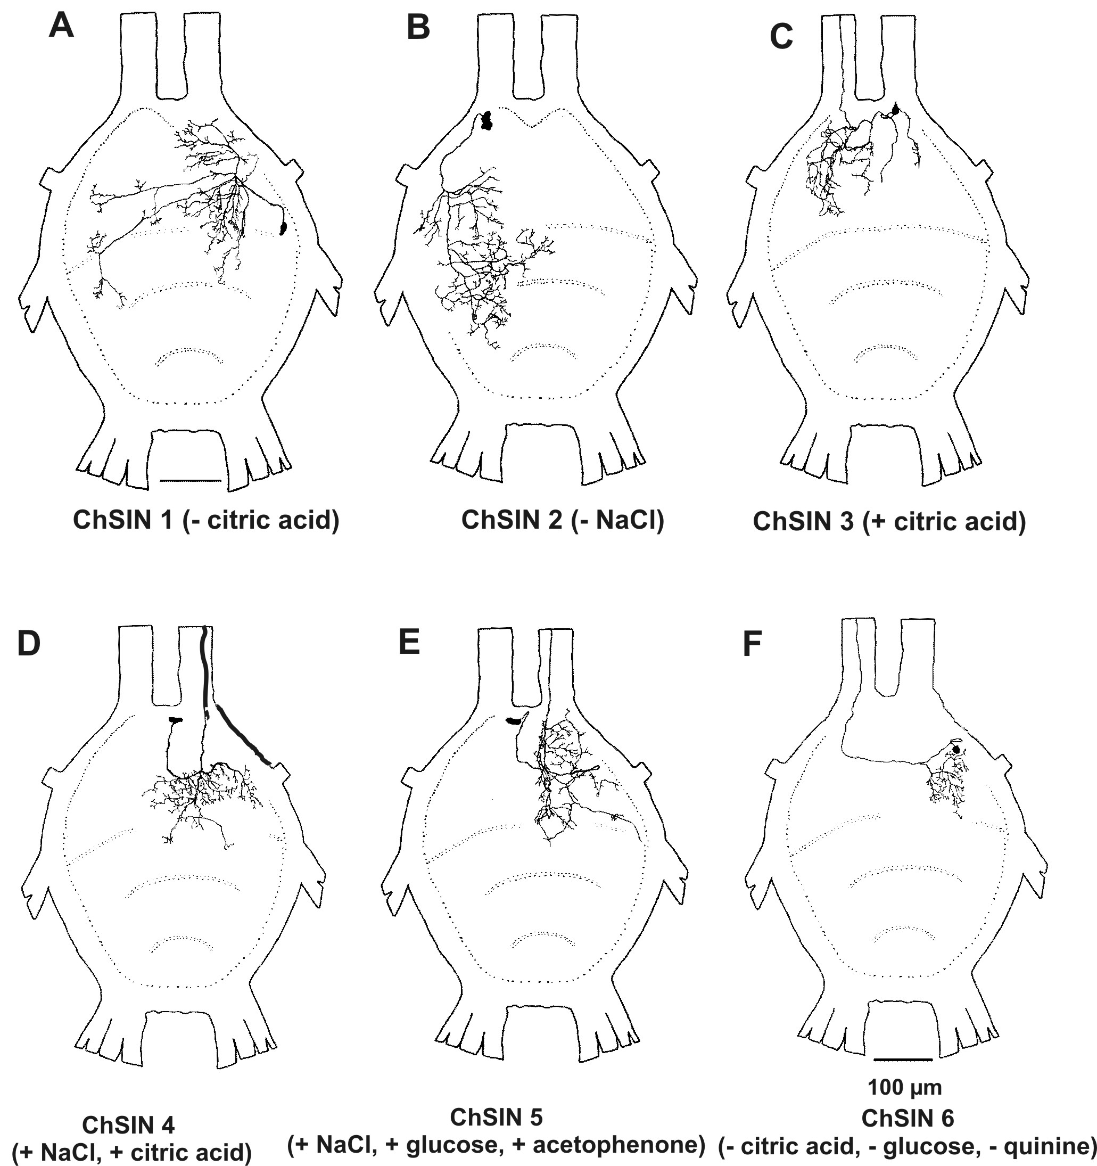
Figure 1. Morphological overview of interneurons that integrate chemosensory information (ChSIN) from the locust ovipositor, stained intracellularly with Lucifer yellow in the terminal ganglion (dorsal view).
A. ChSIN 1 (inhibited by glucose) is a local interneuron branching ipsilateral to the soma in the posterior 8th, the 9th and anterior 10th neuromere. A single contralateral branch also crosses the midline. B. ChSIN 2 (inhibited by NaCl) is an extensive local interneuron with a very lateral soma (in 9th neuromere) branching ipsi- and contralaterally in the 8th and the 9th neuromere. Two main branches cross the midline and extend there far into the contralateral neuropil. C. ChSIN 3 (excited by citric acid) is a projecting interneuron of with contralateral extensive neuropile branching in the 8th neuromere and a contralateral ascending axon. In the ipsilateral 8th neuromere only few branches extend from the primary neurite of the soma. D. ChSIN 4 (excitedby NaCl and citric acid) is a projecting interneuron with an almost median soma, extensive ipsilateral neuropile branching in the 8th neuromere and some branches in the 9th neuromere and across the ganglion midline. The ascending axon extends ipsilaterally. E. ChSIN 5 (excited by NaCl, glucose and acetophenone), with an almost median soma in the 8th neuromere and all other structures extending contralaterally, branches extensively in the 8th neuromere and sparse branching in the 10th while its axon ascends medially. F. ChSIN 6 (inhibited by citric acid, glucose and quinine) with a lateral soma and restricted neurite branching in the posterior 8th neuropile and with an ascending contralateral axon without branching.

3.1 Responses to water at the interneuron level
Responses to application of pure water to basiconic sensilla of the ventral ovipositor were only observed in several larger ascending interneurons (receptor tip recording not possible) (Fig. 2). Their summated extracellular responses are mainly phasic, but cannot be counted or separated as identifiable units. In spite of their intensity none of these could be identified with intracellular methods. It would be interesting to see whether they respond to chemically inert substrates containing different levels of moisture.
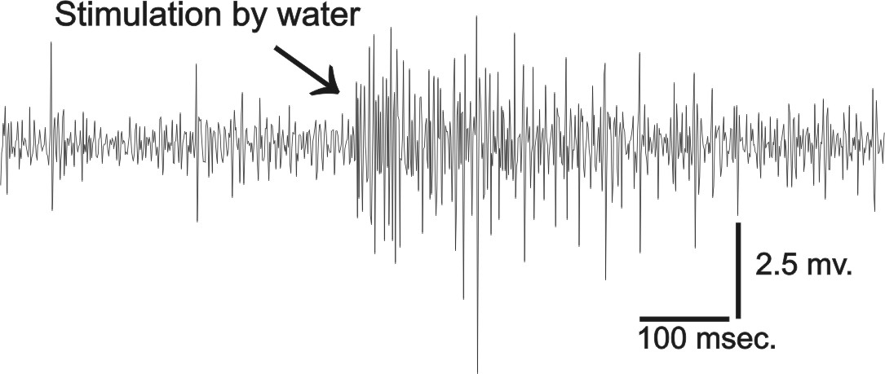
Figure 2. Interneuron responses recorded from the ascending connective of the terminal ganglion during stimulation of the ventral ovipositor with water. At least three units respond phasically.

3.2 Responses to salts
3.2.1 Receptor level
The response to salt in single basiconic sensilla of the ventral ovipositor is phasic with two main units, possibly one for salt and one for water at the concentration of 0,1M sodium chloride (Fig. 3A). Sometimes initially as a third class of afferent units, very large spikes arise (shortly after a contact artefact) from the mechanosensory neuron at the moment of contact.

3.2.2 Interneurons extracellularly

Responses of ascending interneurons to sodium chloride were tested at concentrations of 0.01M to 3.0M (Fig 4A - 4C). Typically, at least three interneurons responded, recognised from their three different unit amplitudes. It cannot be distinguished to which sensory cue contained in the stimulus (mechanosensory, salt and water) the responses are specific. The spiking frequency increases with stimulus concentration up to 1.0M sodium chloride (Fig. 4C). Beyond this concentration, the response by salt-sensitive interneurons remains at a constant level. Rapid adaptation within three seconds occurs at low concentrations while extended adaptation is typical for higher salt concentrations (six seconds for 1.5M sodium chloride).
3.2.3 Interneurons intracellularly
Excitatory responses to salt stimulation (0.1M NaCl) was seen in two ascending interneurons (ChSIN 4/5, Fig. 5 A/B) located in the 8th neuromere of the terminal ganglion with near-midline somata, one ipsi- and one contralateral to the ascending axon and neuropile branching, and only a few posterior branches extending into the ninth neuromere (Fig.1 D/E). The response to stimulating just one basiconic sensillum was phasic with a long tonic after-discharge in ChSIN5 and just phasic in ChSIN4. A third salt-responsive interneuron (ChSIN 2) responded with some inhibition of ongoing activity (Fig. 5C). This local interneuron (Fig.1B) it exhibits a completely different branching pattern extending from a very lateral soma: wide ipsilateral branching in the eighth and ninth neuromere and two separate contralateral neurites reaching far laterally into the ninth and eighth neuromere.

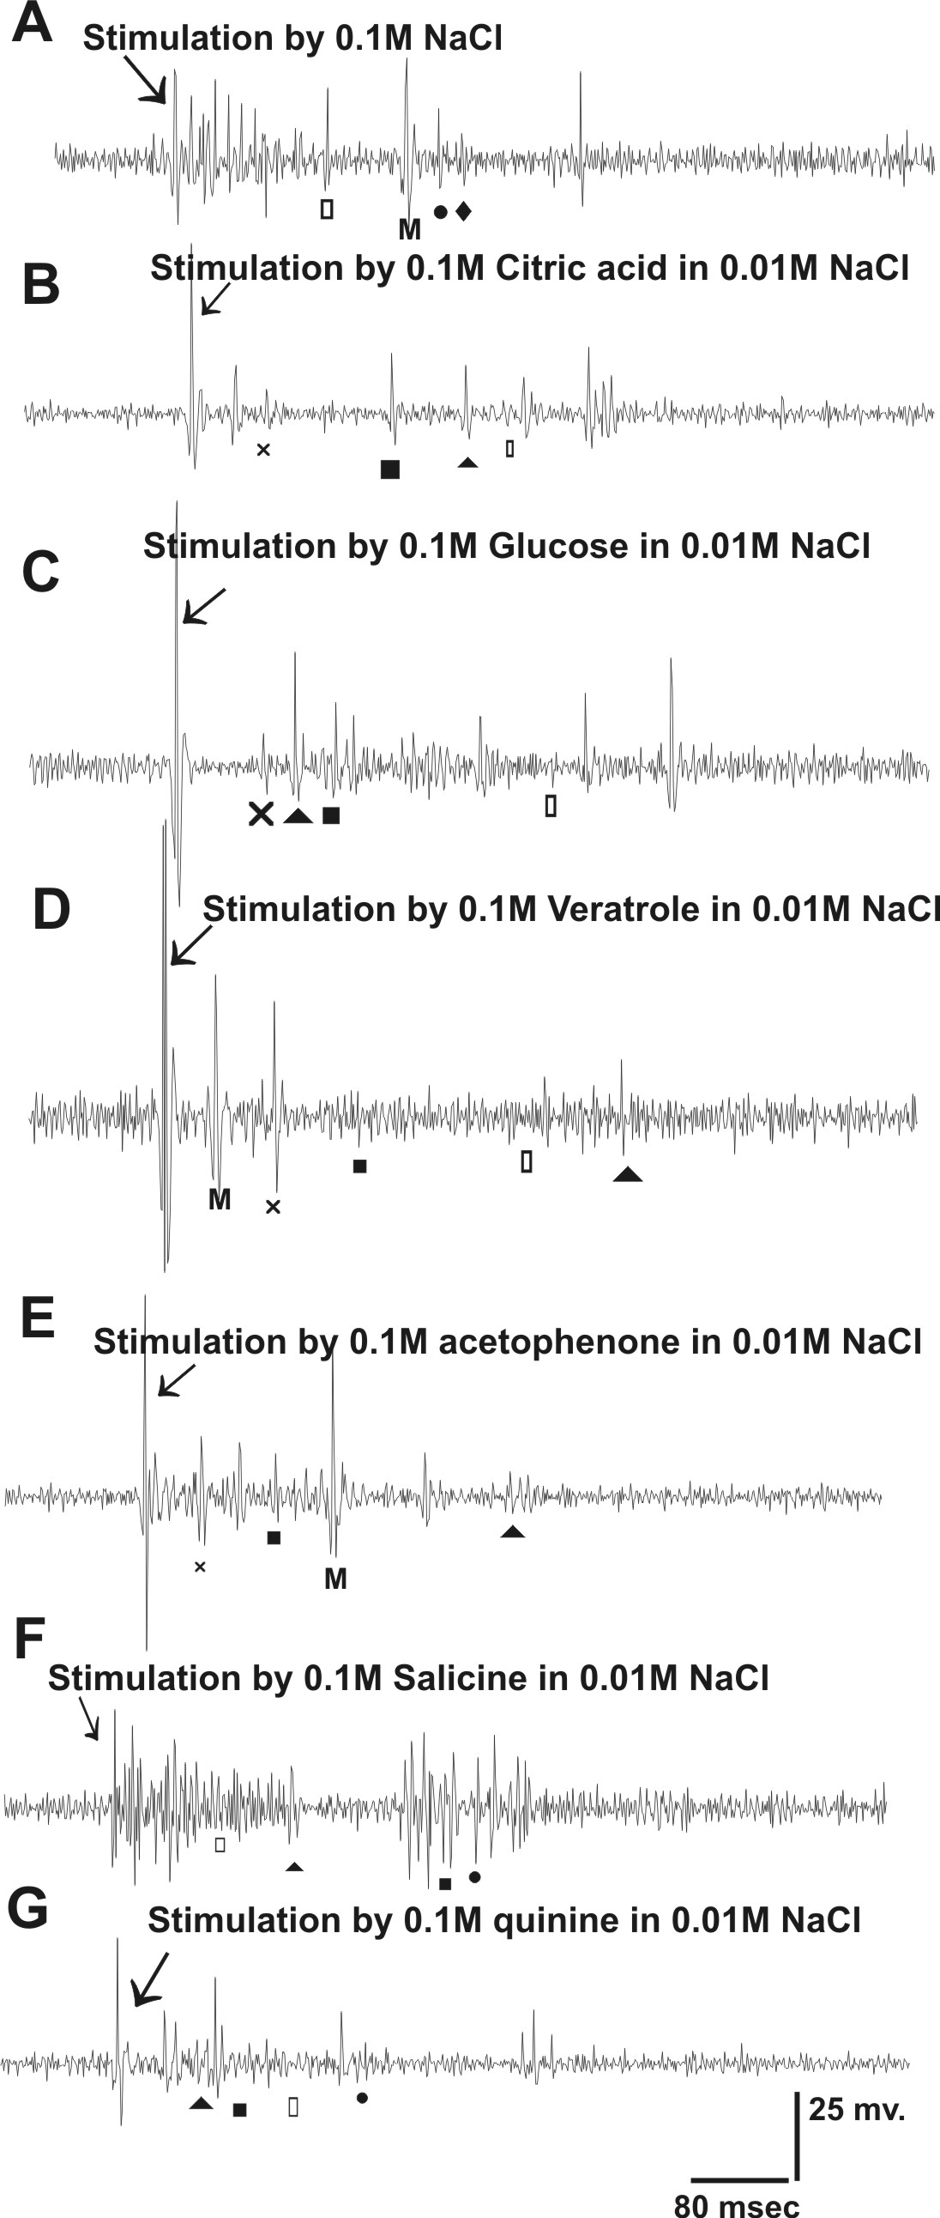

Figure 3. Extracellular responses (recording from the tip of the ventral valve basiconic sensillum) to ovipositor valve stimulation with different kind of chemical substances. A. Stimulation by 0.1M NaCl; B. Stimulation by 0.1M citric acid in 0.01M NaCl; C. Stimulation by 0.1M glucose in 0.01M NaCl; D. Stimulation by 0.1M veratrole in 0.01M NaCl; E. Stimulation by 0.1M acetophenone in 0.01M NaCl; F. Stimulation by 0.1M salicine in 0.01M NaCl; G. Stimulation by 0.1M quinine in 0.01M NaCl

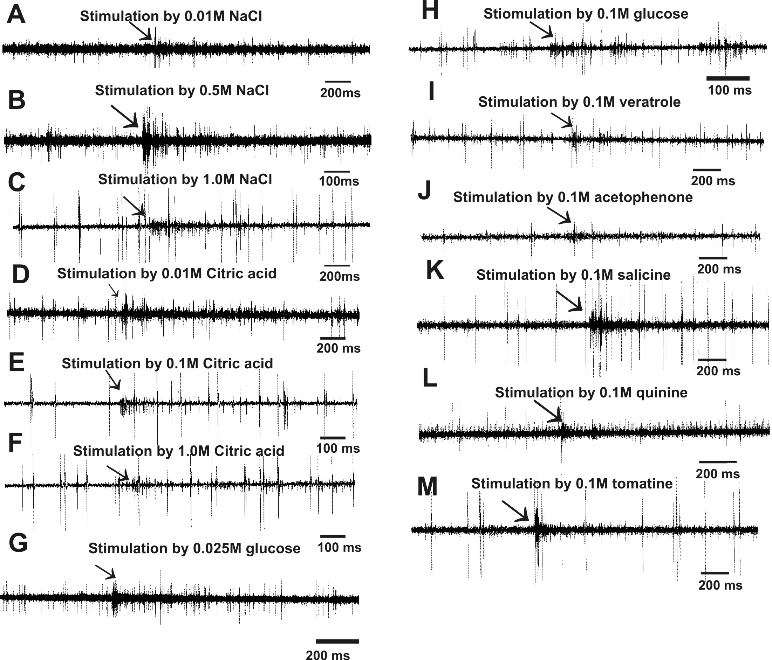

Figure 4. Extracellular responses (recording from the connective between the 7th and terminal abdominal ganglia) to single basiconic sensilla in ventral ovipositor valve stimulation with different concentration of chemical substances. A-C: Responses from interneurons in the ascending connective of the terminal ganglion after stimulation with different concentrations of NaCl (A. with 0.01M NaCl; B. with 0.1M NaCl, C. with 1M NaCL). D-F: Responses from interneurons in the ascending connective of the terminal ganglion after stimulation with different concentrations of citric acid in water (D. with 0.01M citric acid; E; with 0.1M citric acid; F. with 1M citric acid). G, H: Responses from interneurons in the ascending connective of the terminal ganglion after stimulation with different concentrations of glucose in water (G. with 0.025M glucose; H. with 0.1M glucose). Responses from interneurons in the ascending connective of the terminal ganglion after stimulation with 0.1M veratrole (I); 0.1M acetophenone (J); 0.1M salicine (K); 0.1M quinine (L); 0.1M tomatine (M).

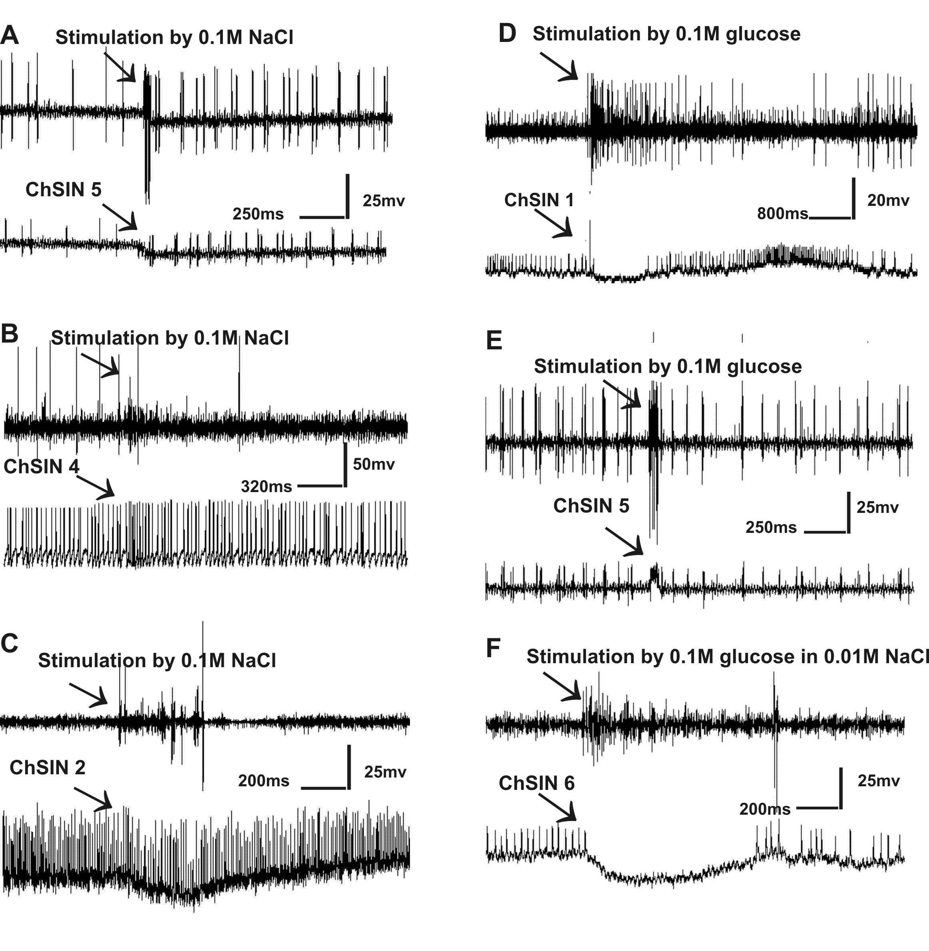

Figure 5A-5C Intracellular responses (lower traces) to ovipositor valve stimulation with 0.1M NaCl in water and extracellular response (upper traces) in 5A. from ChSIN 5, phasic and tonic excitation, 5B from ChSIN 4, phasic excitation; 5C; from ChSIN 2 transient inhibition. 5D-5F: Intracellular responses (lower traces) to ovipositor valve stimulation with 0.1M glucose in water and extracellular response (upper traces) in 5D. from ChSIN 1, transient inhibition; 5E. from ChSIN 5, phasic excitation; 5F. from ChSIN 6, pronounced inhibition

3.3 Responses to acids

3.3.1 Receptor level

The response to citric acid in single basiconic sensilla of the ventral ovipositor is phasic with two main units for citric acid and salt (0.01M sodium chloride serving as electrolyte) and a smaller unit possibly for water (Fig 3B). Initially, as a fourth class of afferent unit's very large spikes arise from the mechanosensory neuron at the moment of contact.

3.3.2 Interneurons extracellularly

Responses of interneurons to citric acid were tested at concentrations of 0.01M, 0.1M and 1.0M (Fig. 4D - 4F). Typical responses occurring from applying a concentration of 0.1M (Fig. 4E) indicate that only one slowly adapting, ascending interneuron is activated in this specific recording. At higher concentration, the interneurons respond less.
3.3.3 Interneurons intracellularly
The salt-responsive interneuron ChSIN 4 can also respond with increased pasic-tonic excitation to citric acid (0.1M) applied to a basiconic sensillum (Fig. 6A). A morphologically different interneuron (ChSIN 3, Fig. 1C, 6B) responds to the same stimulus concentration with prolonged excitation after a short phasic response. It is also an ascending interneuron with a contralateral ascending axon and an extensive branching area in the 8th neuromere, but some sparse branches extend also in the 8th neuromere ipsilateral to the soma.
A third ascending interneuron ChSIN 6 (Fig. 1F, 6C) responds with inhibition or lowered excitation to citric acid (0,1M) applied to the basiconic sensillum. Its soma is located very lateral and from its long primary neurite the only branching area extends ipsilaterally in the 8th neuromere.

3.4 Responses to sugars

3.4.1 Receptor level

The response to glucose solutions in single basiconic sensilla of the ventral ovipositor is phasic. The two larger units could respond to sugar and the electrolyte salt (0.01M sodium chloride) and a small third unit possibly responds to the water (Fig 3C). Initially, as a third class of afferent units' very large spikes arise from the mechanosensory neuron at the moment of contact.

3.4.2 Interneurons extracellularly

Responses of ascending interneurons to glucose were tested at concentrations between 0.25M and 3.0M. The reaction to glucose (Fig. 4G, 4H) indicates that several units of ascending interneurons respond, two of which can only be responses to sugar due to their concentration-related increase in spiking frequency. At 1.0M glucose applied, a maximum spike frequency was reached and adaptation was very slow (not shown). Beyond this concentration bursting of one neuron in response to glucose is typical.
3.4.3 Interneurons intracellularly
Excitation to glucose stimulation (0.1M) of a ventral ovipositor taste receptor was seen in ChSIN 5 (Fig. 1E; 5E), which responds to salts as well. The response is short and phasic in this multimodal interneuron. Pronounced inhibitory responses were seen in ChSIN 1 (Fig.1A; 5D), which is a local and mostly ipsilateral interneuron that extends from the eighth to the tenth neuromere. Its response is very similar to that of ChSIN 6 (Fig 1F; 5F) to glucose, which is inhibited by citric acid also and has a completely different and intersegmental morphology.
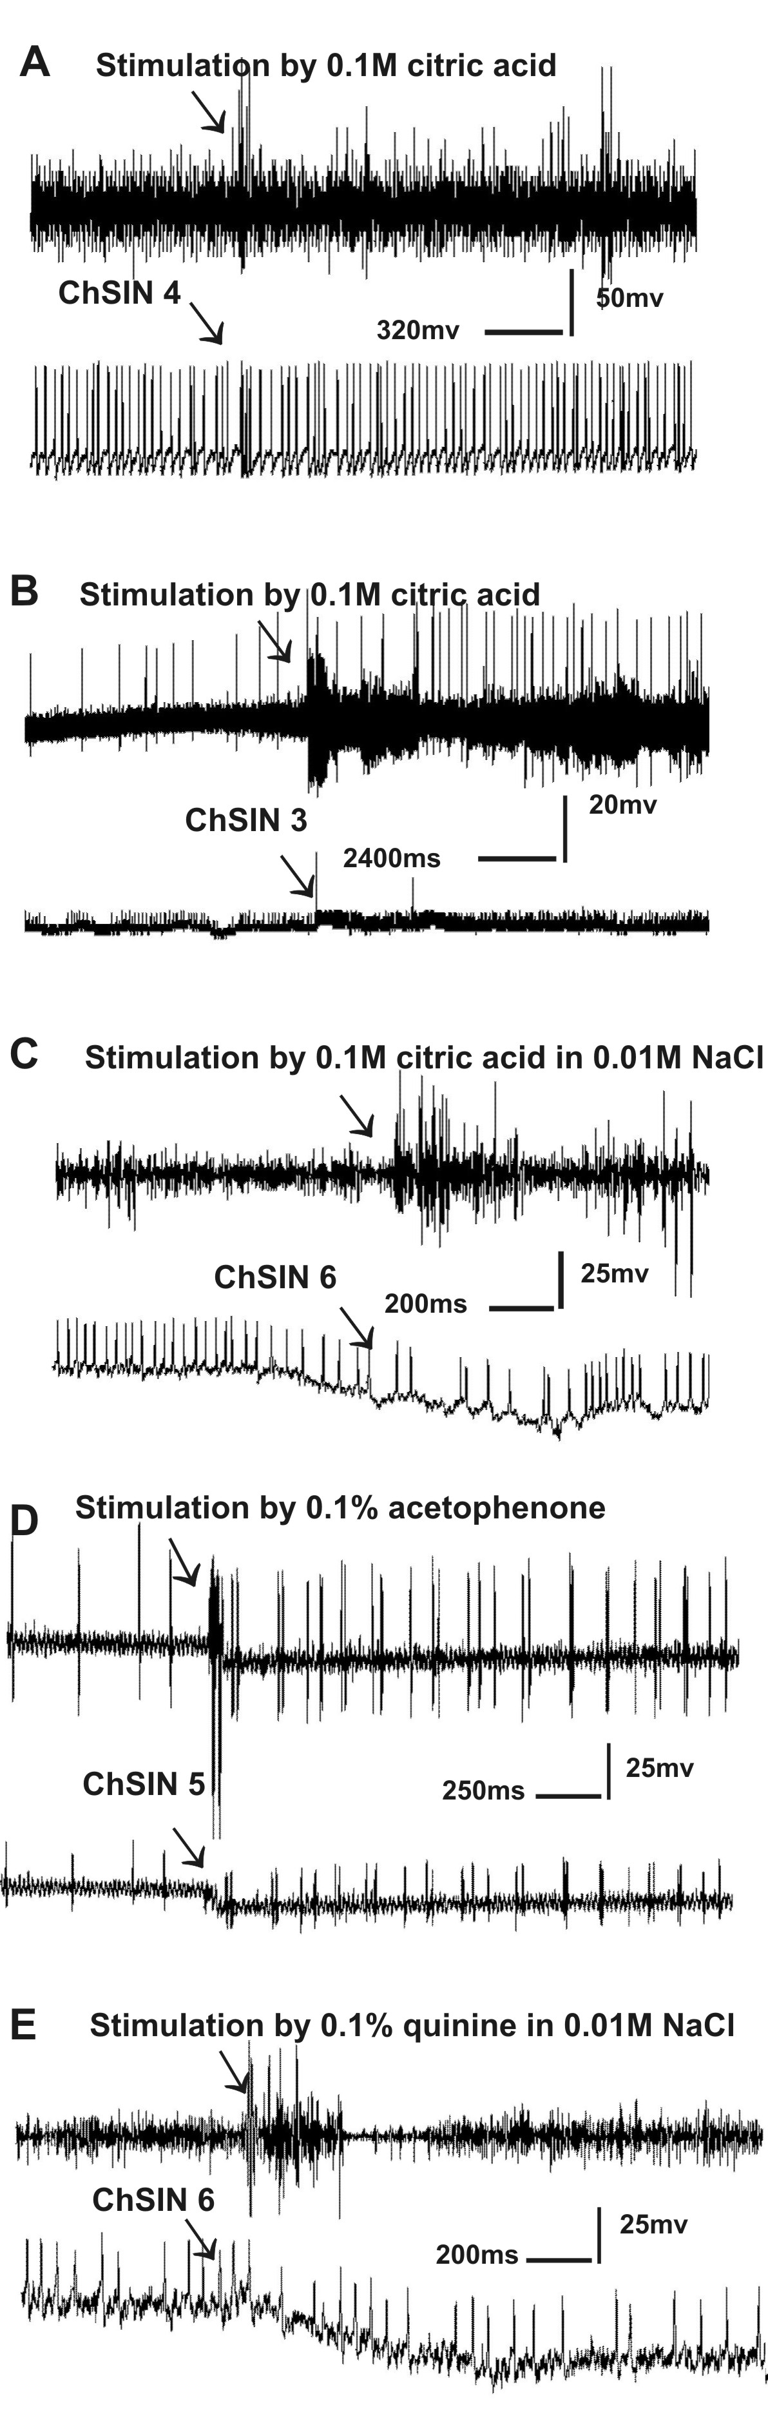
Figure 6A-6C Intracellular responses (lower traces) to ovipositor valve stimulation with 0.1M citric acid and extracellular response (upper traces) in 6A. from ChSIN 4, phasic excitation; 6B. from ChSIN 3, phasic-tonic excitation; 6C. from ChSIN 6 transient inhibition. 6D and 6E. Intracellular responses (lower traces) to ovipositor valve stimulation with 0.1M acetophenone and 0.1M quinine in water and extracellular response (upper traces) in 6D. from ChSIN 5 in response to acetophenone, phasic excitation; 6E. from ChSIN 6 in response to quinine, transient inhibition.

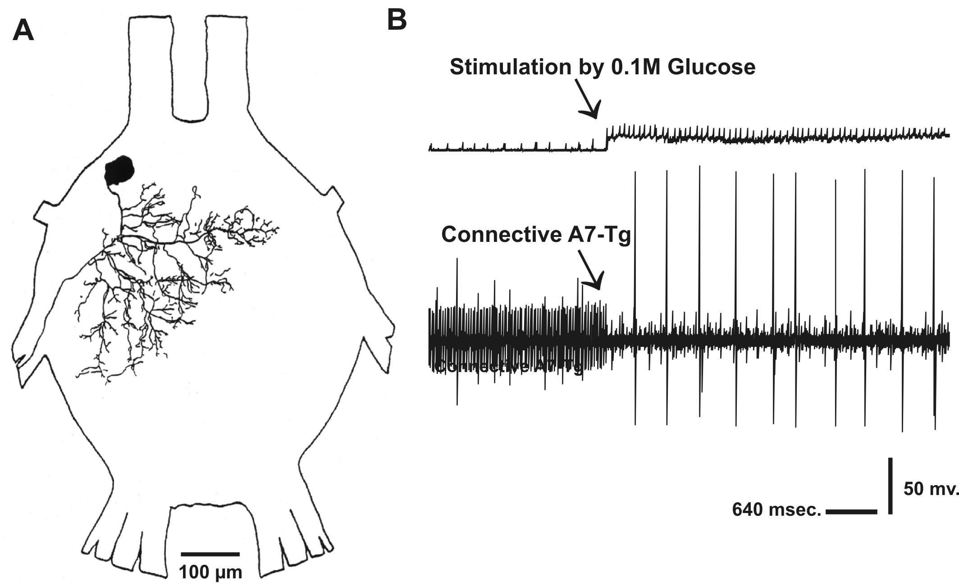

Figure 7. Response of a ventral motoneuron of the 8th neuromere A. Morphological overview; B. Phasic-tonic intracellular response (upper trace) to 0.1M glucose applied to the ventral ovipositor and corresponding activity in the ipsilateral ascending connective (lower trace).

3.4.4 Comparative motor neuron response
For comparison, one motor neuron with chemosensory response in the terminal ganglion was recorded in conjunction with units in the connective ascending from the terminal ganglion when it responded to input from ovipositor chemosensory sensillum (Fig. 7). The cell body (40µm) of this motor neuron is located laterally in the 8th abdominal neuromere and it is characterized by its ipsi- and contralateral dendritic arborisations in the 8th and 9th neuromere. The efferent axon enters nerve 8V. Stimulation with 0.1M glucose at the ovipositor excited this motor neuron tonically while simultaneously it released in ascending interneurones of the ipsilateral connective both inhibitory and excitatory responses. No response to other chemicals (salts, acids, alkaloids, phenols) could be elicited in the motor neuron.
3.5 Responses to potentially significant chemicals:

3.5.1 Aggregation pheromones

In response to the aggregation pheromones veratrole and acetophenone (0.1M) solution (Fig. 3D, 3E), only a few spikes were elicited in the basiconic sensillum after the mechanosensory unit has responded first near the contact artefact of stimulus application. They cannot be attributed clearly to specific applied chemicals, but the responses of the ascending interneurones is pronounced especially to veratrole, but less to higher concentrations of acetophenone (Fig. 4I, 4J). Acetophenone-responses were seen to excite tonically the interneuron ChSIN 5 (Fig. 6D, 1E), which is also responsive to salts and sugar.

3.5.2 Alkaloids and phenols
Responses to application of diluted alkaloids as quinine (0.1M) and the phenolic compound salicine (0.1M) to a basiconic sensillum are rather strong and specific (Fig.3F, 3G). Correspondingly, ascending interneurons clearly perceive these types of stimuli (Fig. 4K-4M) and to tomatine as well. Intracellularly, quinine-responsiveness is seen as inhibition in ChSIN 6 (Fig. 1F, 6E), which is also inhibited by citric acid.

4 Discussion
The locust ovipositor valves are the first to encounter fresh substrates both when probing and digging in the substrate. Their contact chemoreceptors can record chemical compounds of the substrate before and during egg-laying. When a chemical component of the substrate elicits responses in interneurons via contact chemoreceptors it can be considered as perceived by the CNS. Primary sensory responses of insect contact chemoreceptors are usually tested by stimulating and recording from the terminal pore of a gustatory hair^{[26]} since extracellular recording directly from the afferent axons of their very small neurons is impossible. We could study both the type of chemicals recorded by the contact chemoreceptors and their perception due to integration by higher order interneurones extra- or intracellularly from the anterior connectives or the neuropile of the terminal ganglion. In this way, taste sensilla can be stimulated by just one chemical diluted in pure water (without the salts added for electrical conduction) or possibly even gaseous chemicals: smells^{[3, 10, 11, 32, 33]}.
When higher order interneurons integrate one or several taste classes their synaptic input sites must collect information from widespread presynaptic terminals of afferents in the neuromeres of the terminal ganglion. Correspondingly, interneurons integrating single classes of taste selectively from non-glomerular structures in the neuropile should have wide branching areas for chemosensory input similar to the interneurons integrating mechanosensory input ^{[3, 4, 34]}. Our intracellular staining showed this for all taste sensitive interneurons especially when they responded to just one taste class. The occurrence of several local (but inter-neuromere) interneurons responsive to tastes indicates local processing of chemical cues for bilateral and inter-neuromere comparison of information which is required before and during oviposition (but possibly also during mating).
The interganglionic projections could not be traced with Lucifer yellow to their full extent rostrally. If we had been able to pursue the long ascending axons we might have encountered the location of the most anterior CNS areas of decision making (brain or thoracic ganglia) that initiate continuation or cancellation of oviposition on the basis of chemical cues perceived on or near the ovipositor.
We have no clue to where in the CNS of locusts commands for initiation, continuation or abandoning of egg-laying originate, while it is clear that most of the motor programs for the muscles are organised in the abdominal ganglia^{[4, 9, 10, 25, 27, 33, 35, 36]} . Therefore, this study could only indicate basal anatomical and physiological features of primary sensory integration from contact chemosensory information of the ovipositor.
4.1 Perceived stimulants
Recording from higher order neurons of the chemosensory pathway originating from taste receptors of the ovipositor has demonstrated that the typical chemical qualities sensed by the primary taste receptors are transferred and perceived separately and jointly in the higher order interneurones of the locust terminal ganglion. Also, other stimulants unknown to us might be perceived by means of isolated taste receptors which have not been included into our testing protocol. The responses seen here fall into the categories wet (water), salty, acid, sweet, bitter (alkaloid-like) and possibly phenolic, all these being typical for taste receptor sensitivity on other locations of the locust ^{[1,3, 10, 14, 18, 20, 27]}. So presently, we must assume that the gustatory basis for the locust decision to start, continue or terminate oviposition depends on combinations and concentrations of these basic tastes perceived on or in the substrate. We also are curious to know whether functionally the taste sensitive interneurons subserve local and restricted abdominal reflexes only or whether they contribute the perception of taste that underlies behavioural decisions.
4.2 Selective and cumulative pathways
How the different chemical cues arising from the receptor level are utilized remains uncertain since tendencies in two different directions of neural processing appear: interneurons responding to just one type of stimulus can transfer this information further to centres of motor or behaviour decisions while other interneurons do the same for combinations of stimuli that might serve the perception of combined repulsive or attractive chemical stimuli for egg-laying behaviour.

Reference
- White PR, Chapman RF. Tarsal chemoreception in the polyphagous grasshopper Schistocerca americana. Behavioral assays, sensilla distributions and electrophysiology. Physiology Entomology 1990; 15: 105 – 121.
- Newland PL, Burrows M. Processing of mechanosensory information from gustatory receptors on a hind leg of the locust. Journal of Comparative Physiology 1994; 174: 399-410
- Newland PL. Avoidance reflexes mediated by contact chemoreceptors on the legs of locust. Journal of Comparative Physiology 1998; 183: 313-324.
- Tousson E. Neural processing of chemosensory information from the locust ovipositor. Ph.D. Goettingen University, Germany, 2001.
- Chapman RF. Contact chemoreceptors in feeding by Phytophagous insects. Annual Review Entomology 2003; 48: 455-484.
- 24-6 Rogers SM, Newland PL. Taste processing in the insect nervous system. Advanced Insect Physiology 2003; 31: 139-204.
- Opstad R, Rogers S, Behmer T, Simpson S. Behavioural correlates of phenotypic plasticity in mouthpart chemoreceptor numbers in locusts. Journal of insect Physiology 2004; 50: 725-736.
- Hallem E, Dahanukar A, Carlson J. Insect odour and taste receptors. Annual Review of Entomology 2006; 51: 113-135.
- Tousson E, Youssef Z. Innervation, Central Projections and Intersegmental Interneurons with Chemosensory Inputs from the Locust Subgenital Plate Hair Receptors. Egyptian Journal of Experimental Biology (Zoology) 2006; 2: 21-31.
- Newland PL, Yates PI. Nitrergic modulation of an oviposition digging rhythm of locusts. Journal of Experimental Biology 2007; In Press.
- Ômura H, Honda K, Asaoka K, Takasa I. Tolerance to fermentation products in sugar reception: gustatory adaptation of adult butterfly proboscis for feeding on rotting foods. Journal of Comparative Physiology 2008; 194:545-555.
- Dethier VG. The hungry fly. A physiological study of the behaviour associated with feeding. Harvard Univ. Press, 1976.
- Newland PL. Processing of gustatory information by spiking local interneurones in the locust. Journal of Neurophysiology 2000; 82: 3149-3159.
- Gaaboub I, Schuppe H, Newland. Receptor sensitivity underlies variability of chemosensory evoked avoidance movements of the legs of locusts. Journal of Comparative Physiology 2005; 191: 281-289.
- Ma WC, Schoonhoven LM. Tarsal contact chemosensory hairs of the large White butterfly Pieris brassical and their possible role in oviposition behaviour. Entomologie Experimentalis et Applicata 1973; 16: 343-357.
- Städler E, Renwick JA, Radke CD, Sachdev-Gupta K. Tarsal contact chemoreceptor response to glucosinolates and cardenolides mediating oviposition in Pieris rapae. Physical Entomology 1995; 20: 105-121.
- Dougherty MJ, Guerin PM, Ward RD. Identification of oviposition attractants for the sandfly Lutzomyia longipalpis (Diptera: Psychodidae) in volatiles of faces from vertebrates. Physiological Entmology 1995; 20: 23-32.
- Gaaboub I, Hustert H. Motor response to chemical stimulation of tarsal sensills in locusts. Proceeding of the 26 th Göttingen Neurbiology conference 1998; 26 (1): p. 336.
- Tousson E, Gaaboub I, Hustert, H. Response characteristics and specificity of contact chemoreceptors from different sites in Locusta migratoria. Proceeding of the 27 th Göttingen Neurbiology conference 1999; 27 (2): 348.
- Gaaboub I, Tousson E. Ultrastructure and Electrophysiological Studies on the Sense Organs of the Cotton Leaf Worm Spodoptera littoralis (Boisd.). Egyptian Journal of Experimental Biology (Zoology) 2005; 1: 167 – 176.
- Newland PL, Rogers SM, Gaaboub I, Matheson T. Parallel Somatotopic Maps of gustatory and mechanosensory neurons in the central nervous system of an insect. Journal of Comparative neurology 2000; 275: 82-96.
- Tousson E, Hustert H. Contact chemoreceptors from different sites have different projection patterns in the locust terminal ganglion. Proceeding of the 26 th Göttingen Neurbiology conference 1998; 26 (2): 377.
- Tousson E, Hustert H. Central projections from contact chemoreceptors of the locust ovipositor and adjacent cuticle. Cell Tissue Research 2000; 302:285-294.
- Rogers SM, Newland. Gustatory processing in thoracic local circuits of the locust. Journal of Neuroscience 2002; 22: 8324-8332.
- Tousson E, Gaaboub I. neuroanatomical and electrophysiological relationships between sensory afferent arborizations in the locust paraproctal sensory systems. The 3rd Pros ICBS, 2004; 3: 595 – 614.
- Hodgson ES, Lettvin JY, Roeder KD. Physiology of a primary chemoreceptor unit. Science 1955; 122: 417-418.
- Gaaboub I. Neural processing of chemosensory information from the locust legs. Ph.D. Goettingen University, Germany, 2000.
- Blaney WM. Electrophysiological responses of the terminal sensilla on the maxillary palps of Locusta migratoria to some electrolytes and non-electrolytes. Journal of Experimental Biology 1974; 60: 275-293.
- Blaney WM. Behavioural electrophysiological studies of taste discrimination by the maxillary palps of larvae of Locusta migratoria. Journal of Experimental Biology 1975; 62: 555-569.
- Tousson E. Neuroanatomical and electrophysiological studies of identified contact chemoreceptors on the ventral ovipositor valve of 3rd instar larvae of lubber grasshoppers (Taeniopoda eques). Zoology 2004; 107: 65 –73.
- Roper SD. The cell biology of vertebrate taste receptors. Annual Review of Neuroscience 1989; 12: 329-353.
- Lefebvre L. Grooming in crickets: timing and hierarchical organization. Animal Behaviour 1981; 29: 973-984.
- Tousson E, Hustert H. The Intersegmental Network of Afferents in the locust abdominal ganglia. Cell Tissue Research 2006; 325: 151-162.
- Kalogianni E. Morhology and physiology of abdominal intersegmental interneurones in the locust with mechanosensory inputs from ovipositor hair receptors. Journal of Comparative Neurology 1996; 366: 656-673.
- Belanger JH, I Orcha. The role of sensory input in maintaining output from the locust oviposition digging central pattern generator. Journal of Comparative Physiology A , 1992; 171: 495-503.
- Thompson KJ. Oviposition digging in the grasshopper, functional anatomy and motor program Journal of Experimental Biology 1986; 122:387-411.

