Cloning and Higher Expression of Recombinant Human
Insulin-like Growth Factor-1
Yan Yuqing*¹, Xiao Minghui², Sun Hongmei¹, Zhu Hongjie²
¹College of Life Science and Technology in Harbin Normal University 150080; ²Harbin Pharmaceutical Group Bioengineering Co., LTD

Received April 24, 2009
______________________________________________________________________________________________
Abstract
Insulin-like Growth Factor (IGF) is a type of important growth factor, of which chemical structure is similar to proinsulin. There are two relative polypeptides - IGF-1 and IGF-2. This study aims to produce high yield viable IGF-1 using genetic modification and various other methods. [Life Science Journal. 2009; 6(3): 32– 36] (ISSN: 1097 – 8135)

Key words: IGF-1; fusion protein; higher expression; serum free culture medium

______________________________________________________________________________________________

1. Introduction
IGF-1and IGF-2 which belongs to the IGF family play a significant role in the proliferation, differentiation, apoptosis, and growth of tissues, generated and developed of tumor cells. IGF-1 in particular has a special role in influencing cell growth. It correlates with the occurring of diseases such as cardiovascular disease, metabolic syndrome, diabetes, insulin antagonistic. Due to the fact that IGF has properties that low protein expression and difficulty to isolated.
In 1957, Salmon and Daughaday^{[1]} first found that IGF-1 and IGF-2 could promote the cartilage to absorb 35s in sulphate. They named them as sulphation factors ^{[2]}. In 1963, Froesch^{[3]} described them as NSILA1 and 2.
In 1972, they were named as Somatomedin ^{[4]}. In 1976, Rinderknecht and Humbel ^{[5]} isolated two active factors. They shared high degree of structural homology with insulin. They renamed them as insulin-like growth factor-1 and insulin-like growth factor-2 (IGF-1 and IGF-2) ^{[6]}. In 1978, Rinderknecht and Humbel identified the structure and characteristic of IGF-1 and IGF-2^{[7]}.
In this research we isolate the total RNA from healthy human placenta tissues. Based on the records of IGF-1 from GenBank, reference number A29117, the primers were designed and a 227bp IGF-1 segment was gotten through Reverse Transcription PCR methods. After sequence identification, the homologous was 99%

compare with A29117 coden region of IGF-1 polypeptide. The experiment constructed pET-32a-IGF-1
Fusion Protein Expression Vector, and uses Ampicillin
resistance selection, PCR amplification and enzyme cutting to confirm linkage. IPTG was then used to induce the expression of target protein. Analysis of the sequence showed that the target protein didn’t express well was due to rare codons interference. Hence, using contig PCR methods to get a gene and constructed a pET-32a-rIGF-1, inducing higher expression after transformation, expression level up to 38%. The protein was purified using his-tag affinity column chromatography, then putted it into CHO cells culture and confirmed its bioactivity in cells. It has an activity to stimulate cell proliferation.

2. Materials and Reagents
E.coli JM109, E.coli BL21 bought from TAKARA biotechnology (Dalian) Co. Ltd. Plasmid: pMD18-T form TAKARA biotechnology (Dalian) Co. Ltd. pET-32a (+) bought from Novagen Company. Cell: CHO cell system supplied by Company: Harbin Pharmaceutical Group Biological Engineering Co., Ltd.

Cloning and expression of hIGF-1
We isolated the total RNA from healthy human placenta tissues. The primers were designed and a 227bp IGF-1 segment was gotten through Reverse Transcription PCR methods.Primers:

p1:ccatgg ggaccggagacgctctgcggggctg
ncoⅠ
p2: CTCGAG ctaAGCTGACTTGGCAGGCTTGAGG
XhoⅠ
Reaction conditions:
10×ExBuffer 2.5μl
dNTPs （2.5mmol/L） 2.0μl
P1 （10μM） 1.0μl
P2 （10μM） 1.0μl
Ex Taq （5U/μl） 0.5μl
Template（﹤1μg/μl） 1.0μl
ddH₂O 17μl
total volume 25μl

94℃ 5min
94℃ 30s
60℃ 30s 30 circles
72℃ 30s
72℃ 10min
4℃ ∞
Linked the gene with pMD18-T vector, then transformed into E.coliJM109.
Constructed pET-32a-IGF-1 Fusion Protein Expression Vector used Ampicillin resistance selection, PCR amplification and enzyme cutting to confirm linkage.
SDS-Polyacrylamide Gel Electrophoresis
Preparation of the separate solution and condensable solution
Separate solution: Table 1-1 component of the 12% polyacrylamid separate solution.
Condensable solution: Table 1-2 component of the polyacrylamid condensable solution.
Electrophoresis buffer:
5ⅹTris- Glycin electrophoresis buffer:
Tris-base 15.1g
Glycine 94g
10%SDS 50ml
pH 8.3
Water till 1000ml
Modification, clone and expression of IGF-1 gene
After small amount of the gene expression, it was found that the low expression of the target gene even changed the express condition. Through the rare codons analyses, we designed and synthesized 3 DNA single strands and called IGFa, IGFb, IGFc and 2 PCR primers: pup, plow. Used contig PCR methods to get a gene and called it rIGF-1.
IGFa：
5’-ggcccggaaaccctgtgcggcgcagaactggtggatgcactgcagtttgtgtgcggcgatcgcggcttttatttcaacaaacc-3’
IGFb：
5’-agctgcgaaagcagcattcatccacaatgccggtctgcggcgcgcggcgactgctggagccatagccggtcggtttgttgaaat-3’
igfc：
5’-aatgctgctttcgcagctgtgatctgcgccgcctggaaatgtattgcgcgccgctgaaaccggcgaagtcagca-3’
pup: ccatgg gcccggaaaccctgtgcggcgcag
plow:CTCGAGCTATGCTGACTTCGCCGGTTTCAG
Dissolved the synthetic gene segment with the sterile water to run PCR reaction, then after enzyme cutting identification, we constructed the expression vector to express the gene.
Bioactivity Test of rIGF-1
Purified the target protein
Processing the cell break, inclusion body washing, dissolving, renaturation and then purified the fusion protein. Take out the renaturation solution from 4℃. Centrifuge in 30mins with 5000rpm and removal the hybridprotein. Put the supernatant into a clean triangular flask to process the His-tag column purification.
Balanced solution: 20mM sodium phosphate, 0.5M NaCl, 5 mM imidazole (pH 7.4).
Elutriant solution: 20mM sodium phosphate, 0.5M NaCl, 0.5 mM imidazole (pH 7.4).
Filtrating with 0.45μm filter membrane after prepare of the solution. Obtain the target protein through enzyme cutting and process the serum-free cell culture.
Bioactivity test of IGF-1
The concentration of the IGF-1 is 0.76mg/ml through the testing of UV spectrophotometer. Prepared the serum-free medium with the final concentration as 100μg/ml、50μg/ml、25μg/ml to test the activity of insulin.
Put the serum-free DMEM as negative control, and the DMEM with 25μg/ml IGF-1 as the positive control.

Table 1-1 component of the 12% polyacrylamid separate solution

Content | water | 30% acrylamide | 1.5M Tris-HCl (pH8.8) | 10%SDS | 10% Ammonium Persulfate | TEMED
（ml） | 1.28 | 1.6 | 1.04 | 0.04 | 0.04 | 0.004

Table 1-2 component of the polyacrylamid condensable solution

Content | water | 30% acrylamide | 1.0M Tris-HCl (Ph6.8) | 10%SDS | 10% Ammonium Persulfate | TEMED
（ml） | 1.4 | 0.33 | 0.25 | 0.02 | 0.02 | 0.002
Preparation of the medium:
DMEM basic medium
DMEM+100μg/mlIGF-1
DMEM+50μg/mlIGF-1
DMEM+25μg/mlIGF-1
DMEM+25μg/ml insulin.
Adherent culturing the CHO cell with 3-4 generation with good cell shape and stable condition, then digest the cell from 24 pores plate, and removal the digestive juice. Culturing the cell with the five different medium, observe the cell with micro. Use the blood cell counting chamber to calculate the cell amount per ml and the motility rate of the cell.

3. Result and Analysis
Cloning and Expression of hIGF-1
A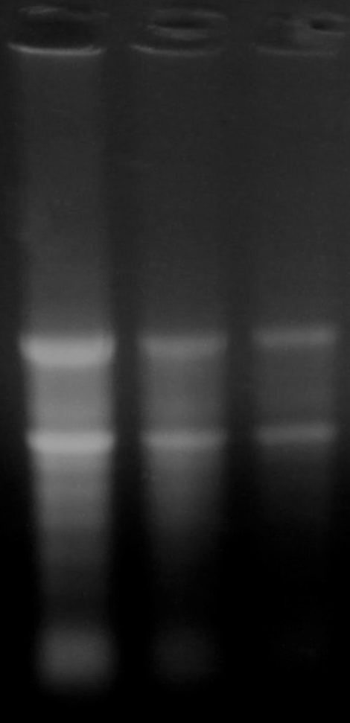B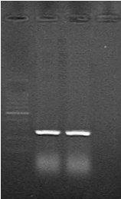
5s
28S
18S
1 2 3
227bp
M 1 2 3
200bp
C
Figure 1-A. Isolation of total RNA from placenta. B. PCR Agarose gel electrophoresis analysis of IGF-1 gene. M: 100 ladder, 1-2: DNA strip, 3: Blank. C. Comparison of nucleotide sequence of IGF-1.

SDS-PAGE of the IGF-1
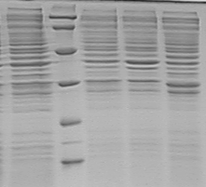
1 M 2 3 4
Figure 2. pET-32a-IGF-1SDS-PAGE.
1: Un-induced, M: LMAP Maker, 2: Induced for 2h, 3: Induced for 3h, 4:Induced for 4h.

Modification, Clone and Expression of IGF-1
Modification of the gene sequence
Sequence after the modification:
ggc CCG GAA ACC CTG TGg GGC GCA GAA CTG GTG GAT GCA CTG CAG TTT GTG TGg GGC GAT CGC GGC TTT TAT TTC AAC AAA CCG ACC GGC TAT GGC TCC AGC AGT CGC CGC gcg CCG cag ACC ggc ATT gtg gat GAA tgg tgg TTT CGC agc tgg gat CTG CGC CGC ctg GAA atg tat tgg GCG CCG CTG AAA CCG GCG aag tca GCA tag
A
B
Figure 3-A. Comparison the nucleotide sequence of rIGF-1 and IGF-1. 3-B. Comparison of the amino acid sequence of rIGF-1 and IGF-1.

Cloning and Expression of the Modified Gene
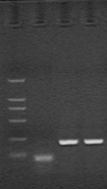
250bp
227bp
M 1 2 3
Figure 4.Slipcing PCR of E.coli preference. M: DL2000, 1: Blank, 2 and 3: PCR result.
Figure 5. Comparison of the sequence of rIGF-1

SDS-PAGE of the Expressed Modified Gene
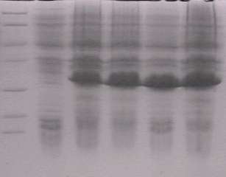
35KD

25KD
25KD
M 1 2 3 4 5
Figure 6. pET-32a-rIGF-1 SDS-PAGE. M: LMWP Maker, 1: Un-induced, 2-5: Expressed protein.
Bioactivity Test of rIGF-1
Purification of the fusion protein.
A
His-tag protein
Sample
B
Figure 7-A. Optical absorption. B. Conduction.

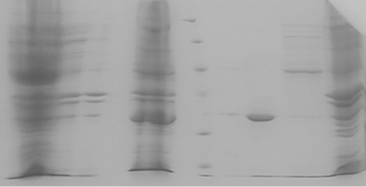
1 2 3 4 5 6 7 8
Purified fusion protein 25KD
Figure 8. Product detection of purification of fusion protein by SDS-PAGE.
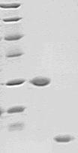
M 1 2
14.4KD
25KD
7.6KD
Figure 9. SDS-PAGE after purification. M: LMWP Marker, 1: Fusion protein before cutting, 2: Target IGF-1.
Bioactivity test
A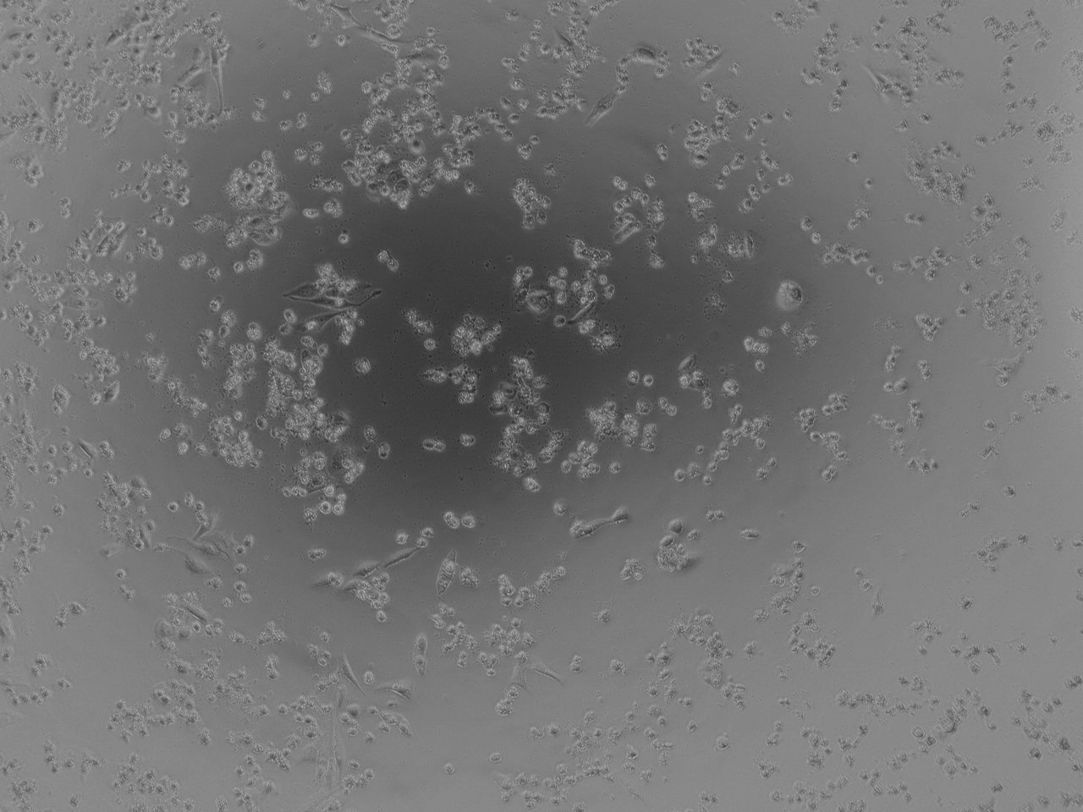B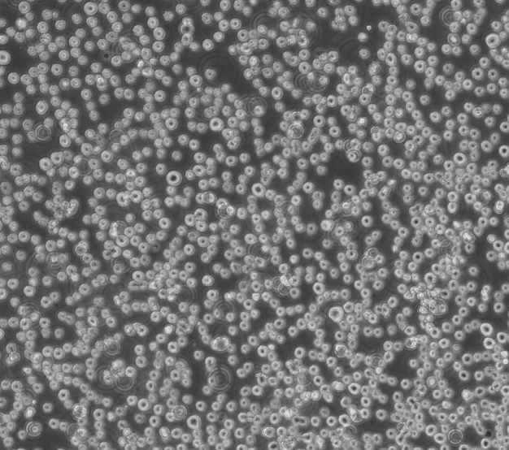
C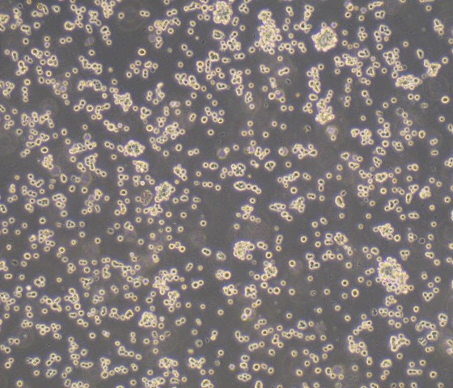D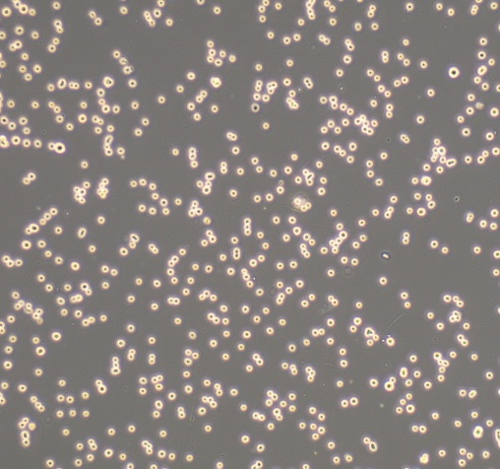
E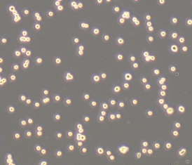
Figure 10-A. Negative control:Dead
cell.B.Positive control.
C.DMEM+100μg/mlIGF-1. D.DMEM+50μg/mlIGF-1.
E. DMEM+ 25μg/mlIGF-1.

4. Discussion
With the rapid develop of biotechnology, the shortage of the prokaryotic expression is coming out. For instance, most of the expressed protein is inclusion body of which has the difficult renaturation and purification. The target cannot process the glycosylation modifications which will influent the function of the protein. More and more researches start to use the eukaryotic cell. And the serum-free medium is the trend of the cell culture.
In this study we obtained the recombinant and high expressed IGF-1 polypeptide which has given the contribution to the serum-free culture.

References:
- Salmon W D, J Daughaday W. A hormonally controlled serum factor which stimulates sulfate incorporation by cartilage in vitro. J Lab Clin Mwd, 1957,49:825-836
- 张应华.核基质结合区MAR调控的胰岛素样生长因子-1表达载体与转化甘蓝的研究.2004.云南农业大学
- Froesch E R , Burgi H. Antibody-suppressible and nonsuppressible insulin-like activities in human serum and their physiologic significance. An insulin assay with adipose tissue of increased precision and specificity[J ] . J Clin Invest , 1963 ,42 :1816 - 1834.
- Daughaday WH ,Hallk. Somatomedin :a proposed designation for the sulfation factor[J ] . Nature , 1972 ,235 :107.
- Rinderknecht E , Humbel R E. Polypeptides with nonsuppressible insulin-like and cell growth promoting activities in human serum: isolation ,chemical characterization and some biological properties of forms1 and Proc Natl Acad Sci, 1976 ,73 :2365-2369.

- 贺淹才. 胰岛素样生长因子的发现及其生理作用. 生命的化学, 1994, 14(3):23-24.
- Rinderknecht E, Humbel R E. The amino acid sequence of human insulin-like growth factor 1 and its structural homology with proinsulin. J Biol Chem, 1978 ,253 :2769 - 2776.

