Title: Potato Seed Production of Cultivar Kufri Himalini, In vitro

Authors: Anoop Badoni* and J. S. Chauhan

Address: Anoop Badoni
Research Scholar and Young Scientist (UCOST)
Department of Seed Science and Technology
Faculty of Agriculture, H. N. B. Garhwal University,
(Chauras Campus), Srinagar- 246 174, Uttarakhand, India

*For correspondence E-mail- annabadoni@yahoo.co.in

J. S. Chauhan
Assoc. Prof. and Head
Department of Seed Science and Technology
Faculty of Agriculture, H. N. B. Garhwal University,
(Chauras Campus), Srinagar- 246 174, Uttarakhand, India

Key words: Tuberization, microtuber, Kufri Himalini, hormonal combination
Abstract

The nodal cuttings of potato cv. Kufri Himalini was cultured in MS medium consisting three different hormonal combinations of GA₃ and NAA (MSH1- 0.25mg/l GA₃+ 0.01 mg/l NAA, MSH2- 0.25mg/l GA₃+ 0.03 mg/l NAA and MSH3- 0.25mg/l GA₃+ 0.04 mg/l NAA) for shoot and root proliferation. After 35-40 days of incubation, shoots in MSH1 (0.25 mg/l GA₃ and 0.01 mg/l NAA) reached 8.28 cm with 9.4 nodes and 11.9 cm root length, higher then all the combinations. For tuberization three concentration of BAP (8 mg/l, 10 mg/l and 12 mg/l) were used with MS liquid medium, the plantlets were shifted to tuberization media and data were reported for the number of microtuber on per original shoot, average weight of microtuber and number of eyes in each microtuber. Formation and development of microtubers were least with 8 mg/l and higher in 10 mg/l BAP concentration, while with the increasing concentration, BAP inhibit the average number, weight and eyes number of microtubers.

Introduction:

Potato is one of the most important crops in the world today. It produces more protein and calories per unit area per unit time and per unit of water than any other major plant food. In all potato growing regions the availability of high quality clean seed tuber has been the most limiting owing to the conventional clonal propagation that favors disease build-up that drastically reduces yield (Gebre and Sathyanarayana, 2001). Conventional propagation of potato is done vegetatively using seed tubers and ensures uniformity of the crop in terms of growth and yield, but results in degeneration of the crop due to virus infection, the rate of degeneration varying from place to place and from cropping season to cropping season (Tadesse, 2000). The viruses are trans-mitted through different ways including through planting infected tubers. If the seed stock is not maintained well or frequently replaced with fresh ones, the virus infiltration can reach up to 100% in 3 - 4 successive crop seasons resulting in almost half or one third yields (Khurana et al. 2001). This is the major problem faced by seed pro-ducers. Conventional seed multiplication methods take a long time and are prone to virus problems (Biniam and Tadesse, 2008).
In the rapid multiplication of clean material in vitro, the use of single nodal cutting is the most preferred method of propagation since it ensure higher propagation rates with maximum genetic uniformity in potato (Chandra and Naik, 1993). The major factors limiting the rates of multiplication in nodal culture are the short height of the plantlets and low number of nodes on plantlets obtained. Improvement has been made possible by addition of growth regulators to the medium. Gas stimulated development of nodal cutting on MS but at high concentration it produced narrow and elongated shoots (Novak et al., 1980) depending on genotype. Longest main shoot and highest node numbers are reported to be obtained in medium containing NAA and BAP (Yousef et al., 1997). Among these methods, the direct use of microtubers has gained a considerable interest owing to their ease of handling, storage and transport of germplasm and reduced period to produce seed tubers (Jones, 1994). Media conditions such as N concentration, sucrose or osmolarity of the medium have either a direct or indirect effect on induction or development processes of in vitro produced microtubers (Garner and Blake, 1989; Khuri and Moorby, 1995).
However, there are limitations both in shoot regeneration and microtuber production. The limitations in many ways are ascribed to the components of the culture environment and to the low photosynthetic ability of the explants or plantlet. Most current systems of microtubers production have problems of obtaining sufficient number and size of microtubers produced per cycle. Thus both shoot and microtuber production systems are still less competitive and economical compared with in vitro rapid multiplication (Gebre and Sathyanarayana, 2001). The aim of present study was to produce the microtuber seed material of potato cv. Kufri Himalini for farmers of Uttarakhand Hills, in different concentrations of BAP with MS media.

Material and Methods:

Shoot proliferation: The shoot proliferation study was done using potato cv. Kufri Himalini, obtained nodal cutting of about 2-4 cm. The medium was prepared using MS (full strength) salts dissolved in double distilled water and consisted 0f 3% sucrose. The pH was adjusted to 5.8 before boiling the medium. Agar was maintained at the standard concentration (8 gm/l). The nodal cutting as explants was cultured in MS medium consisting three different hormonal combinations of GA₃ and NAA (MSH1- 0.25mg/l GA₃+ 0.01 mg/l NAA, MSH2- 0.25mg/l GA₃+ 0.03 mg/l NAA and MSH3- 0.25mg/l GA₃+ 0.04 mg/l NAA). Cultures were than shifted to culture growth room at 25⁰ + 1⁰ c and 16/8 hr photoperiod.

In vitro Tuberization: After shoot development for further proliferation the cultures were cut to size and approx. 5-8 propagules were inoculated in each 250 ml flask containing 50 ml of pre-tuberization media (without agar) and kept with 16/8 hr photoperiod for 25-30 days. For tuberization three concentration of BAP (8 mg/l, 10 mg/l and 12 mg/l) were used with MS liquid medium, the plantlets from pre-tuberization media were shifted to tuberization media and kept at 18⁰±1⁰ C temperature under complete darkness for the duration of 60-80 days depending on the growth of microtubers.

Results:

Shoot proliferation: After 35-40 days of incubation, shoots in MSH1 (0.25 mg/l GA₃ and 0.01 mg/l NAA) reached 8.28 cm with 9.4 nodes and 11.9 cm root length (Table-1). The MSH2 (0.25 mg/l GA₃ and 0.03 mg/l NAA) and MSH3 (0.25 mg/l GA₃ and 0.04 mg/l NAA) combinations respectively having higher concentration of NAA responded the least mean shoot height and number of nodes. In MSH2 shoot height reached 7.1 cm with 8.2 node number and 10.6 cm root length and in MSH3 shoot height reached 6.1 cm with 6.3 node number and 9.4 cm root length.

In vitro Tuberization: In vitro tuberization was obtained after proliferating the culture in pre-tuberization medium (liquid propagation medium) where cultures grew profusely (Plate-1-b). The effect of BAP concentrations with MS medium was studied for microtuber formation and development (Table-2). The perusal of data in Table-2 indicates that the number of microtuber on per original shoot, average weight of microtuber and number of eyes in each microtuber were least with 8 mg/l and higher in 10 mg/l BAP concentration, while with the increasing concentration, BAP inhibit the average number, weight and eyes number of microtubers.

Discussion:

The results of shoot proliferation in the present study are comparable or even better than the most rapid node production (x8 to x10 per month) reported earlier by Hussey and Stacey (1981). The MSH2 (0.25 mg/l GA₃ and 0.03 mg/l NAA) and MSH3 (0.25 mg/l GA₃ and 0.04 mg/l NAA) combinations respectively having higher concentration of NAA responded the least mean shoot height and number of nodes. This could be attributed to the fact that higher concentration of NAA inhibit root and shoot growth (Pennazio and Vecchiati, 1976). The cultures proliferating in MS media were maintained separately for tuber induction.
Pre-tuberization medium composed of MS nutrients, GA₃ and NAA was used following the procedure of Naik and Chandra (1993). Shifting the cultures from pre-tuberization to tuberization stage, cultures were exposed to a major change from vegetative growth phase to reproductive phase leading to tuber development. GA was integral component of pre-tuberization medium but during tuber induction stages, GA was withdrawn as it canalizes all the carbohydrates towards shoot development during pre-tuberization and decrease in GA promotes partitioning of biomass to the tubers (Krauss, 1978). Hence tuber induction could be achieved by withdrawal of GA and addition of GA inhibitor. BA as a GA inhibitor, has been used in varying concentration from 2 mg/l to 10 mg/l and due to its GA inhibitory role and the presence of BA canalize all the resources of plants towards tuberization, i.e anabolic activity rather than elongation of stem, with this idea of GA inhibitory metabolites, triazoles have come up as a suitable tuber inducing substances (Harvey, 1990; Simko, 1994).
The present study confirmed that lower concentration of auxin (0.01 mg/l NAA) with Gibberelic Acid (0.25 mg/l GA₃) is best for development of complete plantlets and 10 mg/l concentration of BAP with MS media was best for microtuber development.

References:
Biniam, T. and Tadesse, M. 2008. A survey of viral status on potatoes grown in Eritrea and in vitro virus elimination of a local variety ‘Tsaeda embaba’, African Journal of Biotechnology, 7 (4) pp. 397-403
Chandra, R. and Naik, P. S. 1993. Potato tissue and cell culture in Potato Research in India, Advances in Horticulture, Chandra, K. L. and Grewel, J. S. (Eds.), pp. 113-141
Garner, N. and Blake, J. 1989. The induction and development of potato microtuber in vitro on media free of growth regulating substances, Annals of Botany 63 pp. 663-674
Gebre, Endale and Sathyanarayana, B. N. 2001. Tapioca-A new and cheaper alternative to agar for direct in vitro shoot regeneration and microtuber production from nodal cultures of potato, Afri. Crop Sci. J., 9 (1), pp. 1-8
Harvey, T. H. 1990. Growth retardants in potato microtuber production, Acta-Agro. Hung. 45, pp. 23-25
Jones, M. B. K. 1994. In vitro culture of potato in Plant Cell and Tissue Culture (eds. Vasil, K. and Thorope, A.), Kluwer Academic Publishers, Dordrecht, The Netherlands, pp. 363-378
Khurana S.M.P., Thind T.S., Mohan, C. 2001. Diseases of Potato and Their Management. In: Diseases of Fruits and Vegetables and Their Management, (ed. Thind TS) Kalyani Publishers, Ludhiana, India.
Krauss, A. 1978. Endogenous regulations mechanisms in tuberization of potato plants in relation to environmental factors, Potato Research 2, pp. 183-193
Naik, P. S. and Chandra, R. 1993. Use of tissue culture techniques in crop improvement with special references to potato, CPRI, Shimla, pp. 110
Novak, F. J., Zadina, J., Horockava, V. and Maskova, I. 1980. The Effect of growth regulators on meristem tip development and in vitro multiplication of Solanum tuberosaum L. plants, Potato Research 23 pp. 155-166
Pennazio, S., and M. Vecchiati, Effect of naphthalene acetic acid on meristem tips development. Potato Research, 1976, 19(3): 232-2341981, 48(6): 787-796.
Simko, I. 1994. Comparison of the influence of some plant growth regulators on acceleration of potato tuberization in vitro, Polnohospodaratvo, 39(5) pp. 409-418
Tadesse, M. (2000). Manipulating the physiological quality of in vitro plantlets and transplants of potato. Ph. D. Thesis, Wageningen University, The Netherlands.
Yousef, A. A. R., M.A. Suwwan, A. M. Musa, and H. A., Abu-Qaoud 1997. In vitro culture and microtuberization of spunta potato (Solanum tuberosum). Dirasat Agri. Sci. 24: 173-181

Table-1: Effect of GA₃+NAA concentrations with MS media on shoot height, node
number, and root length:

Growth regulators (mg/l) Shoot height (cm) Node number Root length (cm)

GA₃ NAA Symbol used

0.25 0.01 MSH 1 8.2 ± 0.5 9.4 ± 1.0 11.9 ± 1.1
0.25 0.03 MSH 2 7.1 ± 0.5 8.2 ± 1.0 10.6 ± 1.0
0.25 0.04 MSH 3 6.1 ± 0.6 6.3 ± 0.9 9.4 ± 1.0

Table-2: Effect of BAP concentration with MS media on in vitro tuberization:

Growth regulator No. of eyes in Average weight of Microtuber no. per
each microtuber microtuber (mg) original shoot
BAP (mg/l)

8 14 (±1.4) 0.342 (±0.02) 4 (±0.7)
10 19.6 (±1.5) 0.450 (±0.02) 6.6 (±0.5)
12 14.4 (±1.1) 0.410 (±0.01) 5.2 (±0.8)

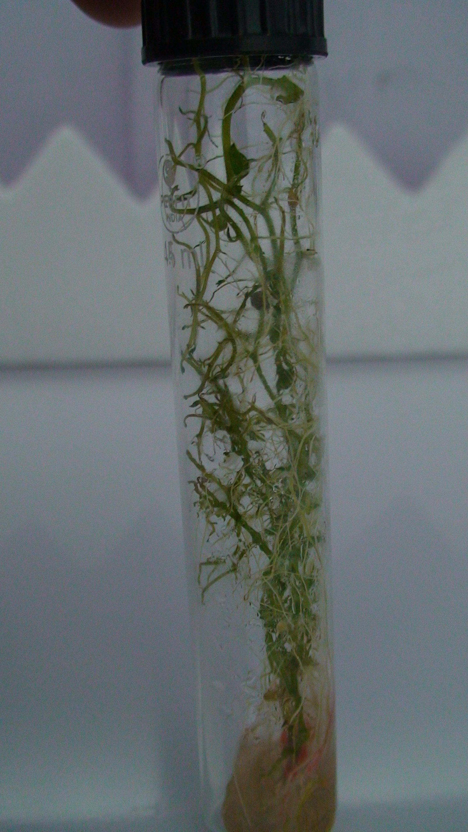a 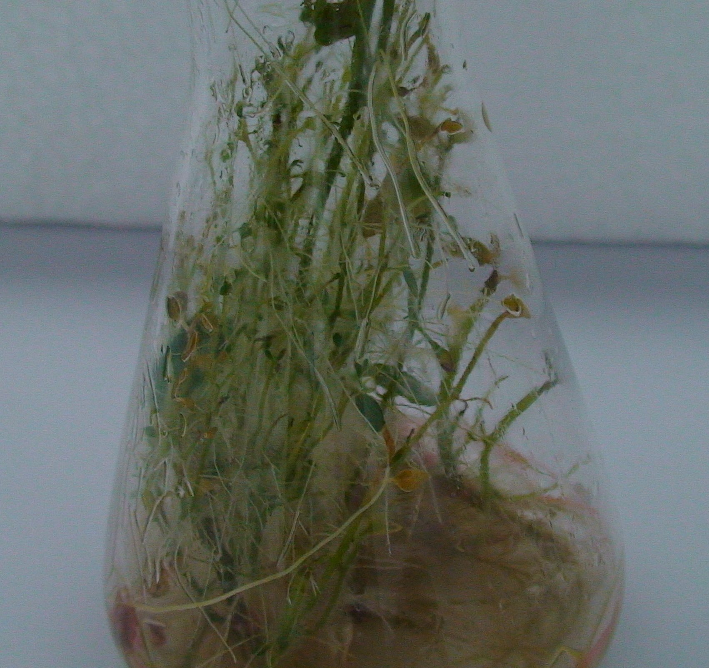b

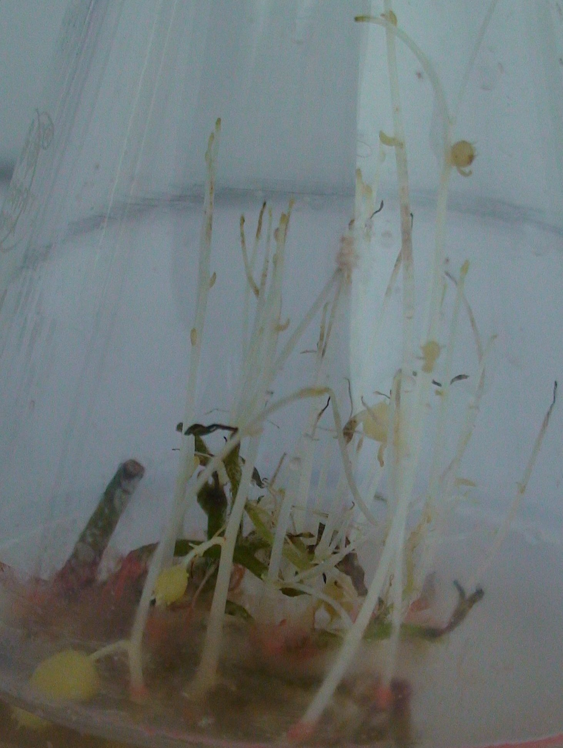c 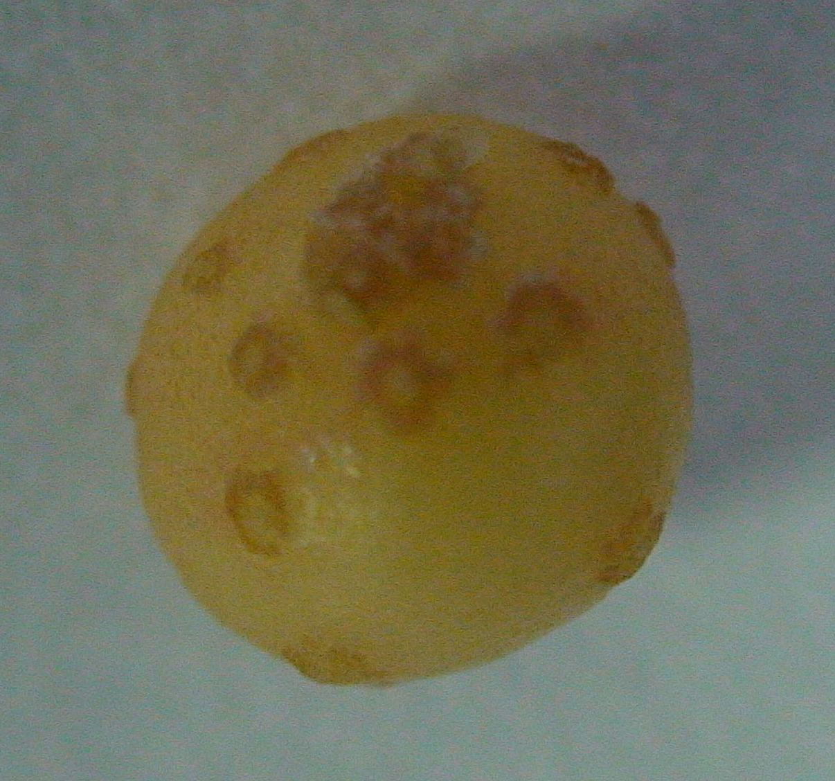d

Plate-1: Seed production of potato cv. Kufri Himalini; (a) Shoot proliferation,
(b) pre-tuberaization stage, (c) in vitro tuberization and (d) harvested microtuber

5/10/2009

