The protective role of folic acid, vitamin B12 and vitamin C on the mutagenicity of the anticancer drug Daunorubicin

Fawzia A. Aly, Souria M. Donya, Mona A. M. Abo-Zeid

Department of Genetics and Cytology, National Research Centre, Dokki, Cairo, Egypt
monaabozeid@yahoo.com

Abstract
Nowadays genotoxicity of anticancer drugs to normal cells is one of the most serious problems of chemotherapy due to the possibility of inducing secondary malignancies. Daunorubicin (DNR) is an anthracycline antibiotic. It has been used for a variety of malignancies. Thus the objective of this investigation is to measure the potential cytotoxicity of DNR alone and in combination with vitamins (FA, VB12 and VC) on the cancer cell line McF7. Also this study aims to assessment the mutagenic effect of DNR in mice normal cells by using different doses as well as the protective role of the previous vitamins in a trial to minimize the genotoxicity of this chemotherapy. The genotoxic potential of DNR was evaluated in vivo using different mutagenic end points. 1- Cytogenetic analysis (chromosomal aberrations in somatic and germ cells, SCEs in bone-marrow and sperm shape abnormalities). 2- DNA fragmentation assay in mouse spleen cells. 3- The protective role of folic acid (FA), vitamin B12 (VB12) and vitamin C (VC) on genotoxic effect of DNR. For chromosome analysis, mice were treated i.p. with 1, 3 and 5mg DNR/ kg b. wt. Samples were taken 24h, 7 and 14 days after treatments. DNR induced a statistically significant increase in the percentage of chromosomal aberrations in both somatic and germ cells with dose and time relationship, which declined with time of recovery for 14 days. The mean frequency of SCEs/ cell was three folds higher than the control indicating that DNR is a strong inducer of SCEs. DNR also induced highly significant percentage of abnormal sperms. The results indicated that DNR increased the percentage of DNA fragmentation in mouse spleen cells as measured colorimetrically with diphenylamine assay and confirmed by agarose gel electrophoresis. The protective role of vitamins, FA (10mg/kg b.wt.), VB12 (0.3mg/kg b.wt.) and VC (50mg/kg b.wt.) was demonstrated after oral administration of these vitamins concurrently with 3mgDNR/kg b.wt. Significant inhibitions in the percentages of chromosomal aberrations induced in somatic and germ cells were demonstrated. Also, vitamins reduced the percentages of DNA fragmentation in mouse spleen cells when administered simultaneously with 5mg DNR/kg b.wt. In conclusion, the results demonstrate the genotoxic effect of DNR on McF7 cell line even with vitamins indicating that vitamins do not reduce the bioactivity of DNR on cancer cell lines. Also, the study illustrates the beneficial role of vitamins against the mutagenicity of the anticancer drug on normal cells in vivo.

Keywords: DNR, FA, VB12, VC, McF7, Chromosomal Aberrations, SCEs, Sperm Shape abnormalities, DNA Damage.

*Corresponding author Fax: +20.2.3370931
E-mail address: monaabozeid@yahoo.com
Introduction
Daunorubicin (DNR) is an anthracycline antibiotic isolated from streptomycin products (Blasiak et al., 2002a), in particular the rhodomycin products. It has been used for more than 30 years for a variety of malignancies such as, acute lymphocytic and acute myelogenous leukemias, Hodgkin's and non-Hodgkin's lymphomas, multiple myeloma, carcinomas of breast, lung, ovary, stomach, thyroid and various childhood malignancies (Doroshow, 1986; Wiernik and Dutcher, 1992; Hortobagyi, 1997).
One of the main actions of the antineoplastic DNR on DNA occurs through the induction of free radicals, which in turn may produce several types of genotoxic damages is the increase in the rate of sister chromatid exchanges (Noviello et al., 1994; Szabova, 1996). Nowadays genotoxicity of the anticancer drugs to normal cells is one of the most serious problems of chemotherapy due to the possibility of inducing secondary malignancies. Beside, there is no doubt that DNA damage plays an important role in most mechanisms underlying the action of anticancer drugs interacting with DNA (Gentile et al., 1998). Recently, it is very important to search for protective substances against mutagenic-carcinogenic agents. Some vitamins may scavenge harmful species, free radicals or electrophiles, which damage DNA and other cell targets (Ames and Gold, 1991; Odin, 1997). Such agents not only have the potential to diminish physiological side effects of the antitumor treatments, but also, provide the potential to limit genotoxic side effects. Our study aims to focus on natural vitamins already found in food to see their ability to reduce the genotoxicity may be induced by DNR. These vitamins such as folic acid (FA), vitamin B12 (VB12) and vitamin C (VC) are necessary constituents of man's diet.
Folic acid (petroylglutamic acid) is converted to the active form tetrahydrofolic acid which is important in DNA biosynthesis and therefore in cell division (Laurence et al., 1997). Vitamin B12 (cyanocobalamine) is closely related metabolically to folic acid and taken part in methyl group transfer from N5- methyltetrahydro-FA to homocysteine (Brody et al., 1984). The antigenotoxic properties of FA and/or VB12 were demonstrated in number of genetic tests (Renner, 1990; Fenech et al., 1997). Vitamin C (ascorbic acid), the enolic form of 3-keto-L-glucofuranolactone takes an active part in tissue metabolism and is connected with numerous electron-transport processes, where it behaves as a strong reducing agent (Odin, 1997). VC decreases the genotoxicity and mutagenicity of several agents (Sharma et al., 2000; Ghaskadbi et al., 1992; Blasiak et al., 2002b).
The objective of these investigations is to measurement of potential cytotoxicity of DNR and vitamins (FA, VB12 and VC) on the cell line McF7 and to study the mutagenic effect of DNR in mice at different doses by using different mutagenic end points as well as the protective role of the previous vitamins in a trial to minimize the genotoxicity of DNR.
Materials and Methods
1. Test substances:
Daunorubicin (C27H29NO10 HCL) (Fig.1) is purchased from Pharmacia and Upjiohn, Italy. The human therapeutic dose 20mg/kg was used in our study. This dose was converted to the mice dose according to Paget and Barnes (1964). The vitamins were purchased as follows: Folic acid (FA) from Nile Co. for Pharm. and Chem Ind. Cairo, Egypt, Vitamin B12 (B12) from Amriya Pharm. Ind., Alexandria, Egypt and Vitamin C (VC) from S.D. Fine-Chem. Ltd., Mumbai, India.
2. Measurement of potential cytotoxicity:
2.1. Doses of DNR and vitamins:
Tested concentrations of DNR were 10, 20, 40ug/ml. the doses of vitamins were FA (5, 10, 20ug/ml), VB12 (0.15, 0.30, 0.60ug/ml) and VC (25, 50, 100ug/ml. the study was carried out on the breast cancer cell line McF7.
2.2. Measurement of cytotoxicity:
Potential cytotoxicity of DNR alone and DNR with each of the three vitamins separately by Sulfo-Rhodamine-B stain (SRB) assay was carried out using the method of Skehan and Storeng (1990).
3. Cytogenetic studies:
3.1. Animals:
Laboratory-bred strain Swiss albino male mice of 8-10 weeks old with an average weight of 27.5+2.5g obtained from the National Research Center, Cairo, Egypt, were used .Animals were housed in groups (5animals/ group) and maintained under standard food and water ad libitium.
3.2. Doses and Treatments:
DNR doses were 1, 3, 5mg/ kg b.wt. as single doses. Vitamins were 10mg FA/ kg b.wt., 0.3mg VB12/kg b.wt. and 50mg VC/ kg b.wt. The anticancer drug DNR and vitamins were dissolved in distilled water. Control groups of animals received distilled water and others received vitamins alone were collected continuously with the treated groups.
3.2.1. Chromosomal Aberrations in Somatic and Germ Cells:
Samples were harvested after 24h, 7 and 14 days of treatment with the different doses of DNR. The groups of animals received the concurrent administration of 3mg DNR/ kg b.wt. with each of the three vitamins separately were sacrificed after 24h.
3.2.2. Sister Chromatid Exchange (SCEs):
Samples were harvested 24h after treatment with the different doses of DNR.
3.2.3-Sperm-Shaped Abnormalities:
Mice were treated once i.p. with each of the three doses of DNR. Samples were collected after 35 days from the treatments.
3.3. Cytogenetic Paramters:
-For chromosomal aberrations in somatic and germ cells, bone-marrow metaphases were prepared according to Yosida and Amano (1965). The diakinase-metaphase I cells collected from the spermatocytes were made following the air-drying technique of Evans et al. (1964). Slides were stained with 7% Giemsa stain in phosphate buffer (pH6.8). 100 well spread metaphases per animal were analyzed for chromosome aberrations. The types of aberrations in bone-marrow cells included breaks, deletions, fragments, centric fusions, centromeric attenuations…etc. The types of aberrations in spermatocytes were XY univalents, autosomal univalents, fragments, breaks and chain IV.
-For sister-chromatid exchanges, the method described by Allen (1982) was used with some modifications. Bone-marrow cells were fixed and stained with fluorescence plus Giemsa method of Perry and Wolff (1974). The frequency of SCE's was recorded for each animal in at least 30 metaphases with second division.
-For sperm-shape abnormalities, the epididymides excised and minced in isotonic sodium citrate solution (2.2%). Smears were prepared and stained sperms with Eosin Y (Wyrobek and Bruce, 1978). At least 1000 sperm per animal (5000/group) were assessed for morphological abnormalities of the sperm shape.
4. DNA Fragmentation Assay:
The groups of animals treated with different doses of DNR were collected 24h after treatments. The other groups of animals received concurrently 5mg DNR/kg b.wt. with each of the vitamins doses were sacrificed 24h after treatment.
The method of DNA fragmentation assay was carried out according to Perandones et al. (1993). Mouse spleen was mechanically dissociated in hypotonic lysis buffer. The cell lysate was centrifuged at 13.000xg for 15 min. then the supernatant containing small DNA fragments was separated immediately, half the supernatant was used for gel-electrophoresis. The other half, as well as the pellet containing large pieces of DNA were used for the colorimetric determination Diphenylamine (DPA) assay.
5. Statistical Analysis:
The significance of the experimental from the control data was calculated using chi square statistic table (X²-test) for chromosomal aberrations in somatic and germ cells and t-test for cytotoxicity, SCE's, sperm-shape abnormalities and DNA fragmentation assays.
Results
1. Cytotoxic effect:
The cytotoxicity of the anticancer drug DNR increased with increasing its concentrations. FA, VB12 and VC are not reducing the effect of DNR on the breast cell line (McF7). Table (1) demonstrated a highly significant percentage of bioactivity compared to control (p<0.001). FA, VB12 and VC statistically demonstrated non-significant percentage compared to DNR concentration treatments.
2. Genotoxic effect of DNR:
2.1. Effect of DNR on somatic cells:
2.1.1. Chromosomal aberrations:
A significant increase in the percentage of chromosomal aberrations was observed in mouse bone-marrow 24h, 7 and 14 days after treatment with 1, 3, and 5mg/kg b. wt. (Table 2). The percentage of induced aberrations decreased with increasing the time of recovery and was found to be statistically highly significant (Fig. 2a and b).
2.1.2. Sister chromatid exchanges:
DNR induced a highly significant and a dose dependent increase in SCE's frequencies in mouse bone-marrow cells (Table 3) and (Fig. 2c).
2.2. Effect of DNR on germ cells:
2.2.1. Chromosomal aberrations:
Table (4) illustrates the number and percentage of diakinase metaphase I cells with chromosome aberrations induced by DNR 24h, 7 and 14 days. This percentage was increased gradually parallel to dose increasing and decreased gradually with increasing the time of recovery (Fig. 2d).
2.2.2-Sperm- shape abnormalities:
The changes, which may be induced in sperms by the anticancer drug, were studied. The main percentage of abnormal sperms was highly significant (p<0.001) with all the doses. Table (5) represents the different types of observed abnormalities (Fig. 3).
3. The protective effect of vitamins:
The protective effect of FA, VB12 and VC administered as a single dose on the induction of chromosome aberrations in somatic (bone-marrow cells) and germ cells (spermatocytes) is presented in tables (6 and 7) respectively. The results showed that FA, VB12 and VC exerted a significant reduction in the percentage of chromosome aberrations induced by 3mg DNR/ kg b. wt. in somatic and germ cells.

4. DNA fragmentation assay:
4.1. Effect of DNR:
4.1.1- DPA assay:
Table (8) demonstrates the mean percentage of DNA fragmentation induced by DNR in mouse spleen cells. The percentage of DNA fragmentation was increased highly significantly (p<0.001) after treatment with the different doses. The maximum percentage of DNA fragmentation was 12.86% after treatment with 5mg DNR/kg b. wt.
4.1.2. Agarose gel-electrophoresis:
DNA fragmentation assessed by agarose gel-electrophoresis was increased in a dose dependent manner with increasing the dose of DNR (Fig. 4).
4.2. Protective effect of vitamins:
Table (8) illustrates the mean percentage of DNA fragmentation induced in mouse spleen cells after i.p. treatment with 5mg DNR /kg b. wt. and oral concurrent treatment with 10, 0.3 and 50mg /kg b. wt. FA, VB12 and VC respectively. The percentage of DNA fragmentation decreased to 5.67%, 5.13% and 8.76% after treatment with FA, VB12 and VC respectively compared with 12.86% for DNR alone. Figure (4) shows the DNA fragmentation assessed by agarose gel- electrophoresis, which was decreased after treatment with vitamins compared to that with 5mg DNR/kg b.wt.
Discussion
The majority of anticancer drugs are specifically designed to interfere with DNA synthesis, cellular metabolism, and for cell division. Due to this mode of action, these drugs are expected to cause different mutations and cytogenetic abnormalities (Pedersen-Bjergaard et al., 1991). Daunorubicin is one of these anticancer drugs which have the ability to intercalate with DNA, therefore blocking DNA, RNA and protein synthesis. Also, it can bind with DNA and inhibits DNA replication and DNA- dependent RNA synthesis (Barton-Burke et al., 2001).
The present studies indicate that DNR has a significant (p<0.001) and a dose dependent genotoxic effects on mouse bone- marrow cells and spermatocytes. These results are in agreement with previously reported, induction of chromosome abnormalities by anthracyclines in patients received chemotherapy (Pedersen-Bjergaard and Philip, 1987; Andersen et al., 1998). In addition, many studies demonstrated the genotoxic effects of adriamycin (doxorubicin) on somatic and germ cells of mice (William and Hsu, 1980), induction of chromosome damage in Ames assay (Bhyuyan et al., 1983) and on mammalian germ cells (Witt and Bishop, 1996). Othman (2000) demonstrated that Epirubicin (anthracyclin analogue) induced genotoxic effect on cultured Chinese hamster cells.
Our studies demonstrated that high frequencies of chromosome aberrations induced by different doses of DNR in somatic and germ cells declined with time of recovery up to 14 days. In respect to the structural aberrations, breaks and/or fragments were represented the dominant types of aberrations in bone-marrow cells. Separations of chromosomes forming univalents (XY and autosomal univalents) were the most common types of aberrations. XY univalents were much more frequency. It worthy to mention that DNR induced numerical aberrations (hyperdiploidy) which were dose dependent and increased with time recovery to reach its maximum value after 14 days. The positive correlation between tetraploid cells and long duration of treatment might lead to induction of secondary carcinoma (Kubota et al., 1997; Silva et al., 2002).
The experimental data indicated that DNR was a strong inducer of SCE's. The mean frequencies were higher than three folds of the control. Other antitumor drugs induced SCE's in human cell culture such as adriamycin (Lambert et al., 1983; Mareczewska et al., 2004).
Sperm abnormalities are usually taken as a characteristic criterion and as an applied test for monitoring the mutagenic potential for many chemicals (Brusick, 1980). The results showed that DNR induced significant sperm abnormalities after treatment with different doses. Both head and tail abnormalities were recorded. The head abnormalities most probably reflect a change in DNA content (Wyrobek and Bruce, 1978). Coiling of sperm tail mainly involves its orientation, which gives an impression of limitation the sperm movement. Such tail deformities were reported to reduce fertility in human and animals (Topham, 1983).
Apoptosis is a form of programmed cell death shown to play a key role in normal development and oncogenesis. Its hallmark biochemical feature is endonuclease activation, giving rise to internucleosomal DNA fragmentation (Arends et al., 1990; Perandones et al., 1993). DNR has the ability to intercalate DNA causing DNA breakage, producing oxidative stress and triggering cell apoptosis (Aligiannis et al., 2002).
The present study indicates the apoptotic changes induced by DNR in mouse spleen cells (in vivo) by measuring the percentage of DNA fragmentation calorimetrically with diphenylamine (DPA) assay and confirming the DNA fragmentations with agarose gel-electrophoresis. The observed increase in the DNA fragmentation might be due to the induction of DNA strand breaks by this compound. These in agreement with the established mechanism underlying anthracyclines cytotoxicity- topoisomerase II mediated DNA cleavage (Binaschi et al., 1997).
Breaks detected by chromosome aberrations in mouse somatic and germ cells and DNA fragmentation assay may be an indication of reactive oxygen species that arise during the metabolism of DNR. These suggestions agree with Blasiak et al., 2002a) who reported that idarubicin (anthracycline analogue) possesses a methyl group in its structure which by unknown way can transfer onto DNA bases, thus methylation might contribute to the DNA damaging effect of the drug. They also hypothesized that oxidative DNA damage observed upon the action of idarubicin might be evoked by free radicals generated by the drug. The genotoxic effect of DNR may be considered as the origin of its anticancer activity but that exerted by the drug on normal cells should not surpass the effect on cancer cells.
Recent studies revealed that DNR induced DNA fragmentation in Hela cells (human leukemia cells) and DNA fragmentation was dose and time dependent (Chan and Chan, 1999). DNR induced apoptosis chromatin condensation, nuclear fragmentation and internucleosomal DNA degradation in A-431 cells (human epidermoid carcinoma cell line (Chen et al., 2000). Also, Masquelier et al., (2004) studied the relationship between DNR concentration and apoptosis induction in leukemia cells.
Vitamins play a beneficial role against the mutagenicity of some chemicals (Odin, 1997). In a trial to minimize the genotoxicity of DNR in somatic and germ cells of mice, vitamins (FA, VB12 and VC) were administered separately simultaneously with the anticancer drug DNR. The mechanism of FA action is connected with thymidylate synthetase activity and through it with DNA synthesis (Glover, 1982) and with modifying cellular nucleotide pools (Kunz, 1988). Also, FA is involved in both methyl metabolism and in DNA repair. VB12 is required for the synthesis of methionine and S-adenosyl thionine, the common methyl donor require for the maintenance of methylation patterns in DNA that determine gene expression and DNA confirmation (Zingg and Jones, 1997). Laurence et al., (1997) demonstrated that VC is a powerful reducing agent (antioxidant) and play a part in intracellular oxidation/reduction system, and scavenging of free radicals produced endogenously. VC can promote the removal of oxidative DNA damage from the DNA and/or nucleotide pool, through the upregulation of repaired enzymes perhaps induced by the vitamins pro-oxidative properties (Cooke et al., 1998). The used vitamins (FA, VB12 and VC) were not reducing the effective of DNR on McF7 cell line. So they must be used as antigenotoxic agents to protect the normal cells from genotoxicity of DNR.
The results indicated that the applied doses of FA, VB12 and VC inhibited significantly the percentage of chromosome aberrations in both somatic and germ cells, also the percentage of DNA fragmentation in mouse spleen cells induced by DNR. The inhibition percentage reached 51.28%, 53.85% and 41.03% in mouse bone-marrow cells after treatment with 10mg FA/ kg b.wt., 0.3mg VB12/ kg b.wt. and 50mg VC/ kg b.wt. respectively. It reached 57.63%, 61.02% and 49.15% in mouse spermatocytes after treatment with the same doses of vitamins. The results showed that VB12 has the maximum protective effect against the chromosome aberrations induced by DNR (VB12>FA>VC). A number of vitamins have been tested to determine their antimutagenic potential, among these vitamins A, E, C and B12 are known to be strong mutagenic inhibitors against the anticancer drugs (Water et al., 1998; Blasiak et al., 2002b; Wozniak et al., 2004; Yunca et al., 2004).
The present study indicates that the anticancer drug DNR is genotoxic in mouse somatic and germ cells. Vitamins (FA, VB12 and VC) are not reduced the effect of DNR on breast cancer cells and they play a beneficial role against the genotoxicity of DNR on normal cells. Thus they may be beneficial with chemotherapy treatments as the active form of these agents being essential for DNA synthesis, cell proliferation and in the oxidation-reduction processes. Further investigations must be carried out to evaluate the importance of vitamins therapeutic regimens with the anticancer drugs. Suitable doses of vitamins can protect the normal cells from the genotoxic effect induced by chemotherapies.
References
- Aligiannis N, Pouli N, Marakos P, Skaltsounis AL, Mitaku S, Florent JC, Perchellet EM, Sperfslage BJ, McIlvain CJ, Perchellet JP. Preparation and cytotoxic activity of some new rhodomycin derivatives bearing modifications in the sugar moiety. J Antibiot 2002 ; 55: 181- 190.
- Allen JW . A method for conducting in vivo SCE, Induction analysis in mice, Genetic Toxicology Division, U. S. Environ. Protection Agency, Research Triangle Park, North Carolina; 1982; 27711.
- Ames BN and Gold LS. Endogenous mutagens and the cause of aging and cancer. Mutat Res 1991; 250: 3-16
- Andersen MK, Johansson B, Larsen SO, Pedersen-Bjergaard J .Chromosomal abnormalities in secondary MDS and AML. Relationship to drugs and radiation with specific emphasis on the balanced rearrangements. Haematologica 1998 ;83: 483- 488.
- Arends MJ, Morris RG, Wyllie AH.Apoptosis the role of the endonuclease. Am J Pathol 1990 ; 136:593.
- Barton-Burke M, Wilkes GM, Ingwersen KC .Cancer chemotherapy: A nursing process approach, 3^{ed} ed., Jones and Bartlett Publishers, Inc, London 2001; pp: 280.
- - Bhuyan B K, Zimmer DM, Mazurek JH, Trzos R J, Harbach PR, Shu VS, Johnson MA . Comparative genotoxicity of adriamycin and menogarol, two anthracycline antitumor agents. Cancer Res 1983; 43(11) 5293- 5297.
- Binaschi M, Capranico G, Dal Bo L, Zunino F. Relationship between lethal effects and topoisomerase II mediated double-strand DNA breaks produced by anthracyclines with different sequence specificity Mol . Pharmacol 1997; 51: 1053- 1059.
- Blasiak J, Gloc E, Warszawski M. A comparison of the in vitro genotoxicity of anticancer drugs idarubicin and mitoxantrone. Acta Biochimica Polonica 2002a; 49: 145- 155.
- Blasiak J, Gloc E, Wozniak K, Mlynarski W, Stolarska M, Skorski T, Majsterek I .Genotoxicity of idarubicin and its modulation by vitamins C and E and amifostine. Chem Biol Interact 2002b; 140(1): 1-18.
- Brody T, Shane B, Stokstad ELR . In: Machlin, L. J. (Ed.), Handbook of vitamins, Marcel Dekker, New York, 1984; pp: 459- 496.
- Brusick D .Fundamentals of genetic toxicology. Plenum Press New York, and London .1980; pp: 33- 34.
- Chan PK, Chan FY. A study of correlation between NPM-translocation and apoptosis in cells induced by daunomycin. Biochem Pharmaco 1999; l 57: 1265- 1273.
- Chen JS, Chai MQ, Chen HH, Zhao S, Song JG. Regulation of phospholipase D activity and ceramide production in daunorubicin-induced apoptosis in A-431 cells. Biochim.Biophy Acta 2000; 1488: 219- 232.
- Cooke MS, Evans MD, Podmore ID, Podmore KE, Herbert K E, Mistry N, Mistry P, Hickenbotham PT, Hussieni A, Griffiths HR, Lunec J . Novel repair action of vitamin C upon in vivo oxidative DNA damage. FEBS Lett 1998; 363: 363- 367.
- Doroshow JH . Prevention of doxorubicin-induced killing of MCF-7 human breast cancer cells by oxygen radical scavengers iron chelating agents. Biochem. Biophys Res Commun 1986; 135(1): 330- 335.
- Evans EP, Breckon G, Ford CE .An air-drying method for meiotic preparations for mammalian testes. Cytogenetics 1964; 3: 289- 294.
- Fenech MF, Dreosti IE, Rinaldi JR. Folate, vitamin B₁₂, homocysteine status and chromosome damage rate in lymphocytes of older men. Carcinogenesis 1997; 18: 1329- 1336.
- Gentile JM, Rahimi S, Zwiesler J, Gentile GJ, Ferguson LR . Effects of selected antimutagens on the genotoxicity of antitumor agents. Mutat Res 1998; 402: 289- 298.
- Ghaskadbi S, Rajmachikar S, Agate C, Kapadi A H, Vaidya VG .Modulation of cyclophosphamide mutagenicity by vitamin C in the in vivo rodent micronucleus assay. Teratog Carcinog Mutagen. 1992; 12: 11- 17.
- Glover TW .FUdR induction of the X chromosome fragile site; evidence for the mechanism of folic acid and thymidine inhibition. Am J Hum Genet 1982; 33: 234- 242.
- Hortobagyi GN. Anthracyclines in the treatment of cancer. An overview, Drugs .1997; 54: 1- 7.
- Kubota M, Sawada M, Watanabe K, Koishi S, Kataoka A, Usami I ,Lin YW, Okuda A, Akiyama Y , Furusho K. Myelodysplastic syndrome presenting as third malignancy after non-Hodgkin's lymphoma and osteosarcoma. Ann Hematol 1997; 74(2): 95- 97.
- Kunz BA. .Mutagenesis and deoxyribonucleotide pool imbalance. Mutat .Res .1988; 200: 133- 147.
- Lambert B, Sten M, Soderhall S, Ringborg U , Lewensohn R . DNA repair replication, DNA breaks and sister-chromatid exchange in human cells treated with adriamycin in vitro. Mutat Res 1983; 111: 171- 184.
- Laurence DR, Bennett P N, Brown M J. Clinical pharmacology, 8th ed., Churchill Living Stone, New York, 1997; pp: 669-675.
- Marczewska J, Anuszewska E L, Priebe W The application of the sister chromatid exchange test for evaluation of the novel anthracycline derivatives. Part I. Acta Pol Pharm 2004; 61: 22-24
- Masquelier M , Zhou QF, Gruber A, Vitols S .Relathionship between daunorubicin concentration and apoptosis induction in leukemic cells. Biochem. Pharmacol 2004; 67: 1047- 1056.
- - Noviello E , Alnigi MG, Cimoli G, Rovini E, Mazzoni A, Parodi S, De Sessaf F, Russo P . Sister chromatide exchanges, chromosomal aberrations and cytotoxicity produced by topoisomerase II-targeted drugs in sensitive (A2780) and resistant (A2780-DX3) human ovarian cancer cells: correlations with the formation of DNA double-strand breaks. Mutat Res 1994;311: 21- 29.
- Odin AP .Vitamins as antimutagens: Advantages and some possible mechanisms of antimutagenic action. Mutat Res 1997; 386: 39- 67.
- Othman OES . Cytogenetic effect of the anticancer drug epirubicin on Chinese hamster cell line in vitro. Mutat Res 2000; 468: 109- 115.
- Paget GE, Barnes J M .Evaluation of Drug Activities. In Pharmacometrics, Vol I, Edited by: Laurence, D R and Bacharach A L, London, Academic Press, 1964; 50.
- Pedersen-Bjergaard J, Daugaard G, Hansen SW, Philip P, Larsen S O, Rorth M . Increased risk of myelodysplasia and leukaemia after etoposide, cisplatin, and bleomycin for germ-cell tumours. Lancet 1991; 338: 359-363.
- Pedersen-Bjergaard J, Philip P .Cytogenetic characteristics of therapy-related acute nonlymphocytic leukaemia, preleukaemia and acute myeloproliferative syndrom: correlation with clinical data for 61 consecutive cases. Br J Haematol 1987; 66: 199- 207.
- Perandones CE, Illera VA, Peckham D, Stunz LL, Ashman RF. Regulation of apoptosis in vitro in mature murine spleen T cells. J of Immunology 1993; 151: 3521- 3529.
- - Perry P and Wolff S New Giemsa method for the differential staining of sister chromatids. Nature (London) 1974; 251: 156-15.
- Renner H W. In vivo effect of single or combined dietary antimutagens on mutagen-induced chromosomal aberrations. Mutat Res 1990 ;244: 185- 188.
- Sharma N, Trikha P, Athar M, Raisuddin S .Inhibitory effect of Emblica officinalis on the in vivo clastogenicity of benzo[a]pyrene and cyclophosphamide in mice. Hum Exp Toxicol 2000; 19(6): 377- 384.
- Silva LM, Takahashi CS, Carrara HH (2002) Study of chromosome damage in patients with breast cancer treated by two antineoplastic treatments. Teratog Carcinog Mutagen 22(4): 257- 269.
- Skehan P, Storeng R, Scudiero D, Monk A, McMahon J, Vistica D, Jonathan T, Warren , Bokesch H, Kenney S, Boyd MR .New colorimetric cytotoxicity assay for anticancer-drug screening. J National Cancer Institute 1990 ;82: 1107-1112.
- Szabova, E. Comparison of the in vitro effect of adriblastina on induction of SCEs in V79 cells and human peripheral blood. Neoplasma 1996; 43: 407- 409.
- Topham JC .Chemically induced changes in sperm in animals and humans. Chem Mutagen 1983; 8: 201- 234.
- Waters MD, Stack HF, Jackson MA. Inhibition of genotoxic effects of mammalian germ cells mutagens. Mutat Res 1998; 402: 129- 138.
- - Wiernik PH and Dutcher JP .Clinical importance of anthracyclines in the treatment of acute myeloid leukemia. Leukemia 1992;6 (Suppl. 1): 67- 69.
- -William W A, Hsu TC .The genotoxic effects of adriamycin in somatic and germinal cells of the mouse. Mutat Res 1980; 79: 351- 361.
- Witt KL, Bishop JB. Mutagenicity of anticancer drugs in mammalian germ cells. Mutat Res 1996; 355:209- 234.
- Wozniak K, Czechowska A, Blasiak J .Cisplatin-evoked DNA fragmentation in normal and cancer cells and its modulation by free radical scavengers and the tyrosine kinase inhibitor STI571. Chem Biol Intact 2004; 147: 309-318.
- Yosida H and Amano K .Autosomal polymorphism in laboratory bred and wild Norway rats, Rattus norvegicus. Misima Chromosoma 1965; 16: 658- 667.
- Yunca M, Eralp A, Koruk M, Sai L, Bogic C, Inaioz S. Effect of vitamin A against methotrexate- induced damage to the small intestine in rats. Med Princ Pract 2004 ;13 (6): 346-352.
- Zingg JM, Jones PA .Genetic and epigenetic aspects of DNA methylation on genome expression, evaluation, mutation and carcinogenesis. Carcinogenesis 1997; 18: 869- 882.
Table (1): Mean percentages of cell viability induced in MCF7 cell lines 48h. after treatment with DNR, FA, VB12 and VC alone or in combination.
Doses and Treatments | O.D.  Mean±SE | % Cell Viability^{(a)}
I. Control^{(b)}  FA20 µg/ml  VB12 0.6 µg/ml  VC100 µg/ml | 2.104±0.065  2.066±0.073  1.974±0.043  2.008±0.074 | 100.00  98.19  93.82  95.44
II. DNR 10µg/ml^{(c)}  DNR+5µg FA  DNR+0.15µg VB12  DNR+25µg VC | 1.316±0.029***  1.377±0.014  1.286±0.027  1.339±0.032 | 62.55  65.45  61.12  63.64
III. DNR 20µg/ml^{(c)}  DNR+10µg FA  DNR+0.3µg VB12  DNR+50µg VC | 1.136±0.022***  1.242±0.096  1.219±0.060  1.279±0.041 | 53.99  57.60  57.94  60.79
IV. DNR 40µg/ml^{(c)}  DNR+20µg FA  DNR+0.6µg VB12  DNR+100µg VC | 1.056±0.018***  0.893±0.061  0.898±0.052  0.978±0.031 | 50.19  42.44  42.68  46.48
(ª) %Cell Viability: All treatments compared to control.
^{(b)} No significance between the O.D. of different vitamins compared to control.
^{(c)} No significance between the O.D. of different doses of DNR plus vitamins compared to related DNR dose.
***p< 0.001 significant of DNR compared to control. (t-test)
Table 2: Number and mean percentage of different types of chromosomal aberrations induced in mouse bone-marrow cells 24h., 7 and 14 days after treatment with different doses of DNR.
Dose | Duration of treatments | % of cells with different types of structural aberrations |  |  |  |  |  |  | % of cells with different types of numerical aberrations |  | Total Chromosomal Aberrations
Dose | Duration of treatments | Gap  No. % | Br. or F.  No. % | Del.  No. % | C. F.  No. % | C. A.  No. % | G. + Br. and/or F.  No. % | Br. + F.  No. % | 41 Ch.  No. % | Tetrap.  No. % | Including Gaps  No. % | Excluding Gaps  No. %
I. Control | 24h.  7 Days  14 Days | 10 2.00  10 2.00  7 1.40 | 5 1.00  4 0.80  4 0.80 | 0 0.00  0 0.00  0 0.00 | 1 0.20  1 0.20  0 0.00 | 0 0.00  1 0.20  1 0.20 | 0 0.00  0 0.00  1 0.20 | 0 0.00  0 0.00  1 0.20 | 0 0.00  0 0.00  0 0.00 | 1 0.20  1 0.20  2 0.40 | 17 3.40  17 3.40  16 3.20 | 7 1.40  7 1.40  9 1.80
II. DNR Dose  1mg/kg | 24h.  7 Days  14 Days | 10 2.00  10 2.00  8 1.60 | 23 4.60  18 3.60  11 2.20 | 1 0.20  0 0.00  0 0.00 | 7 1.40  0 0.00  6 1.20 | 4 0.80  4 0.80  3 0.60 | 2 0.40  1 0.20  1 0.20 | 3 0.60  4 0.80  3 0.60 | 0 0.00  0 0.00  1 0.20 | 4 0.80  6 1.20  9 1.80 | ***  54 10.8  ***  43 8.60  ***  42 8.40 | ***  44 8.8  ***  33 6.60  ***  34 6.80
3mg/kg | 24h.  7 Days  14 Days | 45 9.00  42 8.40  38 7.60 | 43 8.60  23 4.60  26 5.20 | 2 0.40  2 0.40  0 0.00 | 8 1.60  5 1.00  2 0.40 | 1 0.20  3 0.60  0 0.00 | 7 1.40  5 1.00  2 0.40 | 8 1.60  10 2.00  10 2.00 | 2 0.40  1 0.20  2 0.40 | 7 1.40  9 1.80  12 2.40 | ***  123 24.6  ***  100 20.0  ***  92 18.4 | ***  78 15.6  ***  58 11.6  ***  54 10.8
5mg/kg | 24h.  7 Days  14 Days | 54 10.8  50 10.0  46 9.20 | 66 13.2  41 8.20  33 6.60 | 0 0.00  0 0.00  1 0.20 | 2 0.40  4 0.80  4 0.80 | 4 0.80  0 0.00  5 1.00 | 14 2.80  9 1.80  11 2.20 | 30 6.00  18 3.60  3 0.60 | 1 0.20  0 0.00  0 0.00 | 9 1.80  11 2.20  16 3.20 | ***  180 36.0  ***  133 26.6  ***  119 23.8 | ***  126 25.2  ***  83 16.6  ***  73 14.6
The total number of scored cells is 500 (5 animals/ group), G.: Gaps, Br.: Breaks, F.: Fragments, Del.: Deletions, C. F.: Centric Fusions, C. A.: Centromeric Attenuations, Tetrap.: Tetraploidy, *** p<0.001. (X²-test)

Table3: Frequency of sister chromatid exchanges in mouse bone marrow cells induced by different doses of DNR.
Dose | No. of Scored Cells | Total No. of SCE's | Mean± SE
I. Control | 150 | 583 | 3.89±0.058
II. DNR Dose  1mg/kg | 173 | 1477 | ***  8.54±0.28
3mg/kg | 171 | 2525 | ***  14.77±0.76
5mg/kg | 156 | 3214 | ***  20.60±0.73
*** p<0.001. (t-test)
Table 4: Number and mean percentage of different types of diakinase metaphase I cells with chromosomal aberrations induced in mouse spermatocytes 24h., 7 and 14 days after treatment with different doses of DNR.
Dose | Duration of treatments | % of cells with different types of chromosomal aberrations |  |  |  |  | Total Chromosomal Aberrations  No. %
Dose | Duration of treatments | XY un.  No. % | Auto.un.  No. % | XY+ Auto.un.  No. % | Br. or F.  No. % | Chain (IV)  No. % | Total Chromosomal Aberrations  No. %
I. Control | 24h.  7 Days  14 Days | 8 1.60  7 1.40  6 1.20 | 3 0.60  4 0.80  3 0.60 | 0 0.00  0 0.00  0 0.00 | 0 0.00  1 0.20  0 0.00 | 0 0.00  0 0.00  0 0.00 | 11 2.20  12 2.40  9 1.80
II. DNR Dose  1mg/kg | 24h.  7 Days  14 Days | 22 4.40  12 2.40  8 1.60 | 11 2.20  11 2.20  11 1.20 | 2 0.40  2 0.40  1 0.20 | 3 0.60  2 0.40  2 0.40 | 0 0.00  0 0.00  0 0.00 | ***  38 7.60  *  27 5.40  n.s.  17 3.40
3mg/kg | 24h.  7 Days  14 Days | 33 6.60  19 3.80  13 2.60 | 17 3.40  15 3.00  14 2.80 | 5 1.00  2 0.40  1 0.20 | 4 0.80  4 0.80  4 0.80 | 0 0.00  0 0.00  1 0.20 | ***  59 11.8  ***  40 8.00  ***  33 6.60
5mg/kg | 24h.  7 Days  14 Days | 32 6.40  32 6.40  14 2.80 | 36 7.20  10 2.00  12 2.40 | 4 0.80  5 1.00  4 0.80 | 6 1.20  4 0.80  5 1.00 | 1 0.20  1 0.20  0 0.00 | ***  79 15.8  ***  52 10.4  ***  35 7.00
The total number of scored cells is 500 (5 animals/ group); XY un.: XY univalents, Auto.un.: Autosomal univalents, XY+ Auto.un.: XY univalents plus Autosomal univalents, Br.: Breaks, F.: Fragments, *p<0.05, **p<0.01, ***p<0.001, n.s.= not significant. (X²-test).
Table 5: Number and mean percentage of different types of sperm shape abnormalities in mouse sperms induced by different doses of DNR.
Dose | No. of  Scored  sperms | No. of Abnormal sperms | Mean (%) ± SE | No. and % of Different types of abnormal sperms
 |  |  |  | Amor.  No. % | Triang.  No. % | W. Hook  No. % | Ban. Shape  No. % | Big Head  No. % | Small Head  No. % | Forked Head  No. % | Coiled Tail  No. % | Head and Tail  No. %
I. Control | 5099 | 99 | 1.94±0.23 | 52 1.02 | 17 0.33 | 12 0.24 | 2 0.04 | 2 0.04 | 2 0.04 | 0 0.00 | 11 0.22 | 1 0.02
II. DNR Dose  1mg/kg | 5387 | 387 | ***  7.18±0.25 | 223 4.14 | 73 1.36 | 17 0.32 | 8 0.15 | 7 0.13 | 3 0.06 | 3 0.06 | 51 0.95 | 2 0.04
3mg/kg | 5586 | 586 | ***  10.49±0.33 | 396 7.09 | 46 0.82 | 38 0.68 | 16 0.29 | 10 0.18 | 15 0.27 | 0 0.00 | 64 1.15 | 1 0.02
5mg/kg | 5719 | 719 | ***  12.57±0.39 | 250 4.37 | 71 1.24 | 42 0.73 | 10 0.17 | 45 0.79 | 7 0.12 | 1 0.02 | 283 4.95 | 10 0.17
Amor.: Amorphous, Triang.: Triangular, W. Hook : Without Hook, Ban. Shape: Banana Shape, ***p<0.001. (t-test)
Table 6: Number and mean percentage of chromosomal aberrations in mouse bone marrow cells induced by 3mg/kg b.wt. DNR plus folic acid, vitamin B12 or vitamin C.
Dose | No. of cells with different types of structural aberrations |  |  |  |  |  |  | No. of cells with numerical aberration |  | Total Chromosomal Aberrations |  |  |  |  | Inhibition %  Of Aberrant Cells Excluding Gaps
Dose | G. | Br. or F. | Del. | C.F. | C.A. | G+Br. and/or F. | Br.+ F. |  |  | Including Gaps  No. % |  | Excluding Gaps  No. % |  |  | Inhibition %  Of Aberrant Cells Excluding Gaps
 |  |  |  |  |  |  |  | 41 Ch. | Tetrap. |  |  |  |  |  | Inhibition %  Of Aberrant Cells Excluding Gaps
I. Control | 10 | 5 | 0 | 1 | 0 | 0 | 0 | 0 | 1 | 17 | 3.40 |  | 7 | 1.40 | -
FA | 11 | 9 | 0 | 0 | 0 | 2 | 0 | 0 | 3 | 25 | 5.00 |  | 14 | 2.80 | -
VB12 | 12 | 8 | 0 | 0 | 0 | 1 | 0 | 0 | 2 | 23 | 4.60 |  | 11 | 2.20 | -
VC | 10 | 8 | 0 | 2 | 0 | 0 | 0 | 0 | 4 | 24 | 4.80 |  | 14 | 2.80 | -
II. Treatment with the anticancer drug alone
DNR (3mg/kg) | 45 | 43 | 2 | 8 | 1 | 7 | 8 | 2 | 7 | ***  123 | 24.6 |  | ***  78 | 15.6 | -
III. Treatment with the anticancer drug and vitamins
DNR+ FA | 25 | 17 | 0 | 1 | 3 | 2 | 5 | 0 | 10 | •••  63 | 12.6 |  | •••  38 | 7.60 | 51.28
DNR+ VB12 | 31 | 25 | 0 | 2 | 0 | 1 | 3 | 0 | 5 | •••  67 | 13.4 |  | •••  36 | 7.20 | 53.85
DNR+ VC | 28 | 25 | 0 | 3 | 1 | 3 | 7 | 0 | 7 | •••  74 | 14.8 |  | ••  46 | 9.20 | 41.03
The total number of scored cells is 500 (5 animals/ group); ***p<0.001: Significance compared to Control; ••p<0.01, •••p<0.001: Significance compared to treatment with DNR; G.: Gaps, Br.: Breaks, F.: Fragments, Del.: Deletions, C. F.: Centric Fusions, C.A.: Centromeric Attenuations, 41 Ch.: 41Chromosomes, Tetrap.: Tetraploidy, FA: 10mg/kg b. wt.; VB12: 0.3mg/kgb.wt.; VC: 50mg/kg b.wt. (X²-test)

Table 7: Number and mean percentage of diakinase metaphase I cells with chromosomal aberrations in mouse spermatocytes induced by 3mg/kg b.wt. DNR plus folic acid, vitamin B12 or vitamin C.
Dose | Normal Cells | XY un. | Auto.un. | XY+ Auto.un. | Br. or F. | Chain (IV) | Total Aberr.  No. % | Inhibition % of Aberrant Cells
I. Control | 489 | 8 | 3 | 0 | 0 | 0 | 11 2.20 | -
FA | 487 | 7 | 6 | 0 | 0 | 0 | 13 2.60 | -
VB12 | 488 | 8 | 1 | 0 | 3 | 0 | 12 2.40 | -
VC | 490 | 8 | 2 | 0 | 0 | 0 | 10 2.00 | -
II. Treatment with the anticancer drug alone
DNR (3mg/kg) | 441 | 33 | 17 | 5 | 4 | 0 | ***  59 11.8 | -
III. Treatment with the anticancer drug and vitamins
DNR+ FA | 475 | 15 | 7 | 3 | 0 | 0 | •••  25 5.00 | 57.63
DNR+ VB12 | 477 | 9 | 11 | 1 | 2 | 0 | •••  23 4.60 | 61.02
DNR+ VC | 470 | 16 | 11 | 1 | 2 | 0 | ••  30 6.00 | 49.15
The total number of scored cells is 500 (5 animals/ group), ***p<0.001: Significance compared to Control; ••p<0.01, •••p<0.00: Significance compared to treatment with DNR; Br.: Breaks, F.: Fragments, FA: 10mg/kg b. wt.; VB12: 0.3mg/kgb.wt.; VC: 50mg/kg b.wt. (X²-test)
Table 8: Mean percentage of DNA fragmentation induced in mouse spleen cells 24h. after treatment with different doses of DNR and concurrent treatment with DNR plus folic acid, vitamin B12 and vitamin C.
Dose | DNA Fragmentation  Mean%±SE | DNA Fragmentation Inhibition %
I. Control  FA  VB12  VC | 2.95±0.621  2.56±0.869  3.17±0.787  2.87±0.716 | -  -  -  -
II. Treatment with the anticancer drug alone
DNR  1mg/kg  3mg/kg  5mg/kg | ***  10.75±0.778  ***  12.35±0.776  ***  12.86±0.746 | -  -  -
III. Treatment with the anticancer drug and vitamins
DNR (5mg)+FA  DNR (5mg)+VB12  DNR (5mg)+VC | •••  5.67±0.618  •••  5.13±0.525  ••  8.76±0.665 | 55.89  60.09  31.84
(5 animals/group), ***p<0.001: Significance compared to Control; ••p<0.01, •••p<0.001: Significance compared to treatment with DNR, FA: 10mg/kg b. wt.; VB12: 0.3mg/kgb.wt.; VC: 50mg/kg b.wt. (t- test)

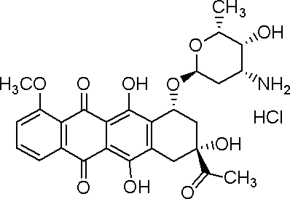
Figure 1: Daunorubicin-HCl

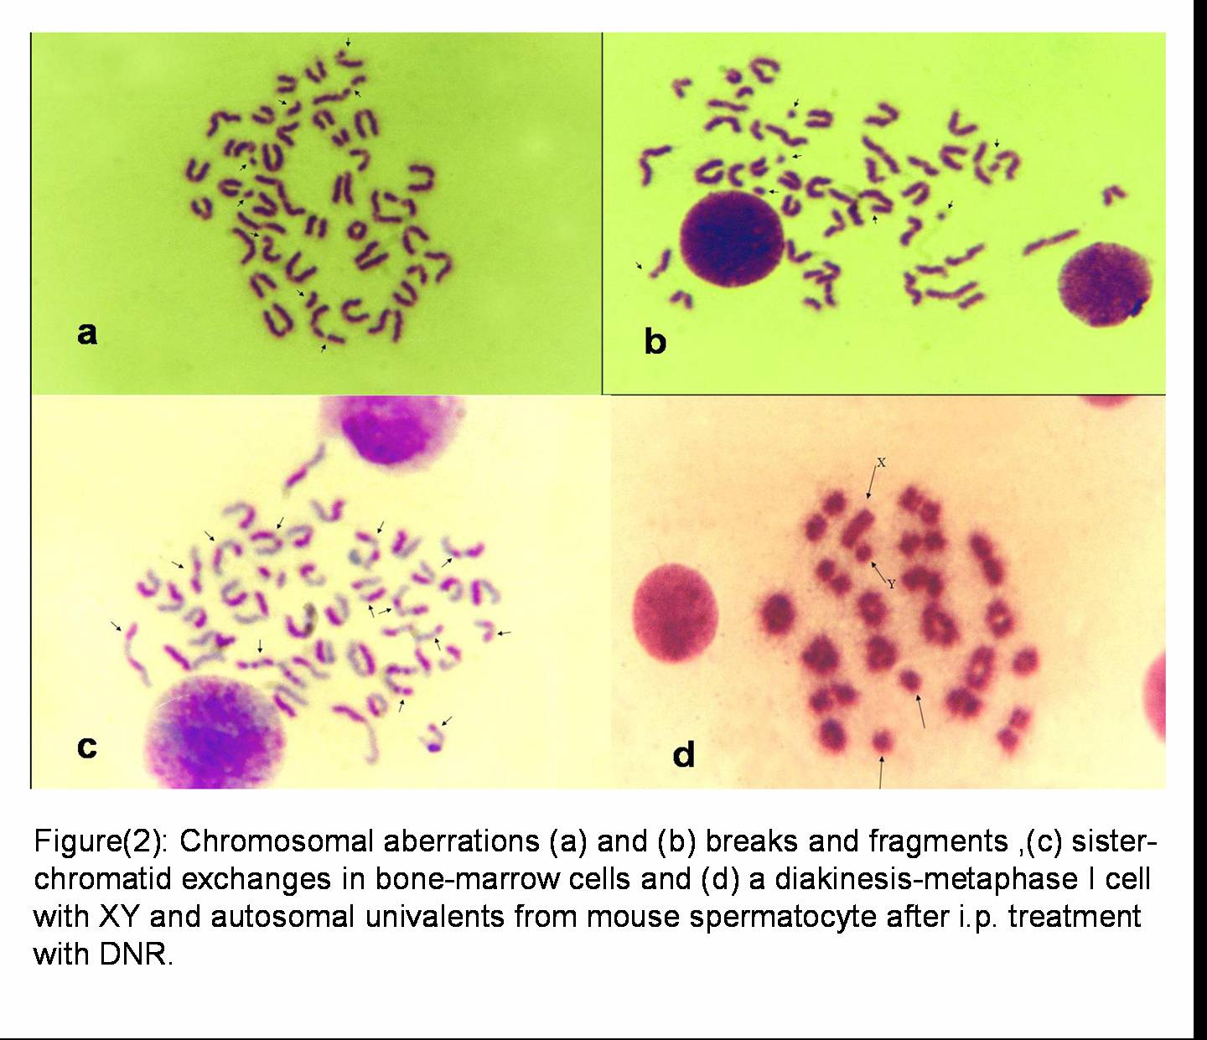

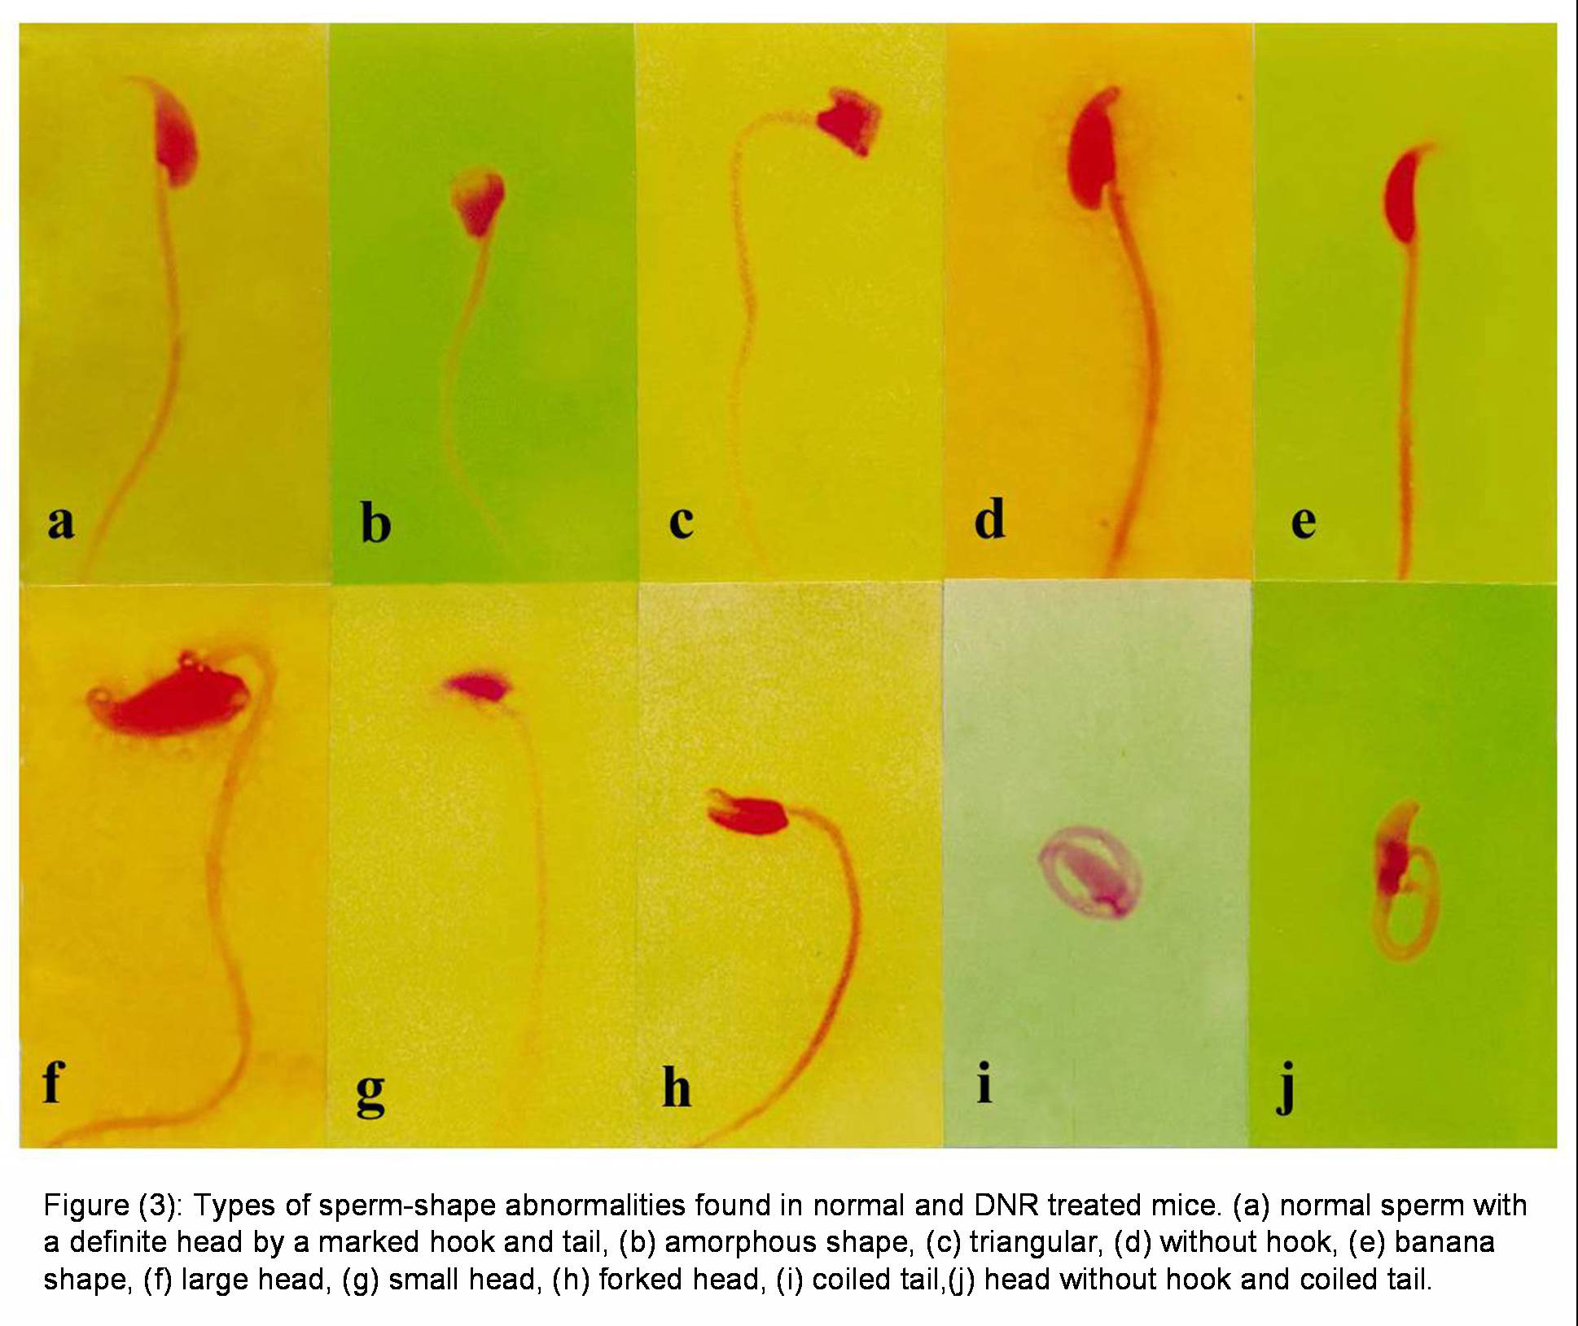

5/13/2009


