Advanced theory on Dust grain orbiting the sun
Manjunath. R. (Reader in physics)
#16, 8th Main road,
Shivanagar, Rajajinagar,
Bangalore-560010
Karnataka, India
manjunathr1988@yahoo.in
Abstract :The new mathematical model allows to calculate Poynting–Robertson force . It is shown that the equation for the calculation of Poynting–Robertson force accounts for the force exerted by incoming solar radiation,gravitational radius of sun and dust grain's orbital radius.The equation FPR = F * (Rg /2R )^1/2 (FPR = Poynting–Robertson force , F= Force exerted by solar radiation , Rg= gravitational radius of sun, C is the speed of light in vaccum , R is the dust grain's orbital radius ) was developed based on the Newton gravitational concepts , classical mechanical concepts and basic concepts of physics.The calculation of wavelength of incoming solar radiation accounts the dust grain's orbital radius and dust grain’s radius.The energy flux of incoming solar radiation ,momentum of solar radiation,sun’s radius and dust grain's orbital radius are brought togather in one frame of reference[Report and Opinion 2010;2(2):77-83]. (ISSN: 1553-9873).
Key words : Poynting–Robertson force , Solar radiation, wavelength, speed of light ,Energy flux ........
Power of radiation can be given by P=hf^2 i.e P= (hf)c/ λ (1)
Force exerted by radiation can be given by F=hf/ λ
Proof for F=hf/ λ :

Determination of the Photon Force and Pressure
Reissig, Sergej
The 35th Meeting of the Division of Atomic, Molecular and Optical Physics, May 25-29, 2004, Tuscon, AZ. MEETING ID: DAMOP04, abstract #D1.102
In [1] the formula for the practical determination of the power of a light particle was derived: P = hf^2 (W) (1). For the praxis it is very usefully to define the forces and pressure of the electromagnetic or high temperature heat radiation. The use of the impulse equation F = fracdPdt = fracd(mc)dt (2) together with the Einstein formula for E = mc^2 leads to the following relationship: F = frac1cfracd(mc^2 )dt = frac1cfracdEdt (3) In [1] was shown: - fracdEdt = P (4). With the use the eq. (1), (3), (4) the force value could be finally determinated: | F | = frachf^2 c or | F | = frachcλ ^2 = fracEλ [N]. The pressure of the photon could be calculated with using of the force value and effective area: p = fracFA [Pa]. References 1. About the calculation of the photon power. S. Reissig, APS four corners meeting, Arizona, 2003 -www.eps.org/aps/meet/4CF03/baps/abs/S150020.html
E=F λ

According to Planck’s theory of radiation
Energy associated with radiation can be given by
E=hf
Thus the equation E=F λ becomes F=hf/ λ
Then the equation (1) becomes P=FC (2)
Here P= Power of radiation, F= Force exerted by radiation ,C= speed of light in vaccum , h = planck’sconstant , f=frequencyof radiation , λ = wavelength of radiation .
Consider a dust grain orbiting the sun in the solar system . Newton's law of universal gravitation states that “Every massive particle in the universe attracts every other massive particle with a force which is directly proportional to the product of their masses and inversely proportional to the square of the distance between them “.
Gravitational force of sun experienced by the dust grains orbiting the sun can be given by
FS= GMS m /R^2 (3) Here F = Gravitational force between thesun and dust grain, G = Universal gravitational constant , Ms= Mass of the sun, m = Mass of the dustgrain, R = Distance between the Sun and dust grain(orbital radius of dust grain).
Centrifugal force is an outward force associated with curved motion, that is, rotation about some (possibly not stationary) center. Centrifugal force is one of several so-called pseudo-forces (also known as inertial forces). Centrifugal force acts on dust grain to prevent the collapse of dust grain towards the sun can be given by
Fc= mv^2 /R (4) Here Fc = centrifugal force , m = Mass of the dustgrain ,R = Distance between the Sun and dust grain(orbital radius of dust grain) , v= velocity of dust grain .
By the comparison of (3) and (4) we get
R= GMS /v^2 (5) Here Ms= Mass of the sun, R = Distance between the Sun and dust grain(orbital radius of dust grain), v= velocity of dust grain, G = Universal gravitational constant .

Solar radiation causes a dust grain in the solar system to slowly spiral inward. The drag is essentially a component of radiation pressure tangential to the grain's motion. The first description of this effect, given by Poynting in 1903. The grain of dust circling the Sun (panel (a) of the figure), the Sun's radiation appears to be coming from a slightly forward direction (aberration of light). Therefore the absorption of this radiation leads to a force with a component against the direction of movement. (The angle of aberration is extremely small since the radiation is moving at the speed of light while the dust grain is moving many orders of magnitude slower than that.)

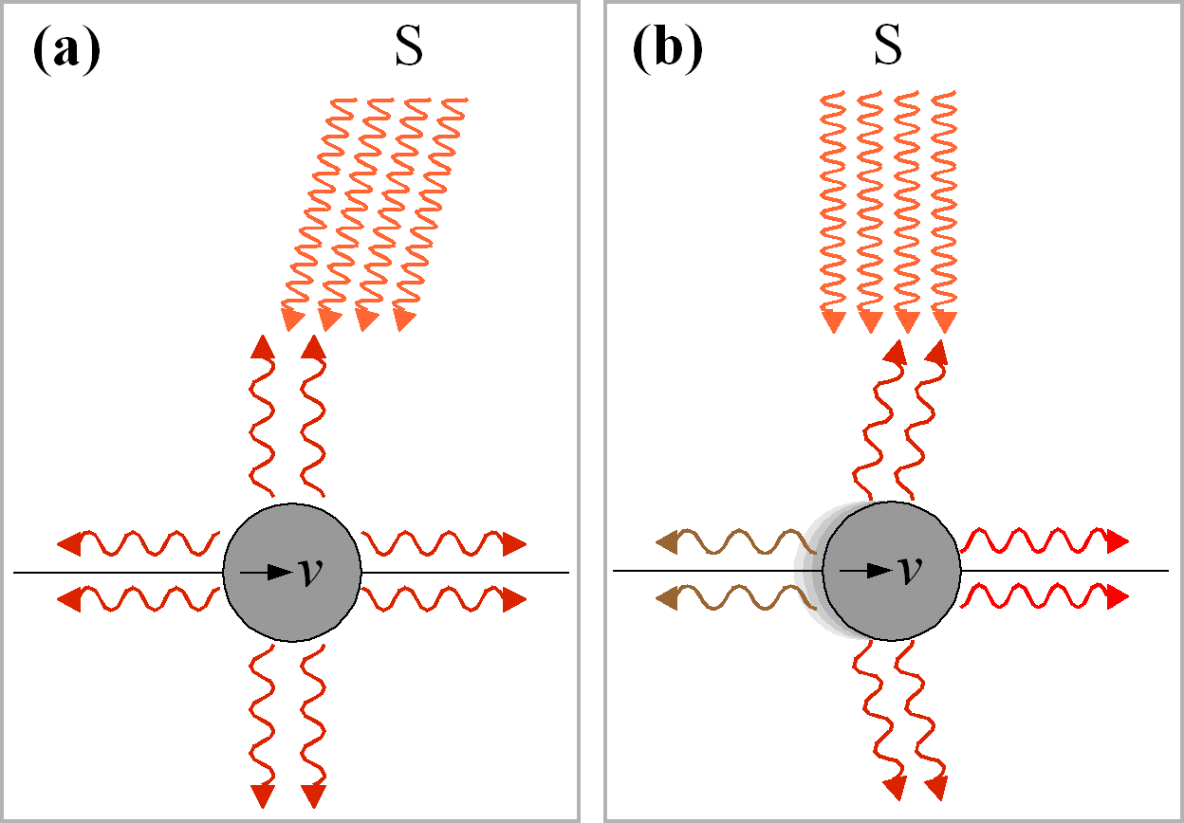

The Poynting–Robertson drag can be understood as an effective force opposite the direction of the dust grain's orbital motion, leading to a drop in the grain's angular momentum. It should be mentioned that while the dust grain thus spirals slowly into the Sun, its orbital speed increases continuously.
Poynting–Robertson force can be given by
FPR = Pv/C^2 (6) Here P is the power of the incoming solar radiation, v is the grain's velocity, C is the speed of light in vaccum, and R isthe dust grain's orbital radius , FPR = Poynting–Robertson force .
From (1) we know that power of incoming solar radiation can be denoted by P=FC
Then the equation (6) becomes FPR = (FC )v/C^2
FPR = (Fv) / C (7) Here FPR = Poynting–Robertson force , F= Force exerted by solar radiation , v is the grain's velocity , C is the speed of light in vaccum .
Squaring the equation (7) we get
FPR ^2= F^2 *(v/ C) ^2 (8)
From (5) we have R= GMS /v^2 i.e v^2= GMS / R
Thus the equation (8) becomes FPR ^2= F^2 *(v^2/C ^2) i.e FPR ^2= F^2 *(GMS/RC^2) .
The Schwarzschild radius (sometimes historically referred to as the gravitational radius) is a characteristic radius associated with every quantity of mass. Gravitational radius of the sun can be given by
Rg=2 GMS/C^2 (9)
From (9) the equation FPR ^2= F^2 *(GMS/RC^2) can be written as
FPR ^2=( F^2* Rg) /2R (10)
FPR = F * (Rg /2R )^1/2 (11)
Here FPR = Poynting–Robertson force , F= Force exerted by solar radiation , Rg= gravitational radius of sun, C is the speed of light in vaccum , R is the dust grain's orbital radius .
Poynting–Robertson force can also be given by
FPR = r^2 /4C^2 *( GMSLS^2/R^5) ^1/2 (12) Here C is the speed of light in vaccum, r = dust grain’s radius, G is the universal gravitational constant, M_{s} the Sun's mass, L_{s} is the solar luminosity and R the grain's orbital radius .
Squaring the (12) we get FPR^2 = r^4 /16C^4 *( GMSLS^2/R^5) (13)
By rearranging (13) we get FPR^2 = (r^4 /16C^2 )*( GMS /c^2) *(LS^2/R^5) (14)
Gravitational radius of the sun can be given by Rg=2 GMS/C^2 then (14) becomes
FPR^2 = (r^4 /16C^2 )*( Rg/2) *(LS^2/R^5) (15)
FPR^2 = (r^4 /16C^2 )*( RgLS^2 / 2R^5) (16)
FPR^2 = (r^4 RgLs^2/32C^4R^5 ) (17)
By equating (17) and (10) we get
F^2Rg/ 2R = (r^4 RgLs^2/32C^4R^5 ) (18)
Luminosity is a measurement of brightness, luminosity of the sun can be given by
LS=AS σ TS^4 (19)
Here AS =Surface area of sun emitting radiation , σ =Stefan’s constant, TS=Surface temperature of sun .
Energy of incoming solar radiation can be given by E= σ TS^4 (20)
F λ = σ TS^4 (21) Here F = force exerted by incoming solar radiation , λ = wavelength of solar radiation .
Thus (19) becomes LS=AS *(F λ ) (22)
By the substitution of value (22) in (18) we get
λ ^2 =16C^4 R^4/AS^2r^4 (23)
λ =4C^2R^2/AS r^2 (24)
Area of the sun can be given by AS =4 ΠRs^2 (25)
By the substitution of value (25) in (24) we get

λ = R^2C^2/Π RS^2 r^2 (26)
Here λ =wavelength of incoming solar radiation , R is the dust grain's orbital radius, Π =constant ( 3.14), C is the speed of light in vaccum , RS= Sun radius , r = dust grain’s radius .
let us assume the shape of dust grain to be a sphere for the purpose of establishment of expression for pressure exerted by incoming solar radiation
Area of the dust grain can be given by Ag =4 Πr^2 , By multiplying the equation (26) by 4
we get λ =4 R^2C^2/ RS^2 Ag (27)
Pressure exerted by incoming solar radiation on dust grain can be given by PS =F/ Ag (28)
By putting (28) in (27) we get λ =4 R^2C^2PS / RS^2 F i.e F λ =4 R^2C^2Pp/ RS^2 (29)
E= 4 R^2C^2PS/ RS^2 (Since E= F λ ) (30)
E / C^2 = 4 R^2PS/ RS^2 (31) Energy of incoming solar radiation can be given by E= mc^2 ,
Here m =Mass of incoming solar radiation
PS = mRS^2 /4 R^2 (32) Here PS= Pressure exerted by incoming solar radiation , m =mass of incoming solar radiation , RS= Sun radius, R is the dust grain's orbital radius .
The mass equivalent density of radiation density can be given by
Ps=u/3 i.e u =3Ps
Here Ps= Radiation pressure ,u = mass equivalent density of radiation
u=3 mRS^2 /4 R^2 (34)
Solar radiation pressure can be given by
Ps = EF /C
Here EF =Energy flux of solar radiation ,PS = Solar radiation pressure,C=Speed of light in vaccum
Equation (32) becomes EF = pRS^2 /4 R^2 (35)
Here p=momentum of solar radiation

Result :
1) Poynting–Robertson force can also be given by FPR = F * (Rg /2R )^1/2 FPR = Poynting–Robertson force , F= Force exerted by solar radiation , Rg = gravitational radius of sun, C is the speed of light in vaccum , R is the dust grain's orbital radius .
2) The wavelength of incoming solar radiation can be given by λ = R^2C^2/Π RS^2 r^2 λ =wavelength of incoming solar radiation , R is the dust grain's orbital radius, Π =constant ( 3.14), C is the speed of light in vaccum , RS= Sun radius , r = dust grain’s radius .
3) The mass equivalent density of radiation density can be given by u=3 mRS^2 /4 R^2 m =mass of incoming solar radiation , RS= Sun radius, R is the dust grain's orbital radius , u = mass equivalent density of radiation .
4) Energy flux of incoming solar radiation can be given by EF = pRS^2 /4 R^2 p=momentum of solar radiation , RS= Sun radius, R is the dust grain's orbital radius , EF =Energy flux of sola r radiation .

Acknowlegement :
I would like to express my deep gratitude to all those who gave me the possibility to complete this thesis. My special thanks to editor of this journal and my parents.

Correspondance to :
Manjunath. R.(Reader in physics)
#16,8th Main road,
Shivanagar, Rajajinagar,
Bangalore-560010
Karnataka, India
manjunathr1988@yahoo.in
manjunath5496@gmail.com

References :
1) Poynting–Robertson effect (From Wikipedia,the free encyclopedia)
2) Luminosity (From Wikipedia,the free encyclopedia)
3) Thermal radiation(From Wikipedia,the free encyclopedia)
4) Centrifugal force (From Wikipedia, the free encyclopedia)
5)Mass –energy equivalence(From Wikipedia,the free encyclopedia).

6)Newton ‘s law of motion (From the free Wikipedia encyclopedia)

7) Newton‘s law of Gravitation (From the free Wikipedia encyclopedia)

8) scienceworld.wolfram.com/physics/RadiationDensity.html - Cached - Similar

9) Schwarzschild radius (From the free Wikipedia encyclopedia).

Conclusion : The Poynting–Robertson effect, also known as Poynting–Robertson drag, named after John Henry Poynting and Howard Percy Robertson, is a process by which solar radiation causes a dust grain in the solar system to slowly spiral inward. The drag is essentially a component of radiation pressure tangential to the grain's motion .According to the equation FPR = F * (Rg /2R )^1/2 , Poynting–Robertson force increases with the Force exerted by solar radiation(FPR a F ) . Poynting–Robertson force decreases with the dust grain's orbital radius (FPR a R).According to the equation λ = R^2C^2/Π RS^2 r^2 , wavelength of incoming solar radiation increases with the dust grain's orbital radius( λ a R) . The wavelength of incoming solar radiation decreases with the dust grain’s radius( λ a r). According to the equation u=3 mRS^2 /4 R^2 , mass equivalent density of solar radiation density increases with the relativistic mass of incoming solar radiation (u a m) . Mass equivalent density of solar radiation decreases with the dust grain's orbital radius ( u a R) . According to the equation EF = pRS^2 /4 R^2 , energy flux of incoming solar radiation increases with momentum of solar radiation(EF a p) . The energy flux of incoming solar radiation decreases with the dust grain's orbital radius (EF a R) .

Date of submission: 15.2.2010

