Regional groundwater flow modeling in Western Nile Delta, Egypt
Rani Fouad Mohamed ^{(1), (2)}, Chen Zhi Hua ⁽¹⁾
(1) School of Environmental Studies, China University of Geosciences, 388 Lumo Road, Wuchang,Wuhan, Hubei, P.R.China; Zip code: 430074.
(2) Faculty of Engineering, Alazhar University, Nasr city, Cairo, Egypt; Zip code: 11341
Rani_fouad@hotmail.com
Tel: 00862762626996

Abstract: Western Nile delta is an important area in Egypt in which the government plans to establish new reclamation projects. The already present agricultural activities are mainly based on groundwater for irrigation. However, irrigation requirements have become so large that they cause depletion of the groundwater levels in most of the existed wells. A hydrogeological model for western Nile delta has been developed using MODFLOW code. The developed model was calibrated for steady state, and used to evaluate groundwater potentiality and reserves. The results have shown that; a reduction in groundwater abstraction by at least 20% becomes necessary to achieve sustainable conditions. This study can be considered as a preliminary regional evaluation for testing the future alternative water management scenarios in Western Nile Delta area.

Keywords: Groundwater modeling, Groundwater/surface-water interaction, western Nile delta.

Introduction
Groundwater is an important source for water supply in Egypt, Nile water alone is no longer sufficient for the increasing water requirements for different development activities. However, many cautions and worries are increasingly being voiced on the dangers that surround the groundwater resources. The main elements of these worries are related to depletion as a result of over abstraction. Western Nile delta has limited water resources although it lies on the western part of Nile Delta aquifer. The government established canals network to divert surface water to this area but farmer still suffering from shortage of surface water and use the groundwater wells. There are more wells operating within the basin. Due to excess abstraction from these public and private wells (1.90 BCM), the water level in the well fields declined significantly. Water table’s decrease leads to salt-water intrusion with the Mediterranean Sea. The farms become covered with the saline water RIGW/IWACO (1998). To avoid the deterioration of the aquifer system in this area an efficient integrated and sustainable management plan for groundwater resources is needed. Groundwater modeling is the best tool to predict the response of the groundwater aquifer and estimate the safe yield (Xuesen Mao et al., 2005).

Study area

Western Nile Delta region occupies the area between Cairo at equator and Alexandria, west of Rosetta branch, and extends westward to the desert area from the west of Wadi el-Natrun up to the eastern edge of the Qattara Depression, the study area covers about 15170.6 km² as shown in Figure [1].

Hydrogeological setting
Western Nile Delta region distinguished into three aquifers, Quaternary aquifer, Pliocene aquifer and the Moghra aquifer. The main aquifer in the Nile Delta is the Quaternary aquifer. The saturated thickness of Quaternary aquifer ranges between 50 m along the desert fringes in the West to 800 m in the North while it reaches about 200 m in the South near El Kanter El Khiria City. The aquifer is semi-confined in the Delta area, being overlain by a Holocene layer of sandy clay and silt, and in the area of Nubaria, where aquifer is covered by loamy deposits. In the rest of the area, the aquifer is phreatic (unconfined). The Moghra aquifer is the main aquifer in the southern and western portions of the study area. The aquifer is overlain by Pliocene and underlain by Oligocene basalt or shales. Both aquifers are connected with each other in a direct hydraulic contact along the stretch Khatatba-Abu Rawash (lateral) and along the stretch Sadat City-Khatatba (vertical). While in all other locations, the two-aquifer systems are separated by Pliocene deposits.
The piezometric head level of groundwater is generally decreasing within the Western Nile Delta from more than 15 m +MSL in Cairo to 1 m +MSL near the coast. The piezometric level decreases from south to north by an average piezometric gradient about 0.00011. The groundwater levels are usually oscillating up and down affected by one or more of the following, levels of water in the river Nile and its distributors, method and frequency of irrigation, horizontal and vertical agricultural extensions, and groundwater extraction.
Recharge to the aquifer takes place due to three factors Infiltration, Infiltration and downward leakage of excess surface irrigation water (originating from the River Nile) and, Leakage from canals.
Discharge of groundwater takes place through four processes: outflow into the drainage system, direct abstraction, evapotranspiration and inter-aquifer flow of groundwater. Groundwater return flow to the river Nile and drains (open drains and tile drains) as well as extraction by wells are the main discharge components from the aquifer. In 1985 the annual abstraction for both drinking water and irrigation was 460 million cubic meters and increased to 635 million cubic meters in 1997. Due to increase in desert fringes reclamation in the Western Nile Delta region in the end of nineties, the abstraction from groundwater increased dramatically to 1370 million cubic meters. The recent filed investigations estimate current abstraction as 1.9 BCM.
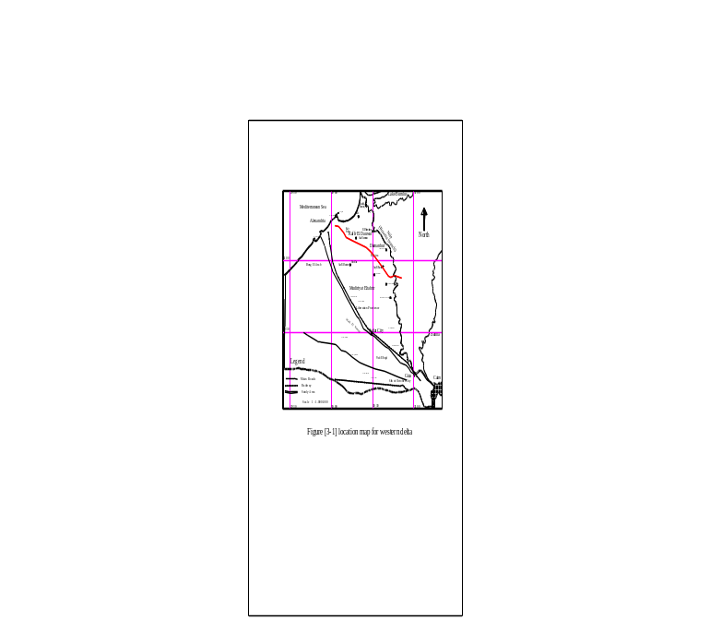

Figure [1], Western Nile Delta Location

Model development
Model set-up
To develop the numerical simulation for the aquifer system MODFLOW code has been selected to simulate three dimensional steady state groundwater flows for the study area. The model consists of multi-layers aquifer system. The first layer represents the semi-confining layer (upper clay layer), which overlies the main aquifer. It is modeled as an aquifer in which vertical and horizontal flows simulated. A finite difference grid is generated for the modeled area. The grid consists of 100 rows and 100 columns, for a total of 10 000 cells. All of the cells have uniform dimensions of 1.6 km by 1.6 km; the cell size is small enough to reflect both the density of input data and the desired output detail, and large enough for the model to be manageable.
All surface water features such as the river, main irrigation canals and main open drains are simulated as ‘rivers’ in the model. The exchange between those ‘rivers’ and the aquifer systems is calculated with Darcy’s equation, and expressed as follows:

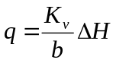 [1]

Equation (1) can be rewritten in the following form:

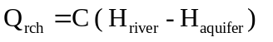 [2]
and 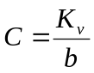 [3]

where q is the flow between the river and the aquifer (positive for baseflow - for gaining streams and negative for river recharge – for losing streams); C is a constant representing the streambed leakage coefficient (hydraulic conductivity of semi-impervious streambed stratum 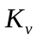divided by its thickness b); and 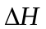 is the difference between the water level in the river 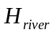 and the groundwater level in aquifer 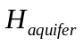.

Boundary conditions
The aquifer boundaries can be described by two types of hydrological conditions. No flow boundary is applied for the southern boundary where a fault exists and previous studies showed that no flow can be from the western desert enters the aquifer system (Mohamed A. et al., 2005). Constant head boundary is used for the eastern, northern and western boundaries; the constant head data were obtained from hydrogeologic map for the Nile delta, as shown in Figure [2].
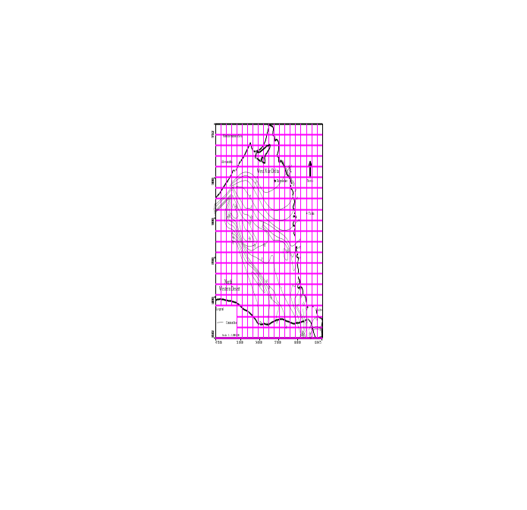

Figure [2], Constant head in Western Nile Delta

Model calibration
The numerical model was calibrated under steady-state conditions through a series of groundwater flow simulations. The conceptualization of the regional flow and the relatively complex model architecture were precisely defined in the preliminary stage of the model development. The only parameters contributing to the uncertainty of the model simulations were: (a) the hydraulic conductivity, and (b) the distribution of the areal recharge rate. . Fig. [1] Shows the initial hydraulic conductivity distribution for the aquifer system. During the calibration, the simulated recharge distribution was depend on the following values, In the central and southern portions of the flood plain, the downward leakage towards the aquifer ranges between 0.25 and 0.8 mm/day, depending on the soil type, irrigation and drainage practices. In the desert areas, relatively high leakage rates are observed for basin, furrow and sprinkler irrigation (1.0–1.5 mm/day) with much lower rates for drip and central pivot irrigation (0.1–0.5 mm/day) RIGW/IWACO (1998). The calibration was performed by trial and error until achieving a reasonable agreement between the simulated heads and the measured groundwater levels observed in (1992),

Model Stability and Sensitivity Analysis
Sensitivity analysis is conducted on a number of parameters including recharge, hydraulic conductivity, and vertical leakance for the Nile Delta aquifer. Two runs done two check the model sensitivity to hydraulic conductivity using factors (0.1, 10) from the original calibrated values of hydraulic conductivity. Using one tenth of the permeability increase the dry cells at the western part of the model and limiting the aquifer active zone to be much near to the Rosetta branch. While the values of ten times the permeability widely spread the piezometric head over the modeled area.
Sensitivity of the model due to recharge also checked by using factors (0.5, 2) from calibrated recharge values. using one half of recharge also increase the dry cells at the western part of the model and limiting the active zone to be much near to the Rosetta branch as occurred when permeability was taken one tenth. While two times of recharge values increase the groundwater levels over the whole modeled area. Sensitivity analysis performed by changing one parameter values at a time and noting the effects of the parameter change on the simulated groundwater levels.

Results and discussion
Results of 16 water level observations wells were used to evaluate the performance of the predevelopment model. The simulated water levels generated by the calibrated model matched the observed water levels quite well. The RMS is 7.5%, on average; the simulated water level differs by about 30 cm from the observed water level. Errors are generally spread across the model area with only a limited number of areas where values are consistently higher or lower than simulated water levels.
The final values for hydraulic conductivity were not changed because they provided a good match between simulated and observed heads together with the solid ground from which they were induced. Streambed conductance was increased by a factor of about three to increase the interaction between streams and the aquifers. Large increases or decreases in the value had the effect of draining the groundwater system or isolating it, respectively. Adjustment of river conductance and canals conductance had minimal effect on the model runs. Canals conductance adjustment had minimal impact due to the limited number of significant canals. Drains were included primarily to insure that the model could discharge water over a large area if the water level exceeded the land surface elevation.
In spite of extensive water pumping and reasonable recharge amounts in northwestern part in the study area, it contains the highest water levels. The analysis indicated that this might be due to small thickness of the aquifer and the elevated aquifer base in this area. According to the calibrated model, the rate of recharge entering the aquifer approximately is 1.54 BCM. The water budget indicated that, the influx and out fluxes along the model boundaries, are 0.16 BCM and 0.3 BCM respectively. The velocity vectors distribution indicated the variations in magnitude and directions inside the modeled area as shown in Figure [3]. Velocity vectors distribution showed the in and out fluxes directions along the model boundaries.

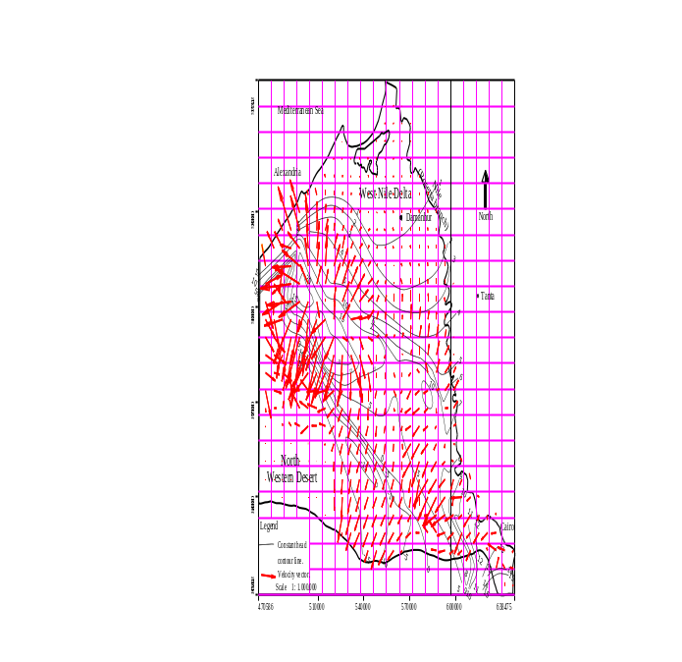

Fig. [3], Velocity vectors distribution
Model limitations
The numerical model developed in this study represents an interpretation and a simplification of observed field conditions. Seasonal variations or other changes in the flow conditions were not accounted for. A model calibration under transient flow conditions and based on the observed groundwater fluctuations can be the next stage in improving the regional flow model.

Summery and Conclusions
A steady state model has been developed to simulate the water resources in the Western Nile Delta. Low vertical permeability of the top clay layer affects the rate of infiltration from the main canals and to the main drains. So, the infiltration from these canals is small compared with gain of the aquifer system from Rosetta branch. Due to the direct hydraulic contact between the surface water bodies and the Nile delta aquifer, any change in the flow and water levels will affect the groundwater levels and the regional water balance due to the surface water/groundwater interaction and the complex flow system. The analysis indicated the highest water levels in northwestern part in the study area are due to small thickness of the aquifer. The rate of recharge entering the aquifer is approximately 1.54 BCM. The water budget indicated that, the values of in and out constant head along the model boundaries are 0.16 BCM and 0.3 BCM respectively. The results show that the situation is far from sustainable, because the total amount of groundwater abstraction for irrigation (1.9 BCM) is larger than the groundwater recharge, which in the long term will undermine the capacity and sustainability of the aquifer, and will lead to salt water intrusion. It is proposed that groundwater abstraction should be diminished with 20% in order to reach a sustainable situation.
This model and obtained results can be considered as preliminary regional evaluation for testing the alternative water management scenarios in Western Nile Delta area

References:
1-Charles V. Camp1, James E. Outlaw Jr.1 Michael C. Brown, 2008. GIS-Based Groundwater Modeling. Computer-Aided Civil and Infrastructure Engineering, 9 (4) Pp. 281 – 293 doi:10.1111/j.1467-8667.1994.tb00336.x
2-Chen-Wuing Liu, Chun-Nan Lin, Cheng-Shin Jang, Chan-Po Chen, Jen-Fu Chang, Chen-Chun Fan, Kuo-Hiang Lou, 2006. Sustainable groundwater management in Kinmen Island. Hydrological Processes, 20 (20) Pp. 4363 – 4372 doi:10.1002/hyp.6171
3-D. Peyrard 1 *, S. Sauvage 1, P. Vervier 1, J. M. Sanchez-Perez 1, M. Quintard, 2008. A coupled vertically integrated model to describe lateral exchanges between surface and subsurface in large alluvial floodplains with a fully penetrating river. . Hydrological Processes, 22 (21) Pp. 4257 – 4273 doi:10.1002/hyp.7035
4-Hilmar Hofmann , Kay Knöller , Dieter Lessmann, 2008. Mining lakes as groundwater-dominated hydrological systems: assessment of the water balance of Mining Lake Plessa 117 (Lusatia, Germany) using stable isotopes. Hydrological Processes, 22 (23) Pp. 4620 – 4627 doi:10.1002/hyp.7071
5-J. Butler Jr., Vitaly A. Zlotnik, and Ming-Shu Tsou., 2001. Drawdown and Stream Depletion Produced by Pumping in the Vicinity of a Partially Penetrating Stream. Journal of ground water, 39 (5), Pp. 651-659 DOI:10.1111/j.1745-6584.2001.tb02354.x
6-J. W. N. Smith, M. Bonell, J. Gibert , W. H. McDowell, E. A. Sudicky, J. V. Turner, R. C. Harris, 2007. Groundwater-surface water interactions, nutrient fluxes and ecological response in river corridors: Translating science into effective environmental management. Hydrological Processes, 22 (1) Pp. 151-157 DOI:10.1002/hyp.6902
7-LaBolle EM, Ahmed AA, Fogg GE. 2003. Review of the Integrated Groundwater and Surface-Water Model (IGSM). Journal of ground water, 41 (2), Pp238-246 DOI:10.1111/j.1745-6584.2003.tb02587.x
8-Leonard F. K., Thomas E. R., (1999): “The Handbook Of Groundwater Engineering” Chapter [20], “ Groundwater Modeling” ISBN 3-540-64745-7. Www.Springer.De
9-Min Sun Chunmiao Zheng , 2007. Long-Term Groundwater Management By A Modflow Based Dynamic Optimization Tooljawra Journal of the American Water Resources Association, 35 (1) Pp. 99 – 111 DOI:10.1111/j.1752-1688.1999.tb05455.x
10-Mohamed A. Dawoud, Madiha M. Darwish, Mona M. El-Kady, 2005. GIS-Based Groundwater Management Model for Western Nile Delta. Water Resources Management, 19, Pp. 585–604 DOI: 10.1007/s11269-005-5603-z
11-Osman A. E. Abdalla, 2007. Groundwater discharge mechanism in semi-arid regions and the role of evapotranspiration. Journal of groundwater, 22 (16) Pp. 2993 – 3009
12-OSMAN Yassin Z. and BRUEN Michael P., 2002. Modelling stream-aquifer seepage in an alluvial aquifer: An improved loosing-stream package for MODFLOW. Journal of hydrology, 264, Pp. 69-86 DOI:10.1016/S0022-1694(02)00067-7
13-RIGW, 1992, ‘Hydrogeological map for the Nile Delta area’, Scale 1: 500000. Research Institute for groundwater, El Kanter El Khairia, Egypt.
14-RIGW/IWACO, 1998, ‘Environmental management of groundwater resources (EMGR): Identification, priority setting and selection of area for monitoring groundwater quality’, Technical Report TN/70.00067/WQM/97/20, Research Institute for Groundwater (RIGW), Egypt.
15-Sophocleous M., 2000. From safe yield to sustainable development of water resources the Kansas experience. Journal of hydrology, 235, Pp. 27-43 DOI:10.1016/S0022-1694(00)00263-8
16-Stefan Krause, Axel Bronstert, 2006. The impact of groundwater-surface water interactions on the water balance of a mesoscale lowland river catchment in northeastern Germany. Hydrological Processes, 21 (2) Pp. 169-184 DOI:10.1002/hyp.6182
17-Xiangjiang Huang, Jeffrey D. Niemann, 2006. Modelling the potential impacts of groundwater hydrology on long-term drainage basin evolution. Earth Surface Processes and Landforms, 31 (14) Pp. 1802 – 1823 DOI:10.1002/esp.1369
18-Xuesen Mao, Jinsheng Jia , Changming Liu , Zhimin Hou. , 2005. A simulation and prediction of agricultural irrigation on groundwater in well irrigation area of the piedmont of Mt. Taihang, North China. Hydrological Processes, 19 (10) Pp. 2071 – 2084 doi:10.1002/hyp.5667

