Rocks for crops: Assessment of the Quality of Adigudom Gypsum for crop production in the northern highlands of Ethiopia
Fassil Kebede
Department of Land Resource Management and Environmental Protection, Mekelle University; P.O.B-231, Mekelle, Ethiopia; E-mail: fyimamu@gmail.com

Abstract: Significant proportions of the landmasses of Ethiopia are covered by massive and continuous Rocky Mountains of different geological origin and composition, which can be useful even for organic farming. In the last decade, in fight against the recurrent drought in the north Ethiopian State of Tigray more than 46 dams have been constructed with a cumulative storage capacity and irrigable area of 49.91 million m³ and 3115 ha, respectively. However, in the irrigated fields of these dams, salt minerals like thenardite (Na₂SO₄), halite (NaCl), zincobloedite (Na₂Zn(SO₄)₂.4H₂O), and anorthoclase (Na,K)(Si₃Al)O₈ have been observed recently, which can cause sodicity thereby crop productivity can be impaired gradually. A list of management options should be tabled urgently before the problem is aggravated. Large gypsum deposit was found in the localities of the irrigated fields. Thus, this study attempted to evaluate the quality of these minerals whether they can be useful for agricultural purposes. Analysis revealed that up to 150 cm of the profile depth of the rock was mainly composed of gypsum (95%) with the predominance of oxides of S (43.5-46.6% SO₃⁻²) and Ca (32.1-33.5% CaO). The oxides in the sampled rock followed the order of: SO₃⁻²> CaO>SiO₂>Al₂O₃>Fe₂O₃>MgO>Na₂O>K₂O>TiO₂>MnO>P₂O₅ with the finest particle size (81.7-90%) dominating over other sizes. This study has come to the conclusion that Adigudom gypsum deposit can be used as rock for crops through enhancing sodicity management and sulphur nutrition.

Keyword: Adigudom gypsum, agromineral, microdams, sodic soils, sulphur nutrition

1 Introduction
Dependence on rainfed agriculture coupled with the erratic nature of rainfall is one of the main causes of widespread food insecurity in the country. Droughts occur every 3-5 years in northern Ethiopia and every 8-10 years for the whole country, with severe consequences for food production (Haile, 1988). Hence a sustainable increase in food production to achieve self-sufficiency depends, at least in part, on how Ethiopia addresses its dependence on rainfall.

Tigray is one of the most land-degraded states of Ethiopia (Hurni, 1993). The region is characterized by subsistence farm households raising predominantly cereal and vegetable crops for local consumption and sale. Crop production in the region has failed to keep pace with population growth due to recurrent droughts, environmental degradation, and war. In response to severe environmental degradation and population-resource imbalance, the government of Ethiopia has initiated a major rural development program called SAERT (Sustainable Agricultural and Environmental Rehabilitation) through which several small dams have been constructed. The water development program is intended to rehabilitate degraded environments, enhance the adoption of irrigation practices, and ultimately increase agricultural productivity and sustainability (MUC, 1994).

Well-designed and constructed small water bodies such as microdams can have multiple benefits for their surrounding communities. Beyond making water available for the irrigation of field crops, microdams may provide water for garden cultivation, trees and other vegetation, and water for cattle. Other productive uses may include fishing and harvesting aquatic plants and animals. To this effect, so far 46 microdams have been constructed over the period of 1996 to 2001 (COSAERT. 2001). However, microdam creation in Tigray is associated with important socioeconomic benefits there are environmental concerns that these new sources of water may have caused specifically salinity and sodicity. Recently, salt patches have been observed on the major irrigated fields of Tigray (Fig.1).

High concentrations of soluble salts found in saline and sodic soils can be toxic by increasing the solute suctions, reducing availability of air and water to plants. Consequently, high concentration of soluble salts in irrigation water with poor quality decreased agricultural productivity in southern Tigray. salt minerals like gypsum (CaSO₄.2H₂O), calcite-magnesian (Mg_{0.064}Ca_{9.38})(CO₃), anorthite (Ca(Al₂Si₂O₈)), thenardite (Na₂SO₄), calcite (CaCO₃), halite (NaCl), zincobloedite (Na₂Zn(SO₄)₂.4H₂O), gismodine (CaAl₂Si₂O₈.4H₂O) and anorthoclase (Na,K)(Si₃Al)O₈ are gradually building up thereby influencing crop productivity through causing soil salinity and sodicity (Fassil, 2006). Recently, large deposit of gypsum was found in Adigudom district of the State. Gypsum improves sodic soils by providing soluble calcium, which replaces the sodium adsorbed on the clay minerals. Results from field experiments in many parts of the world showed that gypsum applied at several tonnes per hectare decreases the sodium adsorption ratio, physically improves the infiltration rate and significantly increases yields (Peter van Straaten 2002).
Gypsum applied at the surface or subsoil, is reported to reduce phytotoxicity in acid soils (Alva and Sumner 1989; Sumner 1995 as cited in Peter van Straaten 2002). The mechanism for this reduction is the downward movement of soluble calcium and the subsequent exchange with aluminium in the subsoil (Mc Ray and Sumner 1990; Sumner 1995 as cited in Peter van Straaten 2002). Besides, gypsum is a low cost source of elemental sulphur. Thus, this study attempted to evaluate whether the quality of this rock suitable for managing the newly emerging agricultural problems.

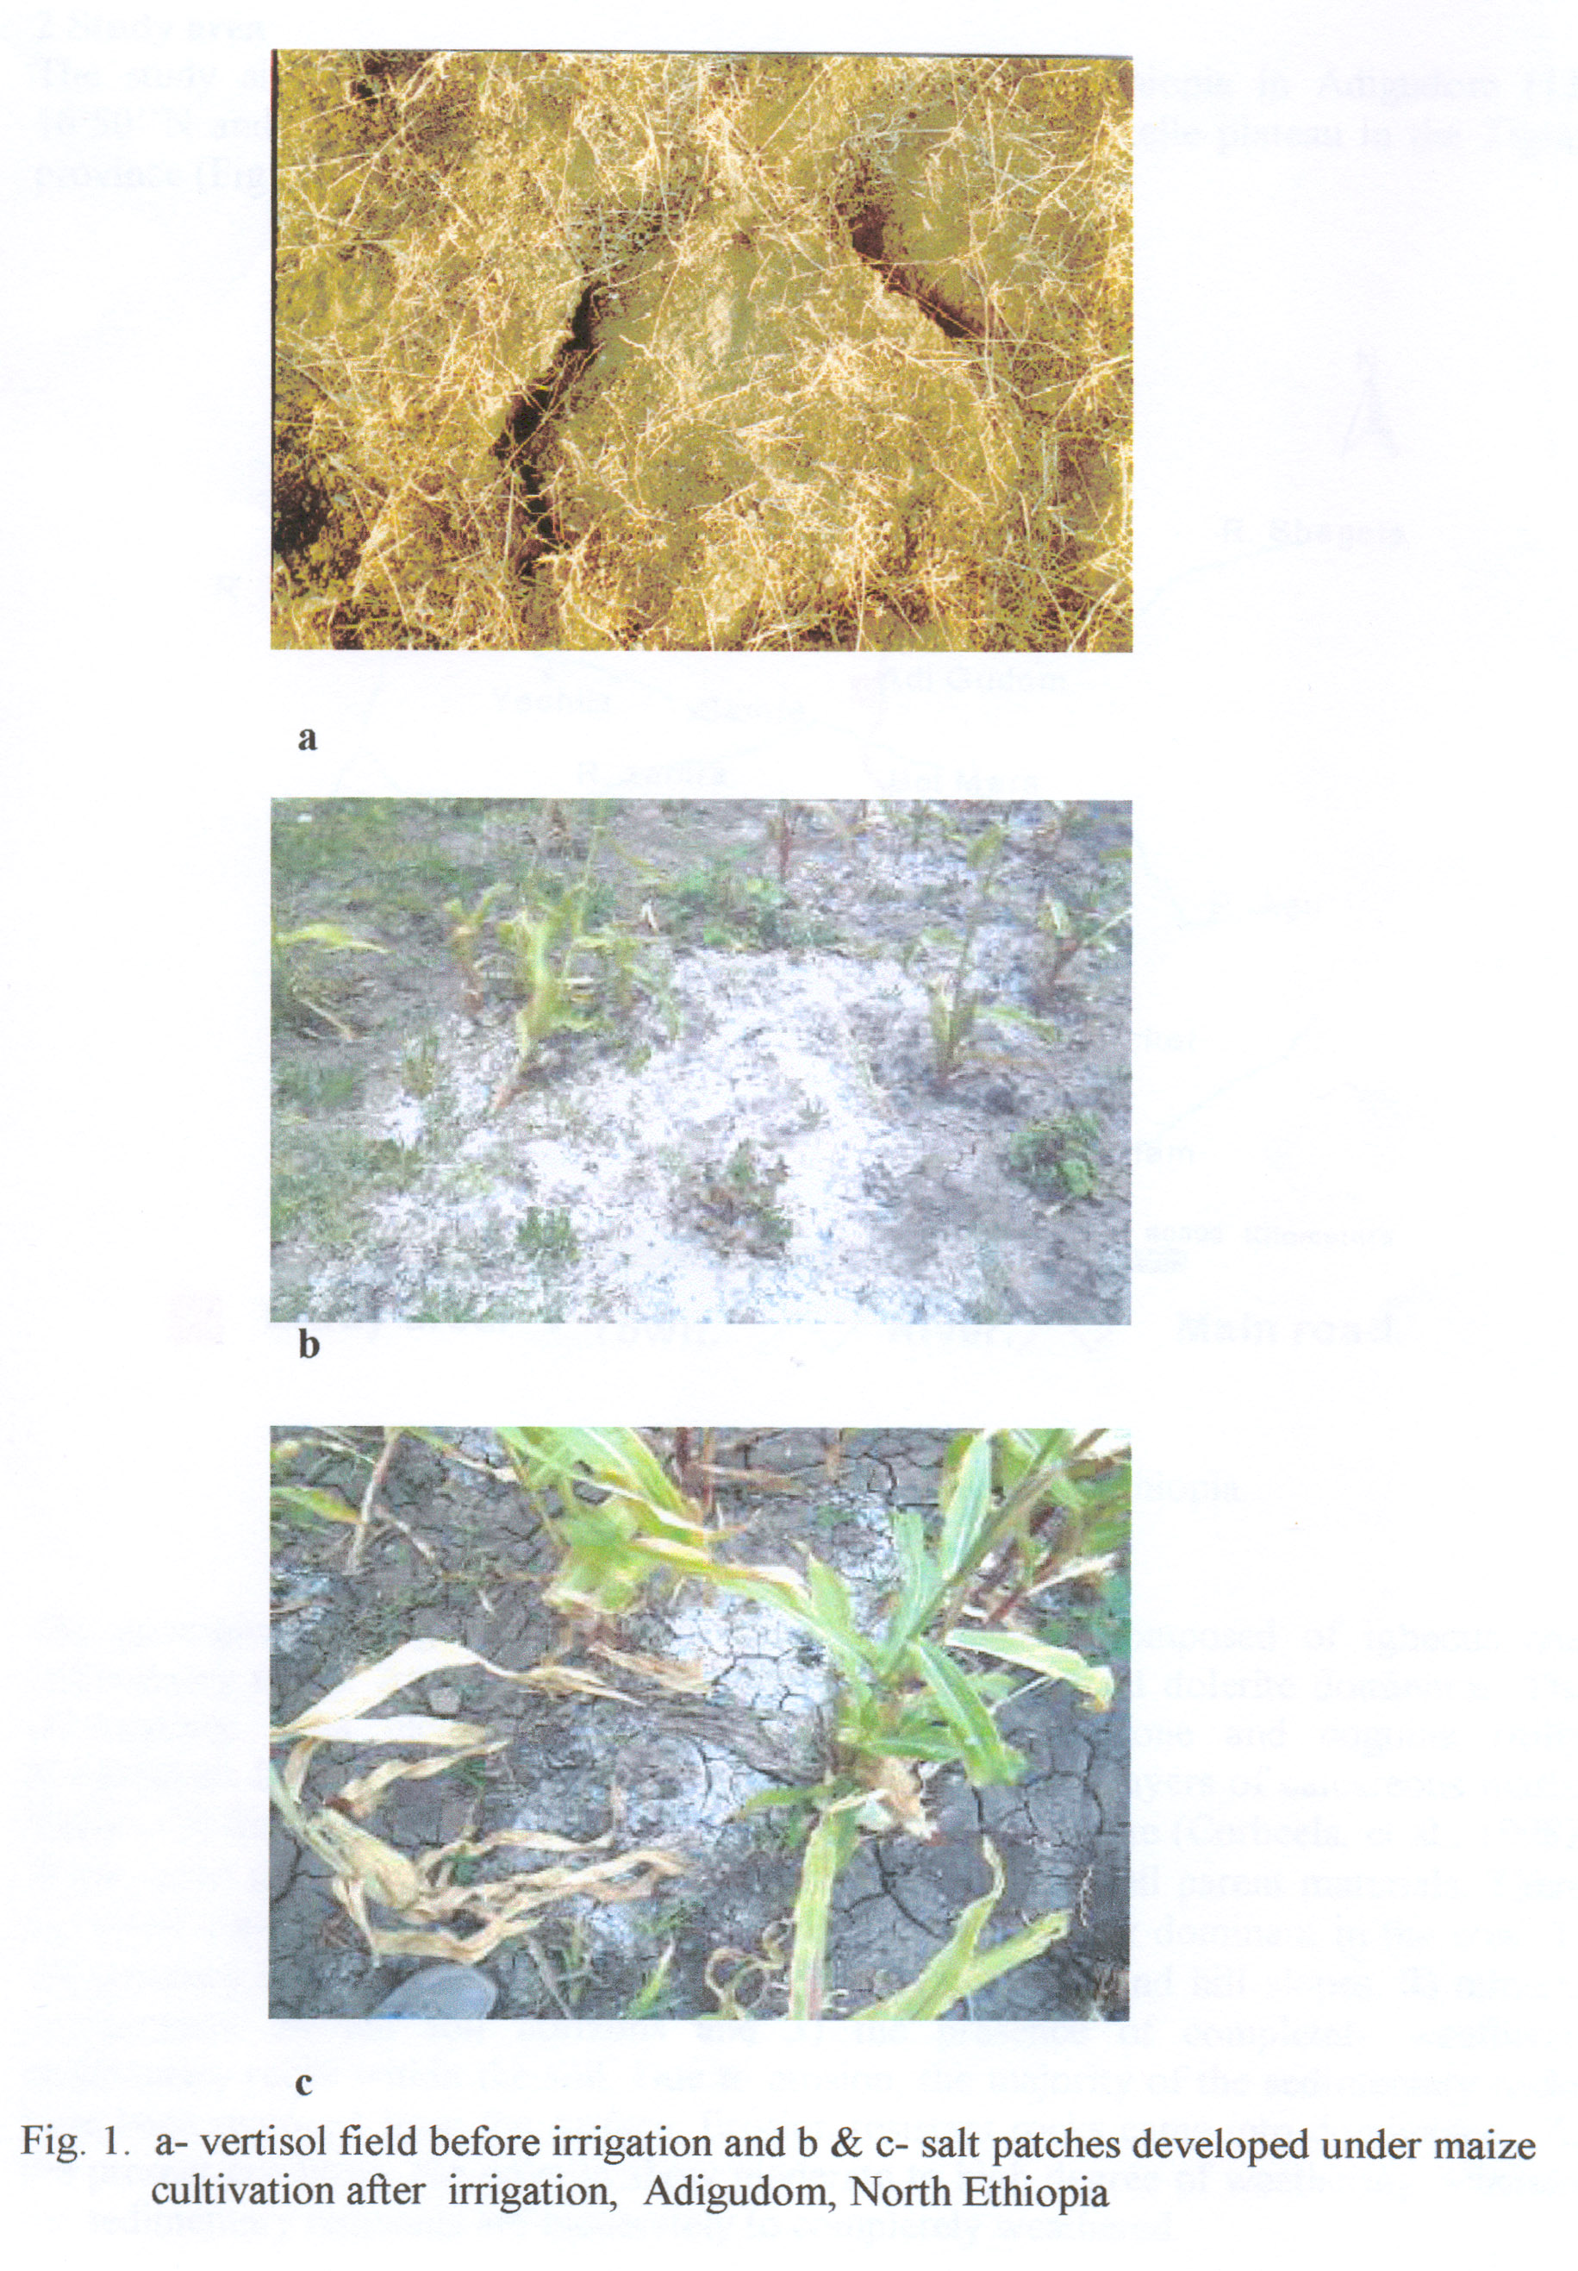

2 Materials and Methods
Study area
The study site is located in the northern highlands of Ethiopia in Adigudom (13° 16’ 50’’N and 39° 28’’E) at an altitude of 1960 m on the Mekelle plateau in Tigray Region (Fig. 2).

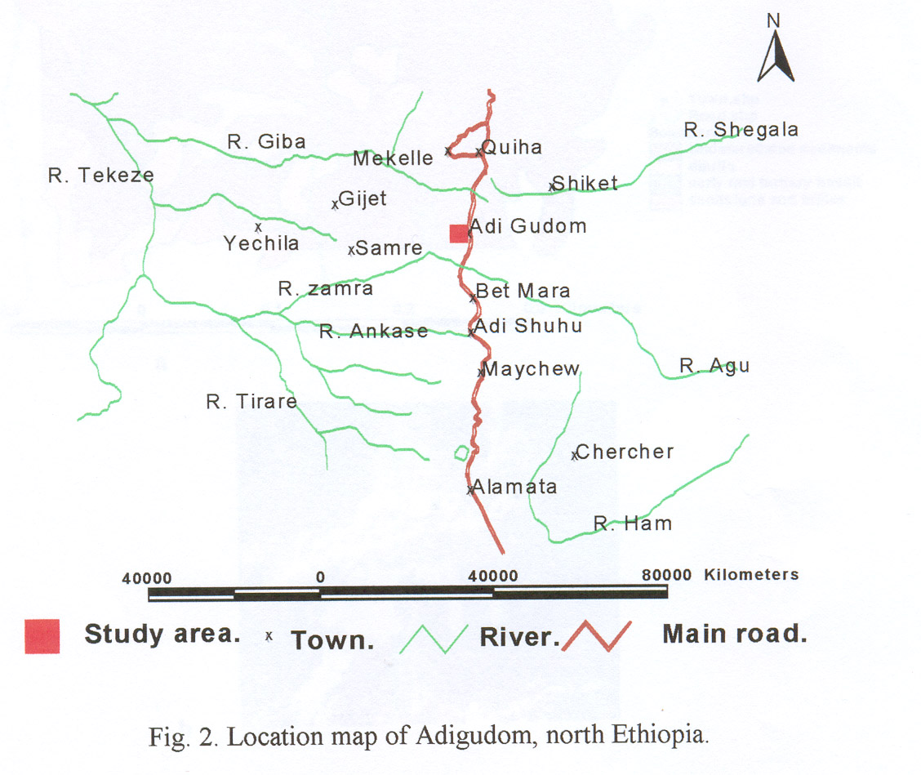

Fig.2. Location map of Adigudom.

Geological setting
The geological setting of Adigudom is mainly composed of igneous and sedimentary rocks. Among the ingenious units, medium grained dolerite dominates. The sedimentary units include agula shale formations, limestone and coguina (fully fossiliferous limestone). The agula shells comprise alternate layers of calcareous marls. Shales and limestones contain many minor inclusions of dolerite (Corbeels, et al., 1998). These rocks give rise to stony, calcareous and fine textured soil parent materials.

Sampling and analytical method

A composite sample of gypsum from Adigudom rock deposit was collected to evaluate its quality. In addition, profile samples of rocks were also collected from 0-40, 40-60, 60-90, 90-140 and 140-160 cm. Physical, chemical and mineralogical analyses were conducted in the Laboratory of the National Geological Survey of Ethiopia in Addis Abeba. The grain size distribution was determined using pipette method. X-ray diffractometer was used to study the crystal structure and the software DIFFRAC ^{plus} Eva (DIFFRAC ^{plus} Manual, 1999) was used to analyse the results. Varian Spectra 50-B Atomic Absorption Spectrometry (AAS) was used to measure the compositions of oxides in the rocks whereas, moisture and loss on ignition were determined gravimetrically.

3 Results and Discussions
Mineralogical analysis
Mineralogical analysis revealed that gypsum is the predominant mineral of the rock deposit ranging from 95.2% in lower horizons to 98.3% in the upper horizons of the profile (Table 1). Anhydrite was found in the range of 1.7 -2.2% and increased with depth whereas quartz ranged from 1.7 to 3.1% showing a downward increment (Table 1). Generally, the mineral sequences of the analysed rock samples are gypsum>anhydrite>quartz.

Table 1. Mineralogical composition of Adigudom gypsum
Horizon, cm | Gypsum | Anhydrite | Quartz
0-40  40-60  60-95  95-140  140-150  Composite sample  Mean | 98.3  98.3  97.8  95.2  96.9  95.7  95.0 | -  -  -  2.2  -  1.9  0.7 | 1.7  1.7  2.2  2.6  3.1  2.4  2.3

Chemical analysis
The chemical analysis revealed SO₃²⁻ to be the most dominant oxide, ranging between 45.1-46.6%, followed by CaO, ranging between 32.14-32.89%. In general, oxides in the sampled rocks were found to be in importance order of SO3²⁻>CaO>SiO₂>Al₂O₃>Fe₂O₃>MgO>
Na₂O>K₂O>TiO₂>MnO>P₂O₅ (Table 2). Loss on ignition and water percentage were also varied from 1.48 to 3.2 and 17.7 to 19.4%, respectively.

Table 2. Chemical composition of Adigudom gypsum
Horizon  cm | SiO₂ | Al₂O₃ | Fe₂O₃ | CaO | MgO | Na₂O | K₂O | MnO | TiO₂ | P₂O₅ | SO₃²⁻ | H₂O | LOI
0-40  40-60  60-95  95-140  140-150  Composite  Mean | 0.91  0.62  1.76  1.17  1.87  0.77  1.2 | 0.39  0.09  0.64  0.79  0.83  0.22  0.49 | 0.23  0.13  0.42  0.27  0.45  0.16  0.28 | 32.4  33.5  32.1  32.7  32.9  32.9  32.8 | 0.05  0.01  0.10  0.09  0.11  0.05  0.07 | 0.02  <0.01  0.03  0.07  0.25  0.17  - | 0.01  <0.01  0.03  0.02  0.17  0.12  - | 0.01  0.01  0.02  0.01  0.04  0.01  0.015 | 0.02  0.02  0.03  0.02  0.02  <0.01  - | 0.01  0.01  0.03  0.01  0.01  <0.01  - | 45.7  46.6  45.4  45.1  45.5  46.4 | 19.2  19.4  17.7  18.5  17.7  19.1 | 1.78  1.48  3.16  2.46  4.06  1.70

Grain size distribution
Dominant grain size distribution of the sampled rocks was found to be with an effective diameter of 0.04 mm, which is ranging between 81.7-90%, followed by grain size of 0.016 mm amounting to 41.2-50% (Table 3). The finer particle size, the greater the geometric surface area and degree of contact between the soil and gypsum particles and thus, the greater the gypsum dissolution rates.

Table 3. Grain size distribution of Adigudom gypsum
Horizon  cm | <0.00063  % | <0.0025  % | <0.0063  % | <0.016  % | <0.04  %
0-40  40-60  60-95  95-140  140-150  Composite  Mean | 12.7  9.3  13.0  14.4  11.2  13.6  15.4 | 17.2  11.1  14.2  15.2  21.1  13.6  15.4 | 26.0  16.2  16.9  18.9  31.1  19.1  21.4 | 46.8  43.6  48.0  41.2  50.0  58.4  48.0 | 90.0  87.9  90.0  81.7  86.7  83.6  86.7

4 Conclusions
Wallace (1998) reported that dehydrated gypsum (CaSO₄.H₂O) provided a guaranteed analysis of 55 to 92% having 79.1% of CaSO₄. Thus, it is evident from the results that quality of Adigudom gypsum is comparable to the standards of guaranteed analyses. Therefore, considering the high levels of calcium and sulphur as well as its predominant fineness, Adigudom gypsum can be served as agro-geologically important mineral deposit to enhance crop productivity by solving sodicity and sulphur nutrition problems (Peter van Straaten 2002).

Acknowledgement
The financial support of the Ethiopian Agricultural Research Organization is duly acknowledged for conducting the study.

Corresponding author:
Dr. Fassil Kebede
Department of Land Resource Management and Environmental Protection
College of Dryland Agriculture and Natural Resources
Mekelle University
P.O.Box-231
Mekelle, Tigray
Ethiopia
Telephone: 00-251-344-40-90-18
Cell phone: 0913-28-73-26 or 0914-70-19-53
E-mail: fyimamu@gmail.com

References
[1] BPED (1998). Bureau of Plan and Economic Development of Tigray Region. Annual Report, Mekelle, Tigray.
[2] COSAERT (2001). Commission for Sustainable Agriculture and Environmental Rehabilitation in Tigray. Preliminary Assessment on the Overall Impact of Dams. Mekele, Tigray, Ethiopia.
[3] Corbeels, M., Fassil Kebede and Mintesinot Behailu (1998). Site characteristics of

Adigudom. Study Report, Mekelle University, Ethiopia.
[4] DIFFRAC ^{plus} Manual (1999). Bruker Advanced X-Ray solutions. Analytica X-Ray systems 5465 East Cheryl Parkway, Madison, WI 53711-5373, USA.
[5] Fassil Kebede (2006). Man induced salt minerals and arsenic distribution in the irrigated fields of north Ethiopia. Poster Paper presented at the 18th World Soil Science Congress, Pennsylvania, USA.
[6] Haile T (1988). Causes and Characters of Drought in Ethiopia. Ethiopian Journal of Agricultural Sciences. 10:1-2, 85-97.
[7] Mekele University College (1994). "The impact of land use change on socioeconomic status and incidence of malaria and schistosomiasis in Tigray," A collaborative project proposal by Mekele University College and Tigray Regional Health Bureau.
[8] Peter van Straaten (2002). Rock for crops: Agromineral of Sub Saharan Africa. ICRAF, Nairobi, Kenya.
[9] Tibebu, M and Hailemichael F., (2003). Industrial minerals and rock resource potential of Ethiopia. Geological Survey of Ethiopia.
[10] Wallace, A. (2001). Good stuff gypsum. Art Wilson Co.

