Extinction of Species from Establishment of Large Water Projects:
The Case of Aloe polyphylla in Lesotho

Maleribe Julia Mofokeng ^{1,2}, Jiwen Ge ^{1,2 *} (*Corresponding Author)
¹Institute of Ecology and Environmental Sciences, China University of Geosciences,
Wuhan, Hubei 430074, China
molatim@gmail.com; mmaleribe@yahoo.com
2 Hubei Key Laboratory of Wetland Evolution & Ecological Restoration
Wuhan, Hubei 430074, China
gejiwen2002@yahoo.com.cn; gejiwen@cug.edu.cn, Tel: +862762493959

Abstract: Water is one resource that can be used in different ways. It is sometimes shared between countries as some countries have too little while others have more. When this sharing of water happens normally biodiversity is negatively affected from constructions involved. Some of these species have extinct while others are left highly endangered. Spiral aloe (Aloe polyphylla), endemic to Lesotho only but valuable worldwide is a good example. The aim of this study was to learn about the life of Aloe polyphylla and then assess how far did Lesotho Highlands Water Project, as a large water project endangered this life of Aloe polyphylla in Lesotho. The research also involved finding out which measures were used to either avoid or remediate this problem. The research was done between May and July 2008. Interviews were conducted in Katse Botanical Garden, ‘Muela Hydropower station, Ts’ehlanyane National Park, Ts’ehlanyane village and Ministry of Environment in Lesotho. Both closed-ended and open-ended interviews were used to gather information. Purposive methods were used to sample the respondents in all areas of study. The results showed that Aloe polyphylla has been highly affected that it has extinct in Ts’ehlanyane area. No natural Aloe polyphylla was found. The results also showed that propagation has been used as a remediation method. [Nature and Science. 2009; 7(7):15-20]. (ISSN: 1545-0740).

Keywords: Extinction, Large Water Project, Aloe polyphylla, Ts’ehlanyane National Park

1. Introduction

Lesotho is a mountainous country whose largest resource is its abundance of water, which results from an annual precipitation of approximately 1 000 mm in the highland areas. Most of this precipitation occurs during the summer months from October to April, although snow does fall periodically throughout the year. The approximate absolute maximum and minimum temperatures for the project area are 29 ℃ and 7 ℃, with a mean monthly temperature of 12 ℃ and with the project area lying between 1 700 m and 2 100 m above sea level, evaporation losses are minimal (Bell and Haskins, 1997). It is because of this characteristic of Lesotho that the two Governments of both Lesotho and Republic of South Africa (RSA) had an agreement that Lesotho has to sell water to RSA. As a result of this agreement, Lesotho Highlands Water Project (LHWP) was born. It is been run by Lesotho Highlands Development Authority (LHDA).
LHWP was established in 1978 by the Governments of Lesotho and RSA, and a joint feasibility study was undertaken. The study recommended that the project to transfer water, under gravity, from the upper reaches of the Orange River to RSA should be constructed in four phases over period of some 30 years. The water supplied to RSA will meet the increasing demand and enable industrial growth to continue (De Bruiyn et al, 2000).
LHWP is situated in the Kingdom of Lesotho and the adjoining north-eastern part of the Orange Free State Province of the RSA in an area underlain by Triassic and Jurassic basalts of the Lesotho Formation and Triassic sandstones and mud rocks of the Karoo Sequence. It consists of a series of dams and tunnels to convey water from the Lesotho Highlands to the industrial centre of the RSA. LHWP just like any other project of its nature and size posed some problems on the land where it has been implemented. It has negatively affected biodiversity found in the areas where it has been implemented both directly and indirectly.

Spiral aloe (Aloe polyphylla, which means “many leaves”) is a rare perennial succulent and beautiful aloe native to the basaltic Maluti Mountains in Lesotho, Africa, a small country entirely surrounded by RSA. It is from the Liliaceae family, Aloe genus and Aloe polyphylla Schönland ex Pillans. It has leaves spine-tipped with the distinctive spiral arrangement, flowers pale red to salmon. It has fleshy leaves, bright green in colour with yellow-white teeth along the edges. The most striking feature of this aloe is the perfect spiral in which its leaves are arranged. This may be clockwise or anti-clockwise. This species is now considered highly endangered. This species and others were part of biodiversity found in the location chosen for LHWP implementation. As a result, the implementation of LHWP highly contributed to its present status. LHWP has negatively affected Aloe polyphylla both directly and indirectly. The most highly affected location was Ts’ehlanyane area. One of the adits of LHWP was constructed in this area. Aloe polyphylla was last seen in Ts’ehlanyane during that the time of that construction.
This study tried to find out what happened and what measures were taken to either reverse or correct the situation in Ts’ehlanyane in relation to extinction of Aloe polyphylla.

2. Description of the Study Area
Phase 1A of this project involved construction of two big dams and a hydropower station. Several tunnels were constructed to move water from the main dam, Katse to ‘Muela (location of hydropower). When that happened, a tunnel was constructed at Ts’ehlanyane area. This area lies at the interface between the Eastern Mountain Province of Lesotho and the lowlands, which are surrounded by the relatively dry interior of RSA and also has plenty of freshwater resources. It is deep in the front range of the Maluti Mountains at the foot of the Holomo Pass. It has an altitude ranging from 1 940 m to 3 112 m and is considered mostly sub-alpine. This is one of the richest places of biodiversity of Lesotho. It is at this village where Ts’ehlanyane National Park (TNP) is located.
It lies at the junction between Ts’ehlanyane and the Holomo Rivers. Over 5 600 hm² of extremely rugged mountain terrain are protected within this park, which includes one of the very few remaining indigenous woodlands in Lesotho. These amongst others include Che-che (Leucosidea sericea) woodland with a number of rare undergrowth plants that are unique to this woodland habitat. On the banks of the rivers and streams are stands of Berg Bamboo (Thamnocalamus tessellatus) which are of cultural significance to Basotho. The reserve also encompasses a reasonable proportion of very rare mountain "fynbos" that do not occur anywhere else in the world and also recorded to be in excess of 220 flowering plant species. The diversity of this habitat types is exceptionally high and derived from the large altitudinal range that the park has. Almost all species found in this park, with the exception of the clawless otter (Aonyx capensis), grey rhebuck (Pelea capreolus) and rock hyrax (Procavia capensis) are considered to be endangered in the park area.
It comprises principally of the Sub-alpine Belt, but includes a limited area of Alpine Tundra, up to 3 112 m. Its lowest point (c. 1 940 m) is just above the interface between the Sub-alpine and Montane Belts. This consists of rolling upland plateau, which extends westwards of the Drakensberg escarpment. This area is characterized by sharp convex break of slope and is entirely underlined by basaltic rocks. It also has large straight simple basaltic slopes falling from about 3 200 m to 2 600 m. TNP also consists principally of the cliff faces, and precipitous scarp and valley slopes of the Sub-alpine Belt. This kind of characteristic leads to very active mass wastage processes and as a result only few areas have deep soils in the park. A high proportion of the park consists of thin skeletal soils lying directly over rock. The soils are relatively young and shallow, derived from the underlying basalt or dolerites. Soils of the summit areas and valley sides are generally shallow (< 600 mm) and of medium texture (loams to clay loams). This is one reason why it had Aloe polyphylla in abundance.
These Alpine and Sub-alpine Belts are sensitive environments, which respond rapidly to disturbances and poor land-use methods. This is one way of showing why it had to be protected after the construction of the LHDA’s Adit. While the soils are inherently stable by virtue of their high organic matter content and favourable state of aggregation, they are nevertheless susceptible to erosion from high intensity rain storm, particularly if the vegetation cover on steep slopes is decreased. Erosion gullies form rapidly following poor siting of roads, paths or other forms of development. Recovery rates are extremely slow. Bared or eroded areas may not recover in many decades. The unique attributes of the alpine flora and ecosystem clearly indicate the need for priority to be given to sustainable land uses and appropriate conservation measures for the vegetation.
Many of the high altitude vegetation formations present in this park are found nowhere else, and constitute two of the seven floristic regions of Africa South of the Sahara, namely the Afro-alpine and the Afromontane Regions. Considering the scale of this park, at least 90% of this area lies between 2 100 m and 2 900 m. There are several major vegetation types in each belt or bioclimatic zone found in this park and are reported to be poorly distinguished on the ground as a result of anthropogenic factors.
Ts’ehlanyane people depend on subsistence agriculture and harvesting natural resources for a variety of needs, mainly firewood, handcrafts, medicine, food, construction, and socio-cultural amenities. They have done so since time immemorial and are singularly responsible for the good conservation value that the area represents. The area has the longest history of conservation championed by a local traditional authority in Lesotho (Letšela et al, 2003). Figure 1 shows the location of Ts’ehlanyane National Park.

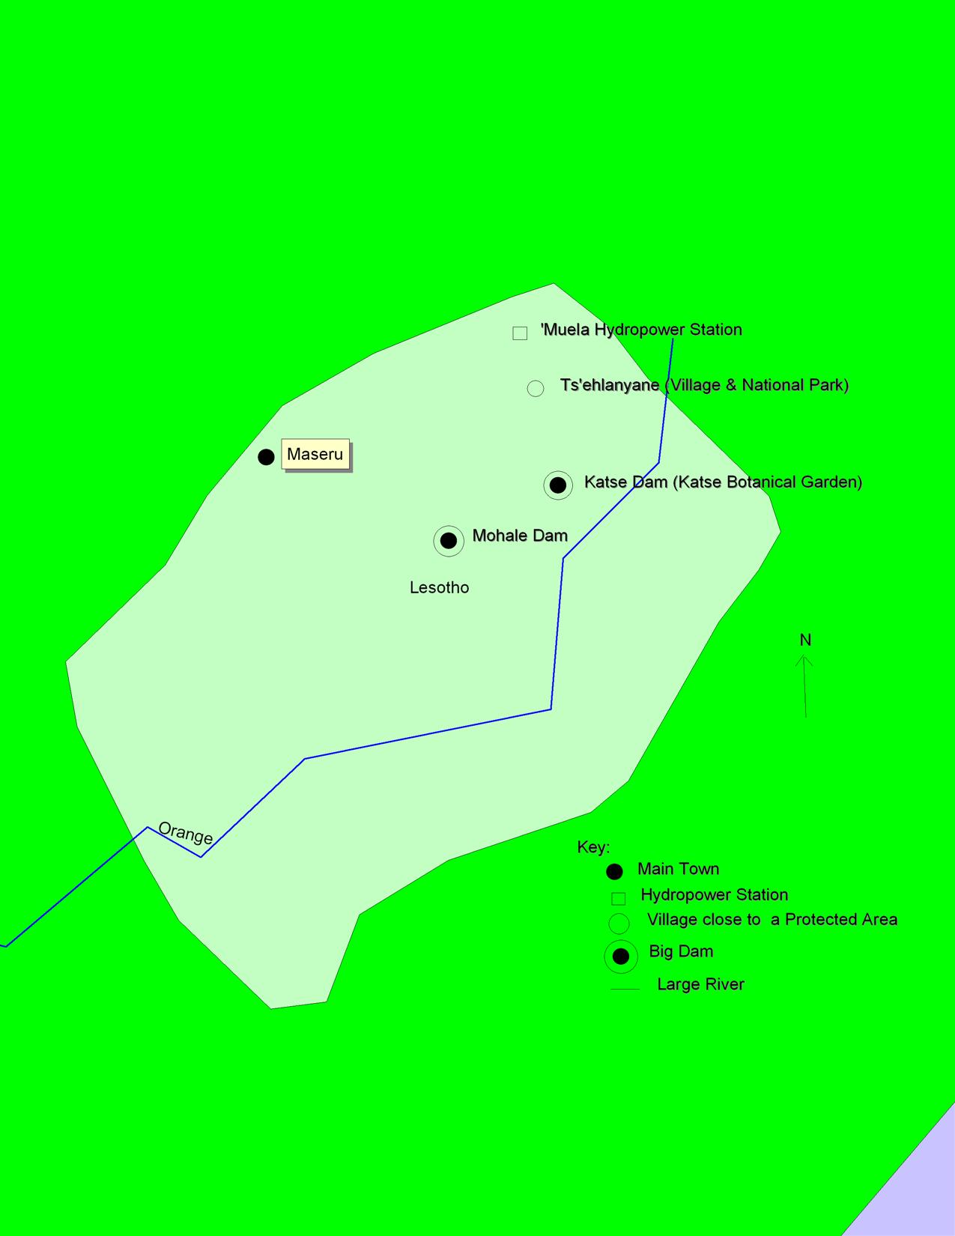

Figure 1. The location of Ts’ehlanyane National Park

3. Materials and Methods
The research was carried out from May to July 2008. Both open-ended and closed-ended interviews were conducted in the three protected areas. The questionnaires used in the closed interviews were developed by the researcher with the guidance from previous studies and other related agencies. The other interviews (mostly open-ended) were conducted in Ts’ehlanyane village. The respondents were workers from TNP, the botanists, villagers (traditional doctors, farmers, herd boys & shepherds) from Ts’ehlanyane Village. Experts from the Ministry of Environment were also interviewed about their involvement and consent about the protection of spiral aloe.
The qualitative methods were used to construct strata in the village. A stratified sampling method was used to divide the village into four strata. The aim of this research was to obtain more rich information and that means the respondents have to be people who really have the rich information about the subject of the study.
In cases like this, Babbie (1992) indicates that it is important that the sample is chosen on the basis of the researcher’s knowledge of the population in which the study is to be conducted. Polit and Beck (2003) therefore say that a purposive or judgmental sampling which is based on the belief about the researcher’s knowledge about the population can be used to hand-pick sample members. In this way, the sample members will be people with the necessary information for the study. Respondents were then chosen using purposive sampling in all areas of the study as to make sure that they all have good knowledge about Aloe polyphylla.
The researcher adopted a phenomenological (qualitative) approach, using semi-structured interviews and observations as data-collection techniques (Polit and Beck, 2003). During the interviews narrative-description data was collected (Polit and Beck, 2003). The semi-structured, in-depth interviews with the individual respondents were the primary data-collection tool. The advantages of semi-structured interviews were that more complex issues could be triggered, answers could be clarified and more in-depth as well as sensitive information could be obtained (Bowling, 1997). To further enrich and support the data, the researcher’ observations, field notes as well as taking pictures of Aloe polyphylla formed part of the study. Tables and standard method were used to analyse data. Results from all protected areas were them compared to make a conclusion of the results.

4. Results
4.1 Findings about the nature and life of Aloe polyphylla
The characteristics of Aloe polyphylla: The results show that Aloe polyphylla is a stem-less high altitude succulent. It prefers basaltic soils. Its leaves have a distractive spiral arrangement (clockwise & anticlockwise). This arrangement of its leaves is unique. It has also been discovered that these leaves are thorny at the edges and have apple green colour.
The results about uses of Aloe polyphylla: It has been found that most people use Aloe polyphylla for ornamental purposes. It is also used for medicinal purposes as well as in manufacturing of toiletries.
The species living in harmony with Aloe polyphylla: Aloe polyphylla can be found together with amongst others various Crassula sp., Erica sp., Themeda triandra, Urginea capitata, Bulbine narcissfolia, Cotyledon orbiculata and Festuca caprina.
The results of relationship between Aloe polyphylla and the species it lives together with: It was mentioned that all species are high altitude species and are unified by the moisture. They are all looking for moisture. Another relationship though not yet fully proven was the other species seem to be acting as protection to Aloe polyphylla as where these species are found, Aloe polyphylla is always hiding under them.
4.2 Findings about the availability of Aloe polyphylla in Ts’ehlanyane area
The results show that presently natural Aloe polyphylla is not available at this area but it used to be present. It was last seen before the construction of LHDA Adit that transfers water from Katse dam to ‘Muela dam.
4.3 Findings about the causes of extinction of Aloe polyphylla
It has been found that a lot of people came to this place in search for work in the construction and while waiting to be hired, they started illegally harvesting Aloe polyphylla in large quantities to sell it. The other cause is easy access to the area resulting from the road constructed as part of the Adit construction. The area became more accessible to everyone so most people came to harvest this species illegally. Other causes of extinction of Aloe polyphylla mentioned are illegal collection for illegal sales and overgrazing.
4.4 Results on the protection and remediation measures for Aloe polyphylla
Before the implementation of the project, Aloe polyphylla was collected together plants with other species that were to be affected by the project activities and propagated in Katse Botanical Garden. In places where it was not collected prior to the construction, in Ts’ehlanyane area in particular, a nature reserve was then established to reintroduce Aloe polyphylla to this area as it has extinct after the construction. LHDA also established a National Park in Ts’ehlanyane area to protect this species together with some other ones affected by the project too. Another measure taken was to encourage people living around the affected areas to establish their own household botanical gardens in order to reduce pressure on the little ones left in the wild.

5. Discussions
5.1 The nature and life of Aloe polyphylla
Aloe polyphylla is a succulent so it has some other general characteristics of all succulent but it has its own distinguishing features. The unique arrangement of its leaves with both clockwise and anticlockwise spirals is one of the main unique features of this species. It falls in the group of stem-less succulents with thorny leaves and has leaves with green apple colour. It is these unique features it has that make it too attractive that most people have decided to use it more as an ornamental plant. This is the most popular use of it. It can also been used for medicinal purposes too.
As it has been mentioned that this species is a succulent, it is clear that it leaves under harsh conditions. It can be found in places with little moisture living in harmony with amongst others species like: Crassula sp., Erica sp., Themeda triandra, Urginea capitata, Bulbine narcissfolia, Cotyledon orbiculata and Festuca caprina. Aloe polyphylla and all these other species are highlands species and they serve as a protection for it. In most cases it can be found somehow under these species.
5.2 The availability of Aloe polyphylla in Ts’ehlanyane area
Ts’ehlanyane area is one of the few places in Lesotho that are natural niches of this aloe. But unfortunately, it cannot be found there anymore. This result from illegal overharvesting that happened during the construction of the adit of the giant project in Lesotho, LHDA/LHWP. As in any other large project, most people waited everyday to be hired. It is during that time that Aloe polyphylla extinct from Ts’ehlanyane. Most people harvested it in large quantities that it had no time to recover.
One of the features of big projects is road construction. LHDA also constructed roads. These roads made some places accessible which were formerly not accessible. It is in this places where Aloe polyphylla is found, rocky inaccessible places. Even the little species which were left after the illegal overharvesting were harvested as its habitats became accessible to almost everyone.
5.3 The protection and remediation measures for Aloe polyphylla
After all the destruction it caused. LHDA took some measures to reestablish the harmed land. One measure used was a nature reserve. Ts’ehlanyane National Park was established as a way to conserve the biodiversity found in the area of its construction. But unfortunately, at the time when the reserve was established, Aloe polyphylla has already extinct. Instead, it has been propagated here in the reserve too. There are also plans to establish colonies for this species and try to plant it in larger quantities. This is from the fact it is been suspected that Aloe polyphylla has still chances of naturally appearing in this area. This result from suspicion that there are some few species that might have grown from the seeds that fell from the last big species to be harvested illegally.
Besides this nature reserve, there are botanical gardens established with the same purpose. One belongs to LHDA while others belong to the people living around the project areas. They are all under the supervision of LHDA.

6. Conclusions
LHWP has highly affected Aloe polyphylla in Lesotho. Some of the measures taken to correct this situation were late in some places like Ts’ehlanyane as it has already extinct when measures were implemented. In cases where it was protected prior to the implementation of the project, it has been fully saved. This clearly shows that, it is better and safer to protect biodiversity prior to establishments than correcting the harm caused. In short, prevention is better than cure, so it will be wiser for all project managers to see to it that they avoid or prevent problems than correcting them. That is not only safer for biodiversity but also reduces costs of implementation of corrective measures which are in most cases expensive and as a result become unsustainable.

7. Acknowledgements
We would like to pass my special gratitude to all people who contributed in any way to make this study successful.

Correspondence to:
Jiwen Ge, PhD, Professor, Director

Institute of Ecology and Environmental Sciences, China University of Geosciences,
388 Lumo Road, Hongshan Administration District,
Wuhan City, Hubei Province, 430074, China
Email: gejiwen2002@yahoo.com.cn; gejiwen@cug.edu.cn
Telephone: +862762493959

References
Babbie, E. The Practice of Social Research. 6th Ed. Belmont, USA: Wadsworth Publishing,1992.
Bell, F G, Haskins, D R. A geotechnical overview of Katse Dam and Transfer Tunnel, Lesotho, with a note on basalt durability. Engineering Geology, 1997, 46(2): 175-198.
Bowling, A. Research Methods in Health: Investigating Health & Health Services. Buckingham, UK: Open University Press, 1997.
De Bruiyn, H, Schoch, A E, Van Der Wesrthuizen, W A, Myburgh, C A. Picrite from the Katse Area, Lesotho: Evidence for the Flow Differentiation. Journal of African Earth Sciences, 2000, 31(3-4): 657-668.
Letšela, T, Witkowski, E T F, Balkwill, K. Plant resources used for subsistence in Ts’ehlanyane and Bokong in Lesotho. Economic Botany, 2003, 57(4): 619–639.
Polit, D F, Beck, C T. Nursing Research: Principles and Methods.7th Ed. Baltimore, USA: Lippincott Williams & Wilkins, 2003.

Submitted to;
sciencepub@gmail.com, editor@sciencepub.net,
Marsland Press,
P.O. Box 21126,
Lansing, Michigan 48909,
The United States, 347-321-7172.

4/22/2009

