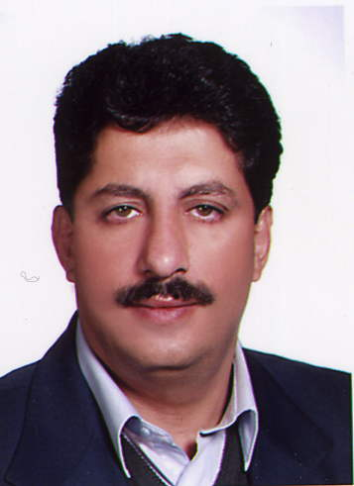

Author information (Moharam Barzegar Zenouz):
PhD of petrochemistry in the specialty of surfactant, he established International Research and Training Institute of Barzegar Zenouz in 1997, the goal is: Developing software and hardware to synthesize surfactant based products, research and innovation in these areas.
Till now the institution has 7 innovations and registered them in Registration Office for Company & Non Commercial Institute and more than 50% of this innovation are applicable and in mass production phase. There are six laboratories in this research institute (water.oil, drug, biotechnology, nano and environment)

