Environmental geological assessment of a Solid Waste Disposal site: a case in Ilorin, Southwestern, Nigeria.

IGE, Olusegun. O and OGUNSANWO, Olufemi

Lecturers, Department of Geology and Mineral Sciences, University of Ilorin, Ilorin, Nigeria, P.M.B 1515, Ilorin, Kwara State
Email: vickyige2002@yahoo.com
Abstract
This study was carried out to evaluate the effects of leachate from open landfill in the Ita-Amo area of Ilorin, southwestern Nigeria. It is also aimed at determining the possibility of upgrading the site to a modern waste containment facility (Sanitary Landfill) by evaluating the geotechnical properties of soils obtained over the site. A total of ten water samples and four representative soil samples were analyzed.
Results of water analyses showed that the P^{H} range from 6.6 to 7.1; Electrical Conductivity range from 107µs/cm to 241µs/cm; TDS range from 61mg/l to 971mg/l ; ca²⁺ range from 7.4mg/l to 64.0mg/l, Mg²⁺ range from 17.0mg/l to 61.0mg/l; HCO₃⁻ range from 93.5mg/l to 250.0mg/l; SO₄²⁻ range from 98.0mg/l to 1400.0mg/l; Cl⁻ range from 56.4mg/l to 880.0mg/l during the wet season. In the dry season, the concentration of ca²⁺ range from 41.3mg/l to 117.2mg/l; Mg²⁺ from 50.0mg/l to 100.4mg/l, K⁺ range from 2.1mg/l to 14.0mg/l; HCO₃⁻ range from 91.8mg/l to 234.0mg/l; SO₄²⁻ range from 91.7mg/l to 1730.0mg/l; and Cl⁻ range from 43.7mg/l to 1347.0mg/l. The concentrations of Pb range from 41.2µg/l to 53.4µg/l and 40.8µg/l to 61.7µg/l; Zn²⁺ range from 57.0µg/l to 60.0µg/l and 15.0µg/l to 67.1µg/l at wet dry season respectively while Ni was 30.3µg/l as measured in the wet season only. Generally, the concentrations of these parameters are higher than WHO recommendations and decrease away from the centre of the waste dumpsite which is suggesting anthropogenic influence on the quality water chemistry.
Geotechnically, the soils have 0.75% gravel, 32% sand, 48% clay and 19% silt in a compactible sandyclay soil. The result of the Atterberg limits tests showed that the soils are absolutely inorganic clay of low plasticity and average clay activity value of 0.39 which is suggesting non-reactive kaolinitic clay. The dry density of the soils are 1.80t/m³ and 2.1t/m³ when compacted at standard and modified Proctor energies respectively while the coefficient of permeability of the soils are in the order of 1x10⁻⁹m/s and 1x10⁻¹¹m/s respectively. These results are found favorably compared to recommendations of several researchers. Thus, satisfied the requirements for use as mineral seals in sanitary landfills. The higher energy of compaction (Modified Proctor) is recommended because it offered lower values of coefficient of permeability.

Keywords: Sanitary Landfill, Leachate, Coefficient of Permeability, Mineral Seals, Nigeria.

1.0 Introduction
Human population is increasing on daily basis, so is the corresponding quantity of waste contending for space with man and its effect impairing the quality of the environment. It is therefore very common to find waste dumps within built-up areas and cities in bags along roads and streets. Attempts by government, groups and individual to check these problems include composting, incineration, open burning and river dump of refuse. These attempts had severally failed because of their inadequacies (Ige, 2003 and Asiwaju-Bello, 2004).
The city of Ilorin is falls into southwestern (Fig. 1) and Northcentral on geological and political classifications respectively the capital town of kwara state, Nigeria. It has a total land coverage of over 400km² (Africa Atlases, 2007) and a population estimate of 2,185,494 people (NPC, 2007) which are responsible for the generation of waste often deposited in open spaces, river banks, road side etc. thereby degrading the quality of the environment. In attempt to alleviate environmental pollution within the city, three (3) final waste disposal sites (unengineered) were prepared and located strategically at the outskirt of the city (Fig. 2). However, the selection, design, construction and operational activities of these sites did not consider the geology and impacts on the adjacent environment. One of the deposal sites, along Ilorin –peke village has been investigated as presented in this study.
This study is therefore aimed at assessing the effects of leahate that is generated from dumpsite on the shallow groundwater of the study area to ascertain the extent of influence on the qualities of such water resources. The geotechnical and environmental issues were also investigated for the possible upgrading of the site to a modern solid waste containment facility such as sanitary landfill.

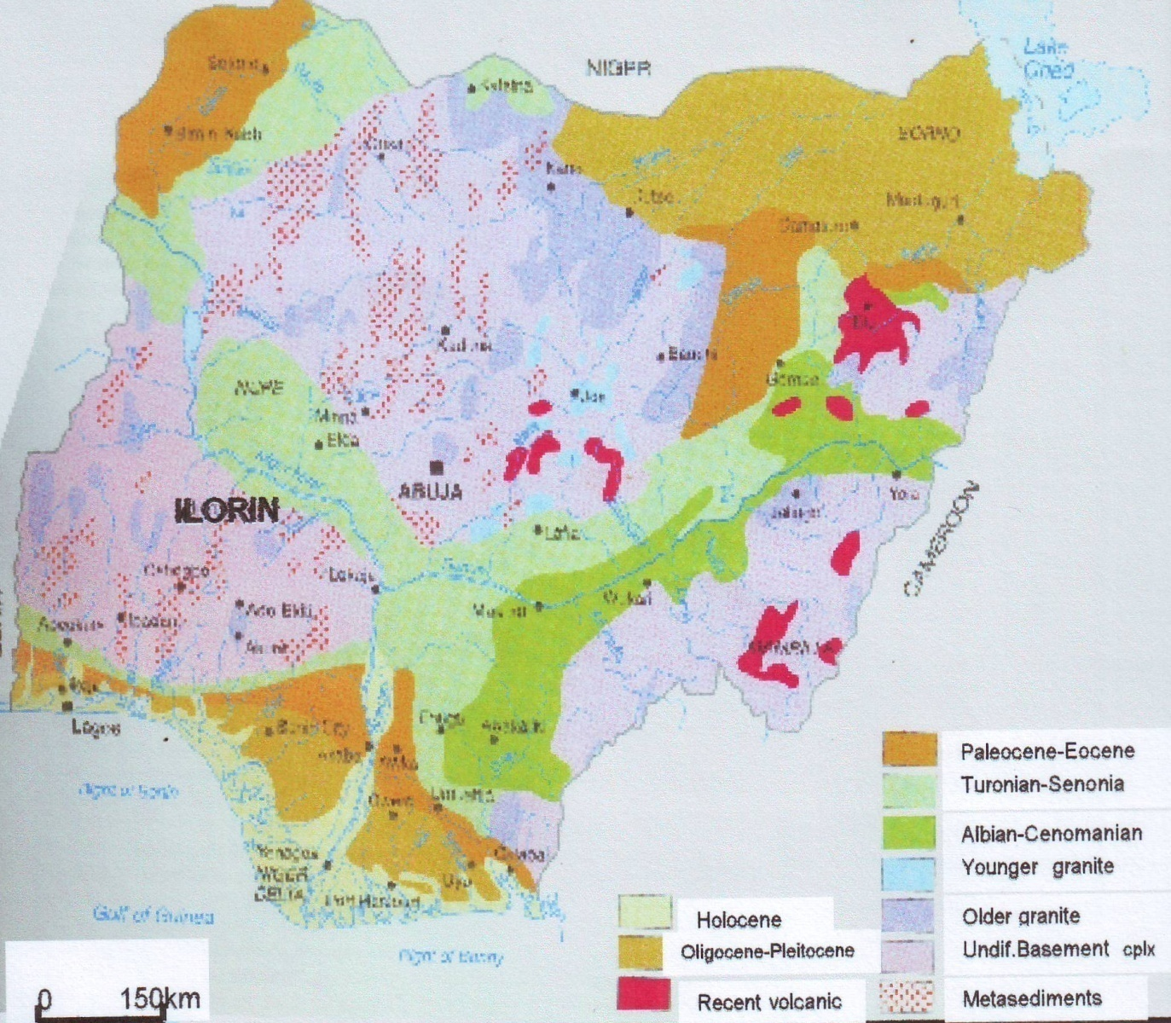

Fig.1: Geological map of Nigeria showing Ilorin (Modified from Africa Atlases, 2007)
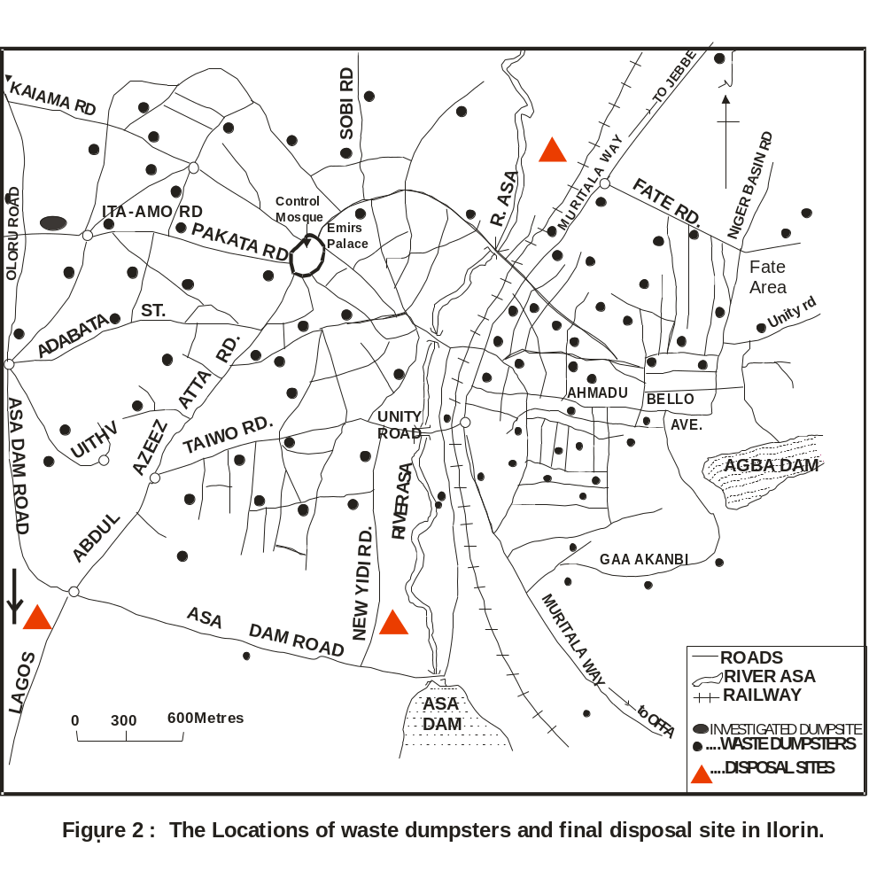

2.0 Study area
The study area (Ita-Amo waste disposal site, Ilorin) is located within latitude 8⁰ 25⁰ and 8⁰ 30⁰ and longitude 4⁰ 20⁰ and 4⁰ 30⁰. The approximate area extent of the dumpsite is 3.63x10⁶m² with average dump thickness of about 7.7m. The site inhabits and still occupying several farm land area. Geological, the area lies in the Precambrian basement complex of southwestern Nigeria and is underlain by rock of metamorphic and igneous type. However, migmatite predominantly underlies the waste dumpsite and characterized by weathered regolith which vary in thickness from place to place. The hydrologic setting of the area studied is typical of what is obtained in other basement complex area where the availability of water is a function of the presence of thick-little clay overburden material and presence of water filled joints, fracture or faults within the fresh basement rocks. The humid tropical climate of Ilorin has particularly encourage relatively deep weathering of the near surface rocks to produce porous and permeable material that allows groundwater accumulation as shallow aquifer which is recharged principally through infiltration of rainwater. At the investigated dumpsite, the waste leachate may also infiltrate to pollute the shallow ground water.

3.0 Material and Methods
10 water samples were used in this study. 4 shallow water wells were dug around the solid waste deposition centre (1within the dump, 3 outside the dump and a river water sample). The well within the dumpsite is labeled 1while wells at distances devoid of hydraulic interconnectivity away from dumpsite and the river water sample and labeled 2,3,4 and 5 (50m, 70m, 120m and 327m away from dumpsite) respectively. Each of the well was dugged below the groundwater table to provide column for water accumulation. The water sampling was done in the well and dry to monitor pollution if any with respect to season.
Each of the water samples was collected into 2-litre container for the determination of anion concentration while 1-litre was used for cation concentration determination. The cation containers were acidified with 1-2 drops of HCl acid to prevent adhering to the surface of the container. The sensitive physical parameter such as total dissolve solid (TDS), Electrical conductivity (Ec) and P^{H} were determined in the field using portable digital conductivity and PH meters also measure on the field and colour, turbidity. The analyses of the chemical constituents of the water sample were carried out at the water laboratory UNICEF office in Ilorin, Nigeria. Major cations (Mg²⁺, Na⁺, Ca²⁺, K⁺) and anions (HCO₃⁻, SO₄²⁻, Cl⁻) were analyzed using the flame photometry and atomic absorption photometry method while calorimetric, gravimetric and titrimetric methods were used for the determination of the anions.
Also four soils were recovered from the shallow wells at different depth within the lateritic zone. The variation in depth of soil sample was necessary to know the geotechnical properties of the whole laterite zone which may be useful as a mineral seals in the construction of modern waste containment facility (sanitary landfill). All the soil samples were analyzed with respect to their grain size distribution, Atterberg limit, moisture content- density relationship and the coefficient of permeability (K) characteristics at the soil laboratory of the Yaba College of technology, Lagos, Nigeria according to the BS 1377: 1990 standard. The results obtained were later compared with the recommendation of several previous researchers and regulatory agencies.

4.0 Results and Discussions

4.1 Physical properties of water samples
Summary of the physical properties (and some site characteristics) of water sample is presented in Table 1. The P^{H} value range between 6.8 - 7.9 at both seasons. This range falls within the acceptable boundary of (WHO, 1993) for water usage in drinking. The colour value range between 15Hazen - 61Hazen units in the wet season and 50Hazen - 92Hazen in dry season with highest value observed at well 1. Turbidity is higher in dry season than in wet season, probably due to dilution activities in the wet season, and decrease away from the dumpsite area (Table 1).

Table1: Physical properties of water sample and other site
characteristics.

Properties | W1 | W2 | W3 | W4 | SW
Static water level (m) | 5.71 | 6.30 | 6.57 | 4.9 | -
Depth of Well (m) | 6.47 | 6.47 | 7.15 | 6.71 | -
Thickness of horizon(m) | 3.90 | 3.58 | 3.84 | 3.79 | -
Depth of soil sampling(m) | 1.15 | 2.70 | 4.50 | 3.10 | -

W1- 4: Well Number SW: Surface Water

4.2 Chemical properties of water samples
The relative abundance of the elements is shown in Table 2. The calcium ion concentration range from 7.4 mg/l - 64mg/l and 41mg/l -121.4mg/l during wet and dry season respectively. While the magnesium ion concentration range from 17.0mg/l -61.0 mg/l and 17.0mg/l-100.4mg/l during wet and dry season respectively. Concentration of sodium ion range from 12.0mg/l – 57.5mg/l in the wet season, and 23.0 mg/l to 109.4mg/l in the dry season while potassium ion concentration range from 0.78mg/l -2.70mg/l and 1.30mg/l -14.0 mg/l during wet and dry season respectively. Calcium concentration falls below the maximum permissible level (MPL) of their concentration in water to be useful for drinking purpose (WHO, 1993). This may be due to little or no interaction of water with the underlying basement rock (the principal source of calcium and magnesium ion) since all water samples were collected within vadose zone. However, concentrations above allowable level (AL) were noticed at wells1, 2 and 3 in dry season and decreases with distance away from the centre of the dumpsite (Figures 3-12).
For the anions, bicarbonate concentrations range from 93.5mg/l - 250mg/l in the wet season and from 91.8mg/l - 234.0mg/l in dry season. The sulphate range from 98.0-1400.0mg/l and 91.7mg/l -1730.4mg/l in the wet and dry season respectively. The chloride ion concentration range from 56.4mg/l - 880.0mg/l ion in the wet and from 43.7mg/l -1347.0mg/l in the dry season. The nitrate ion concentration (where determined) range from 17.0mg/l - 31.0mg/l and 20.1mg/l-53.4mg/l at the two season respectively. All the parameters (anions) were observed to be above MPL at the wells (1-4) during the two seasons and decrease away in concentration from dumpsite centre (Table 2). This may be connected to the liquification and leaching of decomposed dominantly domestic, industrial and commercial waste within the dumpsite as a result of the action of heat, pressure and presence of water. Generally, low concentrations of these parameters were observed which may be due to pollutant filtering capability of the underlying soil, season and age of dumpsite.

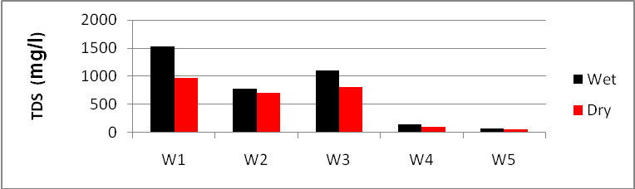
Fig. 3: Concentration of Total Dissolved solid (TDS)

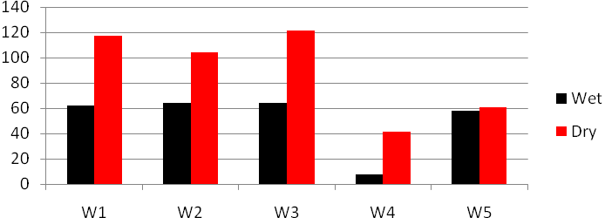
Fig.4: Variation of calcium concentration in the wells

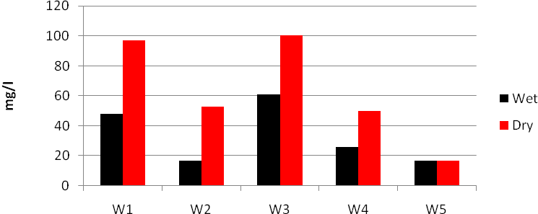
Fig.5: Variation of magnesium ion concentration in the wells

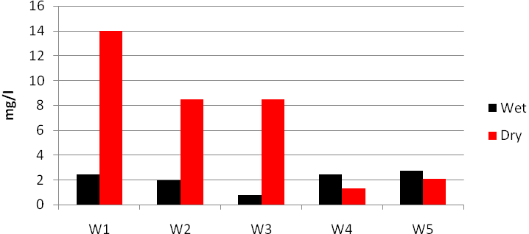
Fig .6: Variation of Potassium ion concentration in the wells

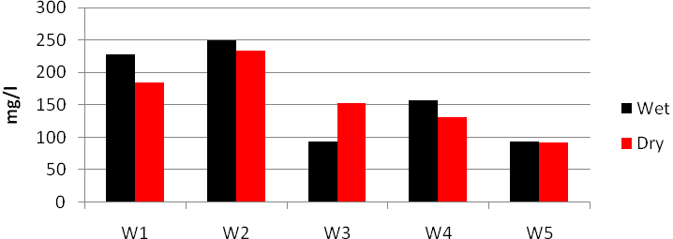
Fig.7: Variation of Bicarbonates ion concentration in the wells

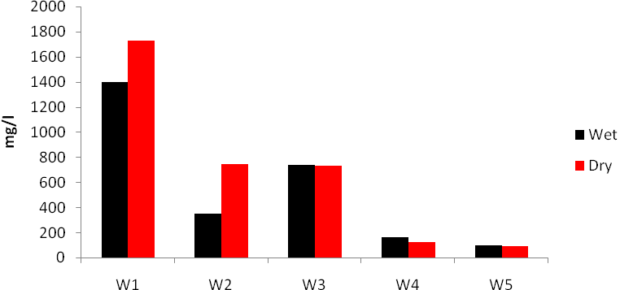
Fig.8: Variation of Sulphate ion concentration in the wells
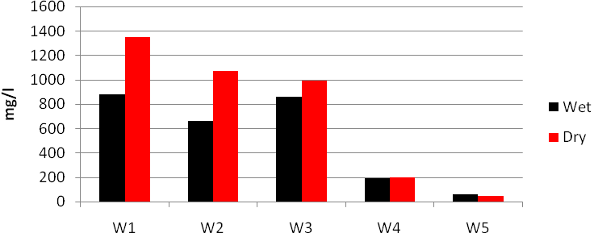
Fig.9: Variation of Chloride ion concentration in the wells

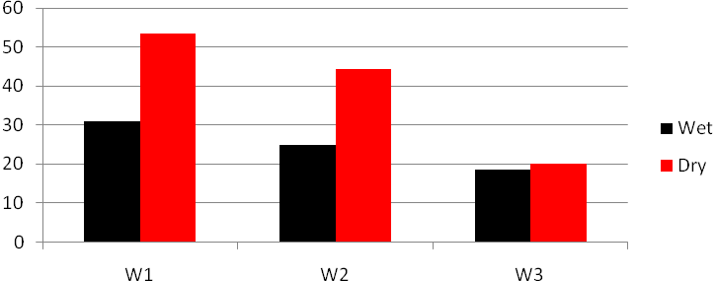
Fig.10: Variation of Nitrate ion concentration in the wells
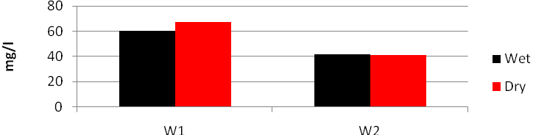
Fig.11: Variation of Zinc ion Concentration in the wells
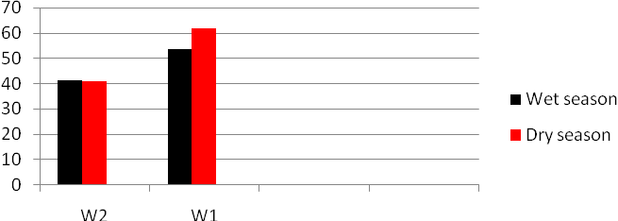
Fig.12: Variation of lead ion concentration in the wells

T able 2: Chemical properties of water samples
Parameters | Wet | Dry | Wet | Dry | Wet | Dry | Wet | Dry | Wet | Dry | AL | MPL
PH | 7.1 | 6.6 | 7.2 | 6.8 | 7.6 | 7.1 | 7.4 | 7.1 | 7.9 | 7.0 | -
Ec (µs/cm) | 3320 | 2411 | 1585 | 1034 | 2360 | 1917 | 500 | 439 | 160 | 107 | - | 400
TDS (mg/l) | 1530 | 971 | 785 | 704 | 1110 | 816 | 142 | 101 | 74 | 61 | - | 1000
Calcium (mg/l) | 62.0 | 117.2 | 64.0 | 104.4 | 64.0 | 121.4 | 7.4 | 41.3 | 58.0 | 61.0 | 75.0 | 200.0
Magnesium(mg/l) | 48.0 | 97.2 | 17.0 | 53.0 | 61.0 | 100.4 | 26.0 | 50.0 | 17.0 | 17.0 | 50.0 | 150.0
Sodium (mg/l) | 12.0 | 49.4 | 57.5 | 109.4 | 12.0 | 61.1 | 23.0 | 27.0 | 25.0 | 23.0 | 20.0 | 200.2
Potassium (mg/l) | 2.4 | 14.0 | 1.95 | 8.5 | 0.78 | 8.5 | 2.4 | 1.3 | 2.7 | 2.1 | 10.0 | 12.0
Bicarbonate(mg/l) | 228.1 | 184.2 | 250.0 | 234.0 | 93.5 | 153.3 | 157.4 | 131.0 | 94.1 | 91.8 | variable | variable
Sulphate (mg/l) | 1400 | 1730.4 | 350.0 | 742.7 | 740.1 | 733.6 | 160.0 | 120.0 | 98.0 | 91.7 | 250.0 | 400
Chloride (mg/l) | 880.0 | 1347.0 | 664.1 | 1074.1 | 860.0 | 994.4 | 193.9 | 200.7 | 56.4 | 43.7 | 250.0 | 600
Nitrate (mg/l) | 31.0 | 53.4 | 24.7 | 44.4 | 18.4 | 20.0 | ND | ND | 17.0 | 20.1 | 25.0 | 50.0
Zinc (µg/l) | 60.0 | 67.1 | 57.2 | 61.0 | ND | 15.4 | ND | ND | - | - | - | 50
Lead (µg/l) | 53.4 | 61.7 | 41.2 | 40.8 | ND | ND | ND | ND | - | - | - | 50
Nickel (µg/l) | 30.3 | 33.1 | ND | 17.4 | ND | ND | ND | ND | - | - | - | 50
Colour (Hazen) | 61.4 | 92.3 | 53.4 | 68.1 | 51.4 | 60.7 | 15.5 | 50.6 | 31.4 | 56.1 | 5 | 50
Turbidity | 21.7 | 28.2 | 17.0 | 33.9 | 9.3 | 20.3 | 7.7 | 7.3 | 12.8 | 7.2 | -

5.0 GEOTECHNICAL PROPERTIES OF SOIL
Several limits have been proposed by various researchers with respect to geotechnical properties of soils to be useful as barriers in landfills. Such limits have been compared with the results of the investigated parameters and presented as follow

5.1 Grain size distribution
In the soils investigated the largest grain has diameter ≤ 6.3mm. This is very small compare to 63mm suggested by ÖNORM S2074 (1990) and less than 50mm suggested by Daniel 1993. The percentage of clay contained in the soil range between 41% - 51% Table 3. These values are much higher than 15% proposed by ÖNORM S 2074 (1990) and less than 30% suggested by Daniel1993, Bagchi(1994), Benson et al (1994), Rowe (2005) and Mohammedzein (1998). Oeltzcshner (1992) preferred soils with clay fraction of greater than 20%.
The percentage of gravel recommended by Daniel 1993, Bagchi (1994) and Rowe (1995) is less or equal 30% of the soil mass. The highest proportion of gravel from the investigated soil sample is 2% with an average value of 0.75% over the whole area. The specific gravity also ranges between 2.61% and 2.69% which is better than 2.2 recommended by ÖNORM S2074 (1990).

Table 3: Grain size analysis of soil samples
S/N | Well No | Depth(m) | Natural Density(t/m³) | Specific Gravity | Grain Size (%) | Sand (%) | Clay (%) | Silt (%) | Fine (%)
1 | W1 | 1.15 | 2.04 | 2.69 | 2 | 28 | 48 | 22 | 70
2 | W2 | 2.70 | 1.67 | 2.64 | 1 | 34 | 45 | 20 | 65
3 | W3 | 4.50 | 1.60 | 2.63 | 0 | 28 | 51 | 2` | 72
4 | W4 | 3.10 | 1.91 | 6.61 | 0 | 36 | 49 | 15 | 64
 |  | Average | 1.81 | 2.64 | 0.75 | 32 | 48.3 | 19 | 68

5.2 Atterberg consistency limits
The results of the liquid limit tests (L_{l}) for the soil range between 35.34% and 40.56% while the index of plasticity (Ip) range between 17.15% and 20.55% (Table 4). These are higher than recommendations of several previous workers. From the results, the Casangrande plasticity chart was plotted for all the soils. All the soil samples fall within the inorganic clay of intermediate plasticity (Fig. 13). This is a good result when compared to the recommendations of Bagchi (1994), Hughes et al (2005) and Jagger and Ash (2008). Clay activities (A_{C}) of the soils were also evaluated to determine the reactivity of the soil. The values range between 0.35 and 0.40. It therefore suggested that the soil contain essentially kaolinitic clay mineral type which are non-reactive and non-expansive (Lambe 1951, Bagchi 1994 and Withlow (1998). They are less attack by chemical and withstand volumetric shrinkage (Taha and Kabir, 2006).

Table 4: Atterberg Consistency limits of the soil samples
Symbol | WL (%) | WP (%) | IP (%) | Plots on Plasticity chart | Ac
W1 | 35.34 | 18.19 | 17.15 | CL | 0.35
W2 | 39.14 | 20.80 | 18.34 | CI | 0.41
W3 | 39.80 | 21.31 | 18.49 | CI | 0.39
W4 | 40.56 | 20.01 | 20.55 | CI | 0.42
Average | 38.71 | 20.00 | 18.63 | CI | 0.39

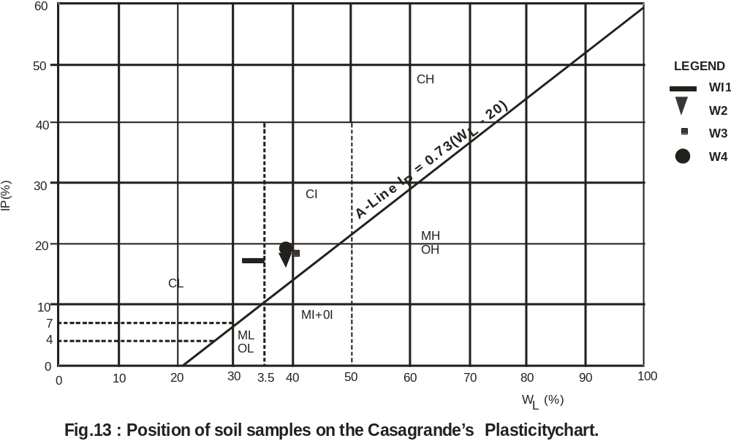

5.3 Moisture Content - Density relationship
The results of compaction tests carried out at different energies of compaction to obtain the soils optimum moisture content (OMC) and the corresponding maximum dry density (MDD) is presented in the Table 5. Benson and Trast (1995) reported that the coefficient of permeability is sensitive to compactive effort and molding water content. The soil MDD values for standard Proctor energy of compaction range between 1.77t/m³ and 1.84t/m³ while MDD at modified Proctor energy range between 1.9t/m³ and 2.2t/m³. These values are higher than 1.7t/m³ stipulated in ÖNORM S 2074 (1990). They are also better than 1.45t/m³ (standard Proctor) and 1.64t/m³ (modified Proctor) of MDD recommended by kabir and Taha (2006) for soils produced from Basement complex rocks to be useful as barrier in landfills.

5.4 Coefficient of permeability (k)
The coefficient of permeability is the key parameter affecting most soils to be useful as barrier in landfill (Benson, 1990). Thus great attention is focused at ensuring a low permeability is achieved. Several investigators and waste management agencies have recommended 1x10⁻⁹m/s as the minimum allowable value for soil to be useful for this purpose. From table 5, values lower than recommendation of several authors (e.g Mark 2002; Joyce 2003; Fred and Anne 2005 and Jagger and Ash, 2008) were obtained from all the soil investigated with both standard and modified Proctor energies. It was also observed that the coefficient of permeability decreases with increased compactive energy (Table 5). This is because there is a decrease in the frequency of pores resulting from the structural rearrangement of soil particle in the soil mass (Acar and Oliveri, 1990). For the purpose of sanitary landfill, the least achievable coefficient of permeability on the field is preferred. Therefore the higher energy (modified Proctor) of compaction is recommended.

Table 5: Maximum dry density and coefficient of permeability of the soil samples.
WELL SYMBOL | STANDARD PROCTOR |  | MODIFIED PROCTOR |  | COEFFICIENT OF PREMEABILITY(K)cm/s
 | OMC (%) | MDD (t/m³) | OMC (%) | MDD (t/m³) | STANDARD PROCTOR | MODIFIED PROCTOR
W1 | 13.4 | 1.84 | 10.8 | 2.2 | 1.1x10⁻⁹ m/s | 3.4x10⁻¹¹m/s
W2 | 14.0 | 1.78 | 10.3 | 1.9 | 4.0x10⁻⁹ m/s | 5.1x10⁻¹¹m/s
W3 | 14.2 | 1.77 | 10.0 | 2.1 | 5.3x10⁻⁸ m/s | 3.6x10⁻¹¹m/s
W4 | 16.7 | 1.80 | 12.5 | 2.0 | 3.7x10⁻⁹ m/s | 2.3x10⁻¹¹m/s
AVERAGE | 14.6 | 1.80 | 10.9 | 2.1 | 3.53x10⁻⁸ m/s | 1.6x10⁻¹¹m/s

Author for all correspondence:
Olusegun, O. IGE
Leturer,
Department of Geology and Mineral Sciences,
University of Ilorin, P. M. B. 1515, Ilorin, Nigria.
Email: vickyige2002@yahoo.com

6.0 Conclusion
The following conclusions were made on the hydrogeological and geotechnical evaluation of the Ita-amo waste dumpsite in, Ilorin, Nigeria.
The physical properties of the water samples are quite lower than the allowable recommended by the WHO for drinking and irrigation purpose. However, there is seasonal influence on the cationic concentration in the dry season with wells 1, 2 and 3 having concentration above the WHO permissible level. Also, Liquification and leaching activities of the deposited large volume of domestic and industrial waste at site may have been responsible for the high increase in the ionic concentration at both seasons. Ionic concentration decreases with increase distance away from the waste dump centre.
The overall engineering characteristics of the soil samples recovered from test pits, irrespective of the depth of recovery, show that the soils are inorganic clay with low to medium plasticity. Generally, these types of soils possess desirable characteristics to minimize hydraulic conductivity of compacted soils. The indices properties (liquid limit, plastic limit, percentage fine, percentage gravel, activity etc) of the soil samples satisfy the basic requirements as barrier materials in landfills. They are inactive clayey soils. Thus, the soils will be less affected by waste chemical and also less susceptible to shrinkage. The soils have hydraulic conductivity of less than 1×10⁻⁷ cm/s, when it is compacted with both modified and standard Proctor compaction efforts.
This result compared favorably with the recommendations of several researchers. Also higher energy of compaction is recommended because it gives lower values of coefficient of permeability for the compacted soils.

REFERENCES
[1] Acar, Y. and Oliveri. I. (1989). Pore Fluid Effects on the fabric and Hydraulic
Conductivity of Laboratory Compacted Clay. United State Transportation
Research Record, vol.12, (19), 144-159.
[2] Africa Atlasses 2007. Atlas of Nigeria. 2nd Editon. 156p.
[3] Ash, J.S. and Jagger, D.E. (2008). Geotechnical considerations at landfill
site. Jagger. Hims Ltd. www.jaggerhims.com, 27p.
[4] Asiwaju- Bello, Y. A. and AKANDE, O.O (2004). Urban groundwater
pollution: Case study of a Disposal sites in Lagos metropolis. Journal of
Water Resources. 12, 22-26.
[5] Bagchi, A. (1994). Design, Construction, and Monitoring of landfills. 2nd Edition,
A Wiley-Interscience Publication. U. S. A, 361.
[6] Benson, C.H. and Daniel, D.E (1990). The effect of clods on hydraulic
Conductivity of compacted clay. Journal of Geotechnical Engineering.
vol.116, (8), 1237-1248.
[7] Benson, C.H., Zhai, H. and Wang , X. (1994). Estimating hydraulic
conductivity of compacted clay liners. Journal of Geotechnical
Engineering. vol. 120, (2), 336-387.
[8] Benson, C.H. and Trast, M.J. (1995). Hydraulic conductivity of thirteen
compacted clays. clays and clay minerals, vol. 43, (6), 669-681.
[9] Daniel, D.E. (1993). Clay Liners. In: Geotechnical Practice for Waste Disposal
(Daniel D.E ed.). Chapman Hall, London, U.K, 137-163.
[10] Kurian.L. (2005). Landfill types and Liners system. Ohio State University Fact Sheet:
www.ohioline.ag.ohio- state.edu
[11] Ige, O.O. (2003). Impact of cultural and industrial waste on surface and shallow
ground water along Asa river, Ilorin metropolis, Kwara State, Nigeria.
University of Ilorin, Geology and Mineral Sciences,M.Sc.,
Thesis, Unpublished.108p.
[12] Joyce, M. P. E. (2003). A study of the merit and effectiveness of alternate liner
Systems at Illinois landfills. A research paper submitted in fulfillment of
house resolution 715. State of Illinois 92nd General Assembly. 46p.
[13] Kabir, M.H. and Taha, T. R. (2003). Sedimentary Residual soils as a
hydraulic barrier in waste containment systems. 2nd International
Conference on Advances in soft soil Engineering. Technology Putrajaya,
Malaysia. 894-904.
Mark, Y. (2002). Geology and Geotechnical Investigation of the Proposed
Canterbury Regional Landfill Kate Valley, North Canterbury Transwaste
Canterbury Ltd. 147p.
[15] Mohamedzein , Y. A. (2005). Assessment of crushed Shales for use as
compacted landfill liners. Journal of Engineering Geology, vol. 80, 271-281.
[16] Ooltzchner, H. (1992). Anforderin an die Geologic, Hydrogeologie Und
Geotechnik beim Bau von Deponie. In: THORME-KOZMIENSKY K. J.
(eds), Additictung Von Deponien and Altlastlen. E. F. Verlag fiir Gnergie
und Umwelttechnik combit, Borlin, 53-82.
[17] ÖNORMS 2074 1990. Geotechnik in Deponiebau-Erdarbeiten. Osterrichisches
Normungsinstitut, Wein. In: Ogunsanwo O. (1999). Geotechnical
Investigation of some soils from Southwestern Nigeria for use as mineral
seal in waste disposal landfills. Bulletin of IAEG, Paris, 54, 119-123.
[18] Rowe, R. k. (2005). Long-term performance of contaminant barrier systems.
Geotechnique, 55, (9), 631-678.
[19] Withlow, R. (1998). Basic Soil Mechanics. 3rd Edition. Longman Group Ltd.
557p.

