Manuscript Title: Vegetative propagation of Angelica glauca Edgew. and Angelica archangelica Linn.: two high value medicinal and aromatic herbs of the Himalaya

Rajiv K. Vashisthaª, Ashish K. Chaturvedi^{b}, B.P.Nautiyal^{c} and M.C.Nautiyal^{d}

ªRajiv K. Vashistha
High Altitude Plant Physiology Research Centre
H.N.B. Garhwal Central University, Srinagar, Garhwal
Pin-246174, Uttarakhand.
*rajiv_vashistha2000@yahoo.com
Phone No. +911346253760
Fax No. +911346252070

^{b}Ashish K. Chaturvedi
High Altitude Plant Physiology Research Centre
H.N.B. Garhwal Central University, Srinagar, Garhwal
Pin-246174, Uttarakhand.
ashi_spc@rediffmail.com

^{c}B.P. Nautiyal
Department of HAMP,
School of ES & NRM,
Mizoram University,
Aizawl- 796001
bhagwatinautiyal@gmail.com

^{d}M.C. Nautiyal
High Altitude Plant Physiology Research Centre
H.N.B. Garhwal Central University, Srinagar, Garhwal
Pin-246174, Uttarakhand
mcnautiyal@gmail.com

Running Title: Vegetative propagation of two Angelica species.

Corresponding author *rajiv_vashistha2000@yahoo.com

Abstract: Angelica glauca Edgew. and A. archangelica (Apiaceae) are high value medicinal and aromatic plant species of the Himalaya. Their ex-situ cultivation is recommended for conservation and regular supply of raw material. Vegetative propagation of these species was carried out at Pothivasa (2200 m asl): a part of western Himalaya, Uttarakhand, India. Three treatments viz., IBA, IAA and GA₃ (100, 200 & 500 ppm, each) were tried to stimulate sprouting and rooting. IBA 100 ppm showed better results in both the species. These treatments may be used for mass multiplication of these species.

Keywords: Angelica spp., conservation, medicinal herb, treatments, vegetative propagation

Introduction: Angelica glauca Edgew. and A. archangelica Linn., belong to family Apiaceae, are high value medicinal and aromatic plant species of the Himalayan Region. A. glauca, locally called as Choru or Gandhrayan, is native and endemic plant species, distributed along 2600 to 3,700 m asl in Uttarakhand, Jammu & Kashmir and Himachal Pradesh (Butola and Badola, 2004). The species is known for its multiple uses in traditional as well as in modern medicine. The rhizomes of the species are considered as cardio active, cordial and useful in constipation (Anonymous, 1985). Whole herb is reported to be useful to cure stomach troubles, bilious complaints, menorrhagia, infantile atrophy and as a stimulant (Chopra et al., 1956 and Anonymous, 1985). A. archangelica Linn., locally called as Rickhchoru in Garhwal region and commonly known as European angelica or wild parsnip, is an aromatic, stout, perennial herb with 60-200 cm in height. It is native to Austria, Belgium, Denmark, Germany, Greenland, Hungary, Ice-land, Poland and Central Russia. In India, it is found in western Himalaya mainly in Kashmir (1000-3900 m), Garhwal and Kumaon regions at altitudes of (2600 m–3900 m); also reported from Sikkim at (3000-3300 m). The herb, including the fruits and roots, is used for flavoring, and is reported to possess carminative properties. The root is aromatic and is reported to posses’ diaphoretic and diuretic properties, and is used in flatulent colic. It is sometimes applied externally as a counter-irritant. Internally it is used in digestive complaints, flatulence or as a tonic for cold and respiratory system (Anonymous, 1985).

Market demand of these species for pharmaceuticals and ethno-medicinal utility, are met through harvesting from wild populations. Due to unsustainable harvesting, habitat loss and grazing pressure these species have been assigned as endangered for the Himalayan region (Ved et al., 2003). Vashistha et al. (2006) reported the status of both Angelica spp. as endangered on the basis of population survey from Garhwal Himalaya. Both the species are propagated by the seed and vegetative parts. However, the existing report on seed germination is not reliable in view of their low germinability (Butola and Badola, 2004; Vashistha, 2006; Vashistha et al., 2009) and slow growth (Butola and Badola, 2006).

Vegetative propagation is one of the potential and useful methods that need to be tried for those species, which are economically important, difficult to raise through seeds and other means. Plant propagation through vegetative means multiplies these plants and preserves their essential genetic characters. This is an easy and effective technique for multiplication and conservation of plant species. Sexual reproduction is considered less important than vegetative propagation for arctic and alpine species (Bliss, 1971). Plant growth regulators and other chemicals are widely used in vegetative propagation to improve rooting and subsequent growth of cuttings (Nadeem et al., 2000; Butola and Badola, 2007). Present study was carried out to develop vegetative propagation protocol for the selected species using rhizome segments.

Materials and methods: In the month of October, rhizomes of selected Angelica species were collected from natural habitat Tungnath (TN): an alpine zone (3600 m asl) located between 30°14' N Lat. and 79°13' E Long. in Rudraprayag district of Garhwal, Uttarakhand Himalaya, India. The rhizomes were washed thoroughly with running tap water. Each rhizome was cut into small pieces (approx 6 cm long) as there were apical buds present on the rhizome. The root part was not considered for propagation. These were treated with different hormonal concentrations by dipping them in particular hormonal solution for 24 hrs. One lot was dipped in distilled water to treat as control. Hormonal solutions of 100, 200 and 500 ppm concentrations of GA_{3,} IBA and IAA were used as treatments. For individual treatment three replicates with twenty cuttings each were used. Subsequently, treated segments were planted in soil beds in October 2004 at Pothivasa (PV) situated in temperate zone (2200 m asl) between 30°28' N Lat. and 79°16' E Long. in Rudraprayag district of Garhwal, Uttarakhand Himalaya, India. Soil beds with pH 4.67-5.01, soil organic carbon 1.0-1.23% and nitrogen content 0.04-0.23% while potassium and phosphorus content was very low in the soil of the experimental site (Vashistha et al., 2007). After the onset of next growing season in May 2005 number of sprouted segments and rooting were recorded in each treatment.

Data analysis: The data was analyzed statistically using MS-Excel 2003. Data presented here are mean values of treatments with standard deviation. ANOVA was used to interpret the variation and to identify the best treatment.

Results and Discussion: Results of vegetative propagation of A. glauca and A. archangelica are shown in table 1 & 2, respectively. Results indicate that maximum sprouting and rooting was observed in 100 ppm of IBA (88.33% and 85.00%, respectively). Rooting of the rhizome cuttings was fairly high in A. glauca (68.33%) and A. archangelica (78.33%) even without using any intervention. However, further increase in rooting percentage was possible by applying different concentrations of IBA, IAA and GA3 (100, 200 and 500 ppm). Butola and Badola (2007) have recommended IAA and IBA as promising treatments to improve rooting, growth and biomass in Angelica glauca and Heracleum candicans. Variation was found significant among different treatments on the basis of ANOVA (P<0.05). When, sprouting as well as rooting was compared with control by using LSD, variation was found significant for IBA 100 ppm and IAA 100 ppm and rest of all treatments were found non-significant. In case of Angelica archangelica, maximum sprouting and rooting was observed in IBA 100 ppm (91.67%, 88.33%, respectively). In this species, variation was significant (P<0.05) only for IBA 100 ppm and rest of all treatments were found non-significant (Table 2).

Rooting response under control set, however, indicates availability of natural auxins within the cuttings in adequate quantities to initiate the rooting. Moreover, better responses under IBA were in conformity with the reports of its effectiveness as compared to several naturally occurring auxins in promotion of adventitious roots (Hartmann and Kester, 1983). Higher concentrations of GA₃ (200 and 500 ppm) were found less effective in both the species. In the present study, transverse rhizome segments were used which responded well for differentiation of root/shoot system (Figure 1 and 2). Rawat et al. (1992) reported that the transversely segmented tuber have the potential to regenerate in new plantlets with well-differentiated root and shoot. Kuniyal et al. (2003) attempted to propagate Aconitum atrox through tuber segments at lower elevation in the Garhwal Himalaya. Apical segments produced single shoot while sub-apical, middle and basal were also able to regenerate several sprouts.

Vegetative propagation can be used as an efficient tool for mass scale propagation of tuberous roots of medicinally important species as in case of Aconitum atrox, the species fails to establish through seeds under natural conditions in an alpine environment (Kuniyal, 1999). In Picrorhiza kurrooa, vegetative propagation using stolon segments was found successful for cultivation up to 1800 m altitude with high moisture regime and proper aeration (Nautiyal et al., 2001). Maturity stage of planting material is suitable for multiplication as maximum number of buds are found in this stage (Manjkhola and Dhar, 2002). Therefore, in present study rhizome segments were used after complete maturity stage of the selected species.

Conclusion: In both the Angelica species, only rhizome segments can be used for vegetative propagation. The collectors of raw material may be suggested to use the terminal part of rhizome for cultivation and utilize the remaining root part for medicinal purposes. Considering the economic potential of these species, this technology has immense potential of easy adoption by the farmers, and has significant value for both conservation and sustainable utilization of these Angelica species.

Acknowledgements: We are grateful to Director HAPPRC for providing facilities and encouragement. We are also thankful to Karan Singh Rauthan, Prem Singh and Jagdeesh Singh for their assistance. Financial support from NMPB, New Delhi is highly acknowledged.

References

Anonymous. The Wealth of India. A dictionary of Indian Raw Materials & Industrial Products. 1985; Vol IA (Revised): 275-276.
Bliss LC. Arctic and alpine plant life cycles. Annu. Rev. Ecology Syst. 1971; 2: 405-438.
Butola JS and Badola HK. Effect of pre-sowing treatment on seed germination and seedling vigour in Angelica glauca, a threatened medicinal herb. Current Science 2004; 87 (6): 796-799.
Butola JS and Badola HK. Assessing Seedling Emergence, growth and vigour in Angelica glauca Edgew. and Heracleum candicans Wall. Under different growing media and environments. Journal of Non-Timber Forest Products 2006; 13 (2): 141-153.
Butola JS and Badola HK. Vegetative propagation of Angelica glauca and Heracleum candicans. J. Trop. Med. Plants 2007; 8 (1): 85-91.
Chopra RN, Nayar SL and Chopra IC. Glossary of Indian Medicinal plants. Publication and Information Directorate. 1956, CSIR, New Delhi.
Hartmann HT and Kester DE. Plant Propagation- Principle and Practice. Fourth edition. 1983, Prentice- Hall, Inc. N J USA.
Kuniyal CP, Rajsekaran C, Prasad P and Bhadula SK. Propagation of threatened medicinal herb Aconitum atrox (Bruhl) Muk. through tuber segments, Plant Genetic Resources Newsletter 2003;135: 41-44.
Kuniyal CP. Mutliplication and Conservation of Aconitum balfourii (Bruhl) Muk. Using Conventional and Tissue Culture Methods.1999, D. Phil. Thesis, HNB Garhwal University, Srinagar Garhwal, India.
Manjkhola S and Dhar U. Conservation and utilization of Arnebia benthamii (Wall.ex G. Don) Jonston–A high value Himalayan medicinal plant. Current science 2002; 83 (4): 484-488.
Nadeem M, Palni LMS, Purohit AN, Pandey H and Nandi SK. Propagation and conservation of Podophyllum hexandrum Royle: an important medicinal herb. Biological Conservation 2000; 99: 121-129.
Nautiyal BP, Prakash V, Chauhan RS, Purohit H and Nautiyal MC. Assessment of germinability, productivity and cost benefit analysis of Picrorhiza kurrooa cultivated at lower altitude. Current Science 2001; 81 (5): 579-585.
Rawat AS, Pharswan AS and Nautiyal MC. Propagation of Aconitum atrox, a regionally threatened medicinal herb. Econo. Bot. 1992; 46 (3): 337-338.

Vashistha Rajiv Kumar. Ecophysiology and agrotechnology of two important Himalayan herbs Angelica glauca Edgew and A. archangelica Linn. Thesis submitted to H.N.B. Garhwal University, Srinagar, Garhwal, Uttarakhand India, 2006.
Vashistha R, Nautiyal BP and Nautiyal MC. Conservation status and morphological variations between populations of Angelica glauca Edgew and A. archangelica Linn. in Garhwal Himalaya. Current science 2006; 91(11):1537–1542.
Vashistha Rajiv Kumar, Nautiyal BP and Nautiyal MC. Economic viability of cultivation of the Himalayan herb Angelica glauca Edgew. At two different agro climatic zones. Current science 2007; 93(8): 1141-1145.
Vashistha Rajiv K, Nautiyal BP and Nautiyal MC. Pre-Sowing Treatments to Improve Seed Germination in Angelica glauca Edgew, an Endangered Medicinal Herb of the Western Himalayas. Journal of Herbs, Spices & Medicinal Plants 2009; 15:73–85.
Ved DK, Kinhal GA, Ravikumar K, Prabhakaran V, Ghate U, Sankar RV and Indreasha JH. CAMP Report: 2003, 206.Workshop, Shimla, Himachal Pradesh, FRLHT, Bangalore, India.

Table 1. Effect of different growth hormones on vegetative propagation of Angelica glauca using rhizome segments.

Treatments | Sprouting Percentage | Rooting Percentage
Control | 70.00±5.00 | 68.33±2.89
IBA 100 ppm | 88.33±2.89* | 85.00±5.00*
IBA 200 ppm | 75.00±5.00 | 73.33±2.89
IBA 500 ppm | 68.33±2.89 | 65.00±5.00
IAA 100 ppm | 85.00±5.00* | 83.33±7.64*
IAA 200 ppm | 68.33±5.77 | 66.67±7.64
IAA 500 ppm | 63.33±2.89 | 61.67±2.89
GA₃ 100 ppm | 75.00±5.00 | 71.67±2.89
GA₃ 200 ppm | 61.67±2.22 | 60.00±5.00
GA₃ 500 ppm | 51.67±2.89 | 48.33±2.89
F value & LSD (P<0.05) | 20.23* 5.80⁺ | 14.85* 6.55⁺
* Significant

Table 2. Effect of different growth hormones on vegetative propagation of Angelica archangelica using rhizome segments.

Treatments | Sprouting Percentage | Rooting Percentage
Control | 83.33±7.64 | 78.33±2.89
IBA 100 ppm | 91.67±2.89* | 88.33±5.77*
IBA 200 ppm | 80.00±5.00 | 76.67±2.89
IBA 500 ppm | 71.67±2.89 | 68.33±2.89
IAA 100 ppm | 83.33±5.77 | 80.00±5.00
IAA 200 ppm | 71.67±7.64 | 68.33±2.89
IAA 500 ppm | 65.00±5.00 | 61.67±2.89
GA₃ 100 ppm | 76.67±5.77 | 73.33±7.64
GA₃ 200 ppm | 65.00±3.33 | 63.33±7.64
GA₃ 500 ppm | 55.00±5.00 | 51.67±2.89
F value & LSD (P<0.05) | 11.80* 7.59⁺ | 14.91* 6.68⁺
* Significant

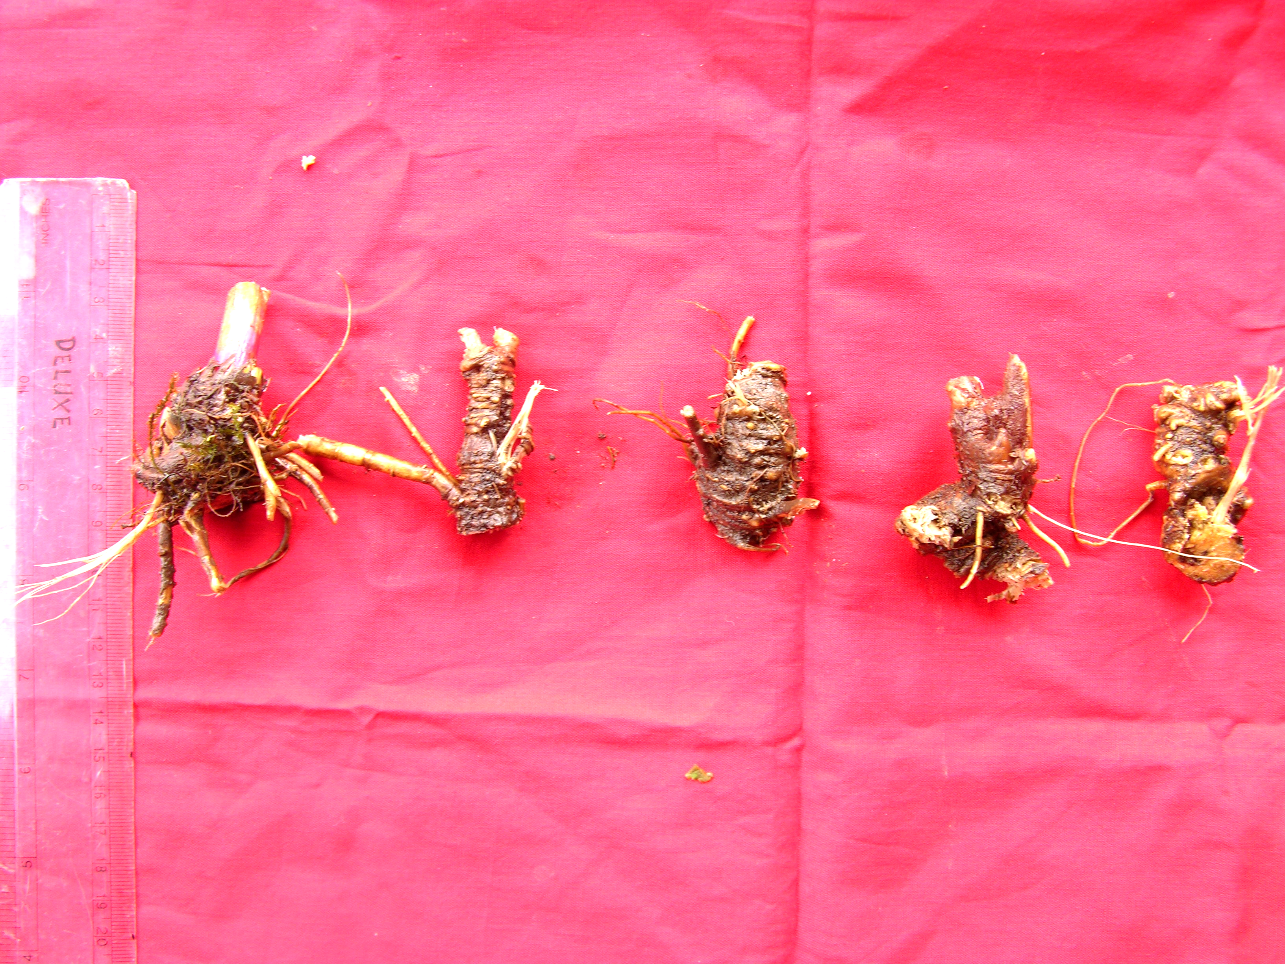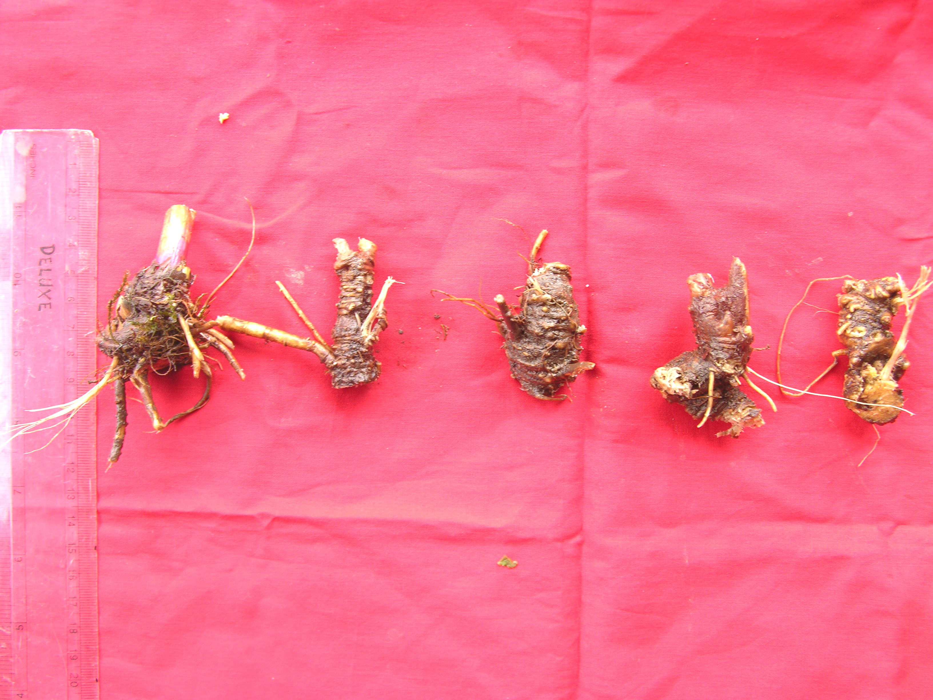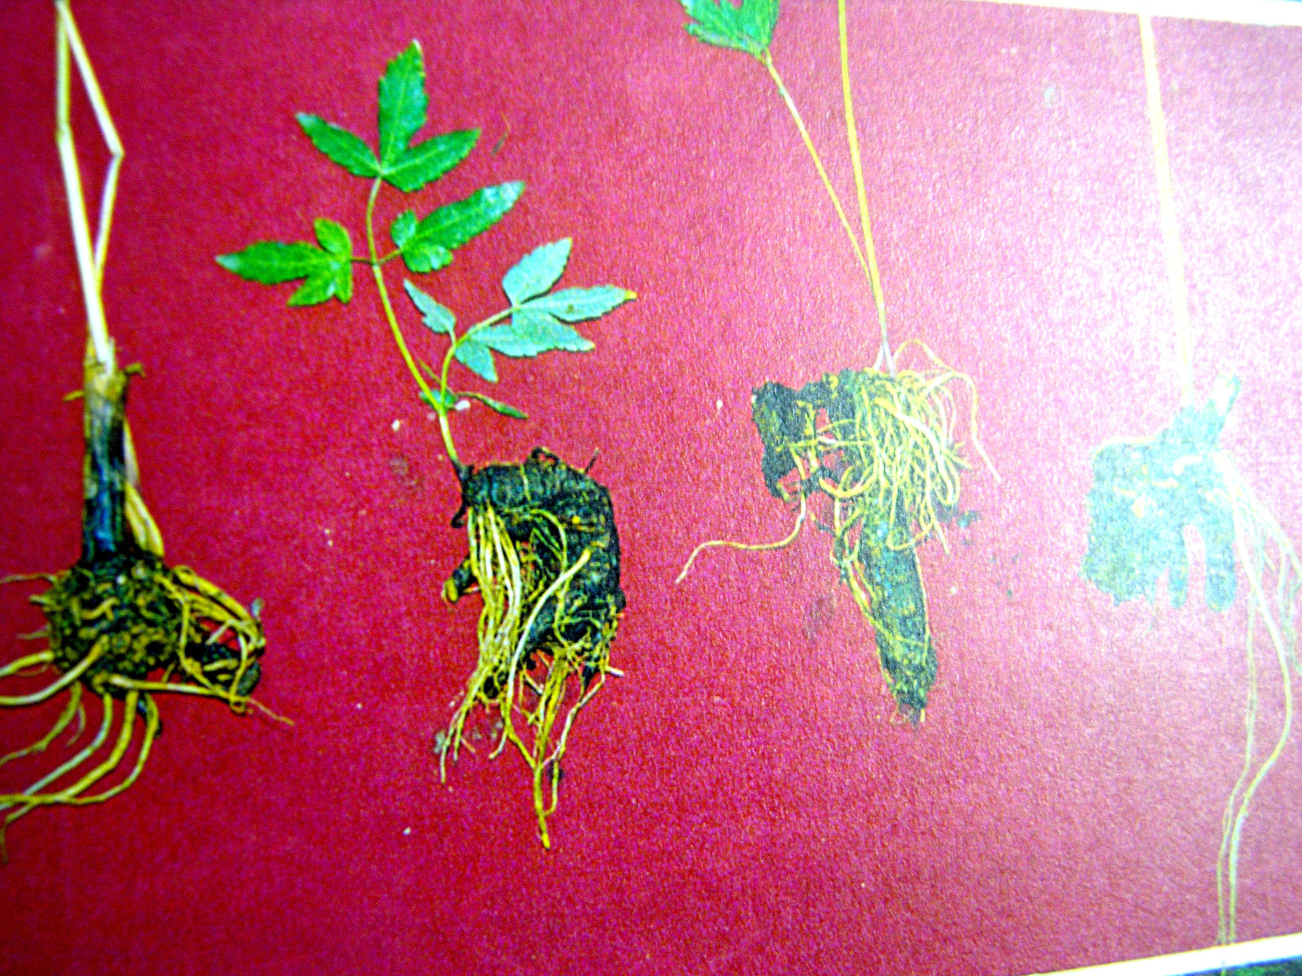
B
A
C

Figure1. Vegetative propagation in Angelica glauca
A
A- Rhizome segments; B- Root initiation in rhizome segments;
C- Vegetatively propagated plants

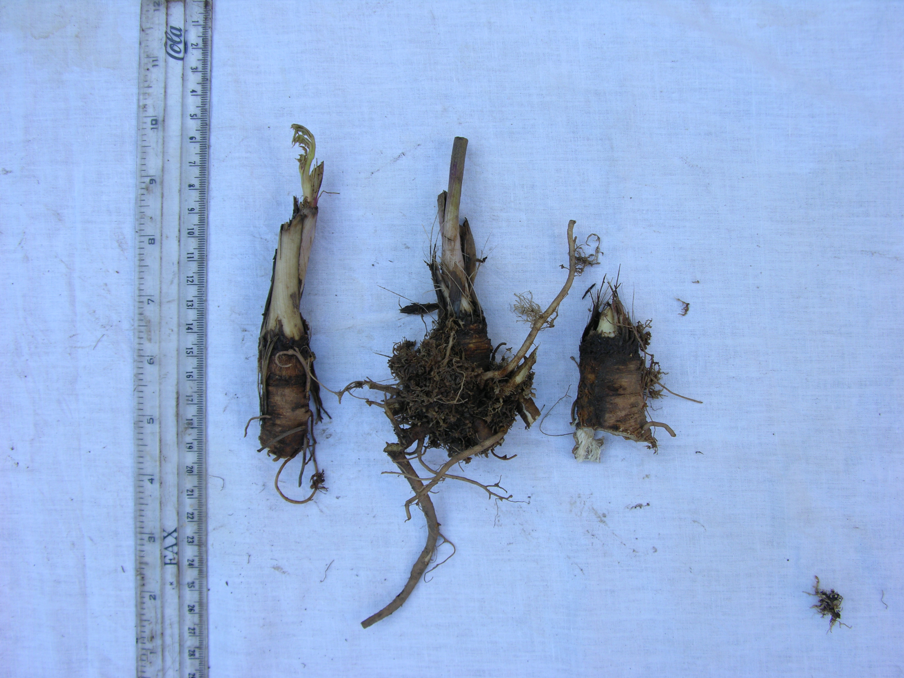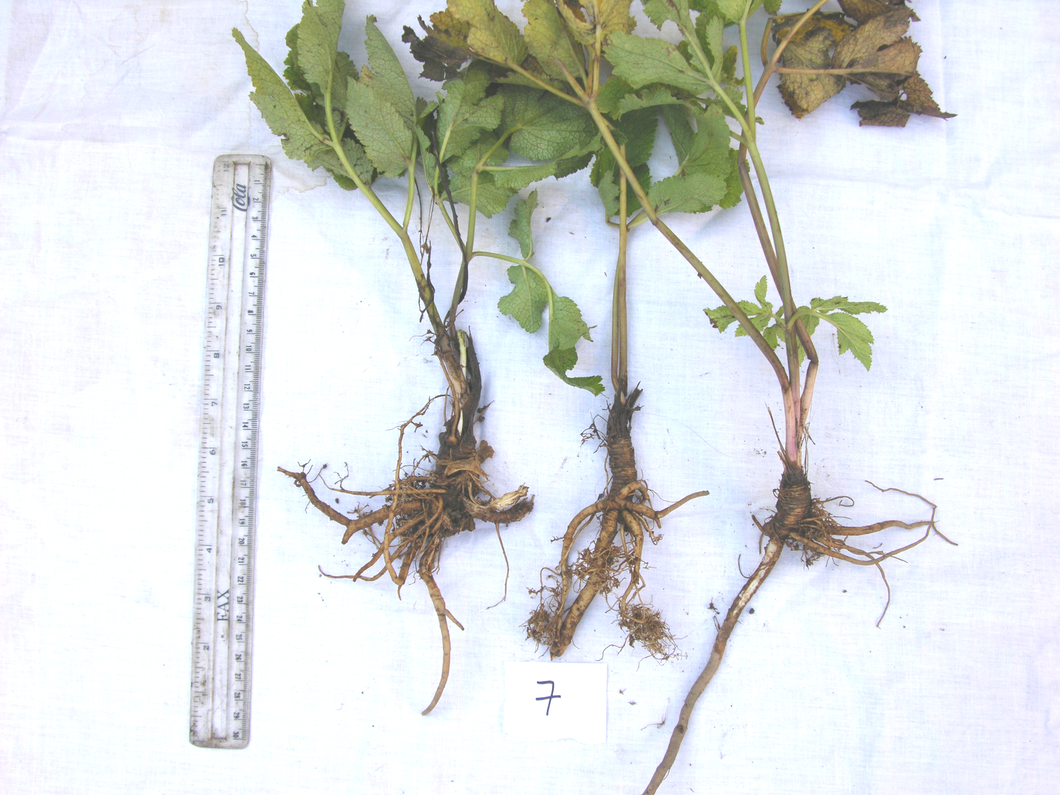
B
A

Figure 2. Vegetative propagation in Angelica archangelica
A- Rhizome segments; B- Vegetatively propagated plants

