Manuscript Title: Influence of foliar spray with paclobutrazol and ethepon on growth and photosynthetic behavior of Saussurea costus (falc.) Lipsch. - an endangered medicinal and aromatic herb
Ashish K. Chaturvediª, Rajiv K. Vashistha^{b}, P. Prasad^{c} and M. C. Nautiyal^{d}

ªAshish K. Chaturvedi
High Altitude Plant Physiology Research Centre
H.N.B. Garhwal Central University, Srinagar, Garhwal
Pin-246174, Uttarakhand.
*ashi_spc@rediffmail.com
Phone No. +911346253760
Fax No. +911346252070

^{b}Rajiv K. Vashistha
High Altitude Plant Physiology Research Centre
H.N.B. Garhwal Central University, Srinagar, Garhwal
Pin-246174, Uttarakhand.
rajiv_vashistha2000@yahoo.com
^{c}P. Prasad
High Altitude Plant Physiology Research Centre
H.N.B. Garhwal Central University, Srinagar, Garhwal
Pin-246174, Uttarakhand
ppratti@gmail.com

^{d}M.C. Nautiyal
High Altitude Plant Physiology Research Centre
H.N.B. Garhwal Central University, Srinagar, Garhwal
Pin-246174, Uttarakhand
mcnautiyal@gmail.com

Running Title: Effect of paclobutrazol and ethepon on Saussurea costus

Corresponding author *ashi_spc@rediffmail.com

Abstract: Paclobutrazol (PCB) and ethepon were applied as foliar sprays (25, 50, 100 ppm and 1.0 mM and 1.5 mM) to greenhouse-grown plants of Saussurea costus (Falc.) Lipsch. seedlings. Under stress conditions the growth of the PCB and ethepon treated seedlings was measured by leaf area, root length and root dry weight. A significant increment in root length was recorded for all treatments and showed a concentration-dependent pattern excluding for 50 ppm PCB treatment where the results were non-significant at 5% P level. Photosynthetic rate (A), transpiration rate (E) and stomatal conductance (gS) were found decreased in all the treatments as compared to control. A decrease in fluorescence ratio (Fv /Fm) indicated lower photosynthetic efficiency. Based on the results of this study, we presume that the stress caused by PCB and Ethepon probably contributes to some extent to the inferior gas exchange but an increase in root length. PCB had a more inhibitory effect than Ethepon.

Keywords: Paclobutrazol, ethepon, root growth, photosynthetic rate (A), transpiration rate (E), stomatal conductance (g_{S}), endangered medicinal and aromatic plant.

Introduction: Saussurea costus (Falc.) Lipsch., locally known as Kuth, belong the family asteraceae is a perennial aromatic herb. It is 1-2 m tall, with a thick fibrous stem. Leaves radical with long lobately winged stalks. Root stout, carrot like, 60 cm long, possessing a characteristic penetrating odour. Flowers are dark purple or black in colour. (Naithani, 1984; Nayar and Shastry, 1988; Stainton, 1988). Blatter, 1927; Samant et al., 1998 reported that it is distributed between 2500- 3000m asl in the Himalaya, and native to the Himalayan region. Its natural populations are reported from the higher elevations of Jammu and Kashmir and Himachal Pradesh (Aswal and Mehrotra, 1994) and now cultivated in Kashmir, Himachal Pradesh and in some part of Uttrakhand. The medicinal properties of Saussurea costus are well documented in different systems of medicine. Its roots have a strong and sweet aromatic odour with bitter taste, and used as antiseptic, in controlling bronchial asthma (Anonymous, 1972). It is also used for curing various diseases like dysentery, rheumatism, cholera, jaundice, cold, fever and stomachache etc. The oil is pale yellow to brownish in color and used in high grade perfumes and in the preparation of hair oil. Because of an endemic species to the Himalaya, the distribution of this species is quite restricted to extremely narrow geographical range (Siddique et al, 2001) which makes it more susceptible to extinction. Being an endangered species (Anonymous, 1972, Nayar and Shastry, 1987, 1988, 1990), enlisted in Appendix I of CITES (Convention of International Trade in Endangered Species of Wild Fauna and Flora), it has been prioritized among the species of high conservation concern (Badola and Pal, 2002; Ved et al., 2003). Its trade is strictly prohibited under Foreign trade Development Act-1992.

Paclobutrazol is a strong growth retardant used in many plants to control their growth and development (Ruter 1996, Whipker and Hammer 1997, Hamid and Williams 1997, Gonzalez et al. 1999). Ethepon, an ethylene releasing compound has also demonstrated a capacity to modify plant growth (Muse and Holcomb 1997, Banon et al. 1998, Cardoso et al. 1998). Both paclobutrazol (Andersen et al. 1998, Kim et al. 1999) and ethepon (Endres et al. 1999) have been shown to have an additional effect of modifying the color of the leaves of some plants, another aspect which may increase their ornamental value. Recently paclobutrazol has been shown to increase root growth of trees in certain landscape situations (Watson 1996, 2004; Watson and Himelick 2004).

Photosynthesis is controlled by several intrinsic and extrinsic factors. Of these, plant hormones have received considerable attention in the past in photosynthetic responses of plants. Ethylene is a phytohormone that influences every aspact of plant growth and development (Abeles et al. 1992). It is synthesized by the activity of 1-aminocyclopropane carboxylic acid synthase (ACS). The response of plants to ethylene depends on the sensitivity of plants to the gas. Most of the work related to paclobutrazol and ethepon has been done on tree species. The response of growth retardant on photosynthetic behavior of herbaceous plant species is still lacking. The present work is focused on the effect of different concentration of Paclobutrazol and ethepon on the photosynthetic parameters as Photosynthetic rate (A), stomatal conductance (g_{S}) and transpiration rate (E). The chlorophyll fluorescence ratio Fv/Fm is correlated with the efficiency of leaf photosynthesis and a decline in its ratio is a good indicator of photoinhibitory damage caused by incident photosynthetic photon flux density (PPFD) when plants are subjected to a wide range of environmental stresses (Bjorkman and Demming, 1987). Thus Chl a fluorescence parameter (Fv/Fm) was also determined for finding a possible relationship of Paclobutrazol and ethepon-mediated changes in foliar gas exchange and growth parameters of Saussurea costus.

Materials and methods: Seeds of Saussurea costus were sown in Styrofoam seedling trays in soil compositions of soil: sand: litter in (1:1:1, v.v.v) proportion during the month of October 2007 inside polyhouse at High Altitude Plant Physiology Research Centre (600 m asl), Srinagar, Garhwal, Uttrakhand. Onset of germination has taken place after 10 days of seed sown. Emergence of true leaf has taken place 21 days after onset of germination. The most homogeneous seedlings with 20 replicates for each treatment were selected for transplantation in polybags of size of 16 cm diameter and 13 cm height with same composition of soil i.e. soil: sand: litter in (1:1:1,v.v.v) proportion during the month of December 2007. The average air temperature inside polyhouse 12.87±2.23°C, minimum temperature 6.19±1.30°C, maximum temperature 16.26±3.59°C; average relative humidity percentage 53.00±5.50 and average soil temperature 12.32 ±2.56°C was recorded.

After one month of acclimatization inside polyhouse these seedlings were given different concentrations of growth retardants as for paclobutrazol [PCB] (25ppm, 50ppm and 100ppm) and for ethepon (1.0mM and 1.5mM). The foliar spray of these growth retardants were done with a hand sprayer. After 15 days of spraying, the growth and photosynthetic parameters were observed.

Measurement of growth parameters: Five plants for each treatment were dug out for observing the growth parameters such as leaf area (cm²), root length (cm) and dry weight (mg) of economically important part i.e. root/rhizome. These plants were taken to laboratory, washed with running water. Further, all samples were dried at 80°C for 24 hours or until constant weight to measure dry weight in milligram per plant. Variation in leaf area, root length and dry weight in different treatments was analyzed using ANOVA.

Measurement of photosynthetic parameters: Photosynthetic rate (A), stomatal conductance (g_{S}), transpiration rate (E) and other parameters were measured using infrared gas analyzer (LCPro⁺, ADC BioScientific Ltd., England.) on fully expanded uppermost leaves at saturation light intensity on five plants from each replicate. The atmospheric condition during experiment between 1100-1200 h were Photosynthetically active radiation (PAR) about 398 μmolm²s^{-1,} relative humidity 52% and temperature 21°C, atmospheric CO₂ concentration 380 μmolmol⁻¹. Study of chlorophyll fluorescence parameters in different treatments was worked out using a Plant Efficiency Analyzer PEA (Haansatech ltd U.K.). Samples were illuminated homogeneously over an area of 4 mm diameter with an array of 6 LED (650 nm, 600 nm) after 30 minutes dark adaptation. Fluorescence signals were detected using PIN Photocell after passing through a long pass filter (50% transmission at 720 nm). Fluorescence transient were recorded from 10 MS- 1s with data acquisition rate or 10 MS from the first 2 MS and then at 1 MS data obtained from 5 independent measurements for each type of plant.

Results and discussion

Effect of paclobutrazol and ethepon treatment on growth: Seedlings of Saussurea costus exhibited typical characteristics of triazole treatment as reported in wheat seedlings earlier by other workers (Fletcher and Hofstra, 1988, Davis and Curry, 1991, Webb and Fletcher, 1996). There was a significant increase in tap roots of plants treated with 25 ppm PCB and 100 ppm PCB (33.60% and 31.03% respectively) whereas in case of 50 ppm PCB there a decrease of 2.91%. Ethepon treated plants have shown increase of 40.95% and 20.79% in tap root length for 1.0mM ethepon and 1.5 mM ethepon concentration respectively. In case of secondary root length, all treatments have shown significant enhancement in root length. Thus, results for root lengths were found significant for both tap and secondary roots except for tap roots of plants treated with 50ppm PCB (mechanism of which is unknown). (Plate 1-4).

Effects of foliar spray with paclobutrazol and ethepon on Saussurea costus were found non-significant for leaf area as maximum leaf area (352.56±10.50cm²) was found in control plants, whereas the leaf area decreased in all other treatments as in case of paclobutrazol in 25ppm concentration the leaf area was 338.03±2.37cm² and in 50ppm the leaf area was 317.56±1.80 cm² but at higher concentration i.e. 100ppm there was a slight increase in leaf area i.e. 329.30±3.44 cm², whereas in ethepon treatment the leaf area was minimum (197.20±2.14 cm²⁾ in 1.0mM ethepon. Contrary to this as the concentration of ethepon is increased to 1.5mM ethepon the leaf area increased to 277.96±1.93cm². In overall result the application of PCB and Ethepon treatment resulted in decrease in leaf area.

Dry weight of roots have shown increase in plants treated with 25ppm PCB concentration and 1.5mM ethepon whereas in other treatments data were found non-significant (table 1).

Changes in photosynthetic parameters of plants treated with PCB and ethepon

In different treatments viz., 25ppm, 50ppm, 100ppm PCB, 1.0mM and 1.5mM Ethepon the photosynthetic rate (A), transpiration rate (E) and stomatal conductance (gs) were compared with the untreated plants i.e. control. In case of PCB treated plants as the concentration of PCB increased, photosynthetic rate decreased as compared to untreated plants. It was found maximum (8.57 μmolm⁻²s⁻¹) in control plants followed by 25 ppm PCB (7.68 μmolm⁻²s⁻¹), 50 ppm PCB (5.40 μmolm⁻²s⁻¹) and 100 ppm PCB (4.20 μmolm⁻²s⁻¹) (figure 1). The data for photosynthetic rate were found negatively correlated with percent variation of 97.28. Conflicting results on the effects of ethylene releasing compounds on net photosynthetic rate (A) have been reported. It has been reported to increase A (Pua and Chi, 1993, Khan et al. 2000, 2003) or decrease it (Kays et al. 1980, Rajala et al. 2001). In this study for ethepon treated plants the photosynthetic rate was also found negatively correlated with a percent variation of 83.53 (figure 2). There was a slight increase in photosynthetic rate at 1.5 mM ethepon concentration. These results were found against the results for crop plants where etehpon treatment resulted in a in increase in photosynthetic rate due to ethepon treatment (Subrahmanyam et al. 1992: Pua and Chi 1993 and Khan et al. 2000). Khan et al. 2000 found that increasing concentration of ethepon upto1.5mM increased A, whereas 3mM ethepon concentration was proved inhibitory. But no definite result has been assigned for this. Transpiration rates as well as stomatal conductance have also shown negative correlation with PCB and Ethepon treatments but percent variation for E and gS were higher in ethepon treated plants i.e. 92.70 and 92.02 respectively as compared to PCB treated plants with 36.67 and 82.49 percent variation for E and gS respectively (figure 3-6).

It was established that paclobutrazol protect stress injury and a similar increase in plant growth parameters was observed earlier by Pinhero and Fletcher (1994). Fluorescence parameters (Fv/Fm) indicated that photosynthetic efficiency of PS II was decreased due to PCB and ethepon treatment as Fv/Fm ratio was found negatively correlated for PCB and Ethepon treatments with percent variation of 97.21 and 93.94 respectively (Figure 7-8).

The overall study shows that both PCB and Ethepon affected the gaseous exchange in Saussurea costus which resulted in increase in root length. Photosynthetic rate (A), transpiration rate (E) and stomatal conductance (g_{S}) decreased in all the treatments as compared to control and a decrease in fluorescence ratio (Fv /Fm) indicated lower photosynthetic efficiency. Based on the results of these studies, we presume that the stress caused by PCB and Ethepon probably contributes to inferior gas exchange.

Acknowledgements: We are grateful to Director, HAPPRC for providing lab facilities, encouragement and constructive criticism.

References

Abeles FB, Morgan PW and Saltveit ME Ethylene in plant biology. 2 nd edn. Academic Press, INC, San Diego, California. 1992, ISBN 0-12-041451-1.
Andersen AS, Beckman U, Moller LS, Conasidine JA (ed.) and Gibbs J. Pseudoeranthemum repandum, potential as a new flowering potted plant. Acta Horticulturae 1998; 454: 229-239.
Anonymous. The wealth of India. 1972; Vol. IX: Rh-So, CSIR,New Delhi.
Aswal BS and Mehrotra BN. Flora of Lahaul-Spiti (A cold desert in North Western Himalaya). 1994, Bishen singh Mahendra pal singh, Dehra Dun, Uttrakhand, India.
Badola HK and Pal M. Endangered medicinal plants in Himachal Pradesh. Current Science 2002; 83(7): 797-798.
Banon S, Gonzalez A, Fernandez JA and Franco JA. The effect of ethephon on the growth and development of Liatris spicata. Journal of Horticultural Science & Biotechnology 1998; 73:777-784.
Bjorkman O and Demming B. Photon yield of oxygen evolution and chlorophyll fluorescence characteristics at 77ºK among vascular plants of diverse origin. Planta, 1987; 170: 489–504.
Blatter E. Beautiful flowers of Kashmir. Vol. I. John Bale, Sons & Danielsson, LTD., London, 1927, pp. 198.
Cardoso AI, Dasilva N and Dellavecchia PT. Effect of ethephon on a summer squash line. Horticultura Brasileira. 1998; 16: 140-143.
Davis T and Curry E. Chemical regulation of vegetative growth. Critic Rev. Plant Sci. 1991; 10: 151–188.
Endres L, Finger FL and Mosquim PR. Phytohormones and postharvest senescence of broccoli. Horticultura Brasileira 1999; 17: 29-33.
Fletcher R and Hofstra G. Triazoles as potential plant protectants. In: Sterol Synthesis Inhibitors in Plant Protection. Eds D. Berg, M. Plempel, Cambridge, Ellis Horwood Ltd, 1988, 321–331.
Gonzalez A, Lozano M, Casas JL, Banon S, Fernandez JA and Franco JA. Influence of growth retardants on the growth and development of Zantedeschia aethiopica. Acta Horticulturae 1999; 486: 333-337.
Hamid MN and Williams RR. Effect of different types and concentrations of plant growth retardants on Sturtís desert pea (Swainsonia formosa). Scientia Horticulturae 1997; 71: 79-85.
Kays SJ and Pallas JE Jr. Inhibition of photosynthesis by ethylene. Nature 1980 ; 385:51-52.
Khan NA, Javid S, Samiullah. Physiological role of carbonic anhydrase in CO2 fixation and carbon partitioning. Physiol Mol Bio Plants. 2003; 10:153-166.
Khan NA, Lone NA, Samiullah. Response of mustard (Brassica juncea L.) to applied nitrogen with or without ethrel sprays under non-irrigated conditions. J Agron Crop Sci. 2000; 184:63-66.
Khan NA. Activity of 1-aminocyclopropane carboxylic acid synthase in two mustard (Brassica juncea L.) cultivars differing in photosynthetic capacity. Photosynthetica 2004; 42: 477-480.
Kim SH, De Hertogh AA and Nelson PV. Effects of plant growth regulators applied as sprays or media drenches on forcing Dutch-grown bleeding heart as a flowering potted plant. Hort. Technology 1999; 9: 629-633.
Muse G and Holcomb EJ. Florel as a growth regulator for use on Vinca major and Pelargonium peltatum. Bulletin Pennsylvania Flower Growers 1997; 439;1-3.
Naithani BD. Flora of Chamoli. 1984, Vol I. Botanical Survey of India, Howrah.
Nayar MP and Shastry ARK. Red data book of Indian Plants. 1987, 1988 and 1990, Vol. I, II & III. BSI,Calcutta.
Pinhero R and Fletcher R. Paclobutrazol and ancymidol protect corn seedlings from high and low temperature stresses. Plant Growth Regul 1994; 15: 47–53.
Pua EC and Chi GL. De novo shoot morphogenesis and plant growth of mustard (Brassica juncea) in vitro in relation to ethylene. Physiol Plant. 1993; 88: 467-474.
Rajala A, Peltonen-Sainio P. Plant growth regulator effects on spring cereal root and shoot growth. Agron J 2001; 93:936-943.
Ruter JM. Paclobutrazol application method influences growth and flowering of New Gold Lantana. Hort Technology. 1996; 6: 19-20.
Samant SS, Dhar U and Palni LMS(). Medicinal Plants of Indian Himalaya: Diversity, Distribution, Potential Values. HIMAVIKAS publication. 1998, No. 13, Gyan.Prakash., Nainital.
Siddique MAA, Wafai BA, Riya AM and Sheikh AS. Conservation of Kuth (Saussurea costus) – a threatened medicinal plant of Kashmir Himalaya. Himalayan Medicinal Plants: potential and Prospects, 2001, pp.197-204.Ed. Samant, S.S., Dhar, U. and Palni, L.M.S., HIMAVIKAS, occasional publication no. 14, Gyan. Prakash., Nanital.
Stainton A. Flowers of the Himalaya. A Supplement. 1988, Oxford University Press, Delhi.
Subrahmanyam D and Rathore VS. Influence of ethylene on carbon-14 labelled carbon dioxide assimilation and partitioning in mustard. Plant Physiol Biochem. 1992; 30: 81-86.
Ved DK, Kinhal GA, Ravikumar K, Prabhakaran V, Ghate U, Shankar RV and Indresha JH. CAMP Report: Conservation Assessment and Management Prioritisation for the Medicinal Plants of Jammu & Kashmir, Himachal Pradesh & Uttrakhand, Workshop, 2003, Shimla, Himachal Pradesh. FRLHT, Bangalore, India.
Watson GW.Tree root system enhancement with paclobutrazol. Journal of Arboriculture. 1996; 22:211–217.
Watson GW.Effect of transplanting and paclobutrazol on Root growth of ‘Green Column’ black maple and ‘Summit’ green ash. Journal of Environmental Horticulture 2004; 22:209–222.
Watson GW and Himelick EB.The effects of soil pH, root density and tree growth regulator treatments on pin oak chlorosis. Journal of Arboriculture 2004; 30:172–177.
Webb and Fletcher JR. Paclobutrazol protects wheat seedlings from injury due to waterlogging. Plant Growth Regul. 1996; 18: 201–206.
Whipker BE and Hammer PA. Efficacy of ancymidol, paclobutrazol, and uniconazole on growth of tuberous rooted dahlias. Hort. Technology. 1997; 7: 269-273

Table1. Effect of paclobutrazol and ethepon treatment on growth of Saussurea costus
Treatments | Leaf Area in cm² | Root length (cm) |  | Dry weight (mg)
Treatments | Leaf Area in cm² | Tap root | Secondary root | Dry weight (mg)
Control | 352.56±10.50 | 4.80±0.26 | 12.33±0.29 | 412.33±2.52
25ppm PCB | 338.03±2.37 ns | 7.23±0.25* | 26.76±0.25* | 520.33±4.16*
50ppm PCB | 317.56±1.80 ns | 4.66±0.15 ns | 23.50±0.50* | 307.33±3.79 ns
100ppm PCB | 329.30±3.44 ns | 6.96±0.50* | 19.66±0.67* | 402.33±3.51 ns
1.0mM Ethepon | 197.20±2.14 ns | 8.13±0.32* | 16.73±0.80* | 268.66±6.51 ns
1.5mM Ethepon | 277.96±1.93 ns | 6.06±0.15* | 15.30±0.26* | 589.00±3.61*
F value  LSD (P<0.05) | 424.31, 4.95⁺ | 64.72, 0.30⁺ | 334.36, 0.51⁺ | 2539.10, 4.31⁺

* Significant, ⁺LSD, ns non-significant

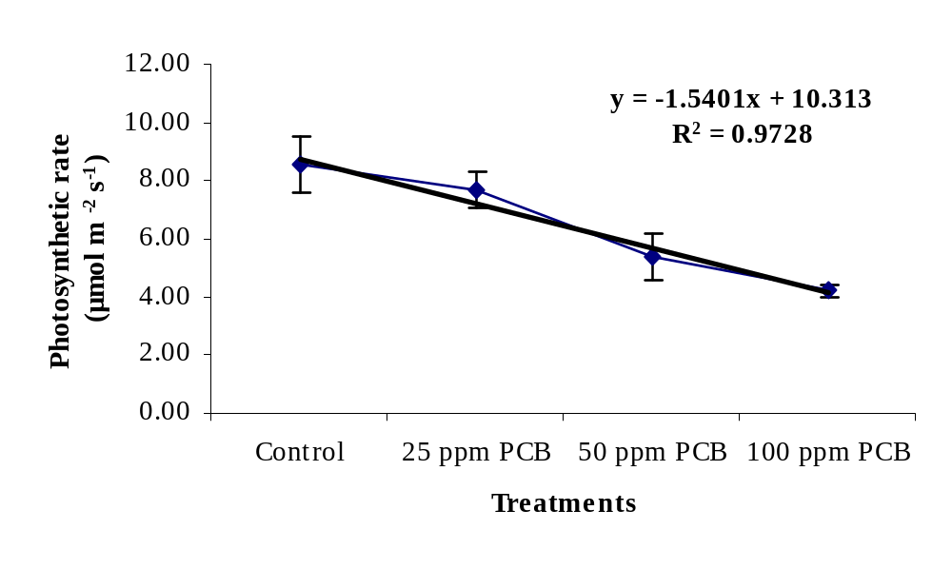
Figure 1- Effect of PCB treatment on Photosynthetic rate of Saussurea costus

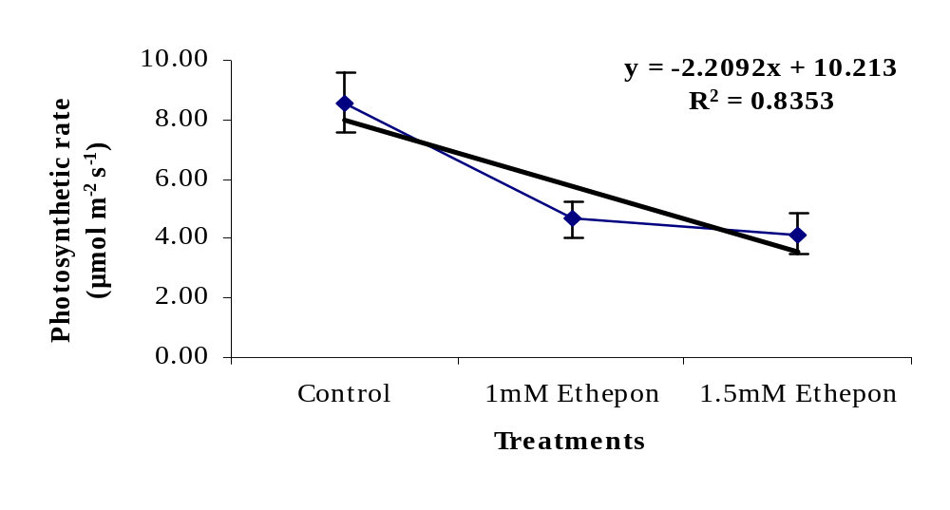
Figure 2- Effect of Ethepon treatment on Photosynthetic rate of Saussurea costus

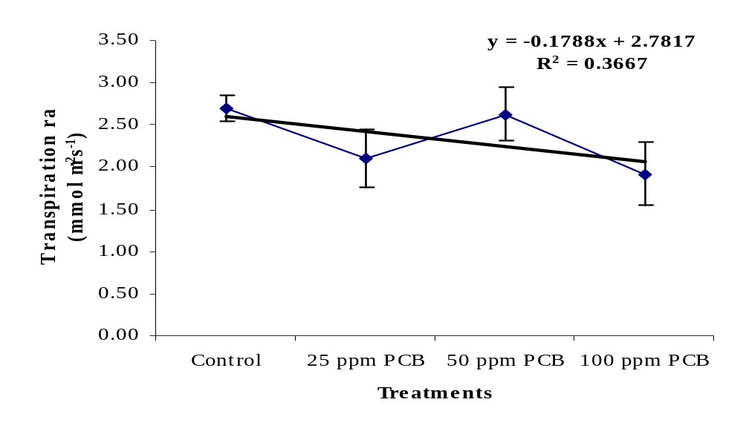
Figure 3- Effect of PCB treatment on Transpiartion rate of Saussurea costus

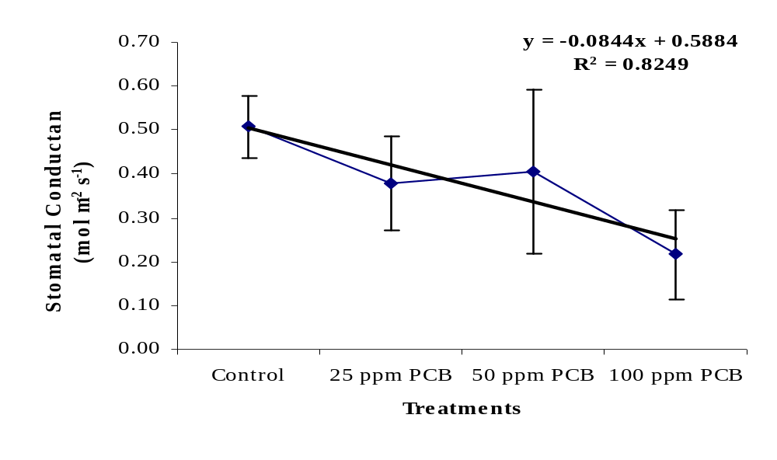
Figure 4- Effect of PCB treatment on Stomatal conductance of Saussurea costus

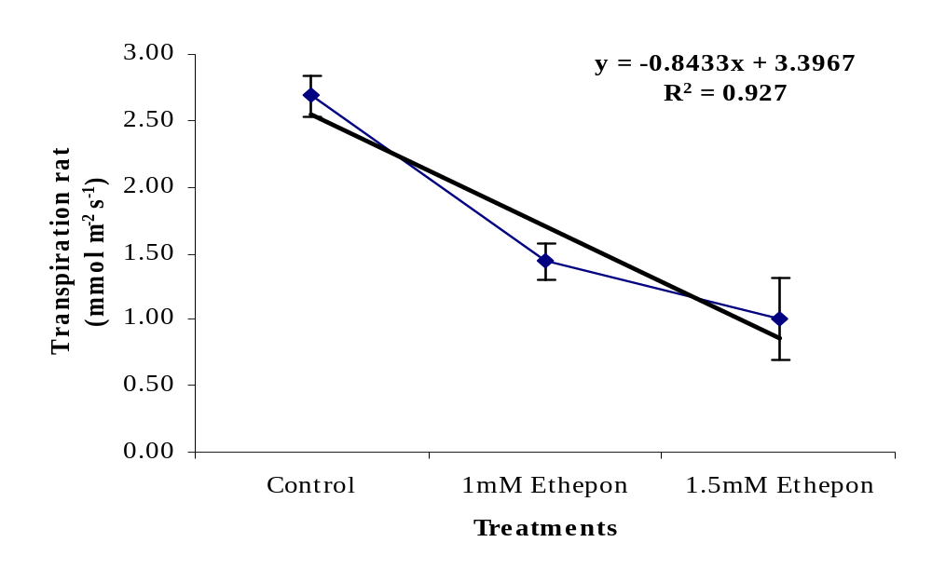
Figure 5- Effect of Ethepon treatment on Transpiration rate of Saussurea costus
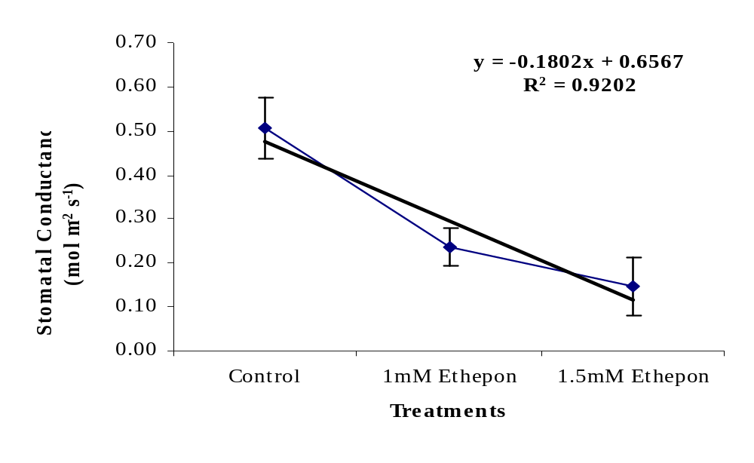
Figure 6- Effect of Ethepon treatment on stomatal conductance of Saussurea costus

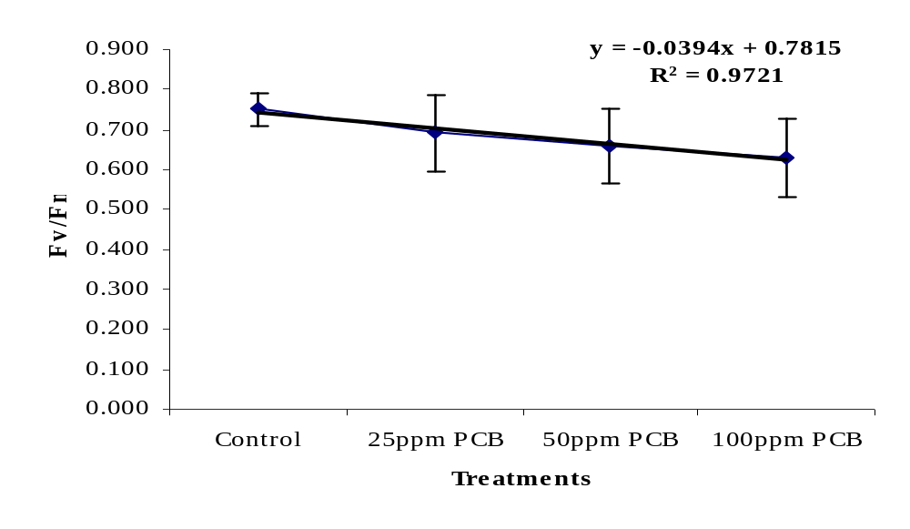
Figure 7- Effect of PCB treatment on fluorescence parameter (fv/Fm) of Saussurea costus

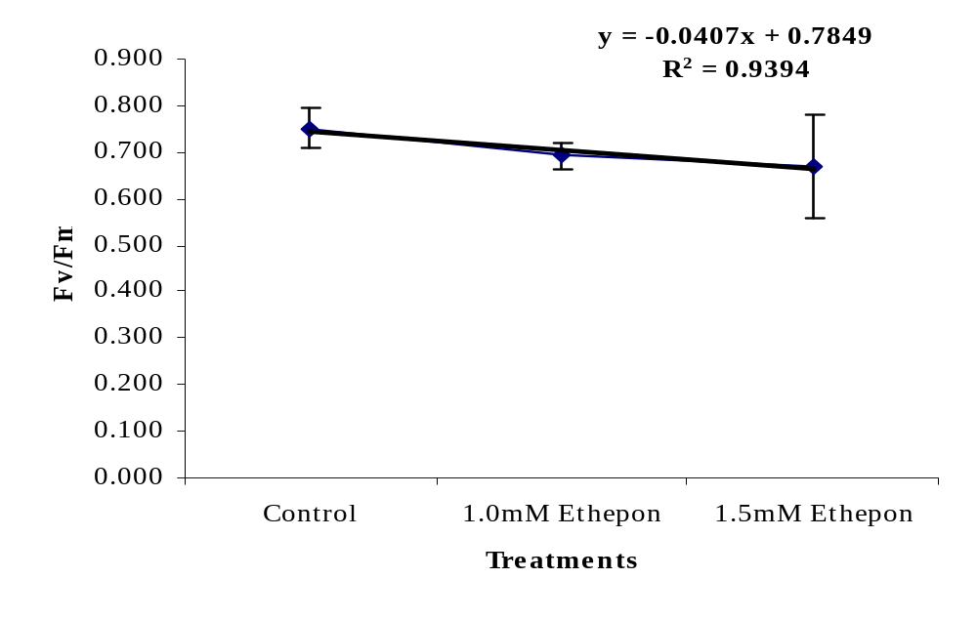
Figure 8- Effect of Ethepon treatment on fluorescence parameter (fv/Fm) of Saussurea costus

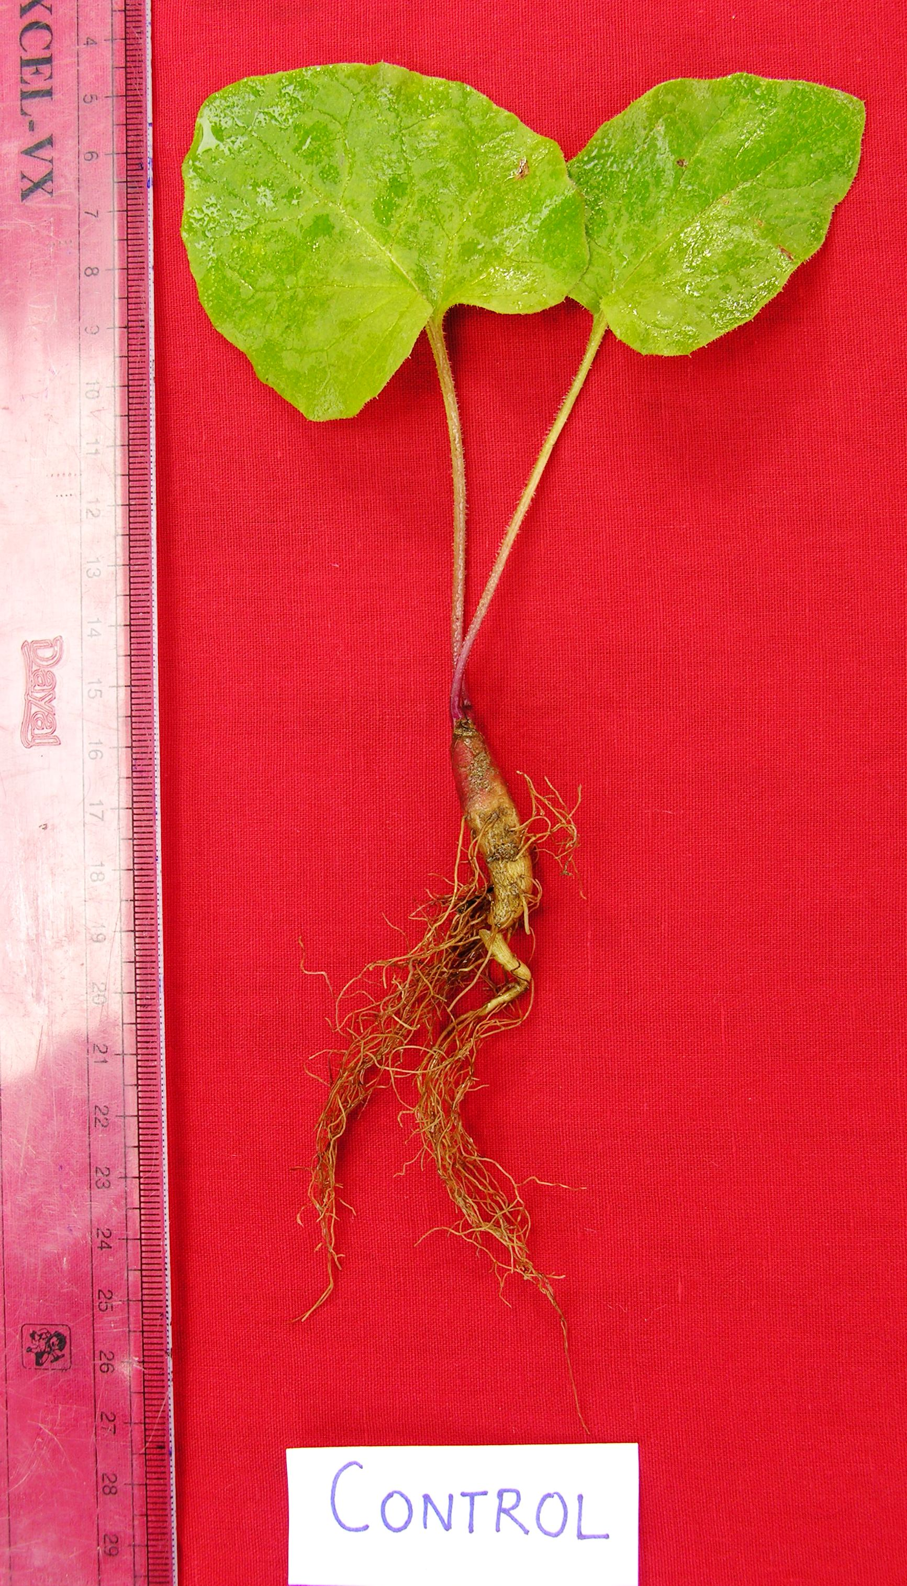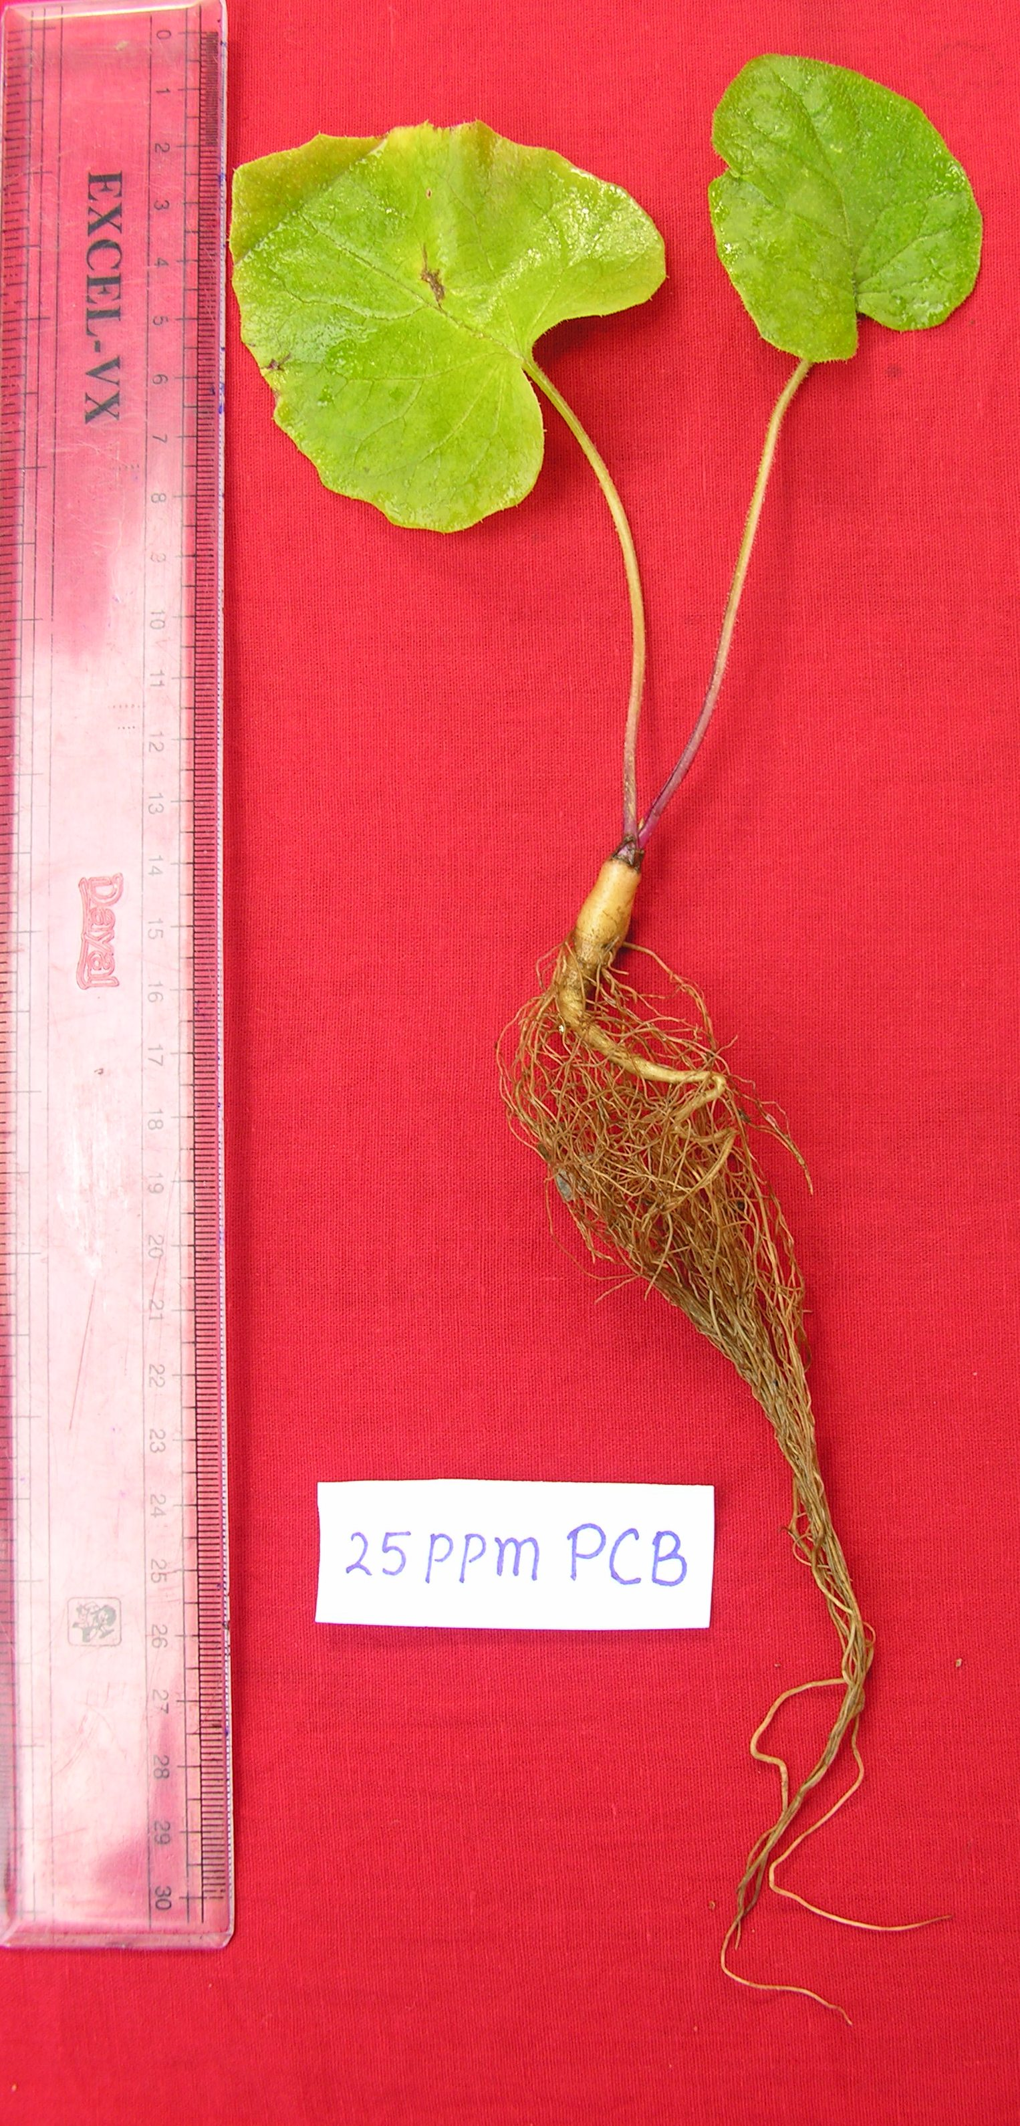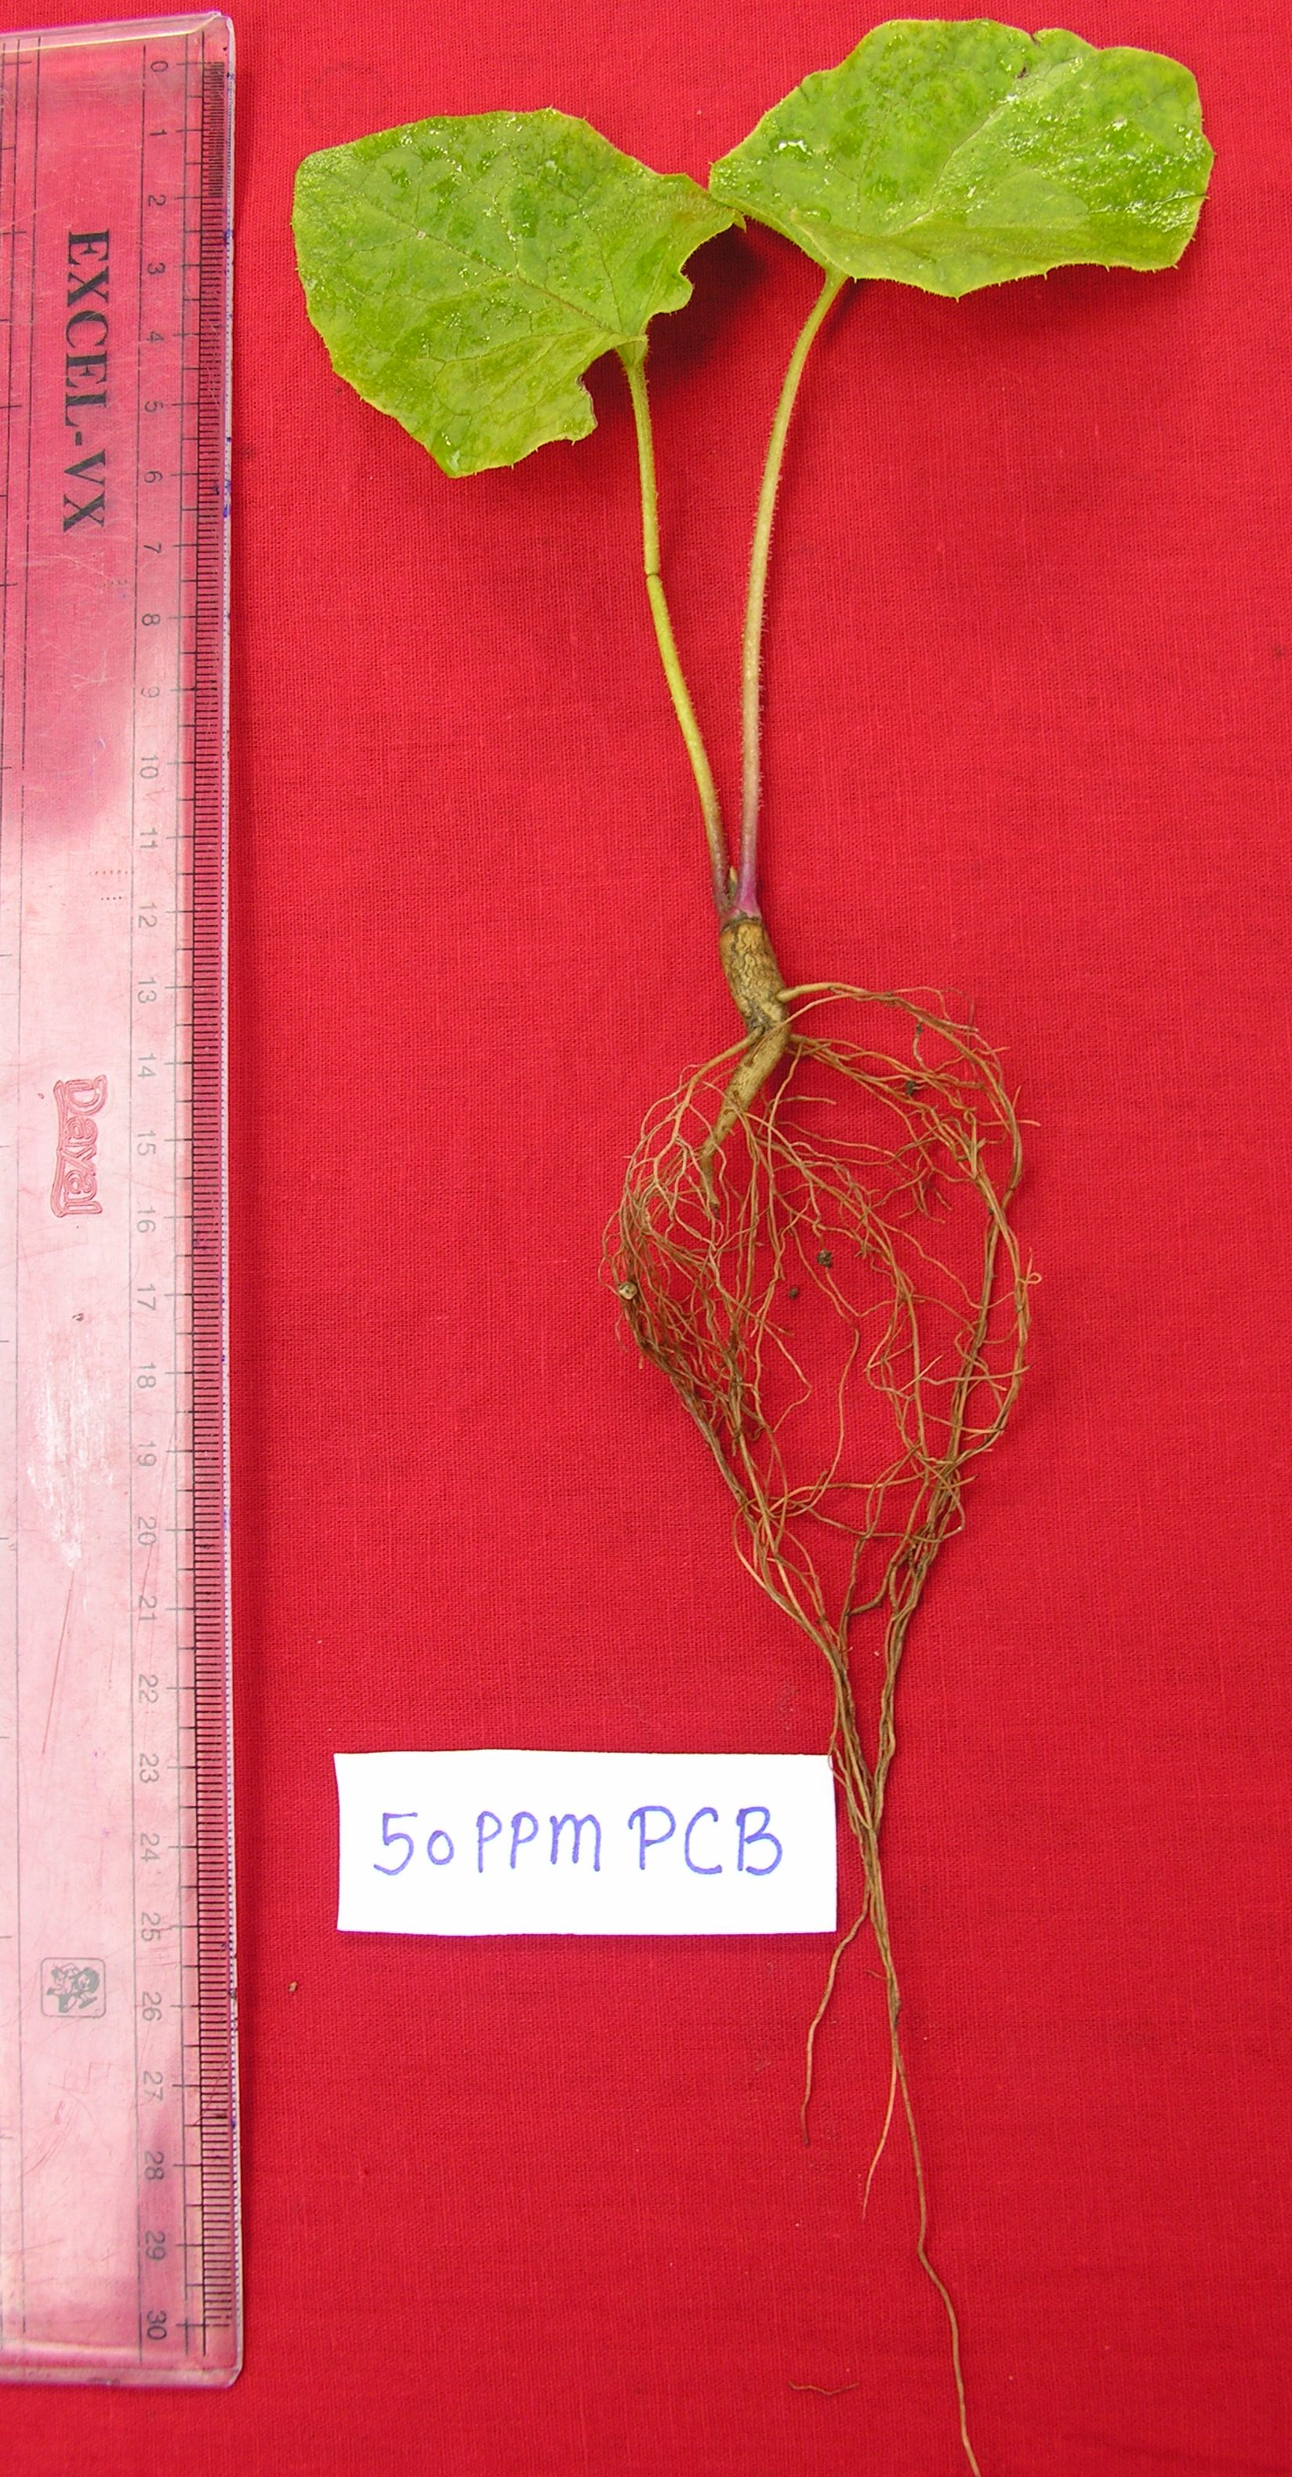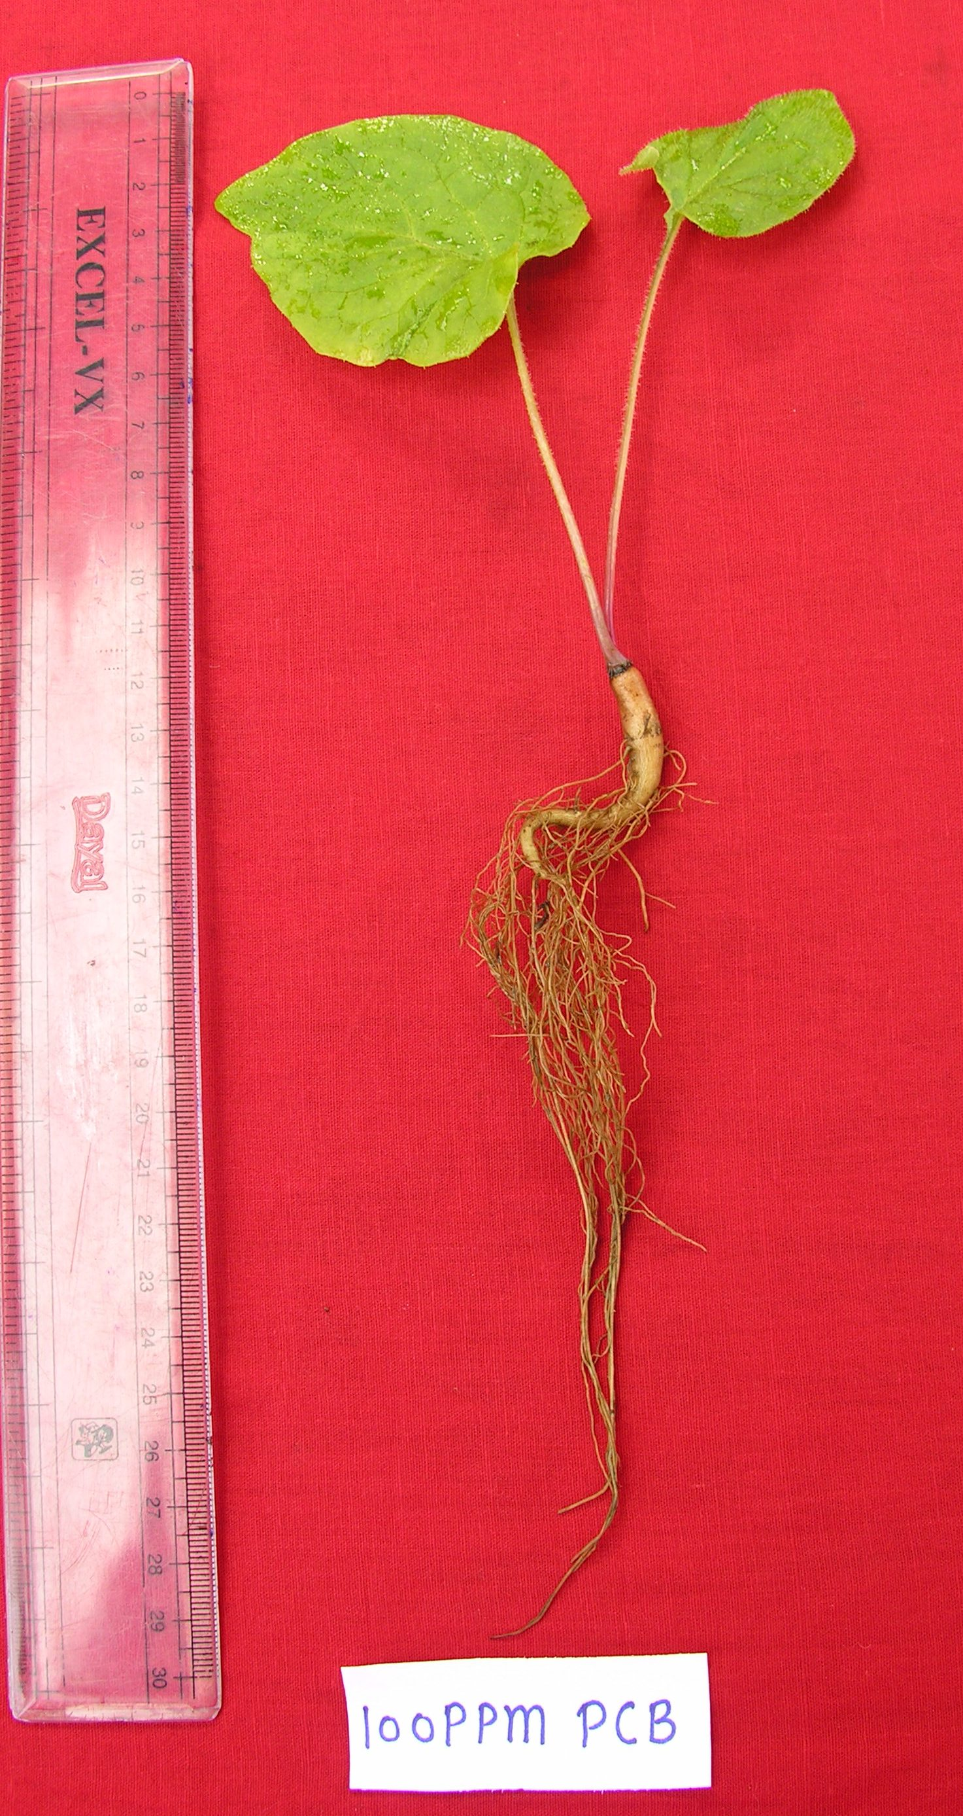
Control 25ppm PCB 50ppm PCB 100 ppm PCB
Plate 1- Showing effect on whole plant of Saussurea Costus treated with Paclobutrazol (PCB)
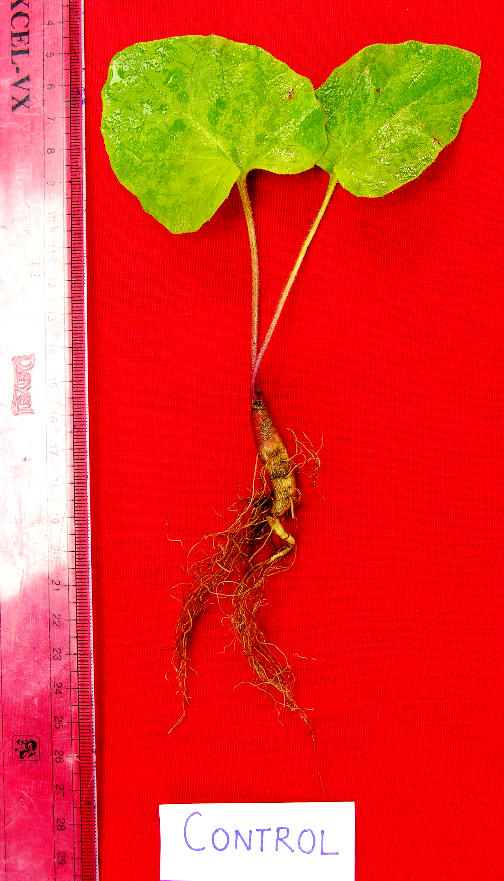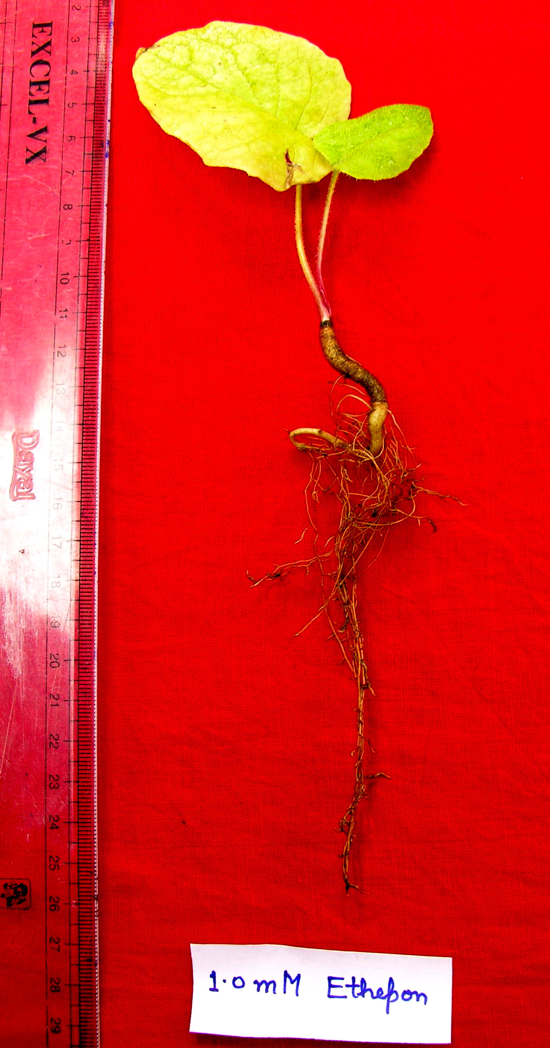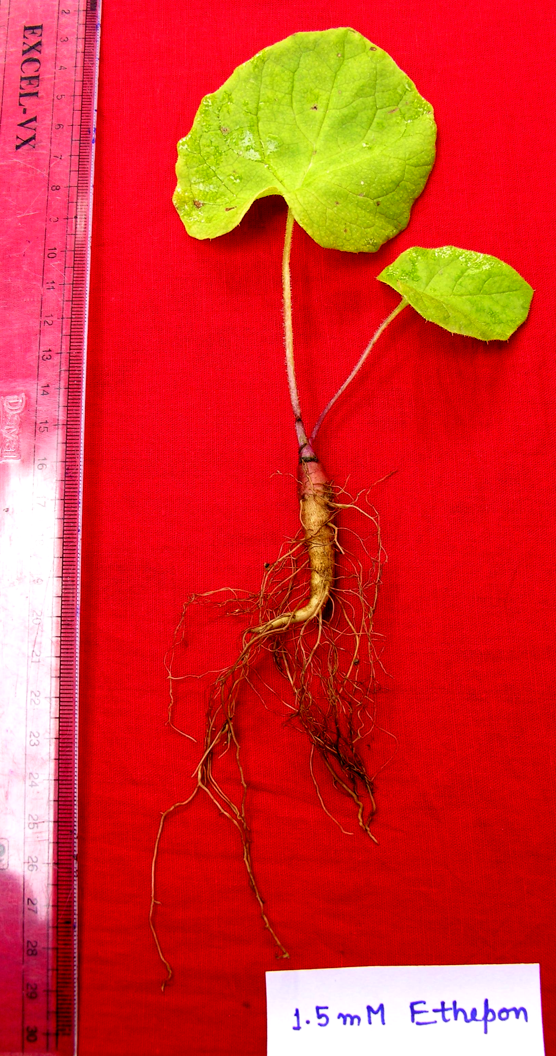
Control 1.0mM ethepon 1.5 mM ethepon
Plate 2- Showing effect on whole plant of Saussurea Costus treated with Ethepon

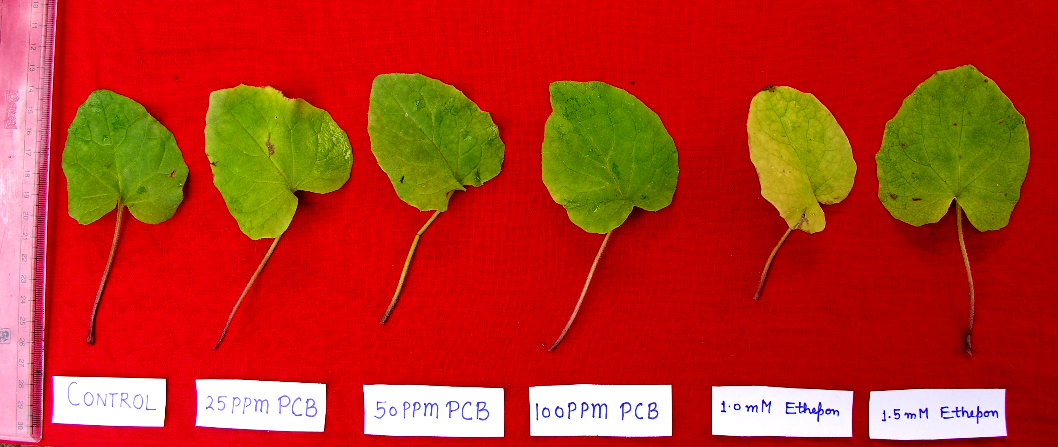
Control 25ppm PCB 50ppm PCB 100 ppm PCB 1.0mM ethepo 1.5 mM ethepon

Plate 3- Effect of PCB and Ethepon treatment on leaves of Saussurea Costus

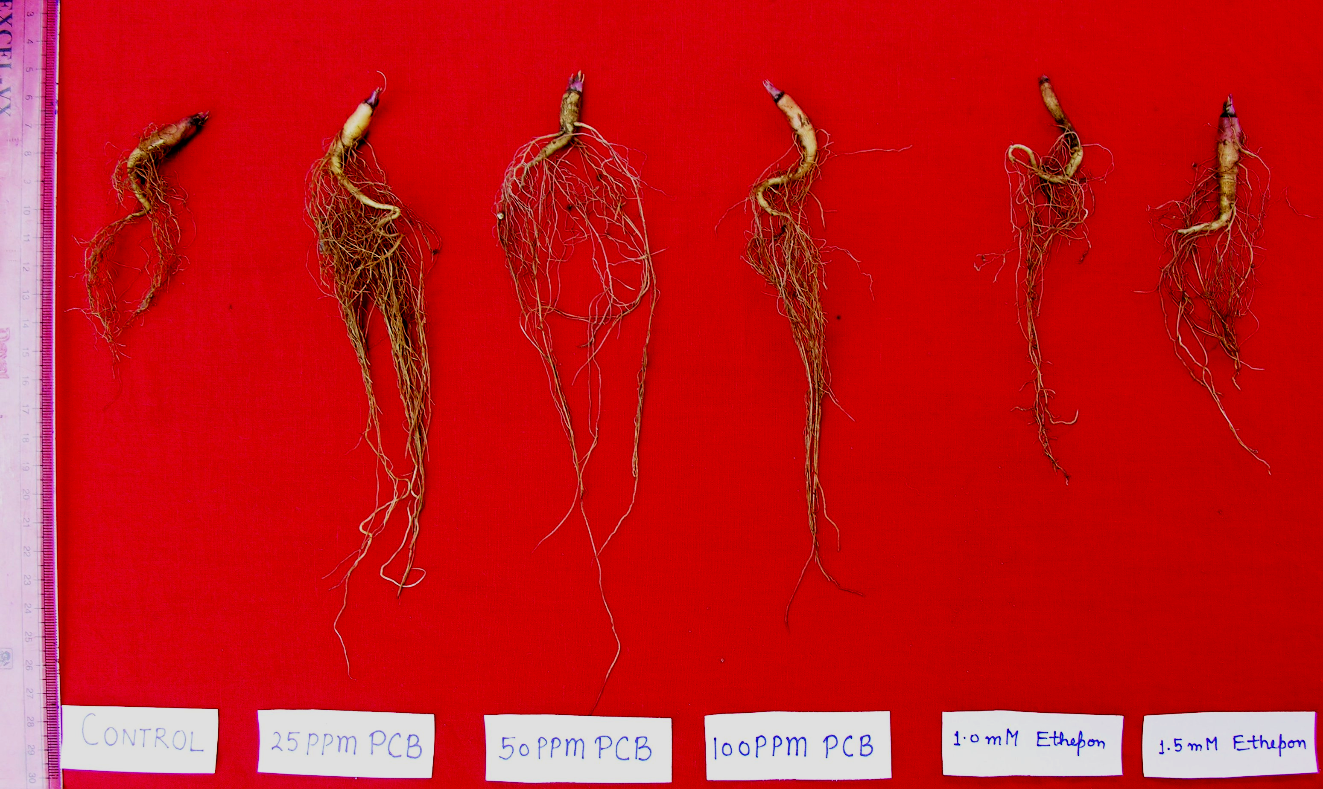
Control 25ppm PCB 50ppm PCB 100 ppm PCB 1.0mM ethepo 1.5 mM ethepon

Plate 4- Effect of PCB and Ethepon treatment on root system of Saussurea Costus

6/10/2009

