Composition Of Tree Species In Ehor Forest Reserve, Edo State, Nigeria.
Jane Ihenyen; Okoegwale E. E. and Mensah J.K.
Department of botany,
Ambrose Alli University,
Ekpoma, Edo State
Nigeria
inejanet@yahoo.com

ABSTRACT
The tree composition of Ehor Forest Reserve in Uhunmwode Local government area of Edo State was evaluated by laying out fifteen sample plots of 30m  30m in three different compartments of 1.6 kilometer square each. Ninety-eight species of trees distributed into 36 families and 87 genera were identified. A total of 2,062 tree stands were encountered in these three compartments (81, 95 and 112) studied with Celtis zenkeri as the most abundant having 129 stands. This was followed by Baphia nitida, Musanga cecropioides, Pentaclethra macrophylla and Uvariopsis dioica with 75, 68, 67 and 64 stands respectively. Conversely, eighteen other species including Afzelia africana, Albizia zygia, Bombax brevicuspe, Milicia excelsa, Cordia millenii and Irvingia gabonensis had only one stand in the three compartments combined with an area of 4.8 Km.sq. This signified that these plants are under threat of extinction from the reserve. Eighty-three percent of the tree species encountered were wildlings having a diameter at breast height of ≤ 10 cm. Less than one percent (0.63%) of the trees were of merchantable size. This situation is quite alarming and calls for a more resourceful and sustainable management techniques. Among others, it is suggested that the reserve be protected from further timber and fuel wood exploitation in order to allow it regenerate itself fully.

Keywords: Compartments, diameter at breast height, density, stands.

INTRODUCTION
A reserve is a forest kept aside /protected or saved for future use or a special purpose. Reserves are established to conserve habitats in their natural state, conserve areas for scientific research and education and to protect vulnerable or endangered species or landscapes. A protected or reserved area is “an area of land especially dedicated to the protection and maintenance of biological diversity; and of natural and associated cultural resources, and managed through legal or other effective means” (IUCN, 1994). Since there are few or no natural forest in the world, the Union described a natural forest as “a forest where human impact has not surpassed the impact of other indigenous species and has not affected the ecosystem structure”.
There are 445 gazetted forest reserves located in different parts of Nigeria. Only about 137 of these reserves are located in the forest region harboring the bulk of the natural forest wealth of the country (UNEP, 1992). Of the 560 species of trees present in these reserves in Nigeria, only 60 species are currently considered commercially important with attention restricted to about 35 of them (Nwoboshi, 1982). This has resulted in the overexploitation of the few commercially available species. The current global attention on the conservation and sustainability of biodiversity particularly in the tropical forests is a consequence of the threat posed by overexploitation. This might lead to depletion of such trees if allowed to go on unchecked resulting also in the elimination of other flora or fauna which depend on such trees for survival. The purpose of this work therefore is to evaluate the effects of such uncontrolled exploitation on the tree population of Ehor Forest Reserve.

MATERIALS AND METHODS
Study Location
Ehor Forest Reserve occupies an area of 76.8 square kilometers in Uhunmwode Local Government area of Edo State, Nigeria. It is located between latitudes 6⁰ 34’N and 6⁰ 38’N and longitudes 5⁰ 54’E and 5⁰ 58’E fifty-six kilometers north of the state capital, Benin-City. It is divided into forty-eight compartments of 1.6 square kilometers each. The Orhionmwon River runs through the reserve. It is surrounded by nine villages viz: Ohe, Eguaholor, Egbisi, Ugieghudu, Uhi, Iriwe, Erhue, Evbowe and Ekudo. There are no settlements within the reserve.
It was constituted into a forest reserve by the native authority notice number 73 of 1950 contained in the Forestry Ordinance Chapter 73 of the Federal Republic of Nigeria. It was originally subdivided into the west and east areas of 16/1 and 16/2 respectively but the later has been de-reserved. This study was carried out in area 16/1. Farming is commonly practiced within the reserve which is situated in the lowland rainforest zone. It had a sizeable number of timber species which made it attractive to logging companies. Apart from logging, cassava production which is the second main cause of forest destruction and soil degradation (WWFN, 1992) is the most commonly encountered crop in the reserve.
The vegetative profile of the reserve is mainly two storey with a few scattered emergents as the third storey. The canopies are mostly opened except in a few places where they are closed. This state of the forest explains the level of exploitation that has taken place over the years.

Survey method
Three compartments were sampled for this study. They were compartment 81 on the western end of the reserve, 95 which is centrally located and 112 at the eastern end of the reserve (Fig 1). This is to have an adequate representation of the whole forest reserve. Five sample plots of 30m  30m were laid out in a randomized complete block design in each compartment using improvised wooden pegs. The trees were identified and the density of each species per compartments noted.
Plant identification was done by using Keay et al.(1964) and Hopkins (1974). The timber species were confirmed using Anonymous (1973) and Gill and Okoegwale (1991).
The girths of the trees at 1.3 meters from the ground level which is at breast heights were measured by means of a measuring tape and recorded. All wildlings above 4 cm circumference were measured while those below were just noted. The number of species and the density of each species per sample plot were also noted.

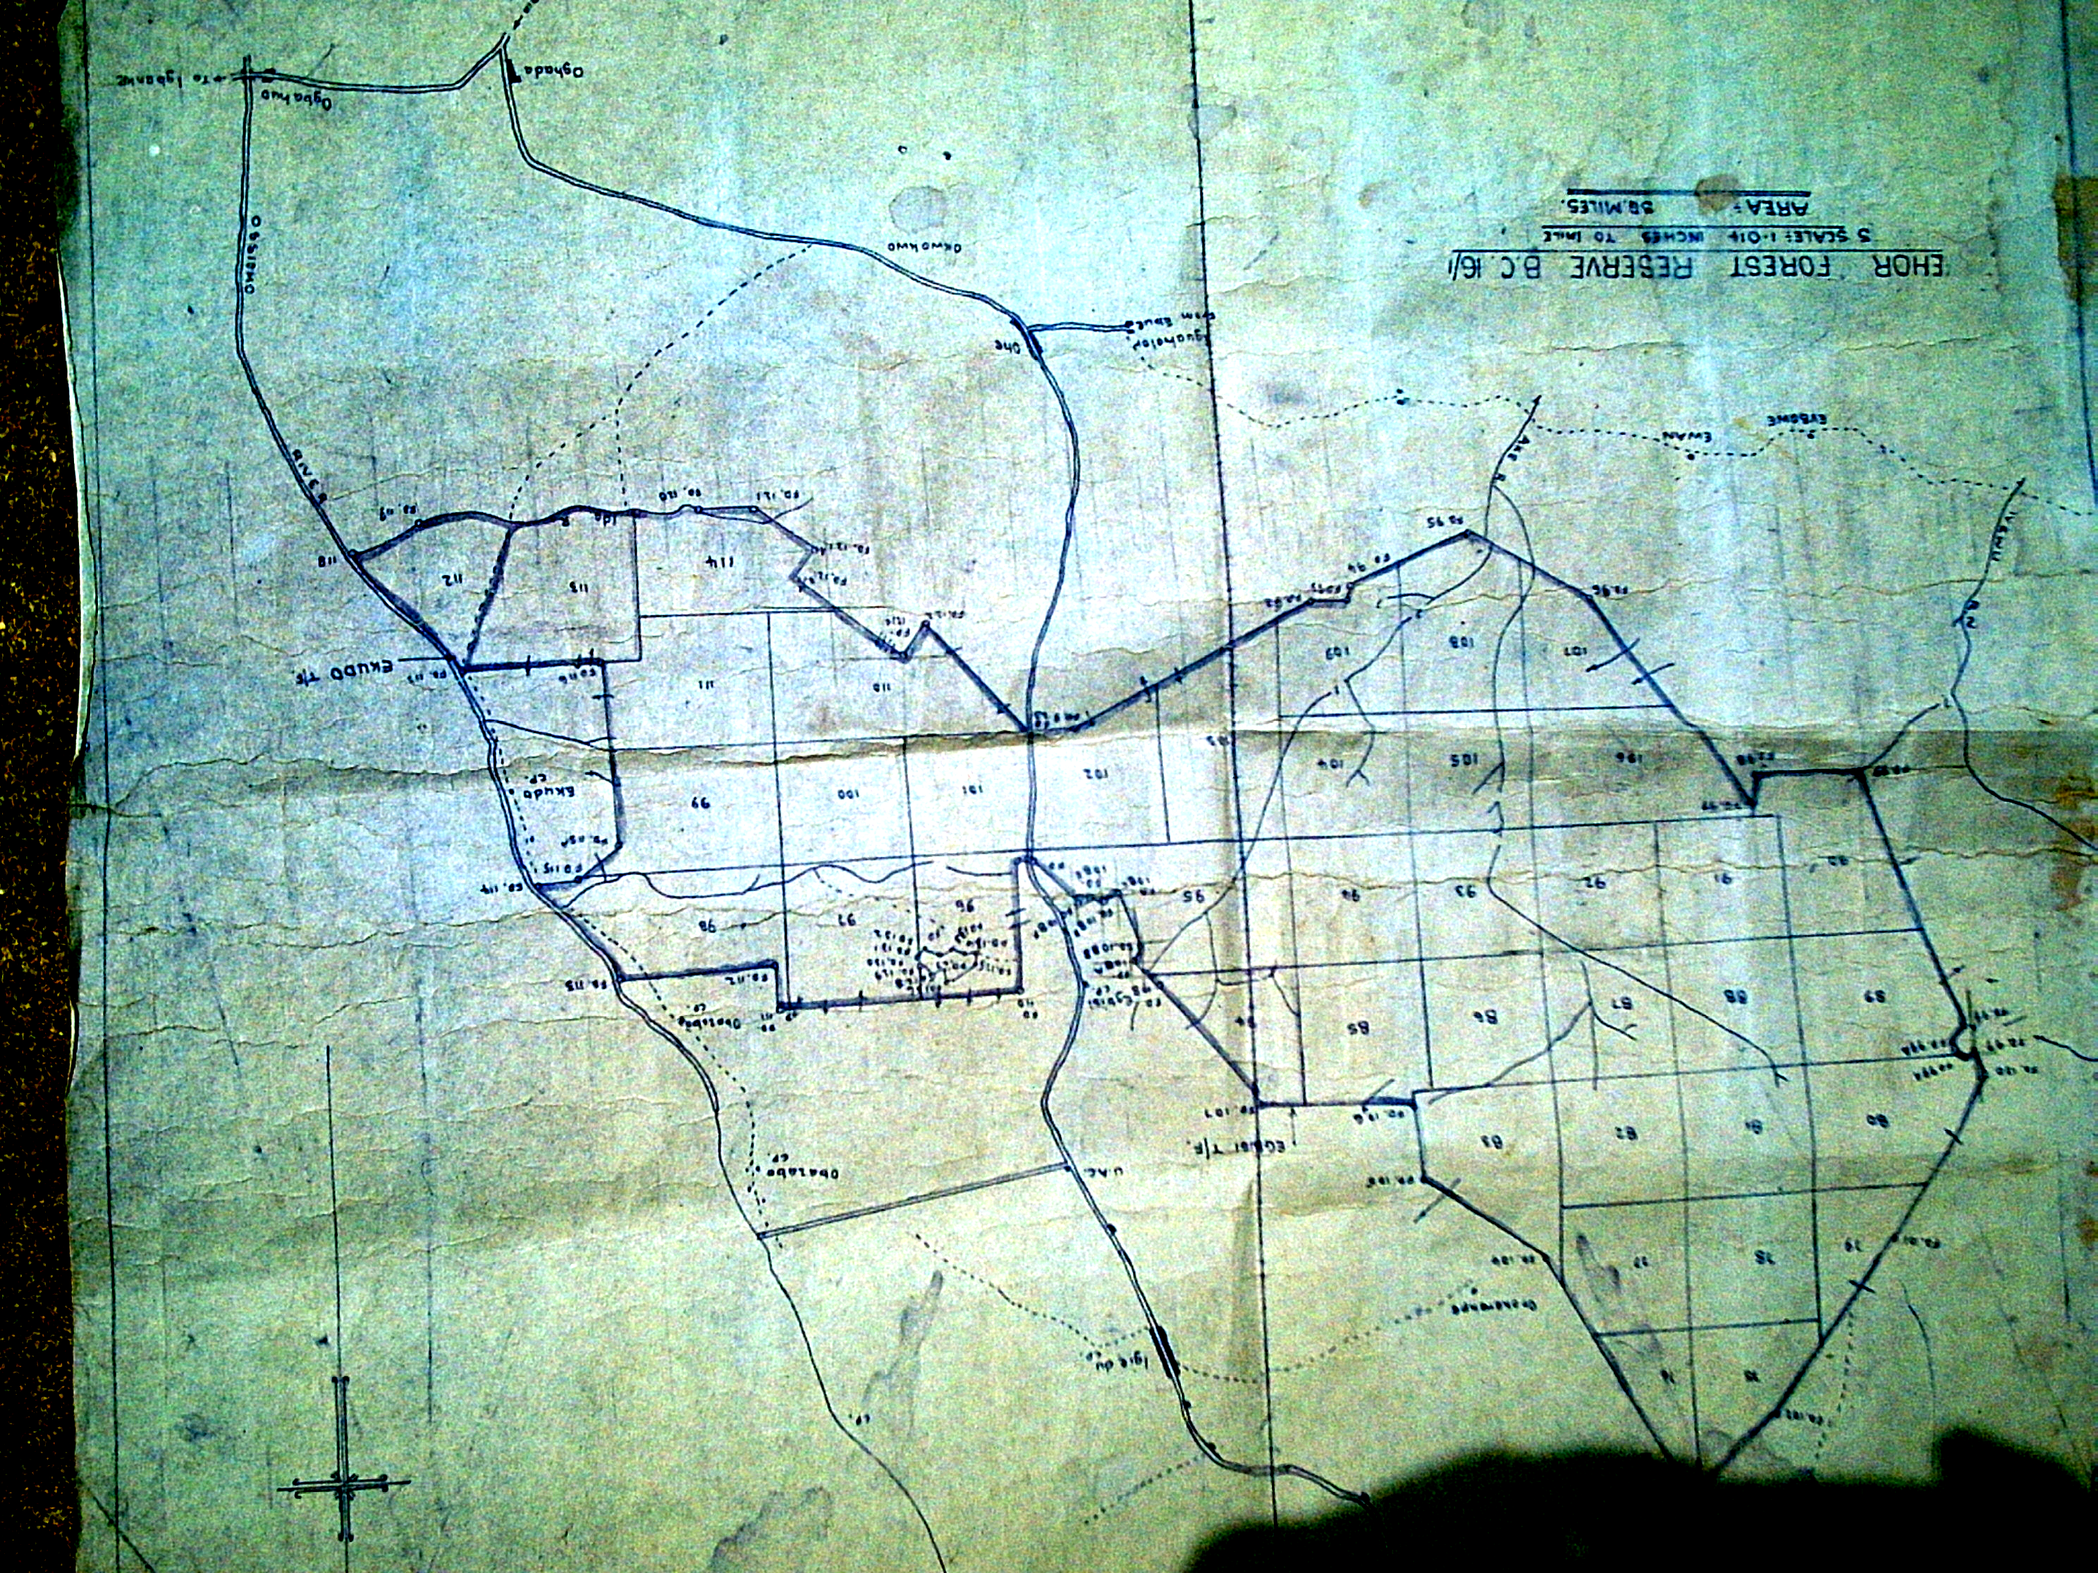
81
112
95

Fig. 1: Map of Ehor Forest Reserve showing Compartments of Study

Analysis of field data
The following parameters were studied
- Relative diversity which is the number of species in each family represented.
- Diameter at breast Height using the formula
girth
л

RESULTS
A check list of the trees species, their families, density and habits in Ehor Forest Reserve are presented in Table 1. A total of ninety-eight (98) species of trees distributed into thirty-six (36) families and eighty-seven (87) genera were encountered. Compartment 81 was the richest with sixty-three (63) species while compartment 95 and 112 had fifty-three (53) and fifty-seven (57) species respectively. Based on their habit, these species were classified into 91% trees and 9% of shrubs.
The family Fabaceae has the highest diversity of eighteen (18) species while fifteen families were represented by only one species each. Meliaceae, Annonaceae, Sterculiaceae and Apocynaceae were represented by seven, six, six and five species respectively in the compartments studied.
The result of the various diameter class sizes are presented in Table 2 and Fig 2. Of the 2,062 stands encountered in the three compartments of study, 1,711 were in the diameter class of ≤ 10
cm making up about 82.98% of the total trees encountered. This was followed by the diameter class of 10-20 cm with 162 stands which is 7.6% of tree population in the reserve. The diameter class of 91-100 cm had no stand while that of 81-90 cm had the least stand of two (2). The most abundant species was Celtis zenkeri with a total of 129 stands in the three compartments of study while eighteen species were represented by only one stand. These figures translate to less than one when calculated per hectare.
Results of further breakdown of the proportion of trees making up the 82.98% of tree ≤ 10cm is presented in Fig. 3. The highest percentage of 34.42% in this case also belongs to the least diameter class of ≤ 2cm.

Table 1: Tree species, Habits and families represented at Ehor Forest Reserve
FAMILIES | SPECIES | DENSITY/HECTARE | HABIT
Anacardiaceae | Antrocaryon micraster A. Chev.  Lannea welwitschi (Hiern) Engl. | 0.008  0.019 | Tree  Tree
Annonaceae | Anonidium mannii (Oliv.) Engl.and Diels  Cleistopholis patens (Benth.) Engl. And Diel  Polyalthia suaveolens Engl. And Diels  Polyceratocarpus parviflorus (Bak. F) Chesq.  Uvariopsis dioica (Diels) Robyn and Chesq.  Xylopia aethiopica (Dunal) A. Rich | 0.027  0.050  0.021  0.008  0.133  0.002 | Tree  Tree  Tree  Tree  Tree  Tree
Apocynaceae | Alstonia boonei De Wild.  Funtumia elastica (Preuss) Stapf.  Hunteria umbellata (K. Schum) Hailier  Rauwolfia vomitoria Afzel.  Tabernaemontana pachysiphen Stapf. | 0.040  0.056  0.067  0.002  0.019 | Tree  Tree  Shrub  Shrub  Tree
Arecaceae | Elaeis guineensis Jacq. | 0.006 | Tree
Asteraceae | Albizia ferruginea (Guill. and Perr.) Benth.  Albizia lebbeck (L.) Benth.  Albizia zygia (DC.) J.F. Machr. | 0.045  0.004  0.002 | Tree  Tree  Tree
Bignoniaceae | Newbouldia laevis (P.Beauv.) Seeman ex Bureau  Spathodea companulata P.Beauv | 0.046  0.046 | Tree  Tree
Bombacaceae | Bombax brevicuspe Sprague  Ceiba pentandra (L.) Garten | 0.002  0.004 | Tree  Tree
Boraginaceae | Cordia millenii Bak. | 0.002 | Tree
Burseraceae | Canarium schweinfurthii L.  Dacryodes edulis. (G. Don.) H.J. Lam | 0.023  0.002 | Tree  Tree
Clusiaceae | Allanblackia floribunda Oliv.  Garcinia Kola Heckel  Pentadesma butyracea Sabine | 0.006  0.002  0.010 | Tree  Tree  Tree
Combretaceae | Terminalia ivorensis. A. Chev. | 0.002 | Tree
Ebenaceae | Diospyros alboflavescens (Gurke) F. White  Diospyros dendo Welw. Ex Hien.  Diospyros mesipiliformis Hochst ex D. AC | 0.045  0.006  0.017 | Tree  Tree  Tree
Euphorbiaceae | Hevea brasiliensis (Knuth.) Muell. Arg.  Maesobotrya bateri (Baill.) Hutch.  Ricinodendron heudelotii (Baill.) Pierre  Tetrorchidium didymostemon (Baill.) Pax and K. Hoffm | 0.002  0.008  0.104  0.027 | Tree  Tree  Tree  Tree
Fabaceae | Afzelia Africana Sm.  Amphimas pterocarpoides Harms  Angylocalyx zenkeri Harms  Anthonotha macrophylla P. Beauv.  Baphia nitida Lodd.  Berlinia grandiflora (Vahl.) Hutch. And Dalz.  Brachystegia nigerica Hoyle and A.P.D Jones  Cylicodiscus gabunensis Harms  Daniellia ogea (Harms) Rolfe ex Holl.  Distemonanthus benthamianus Baill.  Gossweilorodendron balsaminiferum (Verm.) Harms  Guibourtia sp. Benn.  Hymenostegia afzelii (Oliv.) Harms  Lonchocarpus griffonianus (Baill.) Dunn.  Pachyelasma tessmannii (Harms) Harms  Pentaclethra macrophylla Benth.  Piptadeniastrum africanum (Hook F.) Brenan  Pterocarpus osun Craib | 0.002  0.029  0.010  0.069  0.156  0.088  0.169  0.006  0.094  0.006  0.004  0.013  0.048  0.013  0.006  0.140  0.027  0.006 | Tree  Tree  Tree  Shrub  Tree  Tree  Tree  Tree  Tree  Tree  Tree  Tree  Tree  Shrub  Tree  Tree  Tree  Tree
Irvingiaceae | Irvingia gabonensis (Aubry-Lecomte ex O’Rorke)  Irvingia grandifolia (Engl.) Engl. | 0.002  0.004 | Tree  Tree
Lecythidaceae | Combretodendron macrocarpum (P.Beauv.) Keay | 0.046 | Tree
Melastomataceae | Memocylon blakeoides G. Don. | 0.21 | Tree
Meliaceae | Entandrophragma angolense (Welw.) C.DC  Guarea cedrata (A. Chev.) Pellgr.  Khaya grandifoliola C. DC.  Khaya ivorensis A. Chev.  Lovoa trichilioides Harms  Trichilia lanata A. Chev.  Trichilia prieuriana A. Juss. | 0.013  0.121  0.002  0.056  0.006  0.036  0.002 | Tree  Tree  Tree  Tree  Tree  Tree  Shrub.
Moraceae | Antiaris welwitschii Engl.  Bosqueia angolensis Ficalho  Milicia excelsa (Welw.) C.C. Berg  Musanga cecropioides R. Br  Myrianthus arboreus P. Beauv. | 0.042  0.054  0.002  0.142  0.013 | Tree  Tree  Tree  Tree  Tree
Myristicaceae | Pycnanthus angolensis (Welw.) Warb.  Staudtia stipitata Warb. | 0.069  0.015 | Tree  Tree
Ochnaceae | Lophira alata Banks ex Gaertnf. | 0.023 | Tree
Octoknemataceae | Okoubaka aubrevillei Pellgr. And Norman | 0.127 | Tree
Olacaceae | Olax subscorpioidea Oliv.  Strombosia postulate Oliv. | 0.002  0.102 | Shrub  Tree
Pandaceae | Panda oleasa Pierre | 0.002 | Tree
Polygalaceae | Carpolobia lutea G. Don. | 0.017 | Shrub
Rhamnaceae | Maesopsis eminii. Engl. | 0.004 | Tree
Rhizophoraceae | Anopyxis klianeana (Pierre) Engl. | 0.017 | Tree
Rubiaceae | Nauclea diderrichii (De Wild and Th. Dun.) Merrill  Rothmannia hispida (K. Schum) Fagerlind  Pausinystalia macroceras (K. Schum) Pierre ex Beille | 0.002  0.115  0.023 | Tree  Tree  Tree
Rutaceae | Fagara macrophylla Engl. | 0.060 | Tree
Sapindaceae | Blighia sapida Konig. | 0.108 | Tree
Samydaceae | Homalium aylmeri Hutch and Dalz. | 0.063 | Tree
Sapotaceae | Chrysophylllum albidum D. Don.  Chrysophyllum delevoyi De Wild. | 0.017  0.015 | Tree Tree
Simaroubaceae | Hannoa klaineana Pierre and Engl.  Pierreodendron africanum (Hook F.) Little | 0.045  0.004 | Tree  Tree
Sterculiaceae | Cola acuminata (P. Beauv.) Schott and Engl.  Mansonia altissima A. Chev.  Nesogordonia papaverifera (A.Chev.) R. Capuron  Sterculia oblonga Mast.  Sterculia tragacantha Lind.  Triplochiton scleroxylon R. Schum. | 0.006  0.002  0.023  0.035  0.013  0.008 | Tree  Tree  Tree  Tree  Tree Tree
Tiliaceae | Desplatsia subericarpa Bocq. | 0.004 | Shrub
Ulmaceae | Celtis mildibraedii Engl.  Celtis zenkeri Engl. | 0.002  0.269 | Tree  Tree

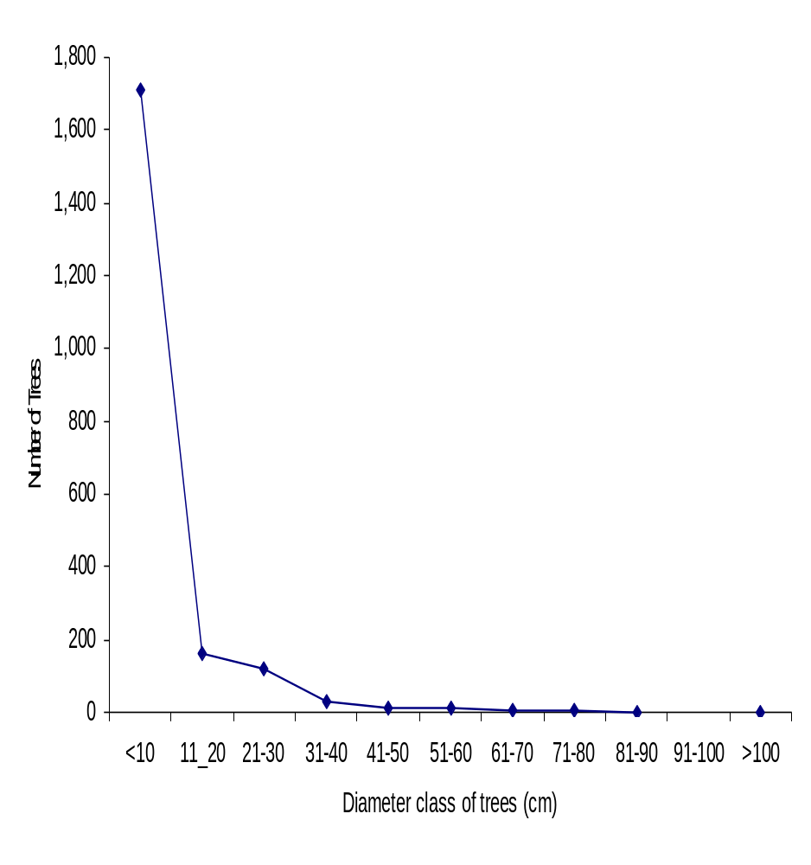

Fig 2: Diameter Class Distribution of trees in Ehor Forest Reserve
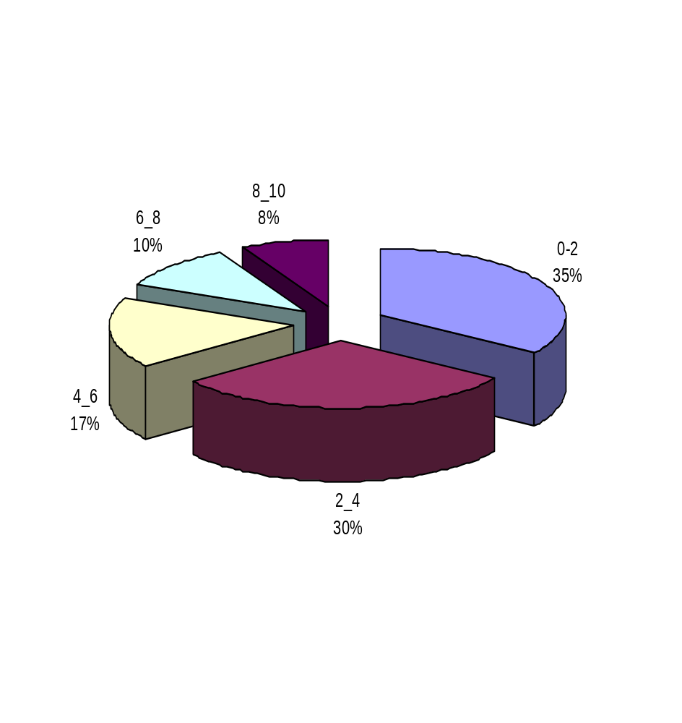

Fig 3: Percentage Distribution of stem diameter classes≤ 10 cm in Ehor Forest Reserve, Edo State
Table 2: Percentage distribution of the various diameter class sizes
Diameter class (cm) | Number of trees | Percentage Proportion
≤ 10 | 1,711 | 82.98
11-12 | 162 | 7.86
21-30 | 118 | 5.72
31-40 | 32 | 1.55
41-50 | 14 | 0.68
51-60 | 12 | 0.58
61-70 | 4 | 0.19
71-80 | 4 | 0.19
81-90 | 2 | 0.10
91-100
> 100 | 3 | 0.15
Total | 2,062 | 100.00

DISCUSSION
Relative diversity
The family Fabaceae has the highest diversity of eighteen species in this study carried out in Ehor Forest Reserve, Edo State in Southern Nigeria. Omorogbe (2004) reported fourteen species from this same family also with the highest species diversity in Sakponba Forest Reserve, Edo State. Fabaceae was distantly followed by Meliaceae with seven spp; Annonaceae and Sterculiaceae with six spp. respectively. Moraceae and Apocynaceae had five while Euphorbiaceae had four. These were the dorminant families represented. Apocynaceae, Sterculiaceae, Euphorbiaceae, Ebenaceae, Olacaceae and Rubiaceae were reported by Ojo (2004) as forming 86% of the stand in Abeku sector of Omo Forest Reserve. Osunde (2004) in an unpublished work on Okomu Forest Reserve also reported high species diversity in Fabaceae, Meliaceae and Apocynaceae. The preponderance of occurrence of species in families with high diversity may be due to their method of seed dispersal. Where explosive mechanism and wind disperse the seeds, they are carried far away from the mother tree where they germinate when conditions are suitable but where dispersal is such that seeds are close to the mother trees, such seedlings may die due to competition for nutrients. Ogunleye et al. (2004) reported the dominance of Fabaceae and Meliaceae in Olokemeji Forest Reserve because of easy wind dispersal which enhanced their spread in the study location. Soladoye et al. (2005) also observed that the dispersal mechanism plays a strong role in addition to climatic condition and soil type in the preponderance of species of Fabaceae, Euphorbiaceae and Rubiaceae on the Olabisi Onabanjo University permanent site.
On the other hand, fifteen families within the Ehor Forest Reserve had poor species diversity. They all had only one species each. Though compartment 81 had the highest spp. of 62 distributed into 27 families, the other two compartments-95 and112- have 54 and 57 species distributed into 28 families each. Diversity is comprised of two components: the variety of species present and the relative abundance of these species (Young and Swiachi, 2006). Hence compartment 95 could be said to be richest in terms of plant population because of its high relative abundance, compared to the other two compartments. The species diversity in the three compartments of study could be attributed to the intensity of logging. This is because only a few trees of merchantable size were left standing resulting in the study sites being populated mainly by wildlings. Brown and Gurevitch (2004) reported that the impact of logging does not only negatively affect the forest diversity but that it exposes the forest to invasive species which is also a major predictor of reduced native species diversity thereby preventing the re-colonization of native species. This could be the case with compartment 95 where we have fewer species but more abundant stands.
Diameter at breast height (dbh)
Eighty-three percent of the trees encountered were in the diameter class of ≤ 10 cm. This then meant that the majority of the trees were wildlings and so were not merchantable. Oduwaiye et al. (2002) reported that all plots studied by them had the largest number of trees in the smallest diameter class of below 10 cm at the Okomu permanent sample plots. They also had the smallest number of trees in the diameter class of 25-30 cm. Conversely, Oduwaiye and Ajibode (2005) reported the highest number of trees for diameter class of 11-30 cm followed by those of between 0-10 cms at Onigambari Forest Reserve, Ibadan. Timber trees are logged at 60 to 90 cm dbh depending on the species (ITTO,2007). Only a few trees amounting to 0.63% (thirteen stands) were in that diameter class. There was no stand in the diameter class of 91-100 cm in the three compartments of study at Ehor Forest Reserve. The three trees above the the diameter class of 100 cm were not accessible to loggers because these species were close to Orhionmwon River. This river is a barrier to moving the logs out of the logging sites hence they are still standing. These trees were Piptadeniastrum africana with a dbh of 136.80 cm in compartment 81, Alstonia boonei with a dbh of 115.50 cm in compartment 95 and Hannoa klaineana with a dbh of 175.00 cm in compartment 112. These three tree stands were located in sample plot demarcated at the centre of the various compartments.
Felling of both timber and fuel trees in Ehor Forest Reserve have gone on for years hence the reserve has been turned to a forest of wildlings. There is therefore need to reverse this trend.

Conclusion
The compartments of study in Ehor Forest Reserve are sparsely populated with ninety-eight species of wildlings mostly in the diameter class of ≤ 10 cm. The low density of this stands of these stands is an evidence of the degree of devastation the forest has been subjected to by loggers and other exploiters of non-timber forest products. This calls for an urgent solution so as not to drive some of this tree species particularly those already threatened into extinction. It is therefore suggested that Ehor Forest Reserve be protected from further exploitation to give it enough time to regenerate itself.
REFERENCES
Brown, K.A. and Gurevitch, J. (2004): Long-term impacts of logging on forest diversity in Madagascar. Proceedings of the National academy of Sciences of the United States of America (PNAS) 101 (16): 6045-6049
ITTO-International Tropical Timber Organisation (2007): Achieving the ITTO objective 2000
and sustainable forest management in Nigeria. Report of the Diagnostic Mission. Forty-third session, 5-10 November 2007 Yokohama, Japan.
IUCN (1994), International Union for the Conservation of Nature: Caring for the earth: A stategy for sustainable living. Gland, Switzerland.
Nwoboshi, L.C. (1982): Tropical Silviculture. Ibadan University Press. Ibadan 333p.
Oduwaiye, E.A., Oyeleye, B. and Oguntala, A.B (2002): Species diversity and potentiality for forest regeneration in Okomu permanent sample plot: Forestry and challenges of Sustainable livelihood, Proceedings of the 28th Annual conference of the Forestry Association of Nigeria, Akure, Ondo State, Nigeria, 4-8 November 2002. pp 264-272.
Oduwaiye, E.A. and Ajibode, M.O. (2005): Composition of tree species and regeneration potentials at Onigambari Forest Reserve, Ibadan, Oyo State, Nigeria. Journal of Raw Materials Research: 2 (1):4-13.
Ogunleye, A.J., Adeola, A.O., Ojo, L.O and Aduradola, A.M. (2004); Impact of farming activities on vegetation of Olokemeji Forest Reserve, Nigeria, Global Nest: the International Journal. 6(2): 130-139.
Ojo, L.O. (2004): The fate of a tropical rainforest in Nigeria; Abeku sector of Omo Forest Reserve. Global Nest: the International Journal 6(2): 116-130.
Omorogbe, RU. (2004): Status of flora biodiversity and exploitation of biological resources in Sakponba Forest Reserve Edo State. M.Sc. Thesis. Ambrose Alli University, Ekpoma. 133p.
Soladoye, M.O.,Sonibare, M.A., Nadi, A.O. and Alabi, D.A. (2005). Indigenous Angiosperm biodiversity of Olabisi Onabanjo University Permanent site. African Journal of Biotechnology 4 (5):554-562.
UNEP- United Nations Environment Programme (1992). Biological diversity in Nigeria- A country study. 53p.
WWFN (1992). World Wild Fund for Nature Cross River National Park project. Unpublished Report. WWFN, Goldaming, United Kingdom 15p.
Young, S. and Swiachi, L.N. (2006). Surveying the Forest Biodiversity of Evansburg State Park: Plant Community Classification and Species Diversity Assessment. International Journal of Botany 2 (3): 293-299.

