Effect of Sulfidic Material as a source of Sulfur fertilizer for the Growth and Yield of Rice in Two Sulfur Deficient Soils in Bangladesh.
Farook Ahmed*, Md. Harunor Rashid Khan**, and Munehide Ishiguro*

*Graduate School of Environmental Science, Okayama University, Okayama, Japan.
**Department of Soil, Water and Environment, University of Dhaka, Bangladesh.
farookahmed12@yahoo.com

ABSTRACT:
The effectiveness of sulfidic materials(SM) and gypsum (G) application on the growth and yield of rice (Oryza sativa L. Var: BR-26 Sraboni) cultivated in two sulfur deficient soils of Sirajgonj (Kamarkhond series) and Gazipur (Kalma series) were studied in the premises of the Department of Soil, Water and Environment, University of Dhaka, Bangladesh in greenhouse condition. The best growth and yield performance were recorded by SM45 treatment in both the Sirajgonj and Gazipur Soils followed by the SM30>SM15>G45 treatments. The application of gypsum at the highest rate of G45 was not as effective as even the lowest dose of SM15 in both the soils. Almost similar and significant (p≤0.05) effects were observed for the panicle length, number of tillers, plant height, 1000 grain weight, and harvest index of rice grown in both the soils. The applied SM increased the average Organic matter and available sulfur contents in the soils by 46 to 78% and 194 to 208% IOC respectively, while the increments were 5 to 19% and 132 to 145 % for gypsum treatments, indicating that the SM is potentially more effective than gypsum as a source of sulfur fertilizer and can also enrich the fertility and productivity of the soils. Moreover, the use of SM treatment did not show any harmful effect on the growth and yield parameters of rice.

Key words: effectiveness of sulfidic materials, growth-yield, gypsum, sulfur deficient soils.

INTRODUCTION:
Due to intensive cropping and lack of use of balance fertilizer the deficiency of sulfur is common in the northern west part of Bangladesh. About 52% of agricultural lands are reported to consist of sulfur deficient soils in the northern region of Bangladesh (SRDI 1999). The current intensive use of agricultural land for crop production has extended the sulfur deficient areas to about 80% in the northern region (Khan et al. 2007). Poor crop production as a result of acute sulfur deficiency has frequently been reported by many scientists in different regions of India (Tiwari et al. 1985) and Bangladesh (Khan2000). Using of gypsum, ammonium sulfate, znic sulfate, etc as sulfur fertilizer for the soils are instantly supplying sulfur to crops but the fertilization for each crop every year is uneconomic and inconvenient for farmers in Bangladesh. A suitable and sustainable source of sulfur is therefore essential. The use of sulfidic materials (SM) from Acid Sulfate Soils (ASSs) as sulfur fertilizer for crop production is very scanty but high organic matter, total sulfur and micronutrients in the ASSs or SM deserve attention for use in the reclamation of alkaline, calcareous or sulfur deficient soils for the amendment or ASSs themselves by the removal of SM from the soils. Khan et al (2002) also reported that the ASSs contained high Mg(1.3 to 2.6 cmol/kg) and Al (1-2 cmol/kg), but the use of ASSs or SM containing high Al did not show any harmful effects when applied to soils with Ph>4.5(Khan et al. 2002). As, the availability of land for growing crops is limited: the use of marginal land/or problem soils any become inevitable. The SM currently being studied is an ASSs layer, which occupies 0.7 M ha of land area, has low pH (<3), high sulfate and organic matter (Khan et al. 2006). When these layers of the soils are exposed to air and water, sulfuric acid is produced which causes many problems on the land and in the Water. Massive fish kill in the waters polluted by toxic elements drained from the ASSs have been widely reported in the world (Callinan et al, 1993). Losses from fish killing from such situations in the coastal plains of Bangladesh were about US$ 3.4 million during 1988-89 (Callinan et al. 1993). In the coastal plains of Bangladesh, the SM can be obtained from the ASSs at depths of about 10 to 18 cm (Khan 2000). The reclamation of these soil materials may be difficult but is essential owing to the presence of high acidity and salinity during the dry periods of the year, which not only hinders crop growth but also destroys aquatic organisms (Khan et al 2006). Orndorff and Daniels (2002) reported that exposure of SM from road construction presents a number of technical and environmental problems. Technical problems are primarily related to the degradation of construction materials, weathering if sulfides exposed along roads cuts and or in fill material, and limitation of roadside vegetation, which promotes erosion. Delayed effects of potential chemical stored in the SM resulted in harmful effects, like a “chemical time bomb” on the associated environments (Khan and Adachi 1999). The removal SM from the ASSs is not only the reclaiming the ASSs for a longtime but use in S-deficient or non-fertile soils at the rate of about 300 to 1500 kg/ha may improve the fertility and productivity of the soils. Khan et al. (2007) reported that the application of SM at the rate of 75 kg S /ha for sulfur deficient soils had no negative effect on soil pH, nutrient status in the soils and sunflower production. They suggested that the application of SM was not only effective as sulfur fertilizer but also enriched the organic matter in the soils. Against this background, the present study was undertaken to evaluate the potentiality and effectiveness of the SM or ASSs compared with gypsum as a sulfur fertilizer in relation to rice production in sulfur deficient soils, which is a new approach for the alternative use of SM and may solve the problems of utilization and management of the ASSs and reduce sulfur deficiency.

MATERIALS AND METHODS:

Soil collection and analyses:
Bulk samples of two sulfur deficient soils (surface soil at depth of 0-20 cm) of Kamarkhond series (Sirajgong soil) and Kalma series (Gazipur soil) were collected, respectively from the district of Sirajgonj and Gazipur in Bangladesh. The sulfidic materials (SM: Acid sulfate soil) used for this study was obtained from the surface soil (depth: 0-20 cm) of the Cox’ Bazar district of Bangladesh. This SM contained high organic matter but had low base saturation. Selected physical and chemical properties of the initial soils, SM and the average of soil data of all the treatments at post harvesting of rice are presented in Table: 1. At each sampling time, soils(0-20 cm depth) were collected from each replicated pot u sing Cork borer (2 cm diameter), then air-dried and screened by 1 mm sieve. The soils were oven dried (105ºC) before analysis. After treatment with 1 M CH₃COONH₄ (pH 5.0) and with 30 % H₂O₂ to remove free salts and organic matter respectively. Particle size distribution of the initial soils was determined by the pipette method (Day 1965). Soil pH was measured in the field by the soil-water ratio of 1:2.5 and for the oven dried (105ºC) soil – 0.02M CaCl₂ (1:2.5) suspension (Jackson 1973) using a Corning pH meter Model-7. The electrical conductivity (soil solution was extracted from saturated soil paste through vacuum pump: Richards 1954), water soluble Na⁺ and K⁺ (Gallenkamp flame photometry using 589 and 766 nm filters, respectively: Black 1965), Ca²⁺ and Mg²⁺ (Pye UniCam-SP 9 atomic absorption spectrometry: Hesse 1971) were from saturation extract of soils. Organic matter content was determined (Nelson and Sommers 1982) by wet combustion with K₂Cr₂O₇. Available N (1.3 M KCl extraction, Jackson 1973), available P (0.002 N H₂SO₄, pH 3 extraction, Olsen et al., 1954) and available S (BaCl₂ turbidity, Sakai 1978) were determined. Cation exchange capacity was determined by saturation with 1 M CH₃COONH₄ (pH 7.0), ethanol washing. NH4⁺displacement with acidified 10 % NaCl, and subsequent analysis by steam (Kjeldhal method) distillation (Chapman 1965). Exchangeable Na⁺, K⁺, Ca²⁺ and Mg²⁺ were extracted with 1 M CH₃COONH₄ (pH 7.0) and determined by flame photometry (Na⁺, K⁺) and atomic absorption spectrometry. Total S was obtained by digestion with a mixture of concentrated HCl /HNO₃ (1:3) and determined by the turbidity method (Sakai 1978). The bulk samples obtained from each soil were stored for a couple of days under field- moist conditions ( by putting the soil samples and the SM into polyethylene bags in an air-tight box) just prior to laboratory analysis, when the sub-samples were air-dried and crushed to 2 mm before analysis.

Pot Experiment:
A pot experiment was conducted in the greenhouse at the premises of the Department of Soil, Water and Environment, University of Dhaka, during the period of May to August 2003, to evaluate the effectiveness of SM compared with gypsum (G) as a sulfur fertilizer in relation to crop growth and yield performance of rice grown in two sulfur deficient soils. Two sets of experiments were set up in a completely randomized design with 3 replications and three sampling times for each treatment. The doses of SM and gypsum were selected according to the sulfur requirement (20-40 kg S ha⁻¹) of the country as reported by BARC (1997). The experimental treatments on the basis of furrow slices of the soils were: control (no application of G and SM); G15, G30 and G45, (G15, 30 and 45 kg S ha⁻¹); SM15, SM30 and SM45 (SM15, 30 and 45 kg S ha⁻¹). Ten kg of air-dried and screened (5 mm sieve) soil was placed in each earthen pot (size: 36 cm height/28 cm diameter). The soil in each pot was fertilized with N, P, and K at the rates of 60, 30 and 20 mg kg⁻¹ as urea, triple super phosphate (TSP) and muriate of potash (MP), respectively. The full dose of TSP and MP and half of urea were mixed with the soil during pot preparation. The remaining urea was applied in equal splits, one at the active tillering stage of rice and the other at the panicle initiation stage. As per treatments, the soils in the pots were also subjected to the application of SM and gypsum at the rates of SM and gypsum at the rates of 0, 15, 30 and 45 kg S ha⁻¹ during pot preparation. Both the SM and gypsum were dried, milled and sieved by 1 mm sieve. Thirty day old healthy and uniform seedlings (Oryza sativa L…Var. BR 26 Sraboni) were transplanted at the rate of three plants per hills per pot. The seedlings were transplanted on May 2003 and harvested at August 2003. The soils in the pot were irrigated by tap water (pH 6.5, EC 0.05 S m⁻¹ and S 0.01 c mol kg⁻¹) whenever necessary, to maintain the soil under the moist to wet conditions required for the production of rice. Seedlings were collected by courtesy of Bangladesh Rice Research Institute (BRRI), Gazipur.

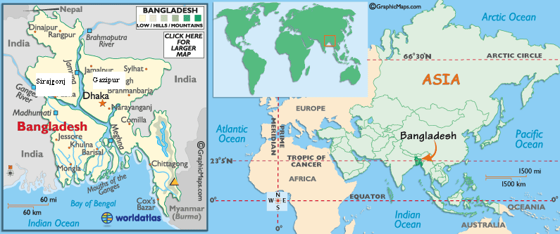
Source: www.worldatlas.com
Fig 1: Showing the area of sampling site in Bangladesh.

Plant collection and analysis:
Plant height, number of tillers were determined at 30 (20-35 early tillering stage=ETS), 60 (36-65 maximum tillering stage=MTS), 90 (66-90 panicle initiation stage=PIS) and 110 (harvesting at maturity) days after transplanting (DT). At each sampling time, one plant per hill was harvested at 1 cm above the soil surface and the oven dry (65⁰C) weight was recorded. Panicle lengths of the plant were recorded. At maturity, grain yield, percentage of filled grains and weight of 1000 grains of rice were determined. The level of significance of the different treatments was determined at different stages of growth using Duncan’s New Multiple Range Test (DMRT) and least significant difference (LSD) techniques (Zaman et al. 1982).

RESULTS AND DISCUSSION:

Agronomic parameters of rice:
The application of sulfidic materials and gypsum exerted significant (p≤0.05) positive effects on the growth and yield of rice plants and their effects varied not only with the kinds and amounts of amending materials but also with the different parameters of rice plants. The highest value of plant height (Fig 3) and maximum number of tillers (Fig 4) at all stages of rice growth were obtained by the application of SM45, followed by SM30>SM15>G45 treatments in both the soils, indicating that these amendments were considerably affected by the kinds rather than the amounts of the treatments. The trends of effects of the amendments were quite similar in both the soils .The number of tillers at all growth stages of the rice plants increased significantly (p≤0.05) under the different rates of SM and gypsum, and the increments were most pronounced at 60 DT (MTS) followed by 90 DT(PIS) of rice. These results indicate that the vegetative growth of rice was much improved by the treatments, especially SM, which might be because of its initial high content of organic matter and other nutrients in addition to the sulfur. The panicle length of rice were obtained by the application of SM45, followed by SM30>SM15>G45 treatments in both the soils (Fig 2). The application of gypsum at 15 kg S ha⁻¹ was found to have significant positive effects for these parameters but its higher rates(30, 45 kg S ha-1)were not particularly effective(Fig 2,3,4), suggesting that application of G45 to these sulfur deficient soils is effective and will be more economic than in higher doses. As expected, the lowest values for these plant characters were recorded in the control pots, where only basal application of N, P, and K was performed. Khan et al. (2007) reported that the application of SM at the rate of 75 kg S ha⁻¹ increased (over control) the flower-head diameter of sunflower and seed yield in the range between 77 to 80, and between 169 to 182 %, respectively, in the sulfur deficient soils, while the same amounts of sulfur fertilization from MgSO4 increased those parameters in the range between 21 to 41 and between 56 to 100%.

Grain yield and yield components of rice:
The effectiveness of SM and gypsum treatments on the yield of grain (table 3) was almost similar to and as significant (p≤0.05) as that of the effects observed for the straw dry matter production of rice. The maximum grain yield was recorded by the highest dose of SM30, SM15, G45 treatments in both soils (Table 2). The average of grain yield obtained from all the SM treatments increased by 108% and 135% IOC in the Sirajgonj soil and the Gazipur soil respectively, whereas these increments were 35% and 58% respectively, in the average of all the gypsum treatments, reflecting that the SM was potentially more effective against gypsum as sulfur fertilizer. The average grain yield obtained from all the treatments was 26% higher in the Gazipur soil than the Sirajgonj soil (Table 2), which was attributed to the initial high content of organic matter and higher responses of sulfur in the Gazipur soil (Table 1). The application of SM exerted significant effects in increasing the 1000 grain weight, percent filled grains and harvest index of rice, but the application of gypsum was found to have positive effects which were not always significant for these plant characters (Table 2). Khan et al (2007) reported that the application of SM at the rates of 25 to 75 kg S ha⁻¹ was effective in increasing the organic matter status in sulfur deficient soils and enhanced the release of essential plant nutrients into the growing media, which are very essential for crop production in poor soils.

Table 1: Some selected properties of the initial soils (depth 0-20 cm, oven dry basis), sulfidic materials and average soil (0-20 cm) of all the treatments at post narvesting of rice used during pot experiment
Soil Properties | Sulfidic Materials  (ASS†) | Sirajgonj soil |  |  | Gazipur soil
 |  | Initial soil (controL) | Post harvested soil | % IOC‡ | Initial soil (control) | Post harvested soil | % IOC‡
Textural class | Silty Clay Loam | Silty Loam |  |  | Silty Clay Loam
Soil pH (Field,1:2.5) | 4.2 | 6.1 | 6.0 | -2 | 5.8 | 5.6 | -3
Soil pH (CaCl₂, 1:2.5) | 3.4 | 5.9 | 5.7 | -3 | 5.0 | 4.9 | -2
EC(1:5 S m⁻¹) | 1.6 | 0.11 | 0.18 | 64 | 0.13 | 0.21 | 62
Organic matter (g kg⁻¹) | 40.3 | 7.7 | 10.6 | 38 | 6.6 | 8.6 | 25
Total Sulfur(cmol kg⁻¹) | 165.6 | 1.40 | 1.96 | 41 | 1.56 | 2.88 | 85
Available S (cmol kg⁻¹) | 24.4 | 0.03 | 0.08 | 162 | 0.03 | 0.09 | 197
Available P (m M kg⁻¹) | 0.11 | 0.10 | 0.12 | 20 | 0.12 | 0.14 | 17
CEC (c mol kg⁻¹) | 18.2 | 14.0 | 14.5 | 4 | 17.0 | 17.4 | 2
Base saturation (%) | 22.2 | 74.4 | 80.4 | 8 | 66.5 | 71.3 | 7
(ASS†)= Acid sulfate soil, IOC‡= increased over control (initial soil)

Figure 2: Effect of of sulfidic materials (SM: Kg S ha⁻¹) and gypsum (G: Kg S ha⁻¹) as fertilizers for the panicle length (cm) for rice.
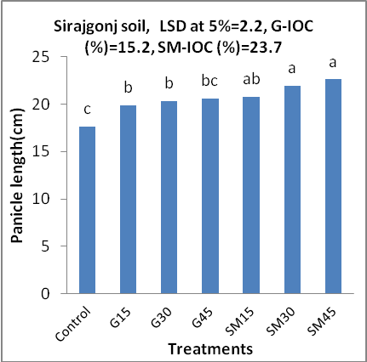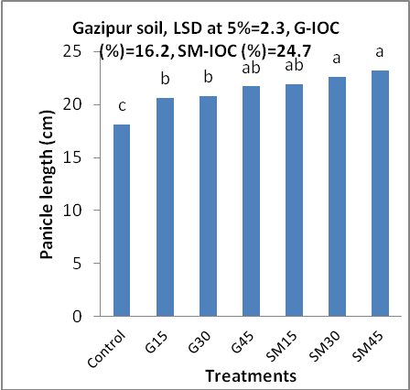
IOC= increased over control and above column the alphabets of common letter are not significantly different at 5% level.
Figure 3: Effect of of sulfidic materials (SM: Kg S ha⁻¹) and gypsum (G: Kg S ha⁻¹) as fertilizers for the plant height (cm) of rice.
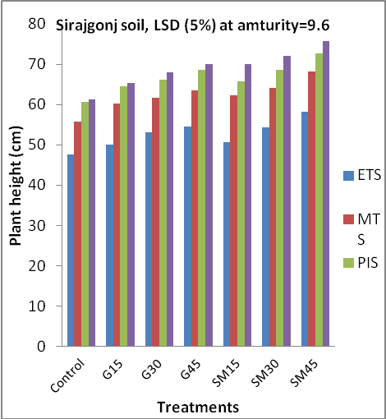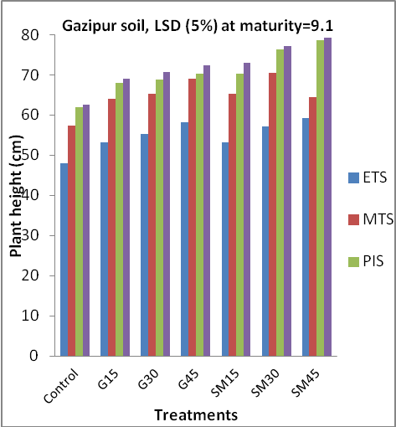
Whears ETS= early tillering stage (20-35 days after transplanting), MTS= Maxium tillering stage (36-65 days after transplanting), PIS= panicle initiation stage (66-90 days after transplanting), MAT= At maturity.
Figure 4: Effect of of sulfidic materials (SM: Kg S ha⁻¹) and gypsum (G: Kg S ha⁻¹) as fertilizers for the tillers (Number/pot) of rice.
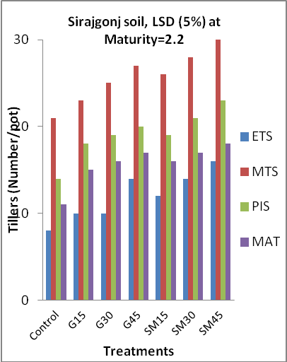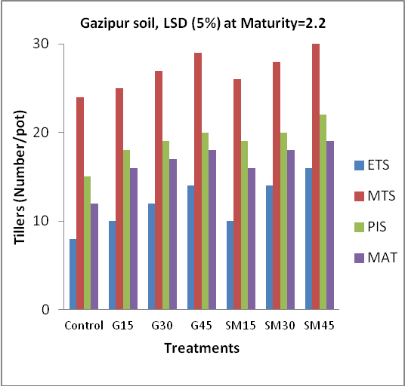
Whears ETS= early tillering stage (20-35 days after transplanting), MTS= Maxium tillering stage (36-65 days after transplanting), PIS= panicle initiation stage (66-90 days after transplanting), MAT= At maturity.

Table: 2 Effect of sulfidic materials (SM: Kg S ha⁻¹) and gypsum (G: Kg S ha⁻¹) as fertilizers for the yield and yield component of rice grown on two sulfur deficient soils.
Treatment Denotation | Grain yield (g/plant) | ‡IOC | ♦Harvest index | 1000- grain wt. (g) | % filled grain
Sirajgonj soil:

Control | 3.9 c® |  | 0.45 | 17.3 c | 65.0
G15 | 4.9 d | 25.6 | 0.48 | 18.9 bc | 67.3
G30 | 5.1 d | 31.3 | 0.48 | 19.5 b | 68.2
G45 | 5.8 dc | 48.7 | 0.49 | 20.1 b | 70.1
SM15 | 6.3 c | 61.5 | 0.49 | 19.8 b | 69.5
SM30 | 8.4 b | 115.4 | 0.50 | 20.5 ab | 72.5
SM45 | 9.6 a | 146.2 | 0.50 | 22.1 a | 75.6
LSD at 5%= | 0.9 |  |  | 2.2
G- IOC (%) | 35.2 |  | 6.6 | 12.7 | 5.4
SM- IOC (%) | 107.7 |  | 9.0 | 20.2 | 11.6
Gazipur soil:

Control | 3.9 f |  | 0.44 | 16.6 c | 63.3
G15 | 5.5 e | 41.0 | 0.46 | 19.1 b | 65.6
G30 | 6.3 de | 61.5 | 0.47 | 19.7 ab | 68.9
G45 | 6.7 d | 71.8 | 0.48 | 20.1 ab | 70.2
SM15 | 7.6 c | 94.9 | 0.48 | 19.4 b | 69.8
SM30 | 9.4 b | 141.0 | 0.49 | 20.1 ab | 70.5
SM45 | 10.5 a | 169.2 | 0.50 | 21.3 a | 72.7
LSD at 5%= | 0.9 |  |  | 2.1
G- IOC (%) | 58.1 |  | 6.4 | 18.3 | 7.8
SM- IOC (%) | 135.0 |  | 10.4 | 22.1 | 12.2
‡IOC = Increased over control. ♦Harvest index = (Grain yield)/(Grain yield+ Straw yield). ® In a column, means followed by a common letter are not significantly different at 5% level.

Conditions of initial and post harvested soils
The Sirajgonj and Gazipur soil had silty loam and silty clay loam textures, initial pH values of 5.9 to 6.1 and 5.0 to 5.8 respectively, as determined by the different conditions. These sulfur deficient soils were subjected to the application of SM and gypsum in relation to rice production. The pH values in different conditions of the average soil data of all the treatments at post harvesting were found to have decreased by 0.1 to 0.2 pH units compared with the initial Sirajgonj and Gazipur soil, indicating that the use of the acidic SM in these soils had very negligible influence on the pH of the soils. On the other hand, the SM strikingly increased the initial low contents of the organic matter, P, available and total sulfur in both the soils by 16 to 197%, compared with the initial soils (Table 1), which was due to high nutrient status of the applied SM. The base saturation of the initial Sirajgonj soil was 74% which were increased to 80% at the final harvesting of rice, while this increment went from 67% to 71% for Gazipur soil. These increases in base saturation were attributed to the high contents of basic cations in the applied SM. The EC values of the soils were found to have increased from 0.11 to 0.18 S m⁻¹ for Sirajgonj soil and from 0.13 to 0.21 S m⁻¹ for Gazipur soil, which are attributed to the higher EC value of the SM used. These increased levels of EC values might not, however, have any extraordinary influence on the production of rice.

Sulfidic materials(SM)
The SM was collected from the surface (depth: 0-20 cm) of an acid sulfate soil (Typic Silfic Halaquept, detailed; Khan et al. 2006) and showed a silty clay loam texture with pH values of 3.4 (0.02 M CaCl₂: lab) and 4.2 (field), indicating that the SM had probably accumulated a large amount of pyrite which had produced H₂SO₄ in the laboratory by oxidation. The EC, available sulfur, total sulfur and content of organic matter content in the SM were very high, while the base saturation was very low (Table 1). The SM was in fact a fertile but unproductive soil owing to its high acidity, salinity and imbalance of nutrients.

Conclusion
The application of SM and gypsum increased the average grain yield by 108 to 135 and 35 to 58 % IOC, organic matter by 46 to 78 and 5 to 19%, available sulfur by 194 to 208 and 132 to 145% respectively, in both the soils, suggesting that the SM compared with gypsum as a source of sulfur fertilizer was potential and effective for the growth of rice. But further field research is essential to find out the best dose of SM for different soils under variable conditions. The high organic matter (4%), available S (24 cmol kg⁻¹) and total S (166 c mol kg⁻¹) of the SM deserve consideration for the use in the reclamation of poor soils like saline, alkaline, calcareous and sulfur deficient soils. The use of SM by removing it from acid sulfate soils will not only let the soils reclaimed permanently but also safeguard the surrounding systems of the ASSs from their severe effects. The use of SM exerted did not show any adverse effects on the growth and yield of rice.. Hence, immediate measures should be considered for these ASSs or SM to have their dual benefits as sulfur fertilizer and in reclamation of the ASSs fully utilized.

Acknowledgements
The study was carried out under the financial and technical support (1998-2005) of the Volkswagen and the Alexander von Humboldt (AvH) foundations. The senior author is grateful to the authority of the Department of Soil, water and Environment, University of Dhaka, Bangladesh and to the Ministry of Education, Culture, Sports, Science and Technology, Japan.

Correspondense to:
Farook Ahmed
Graduate School of Environmental Science
Faculty of Environmental Science & Technology
Okayama University
700-8530, Okayama, Japan
Email: farookahmed12@yahoo.com

References
BARC (Bangladesh Agricultural Research Council) 1997: Fertilizer Recommendation Guide, Publ, BARC, Framgate, Tejgaon, Dhaka, Bangladesh.
Black CA (ed) 1965: Methods of Soil Analysis, Part 2, Series 9, 894-1372. Ame. Soc. Agron. Inst, Publ., Madison, WI.
Callinan RB, Fraser GC, Melville MD 1993: Seasonally recurrent fish mortalities and ulcerative disease out breaks associated with acid sulfate soils in Australia estuaries. In: D.L. Dent and M.E.F. van Mensvort(Ed.). Selected Papers of the Ho Chi Minh city symposium on Acid Sulfate Soils. Pub. 53. Pp403-410. Int Inst. For Land Recommendation and Improvement, Wageningen, The Netherlands.
Chapman HD 1965: Cation exchange capacity. In methods of soil analysis. Part 2 (ED.) C.A. Black. Agrn. Series 9. Pp 891-900. Am. Soc. Agron., Publ. Madison, WI, USA.
Day PR 1965: Particle fractionation and particle size analysis. In Methods of Soil Analysis. Part 2 (ED.) C.A. Black, Agron. Series 9, pp 545-566. Am. Soc. Agron., Publ, Madison, Wi, USA.
Hesse PR 1971: A Text Book of Soil Chemical Analysis, John Murry Publ.. , London. Jackson MI 1973: Soil Chemical Analysis, p 41-330, Prentice Hall of India Pvt, Ltd., New Delhi.
Khan HR, Syeed SMA, Ahmed F, Shamim AHM, OKI Y, Adachi T. 2007: Response of Sunflower to sulfidic materials and magnesium sulfate as sulfur fertilizer. J. Bio. Sci. 7(6): 888-895.
Khna HR, Bhuiyan MMA, Kabir SM, Oki Y, Adachi T 2006: Effect of selected treatments on the production of rice in acid sulfate soils in a simulation study, Jpn, J. Trop. Agr. 50 (3): 109-115.
Khna HR, Bhuiyan MMA, Kabir SM, Ahmed F, Syeed SMA, Blume H-P 2002: The assessment and management of acid sulfate soils in Bangladesh in relation to crop production, Chapter 22, p254-263. In MH Wong and AD Bradshaw(ed). The restoration and management of derelict land: Modernapproaches, World Scientific, www.worldscientific.com.
Khan HR 2000: Problems, prospects and future directions of acid sulfate soils. In Proc. Inter. Conference on Remade Lands 2000, Ed. Biron, A. and R.W. Bell. P 66-67, Nov. 30 to Dec. 2, 2000, Perth, Australia.
Khan HR, Adachi T 1999: Effects of selected natural factors on soil pH and element dynamics studied in columns of pyretic sediments. Soil Sci. Plant Nutr., 45, 783-793.
Nelson DW, Sommers LE 1982: Total carbon, organic carbon and organic matter. In Methods of Soil Analysis. Part 2., Ed. A.L. Page, Agron. Series 9., p539-579, Am. Soc. Agron., Publ. Madison, WI,USA.
Olsen SR, Cale CV, Watanabe ES, Dean LA 1954: Estimation of available phosphorus in soils by extractionwith sodium bicarbonate, USDA Cric, 939, Washington, USA.
Orndroff Z, Daniels WL 2002: Dilenation and management of sulfidic materials in Virginia highway corridors. Final report to the Virginia transportation research council, Charlottesville, Virginia, Sept. 2002, VTRC 03-CR3.
Richards LA(ed) 1954: Diagnosis and improvement of saline and alkali soils. In USDA handbookno.60, p. 84-156, US Govt. Print. Office, Washington, USA.
Sakai H 1978: Some analytical results of sulfur deficient plants, soil and water. Workshop on sulfur nutrition in rice, December, BRRI, Publication no. 41:35-59.
SRDI(Soil Resource Development Institute) 1999: Map of the nutrient status of sulfur and upazila land soil resource utilization guide.
Sremannrayana B, Raju AS, Satyanarayana 1995: Effects of sulfur on yield and quality of sunflower. J. of Moharastra Agricultural Universities 20 (1): 63-65.
Tiwari KN, Dwivedi BS, Pathak AN 1985: Iron pyrites as sulfur fertilizer for legumes. Plant Soil, 86: 295-298.
Zaman SMH, Rahman K, Howlader M 1982: Simple lessons from biometry, Publ no. 54, Bangladesh Rice Research Institute, Gazipur, Bangladesh.

