Response of Mineral Nutrient of Rice to Sulfidic Material as Sulfur fertilizer.
Farook Ahmed*, Md. Harunor Rashid Khan**, and Munehide Ishiguro*

*Graduate School of Environmental Science, Okayama University, 700-8530 Okayama, Japan.

**Department of Soil, Water and Environment, University of Dhaka, Dhaka- 1000, Bangladesh.
farookahmed12@yahoo.com

Abstract:
The response of sulfidic materials (SM) and gypsum(G) application at the rates of 0, 15, 30 and 45 kg S ha⁻¹ on the yield and mineral nutrition of rice (Oryza sativa L. Var: BR-26 Sraboni) grown in two sulfur deficient soils of Bangladesh Kamarkhond series ( Sirajgonj soil) and Kalma series (Gazipur soil) were evaluated in a greenhouse study. The best yield performance and nutrition of rice were recorded by SM45 treatment in both Kamarkhond series (Sirajgonj soil) and Kalma series (Gazipur soil) the followed by the SM30>SM15>G45 treatments. The application of SM increased the grain yield by 108% (increased over control: IOC) for Sirajgonj soil and 135% for Gazipur Soil irrespective of application rates. In case of gypsum, these increments were 35% and 58% for Sirajgonj and Gazipur Soil respectively. The application of SM significantly (p≤0.05) increased the organic matter, N, P, K, Mg, available and total sulfur both the soils than gypsum indicating high nutrient status of the applied SM and also indicating SM is potentially more effective than gypsum as a source of sulfur fertilizer and can also enrich the fertility of the soils. The use of SM did not produce any adverse effect on the plant and soil.

Key words: Response of sulfidic materials, gypsum, mineral nutrition of rice, sulfur deficient soils.

Introduction:
Intensive cropping has been resulting in higher removal of sulfur among the other nutrients. But its replenishment through natural process has been very low compared with the other major nutrients (Balsa et al. 1996). Bangladesh is not free from this threat. About 7 M ha (about 52%) of agricultural lands are reported to consists of sulfur deficient soils in the northern region of Bangladesh (SRDI 1999). The current intensive use of agricultural land for crop production has extended the sulfur deficient areas to about 80% in the northern region (Khan et al. 2007: Nasreen 2001; unpublished PhD thesis). Poor crop production as a result of acute sulfur deficiency has frequently been reported by many scientists in different regions of India (Tiwari et al. 1985) and Bangladesh (Khan2000; Ullah 2003, unpublished PhD thesis). The current use of gypsum, ammonium sulfate, znic sulfate, etc as sulfur fertilizer for the soils can instantly supply sulfur to crops but the fertilization has to be done for each crop every year, which is both uneconomic and inconvenient for farmers. A suitable and sustainable source of sulfur is therefore essential.The use of sulfidic materials (SM) or layers obtained from Acid Sulfate Soils (ASSs) as sulfur fertilizer for crop production is very scanty, Khan et al(2002) reported that high organic matter (2-9%), total sulfur(3-7%) and micronutrients in the ASSs or SM deserve consideration for use in the reclamation of alkaline,calcarious or sulfur deficient soils for the amendment os ASss themselves by the removal of SM from the soils. Khan et al (1994) also reported that the ASSs contained high Mg (1.3 to 2.6 cmol/kg) and Al(1-2 cmol/kg), but the use of ASSs or Sm containing high Al did not show any harmful effects when applied to soils with Ph>4.5(Khan et al. 2002). Moreover, the availability of land for growing crops is limited: the use of marginaland/or problem soils amy become inevitable. The SM currently being studied is an ASSs layer, which occupies 0.7 M ha of land area,has low pH(<3), high sulfate and organic matter(Khan et al. 2006). When these layers of the soils are exposed to air and water, sulfuric acid is produced which causes many problems on the land and in the Water. Massive fish kill in the waters polluted by toxic elements drained from the ASSs have been widely reported in the world (Callinan et al, 1993: Lin and Melville 1994). Losses from fish killing from such situations in the coastal plains of Bangladesh were about US$ 3.4 million during 1988-89( Callinan et al. 1993). In the coastal plains of Bangladesh, the SM can be obtained from the ASSs at depths of about 10 to 18 cm (Khan 2000). The reclamation of these soil materials may be difficult but is essential owing to the presence of high acidity and salinity during the dry periods of the year, which not only hinders crop growth but also destroys aquatic organisms (Khan et al 2006). Orndorff and Daniels (2002) reported that exposure of SM from road construction presents a number of technical and environmental problems. Technical problems are primarily related to the degradation of construction materials, weathering if sulfides exposed along roads cuts and or in fill material, and limitation of roadside vegetation, which promotes erosion. Delayed effects of potential chemical stored in the SM resulted in harmful effects, like a “chemical time bomb” on the associated environments (Khan and Adachi 1999). The removal SM from the ASSs is not only the reclaiming the ASSs for a long time but its use in S0deficient or non-fertile soils at the rate of about 300 to 1500 kg/ha may improve the fertility and productivity of the soils. Khan et al. (2007) reported that the application of SM at the rate of 75 kg S /ha for sulfur deficient soils had no negative effect on soil pH, nutrient status in the soils and sunflower production. They suggested that the application of SM was not only effective as sulfur fertilizer but also enriched the organic matter in the soils. Against this background, the present study was undertaken to evaluate the potentiality and effectiveness of the SM or ASSs compared with gypsum as a sulfur fertilizer in relation to rice production in sulfur deficient soils, which is not only a new approach for the alternative use of SM but might also solve the problems of utilization and management of the ASSs and reduce sulfur deficiency.

Table 1: Some selected properties of the initial soils (depth: 0-20 cm, oven dry basis), sulfidic materials and the average soil (0-20 cm) data of all the treatments at post harvesting of rice used during pot experiment.
Soil Properties | Sulfidic Materials  (ASS†) | Sirajgonj soil |  |  | Gazipur soil
 |  | Initial soil (control) | Post harvested soil | % IOC‡ | Initial soil (control) | Post harvested soil | % IOC‡
Textural class Silty Clay Loam Silty loam Silty clay loam
Soil pH (Field,1:2.5) 4.2 6.1 6.0 -2 5.8 5.6 -3
Soil pH (CaCl₂,1:2.5) 3.4 5.9 5.7 -3 5.0 4.9 -2
EC(1:5 S m⁻¹) 1.6 0.11 0.18 64 0.13 0.21 62
Organic matter(g kg⁻¹) 40.3 7.7 10.6 38 6.6 8.6 30
Extractable N (mM kg⁻¹) 3.65 0.23 0.31 35 0.20 0.25 25
Available P (mM kg⁻¹) 0.11 0.10 0.12 20 0.12 0.14 17
CEC (c mol kg⁻¹) 18.2 14.0 14.5 4 17.0 17.4 2
Base saturation(%) 22.2 74.4 80.4 8 66.5 71.3 7
Exchangeable cations ( c mol kg⁻¹)
Sodium 2.44 0.41 0.71 73 0.37 0.56 51
Potassium 0.25 0.08 0.14 75 0.07 0.13 86
Calcium 0.33 6.69 6.83 2 6.52 6.66 2
Magnesium 1.02 3.23 3.98 23 4.34 5.05 16
Water-soluble ions (c mol kg⁻¹)
Sodium 4.84 0.14 0.19 36 0.12 0.27 125
Potassium 0.21 0.28 0.36 29 0.24 0.31 29
Calcium 0.27 6.47 6.68 3 3.77 3.91 4
Magnesium 3.34 2.37 4.01 69 2.13 3.21 51
Available sulfur 24.4 0.03 0.08 162 0.03 0.09 197
Total sulfur 165.6 1.40 1.96 41 1.56 2.88 85

(ASS†) = Acid sulfate soil, IOC‡ = Increased over control (initial soil)

MATERIALS AND METHODS
Soil collection and analyses:
Bulk samples of two sulfur deficient soils (surface soil at depth of 0-20 cm) of Kamarkhond series (Sirajgong soil) and Kalma series (Gazipur soil) were collected, respectively from the district of Sirajgonj and Gazipur in Bangladesh. The sulfidic materials (SM: Cheringa acid sulfate soil) used for this study was obtained from the surface soil (depth: 0-20 cm) at Dulahazara in the Cox’ Bazar district of Bangladesh. This SM contained high organic matter but had low base saturation. Selected physical and chemical properties of the initial soils, SM and the average of soil data of all the treatments at post harvesting of rice are presented in Table: 1. Three sampling time, ETS (early tillering stage, 30 days after transplantation); MTS (maximum tillering stage, 60 days after transplantation); Mat(at maturity, 110 days after transplantation) soils(0-20 cm depth) were collected from each replicated pot using Cork borer (2 cm diameter), then air-dried and screened by 1 mm sieve. The soils were oven dried (105ºC) before analysis. After treatment with 1 M CH₃COONH₄ (pH 5.0) and with 30 % H₂O₂ to remove free salts and organic matter respectively. Particle size distribution of the initial soils was determined by the pipette method (Day 1965). Soil pH was measured in the field by the soil-water ratio of 1:2.5 and for the oven dried (105ºC) soil – 0.02M CaCl₂ (1:2.5)suspension (Jackson 1973) using a Corning pH meter Model-7. The electrical conductivity (soil solution was extracted from saturated soil paste through vacuum pump: Richards 1954), water soluble Na⁺ and K⁺ (Gallenkamp flame photometry using 589 and 766 nm filters, respectively: Black 1965), Ca²⁺ and Mg²⁺ (Pye UniCam-SP 9 atomic absorption spectrometry: Hesse 1971) were from saturation extract of soils. Organic matter content was determined (Nelson and Sommers 1982) by wet combustion with K₂Cr₂O₇. Available N (1.3 M KCl extraction, Jackson 1973), available P (0.002 N H₂SO₄, pH 3 extraction, Olsen et al., 1954) and available S (BaCl₂ turbidity, Sakai 1978) were determined. Cation exchange capacity was determined by saturation with 1 M CH₃COONH₄ (pH 7.0), ethanol washing, NH4⁺displacement with acidified 10 % NaCl, and subsequent analysis by steam (Kjeldhal method) distillation (Chapman 1965). Exchangeable Na⁺, K⁺, Ca²⁺ and Mg²⁺ were extracted with 1 M CH₃COONH₄ (pH 7.0) and determined by flame photometry (Na⁺, K⁺) and atomic absorption spectrometry. Total S was obtained by digestion with a mixture of concentrated HCl /HNO₃ (1:3) and determined by the turbidity method (Sakai 1978). The bulk samples obtained from each soil were stored for a couple of days under field- moist conditions ( by putting the soil samples and the SM into polyethylene bags in an air-tight box) just prior to laboratory analysis, when the sub-samples were air-dried and crushed to 2 mm before analysis.
Pot Experiment:
A pot experiment was conducted in the greenhouse at the premises of the Department of Soil, Water and Environment, University of Dhaka, during the period of May to August, 2003 to evaluate the effectiveness of SM compared with gypsum (G) as a sulfur fertilizer in relation to yield performance and nutrient of rice grown in two sulfur deficient soils. Two sets of experiments were set up in a completely randomized design with 3 replications and three sampling times for each treatment. The doses of SM and gypsum were selected according to the sulfur requirement (20-40 kg S ha⁻¹) of the country as reported by BARC (1997). The experimental treatments on the basis of furrow slices of the soils were: control (no application of G and SM); G15, G30 and G45 (G15, 30 and 45 kg S ha⁻¹); SM15, SM30 and SM45 (SM15, 30 and 45 kg S ha⁻¹). Ten kg of air-dried and screened (5 mm sieve) soil was placed in each earthen pot (size: 36 cm height/28 cm diameter). The soil in each pot was fertilized with N, P, and K at the rates of 60, 30 and 20 mg kg-1 as urea, triple super phosphate (TSP) and muriate of potash (MP), respectively. The full dose of TSP and MP and half of urea were mixed with the soil during pot preparation. The remaining urea was applied in equal splits, one at the active tillering stage of rice and the other at the panicle initiation stage. As per treatments, the soils in the pots were also subjected to the application of SM and gypsum at the rates of SM and gypsum at the rates of 0, 15, 30 and 45 kg S ha⁻¹ during pot preparation. Both the SM and gypsum were dried, milled and sieved by 1 mm sieve. Thirty day old healthy and uniform seedlings (Oryza sativa L…Var. BR 26 Sraboni) were transplanted at the rate of three plants per hills per pot. The seedlings were transplanted on May 2003 and harvested at August 2003. The soils in the pot were irrigated by tap water (pH 6.5, EC 0.05 S m-1 and S 0.01 c mol kg-1 ) whenever necessary, to maintain the soil under the moist to wet conditions required for the production of rice. Seedlings were collected by courtesy of Bangladesh Rice Research Institute (BRRI), Gazipur.
Plant collection and analysis:
Plant height, number of tillers and shoot or straw dry matter yield were determined at 30 (20-35 early tillering stage=ETS), 60 (36-65 maximum tillering stage=MTS), 90 (66-90 panicle initiation stage=PIS) and 110 (harvesting at maturity) days after transplanting (DT). At each sampling time, one plant per hill was harvested at 1 cm above the soil surface and the oven dry (65⁰C) weight was recorded. At maturity, straw and grain yield of rice were determined. After the crops were harvested at maturity, composite samples of shoot dry matter obtained from each pot were analyzed for N content in H₂SO₄ digested through the micro-Kjeldahl method (Jackson 1973) and P content by spectrometry (Jackson 1973); K content by Gallenkamp flame photometry (Black 1965); S content by turbidometry (Jackson 1973); and Mg content by atomic absorption spectrometry (Pyc UniCam-Sp 9: hesse 1971) in HNO3-HClO4 acid (2:1) digest. The level of significance of the different treatments was determined at different stages of growth using Duncan’s New Multiple Range Test (DMRT) and least significant difference (LSD) techniques (Zaman et al. 1982).
RESULTS AND DISCUSSION:
Condition of Sulfidic materials(SM)
The SM was collected from the surface (depth: 0-20 cm) 0f an acid sulfate soil (Typic Silfic Halaquept, detailed; Khan et al. 2006) and showed a silty clay loam texture with pH values of 3.4 (0.02 M CaCl₂: lab) and 4.2 (field), indicating that the SM had probably accumulated a large amount of pyrite which had produced H₂SO₄ in the laboratory by oxidation. The EC, available and total sulfur and content of organic matter in the SM were very high, while the base saturation was very low (Table 1). The SM was in fact a fertile but unproductive soil owing to its high acidity, salinity and imbalance of nutrients. The content of Ca in SM was low compared with the Mg content, presumably because of occasional flooding with sea water with high Mg content (Khan et al 1994). The content of Na was also high owing to the flooding by high saline sea water.

Table 2 : Sulfur and organic matter contents of the soils at different growth stages of rice as influenced by the application of sulfidic materials (SM: Kg S ha⁻¹) and gypsum (G: Kg S ha⁻¹) in the sulfur deficient soil.
Treatment denotation |  | Available sulfur (mM kg⁻¹) |  |  | Total sulfur (mM kg⁻¹) |  |  | Organic matter (g kg⁻¹)
 |  | 30 DT≈  (ETS) | 60 DT  (MTS) | 110 DT  (maturity) | 30 DT  (ETS) | 60 DT  (MTS) | 110 DT  (maturity) | 30 DT  (ETS) | 60 DT  (MTS) | 110 DT  (maturity)
Sirajgonj soil: Silty loam, pH 6.1, Organic matter=7.7 g kg⁻¹, Total-S=13.95 and available- S= 0.29 mM kg⁻¹
Control |  | 0.29 d® | 0.30 d | 0.28 e | 12.4 e | 11.8 f | 10.8 e | 11.4 dc | 10.5 d | 8.4 d
G₁₅ |  | 0.36 c | 0.44 c | 0.55 d | 15.6 d | 13.9 e | 12.6 d | 12.2 c | 11.8 dc | 8.8 d
G₃₀ |  | 0.38 c | 0.54 b | 0.70 c | 19.5 c | 18.0 d | 17.6 c | 11.8 c | 10.6 dc | 8.6 d
G₄₅ |  | 0.52 b | 0.71 a | 0.81 b | 27.8 b | 26.2 b | 23.5 b | 11.5 c | 10.8 dc | 9.1 d
SM₁₅ |  | 0.40 c | 0.43 c | 0.71 c | 14.7 d | 13.2 e | 12.1 d | 12.6 c | 11.9 c | 10.9 c
SM₃₀ |  | 0.39 c | 0.53 b | 0.83 b | 26.8 b | 23.2 c | 22.6 b | 14.0 b | 13.3 b | 12.3 b
SM₄₅ |  | 0.59 a | 0.78 a | 0.93 a | 35.2 a | 32.3 a | 30.1 a | 15.5 a | 15.2 a | 13.6 a
LSD (5%) 0.06 0.06 0.05 1.7 1.6 1.5 1.4 1.4 1.1
Gazipur soil: Silty Clay loam, pH 5.8, Organic matter =6.6 g kg⁻¹, Total S =15.55 and available S = 0.31 mM kg⁻¹
 | Control | 0.37 e | 0.35 f | 0.34 e | 20.1 e | 17.3 f | 15.4 f | 7.0 c | 6.7 c | 5.8 f
 | G₁₅ | 0.42 d | 0.45 e | 0.57d | 23.2 d | 21.7 e | 18.9 e | 7.1 c | 7.1 bc | 6.3 ef
 | G₃₀ | 0.54 c | 0.58 d | 0.85 c | 33.3 d | 30.1 d | 27.8 c | 7.2 c | 7.2 bc | 6.6 e
 | G₄₅ | 0.64 b | 0.71 c | 0.95 b | 36.5 c | 34.8 c | 29.6 c | 7.2 c | 7.1 bc | 7.8 d
 | SM₁₅ | 0.57 c | 0.69 c | 0.88 c | 33.1 d | 28.7 d | 26.3 d | 7.4 ab | 7.2 bc | 9.4 c
 | SM₃₀ | 0.61 b | 0.82 b | 0.98 b | 39.8 b | 36.2 b | 32.6 b | 8.1 b | 7.9 b | 10.3 b
 | SM₄₅ | 0.88 a | 0.95 a | 1.28 a | 43.6 a | 40.8 a | 37.5 a | 8.9 a | 9.6 a | 11.2 a
 | LSD (5%) 0.06 0.06 0.05 3.2 3.1 2.6 0.9 0.9 0.8
DT≈ =days after transplantation, ®= In a column, means followed by a common letter are not significantly different at 5% level.

Table: 3 Effect of sulfidic materials (SM: Kg S ha⁻¹) and gypsum (G: Kg S ha⁻¹) as fertilizers on the grain and straw yield and Harvest Index of rice grown on two sulfur deficient soils.
Treatment Denotation | Grain yield (g/plant) | ‡IOC | Straw Yield  (g/plant) | ‡IOC | ♦Harvest index
Sirajgonj soil:

Control | 3.9 c® |  | 5.57b |  | 0.45
G15 | 4.9 d | 25.6 | 6.46ab | 15.98 | 0.48
G30 | 5.1 d | 31.3 | 6.48a | 16.34 | 0.48
G45 | 5.8 dc | 48.7 | 6.50a | 16.69 | 0.49
SM15 | 6.3 c | 61.5 | 6.12ab | 9.87 | 0.49
SM30 | 8.4 b | 115.4 | 6.16ab | 10.59 | 0.50
SM45 | 9.6 a | 146.2 | 6.48a | 16.34 | 0.50
LSD at 5%= | 0.9 |  | 0.5
G-IOC(%) | 35.2 |  | 16.34 |  | 6.6
SM-IOC(%) | 107.7 |  | 12.27 |  | 9.0
Gazipur soil:

Control | 3.9 f |  | 5.21b |  | 0.44
G15 | 5.5 e | 41.0 | 5.61b | 7.67 | 0.46
G30 | 6.3 de | 61.5 | 5.95b | 14.20 | 0.47
G45 | 6.7 d | 71.8 | 6.48a | 24.37 | 0.48
SM15 | 7.6 c | 94.9 | 5.64b | 8.25 | 0.48
SM30 | 9.4 b | 141.0 | 5.84ab | 12.09 | 0.49
SM45 | 10.5 a | 169.2 | 5.97ab | 14.59 | 0.50
LSD at 5%= | 0.9 |  | 0.5
G-IOC(%) | 58.1 |  | 15.41 |  | 6.4
SM-IOC(%) | 135.0 |  | 11.64 |  | 10.4
‡IOC = Increased over control. ♦Harvest index = (Grain yield)/(Grain yield+ Straw yield). ® In a column, means followed by a common letter are not significantly different at 5% level.

Iinitial and post harvested soils
The Sirajgonj and Gazipur soil had silty loam and silty clay loam textures, initial pH values of 5.9 to 6.1 and 5.0 to 5.8 respectively, as determined by the different conditions. These sulfur deficient soils were subjected to the application of SM and gypsum in relation to rice production. The pH values in different conditions of the average soil data of all the treatments at post harvesting were found to have decreased by 0.1 to 0.2 pH units compared with the initial Sirajgonj and Gazipur soil, indicating that the use of the acidic SM in these soils had very negligible influence on the pH of the soils. On the other hand, the SM strikingly increased the initial low contents of the organic matter, N, P, K, Mg, available and total sulfur in both the soils by 16 to 197%, compared with the initial soils (Table 1), which was due to high nutrient status of the applied SM, though there might be a little contribution from the small fraction of plant roots. The base saturation of the initial Sirajgonj soil was 74% which were increased to 80% at the final harvesting of rice, while this increment went from 67% to 71% for Gazipur soil. These increases in base saturation were attributed to the high contents of basic cations in the applied SM. The ECvalues of the soils were found to have increased from 0.11 to 0.18 S m⁻¹ for Sirajgonj soil and from 0.13 to 0.21 S m⁻¹ for Gazipur soil, which are attributed to the higher EC value of the SM used. These increased levels of EC values might not, however, have any extraordinary influence on the production of rice.

Fig 1:Effects of sulfidic materials (SM) and gypsum (G) on the Nitrogen Phosphorus contents (g/kg) at different stages of growth of rice shoot grown on two sulfur deficient soils.
Sirajgonj Soil Gazipur Soil
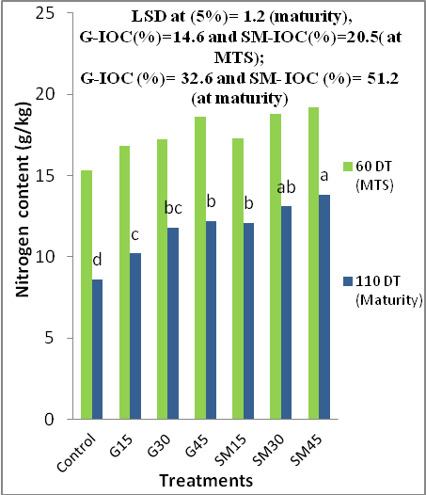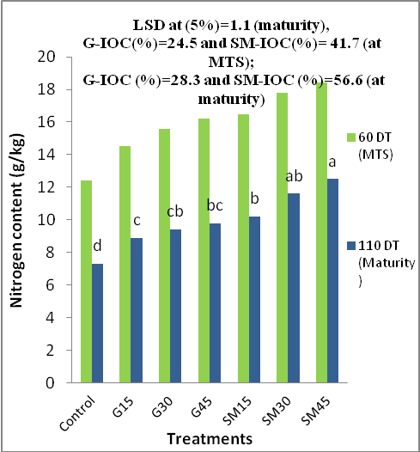

Sirajgonj Soil Gazipur Soil
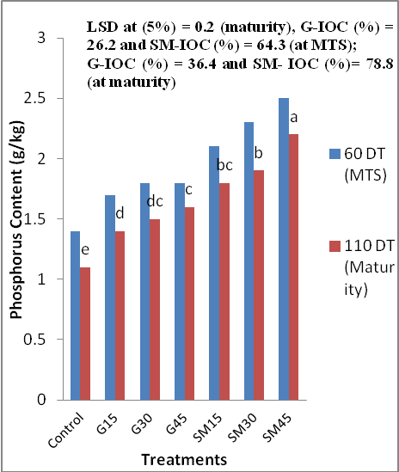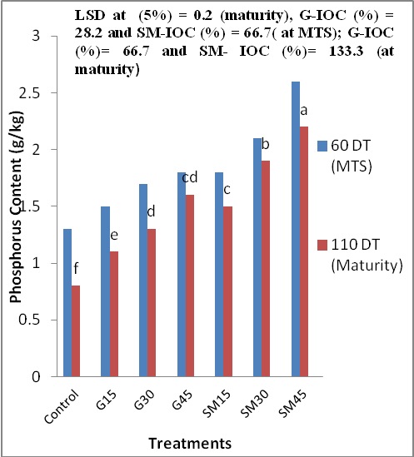

Sulfur and organic matter conditions in the soils
The content of available sulfur in the soils was found to be increased by the application of sulfur bearing materials and the increments were significantly (p≤0.05) stronger wth the passage of time (Table 2). These effects were most pronounced with the highest rate of SM45 fertilization followed by the second highest dose of SM30, which was almost equally effective to the highest rate of G45 in both the soils. The SM exerted better response to the increment of sulfur in both the soils (Table 2). This might be because of the contents of other essential nutrients, especially N in SM (Table 1), which enhanced sulfur uptake by the rice compared with the gypsum-treated pots. On the other hand, the content of total sulfur was found to be increased by the treatments but decreased with the passing of time; this was attributed to the uptake of rice plants and these effects were almost similar to those observed for the available sulfur contents in the soils (Table 2). The content of organic matter in both the soils throughout the experiment period was found to be improved a little by the different rates of gypsum fertilization, whereas almost all the doses of SM significantly (p≤0.05) increased the organic matter status in bothe the soils and the increments were most striking with the higher doses of SM (Table 2). The application of SM increased the average organic matter in the soil by 46 to 78 % IOC at post harvesting of rice at maturity, while these increments were 5 to 19% for gypsum treatments. These increments in organic matter status in the soils were attributed to the high content of organic matter in the applied SM and the slight enrichment of organic matter by the gypsum treatments was attributed to the contribution of cultivation processes. The amounts of increments of organic matter were more pronounced in the Sirajgonj soil then the Gazipur soil(Table 2), which was to the result of the initial high content of organic matter and better physic-chemical properties of the Sirajgonj soil compared with the Gazipur soil (Table 1).
Straw dry matter of rice
The straw dry matter at all growth stages of the rice plants increased significantly (p≤0.05) under the different rates of SM and gypsum, and the increments were most pronounced at 60 DT(MTS) followed by 90 DT(PIS) of rice. These results indicate that the vegetative growth of rice was much improved by the treatments, especially SM, which might be because of its initial high content of organic matter and other nutrients in addition to the sulfur (Table 1). The maximum increase of the straw dry matter was also recorded at 60 DT and then the straw dry matter was drastically reduced following the trend of tiller production in both the soils, regardless of the treatments. Apart from the growth stages, the largest amount of straw dry matter was recorded by the highest dose of SM45. The SM30 ranked 2nd, the SM15 was 3rd and the highest dose of G45 was placed 4th in order of straw dry matter production in both the soils. Most of the straw dry matter obtained by the treatments varied significantly (p≤0.05), indicating that the application of SM at the rate of 15 kg S ha⁻¹ was sometimes more generous and effective than the highest rate of G45 treatment for the production of rice. The application of gypsum at 15 kg S ha⁻¹ was found to have significant positive effects for these parameters but its higher rates (30, 45 kg S ha⁻¹) were not particularly effective, suggesting that application of G45 to these sulfur deficient soils is effective and will be more economic than in higher doses. As expected, the lowest values for these plant characters were recorded in the control pots, where only basal application of N, P, and K was performed. Khan et al. (2007) reported that the application of SM at the rate of 75 kg S ha⁻¹ increased (over control) the flower-head diameter of sunflower and seed yield in the range between 77 to 80, and between 169 to 182 %, respectively, in the sulfur deficient soils, while the same amounts of sulfur fertilization from MgSO₄ increased those parameters in the range between 21 to 41 and between 56 to 100%.
Yield components of rice
The effectiveness of SM and gypsum treatments on the yield of grain (Table 3) was almost similar to and as significant (p≤0.05) as that of the effects observed for the straw dry matter production of rice. The maximum grain yield was recorded by the highest dose of SM45, SM30, SM15, G45 treatments in both soils (Table 3). The average of grain yield obtained from all the SM treatments increased by 108% and 135%IOC in the Sirajgonj soil and the Gazipur soil respectively, whereas these increments were 35% and 58% respectively, in the average of all the gypsum treatments, reflecting that the SM was potentially more effective against gypsum as sulfur fertilizer. The application of SM exerted significant effects in increasing the harvest index of rice, but the application of gypsum was found to have positive effects which were not always significant for these plant characters. Khan et al (2007) reported that the application of SM at the rates of 25 to 75 kg S ha⁻¹ was effective in increasing the organic matter status in sulfur deficient soils and enhanced the release of essential plant nutrients into the growing media, which are very essential for crop production in poor soils.

Fig 2: Effects of sulfidic materials (SM) and gypsum (G) on the Potassium, Magnesium and Sulfur contents (g/kg) at different stages of growth of rice shoot grown on two sulfur deficient soils.
Sirajgonj Soil Gazipur Soil
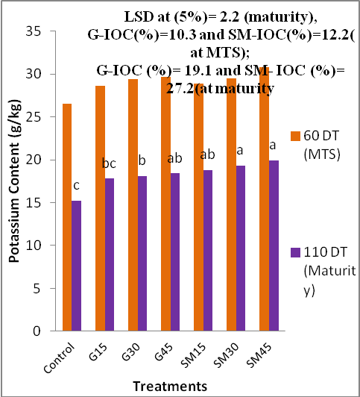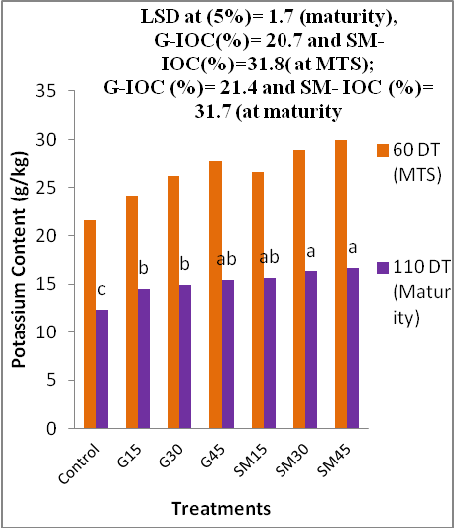

Sirajgonj Soil Gazipur Soil
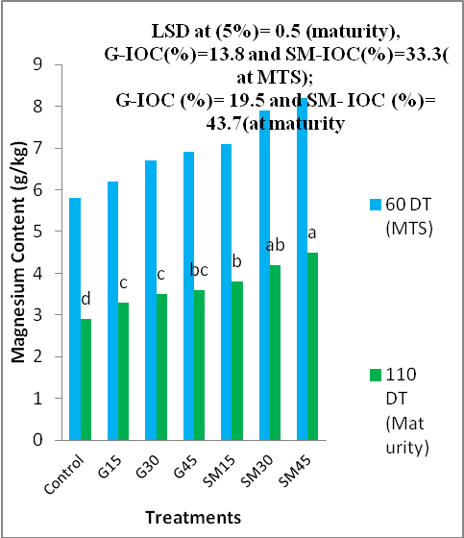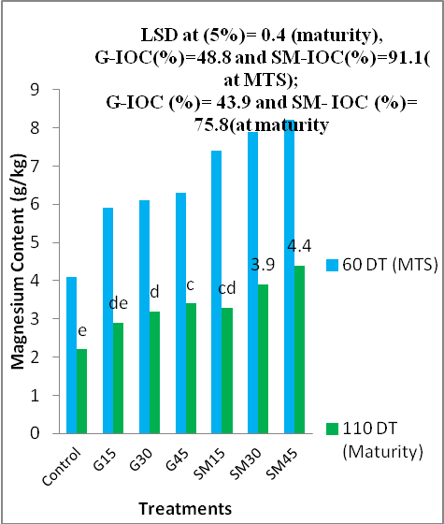
Sirajgonj Soil Gazipur Soil
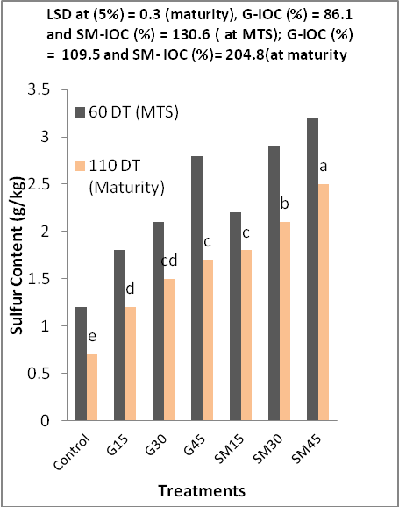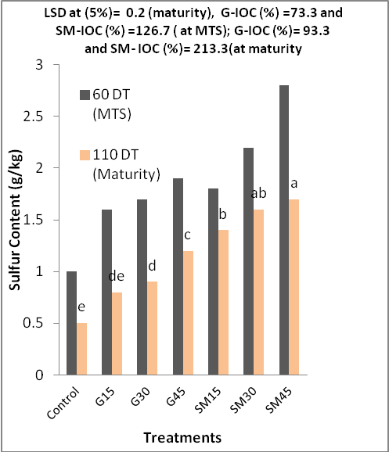

Nutrition of rice
The highest of N, P, K, Mg, and S contents in rice shoot at different growth stages of rice were obtained by the SM45 followed by the 2nd dose of SM30 treatment (Figure 1, 2). The SM15 and the highest dose of G45 were most equally effective and ranked 3rd in order of nutrient contents. The lowest contents of these elements were significant (p≤0.05) with the higher rate of SM and the highest rate of gypsum treatments in both the soils. The average S contents in plant tissues of all the SM treatments at the final harvesting (110 DT) of rice were increased by 205% in the Sirajgonj soil and 213% in Gazipur soil compared with the control treatments. But these increments of S by the average of all gypsum treatments were 110 and 93% for the rice plants grown in the Sirajgonj and Gazipur soils, respectively. The striking increments in N, P, K and Mg were also determined by the applied SM compared with gypsum treatments in both the soils (Table 4). These results suggest that the potentiality and effectiveness of SM as sulfur fertilizer are much higher than those of gypsum and would also be effective for the subsequent crops, indicated by the high content of nutrients of rice plants at the final harvesting (110 DT), as determined from the SM treated soils. The use of SM from ASSs not only cured sulfur deficiency of rice plants but also enhanced the growth of rice and improved the fertility status of the studied soils compared with gypsum’s performance. Moreover, the removal of SM from the ASSs may assist resolution of the acute problem of the ASSs. Khan et al (2007) reported that the nutrient uptake by sunflower was strikingly increased by the application of SM, compared with gypsum and MgSO₄. The SM not only increased the sulfur uptake by the crops but also enriched the S and organic matter status of the soils. They also revealed that the application of SM had pronounced residual effects not only on the crop yields but also on the organic matter and sulfur status of the soils during subsequent trails.
Conclusion
The application of SM and gypsum increased the average grain yield by 108 to 135 and 35 to 58 % IOC, organic matter by 46 to 78 and 5 to 19%, available sulfur by 194 to 208 and 132 to 145% respectively, in both the soils, suggesting that the SM compared with gypsum as a source of sulfur fertilizer was potential and effective for the recovery of sulfur deficiency, improvement of nutrient of rice and fertility status of the soils. But further field research is essential to find out the best dose of SM for different soils under variable conditions. The high organic matter (4%), available S (24 cmol kg⁻¹) and total S (166 c mol kg⁻¹) and high Mg and other nutrient contents of the SM deserve consideration for the use in the reclamation of poor soils like saline, alkaline, calcareous and sulfur deficient soils. The use of SM by removing it from acid sulfate soils will not only let the soils reclaimed permanently but also safeguard the surrounding systems of the ASSs from their severe effects. The use of SM exerted no adverse effects on the nutrition of rice and properties of soils. Hence, immediate measures should be considered for these ASSs or SM to have their dual benefits as sulfur fertilizer and in reclamation of the ASSs fully utilized.
Acknowledgements
The study was carried out under the financial and technical support (1998-2005) of the Volkswagen and the Alexander von Humboldt (AvH) foundations. The senior author is grateful to the authority of the Department of Soil, water and Environment, University of Dhaka, Bangladesh and to the Ministry of Education, Culture, Sports, Science and Technology, Japan.

References
Balsa ME, Serrao MG, Martins MIM, Castelo-Branco MA, Gusmao MR, Fernandes ML, 1996: Effects of pyrite residue amendment on sulfur availability in a calcareous soil cropped with sown pasture. C. Rodrigue-Barrueco (ed), Fertilizer and Environment, Kluwer academic Publ., Printed in the Netherlands. Pp 453-455.
BARC (Bangladesh Agricultural Research Council) 1997: Fertilizer Recommendation Guide, Publ, BARC, Framgate, Tejgaon, Dhaka, Bangladesh.
Black (ed) 1965: Methods of Soil Analysis, Part 2, Series 9, 894-1372. Ame. Soc. Agron. Inst, Publ., Madison, WI.
Callinan RB, Fraser GC, Melville MD 1993: Seasonally recurrent fish mortalities and ulcerative disease out breaks associated with acid sulfate soils in Australia estuaries. In: D.L. Dent and M.E.F. van Mensvort(Ed.). Selected Papers of the Ho Chi Minh city symposium on Acid Sulfate Soils. Pub. 53. Pp403-410. Int Inst. For Land Recommendation and Improvement, Wageningen, The Netherlands.
Chapman HD 1965: Cation exchange capacity. In methods of soil analysis. Part 2 (ED.) C.A. Black. Agrn. Series 9. Pp 891-900. Am. Soc. Agron., Publ. Madison, WI, USA.
Day PR 1965: Particle fractionation and particle size analysis. In Methods of Soil Analysis. Part 2 (ED.) C.A. Black, Agron. Series 9, pp 545-566. Am. Soc. Agron., Publ, Madison, Wi, USA.
Hesse PR 1971: A Text Book of Soil Chemical Analysis, John Murry Publ.. , London.
Jackson MI 1973: Soil Chemical Analysis, p 41-330, Prentice Hall of India Pvt, Ltd., New Delhi.
Khan HR, Syeed SMA, Ahmed F, Shamim AHM, OKI Y, Adachi T. 2007: Response of Sunflower to sulfidic materials and magnesium sulfate as sulfur fertilizer. J. Bio. Sci. 7(6): 888-895.
Khna HR, Bhuiyan MMA, Kabir SM, Oki Y, Adachi T 2006: Effect of selected treatments on the production of rice in acid sulfate soils in a simulation study, Jpn, J. Trop. Agr. 50 (3): 109-115.
Khna HR, Bhuiyan MMA, Kabir SM, Ahmed F, Syeed SMA, Blume H-P 2002: The assessment and management of acid sulfate soils in Bangladesh in relation to crop production, Chapter 22, p254-263. In MH Wong and AD Bradshaw(ed). The restoration and management of derelict land: Modernapproaches, World Scientific, www.worldscientific.com.
Khan HR 2000: Problems, prospects and future directions of acid sulfate soils. In Proc. Inter. Conference on Remade Lands 2000, Ed. Biron, A. and R.W. Bell. P 66-67, Nov. 30 to Dec. 2, 2000, Perth, Australia.
Khan HR, Adachi T 1999: Effects of selected natural factors on soil pH and element dynamics studied in columns of pyretic sediments. Soil Sci. Plant Nutr., 45, 783-793.
Khan HR, Rahaman S, Hussain MS, Adachi T 1994: Growth and yield response of rice to selected amendments in an acid sulfate soil. Soil Sci. Plant Nutr., 40, 231- 242.
Lin C, Melville MD 1994: Acid Sulfate soil-landscape relationship in the Peral River Delta, Southern China, Catena, 22: 105-120.
Nelson DW, Sommers LE 1982: Total carbon, organic carbon and organic matter. In Methods of Soil Analysis. Part 2., Ed. A.L. Page, Agron. Series 9., p539-579, Am. Soc. Agron., Publ. Madison, WI,USA.
Olsen SR, Cale CV, Watanabe ES, Dean LA 1954: Estimation of available phosphorus in soils by extractionwith sodium bicarbonate, USDA Cric, 939, Washington, USA.
Orndroff Z, Daniels WL 2002: Dilenation and management of sulfidic materials in Virginia highway corridors. Final report to the Virginia transportation research council, Charlottesville, Virginia, Sept. 2002, VTRC 03-CR3.
Richards LA(ed) 1954: Diagnosis and improvement of saline and alkali soils. In USDA handbookno.60, p. 84-156, US Govt. Print. Office, Washington, USA.
Sakai H 1978: Some analytical results of sulfur deficient plants, soil and water. Workshop on sulfur nutrition in rice, December, BRRI, Publication no. 41:35-59.
SRDI(Soil Resource Development Institute) 1999: Map of the nutrient status of sulfur and upazila land soil resource utilization guide.
Sremannrayana B, Raju AS, Satyanarayana 1995: Effects of sulfur on yield and quality of sunflower. J. of Moharastra Agricultural Universities 20 (1): 63-65.
Tiwari KN, Dwivedi BS, Pathak AN 1985: Iron pyrites as sulfur fertilizer for legumes. Plant Soil, 86: 295-298.
Zaman SMH, Rahman K, Howlader M 1982: Simple lessons from biometry, Publ no. 54, Bangladesh Rice Research Institute, Gazipur, Bangladesh.

