IR SPECTROSCOPIC ANALYSIS OF POLYMORPHISM IN DIPHENYL CARBAZIDE
F. El-Kabbany, S. Taha* and M. Hafez
Physics Dept., Faculty of Science, Cairo University.
* Physics Dept., Faculty of Science, Fayoum University.
dr_mona_zaki@yahoo.co.uk

ABSTRACT

IR analysis is used here to investigate the changes in N-N, N-H, C=O …modes of thermally treated diphenyl carbazide (DPC) during the variation of temperature from room temperature up to ≈ 160ºC.
Polymorphism in DPC compound has been studied here by detecting the changes in some IR spectroscopic parameters (e.g., mode shift, band contour…) during the elevation of temperature. Also, DSC, X-ray, NMR and atomic mass spectra are used as confirming tools for what is obtained by IR. All of the vibrations of DPC were found to be due to ionic fundamentals 3311 cm⁻¹, 3097 cm⁻¹, 3052 cm⁻¹, 1677 cm⁻¹, 1602 cm⁻¹, 1492 cm⁻¹, 1306 cm⁻¹, 1252 cm⁻¹, 887 cm⁻¹ and 755 cm⁻¹. The results revealed for the first time that the thermally treated DPC traverse four different phase transformations at 50ºC, 90ºC, 125ºC and 140ºC. The crystal structure was found to be amorphous, monoclinic, tetragonal, orthorhombic and amorphous within a temperature range (30ºC-160 ºC). X-ray diffraction patterns support the results obtained by IR and DSC.
____________________________________________________
Keywords: Diphenyl carbazide; FT-IR, Phase transformation

. Introduction1
Diphenyl Carbazide C₁₃H₁₄N₄O is one of the important organic compounds mainly used as an artificial donor material. It is frequently utilized in analytical chemistry for colorimetric determination of chromium and as a sensitive reagent for metal ions (Hg and Cd) [1-6]. Diphenyl Carbazide (DPC) has an orthorhombic structure with space group pbnm with a = 5.7171 Aº, b = 8.4121 Aº and c = 25.6982 Aº. The two phenyl hydrazide groups lie on either side of a crystallographic symmetry plane passing along the bond direction of the carbonyl group [7]. The present work is considered as an extension of our previous work on DPC in which DTA, DSC and electrical measurements were carried out [8, 9]. Previous work on DPC compound showed the presence of an exothermic phase transformation at ≈ 90ºC. Nowadays and after more than twelve years, instrumental resolution, sensitivity and accuracy have been widely improved. Besides that, most of the techniques have been computerized. So it is very interesting and promising to perform thermal scanned programs for studying the effect of heat treatment on the spectroscopic properties of heat treated DPC. Here DPC is subjected to an IR spectroscopic analysis under conditions similar to that performed previously in thermal and electrical study [9]. The nature of the temperature dependence of the vibrating groups is of great interest as its role is fundamental in explaining many of the physical properties of this complex organic compound.
____________________________________________________
*Corresponding author. Prof. S. Taha
e-mail: profdrsthassan@yahoo.com.
Tel: +202 35676753

We reported here the important IR changes accompanying new polymorphic transformations in DPC during controlled heat treatment of the samples. Also, a thermal histogram will be suggested for describing what happened in DPC during transformation to several polymorphic states.
Beside these IR analysis, X-ray diffraction, NMR analysis and mass spectroscopy are used here for several purposes. The present study aims to reveal the presence of several phase transformations in DPC (not only one) during heat treatment between room temperature and 160ºC.
2. Experimental
Diphenyl Carbazide powder (ultra pure) was obtained from the British Drug House (BDH), Laboratory Chemical Division, England. IR spectra were recorded using the FT-IR type Perkin Elmer recorded on satellite 2000 spectrometer and the experimental technique employed has been reported [10]. The samples used were in the form of discs prepared by mixing 20 mg of DPC with one gram of KBr in a cylindrical die of 10 mm diameter. The die was then evacuated to ensure dryness and the sample was pressed. The spectra were recorded in the region of 400- 4000 cm⁻¹ by a computerized system attached to a monitor and a printer. NMR analysis was obtained by a Varian instrument (Gemim 20, 200 MHz) using DMSO solvent. The mass spectra of heat treated DPC were studied using a Quaderpole mass spectrometer (type GCMS – QP 1000 EX, Shimadzu, Japan). The ions are created by electron impact (EI) in the ion source at 70 eV. The working in vacuum, which depends on the vapor pressure of the sample, was of the order 10⁻⁴ Torr. The temperature of the ion source was about 250ºC. X-ray diffraction patterns are carried out by X-ray machine type, Bruker axs D8, Germany) with Cu-K_{α} (λ = 1.5406 Aº) radiation and secondary monochromator in the 2θ range from 20 to 70º. The program which is used in this study is crysfire 2002 interactive powder indexing support system. Crysfire assists to find possible solutions to the powder indexing problem, in the form of complete or partial unit cells.
3. Results
In a previous study on DPC (amorphous) including thermal and electrical properties, it was found that DPC thermograms clearly indicate to a probable phase changes at 50 ºC, 90 ºC, and 140ºC, Fig. 1. Also, obvious sudden change has been observed in electrical properties (dielectric constant, d.c resistively, pyroelectric current…) at 125ºC. So, according to both of the two techniques, probable polymorphs at 50ºC, 90ºC, 125ºC and 140ºC in DPC can be the most probable. IR spectroscopic analysis could be used here to confirm the polymorphism in thermally treated DPC. The spectral change accompanying the polymorphic transitions are obtained from 400 cm⁻¹ up to 4000 cm⁻¹ for original samples of DPC and thermally treated (previously melted DPC) from room temperature (R.T ≈ 30ºC) up to ≈ 160ºC melting point( m.p of DPC). IR analysis used here covered this temperature range.
Fig. 2 shows the IR spectra of DPC samples at room temperature (before heat treatment Fig. 2A), and after melting and cooled to room temperature, Fig. 2B. One can easily observe a slight change in the mode frequencies between spectra A and B. Also, there is a remarkable variation in the transmittance. This may be due to a change in the crystal structure after melting. According to our previous work on DPC [8-11], the crystal structure of the R.T phase of DPC (before heat treatment) is orthorhombic while that after heat treatment is amorphous. The normal modes of vibrations of these two phases are due to ionic fundamentals and given in table (1). The bands obtained are due to ionic fundamentals of N-H, C-H, N-N and C=O.
The nature of temperature dependence of vibrating groups is of great interest since its role is fundamental in explaining many of the physical properties of this organic compound. The spectrum shown in Fig. 2A, indicates that the strongest bands are at 3359 cm⁻¹ and 3276 cm⁻¹. In the amorphous phase Fig. 2B, the strongest band is that at 3311 cm⁻¹. It is due to the asymmetric stretching of N-H, while the mode 3097 cm⁻¹ indicates the symmetric stretching of N-H. The aromatic C-H stretching mode appears here at 3044 and 3052 cm⁻¹ for both orthorhombic and amorphous phases respectively. The variation of the band contours of the three modes 3311, 3097 and 3052 cm⁻¹ at temperatures 30, 80, 110, 130 and 150ºC are those corresponds to different phase states of DPC. As shown in Fig. 3, the frequency and shape changes of these modes at the different temperatures is very good indication of the polymorphic changes in DPC during heating.
Also, it is well known that the distinct shape of a transmittance band for a particular molecule relates to the number of ions that undergo the various energy transitions. Thus, the most intense absorbance line is that which represents the largest number of ions undergoing a particular transition and the band envelope as a whole is an indication of the total number of ions involved. As the temperature of ions increases the band contour will change. Fig. 4 shows detailed variation of the band contours of bending mode of N-H, symmetric and asymmetric stretching vibrations of N-N as DPC temperature increased from 30ºC to 160 ºC. The change in mode frequency here is very little, but the change of the mode shape is very clear. The band contour also change systematic during the temperature elevation and accompanying the successive phase variation in DPC. Fig. 5 shows the band contour variation of C-H stretching vibrations and C=O stretching vibration during polymorphic change. As clear, the mode shift is very little, but the change in band shape is obvious.
Fig. 6 shows the variation of the bond contour of the out of plane C-H bending mode during the elevation of temperature between 30ºC and 160 ºC. Here the change in band shape is very clear. The out of plane C-H bending mode is very sharp one. Its peak height changes alternatively during phase changes. This indicates that the C-H group may be responsible for phase change, i.e., the orientational motion of this group in space is responsible for phase transition in DPC.
Fig. 7 shows the variation of the band contour of monosubstituted benzene during a temperature variation from 30ºC up to 160 ºC. The change in mode frequency and band shape for this band is very limited.
The effect of heating on ten modes of vibrations of DPC is summarized in table (2). This effect is clearly notified in the first two stretching modes of vibrations of N-H (Asymmetric and Symmetric). In the other modes of vibrations, the effect of heating seems to be little. Such behavior of N-H group indicates that N-H group may be responsible for the polymorphism in DPC. This means that the orientational motion of N-H in space may control the phase state of DPC. An important question arises now, after these five polymorphic transitions, what is the molecular formula of the final compound? Is it still DPC
or has changed to a new organic compound?. To put an answer for such question, NMR and mass spectra of DPC is obtained by electron impact at 70 eV.
Based on the results of the microchemical analysis, Table 3, and Figs. 8 and 9. The general molecular formula of the compound under investigation can be given as C₁₃H₁₄N₄O. This means that after all polymorphic transitions, DPC at 50 ºC, 90 ºC, 125 ºC and 140ºC still has the same molecular weight (242), which is the same as the original unheated DPC. But it belongs to another phase modification and new crystal structure. It seems that under the present experimental conditions the formation of this new crystal structures is an end of the thermodynamic phase transformation of the original DPC subjected to heat treatment processes. Fig. 10 showing the effect of heat and reheat treatment of DPC and the resulting polymorphic phase changes.
4. Discussion
Polymorphic transitions in organic compounds are of particular interest especially for pharmaceuticals and light sensitive compounds. However, polymorphism [12] is the property exhibited by certain substances of changing, at certain temperature, their crystal symmetry class or structure. This is accompanied by changes in physical characteristics [13]. In the framework of phenomenological theory, one can describe the anomalies in thermodynamic quantities and also, determine the nature of the changes that occur in the spectrum of the elementary excitations of the crystal of DPC in the neighborhood of the phase transitions. The order parameter is related to the change that occurs in the positions of the atoms in the crystal lattice during phase transition. The changes in the vibrational (phonon) spectrum of the crystal in the neighborhoods of the critical point of such phase transition are experimentally the most noticeable. A change in structure occurs in a displacive – type phase transition as a result of the displacement of the ions (atoms) in the crystal lattice.
Here the IR spectra of thermally treated diphenyl carbazide are due to lattice vibrations of the individual ions and internal vibrations of molecules. Since the vibrations occur through the lattice and are not concerned with a single unit cell, these vibrations are often observed as broad peaks which represent a composite band of several vibrations. In fact the stability of DPC and its critical properties depends on to what extent changes which occur in the hydrogen bonding of the amino ions (N-H) to the carbonyl (C=O) ions.
In a polyatomic molecule like DPC (C₁₃H₁₄N₄O) each atom has three degrees of freedom in three directions which are perpendicular to one another. Consequently a polyatomic molecule like that requires three times as many degrees of freedom as the number of its atoms. In the case of DPC and according to the character of vibration, the normal modes of vibrations of DPC can be divided into two principal groups, stretching vibration and bending vibration. In the first type the atom move essentially along the bond axis, so that the bond length increases or decreases periodically, i.e., at regular intervals. In the second type, there occurs a change in bond angles between bonds with a common atom or there occurs the movement of a group of atoms with respect to the remainder of the molecule without movement of the atoms in the group with respect to one another. The first type appears at high frequencies while the second type appears at lower frequencies. In fact, in a polyatomic molecule like DPC, the same bond can perform stretching and bending vibrations simultaneously.
According to De Ranter et al, DPC has an orthorhombic structure at room temperature. After melting (at ≈ 160ºC), DPC transforms to amorphous structure. Now reheat treatment of amorphous DPC cause a set of phase transformations as follows:
(Amorphous DPC at R.T) 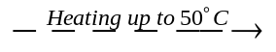 Phase IV (Monoclinic with space group is P21/A)
Phase IV (Monoclinic DPC) 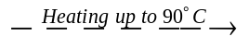 Phase III (Tetragonal with space group is P4/NNC)

Phase III (Tetragonal DPC) 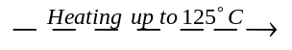Phase II (Orthorhombic with space group is PMNA)
Phase II (Orthorhombic DPC) 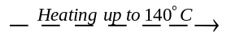 Phase I (Amorphous DPC)

So the effect of heat treatment on DPC is cyclic, i.e., starts with amorphous state and ends with amorphous state. Successive reheat treatment of DPC for several times, repeat the same phase transition cycle and always ends with amorphous state whatever the number of heating cycles passed. To check a behavior like that, an X-ray diffraction pattern for DPC after first heat treatment cycle has been performed, Fig. 11 A and after second heat treatment cycle Fig. 11 B. Both of these two x-ray diffraction pattern indicate amorphous structure for the starting phase and final phase whatever the number of heating cycles passed. Such behavior is summarized in Fig. 10.
References
[1] M. Hassanein, M.F.R. Fouda and R.S. Amin, Thermochimica Acta, 132 (1988) 265-273
[2] K. Verma and D.P. Singh. Current microbiol. 30(6) (1995) 373-379.
[3] S.M. Prasad, J.B. Singh, L.C. Rai and H.D. Kumar, FEMS Microbiol. Lett.Fed.Eur.Microbiol.Soc. 82(1) (1991) 95-100.
[4] A. Melies, J.A. Nemson and M.A. Hanison. Biochim.Biophys, Acta 1100(3) (1992) 312.
[5] D.S. Sundari and A.S. Raghavendra. Photosynthesis Res. 23(1) (1990) 95-99.
[6] U. Mishra, A.K. Kashyap and J. Pande, Environ Technol. 14(4) (1993) 373-378.
[7] C.J. De Ranter, N.M. Blaton, O.M. Peeters, Acta Cryst. B 35(5) (1979) 1295.
[8] F. El-Kabbany, S. Taha, F.M. Mansey, A. Shehap, M. Yousef J.Phys. Chem. Solids 58 (1997) 449.
[9] F. El-Kabbany, S. Taha, A. Shehap, M.M. El-Naggar J. Phys. Chem. Solids, 59(1998) 1614.
[10] F.El-Kabbany, Y.Badr, M.Tosson., Physica. Stat. Solidi, A 63 (1981) 699.
[11] F. El-Kabbany, S. Taha, F.M. Mansey, A. Shehap., Infrared Phys. Technol. 38 (1997) 169.
Reference to a book:
[12] P. Papon, J. Leblond, P.H.E. Meijer, The physics of phase transitions
(2002) Springer-Verlag Berlin Heidelberg, Germany.
[13] J. Bernstein, Polymorphism in Molecular Crystals 2002 Printed by
Oxford university Press.Great Britain.

Figures
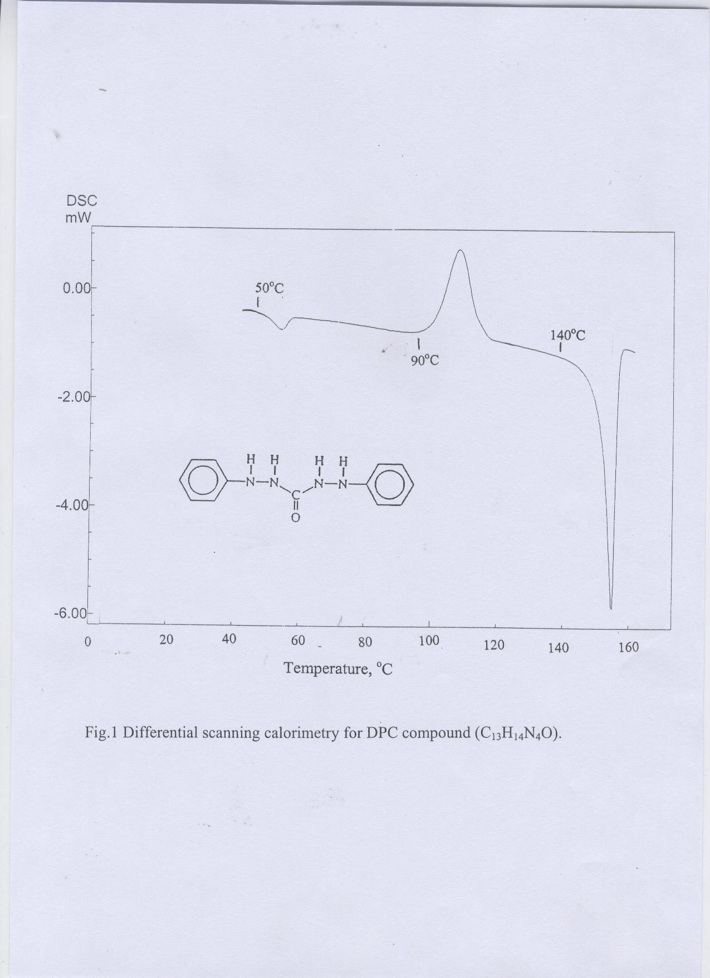
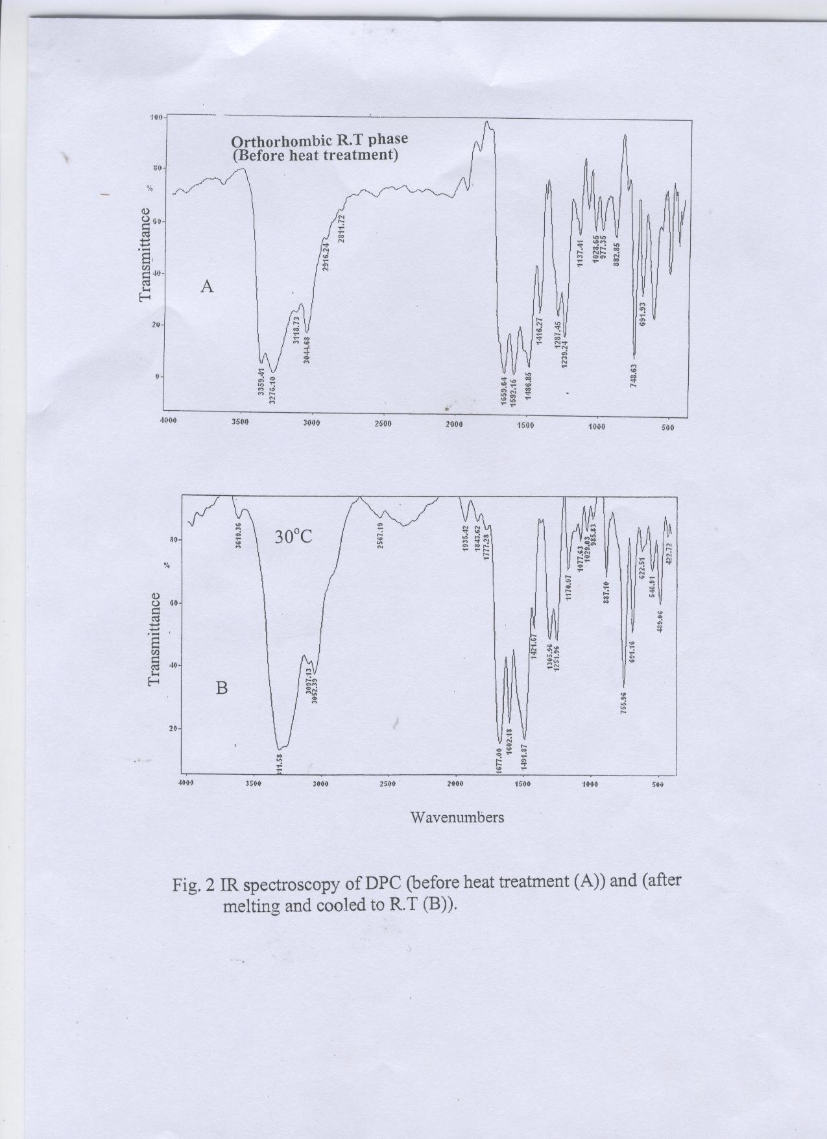
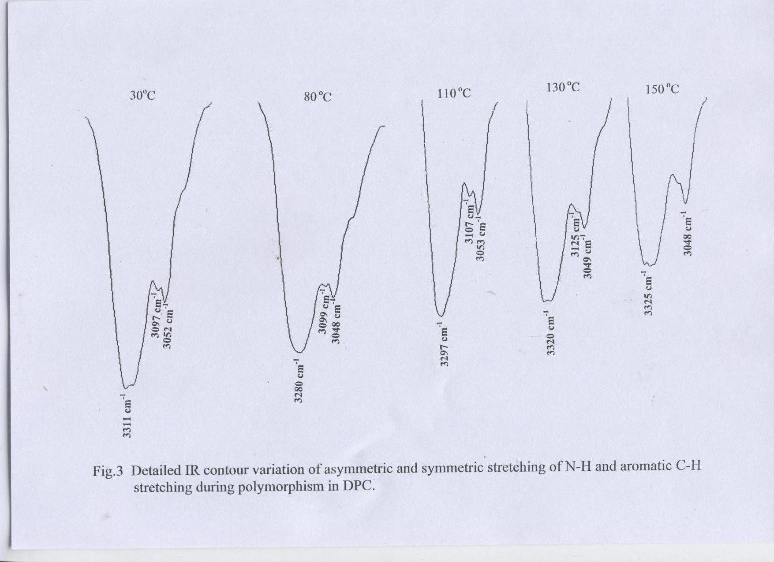
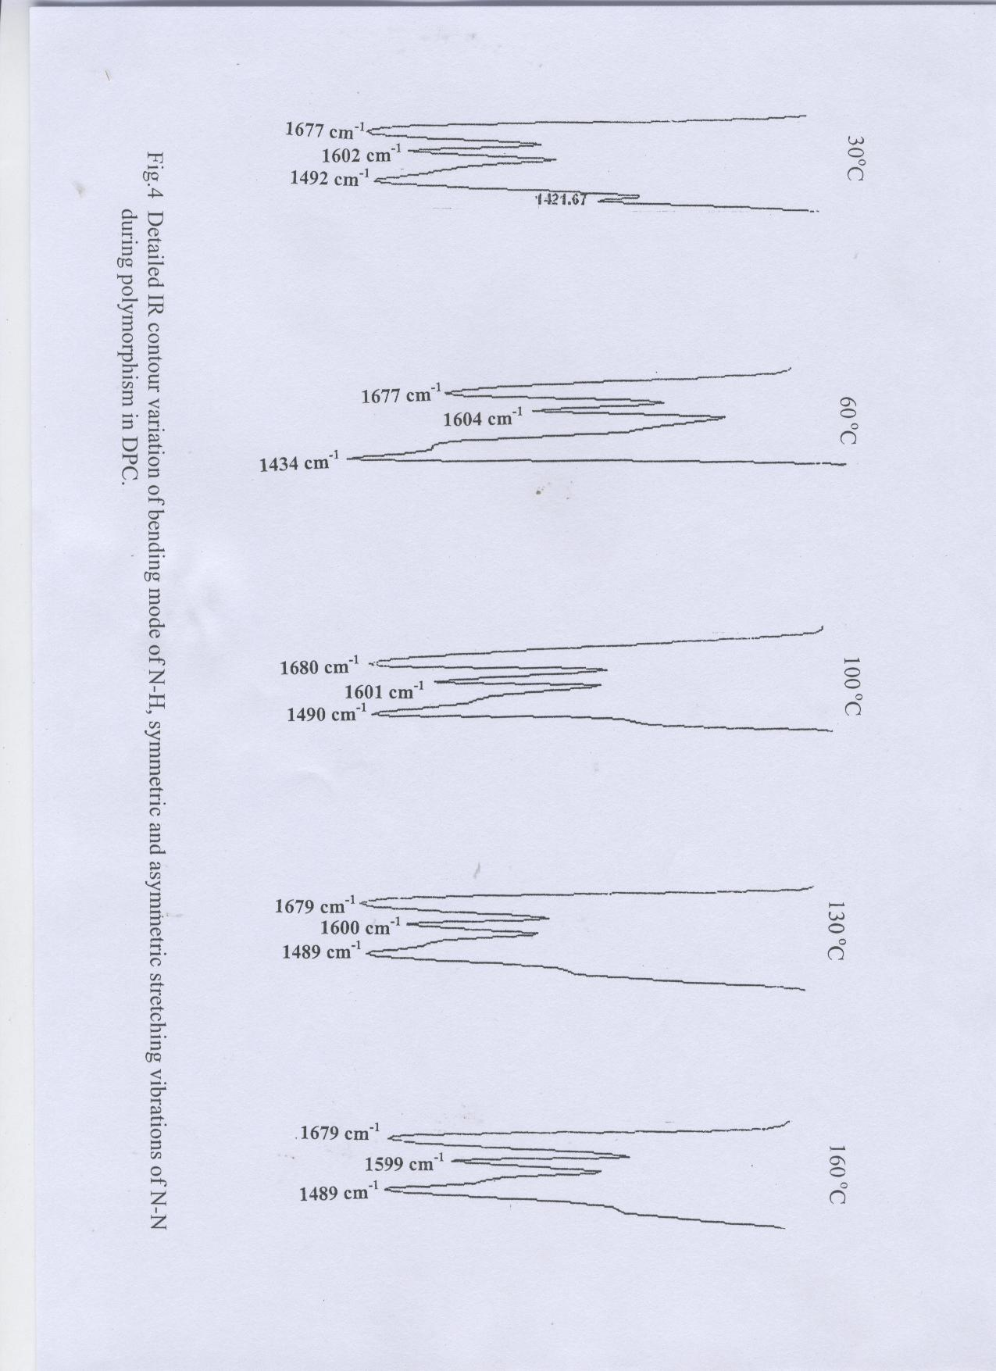
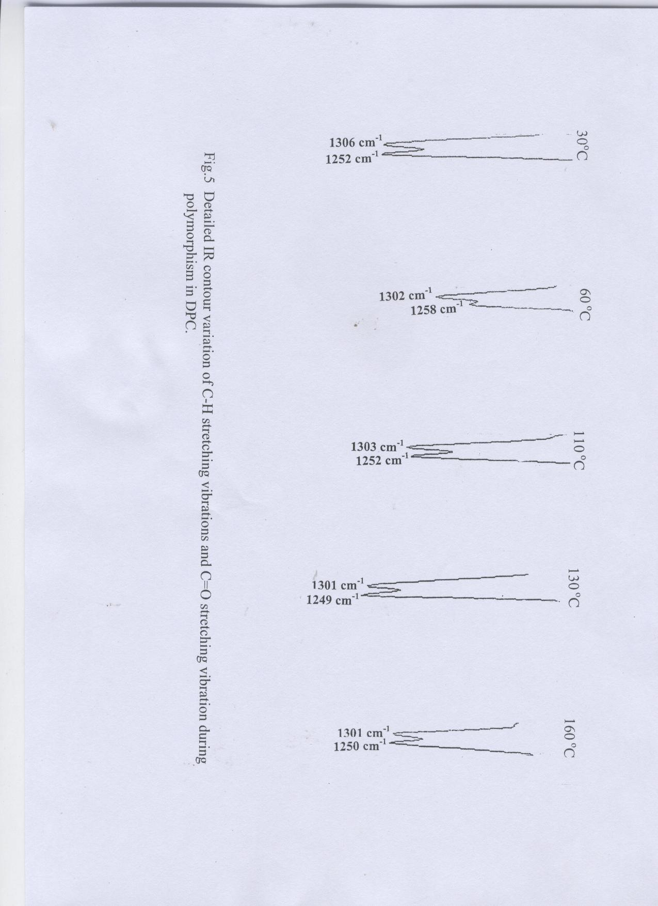
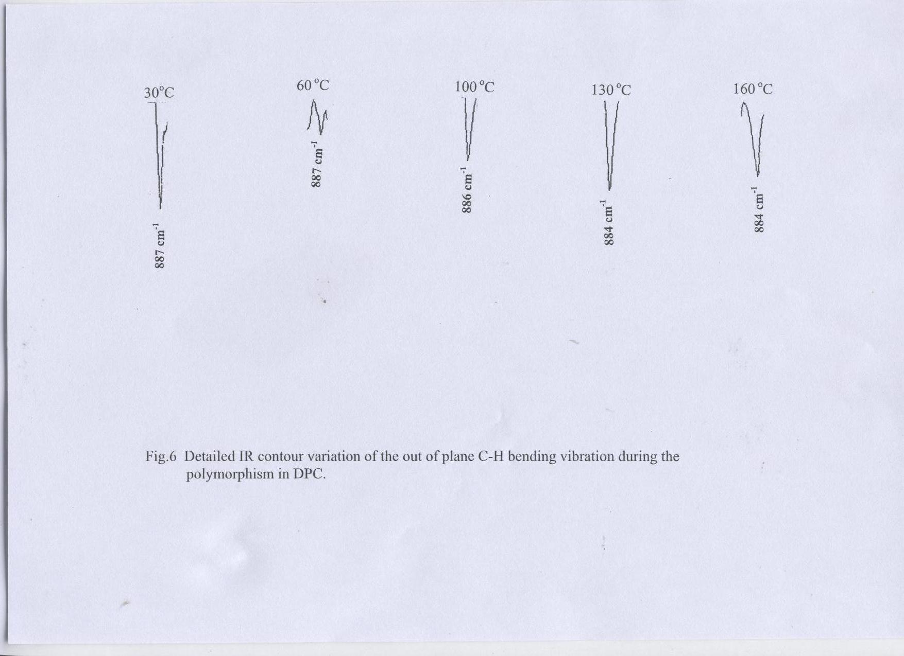

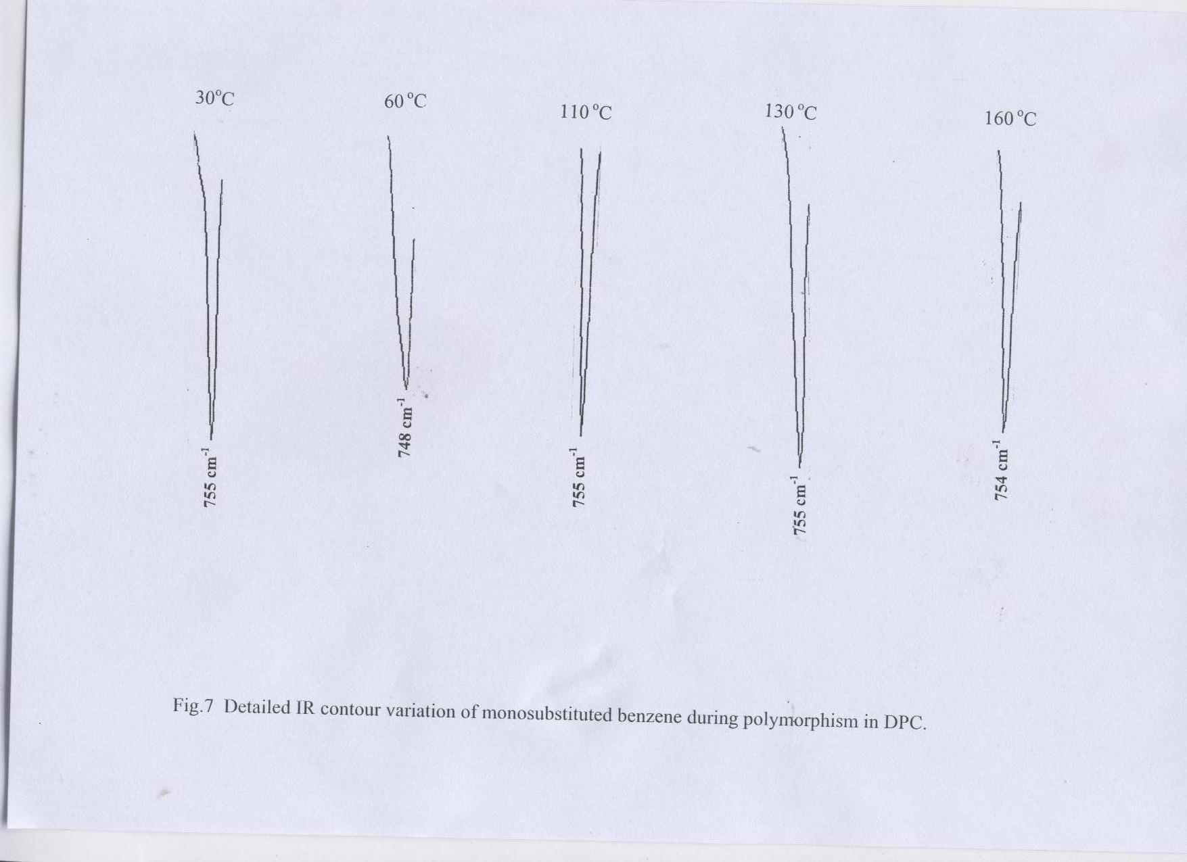
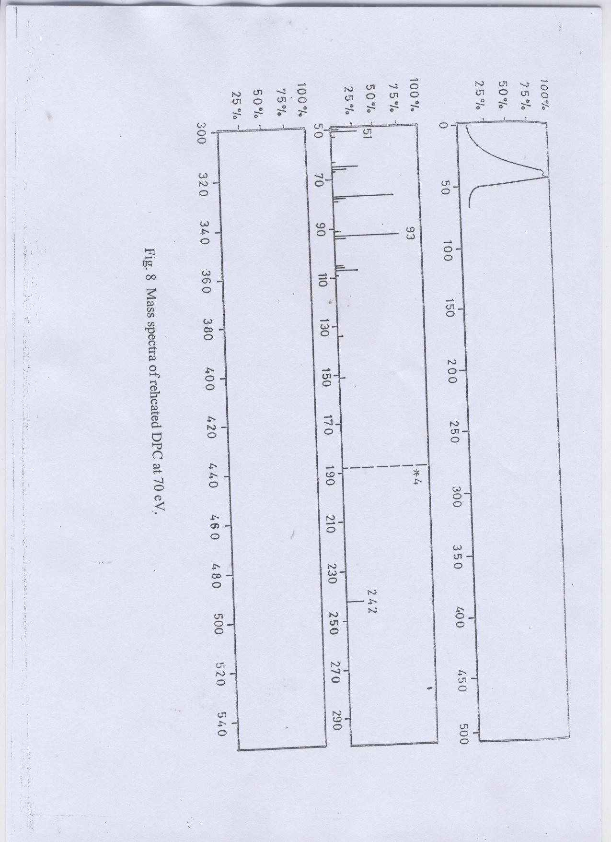
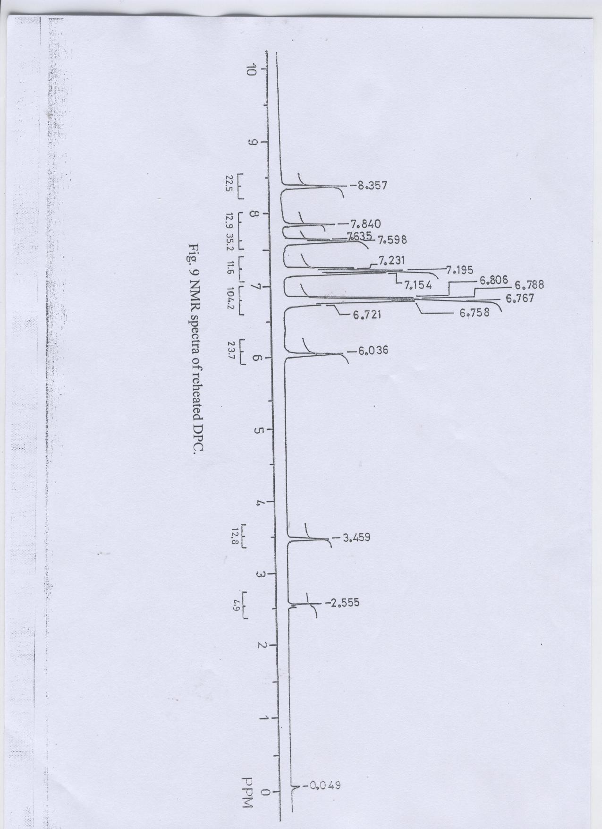
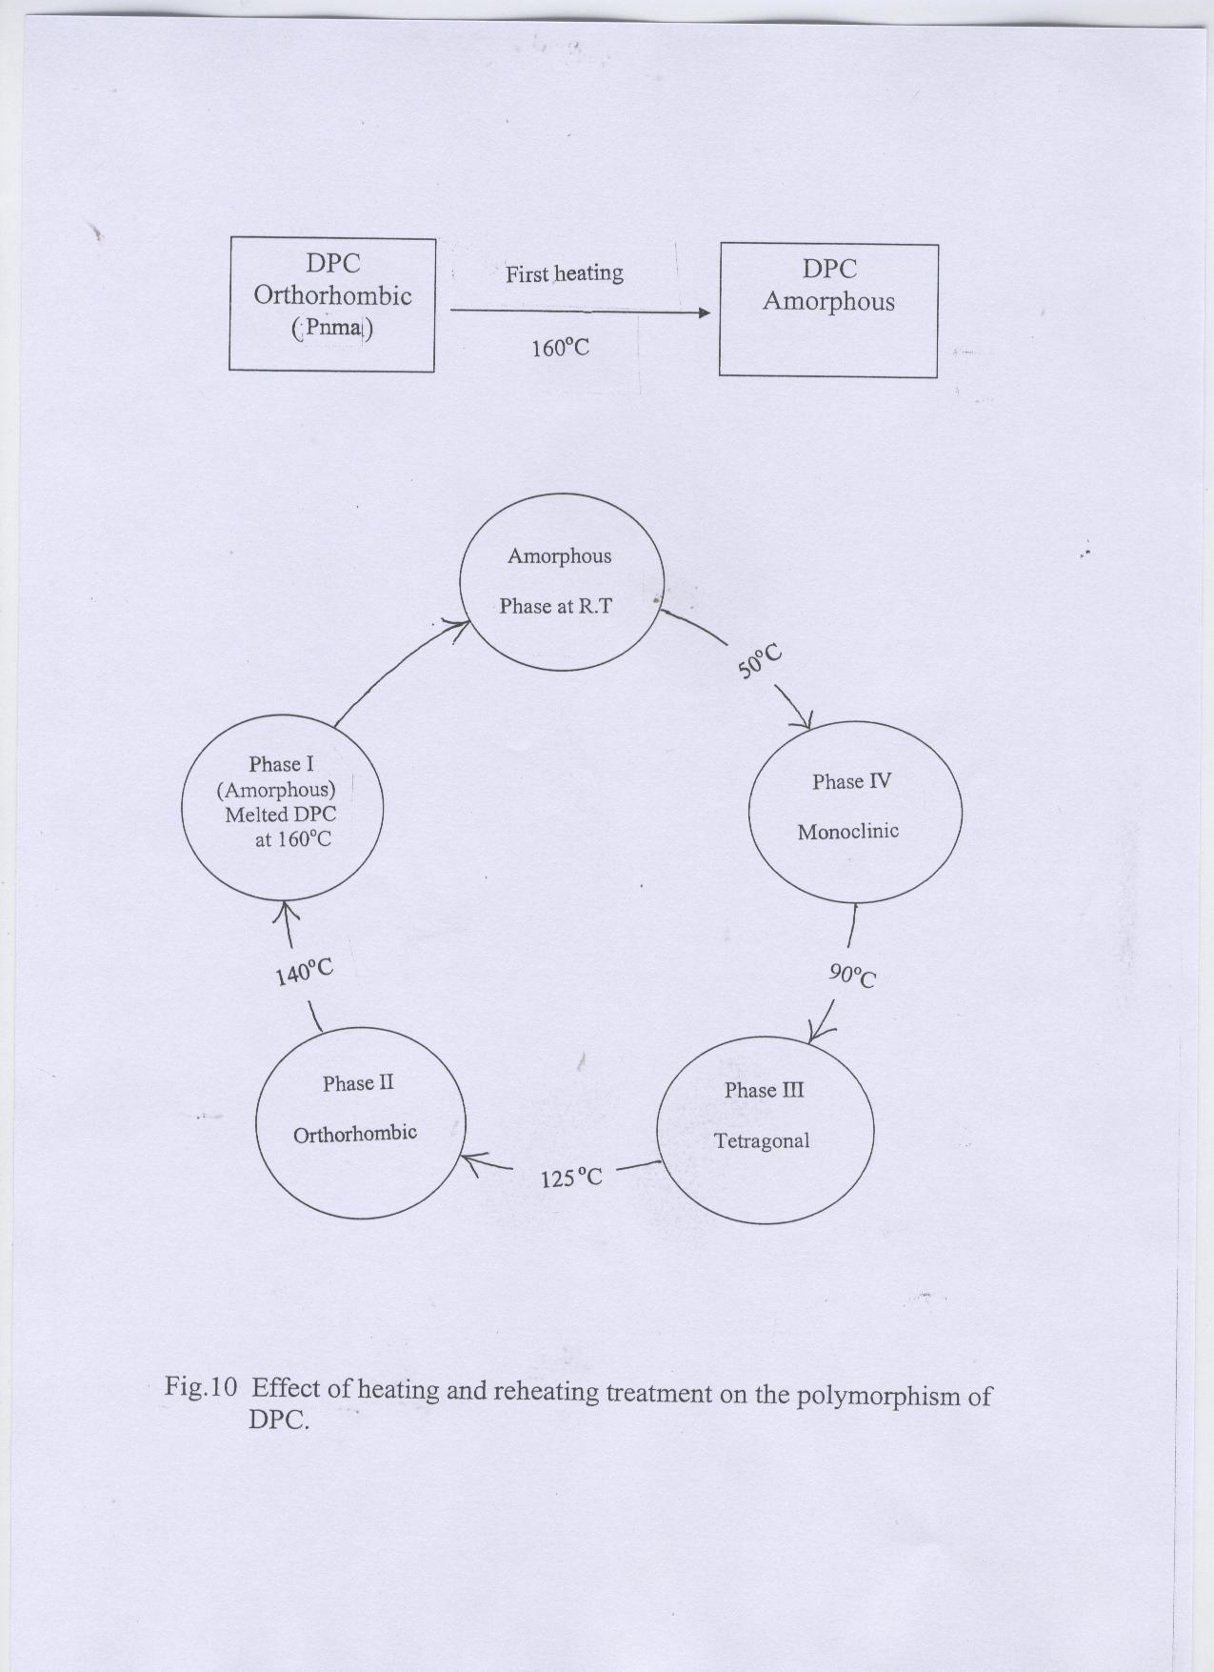
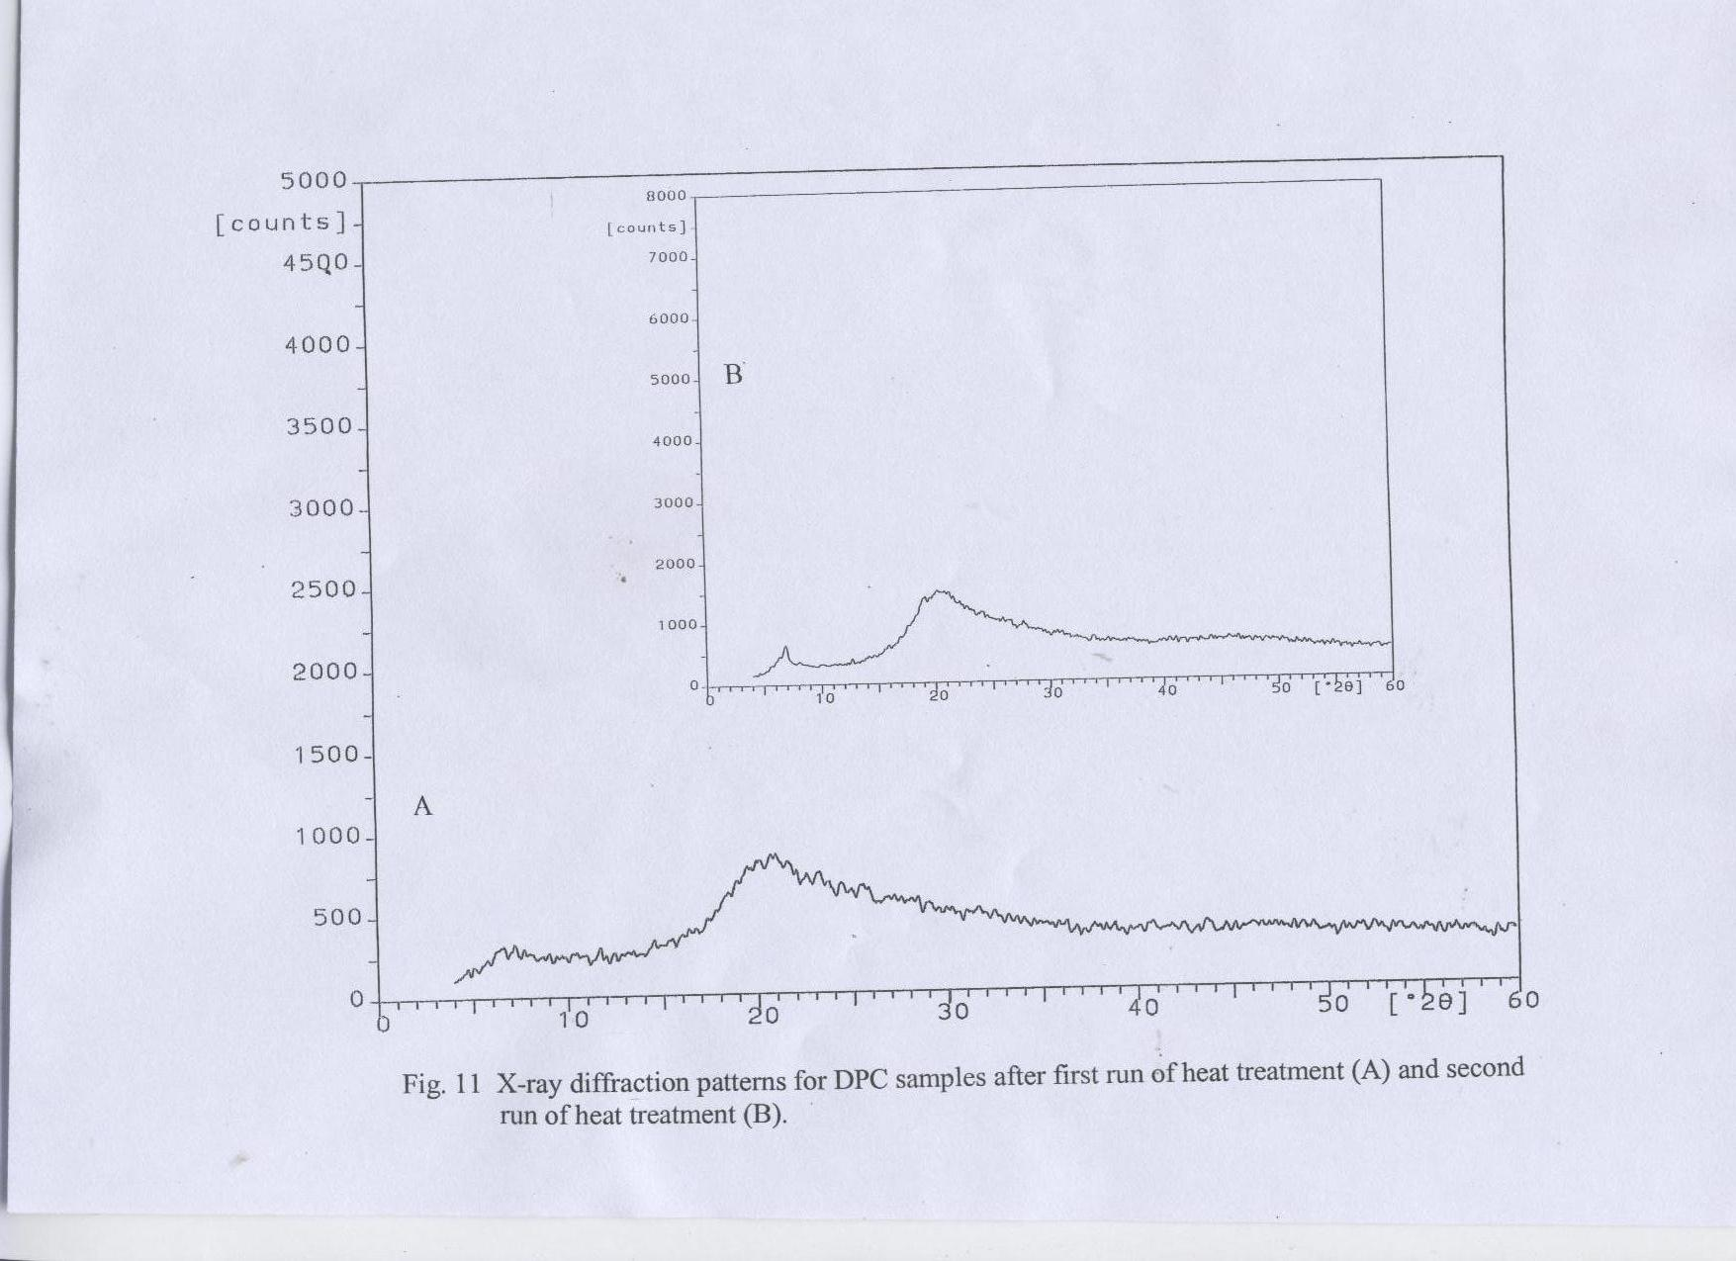

Tables
Table (1) Ionic fundamental vibrations of DPC compound before and
after melting.

Amorphous DPC at R.T | Orthorhombic DPC at R.T | Normal vibrations of DPC due to ionic fundamentals
3311  3097  1677  3052  887  1602  1492  1306  1252  756 | 3359  3118  1659  3044  882  1592  1486  1287  1239  748 | Asymmetric stretching of N-H  Symmetric stretching of N-H  Bending or deformation mode of N-H  Aromatic C-H stretching  Out of plane C-H Bending  N-N stretching symmetric vibrations  N-N stretching asymmetric vibrations  C-H stretching vibrations  C=O stretching vibrations  Monosubstituted benzene


