Algae of soil surface layer of Wadi Al-Hitan protective area (world heritage site), El-Fayum depression, Egypt

By Mansour, H.A and Shaaban, A.S

Botany Department, Faculty of Science, Ain Shams University, Abassia Cairo, Egypt.

dr_mona_zaki@yahoo.co.uk
Abstract
Four artificial solid and liquid media were recommended for cultivation, isolation and purification of algae from the soil surface layer of Wadi Al-Hitan protective area, El-Fayum depression, Egypt. Some selective physical and chemical properties of soil were also determined. These analyses indicated that this soil had sandy texture, alkaline pH, relatively high nitrogen and electeric conductivety, with low phosphorus content (which mainly charcterized the desert, saline and arid soil).Total 35 soil algal taxa were identified. These related to 3 algal divisions which dominated with cyanophycophyta (represented by 30 taxa from 15 genera), followed by Chlorophycophyta, (represented by 3 taxa from 3 genera), and Xanthophycophyta, (each by 2 taxa from 2 genera). Most of the recorded cyanophytes were xeric and found in filamentous and in heterocystous forms which correlated with the relatively high nitrogen content in this arid soil. While green algae were showed in coccal forms. Myer's and modified Chu's No.10 media were relatively the most productive algal media and they were also characterized with high cyanophytes members . While Beijernicks medium was characterized with chlorophytes. These associated with no growth for xanthophytes in Myer's and modified Chu's No.10 media. This study concluded that, pH and E.C were the most physic-chemical controlling and selective factors, which effect on the availability of several soil nutrients and in turn on the biodiversity of soil algae in the studied region. Eco-phycological analysis of the idenified algae isolated from the regarded desert arid soil was indicated that, most of the recorded algae were mainly related to xeric cyanophytes belonging to Nostoc, Anabeana, Cylindrospermum, Calothrix, Camptylonema, and Scytonema algal genera.
Keywords: soil algae; soil algae of arid and semiarid regions; edaphic factors ; Wadi Al-Hitan protective area ; El-Fayum depression; Egypt.
Introduction
Althogh in the natural world, they are important foundations of terrestrial ecosystems but the knowledge of terrestrial algae is still far from being complete. The importance of the biodiversity and abundance of terrestrial algae, particularly from urban habitats have gradually appeared in the last few decades (Mike, 1982). Wherever there is soil there are algae on or near the surface, since soil prokaryotic and eukaryotic algae are dominant in a broad spectrum of terrestrial habitat and able to colonize almost all of the biotopes on earth (Friedmann and Ocampo-Friedmann,1984 and Lukes¡ová, 2001). Rahmonov and Piatek, (2007 ) stated that, the degree of algael distribution on the ground and in the soil profile varies as a result, the role of algae at particular stages of soil development and in different soils is differentiated. soil algae are well-known to play an important ecological role in terrestrial ecosystems as colonizers of soils that have become bare (DeWinder,1990 ; Belnap and Gardner,1993; Johansen and Shubert, 2001;
Corresponding Author: Mansour, H.A. Botany Department, Faculty of Science, Ain Shams University, Abassia Cairo, Egypt.
Lukes¡ová, 2001and Chun-Xiang and Yong-Ding, 2003). The most obvious and significant role of algae in the aried , semiarid soils is in desertification control , primary humus formation and in stabilization of unconsolidated sand (Dor and Danin,2001 ; Chun-Xiang, et al., 2002 and Zhao et al., 2009 ).
Literature data on the soil algal flora of Wadi Al-Hitan in Egypt is completely lacking. In order to fill this gap in knowledge, the present work initiated to investigate the algal biodiversity of the surface soil layer of this desert protective area.
Matrilals and Methods
I.Study area

Wadi Al-Hitan (Whale Valley) is the most important international site in the world, and in 2005 it located within the protected area and was designated as a world heritage sit in recognition of the 40 million year old whale skeletons found here. It represents an outstanding record of middle to late Eocene life and geological evolution. Wadi Al-Hitan provides evidences of millions of years of coastal marine life particularly the evolution of the whales. It is in an area over 10 km long there has been found an unusually large concentration of over 400 fossil skeletons of archaic whales and other vertebrates. Since the fossils of different periods lie at different levels they are valuable indicators of palaeogeologic and palaeoecologic conditions, Eocene life, and the evolution of marine mammals (Uhen, 2004).

Wadi Al-Hitan located at 29° 15’ 13'' to 29° 23’ 56''N by 30° 00’ 41'' to 30° 10’ 06 E in the Western desert 150 km southwest of Cairo and 80 km west of Faiyum and it is included as a special protected area within the Wadi El-Rayan protective area (Map 1). The climate is typically Saharan, hot and dry in summer and mild with scanty rain in winter. The mean winter temperature is 13.7 degrees °C with an absolute minimum of –1.2°C; the mean summer temperature is 28.5°C with an absolute maximum of 48.4°C; the average diurnal range is 15.6°C. Wadi Al-Hitan is extremely barren and was probably always rather abandoned in historical times. There is very little vegetation and no-one lives on the site, but Wadi el-Rayan 40 km away has a few thousand settled and temporary farmers and fishermen (Dolson et al., 2002).
II. Treatment of soil
- Soil sampling
Soil samples of Wadi-El -Hitan were randomly collected at 27 /4/2009 from seven localities in clean and sterilized air-tight polyethylene pags. Soil samples were collected from the soil surface down to a depth of about 17 cm (Gollerbach and Shtina, 1969). In a certain amounts from each locality, soil samples were mixed together to form one processed sample which was analyzed for different chemical and physical characteristics of soil as well as the culturing, isolation, identification and then purification of algae.

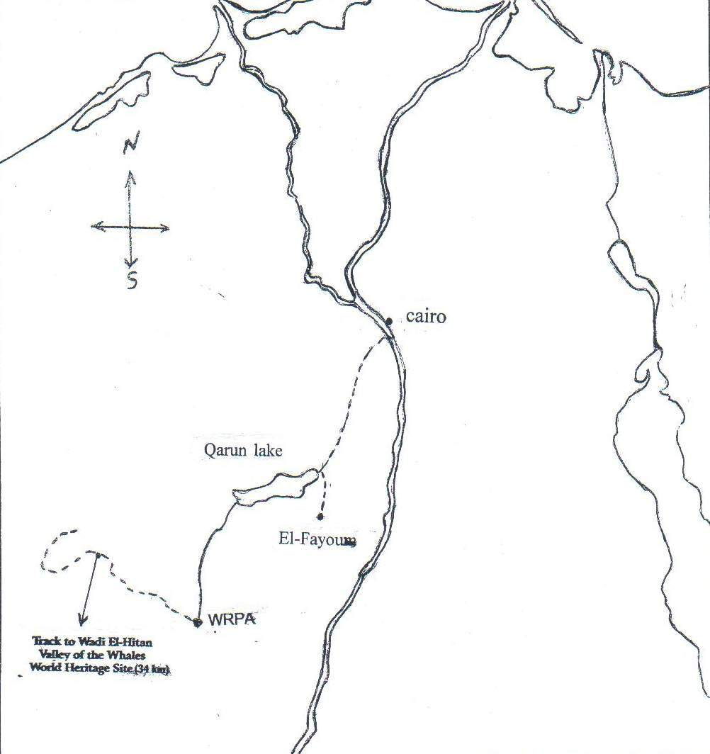
Map (1) indicating the investigated region of Wadi Al-Hitan protective area (1: 100000km)
WRPA = Wadi El-Rayan protective area
- Soil analysis
One kg from the produced soil sample was analyzed for determination of soil texture with the hydrometer method (Brouach and Barthokur, 1997), providing quantitative data on the percentage of sand, silt and clay. The soil samples (soil : water = 1: 2.5) were analyzed with respect to their EC (Electrical Conductivity) and pH range following the methodology outlined by Black,1992. Available phosphorus, nitrogen, organic matter % and micronutrients were determined according to Richard et al., (1954). While silica content was estimated according to Tan .(1996).
III. Culturing, isolation and identification of algal taxa
Culturing studies are essential for isolation, purification and correct identification of soil algae (Round, 1984). In this study, four artificial (solid and liquid) media were recommended for cultivation and isolation of algae from Wadi Al-Hitan soil sample. These were Allen's, (Allen, 1968); Myer's media (Venkataraman, 1969) and Beijernicks & modified Chu's No.10 (Stein, 1979). Under aseptic conditions , liquid media in 250 Erlen Myer's flasks (one gm of the investigated soil was inoculated in 50 ml of sterilized liquid media) , and solid media in 10 cm diameter Petri-dishes were used. For solid media , about 20 gm of agar-agar were added to one liter of each previously recommended , sterilized liquid media. Constant volume was poured in 10 cm diameter Petri-dishes and lifted to solidify. Dissolve 1 gm of soil in 99 ml of sterilized distilled water, then spread one ml from this solution on the surface of the previously solidified and sterilized solid media. The inoculated flasks and Petri-dishes were incubated at 25 ⁰C under continuous light intensity of 4000 lux conditions. For each soil inoculum, the solid and liquid media were used in triplicates and under aseptic conditions. Uni- algal cultures were produced using plating and serial dilution procedures recommended by Jurgensen and Davey, (1968). These supported by microphotographs for each produced and identified common uni-algal species.
The identifications of algal taxa were principally accomplished using one fifty, Reichert binocular research microscope, after mounting the micro algal mass on the microscopic slide and covering them with a thin cover slip, for characterization of the soil algal species up to morphological level. Most of the microscopic characters of prominence specimens were taken into consideration and they were identified according to the systematics works of : Gollerbakh et al., (1953); Kiselov et al. (1953); Korsanov et al., (1953); Dedesenko et al., (1959); Desikachary, (1959); Philipose, (1967) and Komarenko and Vasileva, (1975 and 1978).
Results
Physico-chemical analysis of soil
According to the physical analysis of soil (Table 1), the investigated soil of Wadi Al-Hitan showed sandy texture (92.32% sand), with alkaline pH (8.5) and realtively high electric conductivety (3 m.mohs|cm). Furthermore, chemical soil analysis indicated that, the studied soil had Calcium-Sodium cationic and Sulphate-Chloried anionic structures, with low organic matter, phpsphorous contents and relatively high nitrogen and iron ones (Table 1).

Table 1.Soil physico-chemical characters of Wadi Al-Hitan region.
Parameters | Values
Mechanical analysis % | SAND | 92.32
 | silt | 4
 | clay | 3.68
Texture |  | Sandy
Soil reaction (pH) |  | 8.5
Electerica conductivety (E.C m.mohs/cm) |  | 3
Soluble cations (meq./l) | Ca⁺⁺ | 464
 | Mg⁺⁺ | 73
 | Na⁺ | 334
 | K⁺ | 9
Total soluble cations |  | 880
Soluble anions (meq./l) | CO₃⁻⁻ | 4
 | HCO₃⁻ | 30.5
 | Cl⁻ | 414
 | SO₄⁻⁻ | 431.5
Total soluble anions |  | 880
Calcium carbonate % |  | 4
Organic matters % |  | 0.34
Available macronutrients (ppm) | Nitrogen | 854
 | Phosphorus | 10.4
Available micronutrients (ppm) | Fe | 4.3
 | Cu | 0.4
 | Zn | 0.1
 | Mn | 0.5

Soil algal flora of Wadi Al-Hitan
Algal growth appeared after two weeks from the start of incubation period.Total 35 soil algal taxa were isolated and identified from the concerned soil (Table 2). These related to 3 algal divisions which dominated with Cyanophycophyta (30 blue-green algal taxa from 15 genera), followed by Chlorophycophyta, (3 green algal taxa from 3 genera) and Xanthophycophyta, (2 yellow green algal taxa from 2 genera). In the material examined, most of the recorded cyanophytes were found in filamentous and in heterocystous forms (nitrogen fixing blue-green algae). While green algae were showed in coccal forms.
Table 2. Recorded soil algal flora of Wadi Al-Hitan region.
Algal taxa | Used nutritive media |  |  |  | Microphotographs
 | Allen | Bej | Chus no. 10 | Myers
Cyanophyta |  |  |  |  | Plate | Figer
Synechococcus elongatus Nag. | + | - | + | - | I | A
Siphonema polonicum Geitl | - | + | - | + |  | B
Amorphonostoc paludosum Kossinsk | + | - | - | + |  | D
Amorphonostoc paludosum f.longius Kossinsk | + |  | + | + |  | C
Amorphonostoc punctiforme (Kutz.) Elenk | - | - | - | + |  | E
Nematonostoc flagelliforme (Berk et Curt.) Elenk | - | - | + | - | II | A & B
Sphaeronostoc. microscopicum (Carm.) Elenk | - | - | + | - |  | C
Stratonostoc commune (Vauch) Elenk. | - | - | - | + |  | D
Stratonostoc linckia f. calcicola (Breb.) Elenk | + | + | + | + |  | E
Stratonostoc linckia f.minutum (Desmaz.) Elenk | + |  | + | + |  | F
Stratonostoc linckia f. spongiaeforme (Ag.) Kutz. | - | - | - | + | III | A
Anabeana hallensis (Janez.) Born. et Flah. | + | - | - | - |  | B
Anabeana knipowitschii Ussatsch | - | - | - | + |  | C
Anabeana macrospora Kleb | - | - | - | + |  | D
Anabeana oscillarioides Bory | + | - | + | + |  | E
Anabeana spiroides Kleb. | - | - | + | + |  | F
Anabeana thermalis f. rotundospora Aptek. | - | - | + | - | IV | A
Anabeana variabilies f. rotundospora Hollerb | + | - | - | + |  | B
Cylindrospermum alatosporum F.E.Fritsch | - | - | + | + |  | C & D
Cylindrospermum catenatum Ralfs | - | - | - | + |  | E & F
Scytonema drilosphon (Kutz.) Elenk.et V.Poljansk | + | - | - | - | V | A
Plectonema gracilllinum (Zopf) Hansgirg | - | - | + | + |  | B
Calothrix elenkinii Kossinsk | + | - | - | + |  | C
Calothrix marchica Lemm. | - | - | + | - |  | D
Camptylonema danilovii Hollerb |  |  | + | + |  | E
Symploca muralis var. minor Grander (Kutz) ex Gemont | - | - | - | + |  | F
Symploca muscorum (Ag.) Gom. | - | - | + | - | VI | A & B
Lyngbya lutea (Ag.) Gom | - | - | - | + |  | C
Schizothrix lutea Fremy | - | - | - | + |  | D
Schizothrix tinctoria (Ag.) Gom. |  |  | + |  |  | E
Total | 10 | 2 | 15 | 21
Xanthophyta
Chlorocloster raphidoides | + | + | - | - | VII | C
Botrydiopsis eriensis Snow | + | - | - | - |  | A & B
Total | 2 | 1 | 0 | 0
Chlorophyta
Chlorococcum humicolo (Nag.) Raben. | + | + | - | + | VII | D
Chlamydomonas atactogama Korsch | + | + | + | + |  | E
Scenedesmus quadricauda var. eualternans Proschk | - | + | - | - |  | F
Total | 2 | 3 | 1 | 2

On the level of media used , Myer's and modified Chu's No.10 media were relatively the most productive algal media (represented by totally 23 and 16 taxa respectively), followed by Allen's (total 14 taxa) and Beijernicks (total 6 taxa) media. The results also revealed that Myer's and modified Chu's No.10 media were characterized with high cyanophytes members (21 and 15 blue green algal taxa) respectively.While Beijernicks medium was characterized with chlorophytes (3 green algal taxa). These associated with no growth for xanthophytes in Myer's and modified Chu's No.10 media.
The most common soil algal genera and species present along different media and through all over the studied region were, Stratonostoc linckia f. calcicola (Breb.) Elenk and Chlamydomonas atactogama.
The investigated soil algal list also recorded rare algal genera and species as Anabeana hallensis (Janez.) Born. et Flah. ; Scytonema drilosphon (Kutz.) Elenk.et V.Poljansk ; Botrydiopsis eriensis Snow (only recorded in Allen's medium) - Scenedesmus quadricauda var. eualternans Proschk (only showed in Beijernicks medium) - Nematonostoc flagelliforme (Berk et Curt.) Elenk ; Sphaeronostoc. microscopicum (Carm.) Elenk ; Anabeana thermalis f. rotundospora Aptek ; Calothrix marchica Lemm.; Symploca muscorum (Ag.) Gom. ; and Schizothrix tinctoria (Ag.) Gom. (only characterized Chu's No.10 medium) - and Amorphonostoc punctiforme (Kutz.) Elenk ; Stratonostoc commune (Vauch) Elenk. ; Stratonostoc linckia f. spongiaeforme (Ag.) Kutz. ; Anabeana knipowitschii Ussatsch ; Anabeana macrospora Kleb; Cylindrospermum catenatum Ralfs ; Symploca muralis var. minor Grander (Kutz) ex Gemont ; Lyngbya lutea (Ag.) Gom and Schizothrix lutea Fremy (recorded only in Myer's medium).

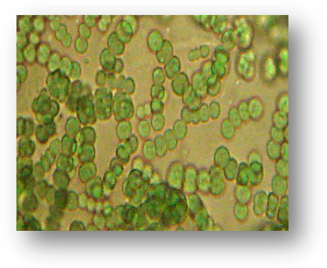
- (B)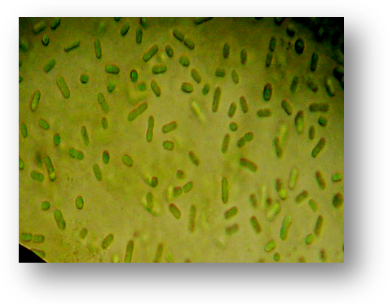
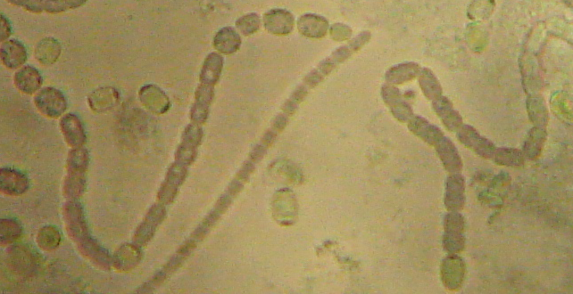
(C )
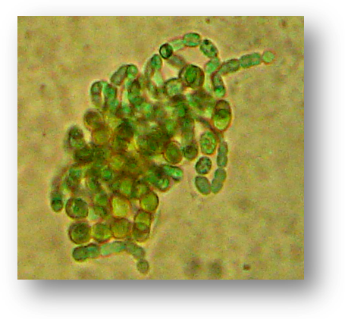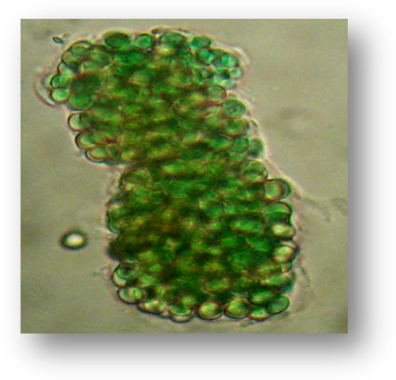
( D ) (E)
Plate I
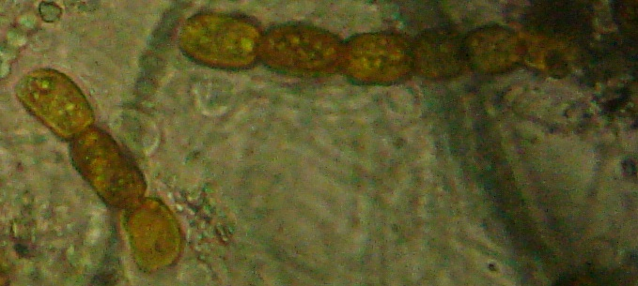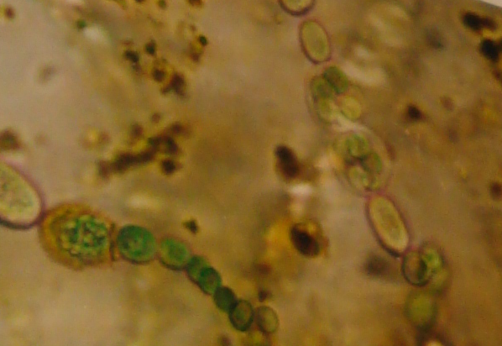
(A) Mature stage (B) Late mature stage
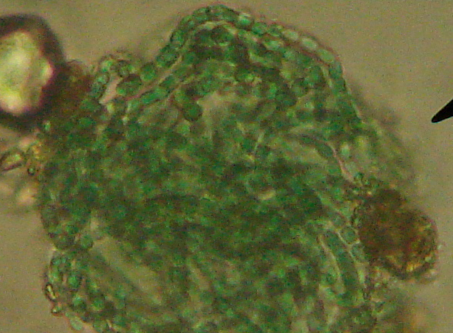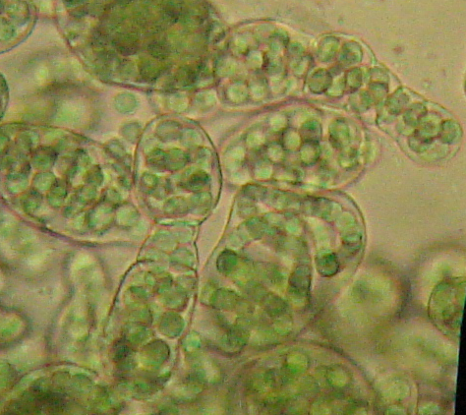
( C ) (D)
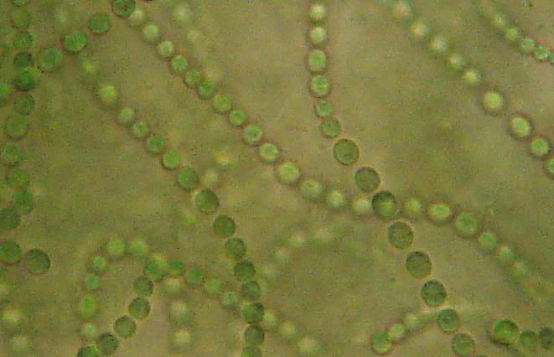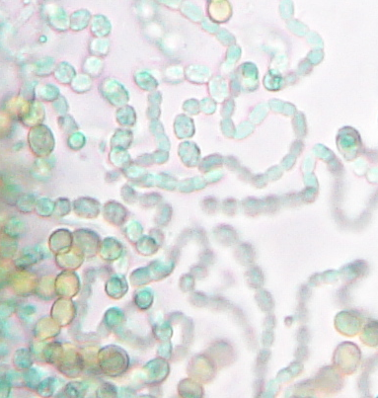
(E) (F)

Plate II

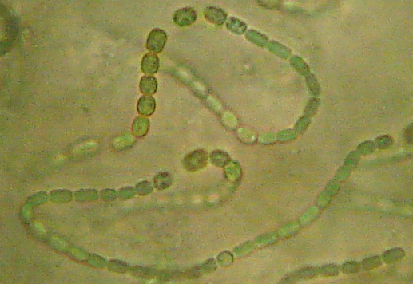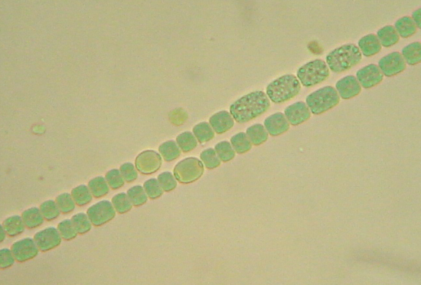
- (B)
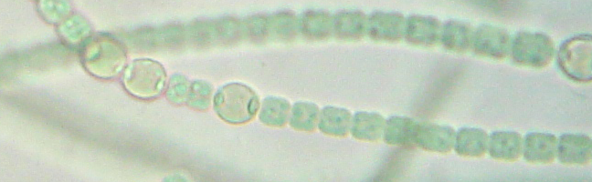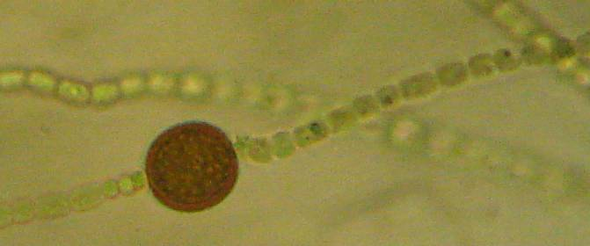
( C) (D)
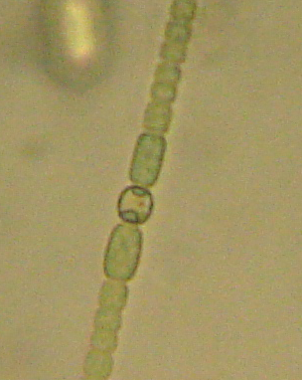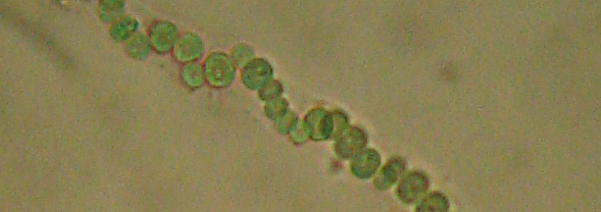
(E) (F)

Plate III

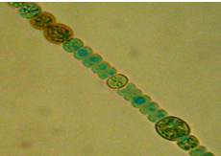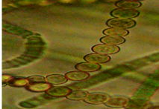
- (B)
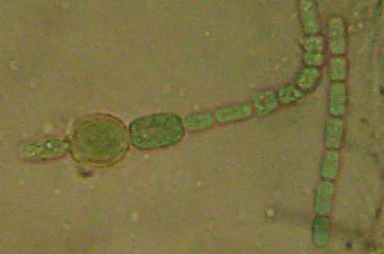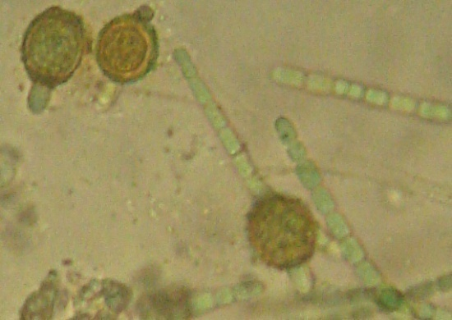
( C) Mature stage (D) Late mature stage

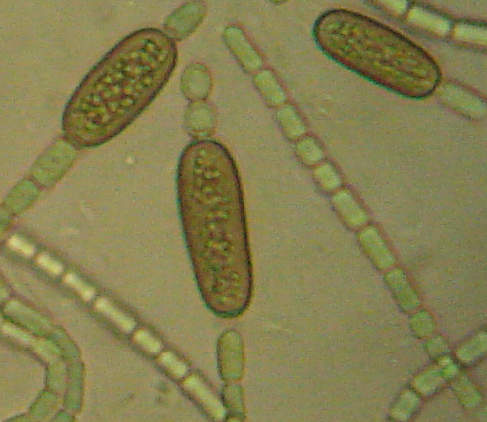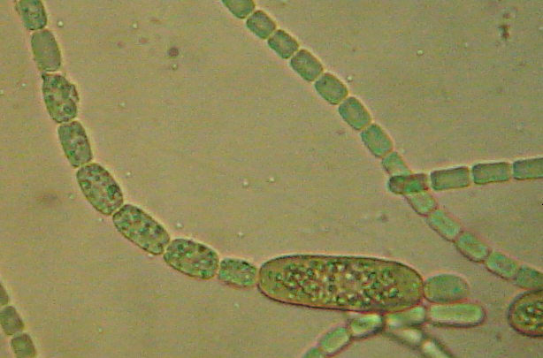
(E) (F) With chain of spores

Plate IV

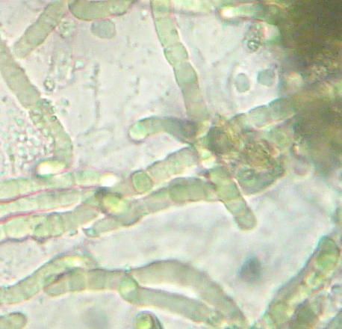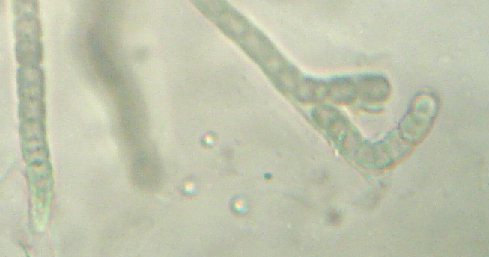
- (B)
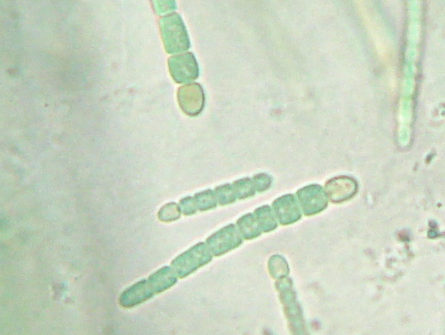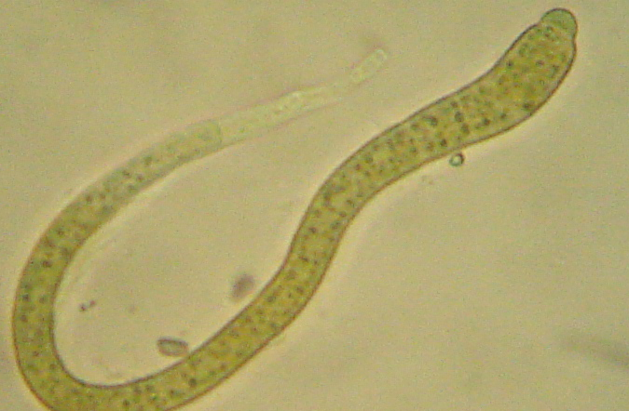
(C ) (D)
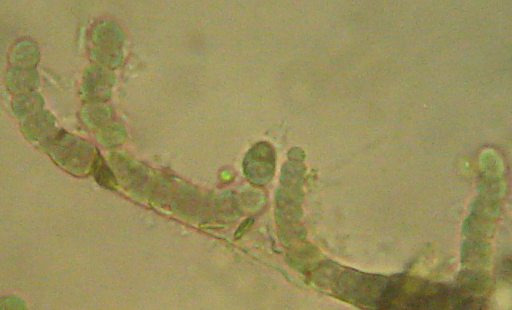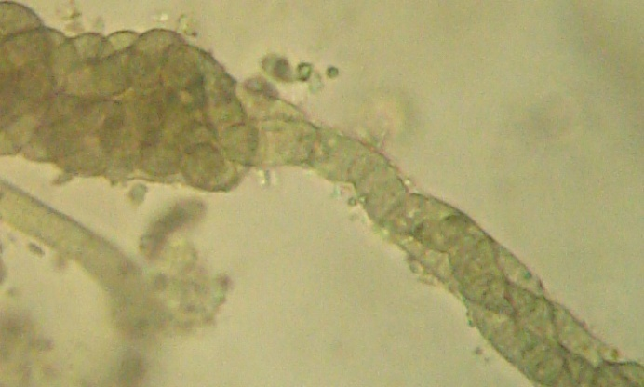
(E) ( F)

Plate V

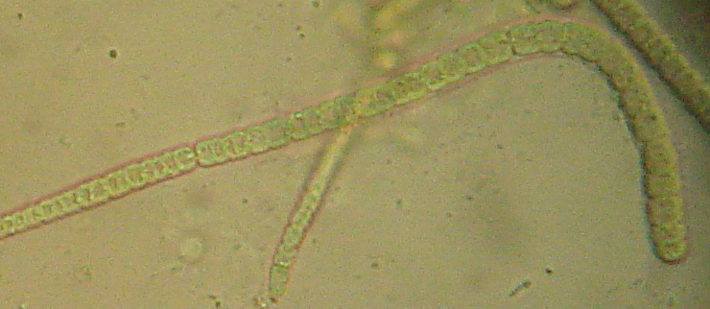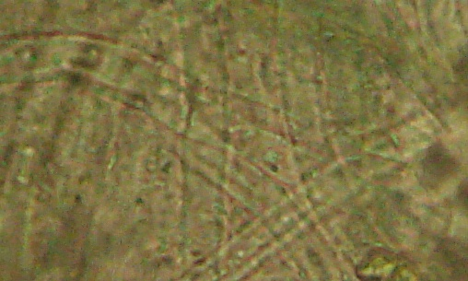
- Trichome out sheath (B) Empty sheaths
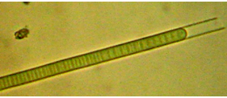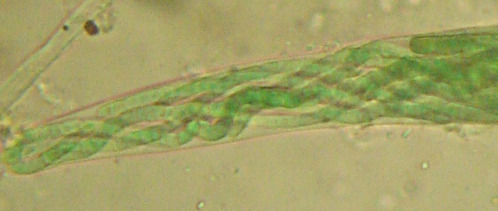
( C) (D)
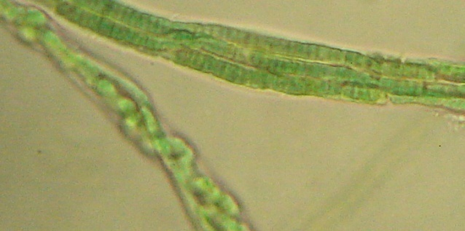
(E)
Plate VI

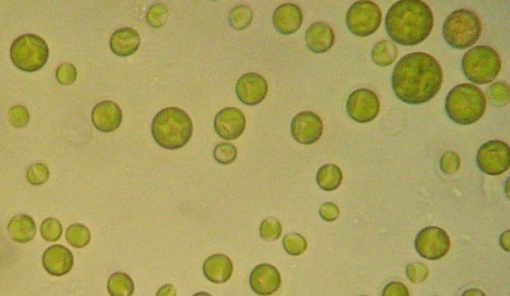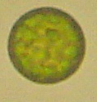
(A) (B) 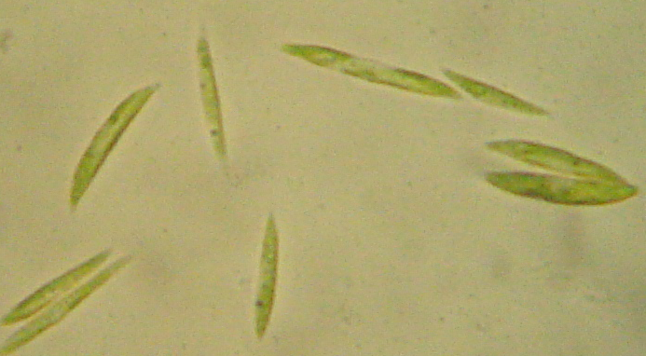 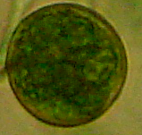
(C ) (D)
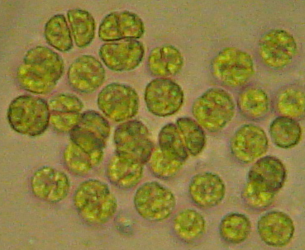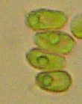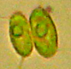
(E) (F)
Plate VII

Discussion
Shields & Durrell, (1964) suggest soil algae as a first stage of succession on substrates poor in nutrients.This applies even more to arid and semiarid regions, since nitrogen-fixing bacteria here are rarer than in other climates (Loftis and Kurtz ,1980). Physico-chemical analyses of Wadi Al-Hitan soil indicated that this soil had arid character with sandy texture; alkaline pH ; relatively high electric conductivety and nitrogen contents, with deficent in organic matter and other nutrients as phosphorous. These were in agreement with the observation of Oldeman (1994) and Veste et al., (2001).
Manchanda and Kau-shik (1997); Misra et al., (2001) and Verma et al., (2002) stated that , salinity and alkalinity significantly influence the diversity of micro-algae, their number, morphology and activity in the arid and semi-aried soil.
Soil algal flora of Wadi Al-Hitan were found to be composed of 35 taxa belonging to 3 algal divisions. Blue-green algae was the most qualitative dominating division. Manchanda & Kau-shik, (1997) and Potts, (2000) observed that, cyanophytes can be survive adverse condition of arid desert, as long period of desiccation.
Patternn of algal composition that isolated from these arid desert soil was predominantly by filamentous, heterocystous cyanophytes as well as some coccal green taxa. In accord with these Hahn and Kusserow, (1998); Chun-Xiang et,al., 2002 and Nayak et al., (2004) pointed out that these members of blue-green and green algae usually characterized the soil algae of arid and semiarid regions. The relatively high nitrogen content was associated with the occurrence of heterocystous nitrogen fixing forms of blue-green algae. This in agreement with the observation of Hahn and Kusserow, (1998) and Singh et al., (2008).
Eco-phycological analysis of the idenified algae isolated from the regarded desert arid soil was indicated that, most of the recorded algae were mainly related to xeric cyanophytes belonging to Nostoc, Anabeana, Cylindrospermum, Calothrix, Camptylonema, and Scytonema algal genera such as, Stratonostoc commune (Vauch) Elenk, Amorphonostoc palodusum f. longius, Stratonostoc linckia f. calcicola (Breb.) Elenk, Anabeana variabilies f. rotundospora Hollerb, Anabeana thermalis f. rotundospora Aptek. Cylindrospermum alatosporum F.E.Fritsch, Calothrix elenkinii Kossinsk, Camptylonema danilovii Hollerb and Scytonema drilosphon (Kutz.) Elenk.et V.Poljansk.

References
Allen, M.M. (1968). Simple conditions for growth of unicellular blue-green algae on plates. Journal of Phycology, 4: 1– 4.
Belnap, J. and Gardner, J.S. (1993). Soil microstructure in the soil of the Colorado plateau: The role of the cyanobacterium Microcoleus vaginatus. Great Basin Nat. 53, 40–47.
Black, C.A. (1992). Methods of soil analysis Part 1. – American society of Agronomy, USA .
Brouach, T.C. and Barthokur, H.P. (1997). A text book of soil analysis. Vikas Publishing House Ltd. 331 pp.
Chun-Xiang, H.U.; Yong-Ding, I.U.; Delu1, Z.; Zebo, H. and Paulsen, B.S.(2002). Cementing mechanism of algal crusts from desert area. Chinese Science Bulletin , 47 ( 16) , Pp 1361.
Chun-Xiang, H.U. and Yong-Ding,.I.U. (2003). Primary succession of algal community structure in desert soil.Acta Bot.Sinica, 45,8 : 917 – 924.
De Winder, B. (1990). Ecophysiological strategies of drought tolerant phototropic microorganisms in dune soils. Academic Proefschrift, University of Amsterdam, The Netherland., 39 pp.
Dedesenko-Schegolova, N.T. ; Matviaka,A.M. and Schkorbatov,L.A .(1959) .Fresh water algae of USSR. Vol 8 , Chlorophyta "Volvocineae" 231pp.Publ. Acad. Nauk, USSR, Moscow, Leningrad.
Desikary, T.V. (1959). Cyanophyta. Indian Council of Agricultural Research, New Delhi, 686 pp.
Dolson, J.; El-Barkooky, A.;Wehr, F.; Gingerich, P.D.; Prochazka, N.,;and Shann, M. (2002). The Eocene and Oligocene Palaeo-Ecology and Palaeo-Geography of Whale Valley and Fayoum Basins, AAPG/EPEX/SEG/EGS/EAGE Field Trip No. 7. Rising Star Energy Publication Ltd, Egypt, 79pp.

Dor, I. and Danin, A. (2001) .Life strategies of Microcoleus vaginatus – a crust forming cyanophyte on desert soils. Nova Hedwigia Beih, 123 : 317 – 339.
Friedmann, E.I. and Ocampo-Friedmann, (1984). Endolithic microorganisms in extreme dry environments: analysis of a lithobiontic microbial habitat. In: M.J. Klug and C.A. Reddy (eds.) Microbial Ecology. American Society for Microbiology, Washington DC, pp. 177–185.
Gollerbakh, M.M.; Kosinskaja, E.K. and Polanskii, V.I. (1953). Fresh water algae of USSR. Vol 2 Cyanophyta. 652 pp. Nauka, Moscow.
Gollerbakh, M.M. and Shtina, E.A. (1969). Soil algae. Pub. Nauka Leningrad, 228 pp.
Hahn, A. and Kusserow, H. (1998). Spatial and temporal distribution of algae in soil crusts in the Sahel of W Africa: Preliminary results. Willdenowia ,28: 227-238. 1998.
Johansen, J.R. and Shubert, L.E .(2001) .Algae in soils. Nowa Hedwigia, Beiheft, 123:295–304.
Jurgensen, M.F. and Davey, C.B. (1968). Nitrogen fixing blue-green algae in acid forest and nursery soils. Candian Journal of Microbiology, 14: 1179 – 1183.
Kiselov, I.A.; Zinova, A.D. and Korsanov, L.I. (1953). Key for lower plants. Vol 2 Algae. 312 pp. Nauka, Moscow.
Komarenko, L.E. and Vasileva, I.I. (1975). Fresh water diatoms and blue green algae of Jakutia water supplies. 424 pp. Nauka, Moscow.
Komarenko, L.E. and Vasileva, I.I .(1978). Fresh water green algae of Jakutia water supplies. 283 pp. Nauka, Moscow.
Korsanov, L.I; Zabelina, M.M.; Meier, K.I.; Roll, I.V. and Tseschinskaja, A. (1953). Key for lower plants. Vol 1 Algae. 396 pp. Nauka, Moscow.
Loftis, S. G. and Kurtz, E. B. (1980). Field studies of inorganic nitrogen added to semiarid soils by rainfall and blue-green algae. Soil Sci. 129: 150-155.
Lukes¡ová, A. (2001). Soil algae in brown coal and lignite post-mining areas in central Europe (Czech Republic and Germany). Restor. Ecol. 9: 341–350.
Manchanda, H. and Kaushik, A. (1997). Halotolerance of cyanobacteria isolated from cultivated alkaline soils of a semi-arid region. Ecology, Environment and Conservation, 3: 133-136.

Mike, M. (1982). Algae - A New Source of Soil Fertility. Tilth (Soil Supplement) , 8 ,1 & 2.
Misra, P.K.; Prakash, A.J.; Srivastava, K. and Kishore, S. ( 2001). Some blue green algae from
Basti, U.P. Biol. Memoirs, 27 (1) :32-37.

Nayak, S.; Prasanna, R.; Dominic, T.K.; Singh, P.K. (2004). Effect of BGA- Azolla biofertilizers on nitrogen fixation and chlorophyll accumulation at different depths in soil cores. – Biology and Fertility of Soils 40: 67-72.
Oldeman, L.R. (1994). The global extent of soil degradation. In: Greenland DJ, Szabolcs I (eds) Soil resilience and sustainable land use. CAB International, Wallingford, pp 99–118.
Philipose, M.T. (1967) .Chlorococcales. Indian Council of Agricultural Research, New Delhi. 365 pp.
Potts, M. (2000) . Nostoc. In The Ecology of Cyanobacteria: Their Diversity in Time and Space. Eds. B A Whitton and M Potts. pp. 466–504.
Rahmonov, O. and Piatek, J. (2007). Sand colonization and initiation of soil development by cyanobacteria and algae. Ekology, 26, 1.
Richards, L.A.; Allison, L.E.,; Brown, J.W.; Hayward, H.E.; Bernstein, L.; Fireman, M.; Pearson, G.A.; Wilcox, L.V.; Bower,C.A.; Hatcher, J.T. and Reeve, R.C. (1954). Diagnosis and improvement of saline and alkali soils. Agriculture Hand book, USDA. 60 pp.
Round, F.E. (1984). The ecology of algae. Cambridge univ. Press London. 653 pp.
Shachak, M. and Steinberger, Y. (1980). An algae-desert snail food chain: Energy flow and soil turnover.  Oecologia 146: 402-411.
Shields, L. M. and Durrell, L. W. (1964). Algae in relation to soil fertility. Bot. Rev. (Lancaster) 30: 92-128.
Singh, P.K. ; Kishore,S. ; Prakash, J. ,;Singh, S.K. and Shukla, M. (2008). Cyanophycean algae inhabiting sodic soil exhibit diverse morphology : And adaptation to high exchangeable sodium. Ecoprint, 15: 15-21.
Stein , J.R. (1979). Handbook of phycological methods, culture methods and growth measurements. Cambridge University Press. pp 11-15.
Tan, K.H. (1996). Soil sampling, preparation and analysis. Marcel Dekker, Inc., New York. 408 pp.
Uhen, M.D. (2004). Form, Function and Anatomy of Dorudon atrox (Mammalia, Cetacea): An archaeocete from the Middle to Late Eocene of Egypt, University of Michigan, USA, 222pp.

Venkataraman, G.S. (1969). The cultivation of algae. Indian council of agricultural research : 240 – 245.

Verma, D.C.; Mehrotra, R.K.; Misra, P.K. and Srivastava, M.N.( 2002). Observation on certain blue green algae from polluted environment. Geophytology, 28,162: 57-63.

Veste, M.; Littman, T.; Breckle, S.M. and Yair, A. (2001). The role of biological soil crusts on desert sand dunes in the Northwestern Negev. Israel. Pub.in Breckle,S_W., Veste,M. and Wucherer,W.(eds.) 2001; Sustainable land- Use in deserts, Springer. Heidelberg, Berling, New York, PP, 357 – 367.
Zhao, J. ; Zheng,Y.; zhang, B.; Chen,Y. and Zhang,Y. (2009). Progress in the study of algae and mosses in biological soil crusts. Front. Biol. China, 4,2 : 143 –150.

The investigated soil algal list also recorded rare algal genera and species as Anabeana hallensis (Janez.) Born. et Flah. ; Scytonema drilosphon (Kutz.) Elenk.et V.Poljansk ; Botrydiopsis eriensis Snow (only recorded in Allen's medium) - Scenedesmus quadricauda var. eualternans Proschk (only showed in Beijernicks medium) - Nematonostoc flagelliforme (Berk et Curt.) Elenk ; Sphaeronostoc. microscopicum (Carm.) Elenk ; Anabeana thermalis f. rotundospora Aptek ; Calothrix marchica Lemm.; Symploca muscorum (Ag.) Gom. ; and Schizothrix tinctoria (Ag.) Gom. (only characterized Chu's No.10 medium) - and Amorphonostoc punctiforme (Kutz.) Elenk ; Stratonostoc commune (Vauch) Elenk. ; Stratonostoc linckia f. spongiaeforme (Ag.) Kutz. ; Anabeana knipowitschii Ussatsch ; Anabeana macrospora Kleb; Cylindrospermum catenatum Ralfs ; Symploca muralis var. minor Grander (Kutz) ex Gemont ; Lyngbya lutea (Ag.) Gom and Schizothrix lutea Fremy (recorded only in Myer's medium).

Map (1) indicating the investigated region of Wadi Al-Hitan protective area (1: 100000km)
WRPA = Wadi El-Rayan protective area

