Effect of injector types, irrigation and nitrogen levels on
II- Garlic yield, water and nitrogen use efficiency.

Tayel, M.Y., Shaaban, S.M., Ebtisam I. El-Dardiry and Sabreen Kh.
Water Relations and Field Irrigation Dept., National Research Centre, Dokki, Cairo, Egypt.
shaabansm@yahoo.com

ABSTRACT
Field experiments were conducted during two consecutive growing seasons in split split plot design on a clay loam soil at Shalaquan, Qalubia Governorate, Egypt. Experiments investigated the effect of three injectors types by-bass pressurized mixing tank (J₁), venturi (J₂) and piston pump (J₃); three rates of irrigation 50, 75; 100% of ET_{c} (I₁, I₂; I₃ ); three nitrogen levels 60, 90; 120 kg fed⁻¹ (N₁, N₂; N₃) on garlic yield, water use efficiency (WUE) and nitrogen use efficiency (NUE). The main results could be summarized as follows; the maximum and minimum garlic yields (6.34, 2.38 ton fed⁻¹) were obtained with treatment J₃ I₂ N₃ and J₁ I₁ N_{1,} respectively. Maximum value of WUE was 3.29 kg garlic m⁻³ of irrigation water as recorded with the treatment J₃ I₁ N₃, while the minimum value was 1.30 kg garlic m⁻³ of irrigation water as recorded with the treatment J₁ I₃ N₁. The maximum and minimum values of NUE in kg garlic kg⁻¹ N were 83.22 and 29.17 for J₂ I₂ N₁ and J₁ I₁ N₃, respectively. A positive linear relationship was found between WUE and NUE.

INTRODUCTION
The use of modern irrigation systems becomes very important to save both water and chemicals .One of the most influencing operations for both production and costs is fertilizer application. Any improvement which takes place on this factor would, no doubt, have a considerably effect on production.
The academic and applied researches emphasized that, lots of fertilizers are lost through leaching with drainage water; this phenomenon is highly remarked under the conventional methods of fertilizing. So the application of fertilizer via the modern irrigation methods will be very effective. El-Gindy [1], studied the optimization of water use for pepper crop, he found that the drip irrigation method increased the pepper yield by 64.0% and water use efficiency over the furrow one. El-Adl [2], recorded maximum water use efficiency for peas crop in the treatment (surge drip irrigation, fertigation, and 75 % of ET_{c}). WUE was 3.78 kg green pods and 0.693 kg dry grain m⁻³ of irrigation water. On the contrary, the same author [3] in his study on peanut crop, found that the maximum value of WUE was 0.42 kg seed m⁻³ of irrigation water for the treatment (irrigation every day with 100% of ET_{c} and traditional fertilization). Morad et. al. [4] revealed that FUE kg N unit⁻¹ was significantly affected by changing the doses of nitrogen; increasing dose from 90, 120 and up to 150 unit of nitrogen caused a considerable decrease in FUE kg N unit⁻¹. These decreases were 13.72 and 21.93 %, respectively
Panchal et. al. [5] studied the effect of irrigation rates as irrigation water/ cumulative pan evaporation ratios (IW/CPE of 1.0, 1.2 or 1.4), N (25, 50 or 75 kg ha⁻¹) and P₂O₅ (25, 50 or 75 kg ha⁻¹) on garlic yield. They found the bulb yields were highest at IW/CPE ratios of 1.2 or 1.4, N at 50 or 75 kg N ha⁻¹, and P₂O₅ at 50 or 75 kg ha⁻¹ . In a study using garlic (cv. G1) grown on a clay loam soil, 5 levels of irrigation as ID/CPE of (0.5, 0.75, 1.00, 1.25 and 1.50) and 3 N levels (50, 100 and 150 kg N ha⁻¹) were compared [6]. They found that the highest yield was 157.33 q ha⁻¹ at 1.5 ID/CPE. These rates of irrigation and N also resulted in the greatest bulb diameters and weight of 10 bulbs. Carvalho et. al. [7] planted garlic, under the conditions of 3 rates of applied N (0-120 kg ha⁻¹) and 4 rates of K (0-160 kg K₂O ha⁻¹) at irrigation rates corresponding to 60, 100 or 140% of maximum evapotranspiration (401.5 -716.5 mm). Rainfall during the growing season was relatively high and no significant effects of irrigation were observed. Although various effects of N and K on emergence and morphology were noted, total and marketable bulb yields were affected only by nitrogen. They added that the highest yields (2400-4440 kg ha⁻¹) were obtained with 70-76 kg N ha⁻¹. Sadaria et. al. [8] studied the effects of irrigation (at irrigation water cumulative pan evaporation ratios (IW/CPE) of 1, 1.2 and 1.4). The highest bulb yields (5594 kg ha⁻¹) were obtained at IW/CPE= 1.4 the increase in productivity obtained in this treatment was significantly higher than that at IW/CPE= 1.2. It is suggested that higher water availability at 1.2 and 1.4 than at 1.0 IW/CPE increased nutrient availability, and therefore increased growth and productivity. The different N treatments tested had no significant effects on bulb yield, and the effects of P treatments were not clear. Tayel et. al. [9] conducted a field experiment on onion (Allum cepal; Giza 20), potato (solanum tubersum, sponta Holand) and peas (Pisum Sativum, Master B- Short) under different irrigation system; surface drip (SDI), sub surface drip (SSDI), uncontrolled surface irrigation (UCSI), and controlled surface irrigation (CSI). They found that WUE varied from 6.45 (SDI) to 10.37 (CSI) and from 2.47 (SSDI) to 5.08 (CSI) for onion and peas crop, respectively at Bahteem and Shalaqan sites. Data indicated that UCSI has the maximum value of WUE (10.2 kg m⁻³) of irrigation water while CSI has the minimum one (4.96 kg m⁻³) of irrigation water for onion crop. Tayel et. al. [10] studied the effect of different irrigation systems (drip, low head bubbler; gated pipe) on yield and both water and fertilizers use efficiency by grape (thompson seedless) grown in silty clay loam soil in Egypt. They found that nitrogen use efficiency ranged from 32.1 to 35.1 kg yield kg⁻¹, whereas, water use efficiency varied from 0.51 to 1.07 kg yield m⁻³ of irrigation water. They found high significant linear relation (R²= 0.896**) between the yield (y) and nitrogen use efficiency (NUE), y= 0.0067 NUE + 18.972. Also, high significant linear equation (R²= 0.911**) between WUE and NUE was found, WUE= 10.515 NUE + 25.538. Abdel- Baset [11] found that the max yield of garlic (19.9 ton fed⁻¹) and the maximum WUE (12.57 kg m⁻³) were achieved in the irrigation treatment 81.2 and 62.5 of ETc, respectively. The main objective of this work was to study the effect of injector types, irrigation and nitrogen levels on garlic yield, water and nitrogen use efficiency.

MATERIALS AND METHODS

Experiments were carried out at the Experimental Farm of the Faculty of Agriculture, Ain Shams University, at Shalaquan village, Qalubia Governorate as follow:

1. Soil
Soil samples were taken randomly to determine some physical and chemical properties as shown in table (1)

Table (1 ): Some soil physical and chemical properties of the experiment site.
Sample depths (cm) |  | Particle Size Distribution % |  |  |  |  | Texture class | θ_{w} % at |  |  |  |  | BD  (g cm⁻³) |  | pH  1:2.5 | ECe  dS m⁻¹  1:5
 |  | Sand | Silt |  | Clay |  | Texture class | FC |  | WP |  | AW |  |  | pH  1:2.5 | ECe  dS m⁻¹  1:5
0-15 |  | 28.3 | 41.4 |  | 30.3 |  | CL | 35.5 |  | 19.2 |  | 16.3 | 1.25 |  | 7.9 | 0.26
15-30 |  | 28.2 | 41.2 |  | 30.6 |  | CL | 35.2 |  | 19.4 |  | 15.8 | 1.26 |  | 7.8 | 0.25
30-45 |  | 28.4 | 38.5 |  | 33.1 |  | CL | 34.7 |  | 19.8 |  | 14.9 | 1.28 |  | 7.6 | 0.26
45-60 |  | 29.1 | 37.3 |  | 33.6 |  | CL | 34.7 |  | 20.1 |  | 14.6 | 1.30 |  | 7.2 | 0.28
FC | : Field capacity |  |  | WP |  | : Welting point |  |  | AW |  | : Available water
BD | : Bulk density |  |  | CL |  | : Clay loam

2. Fertilizer Injectors
Three injector types: By-bass pressurized mixing tank (J₁), venturi (J₂) and piston pump (J₃) were used for nitrogen fertilizer injection in the form of (NH₄)₂SO₄ solution.

3. Experiment layout
Field experiments were conducted during two consecutive growing seasons in split split plot design with three replications. Super phosphate 15.5% P₂O₅ and potassium sulphate 48-52% K₂O were added in soil at rate of 100 kg fed⁻¹ before transplanting and during the vegetative growth in two equal doses, respectively. Chinese garlic (Allium Sativum) variety (Cloves cv.) was planted at the second week of September. The main plots were devoted to irrigation treatment. Three irrigation rates were 50, 75, and 100 % of ET_{c} (1423, 2134 and 2846 m³ fed⁻¹). On the other hand, N- fertilizer treatments occupied the sub-plots. Three levels of N- fertilizer namely 60, 90, 120 Kg N fed⁻¹ (one fed.≈ 4200 m²) were added. Since three methods for fertilizer application (by-bass fertilizer tank, venturi, and piston pump) were used, the layout mentioned above was repeated three times. Garlic was drip irrigated. Interval between irrigation was 4 days. Total growing period of marketable yield was 195 days,

4. Examined parameters:
Water use efficiency (WUE) kg garlic m⁻³ of irrigation and nitrogen use efficiency (NUE) kg garlic per kg N were calculated according to Israelson and Hanson [12] as follows:
WUE = Y / W and NUE = Y / C
where:
Y | = total crop yield, | (Kg fed⁻¹)
W | = total water applied and | (m³ fed⁻¹)
C | = amount of nitrogen fertilizer applied, | (kg N fed⁻¹)

RESULTS AND DISCUSSION
1. Garlic yield:
Tables (2) and Figure (1) indicate the effects of injector types; by-bass pressurized mixing tank (J₁) ,venturi (J₂); and positive displacement pump (J₃) irrigation treatments 50, 75; 100% of ET_{c} (I₁, I₂; I₃ ) and nitrogen treatments 60, 90; 120 kg fed⁻¹ (N₁, N₂; N₃) on garlic yield.
All the main effects of injector types, irrigation treatments and nitrogen treatments on garlic yield are significant at the 5% level on garlic yield. They can be put in the following ascending orders according to the yield J₁> J₂> J₃, I₁> I₃> I₂ and N₁ >N₂> N₃. These results agree with those of [13].
All the first interactions: J₁×I, J₁×N, J₂×I, J₂×N, J₃×I, J₃×N and, I×N have significant effect at the 5% level on garlic yield in ton fed⁻¹. The maximum yields (6.10, 6.04; 5.78) ton fed⁻¹ and the minimum ones (2.96, 3.23; 3.33) ton fed⁻¹ were obtained in the following interactions: (I₂× N₃, I₃×N₃; I₂×N₂) and (J₁×I_{1,} I₁xN₁; J₁×N₁), respectively.
With respect to the second interactions they have significant effects at 5% level on garlic yield in ton/fed. The highest values of yields were 6.34, 6.26; 6.19 and the lowest ones were 2.38, 3.00; 3.36 ton/fed, in the following interactions:(J₃×I₂×N₃, J₃×I₃×N₃; J₃×I₂×N₂ and (J₁×I₁×N₁, J₁×I₁×N₂; J₂×I₁×N₁), respectively .
Data obtained could be due to one or more of the following reasons:
- J₁ and J₂ decrease pressure within the irrigation system,
- Nitrogen concentration is not constant with time in the case of injector J₂
- Nitrogen concentration decreased with time in the case of injector J₁
- Injector J₃ does not decrease pressure within irrigation system and it's piston movement increases N solubility and decreases both precipitation and emitters clogging, [14],
- Increment N levels increases plant growth and emitters clogging, and
- Increasing irrigation rates increases emitters flushing and salt removal from root zone, and decreases both soil aeration and emitters clogging].

Table (2): Effect of irrigation and nitrogen fertilization levels on garlic
yield, WUE* and NUE** under different injector types.
Injector  types  (J) |  | Irrigation  rates (I)  % of ETc | Nitrogen  level (N)  Kg fed⁻¹ | Yield  Ton fed⁻¹ | WUE*  Kg m⁻³ | NUE**
 |  |  |  |  |  | Kg kg⁻¹
a)Fertilizer  tank  (J₁) |  | 100 | 120 (N₃) | 5.73 | 2.01 | 47.75
 |  | (I₃) | 90 (N₂) | 5.07 | 1.78 | 56.33
 |  |  | 60 (N₁) | 3.70 | 1.30 | 61.67
 |  | Mean |  | 4.83 | 1.70 | 55.25
 |  | 75 | 120 (N₃) | 5.80 | 2.72 | 48.33
 |  | (I₂) | 90 (N₂) | 5.10 | 2.39 | 56.67
 |  |  | 60 (N₁) | 3.90 | 1.83 | 65.00
 |  | Mean |  | 4.93 | 2.31 | 56.67
 |  | 50 | 120 (N₃) | 3.50 | 2.46 | 29.17
 |  | (I₁) | 90 (N₂) | 3.00 | 2.11 | 33.33
 |  |  | 60 (N₁) | 2.38 | 1.67 | 39.67
 |  | Mean |  | 2.96 | 2.08 | 34.06
 |  | Total mean |  | 4.24 | 2.03 | 48.66
b) Venturi  (J₂) |  | 100 | 120 (N₃) | 6.13 | 2.15 | 51.08
 |  | (I₃) | 90 (N₂) | 6.03 | 2.12 | 67.00
 |  |  | 60 (N₁) | 4.77 | 1.68 | 79.72
 |  | Mean |  | 5.64 | 1.98 | 65.93
 |  | 75 | 120 (N₃) | 6.17 | 2.89 | 51.42
 |  | (I₂) | 90 (N₂) | 6.04 | 2.83 | 67.11
 |  |  | 60 (N₁) | 4.99 | 2.34 | 83.22
 |  | Mean |  | 5.73 | 2.69 | 67.25
 |  | 50 | 120 (N₃) | 4.31 | 3.03 | 35.92
 |  | (I₁) | 90 (N₂) | 4.10 | 2.88 | 45.56
 |  |  | 60 (N₁) | 3.36 | 2.36 | 56.00
 |  | Mean |  | 3.92 | 2.76 | 45.83
 |  | Total mean |  | 5.10 | 2.48 | 59.67
c) Piston  Pump  (J₃) |  | 100 | 120 (N₃) | 6.26 | 2.20 | 52.17
 |  | (I₃) | 90 (N₂) | 6.18 | 2.17 | 68.67
 |  |  | 60 (N₁) | 4.72 | 1.66 | 78.67
 |  | Mean |  | 5.72 | 2.01 | 66.50
 |  | 75 | 120 (N₃) | 6.34 | 2.97 | 52.83
 |  | (I₂) | 90 (N₂) | 6.19 | 2.90 | 68.78
 |  |  | 60 (N₁) | 4.76 | 2.23 | 79.33
 |  | Mean |  | 5.76 | 2.70 | 66.98
 |  | 50 | 120 (N₃) | 4.68 | 3.29 | 39.00
 |  | (I₁) | 90 (N₂) | 4.37 | 3.07 | 48.56
 |  |  | 60 (N₁) | 3.95 | 2.78 | 65.83
 |  | Mean |  | 4.33 | 3.05 | 51.13
 |  | Total mean |  | 5.27 | 2.59 | 61.54
LSD at 0.05 |  |  | J = | 0.0034 | 0.28 | 3.10
 |  |  | I = | 0.0019 | 0.21 | 2.72
 |  |  | N = | 0.0025 | 0.0082 | 2.42
 |  |  | J x I = | 0.0032 | 0.36 | 4.70
 |  |  | J x N = | 0.0043 | 0.14 | 4.19
 |  |  | I x N = | 0.0043 | 0.14 | 4.19
 |  |  | J x I x N = | 0.0074 | 0.25 | 7.26
WUE*: water use efficiency. NUE**: nitrogen use efficiency.

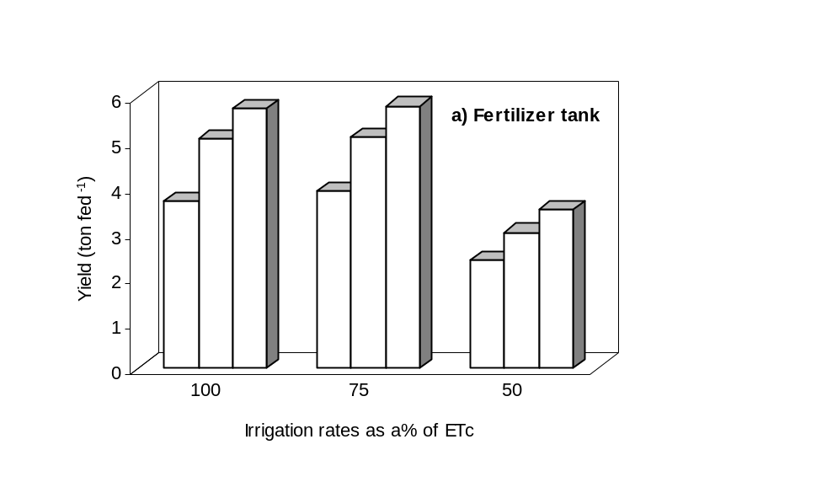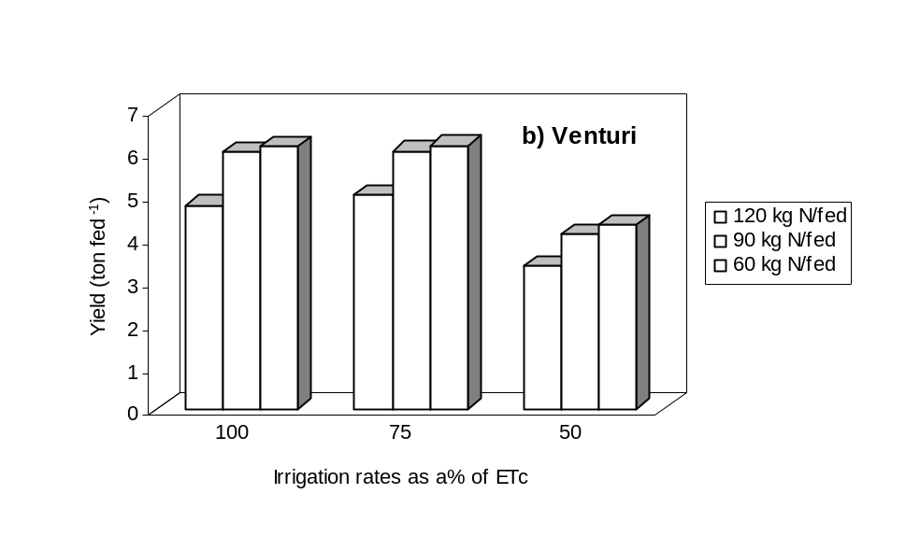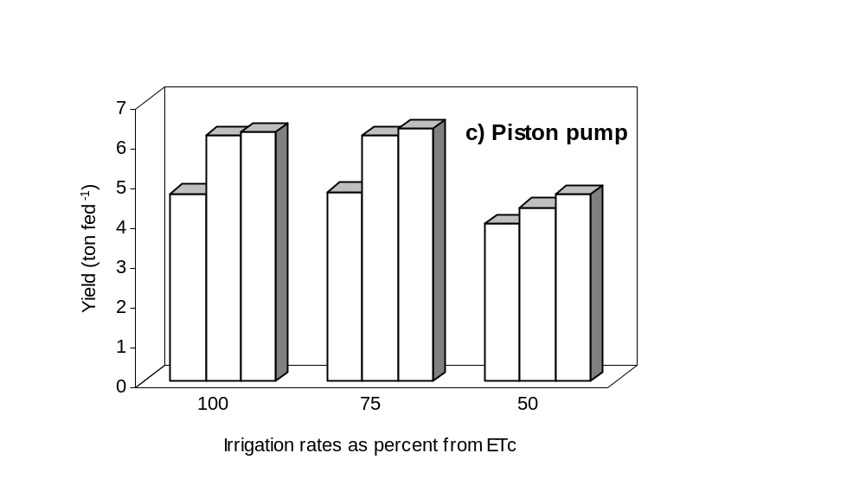

Figure (1 ): | Effect of irrigation and nitrogen fertilization levels on garlic yield under different injection methods.

2. Water use efficiency
Table (2) and Figure (2) show that effects of injectors types (J₁, J₂; J₃), irrigation treatments (I₁, I₂; I₃) and nitrogen treatments (N₁, N₂; N₃) on the water use efficiency (WUE).
Table (2) illustrates the main effects of injector types, irrigation rates and nitrogen levels on WUE. The three parameters have significant effect at 5% level on WUE. According to WUE values, obtained the studied parameters could be written in the following ascending orders: J₁> J₂> J₃, I₃> I₁> I₂ and N₁> N₂> N₃. Data obtained could be due to the effects of the following reasons on yield:
1- The decrease in nitrogen concentration with time when J₁ is used,
2- The fluctuation in nitrogen concentration with time when J₂ is used;
3- Increment of N concentration increases drippers clogging and vice versa.
4- Increasing irrigation rates to some extent (I₂) increases yield and decreases drippers clogging.
In the first interactions, maximum values of WUE were 3.05, 2.93; 2.86 kg garlic m⁻³ of irrigation water) and the minimum ones were 1.55, 1.60; 1.70 kg garlic m⁻³ of irrigation water were obtained in the following interactions: (J₃×I₁, I₁×N₃; I₂xN₃) and (I₃×N₁, J₁×N₁; J₁xI₃), respectively.
Concerning the second interactions they led to significant effects on WUE in kg garlic m⁻³ of irrigation water. The maximum values of WUE were 3.29, 3.07; 3.03 kg garlic m⁻³ of irrigation water) and the minimum ones were 1.30, 1.66; 1.67 kg garlic m⁻³ of irrigation water were due to the following interactions: (J₃×I₁×N₃, J₃×I₁×N₂; J₂×I₁×N₃) and (J₁×I₃×N₁, J₃×I₃×N₁; J₁xI₁×N₁), respectively.

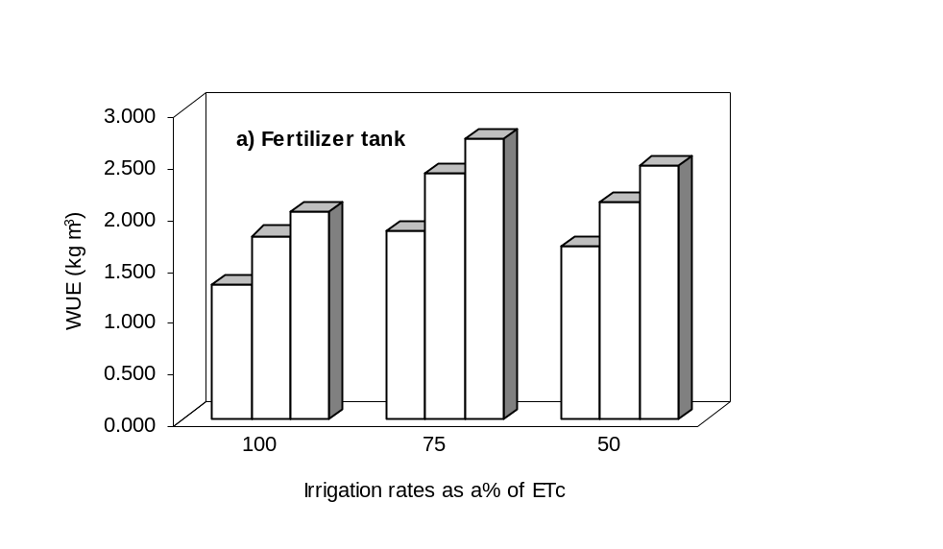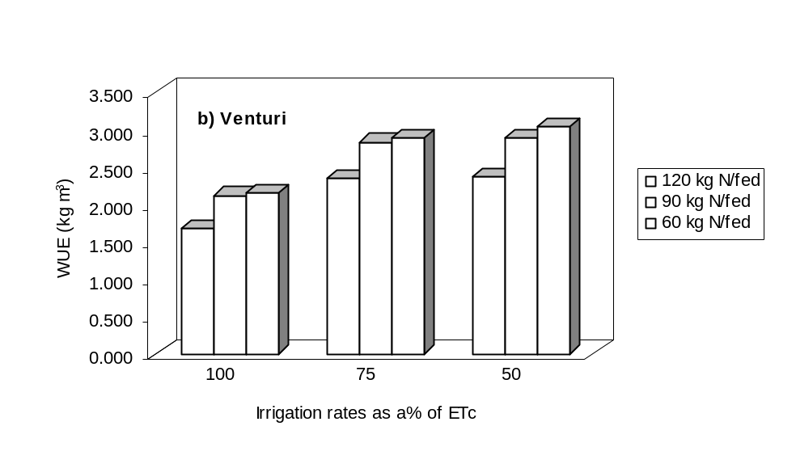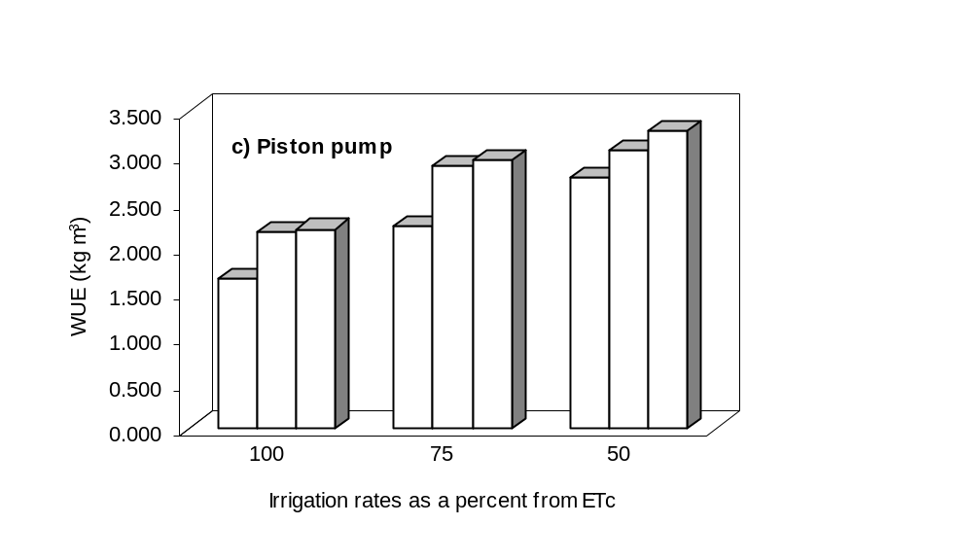
Figure (2 ): | Effect of irrigation and nitrogen fertilization levels on water use efficiency under different injection methods.

3. Nitrogen use efficiency
Illustrated data in Figure (3) show the main effect of injector types, irrigation rates and nitrogen levels all have significant effects on NUE at 5% level. According to the values of NUE, the parameters under investigation could be put in the following ascending orders: J₁>J₂>J₃, I₁>I₃>I₂ and N₃>N₂>N₁. Reasons for this have been previously discussed under yield and water use efficiency.
The maximum values of NUE for first interactions in kg garlic kg⁻¹ nitrogen were 75.9, 74.6; 73.4 and the minimum ones were 34.1, 34.7; 41.8 in the following interactions: (I₂×N₁, J₃×N₁; I₃×N₁) and (J₁×I₁, I₁×N₃; J₁×N₃), respectively.
In the case of second interactions, the maximum values of NUE in kg garlic kg⁻¹ N were 83.2, 79.7; 79.3 whereas the minimum ones 29.2, 33.3; 35.9 were achieved in following interactions (J₂×I₂×N₁, J₂×I₃×N₁; J₃×I₂×N₁) and (J₁×I₁×N₃, J₁×I₁×N₂; J₂×I₁×N₃), respectively.

4. The relationship between water and nitrogen use efficiency
Figure (4) describes the relationship between water and nitrogen use efficiency under different injectors types indicating that there was a positive linear relationship between WUE and NUE which could be written as follow equations:
NUE= 22.446 WUE + 3.0906, R² 0.6246**
NUE= 25.473 WUE + 3.4069, R² 0.5438* and
NUE= 14.299 WUE + 24.57, R² 0.3018
for fertilizer tank (J₁), venture (J₂), and piston pump (J₃), respectively. Data on hand, indicate highly positive significant of correlation coefficient at 1% for J₁, positive significant at 5% for J₂ and no significant for J₃. This means that any increase in WUE is followed by significant increase in NUE. These results are agreeable with those obtained by [9].

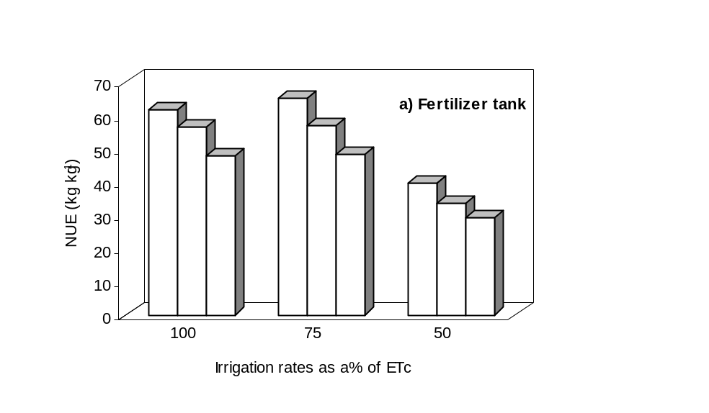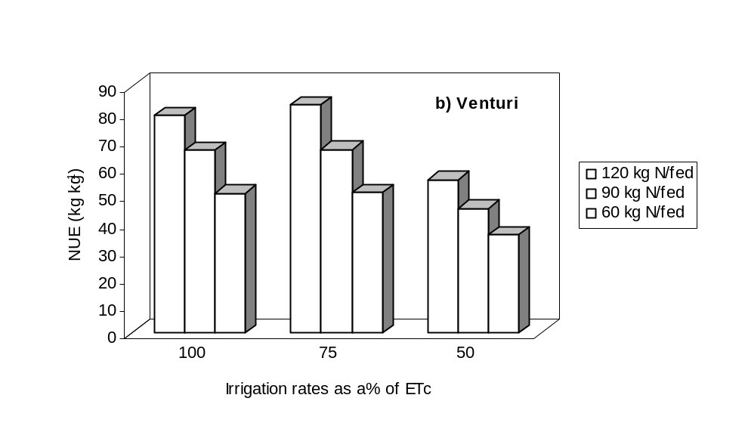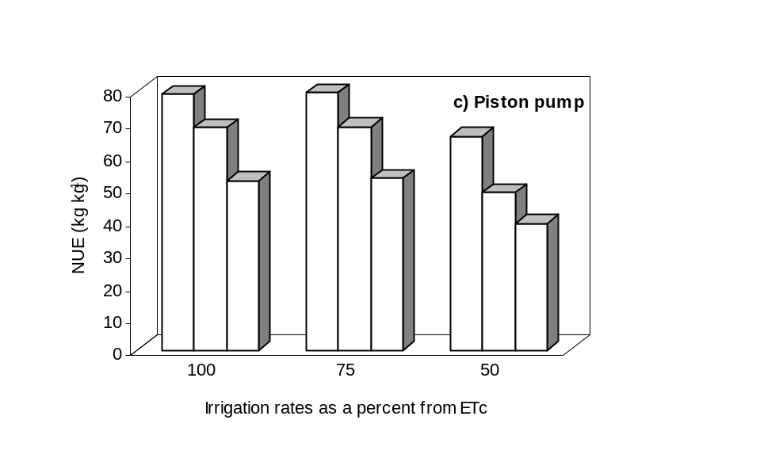

Figure (3): | Effect of irrigation and nitrogen fertilization levels on nitrogen use efficiency under different injection methods.

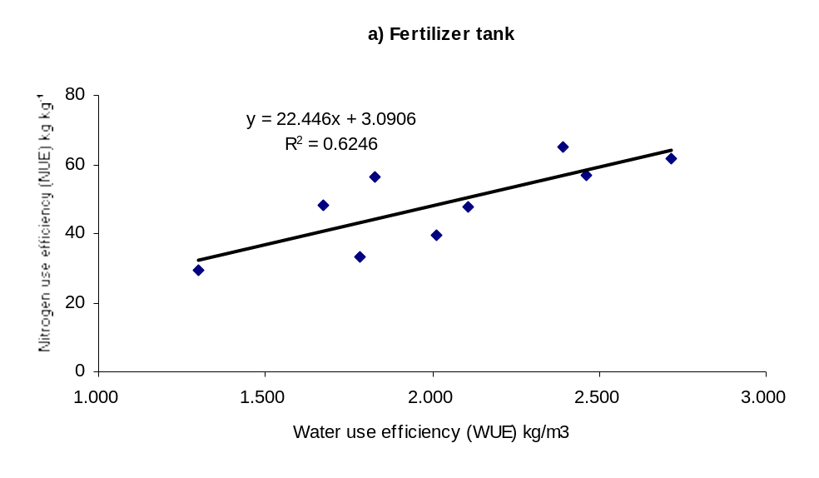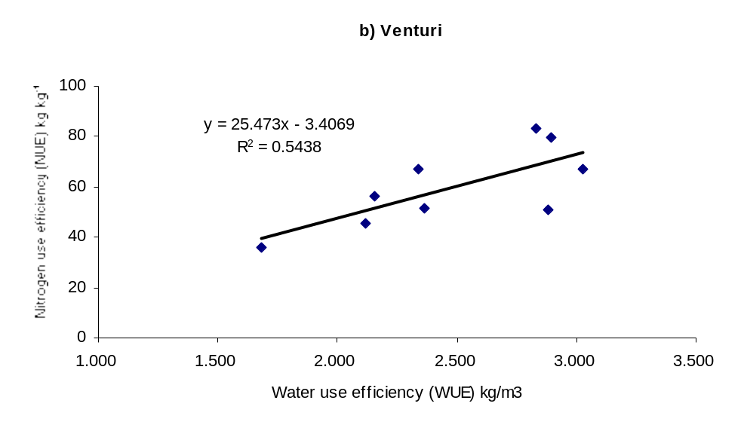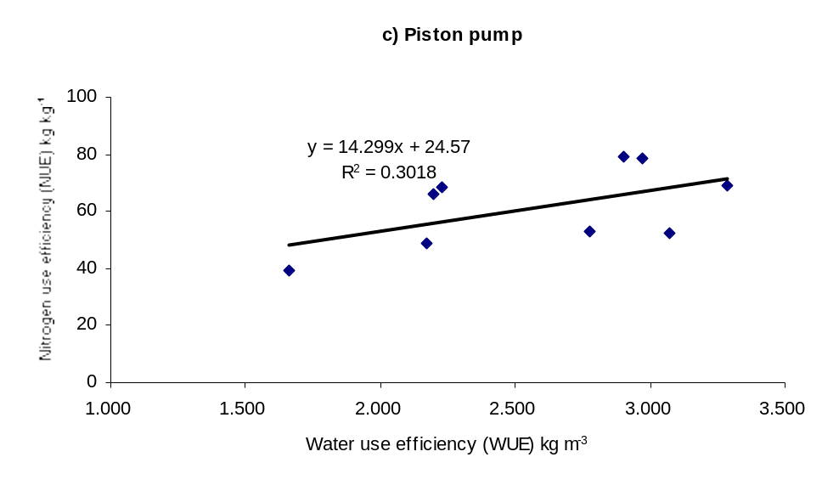

Figure (4): | The relationship between water and nitrogen use efficiency under different injection methods.

CONCLUSION

From the above mentioned presentation, it can be concluded that the highest and the lowest garlic yield (6.34; 2.38 ton fed⁻¹.) was obtained with treatment J₃xI₂xN₃ and J₁xI₁xN₁, respectively. The maximum value of WUE was 3.29 kg garlic m⁻³ of irrigation water as recorded with the treatment J₃xI₁xN₃, while the minimum value was 1.30 kg garlic m⁻³ of irrigation water as recorded with the treatment J₁xI₃xN₁. The maximum value of NUE in kg garlic kg⁻¹ nitrogen was 83.2 and the minimum ones 29.2 in the following interactions between J₂xI₂×N₁ and J₁xI₁×N₃, respectively. A positive linear relationship was found between WUE and NUE.

REFERENCES
[1] El-Gindy, A. M., (1984). Optimization of water use for pepper crop, Misr J. Agr. Eng., 29(1): 539-556.
[2] El-Adl, M. A. (2000). Effect of irrigation and fertilization method on pea production. Misr. J. Agr. Eng., 17 (3): 450 - 468.
[3] El-Adl, M. A. (2001). Sprinkler irrigation and fertigation effects on peanut production. Misr. J. Agr. Eng., 18 (1): 75 - 88.
[4] Morad, M. M., Arnaout, M. A., and Ramadan, T. Y., (1999). Fertilization distribution though irrigation system. Misr. J. Agr., Eng. 16(3): 406-416.
[5] Panchal, G. N., Modhwadia, M. M., Patel, J. C., Sadaria, S. G., and Patel, B. S., (1992). Response of garlic (Allium sativum) to irrigation, nitrogen and phosphorus. Indian-Journal-of-Agronomy. 37(2): 397-398.
[6] Pandey, U. B., and Singh, D. K., (1993). Response of garlic to different levels of irrigation and nitrogen. News-Letter-National-Horticultural-Research-and-Development-Foundation. 13(3/4): 10-12.
[7] Carvalho, L. G., Silva, A. M., Souza, R. J., Carvalho, J. G., and Abreu, A. R., (1996). Effects of different water depths and rates of nitrogen and potassium on garlic. Ciencia. e. Agrotecnologia. 20(2): 249-251.
[8] Sadaria, S.G., Malavia, D. D., Khanpara, V. D., Dudhatra, M. G., Vyas, M. N., and Mathukia, R. K., (1997). Irrigation and nutrient requirement of garlic (Allium sativum) under south Saurashtra region of Gujarat. Indian-Journal-of-Agricultural-Sciences. 67(9): 402-403.
[9] Tayel, M.Y., Abd El-Hady, M. and Ebtisam I.El-Dardiry (2006). Water and fertilizer use efficiency as affected by irrigation methods. American Eurasian J. Agric. & Environ. Sci., 1(3): 294-301. .
[10] Tayel, M.Y., El-Gindy, A.M., Abd El-Hady, M. and Abdel Ghany, H.A. (2007). Effect of irrigation system on: II- yield, water and fertilizer use efficiency of grape. J. Appl. Sci. Res., 3(5): 367-372.
[11] Abdel-Baset, M.M. (2009). Effect of technical operating conditions of central pivot on optimizing water use for some vegetable crops. M. Sc. Thesis, Fac.of Agric., Ain Shams University, Egypt.
[12] Israelson, O.W. and Hanson, V.E. (1962). Irrigation principal and practices 3rd ed. John Wiely and Sons. New York.
[13] Abdel-Aziz, A.A. (1998). Evaluation of some modern chemigation techniques, Ph. D. Thesis, Fac.of Agric., Ain Shams University.
[14] Tayel, M.Y., A. M., El-Gindy, K.F. El- Bagoury and Kh. A.P. Sabreen (2009). Effect of injector types, irrigation and nitrogen levels on: I- Emitter clogging. J. Appl. Sci. Res, (in press).

