Soil and Groundwater Capability of East Oweinat Area, Western Desert, Egypt Using GIS Spatial Modeling Techniques

El Nahry A. H.*, Elewa H. H.*, and Qaddah A. A.**
* National Authority for Remote Sensing & Space Sciences (NARSS), Cairo, Egypt,
** Egyptian Environmental Affair Agency (EEAA), Cairo, Egypt.
elewa.hossam@gmail.com

Abstract. East Oweinat is an important developmental area located at the far southern part of the Western Desert of Egypt. The Nubian Sandstone aquifer system (NSAS) is the sole groundwater resource used for the agricultural and domestic purposes. The hydrogeological and soil capability attributes represented by depth to groundwater, total dissolved solids, well safe yield, sodium adsorption ratio, soil salinity, soil depth, Soil exchangeable sodium percentage and cation exchange capacity were integrated into a multilayer geographic information system (GIS). A weighted spatial capability modeling (WSCM) technique was performed using these layers to determine the soil/groundwater capability areas. A WSCM output map reflecting these capability areas indicated that the high and moderate soil/groundwater capability classes represent about 89.18 % of the total mapped pilot area, whereas the low capability class is restricted only to an area having 10.81 % of the total studied area. The already present-day established land use regime depending on the groundwater resources occurs in the high and moderate capability classes discriminated by the present work, which indicates the success of model logics, and also suggest other promising areas suitable for further expansion in this vital developmental area.

Keywords— Western Desert of Egypt, GIS, Remote Sensing, Soil and Groundwater Weighted Spatial Capability Modeling.

Introduction
East Oweinat area is one of the most important developmental areas which drawn considerable attention of Egyptian government in the last few decades. The soil and groundwater resources of this area cover the requirements of reclamation projects and implementation of new communities. The regional area of East Oweinat is located in the southern part of the Western Desert of Egypt between latitudes 22º 11′ 27.96′′ - 22º 45′ 54.96′′ N and longitudes 28º 13′ 30.02′′ - 28º 50′ 10.95′′ E with an area of 4,924 Km² (1,216,746.89 acre). The pilot study area selected for carrying out the present study lies between latitudes 22º 00′ 04′′ - 23º 27′ 52′′ N and longitudes 27º 58′ 42′′- 29º 15′ 00′′ with an area of about 748.4 km² (184,933.66 acre) (Figure1). It is located at about 880 km from Cairo and 400 km to the southwest of the Kharga Oasis (Figure1). The present work aims to determine the soil/groundwater resources capability areas of East Oweinat area by using weighted spatial capability modeling (WSCM) technique. Determining the developmental capability in terms of soil and groundwater is necessary for setting up a management scheme to optimize the use of natural resources of this vital area. The hydrogeological data of the Nubia Sandstone aquifer system (NSAS) is undertaken according to the recently collected data during an inventory of some selected groundwater wells in addition to the soil profiling in the same areas to reveal the land capabilities, with the subsequent laboratory and office works, including chemical analyses for groundwater and soil samples, mapping and construction of a complete geographic information system (GIS). This system includes all the effective hydrogeochemical and soil attributes needed for the capability mapping. A WSCM was constructed to discriminate the soil and groundwater capability classes according to definite economical criteria, that is depth to groundwater (mbgl), well safe yield (m³/h), and groundwater total dissolved solids (TDS) (mg/l), groundwater sodium adsorption ratio (SAR), soil salinity (dS/m), soil depth (cm), exchangeable sodium percentage (ESP) and cation exchange capacity (CEC) (cmoles_{(c)} kg⁻¹).
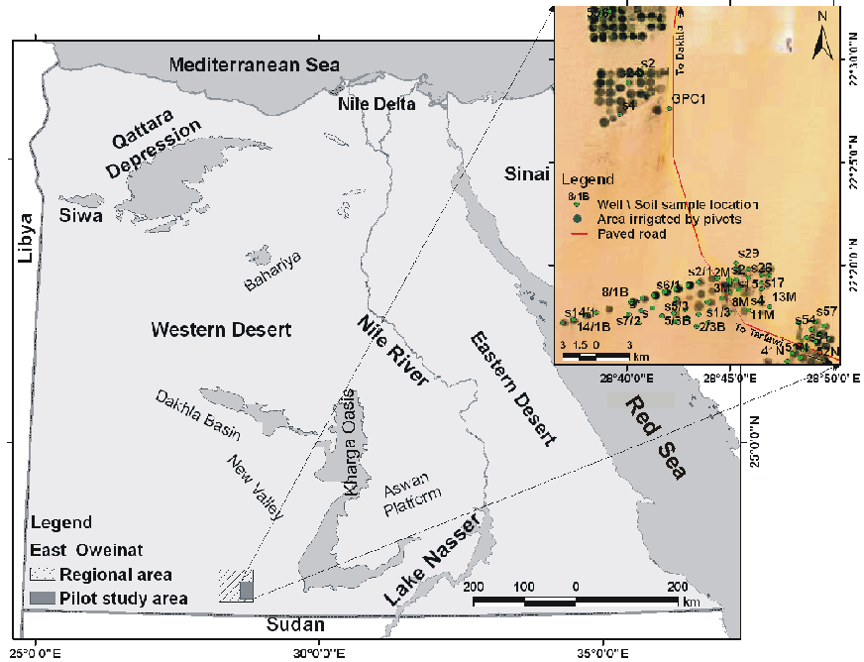
Figure 1. Location of the study area and Ikonos satellite image with groundwater wells/soil samples locations

From the climate point of view, the study area is characterized by extreme aridity with minimal precipitation, virgin soils and huge groundwater storage. Maximum temperature during summer often exceeds 40ºC, whereas minimum temperature during winter may decline close to freezing. Natural evaporation rate ranges between 10 mm d⁻¹ during January to 31 mm d⁻¹ during July, with an average of 22.2 mm d⁻¹. The relative humidity ranges between 11% in May and 41% in December. The mean monthly minimum wind velocity is 21 km h⁻¹ in December and January while the mean maximum is 32 km h⁻¹ in September. The prevailing wind direction is generally northwest to northeast (Nour, 1996).
During the period 1978-1985, a comprehensive and systematic hydrogeological investigations in the East Oweinat Area were carried out by the petroleum sector (G.P.C., 1984) to assess the characteristics of the NSAS and the availability of groundwater for irrigated agricultural projects (Nour, 1996). To keep the water lift in the New Valley area within the economic range, it was planned to reclaim about 103,800 acres for agricultural development during the period 1987-2002 (Idris and Nour, 1990). Measurements of water levels and salinities are being carried out periodically on some representative wells. Nour (1996) introduced the results of the groundwater resources evaluation study and the on-going 1992-1997 plans for groundwater development in the East Oweinat area. His techno-economical feasibility study envisaged to assess the long-term economical groundwater extraction.
From the geological point of view, NSAS overlies the basement rocks that are crosscut by an extensive E-W fault system in southern Egypt (Issawi, 1971; Issawi, 1978). The Nubia Sandstone is classified to six distinct geological units ranging in age from Jurassic to Upper Cretaceous (Klitzsch et al., 1983; Klitzsch and Lejal-Nicol, 1984; GSE, 1987; CONOCO, NG36SW-Luxor Sheet 1987). Recently, the NSAS is viewed in a different way; the rocks of the aquifer system were divided into three units; a surface cover together with a dry part of the Nubia Sandstone, water-saturated beds of the Nubia Sandstone and the basement rocks (Abd El Latif et al., 1997).
The groundwater of the NSAS is the backbone for the development of Western Desert of Egypt, where it represents the sole source for water supply. It is mainly fresh and accepted for all agricultural and domestic purposes. Taking into consideration the ongoing widespread groundwater drilling program, as recently, about 383 wells were drilled in East Oweinat area by the Egyptian Government (Robinson et al., 2007), the results of previous investigations about the long-period simulation (10,000 years) of impact of present and future groundwater extraction rates from the non-replenished NSAS in southwest Egypt, indicated that the aquifer is still under the influence of the past humid period and has been in an unsteady deplenishing process. The simulation results indicated also that there is a real danger of groundwater depletion, particularly in the shallow aquifer in some areas (Ebraheem et al. 2002). However, the results of a very large scale GIS-based groundwater flow model for the NSAS in the Eastern Sahara (Egypt, northern Sudan and eastern Libya) indicated that the groundwater in this aquifer was formed by infiltration during the wet periods 20,000 and 5,000 years b.p. The recharge of groundwater due to regional groundwater flow from more humid areas in the south was excluded. It also indicates that the NSAS is a fossil aquifer, which had been in unsteady state conditions for the last 3,000 years (Gossel et al. 2004). Therefore, groundwater development plans should be based on this concept. Nour (1996) indicated that the quality of the groundwater in the East Oweinat area is fresh, with total dissolved solids (TDS) ranging between 200 and 700 mg/l. The sodium adsorption ratio (SAR) ranges between 0.5 and 1.7, while the residual sodium carbonate (RSC) ranges between 0.69 and 2.45 epm, thus the suitability of East Oweinat groundwater for irrigation purpose is classified as excellent.

Materials and methods
The implementation of developmental activities in the area began in 1980s. Recently, in 2007 and 2008, the National Authority for Remote Sensing and Space Sciences (NARSS, 2008) funded a research project, principally investigated by the second author of the present work. This project enabled groundwater and soil data sampling, using the modern techniques of digital data base and manipulation of GIS and remote sensing for updating the hydrogeological data of East Oweinat area.

Field Sampling
The sampling program was conducted in 2008 for both groundwater and soils. The sampling sites were chosen carefully based on sound hydrogeological reasoning pertinent to the occurrence and movement of groundwater and the localization of soil profiles as well. Groundwater was collected from the production wells tapping the NSAS. Data from drillers’ logs (depth, subsurface geology, static depth to water, etc.) were used to guide selection of wells for sampling. About 73 groundwater samples were obtained for the sake of chemical analyses. Groundwater electrical conductivity (EC) and pH for each sample were determined in the field. Conductivity was measured using a Corning 316 meter to provide a rapid geochemical reference point, with a precision of ±5%. A Corning 315 high-sensitivity pH meter with an Orion Ross combination electrode was calibrated with low ionic strength buffers of 4.10 and 6.97 (corrected for temperature) and used to measure the pH in the field as close to the water temperature as possible. Because the pH of a sample can change due to degassing and warming, samples were placed in a large-volume airtight container and measured at least twice to ascertain electrode stability. The reproducibility of field pH determinations was ±0.02 pH units. Sample aliquots for later chemical analysis in the laboratory were field-filtered through a 0.45 μm nylon filter into their respective bottles and kept cold until analyzed.
During the field inventory, the soil sampling areas were selected in the same locations of the sampled groundwater wells, to better reflect the soil/groundwater capabilities. 50 soil profiles with 69 augers were performed. Auger locations were selected to delineate the boundaries among the different mapping units. Soil profiles were dug to depth of 150 cm, unless obstructed or hindered by bedrock. The soil profiles were thoroughly examined and morphologically described in the field according to the system outlined by FAO (1990).

Laboratory Work
- Hydrochemical analyses were conducted in the Micochemical Analysis Laboratory of Cairo University in 2008. The analytical errors are variable. For the majority of the samples the analytical error is less than 3 %. For the great majority of the data error is less than 2 %. Major cations (Ca, Mg, Na and K) were measured by Atomic Absorption Spectrophotometer and some anions (Cl, SO₄) by Ion Chromatography. Carbonate and HCO₃ were determined by titration. Complete geochemical databases for the field, laboratory, and calculated parameters for groundwater were checked and interpreted using AquaChem 5.1® Program (Waterloo Hydrogeologic, 1997) (table 1). This part of work was written primarily to provide information on the characteristics of groundwater quality, water types segregations, genesis and suitability for domestic and agricultural purposes. Graphical methodologies were used to classify the groundwater samples into homogeneous groups. These methodologies include the diagrams of Durov and Wilcox.

Table 1. Groundwater and soil data used for the GIS database (collected in 2008):
ID | PH | EC  (dS/cm) | TDS  (mg/l) | K⁺  (mg/l) | Na⁺  (mg/l) | Mg⁺²  (mg/l) | Ca⁺²  (mg/l) | Cl⁻  (mg/l) | SO₄⁻²  (mg/l) | HCO₃⁻  (mg/l) | Water  Depth  (mbgl) | Well  Safe  Yield  (m³/h) | SAR | Soil  ESP | Soil  CEC  (cmoles_{(c)} kg⁻¹) | Soil  Salinity  (dS/m) | Soil  Depth  (cm)
1/1B | 8.55 | 891 | 579 | 10.90 | 109.20 | 38.20 | 46.40 | 132.40 | 134.70 | 214.70 | 32 | 225 | 2.88 | 6.52 | 24.59 | 2.79 | 291.93
1/2B | 8.41 | 884 | 575 | 8.75 | 165.00 | 8.30 | 31.90 | 188.00 | 100.00 | 167.60 | 34 | 200 | 6.73 | 6.50 | 29.70 | 4.22 | 219.55
1/3B | 8.31 | 875 | 569 | 8.68 | 163.70 | 8.20 | 31.60 | 186.50 | 99.20 | 166.30 | 34 | 250 | 6.71 | 14.99 | 5.10 | 4.75 | 190.68
11/1B | 8.32 | 741 | 481 | 5.25 | 99.00 | 6.47 | 19.05 | 112.80 | 60.00 | 100.50 | 34 | 225 | 5.00 | 6.21 | 15.15 | 2.13 | 300.00
11M | 8.18 | 1092 | 710 | 10.60 | 200.00 | 9.93 | 38.60 | 228.40 | 121.40 | 177.60 | 32 | 215 | 7.43 | 14.79 | 5.08 | 3.31 | 245.67
12/1B | 8.52 | 557 | 362 | 3.92 | 73.90 | 14.22 | 84.00 | 81.10 | 44.80 | 75.60 | 34 | 225 | 1.96 | 6.04 | 12.32 | 2.09 | 300.00
13M | 8.23 | 978 | 636 | 9.47 | 178.60 | 8.87 | 34.50 | 203.90 | 108.40 | 158.70 | 29 | 210 | 7.02 | 14.58 | 5.07 | 2.15 | 257.84
14/1B | 8.46 | 728 | 473 | 11.20 | 211.50 | 10.6 | 40.80 | 240.60 | 128.00 | 214.60 | 34 | 225 | 7.63 | 9.15 | 14.38 | 2.59 | 117.37
14M | 8.28 | 1017 | 661 | 9.87 | 186.10 | 9.24 | 35.90 | 212.40 | 112.90 | 165.30 | 29 | 210 | 7.17 | 9.18 | 14.28 | 2.45 | 259.02
15M | 8.30 | 987 | 641 | 9.58 | 180.70 | 8.97 | 34.90 | 206.20 | 109.60 | 160.50 | 28 | 210 | 7.06 | 9.20 | 14.19 | 2.21 | 261.76
19M | 8.22 | 950 | 617 | 9.21 | 173.80 | 8.63 | 33.60 | 198.10 | 105.40 | 154.30 | 28 | 215 | 6.92 | 6.70 | 19.76 | 2.09 | 255.38
2/1B | 8.47 | 1054 | 685 | 15.40 | 290.40 | 18,98 | 55.88 | 330.80 | 176.00 | 295.00 | 32 | 225 | 8.60 | 6.59 | 30.64 | 2.83 | 299.90
2/2B | 8.55 | 824 | 536 | 8.40 | 158.40 | 7.96 | 30.60 | 180.50 | 96.00 | 160.90 | 34 | 210 | 6.60 | 6.58 | 36.60 | 4.36 | 211.88
2/3B | 8.46 | 925 | 601 | 9.10 | 171.60 | 8.60 | 33.10 | 195.50 | 104.00 | 174.30 | 34 | 200 | 6.87 | 6.38 | 13.21 | 4.82 | 187.19
200f/1 | 8.15 | 1251 | 813 | 12.40 | 233.60 | 11.70 | 45.10 | 266.20 | 141.60 | 207.30 | 30 | 215 | 8.02 | 9.23 | 14.22 | 2.87 | 275.99
20M | 8.34 | 975 | 634 | 9.50 | 179.20 | 8.90 | 34.70 | 204.20 | 108.70 | 159.10 | 28 | 215 | 7.02 | 9.15 | 14.08 | 1.93 | 239.14
25M | 8.31 | 1195 | 777 | 11.80 | 221.20 | 11.00 | 42.90 | 252.10 | 134.20 | 196.40 | 28 | 220 | 7.80 | 9.11 | 14.03 | 2.26 | 276.36
29M | 8.63 | 1022 | 664 | 10.06 | 189.10 | 9.40 | 36.70 | 215.50 | 114.70 | 167.90 | 29 | 220 | 7.21 | 6.48 | 13.11 | 2.42 | 292.36
2M | 8.31 | 974 | 633 | 9.34 | 177.30 | 8.78 | 34.20 | 202.20 | 107.50 | 157.30 | 30 | 220 | 7.00 | 6.76 | 24.72 | 2.84 | 285.70
3/1B | 8.60 | 975 | 634 | 6.86 | 129.36 | 8.45 | 24.89 | 147.40 | 78.40 | 131.40 | 32 | 225 | 5.73 | 6.67 | 37.69 | 2.78 | 308.47
3/2B | 8.53 | 728 | 473 | 7.21 | 135.90 | 6.83 | 26.20 | 154.90 | 82.40 | 136.10 | 34 | 200 | 4.37 | 6.45 | 12.14 | 4.32 | 214.41
30M | 8.51 | 956 | 621 | 9.40 | 176.70 | 8.78 | 34.30 | 201.40 | 107.20 | 156.90 | 30 | 220 | 6.97 | 6.44 | 14.74 | 2.64 | 287.32
33M | 9.53 | 1100 | 715 | 10.80 | 203.10 | 10.10 | 39.40 | 231.50 | 123.20 | 180.40 | 31 | 210 | 7.47 | 6.47 | 17.44 | 3.17 | 271.44
3M | 8.25 | 1000 | 650 | 9.63 | 182.80 | 9.05 | 35.30 | 208.50 | 110.80 | 162.20 | 32 | 210 | 7.10 | 6.79 | 34.96 | 3.54 | 255.19
4/1B | 8.52 | 948 | 616 | 6.77 | 126.70 | 8.28 | 24.38 | 144.30 | 76.80 | 128.70 | 33 | 225 | 5.66 | 6.74 | 45.51 | 3.11 | 291.61
4/2B | 8.48 | 794 | 516 | 7.84 | 147.80 | 7.43 | 28.50 | 168.40 | 89.60 | 150.20 | 34 | 200 | 6.38 | 15.84 | 5.39 | 4.10 | 228.75
4/3B | 8.39 | 892 | 580 | 8.82 | 166.30 | 8.40 | 32.10 | 189.50 | 100.80 | 168.90 | 34 | 200 | 6.76 | 5.85 | 16.30 | 3.69 | 254.15
41N | 8.40 | 890 | 578 | 8.75 | 165.00 | 8.30 | 31.85 | 188.00 | 100.00 | 167.60 | 31 | 200 | 7.55 | 5.81 | 14.13 | 3.33 | 237.06
44N | 8.40 | 445 | 289 | 4.41 | 83.20 | 4.20 | 16.10 | 94.80 | 50.40 | 84.50 | 31 | 200 | 4.78 | 5.78 | 13.74 | 2.45 | 267.59
45N | 8.52 | 1054 | 682 | 10.40 | 196.70 | 9.90 | 37.90 | 224.10 | 119.20 | 199.80 | 31 | 200 | 7.36 | 5.72 | 11.89 | 2.10 | 286.95
48N | 8.36 | 822 | 534 | 8.12 | 153.10 | 7.70 | 29.60 | 174.50 | 92.80 | 155.60 | 30 | 200 | 6.48 | 6.87 | 37.44 | 1.28 | 310.56
5/1B | 8.48 | 564 | 367 | 3.90 | 75.20 | 4.91 | 14.47 | 85.70 | 45.60 | 76.43 | 32 | 225 | 4.36 | 6.83 | 50.74 | 2.43 | 341.57
5/3B | 8.40 | 937 | 609 | 9.24 | 174.20 | 8.75 | 33.60 | 198.50 | 105.60 | 177.0 | 34 | 200 | 6.92 | 5.69 | 10.57 | 3.36 | 276.13
51N | 8.33 | 985 | 640 | 9.30 | 176.10 | 8.62 | 33.90 | 200.90 | 106.70 | 156.2 | 30 | 200 | 6.99 | 5.65 | 10.07 | 2.67 | 312.58
52N | 8.25 | 915 | 595 | 8.70 | 164.60 | 8.06 | 31.70 | 187.80 | 99.70 | 146.0 | 30 | 200 | 6.76 | 3.87 | 101.42 | 1.39 | 330.95
54 | 8.48 | 1414 | 919 | 14.0 | 263.90 | 13.20 | 50.90 | 300.80 | 160.00 | 234.2 | 33 | 210 | 8.53 | 3.87 | 88.26 | 1.06 | 45.33
55 | 8.33 | 942 | 612 | 9.24 | 174.20 | 8.70 | 33.60 | 198.50 | 105.60 | 154.6 | 33 | 205 | 6.93 | 5.63 | 9.70 | 1.01 | 42.45
55N | 8.26 | 948 | 616 | 9.07 | 171.50 | 8.40 | 33.05 | 195.60 | 103.90 | 152.1 | 29 | 200 | 6.90 | 5.59 | 8.94 | 2.05 | 323.28
56N | 8.21 | 974 | 633 | 9.35 | 176.80 | 8.70 | 34.08 | 201.70 | 107.20 | 156.8 | 29 | 200 | 7.00 | 5.67 | 11.06 | 2.02 | 334.27
57N | 8.30 | 1016 | 660 | 9.74 | 184.20 | 9.05 | 35.50 | 210.10 | 111.70 | 163.4 | 29 | 200 | 7.14 | 5.62 | 10.44 | 2.01 | 293.44
58N | 8.54 | 1164 | 757 | 11.20 | 211.70 | 10.40 | 40.80 | 241.50 | 128.40 | 187.8 | 29 | 200 | 7.66 | 6.91 | 44.46 | 2.34 | 303.78
6/1B | 8.34 | 888 | 577 | 6.30 | 118.80 | 7.76 | 22.86 | 135.00 | 77.00 | 120.6 | 31 | 225 | 5.48 | 6.90 | 51.39 | 2.21 | 362.01
6/2B | 8.42 | 979 | 636 | 9.70 | 182.30 | 9.15 | 35.20 | 207.60 | 110.40 | 185.1 | 33 | 215 | 7.08 | 5.77 | 10.93 | 2.64 | 328.11
60N | 8.67 | 961 | 625 | 9.22 | 175.00 | 8.60 | 33.70 | 199.60 | 106.10 | 155.2 | 29 | 200 | 6.97 | 3.87 | 75.41 | 1.74 | 287.08
67 | 8.50 | 835 | 543 | 8.22 | 155.00 | 7.74 | 29.90 | 176.60 | 93.90 | 137.6 | 33 | 205 | 6.54 | 6.96 | 51.94 | 1.01 | 42.75
7/1B | 8.41 | 645 | 419 | 4.55 | 85.80 | 5.60 | 14.80 | 97.70 | 57.00 | 87.1 | 30 | 225 | 4.82 | 15.49 | 5.17 | 2.01 | 382.27
8/1B | 8.53 | 481 | 312 | 3.36 | 63.30 | 12.20 | 19.05 | 72.20 | 38.40 | 64.4 | 29 | 220 | 2.79 | 6.36 | 19.09 | 1.92 | 395.28
8M | 8.28 | 1203 | 782 | 11.60 | 220.30 | 10.90 | 42.50 | 251.20 | 133.50 | 195.4 | 33 | 215 | 7.80 | 8.59 | 13.76 | 4.01 | 229.13
GPC1 | 8.79 | 480 | 312 | 4.71 | 88.70 | 4.40 | 17.20 | 101.10 | 53.80 | 78.80 | 32 | 210 | 4.94 | 15.46 | 5.30 | 2.97 | 113.52
s | 7.03 | 1270 | 813 | 11.73 | 131.43 | 32.81 | 80.16 | 319.07 | 153.68 | 30.50 | 31 | 220 | 3.11 | 15.47 | 5.23 | 2.64 | 327.05
s* | 7.31 | 1430 | 915 | 19.55 | 110.35 | 37.68 | 118.24 | 358.07 | 187.30 | 18.30 | 28 | 205 | 2.26 | 6.56 | 22.63 | 2.20 | 366.84
s1/3 | 7.32 | 910 | 582 | 11.73 | 85.06 | 25.52 | 60.12 | 297.80 | 24.01 | 12.20 | 33 | 205 | 2.32 | 15.50 | 5.16 | 3.83 | 241.52
s14/1 | 7.08 | 680 | 435 | 7.82 | 75.86 | 14.58 | 42.08 | 145.35 | 120.07 | 12.20 | 34 | 225 | 2.57 | 9.18 | 14.28 | 2.61 | 117.21
s15 | 7.05 | 980 | 627 | 7.82 | 85.06 | 31.60 | 66.13 | 237.53 | 139.28 | 12.20 | 28 | 215 | 2.15 | 9.19 | 14.24 | 2.21 | 261.75
s17 | 7.18 | 1010 | 646 | 7.82 | 89.66 | 30.38 | 70.14 | 248.17 | 139.28 | 12.20 | 28 | 215 | 2.25 | 6.50 | 12.57 | 2.12 | 259.37
s2 | 7.17 | 890 | 570 | 7.82 | 80.47 | 26.74 | 60.12 | 216.26 | 124.87 | 12.20 | 30 | 220 | 2.17 | 3.98 | 12.71 | 2.73 | 289.63
s2 | 7.37 | 790 | 506 | 3.91 | 103.45 | 14.58 | 42.08 | 159.53 | 168.09 | 6.10 | 33 | 215 | 3.50 | 6.70 | 19.78 | 1.36 | 98.58
s2/1 | 7.13 | 920 | 589 | 7.82 | 78.17 | 29.17 | 64.13 | 230.44 | 120.07 | 12.20 | 32 | 225 | 2.03 | 9.15 | 14.08 | 2.83 | 299.86
s21 | 7.15 | 1050 | 672 | 7.82 | 103.46 | 25.53 | 74.15 | 258.80 | 144.08 | 12.20 | 28 | 220 | 2.64 | 3.98 | 12.49 | 2.26 | 276.25
s24 | 7.10 | 1300 | 832 | 19.55 | 131.04 | 36.46 | 76.15 | 301.35 | 196.91 | 24.40 | 33 | 215 | 3.10 | 9.14 | 14.14 | 1.44 | 102.46
s26 | 7.32 | 1060 | 678 | 7.82 | 105.75 | 24.31 | 76.15 | 265.89 | 139.28 | 12.20 | 29 | 220 | 2.70 | 9.12 | 13.99 | 2.37 | 277.23
s29 | 7.27 | 830 | 531 | 7.82 | 80.47 | 23.09 | 54.11 | 248.17 | 52.83 | 12.20 | 29 | 225 | 2.31 | 6.70 | 35.03 | 2.32 | 292.06
s3/3 | 7.35 | 950 | 608 | 11.73 | 89.66 | 25.53 | 64.13 | 304.89 | 28.82 | 18.30 | 33 | 205 | 2.40 | 6.21 | 15.13 | 3.88 | 240.97
s4 | 7.40 | 1070 | 685 | 11.73 | 105.75 | 27.96 | 70.14 | 258.81 | 153.69 | 12.20 | 31 | 215 | 2.70 | 4.02 | 10.35 | 3.30 | 245.70
s4* | 7.17 | 1170 | 749 | 11.73 | 101.15 | 36.46 | 80.16 | 248.17 | 211.32 | 18.30 | 33 | 215 | 2.35 | 6.82 | 30.78 | 2.15 | 114.46
s4/1 | 7.25 | 880 | 563 | 7.82 | 75.87 | 26.74 | 62.12 | 212.72 | 124.87 | 12.20 | 32 | 225 | 2.02 | 6.83 | 50.71 | 2.64 | 322.95
s5/3 | 7.37 | 920 | 589 | 11.73 | 87.62 | 24.31 | 62.12 | 301.35 | 19.20 | 18.30 | 34 | 200 | 2.38 | 5.71 | 11.34 | 3.35 | 276.50
s51 | 7.36 | 990 | 633 | 11.73 | 101.56 | 24.31 | 64.13 | 258.81 | 115.27 | 12.20 | 30 | 200 | 2.73 | 5.67 | 10.30 | 1.03 | 316.14
s54 | 7.50 | 1010 | 646 | 11.73 | 103.46 | 24.31 | 60.12 | 269.44 | 110.46 | 12.20 | 29 | 200 | 2.85 | 5.68 | 11.01 | 2.25 | 309.60
s57 | 7.32 | 930 | 595 | 7.82 | 105.75 | 23.09 | 52.10 | 248.17 | 100.86 | 12.20 | 29 | 200 | 3.07 | 6.91 | 44.45 | 2.05 | 293.71
s6/1 | 7.15 | 820 | 544 | 7.82 | 82.76 | 20.66 | 54.10 | 209.17 | 100.86 | 12.20 | 31 | 225 | 2.43 | 6.95 | 59.44 | 2.21 | 361.92
s7/2 | 7.25 | 1350 | 864 | 3.91 | 117.25 | 42.54 | 96.19 | 141.81 | 451.46 | 6.10 | 32 | 215 | 2.50 | 15.49 | 5.17 | 2.35 | 351.71

- Soil analyses

Physical analyses
Particle size distribution was determined according to Bandyopadhyay, 2007. Soil color (wet and dry) was identified with the aid of Munssel color charts of the Soil Survey manual (Soil Survey Staff 1951).

Chemical analyses
Soil Electric conductivity (EC), soluble cations and anions, CaCO₃, organic matter (OM), pH, Exchangeable sodium percentage (ESP), and cation exchange capacity (CEC), were determined according to Bandyopadhyay (2007) (table 1).

Soil Taxonomy
Soils were classified according to the rules of USDA (2006) Soil Taxonomy.

- Remote sensing
Digital image processing of Landsat 7.0 ETM+ satellite images dated to year 2005 was executed using ENVI 4.7© software (ITT, 2009) for classifying the geomorphologic units. The image analysis included:

Preprocessing
- Data calibration to radiance according to Lillesand and Kiefer (2007).
- Data manipulation (image stretching, filtering, and histogram matching).

Digital image processing
- Atmospheric correction was done using FLAASH module.
- Rectification of satellite images.
- Enhancing the ground resolution from 28.5 m to 14.25 m. Fusion methodology was applied according to Ranchin and Wald (2000).
- Producing image mosaics from Landsat 7.0 ETM+ satellite images. The mosaic covered the study area.
- Generation of ASTER DEM from ASTER images 3n (nadir) and 3b (backward) level 1b dated to 2005. To improve the accuracy of 25 meter, topographic maps scale of 1:50,000 were used. Additional spot heights collected from the field by using total station STONEX STS02 (accuracy 2 mm) were spatially added for deriving high resolution Digital Elevation Model (DEM).

- Geographic information system (GIS)
ArcGIS 9.3.1© with its ArcGIS Geostatistical and Spatial Analyst extensions (ESRI, 2009) were used for mapping groundwater and soil variables and constructing a "Weighted Spatial Capability Model" (WSCM) successively with the aid of some thematic maps (Talbot, 1998; Mitchell, 1999; Malczewski, 1999).

Geostatistical analyses (groundwater and soils’ variables)
Spatial variability of groundwater and soil characteristics
To study the spatial variability for water/soil characteristics, an interpolation method was used to visually identify patterns of the water/soil characteristics on two-dimensional water/soil data sets. Interpolation between sampling locations was made by ordinary Kriging interpolation method performed using the Geostatistical Analyst extension available in ESRI© ArcMap™ v9 (ESRI, 2009).
Ordinary Kriging (Deutsch and Journel, 1992) was used to estimate the value of a continuous water/soil characteristic z at a non-sampled locations (u) using only the data on this characteristic [z(ua), α = 1, . . ., n] as a linear combination of neighboring observations (eq 1):
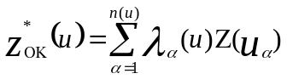 (eq 1)

As for other linear regression procedures, ordinary Kriging weights are chosen so as to minimize the estimation or error variance σ²_{E}(u) = Var [Z*(u) – Z(u)] under the constraint of an unbiased procedure of the estimator. These weights are obtained by solving a system of linear equations (eq 2):
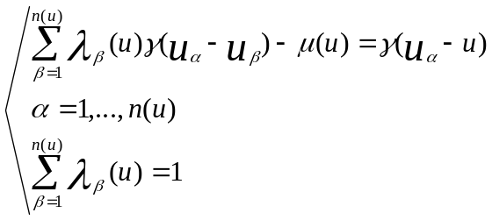 (eq 2)
Unbiased estimation is ensured by constraining the weights to sum to one, which requires the definition of the Lagrange parameter m(u) (Journel and Huijbregts 1981).
Semi-variogram values for different lags are derived from the semi-variogram model fitted to experimental values. The error variance was computed as (eq 3):
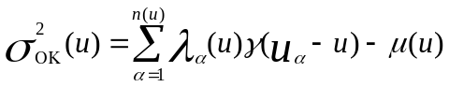 (eq 3)
Under stringent hypotheses of normality and homoscedasticity, the Kriging variance was combined with the estimated value to derive a confidence interval of 95% as (eq 4):

(eq 4)

- Weighted Spatial Capability Model (WSCM)
WSCM was designed as shown in the following:
The soil/groundwater capability mapping was performed through investigation of the main controlling hydro- and pedo-economic criteria as effective input parameters (GIS layers) for running the WSCM to obtain the spatial distribution of capability regions. The total weights of all criteria are equal to 100 % (table 2).

The outlined procedures of weighted spatial capability modeling could be summarized as follows:
- To define the parameters of capability (or goals),
- To recognize the evaluation criteria,
- To define weights for criteria,
- To calculate a ranking, degree of effectiveness and weights of the model inputs,
- To evaluate results and mapping.
Groundwater and soils’ inputs for WSCM
Groundwater inputs:
1. Depth to water (mbgl).
- Water TDS concentrations (mg/l).
- Sodium Adsorption Ratio (SAR).
- Well safe yield (m³/h).

Soil inputs:
- Soil depth (cm)
- Soil salinity (dS/m)
- Soil sodicity (ESP)
- Cation exchange capacity (CEC) (cmoles_{(c)} kg⁻¹)

One of the most common functions in vector GIS spatial analysis is the classification function. This is used to transform a relatively complex set of vector values to a simpler one. In many respects, this is like using lookup tables in raster classifications, but it accommodates the fact that there is actually only one attribute in a grid that can be used for analysis (Mitchell 1999).
Subsequently, a WSCM was constructed using the prepared multi-layer GIS, to classify the study area into the dominant soil/groundwater capability classes. The overall flowchart of methodology is given in Figure2.
The results of WSCM will guide planners to maintain these hydro-environmentally sensitive areas. The model predicts areas that can economically accommodate the future sustainable development of East Oweinat area.

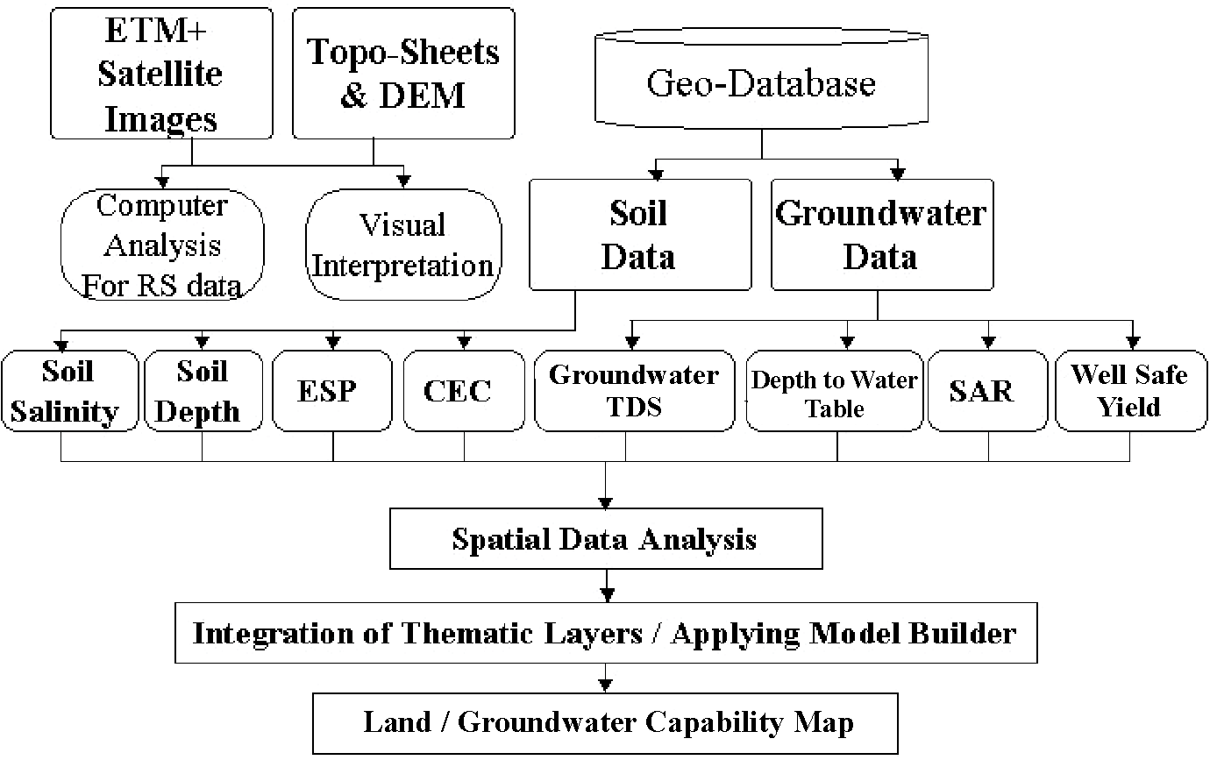
Figure 2. Flowchart of the methodology used for the study

Results and Discussions
The integration of the previously discussed layers in the GIS system, within ArcGIS 9.3.1® software enabled performing the WSCM, and a soil/groundwater capability map with three classes, ranging from low to high capability was produced.
Accordingly, the capability decisive parameters are different in space and time. It implies: a) depth to water as a measure for the accessibility and economy of abstraction, b) well safe yield as a measure for the prolific quantity of water available for agricultural use, c) groundwater total TDS (water quality) as a suitability factor for the water use in agriculture, d) SAR as a measure for sodium hazards of groundwater in irrigation, irrigation water quality assessment, besides its effect on the soil structure, e) soil depth as a measure for soil thickness significant to soil use and management, f) soil salinity that affect the crop productivity, soil sodicity (ESP) that refers specifically to the amount of sodium in soils that affect the plant growth and soil structure under field irrigation, and g) soil cation exchange capacity (CEC) as a value indicating its capacity to hold cation nutrients.
The following is a detailed discussion of the used WSCM parameters:

Table 2. Ranks and weights for data layers and their influencing classes used for soil/groundwater capability mapping
Data Layers | Classes | Average  Rates  (Rank) (R_{f}) | Weights  (W_{f}) | Degree of  Effectiveness  (E)
Groundwater TDS (mg/l) | I (Very High)  II (High)  III (Moderate)  IV (Low)  V (Very Low) | 90  70  50  30  10 | 15 | 13.5  10.5  7.5  4.5  1.5
Depth to groundwater (mbgl) | I (Very High)  II (High)  III (Moderate)  IV (Low)  V (Very Low) | 90  70  50  30  10 | 15 | 13.5  10.5  7.5  4.5  1.5
Groundwater SAR | I (Very High)  II (High)  III (Moderate)  IV (Low)  V (Very Low) | 90  70  50  30  10 | 10 | 9  7  5  3  1
Well safe yield (m³/h) | I (Very High)  II (High)  III (Moderate)  IV (Low)  V (Very Low) | 90  70  50  30  10 | 10 | 9  7  5  3  1
Soil EC (dS/m) | I (Very High)  II (High)  III (Moderate)  IV (Low)  V (Very Low) | 90  70  50  30  10 | 15 | 13.5  10.5  7.5  4.5  1.5
Soil Depth (cm) | I (Very High)  II (High)  III (Moderate)  IV (Low)  V (Very Low) | 90  70  50  30  10 | 15 | 13.5  10.5  7.5  4.5  1.5
Soil ESP (%) | I (Very High)  II (High)  III (Moderate)  IV (Low)  V (Very Low) | 90  70  50  30  10 | 10 | 9  7  5  3  1
Soil CEC (cmoles_{(c)} kg⁻¹) | I (Very High)  II (High)  III (Moderate)  IV (Low)  V (Very Low) | 90  70  50  30  10 | 10 | 9  7  5  3  1

Groundwater Movement and Well safe Yield
Regionally speaking, the depth to groundwater in East Oweinat area ranges from 30-40 mbgl, whereas the depth to top of aquifer ranges from 10-20 mbgl. The direction of groundwater flow is generally northeastwards, following the regional flow trend exhibited by NSAS in the Western Desert, but occasionally distorted by local faults and fracture zones (Fig 3A-C). The aquifer system in East Oweinat area attains high hydraulic conductivity and porosity, where their ranges are 10-20 m/day and 20-30 %, respectively (El Tahlawi et al., 2008).
Locally speaking, the depth to groundwater ranges from 28 to 34 mbgl (Figure 4A). The delineation of the groundwater movement in the pilot study area reflects the influence of subsurface structural conditions represented by horsts and grabens structures causing the reversing of groundwater flow in some locations. The deduced flow direction according to the most recent data is from northwest and south areas towards the southern-central part of the mapped area (Figure 4A).
The recorded present-day hourly discharge rates (well safe yields) (Q) of production wells are within the range of 200-250 m³/h (Figure 4B). The value of Q increases at the south-central part of the mapped area, whereas decreases at its northwestern and southeastern parts. However, although the evaluation of the groundwater resources in East Oweinat has proved that the groundwater can be safely extracted at a rate of 4.7 x 106 m³ d⁻¹ (Nour, 1996), the long-term economies of extraction rates that can sustain the large-scale developmental projects has to be assessed carefully.

Aquifer Thickness
The Six Hills Formation of the NSAS represents the oldest sedimentary rock unit in East Oweinat area and is the sole water-bearing unit, which belongs to the Pre-Aptian age (Said, 1990). The presence of semi-permeable sediments (clay and siltstone) is discontinuous, which is attributed to the rapid lateral facies change. The semi-permeable layers are hydraulically connected with the sub water bearing units, so the Six Hills Formation acts as a water bearing bed of sandstone, which is named commonly as Nubian Sandstone (Yousef 1996; El Tahlawi, 2008). The Six Hills Sandstone aquifer is hydraulically connected with the underlying Precambrian fractured basement rocks, as a result of the fracture system, which initiates secondary porosity zones, but only for shallow few depths within the basement. The measured thickness of this aquifer in the subsurface ranges from 186 to 706 m, with an average of about 446 m. The aquifer saturated thickness range is 100-300 m. Generally, from the constructed cross sections, the thickness increases from the SE (240 m) to NW (580 m), and also from E (160 m) towards W (700 m) directions (Figure 3A-C). The thickness variation of this aquifer is mainly due to the structural setting, which is represented by the effect of numerous fault systems with trends of NE-SW and NW-SE, which configured the basement relief. The sand percentage of this aquifer varies from 74 % to 87 %, with an average value of about 78.74 %. Generally, the sand percentage decreases towards the south (Ghoubachi, 2004).

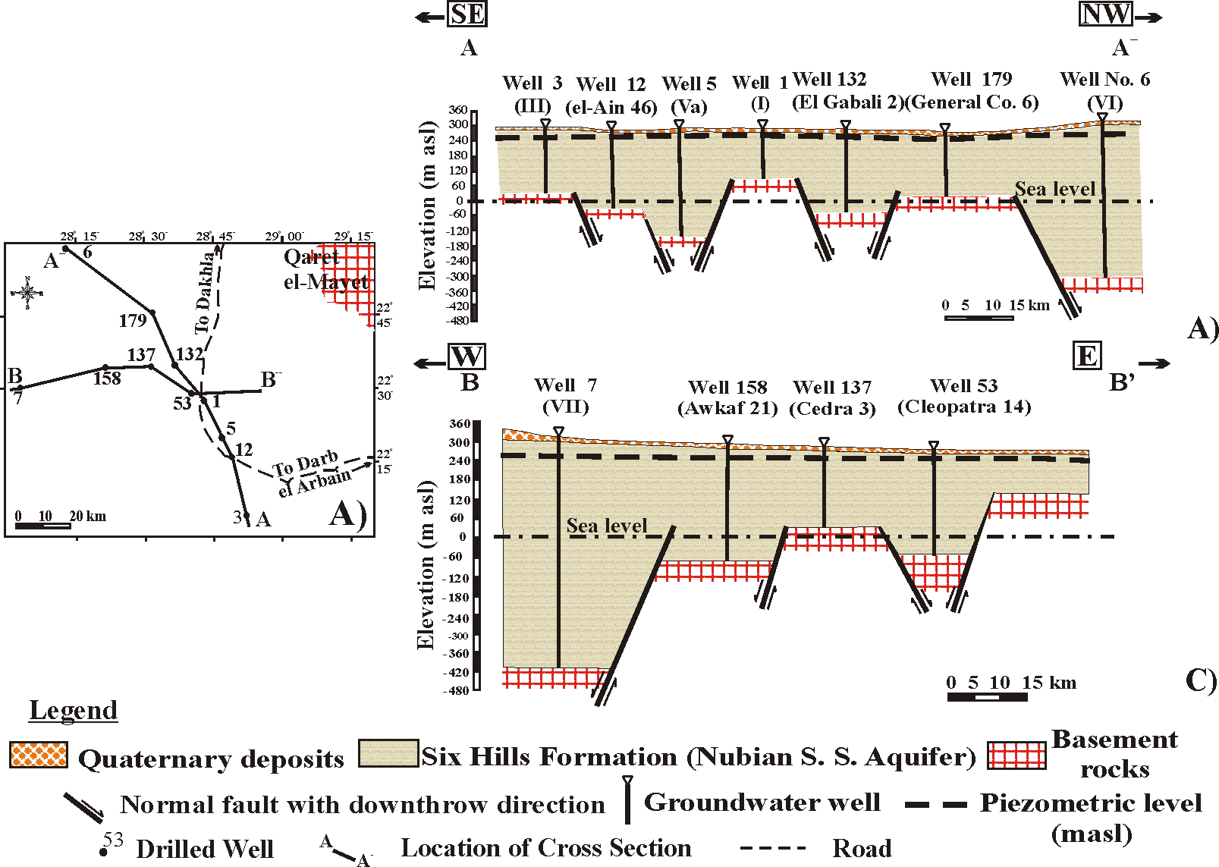
Figure 3. A) Key map of cross sections; B) Hydrogeological cross section A-A⁻; C) Hydrogeological cross section B-B⁻ in East Oweinat regional area
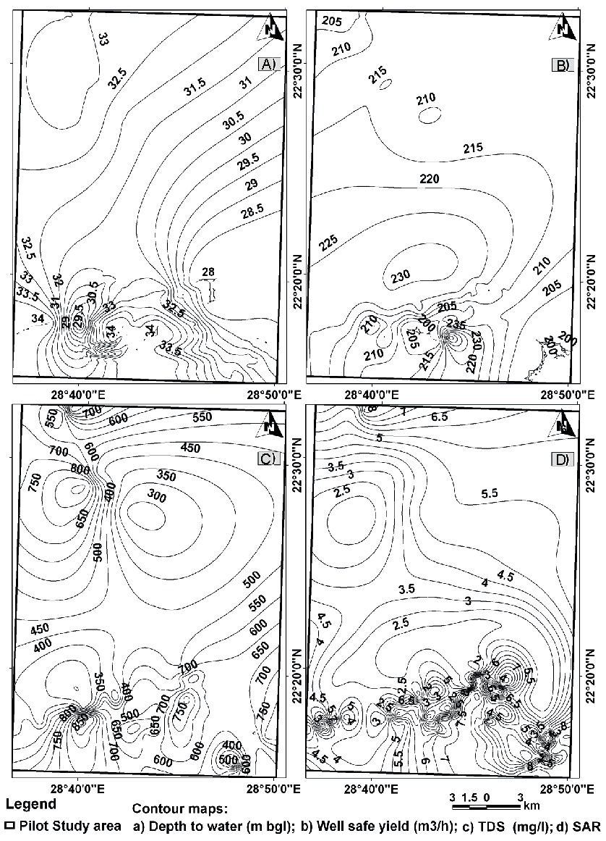
Figure4A-D Groundwater contour maps of WSCM input parameters

General Hydrogeochemistry
The chemical analyses of the collected groundwater samples indicate a low salt content and suitability for irrigation purposes. As the estimated recharge to the area is low compared with the foreseen irrigation water requirements, the development of groundwater in the East Oweinat should be based on groundwater mining. According to Werwer et al., (2000), the groundwater investigations of East Oweinat proved the occurrence of two types of water suitable for irrigation and domestic purposes with the TDS ranges between 278 and 824 mg/l. However, in the present work and according to the data collected in 2008, the TDS variation is from 282 mg/l (well s8/1) to 915 mg/l (well S*). There are no sharp lines of demarcation between water of different salinities. As reflected from the data collected in 2008 (Table 1), the salinity content in East Oweinat area is mainly governed by the location of each well, the subsurface structural setting of water bearing layers, and the lithological variations.
The regional salinity distribution shows increasing salinities towards the north from fresh water (TDS < 1,000 ppm) south of latitude 29º towards highly saline water in the north. Locally speaking, the TDS increases towards the northwestern and southern parts, whereas decreases in the central-northeastern parts of the study area (Figure 4C). The general trend of TDS is towards to the relative salinization. The salinization occur due to the water level depletion resulted from the heavy consumption which led to the withdrawal of more saline deeper horizons, in addition to the prevailing local structural conditions that favor the occurrence of relative hydrogeological closed systems (basins). These basins are characterized by the presence of fault planes exhibiting non-flow boundary conditions. These non-flow boundary conditions are frequently revealed from the long-duration pumping tests (GARPAD, 1994).
The hydrochemical analysis and field measured water quality variables (EC, pH) shows wide hydrochemical variations. In general, sodium and chloride represent the dominant cation and anion, respectively. The majority of the groundwater samples have sodium concentration ranging from 50 to 290 mg/l; while for the chloride, it ranges from 72 to 358 mg/l (table 1). The prevailing water types (hydrochemical facies) are Na-Mg-Ca-Cl-HCO3, Na-Cl-HCO3-SO4, Ca-Na-Cl, Na-Ca-Mg-Cl-SO4, Ca-Na-Mg-Cl-SO4, Na-Ca-Mg-Cl, Na-Ca-Cl-SO4 and Na-Ca-Mg-Cl. However, the dominant water types are Na-Cl-HCO3-SO4 and Na-Ca-Mg-Cl-SO4, respectively, which reflect the prevalence of continental meteoric freshwater conditions, which replaced the original depositional marine saline water trapped between the pores of the Nubian Sandstone.
The dominance of Na and Cl is clearly evident from the Durov diagram (Figure 5). It displays at least three types or facies of waters representing the studied physiographic region. These are Na-Cl-HCO3-SO4, Na-Ca-Mg-Cl-SO4, Na-Ca-Mg-Cl and mixed types (between the three end members). Similarities of water facies would suggest mixing and give an evidence for the hydraulic continuity of water bearing layers. In contrary, major differences would imply that the aquifer units behaved independently due to the subsurface structural setting. The existence of different hydrochemical facies corresponds to the variations in lithology, groundwater recharge rates, temperature gradients and residence time of groundwater in the subsurface semi-closed structural troughs (Figure 3A-C). The groundwater facies change and evolution trends were also revealed by Durov diagram (Durov, 1948; Lloyd and Heathcoat, 1985) (Figure 5). This diagram is based on the percentage of the major ions in meq/l. Both the positive and the negative ion percentages have a total of 100 %. The values of the cations and the anions are plotted in the appropriate triangles and projected into the square of the main fields. The advantage of this diagram is that it displays some possible geochemical processes that could affect the water genesis. Durov diagram for the major cations and anions in the present work was plotted by AquaChem 5.1® software. The fields and lines on the diagram show the classifications of Lloyd and Heathcoat (1985). According to this classifications, the groundwater samples of the study area occurred in Fields numbers 4, 5 and 8, which indicate the water genesis and facies evolution from SO₄ dominant, or anion discriminate and Ca dominant, Ca and SO₄ dominant, which frequently indicates a recharge water in gypsiferous sand deposits, otherwise a mixed water or water exhibiting simple dissolution processes (i. e. Wells 8/1B, GPC1) (Field 4) to no dominant anion or cation, which indicates water exhibiting simple dissolution or mixing processes (that is Wells 1/1B, s7/2, 12/1B) (Field 5) to Cl dominant anion and Na dominant cation, indicating that the groundwater is related to the reverse ion exchange of Na-Cl waters (that is Wells s4, s, s2, s*, s5/3, s8/1, s4/1, Watania, etc.) (Field 8).
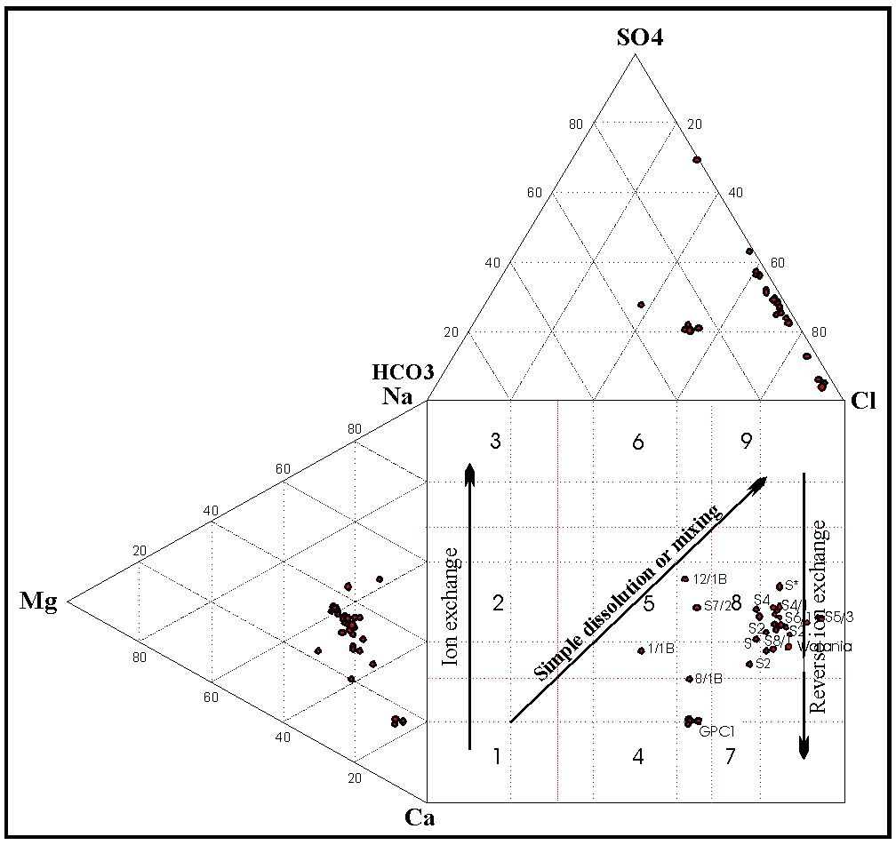
Figure 5. Plot of groundwater samples in Durov’s diagram reflecting the hydrochemical facies evolution and discrimination
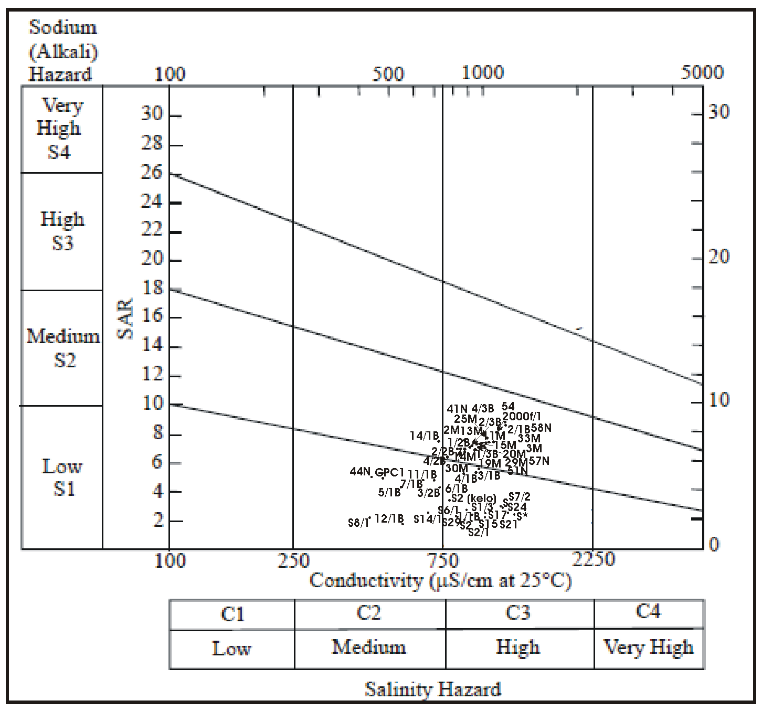
Figure 6. Wilcox diagram illustrating the suitability of groundwater in irrigation purposes

Evaluation of groundwater quality for irrigation uses
The suitability of groundwater for irrigation purposes is determined by its mineral constituents and the type of the plant and soil to be irrigated. Many water constituents are considered as macro or micro nutrients for plants; so, direct single evaluation of any constituent of these will not be of great value except if complete analysis of soil and determination of plant needs are done. Due to that more generalized criteria, which represent combinations of the different water parameters, were adopted worldwide (that is salinity (EC) and SAR), for the evaluation of water quality for irrigation purposes, and will be used in this work.

Groundwater Salinity
Excess salt content of the groundwater increases the osmotic pressure of the soil water and produces conditions that keep the roots from absorbing water. This results in a physiological drought condition. Even though the soil appears to have plenty of moisture, the plants may wilt because the roots do not absorb enough water to replace water lost from transpiration. Based on the EC, irrigation water can be classified into four categories (College of Agricultural Sciences, 2002) as shown in table 3. Based on this classification, the groundwater of the NSAS in East Oweinat has C2 and C3 water types. According to this classification, about 85 % of wells samples fall within the class C3 (High salinity water).

Table 3. Classification of groundwater for irrigation purposes based on salinity (EC) values (College of Agricultural Sciences 2002):
Level | EC  (μS/cm) | Hazard and limitations | Well No.
C1 (Low salinity) | < 250 | Low hazard; no detrimental effects on plants, and no soil buildup expected. | None
C2  (Medium salinity) | 250 - 750 | Sensitive plants may show stress; moderate leaching prevents salt accumulation in soil. | 11/1B, 12/1B, 14/1B, 3/2B, 44N, 5/1B, 7/1B, 8/1B, GPC1, s14/1, s7/2
C3  (High salinity) | 750 - 2250 | Salinity will adversely affect most plants; requires selection of salt-tolerant plants, careful irrigation, good drainage, and leaching. | 1/1B, 1/2B, 1/3B, 11M, 13M, 14M, 15M, 19M, 2/1B, 2/2B, 2/3B, 2000f/1, 20M, 25M, 29M, 2M, 3/1B, 30M, 33M, 3M, 4/1B, 4/2B, 4/3B, 41N, 45N, 48N, 5/3B, 51N, 52N, 54, 55, 55N, 56N, 57N, 58N, 6/1B, 6/2B, 60N, 67, 8M, s, s*, s1/3, s15, s17, s2, s2* (kelo), s2/1, s21, s24, s26, s29, s3/3, s4, s4* (kelo), s4/1, s5/3, s51, s54, s57, s6/1
C4  (Very high salinity) | > 2250 | Generally unacceptable for irrigation, except for very salt tolerant plants, excellent drainage, frequent leaching, and intensive management. | None

Groundwater Sodium hazard
The main problem with the high sodium concentration in groundwater is its effect on the soil permeability and water infiltration. Sodium also contributes directly to the total salinity of the water and may be toxic to sensitive crops. The sodium hazard of irrigation water is estimated by the sodium absorption ratio (SAR), which is calculated by the following formula:

SAR = Na⁺ / ((Ca²⁺ + Mg²⁺) / 2)^{0.5} where the cations are expressed in meq/l. eq. 5

Continued use of groundwater having a high SAR leads to a breakdown in the physical structure of the soil. The sodium replaces calcium and magnesium sorbed on clay minerals and causes dispersion of soil particles. This dispersion results in breakdown of soil aggregates and causes a cementation of the soil under drying conditions as well as preventing infiltration of rain water. Classification of irrigation water based on SAR values is shown in Table 4.

Table 4. Classification of irrigation water based on SAR values (College of Agricultural Sciences 2002):
Level | SAR | Hazard
S1 | <10 | No harmful effects from sodium (All groundwater samples of the study area).
S2 | 10-18 | Appreciable sodium hazard in fine-textured soils of high CEC, but could be used on sandy soils with good permeability (No groundwater samples fall in this category).
S3 | 18-26 | Harmful effects could be anticipated in most soils and amendments such as gypsum would be necessary to exchange sodium ions (No groundwater samples fall in this category).
S4 | >26 | Generally unsatisfactory for irrigation (No groundwater samples fall in this category).

All the samples collected during this study belong to S1 and S2 groups with SAR values < 10. However, 22 well samples out of 74 have SAR values below 3 (samples 12/1B, 8/1B, S*, s1/3, s14/1, s15, s17, s2, s2/1, s21, s26, s29, s3/3, s4, s4*, s4/1, s5/3, s51, s24, s6/1, s7/2, s8/1). Thus, these wells constitute about 30 % of the total samples and are characterized by excellent water suitable for irrigation. The other 70 % of wells (SAR >7) could be used safely for irrigation, but under certain precautions with continuous leaching and selection of salt tolerant crops. The areas characterized by low SAR values occur at the western and southern-central parts of the study area (Figure 4D). A graphical representation, Wilcox diagram (Wilcox, 1955) presented with the help of the GWW software (United Nations, 1995), of the EC and SAR water types recorded in the study area is shown in Figure 5.

Geomorphologic Setting and Soil Characteristics
The area of study is generally a flat plain with hills ridges and scarps, which are mostly rugged and rough. The ground surface elevation varies from about 150 m to 320 m above sea level (masl). The northwestern part of the area is occupied by sedimentary rocks of Paleocene. Lower Eocene forming three pediments of different elevations. The lower pediment stands at 30 m above the surface of the desert plain followed upwards by the middle pediment, which rises more than 60 m above the lower one, followed by the topmost pediment, which rises about 100 m above the middle one (Figure 7).
Nowadays many researchers are increasingly demonstrating the close dependence of soils and geomorphology and a new discipline ”soil geomorphology or pedo-geomorphology” has emerged, incorporating traditional approaches to soils. Soil geomorphology is basically an assessment of the genetic relationship of soils and landforms (Gerrard, 1992). Seven main landforms and their associated soils were identified and delineated across the studied area as shown in Figure (7) and Table (5). These landforms could be presented as follows:

Sand sheets
Sand sheets in the investigated area are flat or gently undulating broad floors with little rock exposure (tabular deposits ranging in thickness from a few centimeters to a few meters). Sand sheets are mainly derived from the Nubian Sandstone scattered over the whole area (Breed et al., 1987). Sand sheets are probably built from successive deposits of sand left behind by the migration of ordinary small sand ripples, along with the fine sediments forming the sand sheets (dust deposited from suspension, and gravels or granules moved by creep). Sand sheets are protected by lag deposits, one grain thick, of the coarsest particles that cannot be moved by the wind, and ranging from coarse sand to pea-sized gravels. This landform could be subdivided into three subunits: high (181.58 km²), moderate (185.94 km²) and low (159.87 km²) (Table 5). The associated soils could be presented as follows:

Table 5. Soil Taxonomy in the different landforms:
Landform | Soil Taxonomy | Area (km²)
High sand sheets  Moderate sand sheets  Low sand sheets  High gravelly sand plains  Low gravelly sand plains  Depressions | Typic Torripsamments  Typic Torripsamments  Typic Torripsamments  Lithic Torripsamments  Lithic Torripsamments  Typic Haplocalcids | 181.58  185.94  159.87  1.94  101.14  117.97

-High sand sheets have deep loamy sand profiles (> 200 cm), where it ranges from 50 to 250 cm (Figures 7 and 8A). Soil salinity (EC) (electrical conductivity) is low where it ranges between 1.5 and 2.5 dS m⁻¹ with very few exceptions (Figures 7 and 8B). Soil reaction is neutral to moderately alkaline (pH locations, where it ranges between 7.07 and 8.20). Organic matter (OM) content is moderate, which is attributed to the relative draught conditions of this arid area, as it ranges between 1.15 and 1.50 %. CaCO₃ content is low, where it ranges from 1.06 to 3.91 %. Cation exchange capacity (CEC) is moderate to high in such texture and organic content, where it ranges between 5 and 30 but with a progressive trend reaching 70 cmoles kg⁻¹ for soils derived from sheet erosion at the southeastern corner of the studied area (Figures 7 and 8C). Exchangeable sodium percentage (ESP) is low to medium where it ranges between 4.5 and 13.5 (Figures 7 and 8D). Compared to the EC values, these ESP values refer to a non-salt affected and flocculated soil, but relative sodium toxicity symptoms may be expected at some areas at the southern and northern parts having ESP more than 10. This unit could be classified as Typic Torripsamments.

–Moderate sand sheets are moderately deep soils, which are almost loamy sand-textured (75-275 cm depth) with few exceptions of sandy layers (Figures 7 and 8A). EC is low where it ranges between 1.5 and 3.0 dS m⁻¹ (Figures 7 and 8B). pH is neutral with few exceptions characterized by the moderately alkaline nature, where it ranges between 7.10 and 8.00. OM is moderate, where it ranges between 1.00 and 1.56 %. CaCO₃ content is very low where it ranges between 1.91 and 2.21 %. CEC is moderate in such texture and OM content, where it ranges between 5.0 and 30.0 but with a progressive increase that may reach 45.0 cmoles_{(c)} kg⁻¹ for soils derived from sheet erosion at the southwestern part of the studied area (Figures 7 and 8C). ESP is low to medium where it ranges between 4.5 and 15 (Figures 7 and 8D). Compared to the EC values, these ESP values refer to a non-salt affected and flocculated soil. This unit could be classified as Typic Torripsamments.

-Low sand sheets Soil depth ranges between 50 and 275 cm (Figs. 7 and 8A). Soils have low to moderately deep profile almost loamy sand layers with some few exceptions of sandy layers. EC is low, where it ranges between 1.5 and 3.0 dS m⁻¹ (Figures 7 and 8B). Soil pH is neutral to slightly alkaline, where it ranges between 7.23 and 7.95. OM is moderate, where it ranges between 0.82 and 1.28 %. CaCO₃ content is low, where it ranges between 1.09 and 2.72 %. CEC ranges between 5.0 and 15.0, but with a progressive increase that may reach 60 cmoles_{(c)} kg⁻¹ for soils derived from sheet erosion at the northwestern part of the studied area (Figures 7 and 8C). ESP is low, where it ranges between 5.0 and 10.5 (Figures 7 and 8D). Compared to the EC values, these ESP values refer to a non-salt affected and flocculated soil. This unit could be classified as Typic Torripsamments.

Depressions of the study area are low-lying deflated area, which are called blowouts. It looks like hollows. It was formed by the removal of particles by the wind action or what is called deflation. Blowouts may cover several kilometers in diameter. Grinding by particles carried out by the wind creates grooves or small depressions. Depression in the studied area was formed by tectonic movements in the past, which was subsequently reshaped by the deflation processes. Depression area is represented by an area of117.97 km². It is associated with a relatively shallow soil, where the soil depth ranges between 75-250 cm of sandy textured profile (Figures 7 and 8A). .EC is low, where it ranges between 1.5 and 3 dS/m (Figures 7 and 8B). pH ranges between 7.72 and 7.97, reflecting the slightly alkaline soil type. OM is low, where it ranges between 0.10 and 0.60 %. CaCO₃ content is very high, where it ranges between 24.56 and 46.67 %. Calcic horizon was observed through the abundance of hard lime concretions in these soils. CEC is low where it ranges between 5.0 and 20.0, but with a remarkable increase to the northwestern part that may reach 60.0 cmoles_{(c)} kg⁻¹ (Figs. 7 and 8C). ESP is medium where it ranges between 5.0 and 13.5 (Figures 7 and 8D). Compared to the EC values, these ESP values refer to a non-salt affected and flocculated soil. Soils of this unit could be classified as Typic Haplocalcids.

Gravelly sand plains
These plains are entirely covered by gravels with different diameters. These layers of gravels preclude the agriculture development. The gravelly plains could be subdivided into two subtypes that is, high gravelly sand plains and low gravelly sand plains as follows:

-High gravelly sand plains (1.94 km²) are composed of gently sloping or nearly horizontal layers. Soil depth ranges between 175 and 275 cm (Figures 7 and 8A) .Its depth is limited by the bedrock (parent) material. Soils have low elevated gravely sand profiles (around 75 cm depth), where a lithic contact within 50 cm of the topsoil was found. EC is low, where it ranges between 2.0 and 2.5 dS/m (Figures 7 and 8B). pH ranges between 7.11 and 8.22, reflecting the neutral to moderately alkaline soil type. OM is low where it ranges between 0.13 and 0.63 %. CaCO₃ content is high ranging between 13.98 and 16.34 %. CEC ranges between 15.0 and 20.0 cmoles_{(c)} kg⁻¹ (Figures 7 and 8C). ESP is low, where it it is about 6.0 (Figures 7 and 8D). Compared to the EC values, these ESP values refer to a non-salt affected to saline and flocculated soil. This unit could be classified as Lithic Torripsamments.

-Low gravelly sand plains (101.14 km²) are similar to the high gravelly sand plain. They are composed of gently sloping or nearly horizontal layers. Soil depth ranges between 175 and 300 cm (Figures 7 and 8A). Its depth is limited by the bedrock material. Soils have low elevated sandy profiles (around 55 cm depth), where a lithic contact within 53 cm of the topsoil was found. EC is low, where it ranges between 2.5 and 4.5 dS/m (Figures 7 and 8B). pH ranges between 7.10 and 8.12, reflecting the neutral to moderately alkaline soil type. OM is low, where it ranges between 0.19 and 0.53 %. CaCO₃ content is high, ranging between 10.18 and 17.54 %. CEC ranges between 5.0 and 50.0 cmoles_{(c)} kg⁻¹ (Figures 7 and 8C). ESP ranges from 6.0 to 15.0 (Figures 7 and 8D). Compared to the EC values, these ESP values refer to a non-salt affected and flocculated soil. This unit could be classified as Lithic Torripsamments.
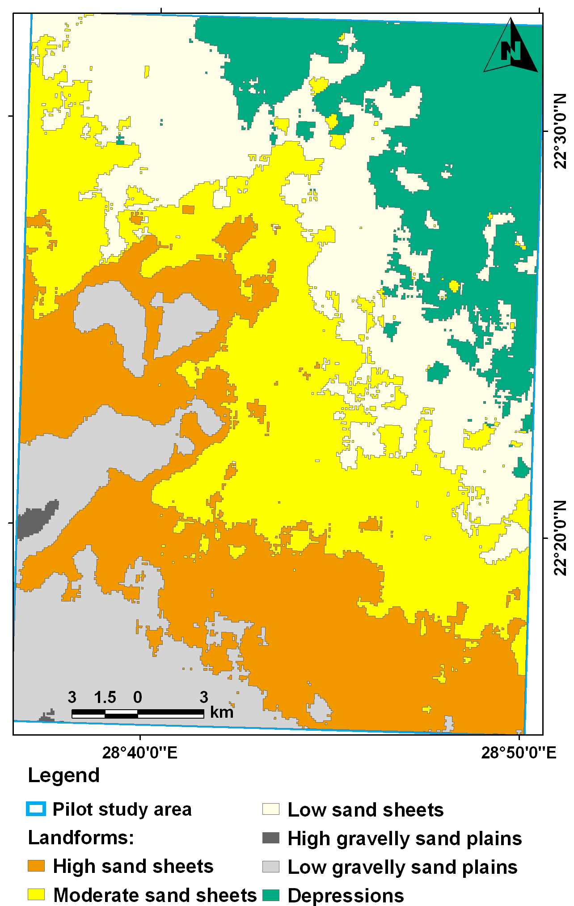
Figure 7. Geomorphologic map with soil sampling pattern and soil taxonomy (based on Landsat 7 ETM+ image, taken in 2005)
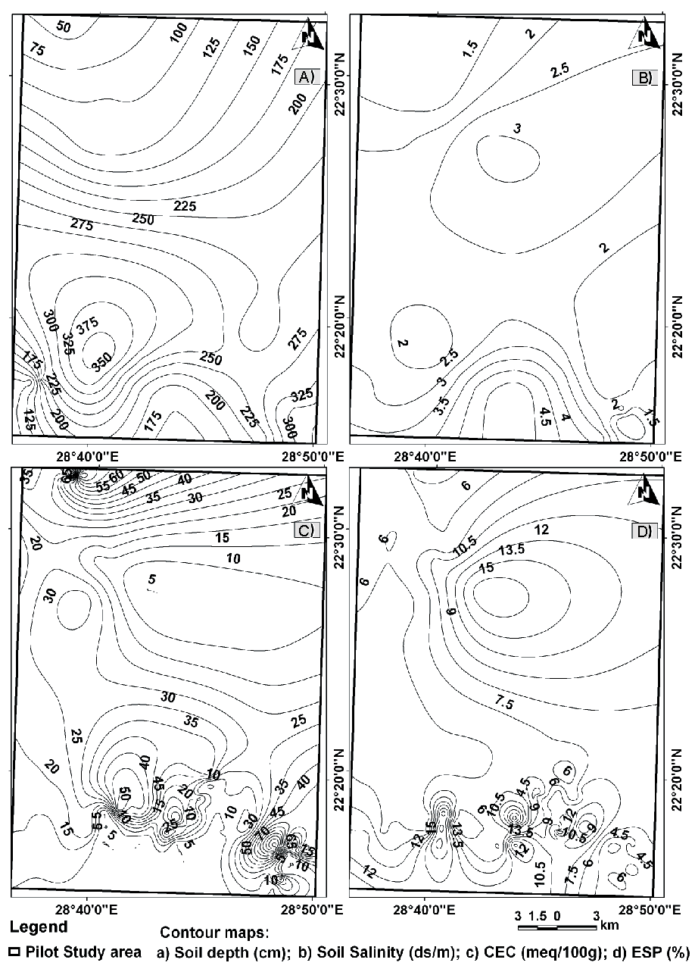
Figure 8A-D. Groundwater contour maps of WSCM input parameters

Soil and groundwater capability classes and running the WSCM
The spatial analysis was performed on the previously discussed GIS layers through running the WSCM to determine the capability classes according to the previously discussed capability criteria confirmed by field truthing, where the soil/groundwater capability map was produced (Figure 9). The model parameters (layers), their rates, assigned weights and degree of effectiveness are given in table (2). The ranges of these layers were determined for each layer as according to the their graded values, from very high to very low, as: < 450, 415-541, 541-667, 667-793, > 793 mg/l for the groundwater TDS; < 29, 29-30, 30-32, 32-33, > 33 mbgl for the depth to groundwater; < 3.2, 3.2-4.6, 4.6-5.9, 5.9-7.3, > 7.3 for groundwater SAR; > 238, 238-229,229-219, 219-210, < 210 m³/h for well safe yield; > 318, 318-249, 249-180, 180-111, < 111 cm for soil depth; < 1.8, 1.8-2.5, 2.5-3.3, 3.3-4.0, > 4.0 dS/m for soil EC; > 71, 71-54, 54-38, 38-21, < 21 cmoles_{(c)} kg⁻¹ for soil CEC; and < 6.2, 6.2-8.6, 8.6-11.0, 11.0-13.4, > 13.4 for soil ESP. Thus, the capability areas could be described as integrated roles of these criteria.
The data manipulation implied integrating all thematic layers within the WSCM. However, not all these layers have the same magnitude of contribution on soil/groundwater capability mapping. For example, the layers of groundwater TDS, depth to groundwater, soil salinity and soil depth are more effective than the groundwater SAR, well safe yield, soil ESP and soil CEC. Also some factors work negatively while others work positively in soil/groundwater capability mapping, like that in groundwater TDS, depth to groundwater, groundwater SAR, soil salinity and soil ESP which work negatively in capability classification, whereas the Well safe yield, soil depth and soil CEC work positively in such task. For this reason, each layer was assigned a specific weight of effect on capability mapping (table 2). The given weights were adopted, in addition to the field observations and the experience gained from the previous similar works (that is Bennet DA (1997a and b). therefore, the integrated layers in this study were given the weights (W_{f}), average rates (R_{f}) and degree of effectiveness (E) as shown in table (2). The degree of effectiveness was obtained for each class category according the following equation (eq 6):

E = W_{f} x R_{f} (eq 6)

Upon running the WSCM the soil/groundwater capability map was evolved only into three classes as: high, moderate and low (Figure 9). For a variety of reasons, the high (174.48 km²) and moderate (492.99 km²) soil/groundwater capability classes (areas) may be determined to be of highest priority for land use. The moderate capability class occupies 65.87 % of the total mapped area, whereas the high capability class represents 23.31 % of the studied area. The high capability class occupies a more or less rectangular strip in the central-southern portion of the mapped area, whereas the low capability class (80.94 km²), which constitutes only 10.81 % of the total mapped area and is encountered only at the southern part with some small enclosed areas at the northern one. The map indicated that the high and moderate soil/groundwater capability classes represent about 89.18 % of the total mapped pilot area, whereas the low capability class is restricted only to an area having 10.81 % of the total studied area. The already established land use regime depending on the soil and groundwater resources occurs in the high and moderate capability classes discriminated by the WSCM map, which indicates the success of model logics, and also suggests other promising areas suitable for further developmental expansion in this vital developmental area.

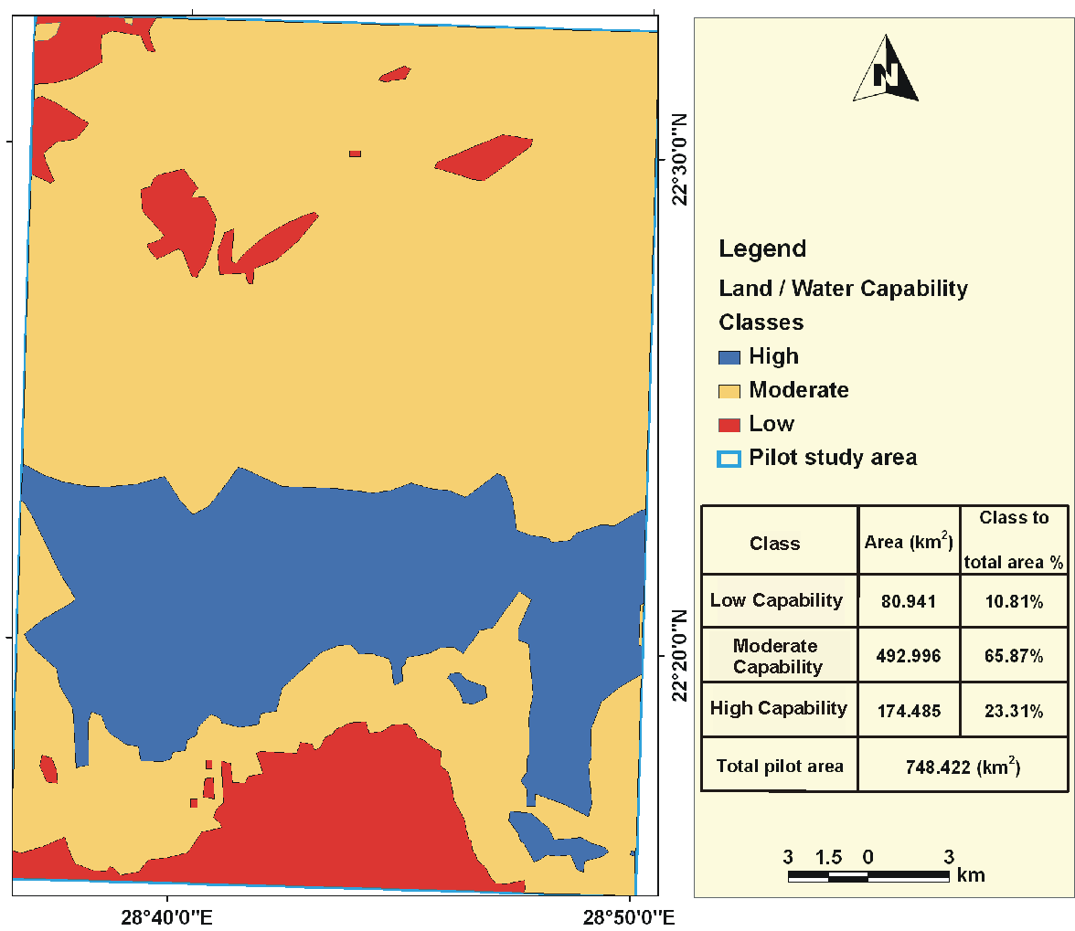
Figure 9. Soil/groundwater capability map constructed by WSCM technique, according to the data acquired in 2007-2008

Conclusion
The present work aims to use the NSAS hydrogeological, hydrogeochemical and pedological characteristics as trustful input multi-decision criteria for determining the different soil/groundwater capability classes. Complete upgradable geographic information system (GIS) and weighted spatial capability model (WSCM) were built to determine these classes. The output map of WSCM reflected that the capability classes high, moderate and low are distinguished in the mapped pilot area. However, the WSCM technique proved its usefulness for determining soil/groundwater capability classes, and for being a good tool for management and land use planning. The classes established indicate the dominance of the moderated soil/groundwater capability class, which reflects the success of present land use pattern of East Oweinat area in the last few decades. Additionally, this indicates that the high potentiality of both groundwater and soil resources that should be protected against any future mal practices.

Acknowledgement
The authors acknowledge the National Authority for Remote Sensing and Space Sciences (NARSS) for funding an internal research project principally investigated by the second author of the present work, from which, the data of the present work was derived. Thanks also dedicated to the anonymous reviewers and editors of the Environmental Earth Sciences.

References
Abdallatif, T. A., Mabrouk, M. A., and Youssef, A. M., 1997, Geoelectrical resistivity survey to delineate the geologic setting of East El-Oweinat area, South Western Desert, Egypt. EGS Proc Ann, v. 15, p. 45–58
CONOCO (Continental Oil Company), 1987, Geological Map of Egypt, Scale 1: 500,000.
Bandyopadhyay, P., 2007, Soil Analysis. 286 p Hardcover ISBN-13: 9788189729691.
Bennet, D. A., 1997a, A framework for the integration of geographical information systems and model base management. International Journal of Geographical Information Science, v. 11(4), p. 337-357.
Bennet, D. A., 1997b, Managing geographical models as repositories of scientific knowledge. Geographical and Environmental Modeling, v. 1(2), p. 115-133.
Brinkmann, P. and Heinl, M., 1986, Numerical groundwater model. In: Thorweihe U (ed) Impact of climatic variation on East Saharan groundwater. Modeling of large scale flow regimes. Proceedings of a workshop on hydrogeology, 20–22 May 1985. SFB 69, Berl Geowiss-Abh (A) 72.
Brinkmann, P. J., Heinl, M., Hollander, R., and Reich, G. 1987, Retrospective simulation of groundwater flow and transport in the Nubian Sandstone aquifer system. Berl Geowiss-Abh (A), v.75 (2), v. 465-516.
College of Agricultural Sciences, 2002, Irrigation water quality. The Pennsylvania State University, USA. (http://www.cas.psu.edu/docs/casdept/Turf/Education/Turgeon/CaseStudy/OldRanch/IrrWatQual.html).
Deutsch, C. V., and Journel, A. G., 1992, GSLIB: Geostatistical Software Library and User's Guide. Oxford University Press, New York,.
Durov, C. A., 1948, Natural waters and graphic representation of their composition. Akad. Nauk S.S.S.R. Doklady, v. 59, p. 87-90.
Ebraheem, A. M., Riad, S., Wycisk, P., and Seif El-Nasr, A. M., 2002, Simulation of impact of present and future groundwater extraction from the non-replenished Nubian Sandstone aquifer in Southwest Egypt. Environmental Geology, v. 43, p. 188-196.
El Tahlawi, M. R., Farrag, A. A., and Ahmed, S. S., 2008, Groundwater of Egypt: ‘‘an environmental overview’’. Environ Geol (2008) 55:639–652. DOI 10.1007/s00254-007-1014-1
ESRI, 2009, ArcGIS 9.3.1© Software and user manual. Environmental Systems Research Institute, Redlands, California 92373-8100, USA. http://www.esri.com.
FAO, 1990, Guidelines for soil profile description. 3rd edition (Revised), FAO, Rome.
GARPAD (General Authority for Rehabilitation Projects and Agricultural Development), 1994, Internal Report for Projects Resource Evaluation of (3000 ft), Ministry of Agriculture and Land Reclamation, Cairo.
GPC (General Petroleum Company), 1984, Hydro-Agriculture study of East El-Oweinat region, Western Desert, Egypt: Ministry of Petroleum, ARE, V. 3-A, 178, p.20.
Gerrard, J., 1992, Soil Geomorphology. An integration of pedology and geomorphology. -Chapman & Hall, 269 p.
GSE (Geological Survey of Egypt), 1987, Geology and geomorphology of the Egyptian component transitional Nubian Sandstone project: Report to Groundwater Research Institute, Egypt.
Ghoubachi, S. Y., 2004, Comparative hydrological studies of the Nubia Sandstone aquifer system in East El-Oweinat and Bir El Shab areas, South western Desert, Egypt. Ph.D. thesis, Al-Azhar University, , , 187 p.
Gossel, W., Ebraheem, A. M., and Wycisk, P., 2004, A very large scale GIS-based groundwater flow model for the Nubian sandstone aquifer in Eastern Sahara (Egypt, northern Sudan and eastern Libya). Hydrogeology Journal, v. 12, p. 698–713.
Heinl, M., and Thorweihe, M., 1993, Groundwater resources and management in SW Egypt: Catena supplement, v. 26, p. 99-121.
Idris, H., Nour, S., 1990, Present Groundwater Status in Egypt and the Environmental Impacts. Environ Geol Water Sci, V. 16 (3), p. 171-177.
Issawi, B. 1971, The geology of Darb E1 Arbain, Western Desert, Egypt. Ann Geol Surv Egypt, v. 1, p.53-92
Issawi, B., 1978, Geology of Nubia West Area, Western Desert, Egypt: Ann. GSE, Cairo, V. 3, p. 237- 253.
Journel, A. G., Huijbregts, C. H. J., 1981, " Mining Geostatistics", Academic Press.
ITT, 2009, ITT corporation ENVI 4.7 software, 1133 Westchester Avenue, White Plains, NY, 10604, USA.Klitzsch, E. and Lejal-Nicol, A. 1984, Flora and fauna from strata in Southern Egypt and Northern Sudan, Nubia and surrounding areas: Berliner gewiss. Adh., (A), Berlin. v. 50, p. 47- 79.
Lillesand, T. M., and Kiefer, R. W., 2007, Remote sensing and image interpretation,5th ed. Paper back September 2007,John Wiley, New York, 820 p..
Lloyd, J. W., Heathcote, I. A., 1985, Natural inorganic hydrochemistry in relation to groundwater. Clarendon Press, Oxford.
Malczewski, J., 1999, GIS and Multicriteria Decision Analysis. John Wiley and Sons, New York, NY.
Mitchell, A., 1999, The ESRI Guide to GIS Analysis: Geographic Patterns and Relationships, Environmental Systems Research Institute, Inc., v. 1, p. 48-49.
NARSS (National Authority for Remote Sensing and Space Sciences), 2008, Regional flow conditions and structural setting of the Nubian Sandstone aquifer system in Southern Western Desert of Egypt using remote sensing and GIS and mathematical modeling techniques. Unpublished Report, 132 p.
Nour, S., 1996, Groundwater potential for irrigation in the East Oweinat area, Western Desert, Egypt. Environmental Geology, v. 27, p. 143-154.
Ranchin, T., and Wald, L. (eds), 2000, Proceedings of the third conference -Fusion of Earth data: merging point measurements, raster maps and remotely sensed images", Sophia Antipolis, France, January 26-28, 2000, published by SEE/URISCA, Nice, France, 166 p.
Robinson, C. A., Werwer, A., El-Baz, F., El-Shazly, M., Fritch, T. and Kusky, T. 2007, The Nubian Aquifer in Southwest Egypt. Hydrogeology Journal “Remote Sensing & GIS in Hydrogeology”, V. 15:1, p. 33-45.
Sadek, M. A., Abd El-Samie, S. G., El-Arabi, N. E., and Ahmed, M. A., 2001, Hydrochemical, isotopic and age characteristics of the groundwater in the Nubian sandstone aquifer, South Western Desert, Egypt. Isotope Rad. Res., v. 33, p. 161–177.
Said, R., 1990, The geology of Egypt: Balkema, Rotterdam, 734 p.
Salem, O., and Pallas, P., 2001, The Nubian Sandstone Aquifer System (NSAS). In: Puri, S. (editor): International Shared (Transboundary) Aquifer Resources Management – Their significance and sustainable management. IHP-VI, IHP Non Serial Publications in Hydrology. UNESCO, Paris.
Soil Survey Staff (1951) Soil Survey Manual U.S. Dept. Agric., Handbook, No. 18., Government printing office, Washington, D.C.
Sonntag, C., 1986, A time-dependent groundwater model for the Eastern Sahara. Berl Geowiss-Abh (A), v. 72, p. 124–134.
Talbot, C., 1998, Geographic Information System Applications in the Retail Banking Sector. OXIRIM. Retrieved: November 11, 2005 from EBSCOhost database.
Thorweihe, U., 1990, The Nubian aquifer system. In: Said R (ed) The Geology of Egypt. Balkema Lisse, The Netherlands, p. 601–614.
UNITED NATIONS, 1995, Ground water software for windows (GWW), New York.
USDA, 2006, Keys to Soil Taxonomy United States Department of Agriculture, Tenth Edition, 2006, USA.Waterloo Hydrogeologic, 1997, AquaChem 3.7 Software. Copyright 1997, Lucas Calmbach, All rights reserved. www.swstechnology.com (accessed in 2010).
Werwer, A. M., Mahmoud, M. E, Esmail, A. H., 2000, Groundwater quality of east El-Oweinat (Western Desert, Egypt). The first international conference for environmental hazards mitigation (ICEHM2000) Abstracts, Cairo University, Giza.
WILCOX, L. V., 1955, Classification and use of irrigation waters. US Dept. Agric. Circ. 969. Washington, D.C., USA. 19 p.
Yousef, A. M., 1996, Geophysical study on the Nubia Sandstone Aquifer in East El Oweinat area Southwest Egypt: Ph.D. thesis, Geophysics Dept., Fac. of Sci., Ain Shams Univ., 174 p.

