GENETIC DIVERSITY OF Shistosoma mansoni ISOLATES GENOME AND PROTEIN ANALYSIS

Mohammed Yahia Araishi
Collage of health Science, Jazan Univ., Saudi Arabia.
dr_mona_zaki@yahoo.co.uk

ABSTRACT

Five of Shistosoma mansoni isolates which differ in disease potential show genetic variability. Esterase isozymes, protein pattern and DNA finger-print analysis successfully revealed genetic diversity. DISC PAGE esterase isozymes revealed 5 bands which differ in density and relative mobility among SM₁, SM₃, SM₄, SM₅, while 4 bands with SM₂. SDS-PAGE of protein finger print varied among the five isolates in number of protein species 19.18, 17.16 and 16 bands of SM₁, SM₂, SM₃, SM₄ and SM₅ isolates respectively as well as in intensity. Molecular weight and reproducibility polymorphism analysis presented 12 common fragments (monomorphic) with 54%, 8 specific bands (polymorphic) with 45% and 4 bands unique with 20%. RAPD-PCR for identification of the 5 S. monsoni isolates were conducted on the screening of primers and on the extraction of template DNA. Three out of 10 sequence 10 mer primers were successful in identification of the 5 S. monsoni isolates. PCR amplification yielded reproducible RAPD patterns which differentiated the 5 isolates examined. The difference also recognized the RAPD patterns specially of SM5. Esterase isozymes, protein and DNA fragments conformed the genetic diversity among 5 S. mansoni isolates.
Key words: S. mansoni, esterase isozymes DISC-PAGE, RAPD-PCR, protein and DNA fragments.

INTRODUCTION
Schistosoma mansoni is one of the most severe tropical diseases in the world. Egypt is one of the most highly endomic areas in some localities in the Nile Valley. Biomphalaria alexandrina snail as specific intermediate host of S. sansoni are prevalent in both upper and lower Egypt, but during the last decade, it become the most dominant species in the Nile Delta forming a main threat for Schistosomiasis transmission in the North of Egypt. This wide distribution of the disease makes the study of genomic variability extremely important. There are well known two distinct geographical strains of S. mansoni, the Puerto Rican and the Egyptian strains (Saoud, 1966). However a new geographical strain namely, Saudi Arabian strain has been reported based on differences with the Egyptian strain shown by seanning electron microscopy (Shalaby et al., 1993).
Several techniques of molecular biology for studies S₁, S₂, S₃, S₄ , S₅, of genetic variability in Schistosomiasis vector have been used (Da Silva et al., 2004). An introduction of the random amplified polymorphic DNA-polymerase chain reaction (RAPD-PCR) technique (Jamjoom, 2006) has amplified possibilities of polymorphism analysis and biochemical markers, as enzyme isozymes (Lockyer et al., 2000).
The present study emphasizes our interest in soil genetics to detect genetic variability among five S. mansoni using RAPD-PCR and isozymes for genetic analysis of DNA genome of S. mansoni snails and protein enzymes.

MATERIALS AND METHODS
Parasite isolates: Five adult worms isolates of repeated twice S. mansoni from (Southern region). (Delta region) and (east region) at Egypt. They were obtained from theodor Bilharz Research Institute and originally selected on the basis of healthy different size and pathogenicity according to Longand and Marand (1995).
SDS-PAGE electrophoresis: Protein content of adult worms was determined by Lowry’s method (Lowry et al., 1951) using bovine serum albumin as a standard.
Protein pattern was determined by sodium dodecyl sulfate polyacrylamide gel electrophoresis (SDS-PAGE) as described by Laemmli (1970) under reducing condition using 12% pore gel with 3.7% stacking gel in a discontinuous electrode buffer system. Protein samples and molecular weight markers (Sigma) were denatured and reduced completely before electrophoresis by mixing the samples with an equal volume of 2x sample buffer and heating the mixture at 95ºC in a water bath for 5 min. Treated samples were centrifuged at 12000 rpm for 10 min and chilled on ice before use. Each lane was charged with 25 µg protein of supernatant. For subsequent fractions, the lanes were field up to their full capacity (50 µl). Electrophoreis was carried out a room temperature at a constant current of 25 mA for 1 hr followed by 30 Am for 4 hr. At the end of the run, gel was stained with commassie blue and destained in the stain solvent and photographed.
Isozyme electrophoresis: The adult worms were homogenized in Tris. Glycine buffer and centrifuged at 10000 rpm for 10 min. The suprnatent was kept at -20ºC until electrophoresis according to Jonathan an Wondell, 1990).
Isozyme variability was assayed by nature polyacrylamide slob gel electrophoresis using 8% acrylamide. Each sample was mixed with bromophenol blue and applied to each well, the nels were stained with the solution contain Na-phosphate and α, β naphthyl acetate an fast blue CR salt. The get was inoculated at 4ºC in work and adding the appropriate substrate and staining solution (Jonathan and Wendell, 1990).
DNA isolation: DNA was extracted from individual frozen adult worms and homogenized with a pestle on Eppendrof tube containing 100 µl of 10 mM Tris-HCl pH 8.0; 1 mM EDTA, 10 mM NaCl an 70 mM sucrose. Sodium dodecyl sulfate (10%) and (12 µl) proteinase 10 mg ml⁻¹ were added to Eppendrof tube. The tubes were incubated at 57ºC for 2 h. Then extracted once with an equal volume of phenol and once with chloroform. The DNA was precipitated by 0.3 M sodium acetate; 2 volume of absolute ethanol at 20ºC overnight. The DNA was pelleted by centrifugation (15000 g/20 min at 4ºC) then rinsed with ethanol 10% dried and finally resuspended in 100 µl of TE buffer (10 mM Tris HCl pH 8.0 and 1 mM EDTA. The purified DNA concentration was determined spectrophotometrically at 260 nm and 280 nm and also by using 2% agarose gel electrophoresis.
RAPD-PCR analysis: Three orbitrary primers, A7 (5` gaaocaaatg –3`) A8 (5`-gtgacgtagg-3`) and A6 (5`-gtgcaagtct-3`) were used a described by Simpson et al. (1993) with modifications: 2 ng of DNA genome were amplified PCR thermal cycler). Each reaction was carried out in a final vol. Of 10 µl containing 1 unit Taq DNA polymerasem 1x PCR buffer, 0.2 mM each dNTP and 7 p mol of each random primer (Gibco). The amplification conditions were as follows: 1 cycle at 95ºC for 5 mm, 3 steps, at 95ºC for 30 sec, 30ºC for 2 min and 72ºC for min and 72ºC for 1 min and 33 cycles during which the annealing temperature was changed to 40ºC and the time of the extension step was increased to 5 min during the final cycle.
The PCR products were visualized on 1.5% agarose gels and stained with ethidium bromide to resolve amplified fragments and photographed.

RESULTS
Somaclonal variations among 5 isolates of S. mansoni were detected by protein pattern, esterase activity, isozymes and DNA fingerprint.
Protein content was determined in adult warm of each isolate related to BSA (Table 1). It was revealed that the protein content was varied among 5 isolates with 480, 425, 392, 405 and 385 mg/g fresh weight of adult worms.
Esterase activity was assayed of each isolate. The specific activities of enzyme was 4.25; 4.75; 3.82; 5.12 and 3.25 µ/mg protein for SM₁; SM₂; SM₃; SM₄ and SM₅ respectively (Table 1). Esterase isozymes are shown in Fig. (1.A) and calculated in Table (2). The total number of isozymes 8 bands differ in number and density among five isolate such as 4 band of SM₁ isolate and 5 bands of each SM₂, SM₃, SM₄ and SM₅ out of 8 total isozymes bands. The esterase isozyme variability among isolates showed some isozymes band disappeared in SM₁ (0.25, 0.35, 0.55, 0.75 R_{f}); SM₃ (0.25 M, 0.35, 0.75 R_{f}); SM₃ (0.25, 0.55, 0.75 SM₄ (0.35, 0.55, 0.75 R_{f}) and SM₅ (0.25, 0.35, 0.55 R_{f}). As well as one unique band (genetic marker) at R_{f} 0.25 (SM₄), 0.35 (SM₃); 0.55 (SM₂) and 0.75 (SM₅) isolates and monomorphic (common isozyme band) in five isolates at R_{f} 0.42, 0.45, 0.61 and 0.64.

Table (1): Protein content and esterase activity of five Schitosoma mansoni isolates.
 | Esterase activity
S. monsoni isolates | Protein content (mg/g) | Total activity  (µ) | Specific activity  (µ/mg)
SM₁  SM₂  SM₃  SM₄  SM₅ | 480  425  392  405  385 | 2040.00  2018.75  1497.44  2673.60  1251.25 | 4.25  4.75  3.82  5.12  3.25

Table (2): Esterases isozymes analysis of the Schistosoma monsoni five isolates.
Schistosoma monsoni isolates
No. | R_{f} bands | SM₁ | SM₂ | SM₃ | SM₄ | SM₅ | Polymorphism
1 | 0.25 | - | - | - | + | - | Unique
2 | 0.35 | - | - | + | - | - | Unique
3 | 0.42 | ++ | ++ | ++ | ++ | ++ | Monomorphic
4 | 0.45 | +++ | +++ | +++ | +++ | +++ | Monomorphic
5 | 0.55 | - | ++ | - | - | - | Unique
6 | 0.61 | ++++ | ++++ | ++++ | ++++ | ++++ | Monomorphic
7 | 0.64 | +++ | +++ | +++ | +++ | +++ | Monomorphic
8 | 0.75 | - | - | - | - | + | Unique
Total |  | 4 | 5 | 5 | 5 | 5
R_{f} = Relative mobility
Unique = Genetic marker
Monomorphic or common isozyme band
Band density ++++ very strong; +++ Strong , ++ Moderate
+ Weak and - Absent band

SDS-PAGE protein fractions was illustrated in Fig. (1-B) and Table (3). The results showed the variation of S. monsoni isolates in protein fractions and density bands. The variability analysis among isolates appeared 24 protein fractions. Out of them 19, 18, 17 polypeptides appeared in SM₁, SM₂, SM₃ isolates respectively and 16 polypeptides in both SM₄ and SM₅. Some polypeptides bands disappeared among isolates (Table 3). The molecular weight of polypeptides were determined related to protein marker (Table 3). The most prominent alteration (polymorphic bands) among 5 isolates 122, 108, 60, 20 KDa with percentage 16%. The prominent polypeptide bands in all isolates (monomorphic or common fragments) were 156, 110, 100, 97, 85, 70, 54, 44, 36, 33, 24, 18 and 10 KDa with percentage 54%. The unique fragment (genetic markers) with 73, 39 (SM₁); 15 (SM₂); 65 (SM₃), 175 (SM⁴) and 28, 26 (SM₅) with percentage 30%.

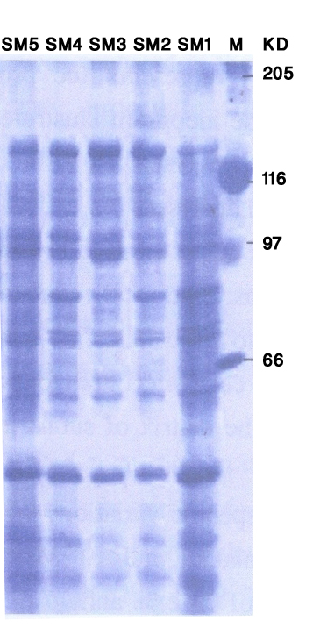
A

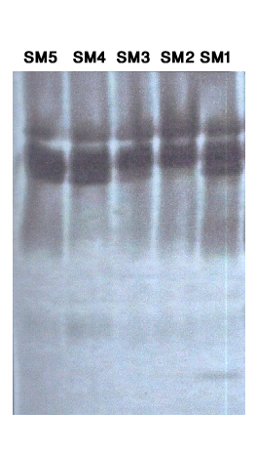

B

Fig. (1): Electrogram protein and isozymes profiles of five S. mansoni isolate.
1-A: SDS-PAGE (12%) of denaturated protein extracted from 5 isolates.
1-B: DISC-PAGE (12%) of native protein esterase isozymes.
M: Markers protein (KDa), S₁, S₂, S₃, S₄ and S₅: S. mansoni isolates.
Table (3): Protein fractions of Schistosoma monsoni five isolates by SDS-PAGE.
Schistosoma monsoni isolates
Molecular weight (KDa) | S₁ | S₂ | S₃ | S₄ | S₅ | Polymorphism
175 | - | - | - | + | - | Unique
156 | +++ | +++ | ++++ | +++ | ++ | Monomorphic
122 | ++ | ++ | ++ | + | - | Polymorphic
110 | ++ | ++ | ++ | ++ | + | Monomorphic
108 | + | + | + | - | - | Polymorphic
100 | ++ | ++ | ++ | ++ | + | Monomorphic
97 | +++ | +++ | +++ | ++ | ++ | Monomorphic
85 | +++ | ++++ | +++ | +++ | +++ | Monomorphic
73 | + | - | - | - | - | Unique
70 | +++ | +++ | ++ | ++ | ++ | Monomorphic
65 | - | - | + | - | - | Unique
60 | + | + | + | + | - | Polymorphic
54 | ++ | ++ | ++ | ++ | ++ | Monomorphic
44 | +++ | +++ | +++ | +++ | ++ | Monomorphic
39 | + | - | - | - | - | Unique
36 | ++ | ++ | ++ | + | ++ | Monomorphic
33 | +++ | +++ | +++ | +++ | +++ | Monomorphic
28 | - | - | - | - | + | Unique
26 | - | - | - | - | + | Unique
24 | ++++ | +++ | +++ | +++ | ++++ | Monomorphic
20 | + | + | - | - | ++ | Polymorphic
18 | ++ | ++ | + | + | +++ | Monomorphic
15 | - | + | - | - | - | Unique
10 | ++++ | +++ | ++ | ++ | ++++ | Monomorphic
Number protein | 19 | 18 | 17 | 16 | 16

DNA fingerprint: Total DNA preparation as found crucial for RAPD-PCR. The DNA yield was determined spectrophotomatically as 8 µg/ 0.15 g tissues. The DNA purity as indicated by 260/280 was 1.8. The reproducibility of RAPD analysis is known to be singly influenced by experimental conditions. It is therefore essential to optimize the PCR conditions to obtain reproducible and interpretable results before going on routine analysis. It was found that DNA quality was a good template per PCR amplification. However, treatments of DNA with RNase gave sharp and clear amplification products compared with untreated DNA.
The PCR reaction conditions, polymorphism among the five S. mansoni isolates were detected using different random primers by RAPD-PCR gave the best results of amplification expressed on average number of bands per primer. Of the three primers (Operon random primer) were screened in RAPD analysis for their ability to produce sufficient amplification products. Three random primer namely A₈, A₇ and A₆ were more stable and reproducible and gave sufficient polymorphism among five S. manoni isolates. Therefore are focused our efforts on these primers are summarized in Table (4, 5) and Fig. (2).
The RAPD analysis of DNA extracted from 5 S. mansoni isolates revealed 22 amplified bands, (8, 7 and 7 bands) with different molecular weight ranged from 1.450 ta 205 bp of primers A₈, A₇ and A₆ respectively. The DNA amplified fragments of 5 isolates were varied in number, density and molecular weight. The variability analysis among 5 isolates showed some DNA amplified fragments absent or/and in some isolates (Table 3). The polymorphism analysis among isolates, 11 monomorphic amplified bands (common in all isolates) with 50%; 4 polymorphic amplified bands (specific bands) with 18% and 7 unique bands (genetic markers) with 32%. The genetic markers were 575 bp (S₁ isolate), 275 bp (S₂ isolate), 1025 bp (S₃ isolate) and 1450, 1025 and 855 bp (S₅ isolate).

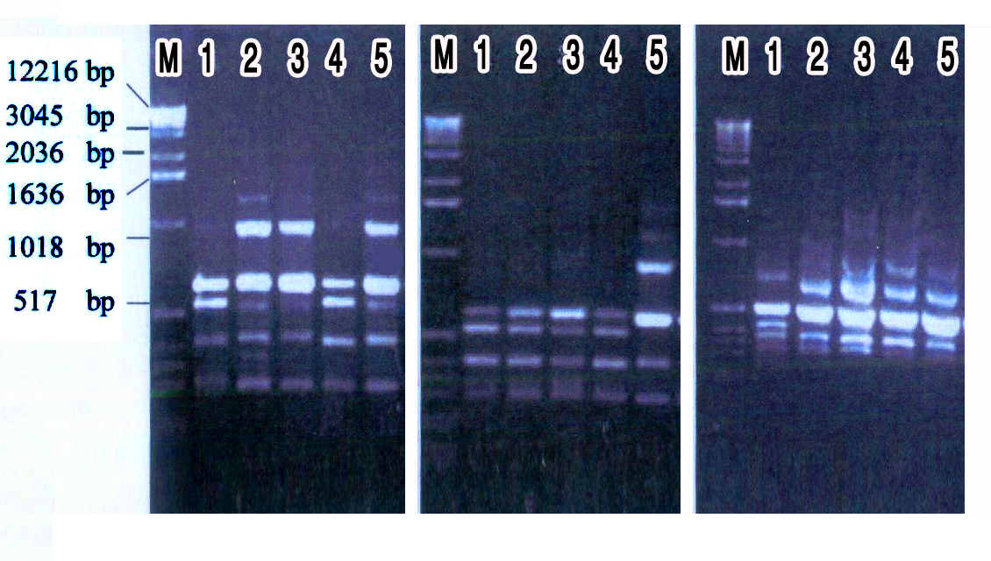

Fig. (2): Electrogram of agarose gel 15% showing DNA polymorphism based on RAPD analysis from the studied five S. mansoni against random primers (A₈, A₇ and A₆)
M: DNA molecular, S₁, S₂, S₃, S₄ and S₅ isolates, A₈, A₇ and A₆ random primers.

Table (5) : Polymorphism and genetic markers among 5 isolates of
S. mansomi using random primers by RAPD-PCR.

Primer | Polymorphism |  |  |  | Genetic markers of isolates
 | TAF | MAF | PAF | Unique | M.W (bp) | S₁ | S₂ | S₃ | S₄ | S₅
A₈ | 8 | 4 | 2 | 2 | 855  275 |  | + |  | -  - | ++++
A₇ | 7 | 4 | - | 3 | 1450  1025  855 |  |  |  | -  -  - | +  +  +
A₆ | 7 | 3 | 2 | 2 | 1025  575 | -  + | -  - | +  - | -  - | -  -
Total bands | 22 | 11 | 4 | 7 | 7 | 1 | 1 | 1 | - | 4
Percentage | - | 50 | 18 | 32 | 32 | 4.5 | 4.5 | 4.5 | - | 18

DISCUSSION
Schistosoma are dioecious digenetic treamatodes carrying a large (270 Mb) genome. Gaining Knowledge about the genome of these parasites is of importance for the understanding of their biology, mechanisms of drug resistance and antigenic variation that determine escape from the host’s immune system (Franco et al., 2006). This aim of the present study the genetic diversity of five S. mansoni isolates selected on the basis of different in disease potential (Longand and Morand, 1998).
Several techniques of molecular biology for studies of genetic diversity in Schustosomiasis vectors have been used (Spada et al., 2002; Florence et al., 004; Hertel et al., 2004; Abdel-Hamid et al., 2006; Jamjoom, 2006 and Haggag and El-Sherbiny, 2006).
Electrophoretic protein banding pattern of an organism can be used to elucidate reliable biochemical genetic markers of this organism. It can also provide information about structural genes and their regulatory systems which control the biosynthetic pathways of that protein banding pattern (Abdel Salam et al., 1992).
In the present study, variation in protein banding patterns between five isolates were revealed using SDS-PAGE electrophoresis. The obtained protein profiles were analyzed and scanned for gel quantitations using Gel Doc 2000 instrument and quantity one. Software package (Bio-Rad). For comparisons among the five isolates of S. mansoni were analyzed in the same gel. The same procedures of scanning and quantitations were done. The observed changes in protein banding patterns in the present study could be reasonably interpreted to be the result of gene mutation. This conclusion is in accordance with Brown and Langley (1979) and Abdel Salam et al. (1992). However, other investigators El-Gamal El-Din et al. (1988) traced such changes back to the induction of chromosomal abnormalities such as bridges breakes, laggards and micronuclei which can lead to loss of some of the genetic material. Therefore, some electrophoretic bands disappeared due to the deletion of their corresponding bands.
Disappearance of some bands could also be explained on the basis of a mutational event at the regulatory genes which are suppressed at transcription level. Meanwhile, the appearance of new bands could be explained on the basis of a mutational event at the regulatory system of unexpressed gene(s) that activate them (Abd El-Salam et al., 1992).
Gel electrophoresis is a widely used tool in studies of genetic variability. The electrophoretic differences reflect the allelic variations of S. mansoni enzymes which might due to mutational events occurring in the shistosoma under stress and affecting the loci controlling the synthesis of isozymes.
Several factors may be considered as primary determinants of the number of bands observed on a gel, including. (a) The number of coding genes, (2) Their allelic states (homozygous or heterozygous) and (3) The quaternary of the protein products. The simplest case involves a single region of salinity with variant electromorphs (allozymes) observed in different individuals. Because allozymes are usually codominanly inherited, the presence and number of bands are depending on the number of polypeptide subunits contained in the active enzyme (Kahler and Allard, 1970).
An electrophoretic analysis was made on the homogenate of progeny of five S. mansoni for esterase isozymes in order to determine isozymes. Since S. mansoni were collected and from different locations, therefore separate electrophoretic runs were made for some S. mansoni from each location. Esterase isozymes are enzymes that characterized by their common activity on many naphthyl ester substrates (Korochkin et al., 1973). The group of esterase isozymes is one of the largest and most complicated system that has been intensively studied in many organisms of animal kingdom in vertebrates, esterase isozymes are mostly monomeric. Consequently, each band of esterase activity reflects a structure of one polypeptide chain. Hence, each band on the gel represents the end product of one locus (allele). As revealed from Est zymograms, all bands were anndelly migrated and their distributions were varied, some bands were present in a certain S. mansoni and were lacking in another. A total number of 4 were present in all five S. mansoni (minomorphic) and could considered as common bans for all the five S. mansoni which seem to be necessary ones for the enzyme constitution. Bands No. 1, No. 2 and No. 3 observed only in S. mansoni isolatges S₄, S₃, S₂ and S₅ respectively which could be a result of gene expressed under stress. The result indicates that there were allelic variants in this locus in all S. mansoni. Suggesting a polymorphic type of inheritance for this enzyme.
The results obtained after RAPD-PCR are presented in Fig. (3) and molecular weights of each primer was summarized in Table (3-4). From the RAPD profiles generated by these primers, bands with MW 1450, 1025, 855, 700, 75 and 205 bp were present in some S. mansoni and absent in others (polymorphic), while the two bands MW 510 and 325 bp were present in all the five isolates (monomorphic). One unique band was detected in S₁ isolate with MW of 575 bp while was not seen in the other isolates.
Fortunately, the averages of similarities among five S. mansoni were 52.5, 76.5, 70.5, 40.5 and 82.2% for S₁, S, S₃, S₄ and S₅ respectively. This we expect the similarity of genetic backgrounds of many S. mansoni isolates.
The introduction of RAPD-PCR technique has amplified the possibilities of polymorphisms analysis, as it allowed the use of small arbitrary nucleotide segments without the need of a previous knowledge of genes and/or genomic sequences (Welsh and Mc Clellend, 1990). Also, RAPD assay clearly has certain proactively advantages for detecting DNA variation. It is technically less demanding, cheaper and quicker than other molecular techniques (Stothard and Rolliknson, 1996).
Rollinson et al. (1998) reported that, snails resistant to infection occur naturally and there is a genetic basis for this resistance, in B. glabrata resistance to S. mansoni is known to be polygenic trait. So, we have initiated a preliminary search for snail genomic regions linked to, or involved in resistance by using a RAPD-PCR based approach in conjunction with progeny individual methods.
The present study, demonstrated the utility of RAPD-PCR method for the differentiation of S. mansoni isolates. The isolates studied were selected on the basis of different location and pathogenic by well characterized resistance, susceptibility phenotypes upon exposure to S. mansoni. Reproducible and inheritable stable polymorphic markes for S. mansoni were identified with one out of the ten arbitrary primers tested. Several of the primers produced monomorphic bands among the stocks, or the polymorphism identified were not reproducible. In previous studies, genetic diversity among S. mansoni snails was evaluated either by allozyme or restriction fragment length.

REFERENCES
Abdel Salam, A.Z.E.; S.A. Mansor and M. Abdel-Mordy (1992). Isozyme polymorphism in Drosophila. VII. Sensitivity of three major chromosomes to the effect of aromatic organophosphorus compounds as revealed by the induced mutations at twelve enzyme loci in
D. melanogaster, Egypt J. Genet. Cytol. 21: 105-13.
Abdel-Hamid, Z.A.; S.M. Rawi and Azza, F. Arafa (2006). Identification of a genetic marker associated with the resistance to Schistos9oma mansoni infection using random amplified polymorphic DNA analysis. Mem. Inst. Oswaldo Gruz, Rioo de Janeiro Vol. 101 (8): 863-868.
Brown, A.J. and C.H. Langley (1979). Reevaluation of level of genic heterozygosity in natural population of D. melanogaster by two dimensional electrophoresis. Proc. Nail. Acad. Sci, USA. 76 (6): 238-2384.
Da ilva, D.; R.G. Spada; S.S. Sobral-Hamaguchi; Z. Abdel-Hamid; N.R. Zuim; E.M. Zanotti-Magalhaes; A.L. Magalhaes and J.T. Riberiro-Paes (2004). Biamphalaria tenagophila Genetic Variability Within Intermediate Snail Hosts Susceptible and Resistant to Schistosoma nansoni Infection. Parasite, 11: 43-19.
Florcnce, M.R.; L.C. Roberta; C. Omar do Santos; B.G. Ana Lucia and Paulo Z.C. Marcos (2004). Dominant charaxcter of the molecular marker of a Biophalarin tenagophila strain(Mollusca planorbidae) resistant to Schistosoma mansoni. Mem. Inst. Oswaldo Cruz. 99: 85-87.
France, G.R.; A.F. Valadao; V. Azevedo and E.M. Rabelo (2006). The Schistosoma gene discovery programs state of the art. Int. J. Parasitol.; 10: 53-63.
Gamal El-Din, A.Y.; E.H.A. Hussein and M.A. Eweda (1988). Variation in chromosome number and its bearing on electrophoretic protein banding pattern in vien. Bull. Fac. Agric., Cairo Univ, 39 (1): 143-153.
Haggag, S.H. and M. El-Sherbiny (2006). Molecular markers associated with resistanc e to Schistosoma mansoni infection in the Biomphalaria glabrata snails. Biotechnology 5 (4): 404-412.
Hertel, J.; K. Keddves; A.H.M. Hassan; B. Haberel an W. Has (2004). Detection of Schistosoma mansoni cercariae in plankton samples by PCR. Acta Tropica 91: 43-46.
Jonathan, F.W. and N.F. Wondell (1990). Visualization and interpretation of plant isozymes. In isozymes in Plant Biology- D.E Saltis and P.S. Soltis (eds). London Chapman and Hall, pp. 5-45.
Kahler, A.L. and R.W. Allard (1970). Genetics of isozyme variants in barley 1. Esterases. Crop Science 10: 444-448.
Korochkin, L.I.; N.M. Matveeve and M.B. Evageniev (1973). Expression of esterase isozyme in hybrids of Drosophila virils. Genetika 9 (12): 55-61.
Laemmli, J.K. (1970). Cleavage of structural proteins during the assembly of the head of bacteriophage T₄. Nature 227: 680-685.
Langand, J. and S. Morand (1998). Heritable non susceptibility in an allopatric host-parasitic system: Biomphalaria glabrata(Mollusca). Echinotoma caproni (Platyhelmonth digenea). J. Parasitol, 84: 739-742.
Lockyer, A.E.; C.S. Jones; L.R. Noble and D. Riollinson (2000). Use of differential display to detect changes in gene expression in the intermediate snail host Piomphalaria glabrata upon infection with Schistosoma mansoni. Parasitology, 120: 399-407.
Lowry, O.H.; N.J. Resebriugh; A.L. Farr; R.J. Ranall (1951). Protein measurement with the folin phenol reagent. J. Biol. Chem. 193: 265-275.
Manal, B. Jamjoom (2006). Molecular identification of some Schistosoma mansoni isolates in Saudi Arabia. World Journal of Medical Sciences 1 (2): 102-107.
Saoudl, M.F. (1966). The infectivity and pathogenicity ofd geographical strains of Schistosomi mansoni. Trans. Royal Soc. Trop. Med. and Hyq. 69: 583-600.
Shalaby, I.M.; A.A. Banaja and A.M. Ghandour (1993). Comparative scanning electron microscopy study of the regimental surface of Schistosoma mansoni (Egyptian and other strains) in mice. J. Egypt. Ger. Soc. Zool., 12: 37-41. Da Silva, D., R.G. Spada; S.S. Sobral-Hamag.
Simpson, A.J.G.; E.D. Neto; M. Steindel; O.L.S.D. Gaballero; L.K.J. Pyssos and S.D.J. Pena (1993). The use of RAPDs for the analysis of parasites DNA Fingerprinting State of the Sciences 331-337.
Spada, R.G.; Dida Silva; A.Z. Abdel-Hamid, S.S. Sobral-Hamaguctu. N.R. Zuim; E.M. Zanotti- Magalhaes, L.A. Magalhaes and J.T. Riberio-Paes (2002). Genetic markers between Biomphalaria glabrata snails susceptible and resistant to Schistosoma mansoni infection. Mem. Irst, Oswalde. Cruz, 97: 53-58.
Stothard, J.R. and D. Rolliknson (1996). An evaluation of random amplified polymorphic DNA (RAPD) for identification and phylogeny of freshwater snails of the genus Bulinus (Gastrophoda Planorbide). J. Mol. Stud. 62: 165-176.
Welsh, J. and M. Mc. Clellend (1990). Fingerprinting genome using PCR with orbitrary, primers. Nucleic acids. Res. 18: 7213-7218.

