Early-age compressive strength assessment of oil well class G cement due to borehole pressure and temperature changes
M. Labibzadeh¹, B. Zahabizadeh²
1) Head of Civil Engineering Department, Faculty of Engineering, Shahid Chamran University, Ahvaz, Iran.
2) Civil Engineering Department, Faculty of Engineering, Shahid Chamran University, Ahvaz, Iran. .
Email¹: Labibzadeh_m@scu.ac.ir
Abstract: Development of high early-age compressive strength oil well cement is an important task in the oil well cement design. Achievement of suitable early-age compressive strength of oil well cement ensures both the structural support for the casing and hydraulic/mechanical isolation of borehole intervals. Holding this issue in mind, in this research, the effect of pressure and temperature changes inside the borehole on the class G oil well cement compressive strength has been studied. In the proposed work, in contrast to the mostly previous studies which considered some certain temperatures and atmospheric pressure in their tests, the effects of contemporary pressure and temperature changes on the early-age compressive strength of oil well cement have been investigated. Using a non-destructive method, the compressive strength of 48 hours cured cement samples under progressive changing of simultaneously pressures and temperatures coincident to a real oil well data were measured and recorded continuously at predefined intervals during this 48 hours period time. The case study was an oil well located in Darquain region of Khuzestan province in Iran. Obtained results showed that 8 and 12 hours aged samples have a maximum compressive strength in a certain combination of pressure and temperature, 51.7 MPa and 121°C, whereas 24, 45 and 48 hours aged samples have a minimum point in their compressive strength curve at 17.2 MPa and 68°C and a maximum point at 41.4 MPa and 82°C. All the samples show the significant reduce (up to approximately 70%) in compressive strength after the 51.7 MPa and 121°C point. Considering the case study oil well profile of borehole pressure and temperature changes, this tested class G cement is recommended to use in cementing job from ground level down to the almost 4000 m below the surface.
Keywords: Compressive Strength, Oil Well, Cementing, borehole Pressure and Temperature

1. Introduction

Among all operation being performed during oil or gas well drilling, the wellbore tubing and cementing can certainly be known as the most important activities. Durability and efficiency of well production rate depend a lot on the degree of success of this stage. In tubing operation, wellbore is covered by special steel pipe string segments (casing) and consequently at cementing stage, annulus between casing string and well-rock (Formation) are filled with a certain compound of cement grout. This compound could be makeup from different ingredients with different percentage of weight with respect to the weight of cement in the grout mixture. For example, A cement slurry is comprising as follows: an aluminous cement the alumina content of which is at least 30%; a microsilica with a granulometry in the range 0.1 to 20 μm the percentage of which is less than 35% by weight with respect to the weight of cement; mineral particles with a granulometry in the range 0.5 to 500 μm the percentage of which is less than 35% by weight with respect to the cement, the percentage of said particles remaining below the percentage of said microsilica; a hydrosoluble fluidifying agent the percentage of which is in the range 0.2% to 3% with respect to the weight of cement; a retarding agent to control the setting time of the slurry; water in a quantity of at most 40% with respect to the cement ( Asadi, 1983) . The cement grout is gradually being set over a certain time interval (usually after several hours or several days) and converts to a stiff cement sheath. Cement sheath must be able to resist against to the pressure of formation consists of pore pressure and fracture pressure. Sum of these two pressures is called the in-situ pressure or total pressure. Furthermore, cement sheath must be able to withstand against to hydrostatic pressure due to drilling fluids inside the casing string, thermal loads due to temperature rise from surface to the bottom of the well and also periodic loads due to various operations inside the well consist of cement hydration, hydrocarbon production, stimulation treatments, pressure integrity tests of cement and casings that they can change pressure and temperature exposed on the cement sheath after placement in annulus (Abbaszadeh, 2005, Ravi et al. 2007, Al-Suwaidi et al. 2008). Monitoring wellbore temperature is one of the most important factors controlling the chemical reaction and performance results of a cementing operation. In oil well cementing, the cement slurry placed at total depth is subject to progressively increasing temperature from the time it is mixed on the surface and pumped into the well until the time the cement cures and the formations adjacent to the wellbore return to their ultimate static pressure. Circulating and static temperatures both affect cement design. Circulating temperature is the temperature the slurry encounters as it is being pumped into the well. Static temperature is the formation heat to which the slurry will be subjected after circulation is stopped for a set period of time. Designers should know the bottom hole static temperature (BHST) to design and assess long-term stability, or rate of compressive strength development for the cement slurry. Determining BHST is especially important in deep well cementing, where the temperature differential between the top and bottom of the cement can be great. Generally, cement sensitivity increases as the BHST increase (Abbaszadeh, 2005). In the oil and gas industry, two types of compressive strength for cement are defined. Early-age compressive strength is the compressive strength of cement at initial times after the preparation and placement of cement grout into the wellbore and long-term compressive strength is the compressive strength of cement after completion of hydration process and exploitation of the well and or even after several years of the well production operation. Development of high early-age compressive strength oil well cement is an important task in the oil well cement design (Di Lullo, 2000). Achievement of suitable early-age compressive strength of oil well cement ensures both the structural support for the casing and hydraulic/mechanical isolation of borehole intervals (Di Lullo, 2000). When the cement grout is produced and pumped into the wellbore, the cement slurry starts changing from a true fluid into a semi solid set material with measurable compressive strength at beginning of the gel formation and the fluid starts undergoing hydrostatic pressure through shear strains and gel gradually gains its strength. The static gel strength which occurs due to decrease in volume leads to reduction in pressure. The transition phase is very critical, because under this condition cement column starts to support itself and does not transfer a major part of the hydrostatic pressure to the flow zone and so a longer transition phase allows a longer time for the volume to decrease (Johnstone et al., 2008). This phenomenon which leads to more gas leaking thorough the cement column is known as gas migration and caused inefficiency of cementing operation. Gas migration can be prevented by reducing the time of transition phase and in other words by speed up the development of cement compressive strength (Johnstone et al., 2008, Pedam, 2007). Another important time at initial times after cementing to note is the Wait-On-Cement (WOC) time; this is defined as the time at which compressive strength begins to develop in the slurry right after the time when the static gel-strength development ends. In other words, WOC time is the time that takes along to cement gains minimum compressive strength, equal to 3.45 MPa (500 Psi) according to API (American Petroleum Institute), for resisting the shocks caused by drilling operation at later stages. Delays in strength development cause significant amounts of lost time due to the need to WOC. Thus, drilling operations cannot proceed and the rig must sit idle until the cement is deemed hard enough to continue (Di Lullo, 2000, Pedam, 2007, Nelson, 1999). Compressive strength of cement in the long-term is important and necessary against the conditions encountered within the well, in addition to the early-age compressive strength. Hard cement must be able to cover well's casing strings and link them to the formation. Also, hard cement cause stability of wellbore and protects of casing strings against external pressures resulting from earth floors, which may even cause the pipes will be broken and against electrolysis and corrosion caused by corrosive waters underground and sour hydrocarbons or straight contact with stratums; and prevents of fluid migrations between formations and unwanted pollution of valuable hydrocarbons (Asadi, 1983). A three-step approach, outlined in Figure 1, can help operators in properly cementing a well that can produce hydrocarbons safely and economically (Ravi et al., 2007, Reddy et al., 2005). Step 1 is the engineering analysis. The outcome of the engineering analysis is to help provide the optimum cement sheath properties needed to withstand the well operations. Step 2 is cement slurry design and testing for providing a cement system that can match or exceed the cement-sheath properties evaluated in Step 1. Examples of the cement-sheath properties that should be tested in Step 2 are:
- Compressive strength
- Tensile strength
- Young’s modulus
- Poisson’s ratio
- Plasticity parameters
In addition, the laboratory-measured values from Step 2 are a part of the input variables for the engineering analysis (Step 1) to evaluate the cement-sheath integrity. To help achieve zonal isolation, Step 1 and 2 should be followed by Step 3, effective cement slurry placement and monitoring during the life of the well (Ravi et al., 2007, Reddy et al., 2005).

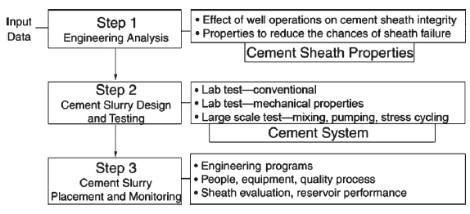
Figure 1: Steps in Cementing an Oil Well

The subject of this paper is related to step 2 in figure 1 and deals with the importance of early-age compressive strength development and its role in the degree of success of a cementing operation by evaluating the behavior of cement in terms of compressive strength under conditions of pressure and temperature changes within the well at initial times after starting operation. The main aim of the authors of this research is to achieve an optimum safety depth for injection of class G cement into the oil wells located in Darquain region of Khouzestan province of Iran in order to prevent the gas migration during well construction time and improve the safety factor in construction stage.
The main difference between this research and previous works which will be briefly mentioned in the following is that in the foregoing studies pressure was assumed constant and temperature was set to be varied. But in the present work, the pressure and temperature are set to be changed according to real conditions in the borehole, and these effects on the early-age compressive strength of cement is investigated.

  - Literature review

Assessment of the various treatment aspects of the cement considering the application and its impression within the oil and gas wells, always has been attended by researchers. Some of the scientists have been studied the water and additives effect on cement mechanical properties without considering the effect of pressure or temperature inside the well bore. (Dahab and Omar, 1989) prepared a cement slurry mixture mostly used in the Saudi Arabia country using sea water, fresh water and distilled water. They deduced through their investigations that cement which prepared with sea water shows more compressive strength than the other two types of grout in 1, 2 and 3 curing times. Also their evaluation on effect of additives such as calcium chloride, lignosulfonate and bentonite on the cement slurry indicated that in a certain concentration of each of these additives, cement compressive strength increases with increasing in the curing time; but in a fixed time, compressive strength is diminished with increasing concentration of each of these additives (Dahab and Omar, 1989). Lecolier, 2007 studied long-term curing time condition effects of water, salt water and crude oil on cement compressive strength. Results from the first mold (containing water) illustrated that during the first six months, the mechanical strength change is not significant. But after a year, the compressive strength slowly starts to decrease. Results of the second mold (containing salt water) which the curing fluid in it was renewed every month showed that during the first four months compressive strength is similar to the situation that curing fluid was not change. After four months, compressive strength started to severe decrease. After a year, reduced in the compressive strength was about 50 percent. But in the third case unlike what was observed in two previous tests, compressive strength remains stable over time. This could be due to the absence of acidic compounds in the crude oil (Lecolier, 2007). Some of the others add the effect of temperature factor in their studies. For example, in 1999, Noik and Rivereau compared behavior of four various compounds of cement class G at 120°C, 140°C and 180°C. Their target was the evaluation of silica sand effects on cement slurry. Their experiments demonstrated that at 180°C temperature, compressive strength values without silica was very low and would be increase with addition of silica to the cement slurry (Noik and Rivereau, 1999). Mirza, 2002 examined the effect of fly ash on cement properties. This research exerted that the use of fly ash at cement mixture in 20°C temperature and atmospheric pressure causes a reduction in the 28 and 91 day compressive strengths, compared to the reference grout having an equivalent value of water to cement ratio; But as the grout matures, the difference between the increase in strength of the reference grout and the fly ash grout decreases (Mirza, 2002). Another group of scientists consider some certain combination of temperature and pressure in their work: Jennings, 2005 tested a combination of cement containing hollow ceramic spheres at 1.14 gr/cm3 cured for one year at 149°C and 20.7 MPa and found that the provided sample has unaccepted decline in compressive strength. The highest registered of compressive strength in one week was 7.19 MPa; and after a year of curing has decreased to 7.3 MPa. This combination declined 81% in 11.75 months when curing at 149°C and 20.7 MPa (Jennings, 2005). Also, Al-Yami, 2007 and 2008 tested another low-density blend of cement class G, aluminum silicate, crystalline silica, hollow glass microspheres and water at 1.12 gr/cm3. First in 2007, he cured this combination at 66°C and 12.4 MPa; in this case, the compressive strength continued to develop over more than one month, but then stabilized after 2 and 3 months as the system reached equilibrium. The final compressive strength of this combination after curing for 3 months at 66°C and 12.4 MPa was 15.15 MPa (Al-Yami et al., 2007). Then in 2008, he examined this mixture at 127°C and 20.68 MPa; the compressive strength in this pressure and temperature conditions was stable over the three months test period, too. The final compressive strength after curing for 3 months at 127°C and 20.68 MPa was 9.94 MPa, which significantly exceeds the recommended values of 3.45 Mpa according to API to hold many casings in place (Al-Yami et al., 2008).

2. Materials and Methods
2.1. Pressure and Temperature Conditions inside the Proposed Wellbore

Pressure and temperature conditions required for curing samples of cement, were selected in accordance with actual well conditions of Darquain region located 40 Km north of Abadan city along the west bank of Karun River in Khuzestan province of Iran.
Considering the given static temperature gradient in our proposed drilled borehole ( Darquain wellbore ) temperature values in various depths of the well has been calculated. These data have been measured by instruments inside a real oil well at April 2009.

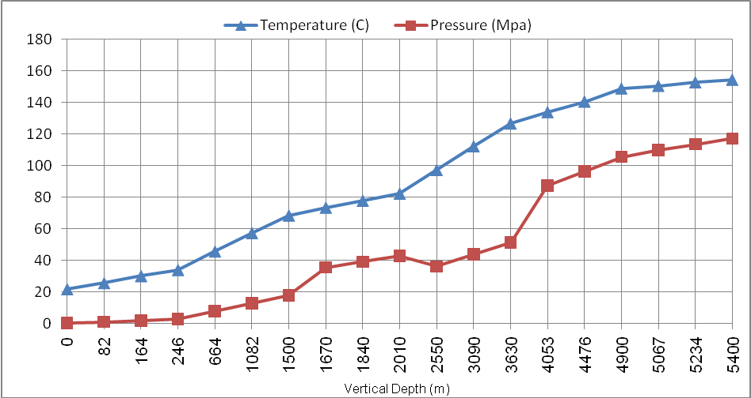
Figure 2: Temperature and Pressure Changes in Depths of Studied Oil Well-April 2009

According to Figure 3, the pressure values inside the wellbore and around it (inside the formation) are both functions of depth variable, and should be noted. The value of hydrostatic pressure inside the wellbore can be directly calculated with Equation 1 (Abbaszadeh, 2005).

(1)

Where, = hydrostatic pressure (Pa)
= drill mud density (Kg/m3)
TVD= total vertical depth (m)
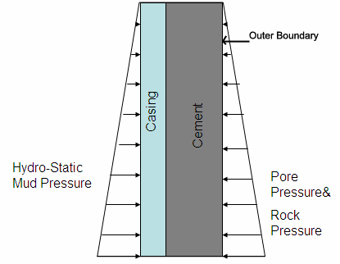
Figure 3: Schematic of Pressures Around and Inside the Wellbore

In the outer boundary we encounter two types of pressures, the rock pore pressure and the overburden pressure. The resultant pressure acts horizontally toward the wellbore (Abbaszadeh, 2005). Pressure in the outer boundary always must be in equilibrium with hydrostatic pressure due to drilling fluids. Imbalance between the two pressures mentioned can lead to gas blow out of annulus between casing and formation (if in-situ pressure be more than hydrostatic pressure) or lead to crush the around stones and fluid loss (if hydrostatic pressure be more than in-situ pressure).
When cement slurry pumps into the annulus, it creates hydrostatic pressure equivalent to mentioned pressures until is in the liquid phase. Therefore, pressure which cement encountered inside the well at curing time and after hardening is in-situ pressure in the outer boundary that should be equal to hydrostatic pressure of drilling fluid within the well. Hence, considering given values of mud density in various depths of studying well, pressure values were calculated using the Equation.1 and used for cement samples test in the laboratory to create pressures in accordance with actual conditions inside the well. Pressure changes have been showed in Figure 2.
According to Figure 2, six different points of pressure and temperatures conditions inside the well were selected for curing cement samples. The pressure at the sixth point is not real because of the limitation of the serviceability of the test machine. These points are surrounded by ellipses in figure 2.
Cement mechanical failure may be caused by stresses induced by condition variations in borehole such as:
- Pressure integrity test
- Pressure increase due to gas production
- Change in mud weight after cement placement
- Stimulation treatments
- Temperature Changes
Cement compressive failure may be occurred if the cement is placed between two casings or across a hard formation and the radial stresses exceeds the cement rupture strength (Al-Suwaidi, 2008).
Benchmarked points are ambient pressure and temperature; pressures of 2.8 MPa, 17.2 MPa, 41.4 MPa, 51.7 MPa and 51.7 MPa; and corresponding temperatures of 38°C, 68°C, 82°C, 121°C and 149°C. As stated earlier, the reason for same pressure at the last two points was limitation of pressure increase over this amount due to laboratory safety conditions.

2.2. Design of Cement Slurry

Slurry blend consists of cement class G, additives and water. There are currently eight classes of API Portland cements, designated A through H. They are arranged according to the depths, to which they are placed, and the pressures and temperatures to which they are exposed (Nelson, 1999, API, 1997). In oil well drilling industry class G and H well cements are known as basic well cements, because no additions other than calcium sulfate or water, or both, shall be inter-ground or blended with the clinker during manufacture of these well cement classes. Hence, with addition of appropriate additives such as accelerators and retarders can change their setting time to cover a wide range of well depths, pressures and temperatures (Asadi, 1983, Nelson, 1999). The main phases of class G cement clinker are consists of 50% Tricalcium Silicate (C3S), 30% Dicalcium Silicate (C2S), 5% Tricalcium Aluminate (C3A) and 12% Tetracalcium Aluminoferrite (C4AF) (Asadi, 1983).
Additives which used in cement composition are selected based on the test pressure and temperature conditions. Calcium Chloride (CaCl2) used as accelerator for reducing the setting time of cement slurry at ambient pressure and temperature and D-013 used as retarder for increase the setting time of cement slurry at high pressures and temperatures (Asadi, 1983). Considering the aim of this research, the additives which had the least possible effect on cement compressive strength were used; at the same time these additives would be able to provide relatively acceptable conditions of rheological properties and setting time close to slurries conditions used in application.

Calcium Chloride was added in cement slurry at ambient pressure and temperature in concentration of 1% by weight of cement (BWOC). D-013 was added in cement slurries in concentration of 0.1% BWOC for curing at (17.2 MPa and 68°C) and in concentration of 0.3% BWOC for curing at (41.4 MPa and 82°C), (51.7 MPa and 121°C) and (51.7 MPa and 149°C) conditions. Researches done in the past showed moderate retardation had minimal effect on the static cement properties (i.e. properties that measured under static temperature such as compressive strength) (Pedam, 2007). Considering this issue in mind and for prevention of additives effects on cement compressive strength in order to determine the true effect of pressure and temperature on the cement, the maximum value of retarder used in cement slurry was determined in concentration of 0.3% BWOC.
Also, cement slurries density in the all tests was considered as 1.84gr/cm3, which this density is placed in the density range of neat cement slurries (the density of neat cement slurries are between 1.79 gr/cm3 to 1.92 gr/cm3 ). Cement slurries with density lower than 1.79 gr/cm3 are called low-density cements and with density more than 1.92 gr/cm3 are called high-density cements. The water to cement ratio (WCR) was determined as 0.5 in all cases.

2.3. Measurement of Cement Compressive Strength

By measuring the change in velocity of an acoustic signal, the Ultrasonic Cement Analyzer (UCA) provides a continuous non-destructive method of determining compressive strength as a function of time, according to API (API, 1997, Instruction Manual, 2007). The UCA measures the delay time of an ultrasonic wave pulse through the sample; using set equations, this velocity is converted to uniaxial compressive strength and recorded. The basis on which this setup works is the fact that the ultrasonic compressive wave transit time, density of the substance which the wave is traveling through it and the compressive strength of the substance are inter-related (Pedam, 2007). Figure 4 shows this device and its different parts.

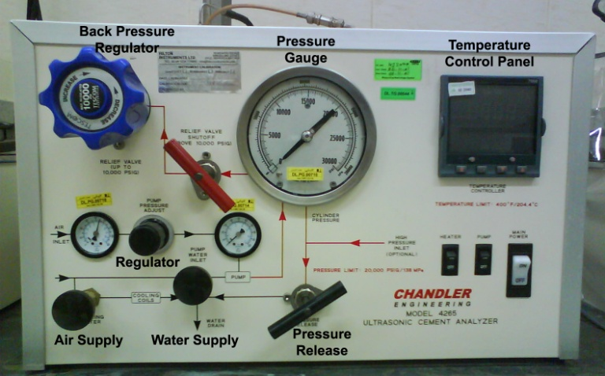
Figure 4: Different Parts of UCA Device

Since over 90 % of the total compressive strength typically develops in oil field cements at 48 hours after blending time the time interval for measuring strength in this study was determined as 48 hours. It is worth to note that this is the minimum time recommended before running bond logs to evaluate zonal isolation (Di Lullo, 2000).

3. Results and Discussions
3.1. Curing Conditions: Ambient Pressure and Temperature (0.1 MPa, 22°C)

Before considering the results of UCA, we introduce test results under ambient pressure and temperature conditions. Under these conditions cubic molds with dimensions of 5.08 cm were used. After the curing of samples at 24 and 48 hours, they were axially compressed using hydraulic press setup and the compressive strength of samples was measured. Obtained results are summarized at Table 1. In this case, compressive strength is computed as the division of final force exerted to samples to their surface area. In each curing time, three samples were implemented and average values of the compressive strength of samples were calculated and recorded as the total compressive strength in the corresponding time.

Table 1- Compressive strength values at ambient pressure and temperature
Curing Time  (Hr) | Compressive Strength
Curing Time  (Hr) | PSI | MPa
24 | 1588 | 10.95
48 | 2400 | 16.55

Respect to the fact that the UCA device provides compressive strength values by the pounds per square inch (PSI), in this sections both strength units; MPa (SI system) and PSI are used. It can be derived from the table 1 that compressive strength of the proposed cement after 48 curing hours is increased approximately up to 150 percent in comparison to the corresponding value after 24 curing time under ambient pressure and temperature.

3.2. Curing Conditions: 2.8 MPa (400 PSI) and 38°C

In this test, results show (Figure 5) that the minimum gel strength equal to 0.34 MPa (50 PSI) is achieved at 05:55:00 and minimum acceptable cement compressive strength equal to 3.4 MPa (500 PSI) according to API is executed at 10:28:00. Also, the maximum compressive strength is observed equal to 14.24 MPa (2066 PSI) at 47:43:42. Figure 5 indicates that under these conditions trend of obtained compressive strength curve is increasing, and after reaching to the maximum value, in the last 17 minutes duration of the test, it continues nearly constantly. By comparison of corresponding results introduced in figure 5 and table 1, it can be deduced that the cement compressive strength after 24 hours of curing time is not altered under 400 PSI and 38°C, but the mentioned value is decreased about 14% after 48 hours of curing time. By the author opinion, this observed reduction can be result of the fact that the accuracy of two measurement instrument is not the same and can be neglected.

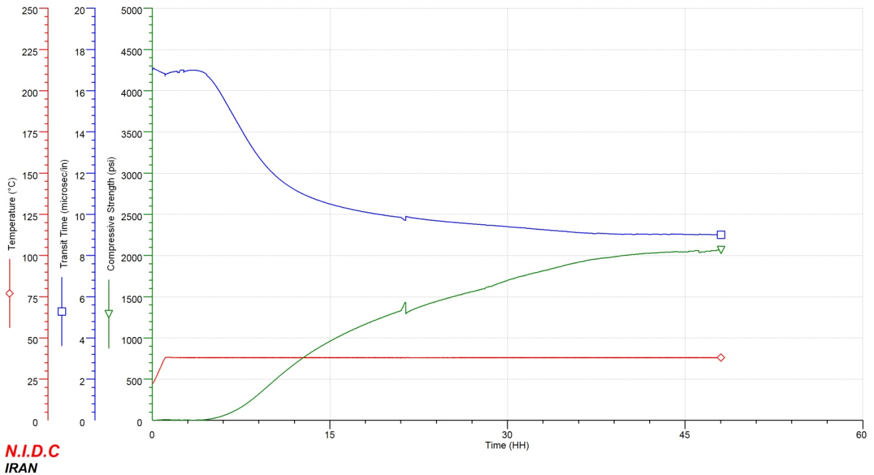
Figure 5-: Changes of Compressive Strength at 2.8 MPa and 38°C
3.3. Curing Conditions: 17.2 MPa (2500 PSI) and 68°C

In this situation, results reveal (Figure 6) that the minimum gel strength is reached at 06:16:00 and minimum acceptable cement compressive strength according to API is measured at 08:37:00.The maximum compressive strength equal to 12.72 MPa (1845 PSI) is measured at 47:27:30. Figure 6 demonstrates that in these conditions similar to previous case, trend of compressive strength envelope curve is increasing and after reaching to the maximum value, in the residual 33 minutes to the end of test, it continues constantly. In this case, the time of reaching to the peak of the green curve is shorter. The final compressive strength of cement under these conditions is measured equal to 12.72 MPa (1844 PSI).

3.4. Curing Conditions: 41.4 MPa (6000 PSI) and 82°C

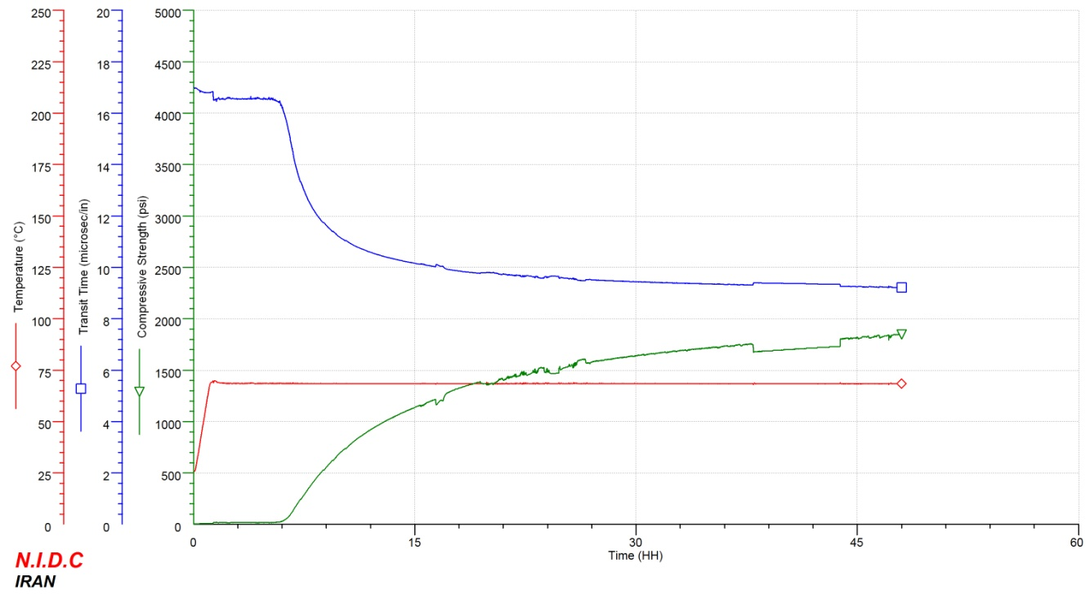
Results in this state indicated (Figure 7) that the minimum gel strength was achieved at 01:59:30 and minimum acceptable cement compressive strength according to API was observed at 02:49:30. Furthermore, the maximum compressive strength equal to 18.91 MPa (2742 PSI) was happened at 44:35:30. Figure 7 shows that under these qualifications compressive strength trend are increasing too, But with this difference that values of compressive strength in the early hours is much more and minimum of compressive strength is achieved much sooner than other two cases. After reaching the maximum value of compressive strength, strength decreases slightly and then in the 3 residual hours to the end of the test, it ongoing uniformly. The final compressive strength of cement under these conditions was measured equal to 18.82 MPa (2730 PSI).

Figure 6: Changes of Compressive Strength at 17.2 MPa and 68°C

3.5. Curing Conditions: 51.7 MPa (7500 PSI) and 121°C

In this mood of the test, results proved (Figure 8) that the minimum gel strength was overtaken at 00:50:30 and minimum acceptable cement compressive strength according to API was reached at 02:05:30. The maximum compressive strength equal to 17.71 MPa (2569 PSI) was achieved at 17:20:00. Figure 8 shows that under these conditions cement compressive strength develops more rapidly and with much higher value than previous tests. After reaching the maximum value, compressive strength unchanged over the 1 hour and 10 minutes, then strength started decreasing and this decreasing trend was continued to the end of the test. The final compressive strength of cement under these situations was measured equal to 16.40 MPa (2383 PSI).

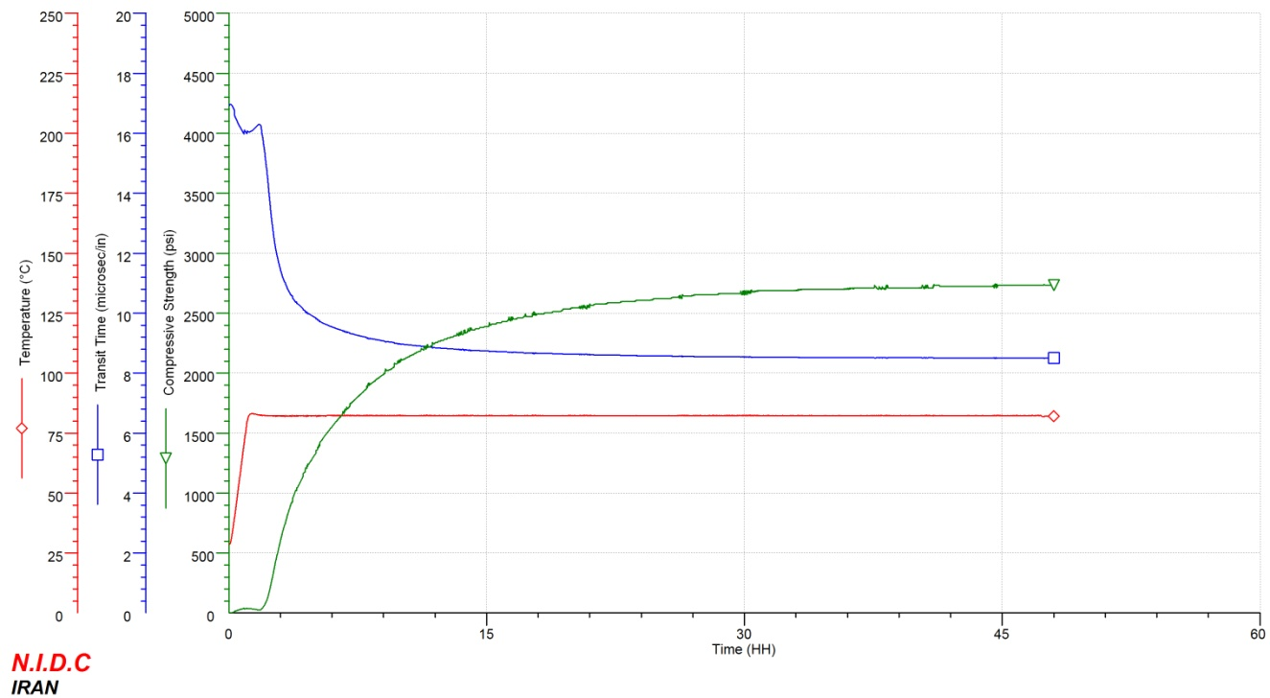
Figure 7: Changes of Compressive Strength at 41.4 MPa and 82°C

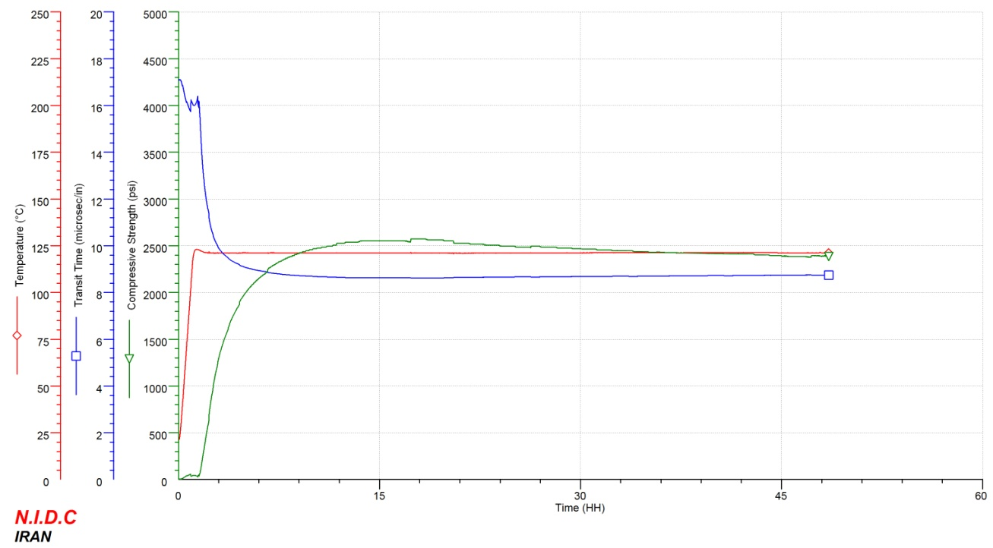
Figure 8: Changes of Compressive Strength at 51.7 MPa and 121°C
3.6. Curing Conditions: 51.7 MPa (7500 PSI) and 149°C

Outcomes illustrate thorough Figure 9 that the minimum gel strength was overtaken at 00:55:30 and minimum acceptable cement compressive strength according to API was caught up at 01:28:30. Also, the maximum compressive strength was achieved equal to 7.99 MPa (1159 PSI) at 03:31:00. Furthermore, Figure 9 shows which under these conditions compressive strength of cement sample develops more rapidly than the all previous cases and therefore was reached in the shorter time to the maximum value of strength. After that compressive strength reached to the maximum value, strength started decreasing and continues in this fashion to the end of the test. The final compressive strength of cement under these conditions was measured equal to 4.59 MPa (666 PSI). It is important to remember that this condition does not exist inside the wellbore and the real state is 110 MPa and 149°C. As it was mentioned before, this is due to limitation of serviceability of the UCA machine test .

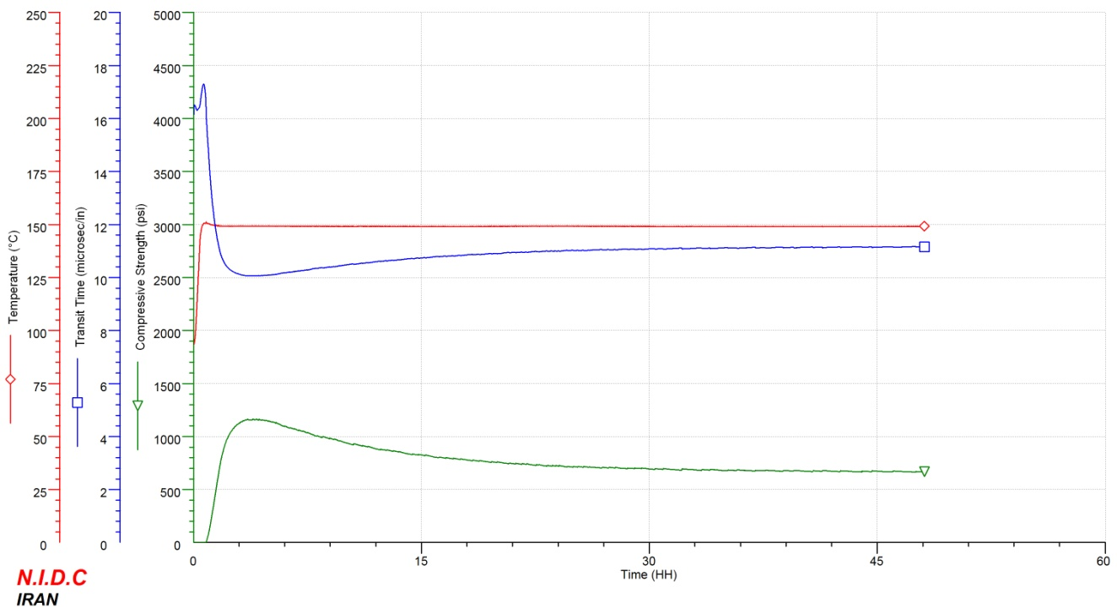
Figure 9: Changes of Compressive Strength at 51.7 MPa and 149°C

In Figures 5 to 9, green lines indicate cement compressive strength changes with time; blue lines show transit time of compression wave into cement samples and red lines show temperature value in each test. Pressure values have been set up on UCA device and were not shown in figures. Compression wave transition velocity increases with change of cement slurry density as it converts into gel state and then into hard material; so with the elongation of the test time, wave transition time becomes shorter. Temperature stays constant after reaching to required value at one hour.

4. Conclusion

It was revealed from table 1 and figures 5 through 8 that when pressure and temperature contemporary increases from (0.1 MPa, 22°C) to (51.7 MPa and 121°C) the early-age compressive strength of proposed class G cement used in our study increases. The rate of this increase is intensified with the appearance of higher pressure and temperature. Faster development of early-age compressive strength can lead to reduction in transition phase time. This can be reduced the potential of gas migration through the cement column placed inside the oil well through the initial times (48 hour) and develops the safety factor of the project during construction . But from (51.7 MPa and 121°C) to (51.7 MPa and 149°C) it can be seen that compressive strength reduces significantly. Although this state does not occurred in the wellbore and the pressure is not changed through theses two last states, but the author believes on in accordance to literatures (Lecolier et al, 2007, Noik, and Rivereau, 1999) because of the high temperatures in this range the compressive strength would be reduced inside the wellbore in actual situation. So, it can be say that the class G oil well cement can be used in the Darquain region oil wells from surface to the depth equal to approximately 3600m safely but for the deeper depths this type of cement is not be recommended.

5. References

[1] Asadi, B. 1983. Oil Well Cementing. First Edition, Central Printery of Oil Company, Ahwaz, Iran.

[2] Abbaszadeh, M. 2005. Detecting and Modeling Cement Failure in High Pressure/High Temperature Wells, Using Finite Element Method. M.Sc. Thesis, A & M University, Texas, U.S.A.

[3] Ravi, K., et al, 2007.A Comparative Study of Mechanical Properties of Density-Reduced Cement Compositions. SPE Drilling & Completion, Vol. 22, No. 2, pp. 119-126.

[4] Al-Suwaidi, A.S., et al, 2008. A New Cement Sealant System for Long-Term Zonal Isolation for Khuff Gas Wells in Abu Dhabi. Paper SPE 117116 Presented at the International Petroleum Exhibition and Conference, Abu Dhabi, U.A.E., 3-6.

[5] Di Lullo, G., and Rae, Ph., 2000. Cements for Long Term Isolation – Design Optimization by Computer Modelling and Prediction. Paper IADC/SPE 62745 Presented at the Asia Pacific Drilling Technology, Kuala Lumpur, Malaysia, 11-13.

[6] Pedam, S.K., 2007. Determining Strength Parameters of Oil Well Cement. M.Sc. Thesis, The University of Texas at Austin, U.S.A.

[7] Johnstone, K., et al, 2008. Cementing Under Pressure in Well-Kill Operations: A Case History from the Eastern Mediterranean Sea. SPE Drilling & Completion, Vol. 23, No. 2, pp. 176-183.

[8] Nelson, E.B., 1999.Well Cementing. Schlumberger Educational Services, Sugar Land, Texas.

[9] Reddy, B.R., et al, 2005. Cement Mechanical Property Measurements under Wellbore Conditions. Paper SPE 95921 Presented at the Annual Technical Conference and Exhibition, Dallas, Texas, U.S.A., 9-12.

[10] Dahab, A.S., and Omar, A.E. 1989. Rheology and Stability of Saudi Cement for Oil Well Cementing. J. King Saud Univ., Vol. 1, Eng. Sci. (1,2), pp. 273-286, Riyadh.

[11] Lecolier, E., et al, 2007. Durability of Hardened Portland Cement Paste used for Oilwell Cementing. Oil & Gas Science and Technology, Rev. IFP, Vol. 62, No. 3, pp. 335-345.

[12] Noik, Ch., and Rivereau, A. 1999. Oilwell Cement Durability. Paper SPE 56538 Presented at the Annual Technical Conference and Exhibition, Houston, Texas, 3-6.

[13] Mirza, J., et al, 2002. Basic Rheological and Mechanical Properties of High-Volume Fly Ash Grouts. Construction and Building Materials, Vol.16, Issue 6, pp. 353-363.

[14] Jennings, S.S. 2005. Long-Term High-Temperature Laboratory Cement Data Aid in the Selection of Optimized Cements. Paper SPE 95816 Presented at the Annual Technical Conference and Exhibition, Dallas, Texas, U.S.A., 9-12.

[15] Al-Yami, A.S., et al, 2007. Long-Term Evaluation of Low-Density Cement: Laboratory Studies and Field Application. Paper SPE 105340 Presented at the 15th Middle East Oil & Gas Show and Conference, Kingdom of Bahrain, 11-14.

[16] Al-Yami, A.S., Nasr-El-Din, H.A. 2008. Long-Term Evaluation of Low-Density Cement, Based on Hollow Glass Microspheres, Aids in Providing Effective Zonal Isolation in HP/HT Wells: Laboratory Studies and Field Applications. Paper SPE 113138 Presented at the Western Regional and Pacific Section AAPG Joint Meeting, California, U.S.A.

[17] API Recommended Practice 10B, 1997. Recommended Practice for Testing Well Cements. Exploration and Production Department, 22nd Edition.

[18] Instruction Manual, 2007. Ultrasonic Cement Analyzer. OFI Testing Equipment Inc., Houston, Texas, U.S.A.

