Microscopic Evaluation of the Role of Yeast Extract in Flutamide Hepatotoxicity
Hafiza A. Sharaf ¹., FathyE. Mattar ².,,Nabila S. Hassan ¹. and Manal Mahmoud³
¹pathology Dept.National Research Centre,Dokki,Egypt , ²Histology Dept.,Faculty of Medicine,Al-Azhar University.Cairo,Egypt
³Biology Dept.,Faculty of Applied Science For Girls.Umelqura University, Macca,.K.S.A.
dr_mona_zaki@yahoo.co.uk

Abstract
The possible protective role of yeast extract from hepatotoxicity produced by flutamide administration was evaluated using histological, quantitative histochemical and immunohistochemical methods. Twenty four adult male albino rats were divided into three groups: the control group was drenched water; the flutamide treated group was drenched 100mg/kg/ day aqueous flutamide solution; and the flutamide and yeast extract treated group was drenched 4.8mg/kg/day yeast extract for 15 days then flutamide and yeast extract for another 15 days. At the end of the experiment, the rats were sacrificed and their livers were fixed, processed for wax embedding. Six micrometer sections were prepared for study of general structural changes using Hematoxylin and eosin stain, DNA evaluation using Feulgen method, and immunohistochemical evaluation of PCNA (proliferating cell nuclear antigen). Morphometry and cytophotometric measurements were performed using Image Pro Plus image analysis software (Media Cybernetics Inc. 2002). The quantitative data were statistically analyzed using Microsoft Excel XP 2003. Liver of rats treated with flutamide presented several signs of injury which was ameliorated in livers of animals treated with yeast plus flutamide.

Key words: flutamide- yeast –histology- histochemistry- immunohistochemistry -liver-DNA

Introduction

Flutamide, an oral non steroidal antiandrogenic anilid compound which inhibits the uptake and binding of androgens to nuclear receptor in the prostate, is used for treatment of prostate cancer (Moguilewsky et al.1986). The therapeutic activity of flutamide is compromised because of its potential liver toxicity (Wysowski and Fourcroy 1996). In isolated rat hepatocytes, Flutamide toxicity can be decreased by piperonyl butoxide (an inhibitor of cytochrome p450). Liver toxicity is increased by administration of B-naphthoflavone (an inducer of cytochrome p450) indicating that cytochrome p450 plays an important role in flutamide induced liver toxicity (Wang et al. 2002). The inhibition of liver toxicity is bound to the action of the cellular antioxidant, glutathione. Matsuzaki et al. (2006) reported that signs of liver injury were detected in knockout mice fed with diet deficient in amino acid with reduced GSH. Flutamid administration was also found to result in a decrease in cellular GSH and increase in leakage of ALT, AST, and LDH (Wang et al.2002).
Yeast Saccharomyces cerevisae extract was reported to have antioxidative and antimutagenic effect due to the effect of mannan, a component of its cell wall (Krizkova et al., 2001). The water soluble components of yeast extract, sulfoethyl-glucan was also reported as having antioxidant properties (Krizkova et al., 2003).
The aim of the present work is to evaluate the role of yeast extract in the protection against hepatotoxicity in flutamide treated rats.

Material and Methods
Materials:
Yeast was produced by The Egyptian Starch, Yeast and Detergents Co.,Alexandria, Egypt. Flutamide was produced by Schering Plough co., U.S.A.
Expermintal animals and desing:
Twenty four adult male albino rats weighing 170-200 g, obtained from The Animal house of National Research Center, were used in this study. The animals were fed standard laboratory pallet diet and tap water ad libitum. The environmental conditions were standardized with respect to temperature, humidity and light. The animals were divided into three groups, 8 rats each. The first group served as control and drenched water. The second was drenched aqueous flutamide solution (100 mg/ kg body weight (B.W.)/day) for 15 days. The animals of the third group were drenched yeast extract suspension (4.8 mg/kg/day) for 15 days, then a mixture of yeast and flutamide was administered for another 15 days.
Methods:
At the end of the experiment, the rats were sacrificed and their livers were fixed, processed for wax embedding. Six µm sections were stained by Hematoxylin and eosin and Feulgen method.
For immunohistochemical evaluation of PCNA, sections were incubated with anti PCNA antibodies labeled with horse raddish peroxidase enzyme. The number of PCNA-positive and negative hepatocytes were counted per fixed area using computerized image analysis software. under The percentage of PCNA positive hepatocyte nuclei was derived from nuclear count.
Phases of the cell cycle were elucidated from Feulgen stained sections subjected to measurement of optical density using Image Pro Plus image analysis software (Media Cybernetics Inc. 2002).
The quantitative data were manipulated and statistically analyzed by student (t) test and graphically presented using Microsoft Excel XP 2003.

Results
Treatment with flutamide resulted in the death of hepatocytes. Apoptosis was more evident in the pericentral hepatocytes while extensive oncosis was more pronounced in periportal cells (figure 1F). The central vein, portal vein and hepatic artery were highly congested with blood. Cell injury was manifested by increased eosinophilia of hepatocytes.
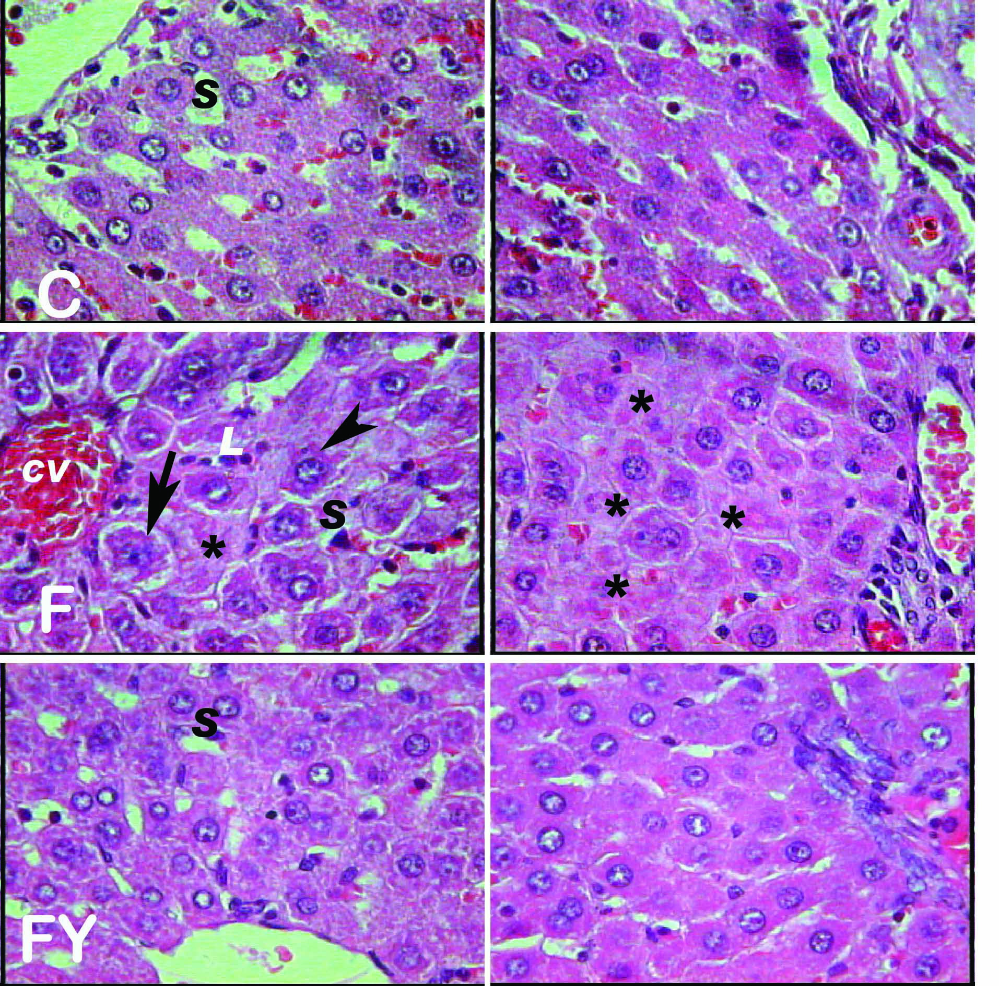
In liver sections of animals treated by both yeast and flutamide (Figure 1 FY), the incidence of cell injury was much less than in the flutamide treated animal liver and similar to control (Figure 1C).
In sections stained by Feulgen for DNA demonstration, hepatocytes with different features of injured and dying cells were observed in the liver of flutamide treated animals (Figure 2F). Such features were not observed in control (Figure 2C) or yeast and flutamide treated animal liver (Figure 2FY). The frequency distribution of the hepatocyte nuclear DNA of the three experimental groups is presented in figure (3). The population of cell nuclei containing sub Go/G1 complement of DNA representing dying cells was high in flutamide treated group (27.1%) compared with control (7.9%) and flutamide and yeast extract treated(4.3%) groups. On the other hand, the percentage of cells in the S-phase was very low in flutamide treated animal liver (.15%) compared with control (16.5%) and flutamide and
Figure 1: Histopathological changes in liver sections of different groups. The right half is pericentral and left half periportal areas. C: control, F: flutamide treated, FY flutamide and yeast treated specimens.
Notice the congested blood vessel (cv), apoptotic bodies (arrow), eosinophilic cytoplasm (arrow head) and oncotic cells (asterisk). Hx and Eosin X 400)

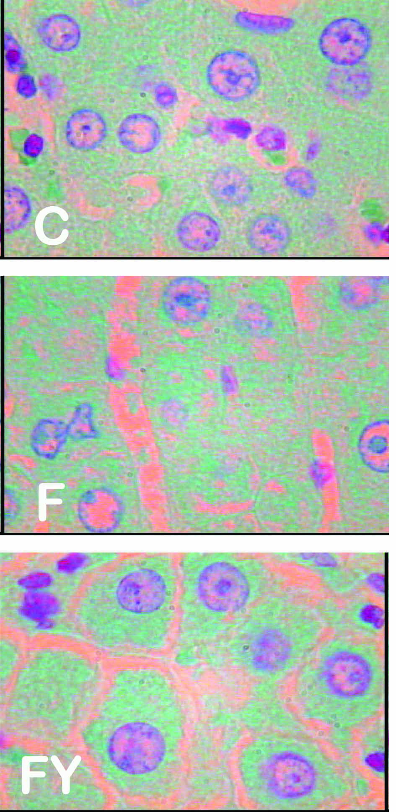
Figure 2: Feulgen stained nuclei to demonstrate DNA. C: control, F: flutamide treated and FY flutamide plus yeast
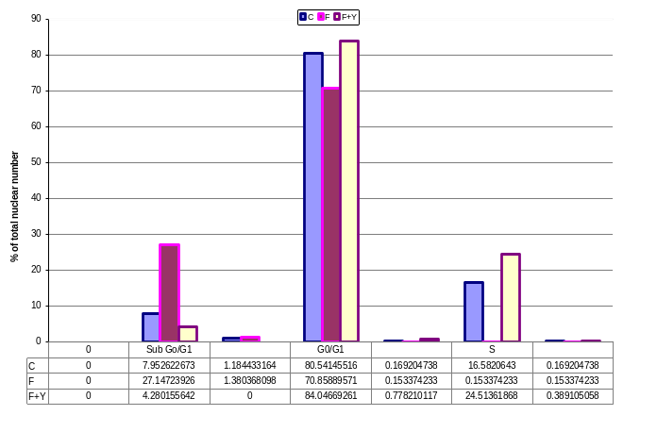
Figure 3: Frequency distribution of nuclear DNA in feulgen stained nuclei of different groups.

Iiver sections stained by immunohistochemical method for demonstration of proliferating cell nuclear antigen (PCNA) are demonstrated in figure (4). Quantitative evaluation of the antibody bound antigen presented in figure (5) indicates a significant increase in the antigen in flutamide treated animal hepatocytes compared with control. The value for the yeast and flutamide treated group was not significantly different from control.
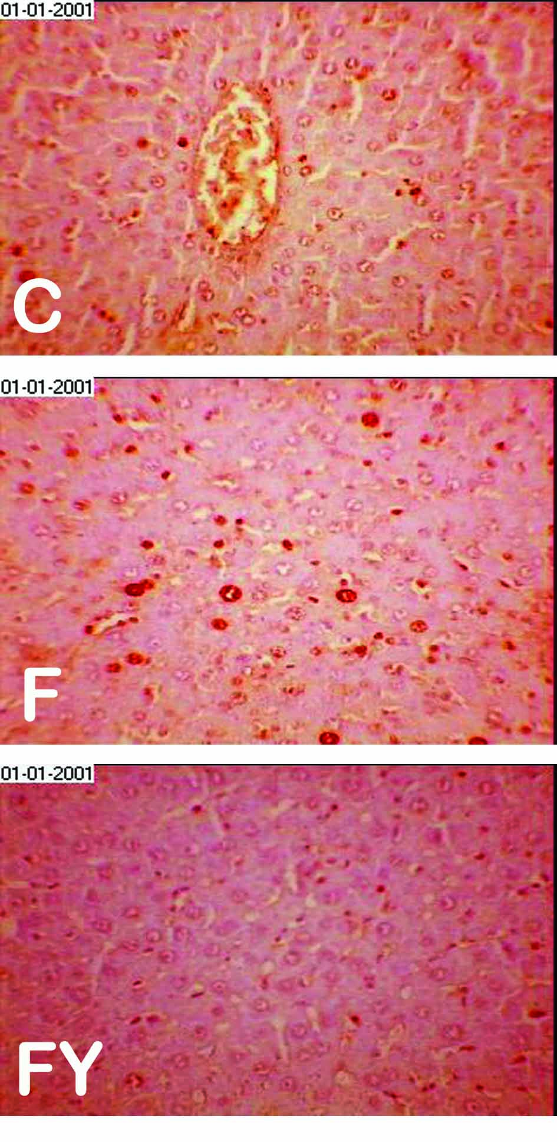
Figure 4 : immunohistochemical demonstration of proliferating cell nuclear antigen (PCNA)

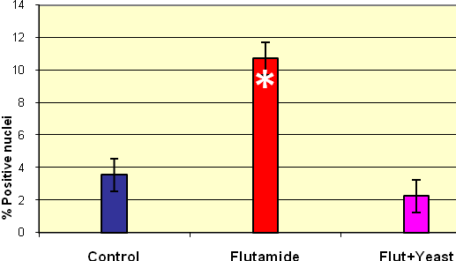
Figure 5: Mean number of PCNA positive nuclei.
The error bar represents the standard deviation,
the astrisk indicates statistically significant difference
from the mean of control (p ≤0.001)

Discussion
Flutamide (2-methyl-N-[4-nitro-3-(trifluoromethyl) phenyl]-propan-amide), was the first pure nonsteroidal antiandrogen compound discovered. It is used in the treatment of prostate cancer. Patients were reported to develop serious hepatotoxicity while using flutamide. Some of these patients even died of progressive liver disease(Wysowski et al.1993). This calls for the search to avoid such effect on using the drug. The present work is aimed to study the possible protective effect of yeast extract in rats treated with flutamide.
In flutamide treated rats, signs of hepatotoxicity were demonstrated in histological sections of liver. Hepatocytes undergoing apoptotic cell death were found mainly in the pericentral area while oncosis was more abundant in hepatocytes at the portal area. Both the portal vein and central vein were congested with blood. Frequency distribution analysis of nuclear DNA content verified a high incidence of cell with sub Go/G1 values (fragmented DNA).
The observed congestion could be the result of inhibition of the vasodilator effect of testosterone by flutamide (Hutchison et al . 2005). Vascular congestion and stagnant blood flow can lead to hypoxia that affects mitochondrial respiration which was reported in flutamide hepatotoxicity (Thole et al.2004; Scatena et al. 2007). Flutamide result in the expression of genes associated with oxidative phosphorylation, fatty acid beta-oxidation, antioxidant defense, and cell death pathways(Coe et al. 2007)
Another factor that can cause cell death is oxidative stress (Hong et al.2009). The bioactivation of flumide by P450, results in the formation of hydroxylated and free radical metabolites (Tevell et al. 2006). Such metabolites have the ability to deplete reduced glutathione by oxidation and adduct formation (Kang et al.2007). Induced glutathione (GSH) depletion was reported to be the major contributor to the oncotic and apoptotic cell death induction (Tsay et al. 2009). GSH depletion can also cause the DNA fragmentation (Kanz et al. 2003) observed in the DNA frequency distribution.
The frequency of cells in the S-phase in flutamide treated population calculated from density measurement of Feulgen stained liver sections was very low. The results suggest an inhibitory effect of flutamide on hepatocyte DNA replication and cell proliferation. This effect was also reported for the proliferation of human vascular cells (Somjen et al. 1998).
The percentage of PCNA positive hepatocyte nuclei was significantly higher in flutamide treated animals compared with control. This seems controversial for the above results. However, following exposure of cells to DNA damaging agents that block the progress of the replication fork, mono-ubiquitination of PCNA mediates the switch from replicative DNA polymerases to polymerases specialized for translation synthesis ( Brown et al. 2009). It is possible that flutamide generated oxidative stress and depletion of glutathione results in DNA damage that can cause such a switch replication to translation synthesis (Himmetoglu et al. 2009).
The histological, immuno- histochemical and DNA frequency distribution analysis indicate that drenching aqueous yeast suspension greatly reduced the signs of flutamide induced hepatotoxicity.
Histologically, signs of vascular congestion were absent in sections of liver treated with yeast extract and flutamide. This could be due to the antihypertensive effect (Penna et al .2008) of yeast extract (Kanauchi et al.2005) .
In sections of liver of animals treated with flutamide and yeast extract, the frequency of cells in the S-phase was high; and the mean percentage of nuclei positively stained for PCNA were statistically non significant from control. Both results support the ability of yeast extract to maintain the cell proliferating activity. The ability of yeast extract support for proliferation was recorded by Erikssona et al.(2005). They found that insect Trichoplusia ni cells were able to proliferate in serum-free culture media only in the presence of yeast extract.
The incidence of cell death was much lower in yeast extract and flutamide treated group than that of flutamide alone. This was evident in histological sections as well as the percentage of cells containing fragmented DNA. The yeast cell wall mannans was found effective in reducing DNA damage and having antioxidant properties (Krizková et al., 2001) . The same effect was also addressed to carboxymethyl-glucan (CM-G) and sulfoethyl-glucan (SE-G) both from the baker's yeast (Krizková et al., 2003).
The present study, therefore, reports that drenching yeast extract suspension to rats protected from the signs of hepatotoxicity induced by flutamide. Vascular congestion, cell death and DNA fragmentation induced in liver of flutamide treated animals were much ameliorated in the liver of rats treated by both flutamide and yeast extract.

References

