New Crinkles Approach for Development of Aesthetics Wrinkled Fabrics Containing Spandex

ElSayed ElNashar^{1*}, Fatma Kalaoglu², Mohamed Hashem³
¹ Faculty of Specific Education, Kafrelshekh University, Kafrelshekh, Egypt.
² Faculty of Textile Technology and Design, Technical University of Istanbul, Turkey
³ Textile Division, National Research Centre, Cairo, Egypt
dr_elnashar@hotmail.com
Abstract
Development of the wrinkled fabrics depends on geometry and relaxation behavior of the woven fabrics. After bleaching and relaxation, the new shapes and sizes of crinkles were recorded. The results prove that the manner of fabric deformation during relaxation depends upon the fabric structure. The quantities of the crinkles on the fabric are related to the float length type. Fabrics with longer float length show higher crinkled, and its deformation behavior is non-linear. Thus, connected deformations are closely related to the stretch potential and influence fabric draping and fitting of the garment. For this purpose, we have postulated new model for the relationship between fabric geometry and stretch potential. The suggested hypotheses make it possible to predict mathematically the crinkle of woven fabrics and prediction of suitable sett of warp and weft. The area covering value was chosen as suitable model for description of woven fabric structure. The study was divided into two parts, the first presents the relationship between fabric geometry of the relaxation behavior whereas the second investigated the influence of fabric stretch potential on the relaxation ability of bleached fabric. Three variants of cumulative parameter of a crinkle woven fabrics structure were introduced. The realistic models based on a better approach of geometry and material properties will be created in order to investigate the numerical analysis performance of the mechanical properties of crinkle woven fabrics. A correlation between calculated values of structural parameters crinkle woven fabrics values was evaluated.
Keywords: Geometry, Stretch, Crinkles, Relaxation, Distortion.

1. Introduction
Crinkles in woven fabric as wrinkled from being apart of potential aesthetic interest to the fashion or mass-market garment industry, can be used as a detection and response mechanism in high performance garments. [5].
The crinkle problem can occur in warping, weaving, and finishing processes. Tension variation across the width of the warp beam could cause bow and crinkles at warping and weaving stage [6]. In case of sectional warping, improper slope or tension applied to each band of the warp can create the same distortion. In addition, two sides of the weaving cloth are not equally tensioned causing crinkles. The main cause at any step of the finishing process is the variation in running speed across the width of the fabric, which causes shear deformation.
Spandex is a generic name for rubber-like synthetic fibers comprised of at least 85% of segmented polyurethane. To improve the recovery of woven fabrics, it is now common to co-weave a small amount of spandex yarn with the companion hard yarn. This paper will deal with single layer fabric construction with the companion hard yarn being cotton. Rephrase process variations exist for different woven fabric constructions and fabric end uses, a general process for woven fabrics with spun hard yarns is as follows: the plain-woven fabric is processed in open-width form and laid flat. The open fabric is subsequently relaxed either by subjecting it to steam or wetting it by dipping and squeezing (padding). When the fabric relaxed with a tender frame and heated (for heat setting) in an oven, the flat fabric is released from the stretcher. The plain-woven fabric is then subjected to wet processing consisting of scouring, bleaching. In making the roll, the fabrics containing elastane yarns exhibits viscoelastic properties of a viscoelastic solid and respond to the Hook’s law and as a viscous liquid as stipulated by the Newton’s law. Due to the typical viscoelastic properties of the wound fabric, the stresses in the roll in tangential direction are lower than in radial one [12]. This can be seen after manually unwinding the first layer of the fabric roll, as there is no change of length of the cut layer after particular relaxation time [17]. On the contrary, the stresses in the radial direction from the outside to the inner part of the roll increase [8].The behavior of the fabric in the roll as a viscoelastic material is described using the mechanical models, which consist of the basic model of the spring and the dashpot. The spring presents the elastic properties of the fabric according to the Hook’s law, while the dashpot presents the viscose component of the deformation, which is not recoverable and timely dependent. The behavior of the viscose component is described by the Newton’s law [12]. In an attempt to clarify this complex problem, fabric elastic properties and their elastic potential are presented in this paper, as well as the relationship between fabric geometry and elastic stretch potential. The prediction of the mechanical behavior of crinkle woven fabrics using analytical method is restricted by the complexity of the fabric structures, the anisotropic properties of the yarns, and the contact phenomena. For these reasons, the use of FEA (Finite Elements Analysis) becomes continuously wider for the modeling of suitable fabrics’ structures. The modeling requires the knowledge of mechanical properties of the yarn and the geometrical characteristics of the fabric. Several studies have been analyzed the dimensional properties of woven fabrics structures with prevailing these form [4, 15]. These studies have presented geometrical models consisting of known curves, for example, circular arcs and straight lines, or the results of measurements that have been carried out on a series of suitable crinkle woven fabrics structures. A recent extended research work presents the 3D modeling based on elastic theory. The problem with the existing geometrical models of crinkle woven fabrics structures is in some cases the insufficient accuracy of the predicted dimensions or their difficulty to be used for the generation of the 3-dimentional representation of the structure [21]. While crinkle woven fabric buckles without tension a non-uniform load distributed over a short distance or asymmetrically distributed [11]. The present work focuses on the estimation of the geometrical characteristics of a crinkle woven fabrics structure supporting the maximum and suitable possible accuracy in order to ensure the numerical modeling success by using new modeling with a special analysis. The maximum number of ends and picks per unit length that can be woven with given yarn and weave is an important issue for weaving designers. A weaving designer should be sufficiently familiar with construction limit to avoid difficult and unachievable constructions. With constructions above or near the upper weaveability limit, parts of weaving machine may be over stressed and damaged. For this reason, the empirical and theoretical relationships relating maximum warp and filling cover factors of regular yarns have been derived to theoretical relationships provided in graphic forms for simple weaves [19, 16].For weaving tight fabrics a full-width temple and early shed is recommended [19]. In a study of the weaveability limit of fabrics made from irregular thickness filling yarn, it is concluded that yarn regularity increases weaveability limit [18]. Weaveability limit depends on loom (light or heavy), dobby mechanism (negative or positive), let-off mechanism, and take-up mechanism. Weaving condition that affect limits of setts are warp tension, shed change timing and backrest position.
Maximum construction theories [20]
Ashenhurst`s “ends plus intersections” theory: this theory states that
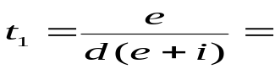 (1)
t=max. ends or picks/inch, e= ends or picks/weave repeat, i= intersection/ weave repeat, d= yarn diameter in inches
A) Weave angle [7]
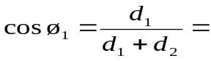 (2)
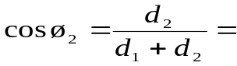 (3)
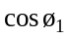 + 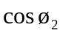 = 1 (4)
d is yarn diameter
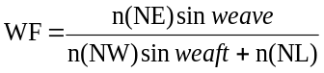 (5)
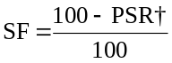(6)
WF; Weave factor, n(NE): number of ends, n(NW): number of weft, n(NL): number of interlacing,
SF: shrinkage factor, PSR: Percent Shrinkage Required, †percent shrinkage required should normally be extended by a small amount to allow for permanent stretch due to dyeing, finishing and other processing operations [1]. We calculate dimensional change as indicated in the following equations and express the result for each individual specimen to the nearest 0.1%. The average for the roll or fabric piece is expressed to the nearest 0.5% or as agreed upon by the interested parties.
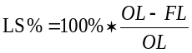(7)
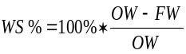 (8)[10]
LS: length of shrinkage, OL: original length, FL: final Length, WS: widths of shrinkage, OW: original width, FW: final width
The object of this work:
The main objective of the proposed research is to reveal the influence of the structure parameters (filling yarn, fiber type, and weave) of woven fabrics with spandex constituents on their physical and mechanical properties (stretch and stretch recovery, thickness,) for crinkle.
2. Experimental
Experiments are carried out on two group of fabrics structure. One group contains elastane yarn and the other group not. The weaving trials using Lycra® yarns were conducted on Picanol weaving machine with an attachment of jacquard head with the following specifications; warp yarn:30(cotton),warp density:70ends/inch,weft density: 56 weft/inch , with using 1/1plain, 45x45 spider, 12x14 on based twill weaves, in El-Delta spinning and weaving, Tanta and (Zeifta factory) company-Egypt. In additional the fabrics were tested in faculty of textiles NCSU, USA, and Faculty of Engineering Elmansura University. A group of samples made from polyester, Fibran, rayon viscose, blended, cotton and Lycra® fibers as weft, but with different weight per unit area another group made from same weft but with arranging 14 of weft from polyester, Fibran, rayon viscose, blended (cotton/polyester (50/50)), cotton, and 14 of weft from Lycra®, with different weight per unit area for evaluation the thickness of clothing: The measurement of thickness of each of the trials woven fabrics has been carried out according to the A.S.T.M standard [3, 12]. The 15 samples were obtained with the three models of fabric structures with several weft (cotton, polyester, Fibran, blended (cotton/ polyester (50/50)), and viscous rayon) with Lycra®. The bleaching was carried out with hydrogen peroxide using a single recipe for all fabrics under investigation.
2.1. Chemicals used: Sodium hydroxide (50%), Hydrogen peroxide (50%), Kierlon® NE (non-ionic surfactant), Quest® special (sequestering agent) Prestogen® ND (peroxide stabilizer), Uvitex BNB (optical brightener for cellulosic components) and Uvitex® NB (Optical Brightener for polyester and polyurethane component) were of technical grade chemicals.
2.1.1. Bleaching procedures: Exhaustion technique was employed to effect bleaching using Mathis® Lab Jumbo Jet model JFO, from Werner Mathis AG, USA. 50 cm from each sample were sewed together in one rope then introduced into the jet machine. Using a liquor ratio of 30, the calculated amount of water was pumped first followed by the addition of 3 g/l NaOH (50%), 6 g/l, H2O2 (50 %), 1 g/l Kierlon®NE, 1 g/l Quest Special and 1 g/l Prestogen® ND. The bleaching temperature was gradually increased to 100ºC in 30 min then kept constant for another 30 min. At the end of bleaching time, the liquor cooled down then drained and the samples washed with hot water then washed with cooled water containing 1 g/l acetic acid. Finally the samples washed again twice with water then centrifuged and dried at ambient conditions. Parts of these samples were subjected to treatment with optical brightener using the same technique and the same machine. The experimental conditions were adjusted as follows: mixture from 1 % (owf) Uvitex® BNB and 1 % (owf) Uvitex NB was pumped in the machine and the treatment was carried out at 100°C for 30 min. The samples were centrifuged then dried at ambient conditions.
2.1.2. Testing and analysis: All the woven samples were conditioned at 70 °F and 65% RH for 24 hours and 20 cm x 20 cm squares were marked on the samples. Wettability was assessed in terms of drop disappearance, measured by allowing a drop of water to fall on the sample and recording the time required for drop disappearance [2]. The degree of whiteness and yellowness of the fabric sample expressed as whiteness index and yellowness index was measured according to reported method [14].

3. RESULT AND DISCUSSION
The basic theories of design do not change when designing stretch filling fabrics. The fabric in a plain, twill weave cannot stretch until they shrink. A construction must therefore provide for shrinkage, and there must be sufficient space between ends such as spider weave. This section includes a comparison of woven fabrics produced from wefts (Polyester, Fibran, Spandex, Viscose, Blended (Cotton/ Polyester)) and the arranging as horizontal stripes of weft with spandex “Lycra®”, All the woven samples were then wet-relaxed and the relaxed dimensions of the marked squares were measured and recorded. The dimensions of the woven samples before and after wet relaxation were used to calculate stretch potential. Several goals were established for statistical analysis of the data.
3.1. Calculate Crinkle Woven Fabrics %: Tested of weight per unit area of the fabrics were carried according to ASTM standard [3] in standart atmosphere. In addition, weight by geometry method [9] is also applied: the sample tested by find the diameters of warp and weft cross-section, according to Grosberg in the following equation:
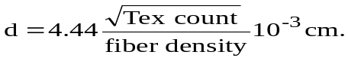(9)
Where: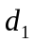,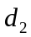=diameter of warp-weft cross section, For obtain a weight of warp or weft by the following equation:
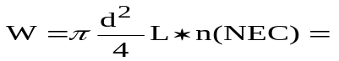 gram (10)
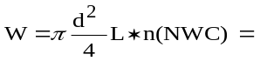 gram (11)
n(NE): number of ends in Cloth, n(NW): number of weft in Cloth ,
3.1.1 Location of the Free Spaces: Comparison of 1/1plain, 45x45 spider, 12x14 on based twill weaves, shows a direct relationship between the float length and the contraction and repeats of interlacing. The following Figures from 1 to 3 shows the type of woven construction as the location of the free spaces assigned the direction of the float movement. Indeed, the location of the free spaces (on either side of the float) offered a free way of assigning the direction in which the float (an in-plane lever) could repeat.
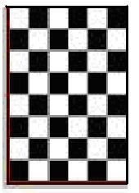
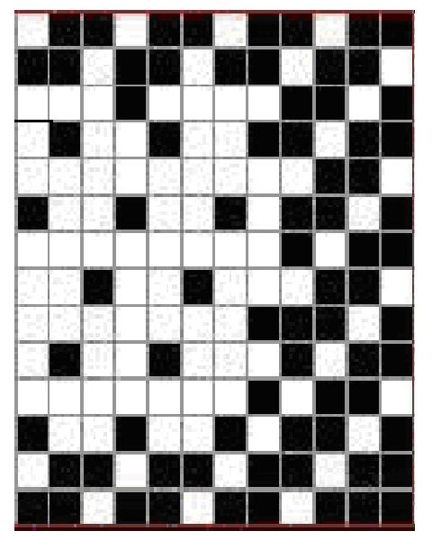
Figure2. (12x14 twill)

Figure1. (1/1plain)

The warp floats offering crinklewise turn having free zones located on left
side of the top part and right side of the bottom part of the warp floats to let them repeat counter crinklewise. As the float length gets longer, the freedom of the float to contract goes higher in Figure 2. The comparison of 1/1plain weave, 45x45 spider weaves, 12x14 on based twill weave, shows a direct relationship between the float length and contraction, as the float length gets longer the freedom of the float to contract goes higher in Figure 3. Fabrics, the angle in which the warp float will migrate (the warp lane movement) is: weft float distortion as weft degree of movement
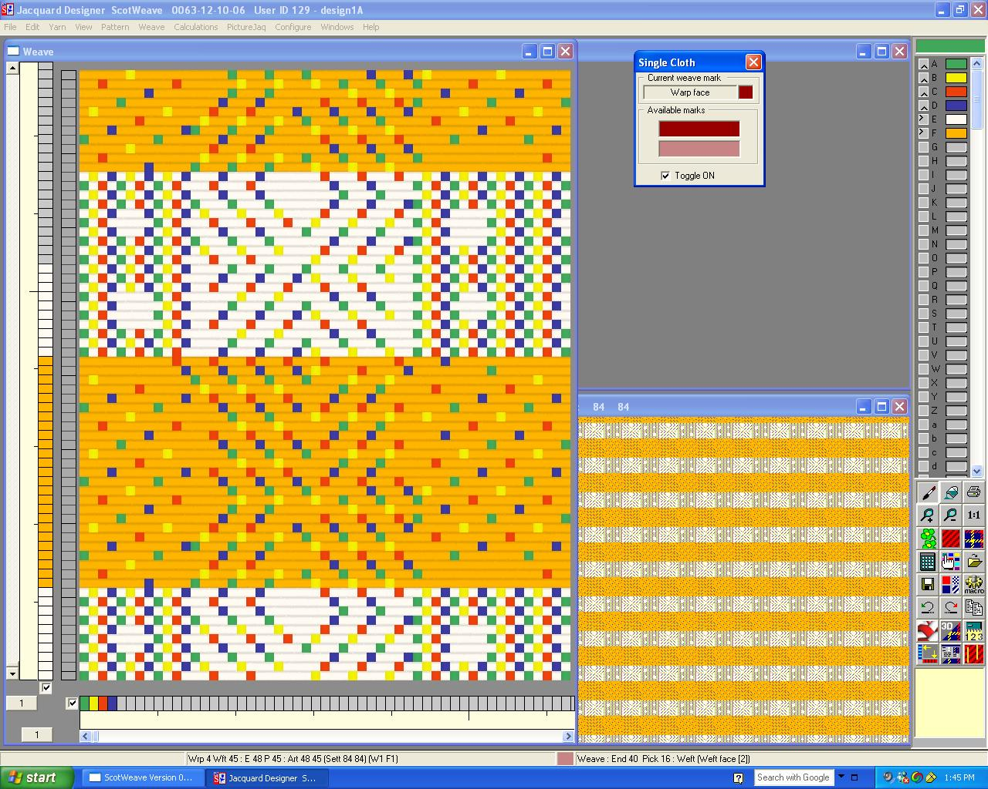
Figure3. (45x45spider) by using ScotWeave software in weaving laboratory
in college of textiles NCSU.

3.1. 2. Geometry of the relaxation behavior: As the free spaces (voids) increase, the freedom of movement for the yarns goes higher in Figure 3. In other words, the firmness of the fabric reduces. Comparison of the three woven fabrics by using different materials is shown in Table1. The weave factor and shrinkage factor are calculated according to equations 5 and 6.
3.2. Calculation Warp Float Distortion
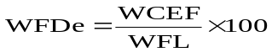(12)

WFDe: Warps float Distortion, WCEF: weft construction for each float, WFL; the warp float length.
Warp degree of movement of the 1/1plain weave, 45x45 spider weave, 12x14 twill weave of 1/1plain weave, 45x45 spider weaves, 12x14 twill weave is calculated. The angle in which the weft float will migrate (the weft plane movement) is: Warp float migration (mm): The movement of the warp float is related to the amount of weft contraction. In other words, warp float migration is the weft contraction per each warp. The maximum possible movement of the warp float is equal to (5 mm/27). Therefore, there is no migration and movement for the weft float is related to the amount of warp contraction by using the spandex.

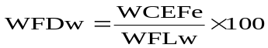(13)

WFDw: Wefts float Distortion, WCEFe: warp construction for each float, WFL; the weft float length.
Table 1: woven fabrics using various materials as filling
 | Cotton | cotton | Fibran | viscose | Blended | Polyester | Lycra
Warp linear density (Tex) | 30
Measured (d1) mm | 0.0195
Weft linear density (Tex) |  | 40 | 40 | 40 | 40 | 40 | 34
Measured (d2) mm |  | 0.0226 | 0.0227 | 0.0232 | 0.0232 | 0.0239 | 0.0220
In addition, we used standard density of weft per cm. the Yarn Density (27x18) Yarn /cm.
Fiber densities were: Cotton=1.54, Viscose =1.46, Polyester =1.38, Fibran =1.52, Blended (cotton/polyester (50/50) =1.46,

3.3. Stretch Potential and Target Stretch [13].
The dimensions of the woven sample before and after wet relaxations are calculated the stretch potential using Equations 23, 24 and 25. Maximum Stretch Potential % in length (warp) direction,
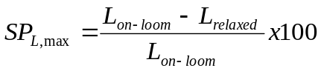 (14)
Maximum Stretch Potential % in width (weft) direction,
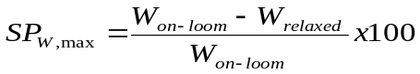 (15) Here L_{on-loom} and W_{on-loom} are the length and width of the on-loom fabric. L_{relaxed} and W_{relaxed} are length and width of the woven samples after wet relaxation. The target stretch dimensions at which the woven samples would be heat-set were calculated using equation 16.
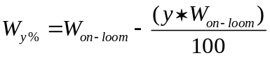 (16)
y %.; fabric dimensions at target stretch.
3.4. Construction Repeats: The fabric repeat angle is the sum of the warp and weft repeat angles. In other words, the fabric repeat is the degree of the warp and weft float distortion, based upon the above theoretical suggested estimation, the maximum possible repeats for each fabric is calculated and the values are recorded in Table 2 and compared with the actual measured repeats. The comparison of the estimated and measured values of repeats shows an acceptable agreement with the relationship between woven and crinkle fabrics in Figure 4.
Calculation length (L) of crinkle woven fabrics: Crimp ratio and change of cross-section is not neglected, that greater angle of contact will be connected with more important change of yarn cross-section from circular into approximately elliptical. This equation gives us more fitting results especially to calculate the crinkle woven fabrics in garments. This model was constructed to have a geometry complicated enough to see the effect of changing the medium location but simple enough to save computational time by using the equation (16, 17, 18). So we had established new equation for calculation the crinkle distortion
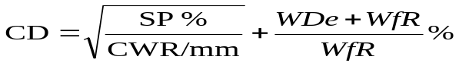 (17)
CD; crinkles distortion, SP; stretch potential, CWR; crinkles width repeat, WDe; warp density of ends
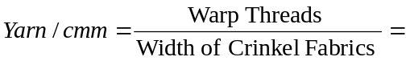
(18)
For calculating yarn per centimeter as: Then must be used new equation for calculation a length (L) of crinkle woven fabrics
Calculation a length (L) of crinkle woven fabrics:
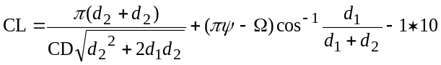
(19)
Where; CD; crinkles distortion, CL; crinkle length, ℓ;crinkle length (mm),  is crinkle width (mm), 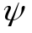 is crinkle height (mm), as example for calculation crinkle length of sample 1 as the following to:

3.4.1. EVALUATION OF THE GEOMETRICAL MODEL
For detection, the geometric characteristics of the crinkle woven fabrics structure of weft (cotton, spandex, polyester, viscose rayon, blended (polyester/cotton) and the warp of cotton, the individual parameters of the three woven fabric were measured. The evaluation of the geometrical model is based initially on the comparison of the experimentally defined crinkle length of a given fabric to the respective calculated by the geometrical model for the same main parameters (plain, twill, and spider) weave. The main structural parameters of a fabric can be defined after a microscopic observation and the crinkle length can be measured by using the crimp tester. Table 2 contains the main parameters, the measured crinkle woven fabrics lengths, and the geometrically calculated crinkle woven fabrics lengths for fifteen randomly selected fabrics. The error between the calculated crinkle woven fabrics length and the measured one is considered as the indication of the accuracy of the geometrical model.

Table 2: measurement/dimensions of crinkle fabrics at three woven fabrics

Fabric | % contraction |  | Weave | Crinkle Width Repeat/mm |  | Crinkle Relaxed Fabric  (yarns /cm) |  | Crinkle Distortion% | Crinkle Length  mm
Fabric | Warp | Weft | Weave | Actual Relaxed | *Wet-Relaxed | Relaxed yarns/cm | *Wet-Relaxed yarns/cm | Weft Float%
1 | 2 | 2 | Plain weave | 5.86 | 4 | 46 | 46.4 | 180 | 7.5
2 | 2 | 2 | Plain weave | 8 | 6 | 47 | 47.27 | 166.6 | 9.310
3 | 12 | 14 | twill weave | 3 | 2.5 | 87.48 | 87.91 | 223 | 5.244
4 | 12 | 14 | twill weave | 3 | 2 | 76.73 | 77.12 | 226 | 8.23
5 | 48 | 45 | Spider weave | 5 | 4 | 71.70 | 72.07 | 215 | 9.463
6 | 48 | 45 | Spider weave | 8 | 5 | 74.13 | 73.88 | 214 | 9.374
7 | 12 | 14 | twill weave | 4 | 3 | 75.41 | 75.79 | 218 | 9.459
8 | 48 | 45 | Spider weave | 5 | 4 | 72.29 | 73.26 | 213 | 9.459
9 | 12 | 14 | twill weave | 6.5 | 4.5 | 51.15 | 51.41 | 208 | -5.366
10 | 2 | 2 | Plain weave | 5 | 3 | 44.18 | 44.40 | 379.8 | -5.366
11 | 12 | 14 | twill weave | 7.52 | 7 | 82.52 | 82.95 | 207 | -5.285
12 | 48 | 45 | Spider weave | 5 | 3 | 76.87 | 77.26 | 217 | 9.362
13 | 48 | 45 | Spider weave | 3 | 2.5 | 72.9 | 73.26 | 217 | -4.2056
14 | 12 | 14 | twill weave | 8 | 6 | 78.10 | 78.49 | 207 | -4.119
15 | 12 | 14 | twill weave | 0.00 | 0.00 | 28.96 | 29.11 | 0.00 | 0.00

Warp contraction per each weft.
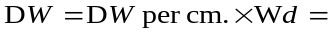(20)
DW; Density of Warp, Wd; width of warp
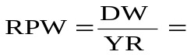(21)

RPW ; Repeated of plain weave, YR; yarn repeated
Warp threads = 27*162= 4374 yarns
Repeats of Plain weave = 4374/ 2= 2187
Repeats of on Based twill weave= 4374/12= 364.5
Repeats of Spider weave=4374/ 48= 91.125

3.4. Aesthetics Distortion of the Structure of the Crinkle Woven Fabrics
We can get the aesthetics crinkle fabrics by distortion structure of woven fabrics, due to the structural symmetry as repeats of a crinkle woven fabrics and the unit cell is considered as the one quarter of spider crinkle woven fabric. The yarns are represented as homogenous cylinders of constant diameter, with initially restricted contact area between them. We consider orthotropic structure properties of the spandex yarn with three levels of crinkle woven fabrics modules, one for the yarn axis direction, and one for the yarn radius direction as Figure 4. The levels of crinkle woven fabrics allow the unit cell of deformation as distortion structure considered as being positioned in the center of the specimen. Simulation of the structure test of a of a crinkle woven fabrics as it is executed at the main purpose of this distortion structure for crinkle unit is the creation of a model of the crinkle woven fabrics structure via Photoshop software programming and use of the 3D visualization of the structure. This method supports the better understanding of the deformation process of the yarns crinkle due to the applied distortion structure in the fabrics, by the superposition of three deformation modes (height, medium, graven) levels, figure 4. With three woven fabric structures, which correspond in the distortion structure, these three regions cannot be distinguished and are accompanied by the yarn slippage and the compression deformation of distortion structure by spandex weft at the link points of the crinkle woven fabrics. Especially at spider weave condition, that is the zone of the main interest, the dominating mechanism of deformation is the change of the crinkle woven fabrics shape due to the distortion structure of the yarns in woven fabrics. Under these conditions, the shaped arcs of the crinkle cell have a significant influence in the deformation process of distortion structure. Since the mechanical loading of the yarns imposes increase of the contact area with essential local deformations and distortion structure. The satisfactorily fitting of the theoretical curves to the experimental ones ensures the accuracy of the geometrical characteristics that are used for the modelling. All parameters of distortion for crinkle woven fabrics structure mentioned above were calculated for all crinkle woven fabrics. The specific volume is significantly influenced by behavior of the spandex filling spaces in between structural characteristics values of porosity and rephrase fabrics in figure 4 and their deviations from experimental crinkle woven fabrics values after bleaching. In open structure fabrics the suggested method gives relatively good results. In dense fabrics the results (predicated values of crinkle woven fabrics) are not so accurate.
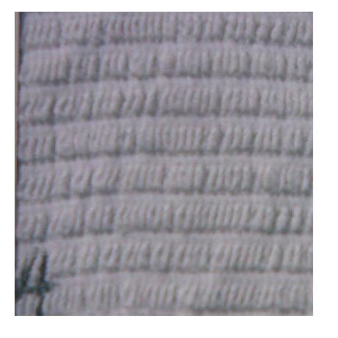
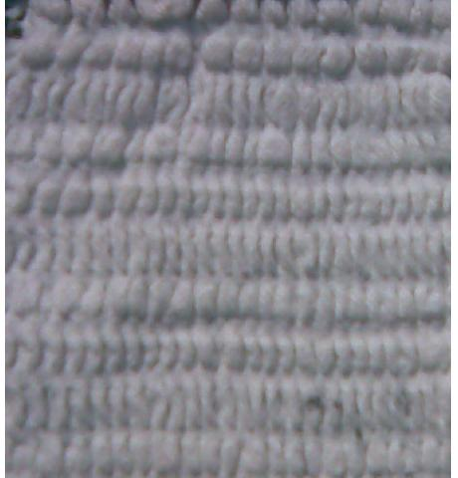
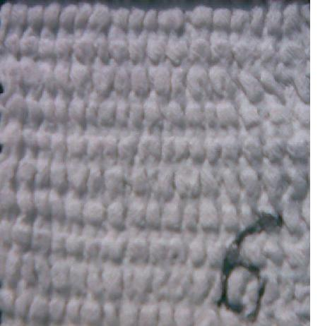
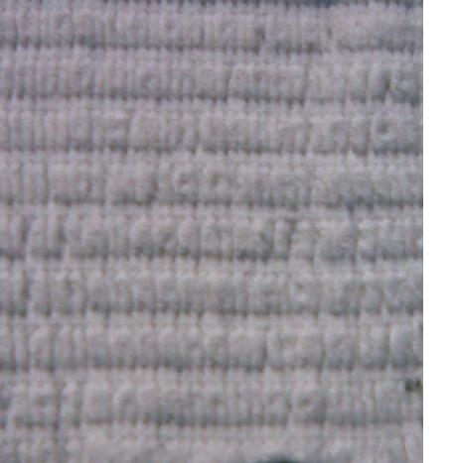
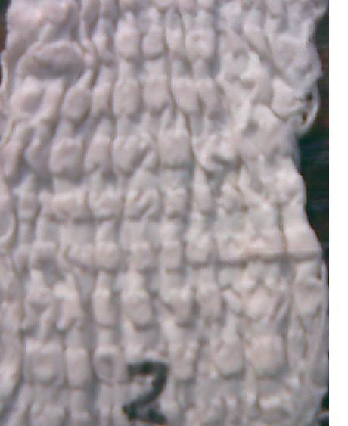
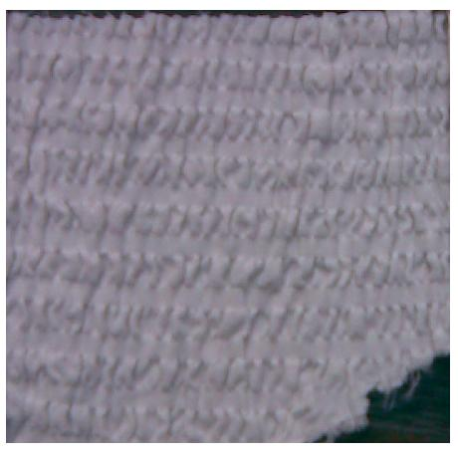

Fabric 3
Fabric2
Fabric 4
Fabric1
Fabric 5
Fabric 6
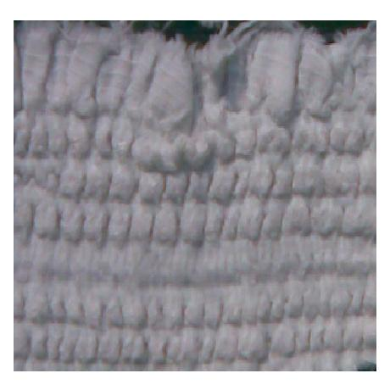
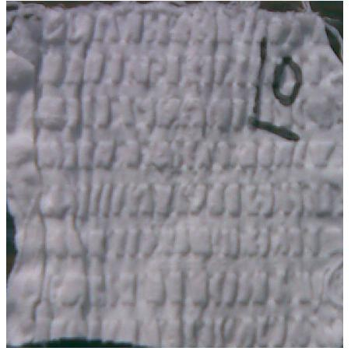
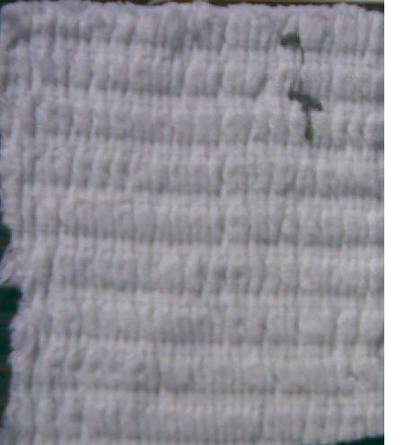
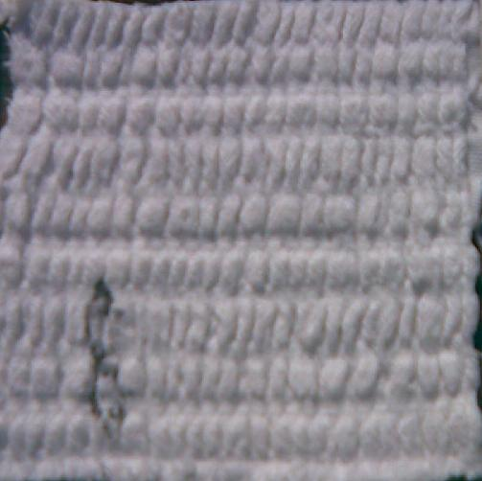
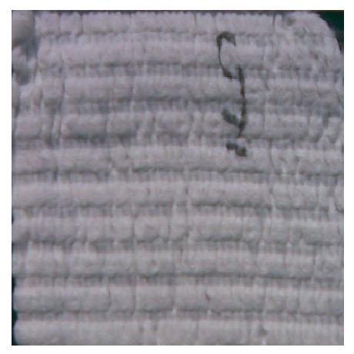
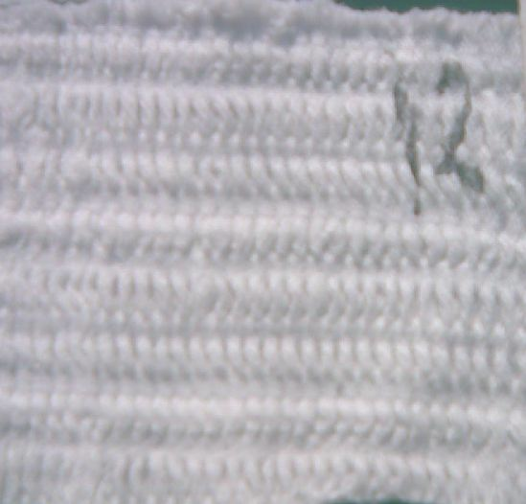

Fabric 12

Fabric 11

Fabric 7
Fabric 8
Fabric 9

Fabric 10

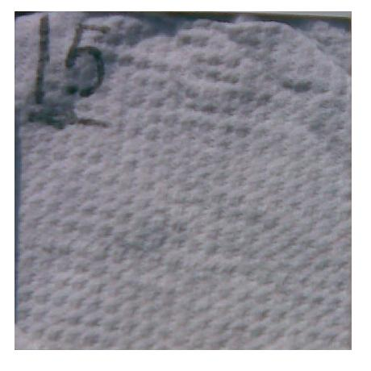
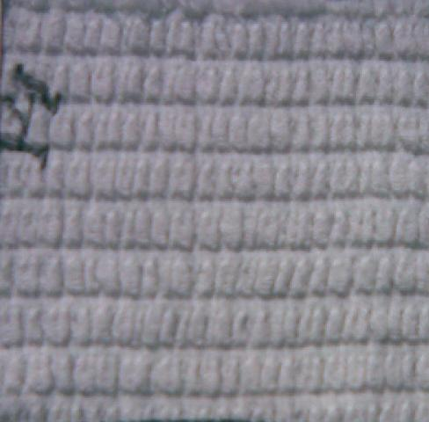
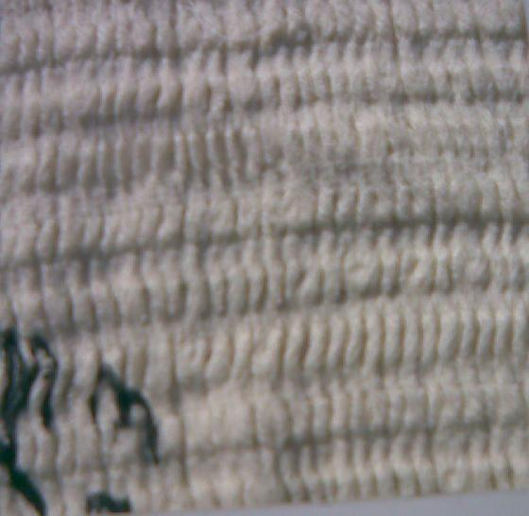

Fabric 15

Fabric 14

Fabric 13

Figure 4: Appearance after bleaching crinkle fabrics
As it was expected, the fabrics contracted in both directions (width and length). Although, on the loom, all of the fabrics were almost of the same size (167×100 centimeters), after relaxation the fabrics became different in size as shown in Table 3. In other words, each fabric weave ended up with its own new size as shown in figure 5.
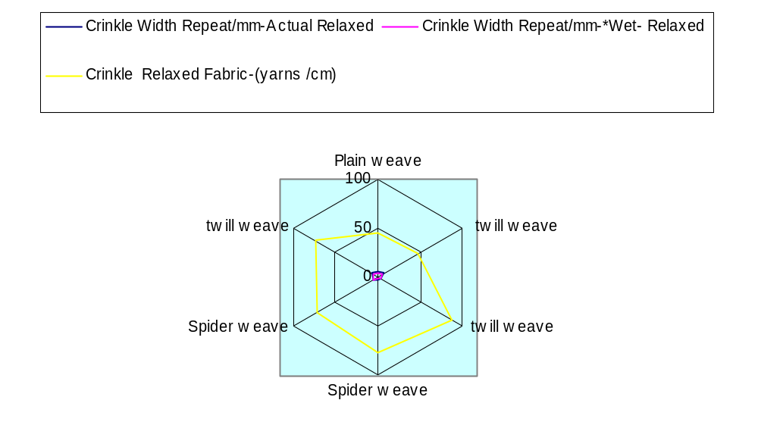
Figure 5: Relationship between woven and crinkle fabrics
It is obvious that when fabrics were released from the weaving conditions, the warps and wefts start to contract to their conditions of equilibrium. Naturally, floats get shorter, yarns get closer to each other and depending upon the existing space by using the weft of spandex, each float finds its own seat. At this stage, when each float is finding and sitting on its final space the free spaces between the yarns play a vital role. In fact, the free spaces would give neighbouring yarns (floats) an open space to move and fit in by using the weft of spandex. Therefore, such conditions make each float to have two or three regions movements. (Figure 4 shows shortening the length, movement toward the free zone). In order to have a better understanding, we take three weaves into consideration, plain, 48/45 spider and simple 12/14 on based twill. In a 1/1 plain weave, the ends, and picks float over one thread, causing each float to be surrounded (tightened) by 4 interlacing points. In such case, floats are comparatively small, interlacing points are high and free spaces between yarns are zero, spandex making the fabric to be relatively firm (giving the yarns no freedom to move). In a 12/14 on based twill weave, the ends and picks float over two consecutive threads without any interlacing. Such a condition makes the floats to be longer, the number of interlacing points to be lower weave and the existence of a free space between each of the two yarns makes the fabric relatively loose (Table 3). In such case, 48/45 spider weave, the ends and picks float over two consecutive threads without any interlacing. Such a condition makes the floats to be longer more than 12/14 on based twill weave, the number of interlacing points to be more lower weave by using spandex and the existence of a free space between each of the two yarns makes the fabric relatively loose (Table 4,5).
Table 3: On-loom fabric dimensions, wet-relaxed fabric dimensions, stretch potential %, and
Fabrics dimensions at three woven fabrics
Na | Weave | On-loom Fabric Dimension, cm |  | Relaxed Fabric Dimensions, cm |  | *Wet-Relaxed Fabric Dimensions, cm |  | Stretch Potential %
Na | Weave | L | W | L | W | L | W | L | W
1 | 1/1 plain weave | 100 | 162 | 86.0 | 95.0 | 85.57 | 94.25 | 0.14 | 41.35
2 | 1/1 plain weave | 100 | 162 | 86.0 | 93.0 | 85.57 | 92.53 | 0.14 | 42.59
3 | 12/14 on Based twill weave | 100 | 162 | 89.0 | 50.0 | 88.55 | 49.75 | 0.11 | 69.13
4 | 12/14 on Based twill weave | 100 | 162 | 89.0 | 57.0 | 88.55 | 56.71 | 0.11 | 64.81
5 | 48/45 spider weave | 100 | 162 | 91.0 | 61.0 | 90.54 | 60.69 | 0.09 | 62.0
6 | 48/45 spider weave | 100 | 162 | 91.0 | 59.5 | 90.54 | 59.2 | 0.09 | 63.27
7 | 12/14 on Based twill weave | 100 | 162 | 89.0 | 58.0 | 88.55 | 57.71 | 0.11 | 65.0
8 | 48/45 spider weave | 100 | 162 | 91.0 | 60.5 | 90.54 | 59.7 | 0.09 | 62.56
9 | 12/14 on Based twill weave | 100 | 162 | 89.0 | 85.5 | 88.55 | 85.07 | 0.11 | 47.27
10 | 1/1 plain weave | 100 | 162 | 86.0 | 99.0 | 85.57 | 98.5 | 0.14 | 38.8
11 | 12/14 on Based twill weave | 100 | 162 | 89.0 | 53.0 | 88.55 | 52.73 | 0.11 | 67.28
12 | 48/45 spider weave | 100 | 162 | 91.0 | 56.9 | 90.54 | 56.61 | 0.09 | 65.12
13 | 48/45 spider weave | 100 | 162 | 91.0 | 60.0 | 90.54 | 59.7 | 0.09 | 62.96
14 | 12/14 on Based twill weave | 100 | 162 | 89.0 | 56.0 | 88.55 | 55.72 | 0.11 | 65.43
15 | 12/14 on Based twill weave | 100 | 162 | 89.0 | 151.0 | 88.55 | 150.24 | 0.11 | 6.79
*Wet-Relaxed it means belching
Table 4: On-loom fabric dimensions, fabric properties (Fifteen samples)
Na | Weave | On-loom Fabric Dimension, cm |  | Sample Weigh/ g |  | Thickness mm. |  | Air permeability (m3 / sec .m2)
Na |  | L | W | L* | W** | L* | W** | Before* | After**
1 | 1/1 plain weave | 20 | 20 | 174.9 | 177.5 | 2.3 | 2.36 | 31 | 29.76
2 | 1/1 plain weave | 20 | 20 | 161.4 | 163.8 | 3.4 | 3.5 | 31.9 | 30.62
3 | 12/14 on Based twill weave | 20 | 20 | 210.4 | 213.5 | 3.3 | 3.39 | 31.14 | 29.89
4 | 12/14 on Based twill weave | 20 | 20 | 207.3 | 210.1 | 3.2 | 3.29 | 32.33 | 31.03
5 | 48/45 spider weave | 20 | 20 | 353.2 | 358.4 | 3.7 | 3.81 | 32.13 | 30.8
6 | 48/45 spider weave | 20 | 20 | 354.5 | 359.8 | 5.3 | 5.45 | 32 | 30.72
7 | 12/14 on Based twill weave | 20 | 20 | 239.8 | 243.3 | 4.7 | 4.84 | 32.13 | 30.84
8 | 48/45 spider weave | 20 | 20 | 372.3 | 377.8 | 3.9 | 4.0 | 32.33 | 31.03
9 | 12/14 on Based twill weave | 20 | 20 | 241 | 244.6 | 5.4 | 5.56 | 30.74 | 25.24
10 | 1/1 plain weave | 20 | 20 | 202.1 | 305.1 | 3.1 | 3.19 | 31.9 | 30.62
11 | 12/14 on Based twill weave | 20 | 20 | 230 | 233.4 | 4.4 | 4.53 | 31 | 29.76
12 | 48/45 spider weave | 20 | 20 | 275.2 | 279.3 | 1.8 | 1.85 | 31.14 | 29.89
13 | 48/45 spider weave | 20 | 20 | 170.6 | 173.1 | 1.91 | 1.94 | 32.53 | 31.22
14 | 12/14 on Based twill weave | 20 | 20 | 173.8 | 176.4 | 1.65 | 1.67 | 32.13 | 30.84
15 | 12/14 on Based twill weave | 20 | 20 | 195.6 | 198.5 | 1.7 | 1.75 | 32 | 30.72
* Before bleaching , ** after bleaching

In addition, the points of intersection move one to the right and one upward on succeeding spandex picks forming distortions the diagonal line in the cloth, for the 48/45 spider weaves. In 12/14 on based twill weave between the seven to nine yarns over which a thread floats, there is a gap or free space at least equal to the actual diameter of the yarn. This free space makes distortions possible for the floated length of the yarn to bring the crossing yarns closer to each other due to contraction. Shortening the floats of yarns due to distortions of contraction in such a condition cause the float is affected by two forces acting opposite to each other and makes each float work like an in-plain lever. This distortion of warp float shortening causes the spandex weft floats to act like in-plane lever and the same for weft floats as shown in figure 6. This phenomenon and the relation between warp and spandex weft floats in twill structure will create a free zone in the diagonal direction of the fabric, which warp yarns and wefts floats act like the 4 yarns of a scissor and come closer to each other causing distortions elongation of the main diagonal and shortening of the off diagonal. This phenomenon and the relation between warp and spandex weft floats in 48/45 spider weave structure will create a free zone in distortions the diagonal direction of the fabric which warp and weft more floats act like the 14 yarns of a scissor and come closer to each other causing distortions elongation of the main diagonal and shortening of the off diagonal. At interlacing points where each yarn is held and kept tight by the 14 neighbour crossing yarns, there are also three types of distortions movements.
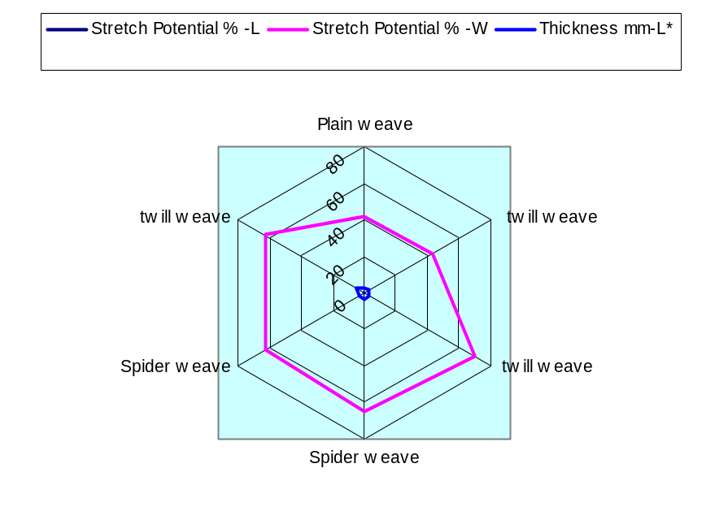
Figure 6: Relationship between Stretch Potential % and crinkle fabrics
In-Plane movement: This portion of the spandex yarn, in one hand is shrinkage and causing to bring the crossing yarn closer to each other and the shrinkage forces of the crossing cotton yarns effect clamping itself tighter on the other hand. The shrinkage forces acting on the Interlacing parts of the spandex yarn are opposite to each other and act against the in-plane float movement. However, the distortions resultant quantity of the moment is relatively low due to the short length of the cotton yarn and lower freedom to migrate. The second movement is in the direction perpendicular to the plane of the fabric, in the thickness direction of the fabric and does not have a direct effect on in plane movement of the floats.
In-Twill movement. : This portion of the spandex weft, in one hand is shrinkage and causing to bring the crossing warp cotton yarn, more closer to each other and clamping itself tighter in twill weave and on the other hand is rephrase by the shrinkage forces of the crossing warp cotton yarns. The shrinkage forces acting on the interlacing parts of the warp cotton yarn are opposite to each other and act realizing the in-twill float movement. However, the distortions resultant quantity of the movement is relatively high due to the longer length of the warp cotton yarn and lower freedom to migrate. The second movement is in the direction perpendicular to the twill of the distortions fabric, in the thickness direction of the fabric, and has direct effects distortions crinkles on in twill movement of the floats while fabrics thickness go up.
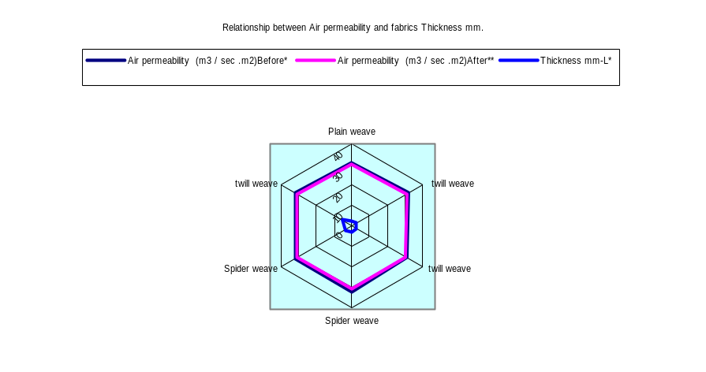
Figure 7: Relationship between Air permeability and fabrics Thickness mm.
In-Spider movement: This portion of the spandex yarn, in one hand is shrinkage causing to bring the crossing warp yarn closer to each other and clamping itself tighter in spider weave and on the other hand is affected distortions by the shrinkage of the crossing warp cotton yarns. The shrinkage forces acting on the interlacing parts of the warp cotton yarn are closer to each other and more act realizing the in-spider float movement. However, the results of distortions quantity by the yarns of warp migration are high relatively due to the short length of spandex. The second movement is in the direction perpendicular to the spider of the fabric in the thickness direction of rephrase on in-spider movement of the floats. However, total movements acting on each yarn in one repeat is the sum of the forces acting on floats making the floats to distortions crinkles and movements acting on the interlacing portion of spandex weft. Therefore, effective movement is related to the characteristic of spandex to contract and its distortions surface character, the weaving conditions especially the spider weaving tension, and the fabric structures the lower the weave factor, the higher the freedom to migrate.
Location of the Free Spaces: The location of the free spaces assigned the direction of the float movement. Indeed, the location of the free spaces on either side of the float offered a free way of assigning the direction in which the float in plane is distortion crinkles. Twill have free interlacing zone on right side of the top part and left side of the bottom part of the cotton warp floats offering the warp floats to turn crinklewise. So twill weave have free interlacing zones located on left side of the top part and right side of the bottom part of the cotton warp floats to let them crinkles counter crinklewise, so spider weave has free interlacing zones on warp cotton located on left side of the top part and spandex right side of the bottom part of the yarns floats to let them crinkles counter crinklewise of horizontal direction. It causes less air permeability while fabrics crinkle go up.
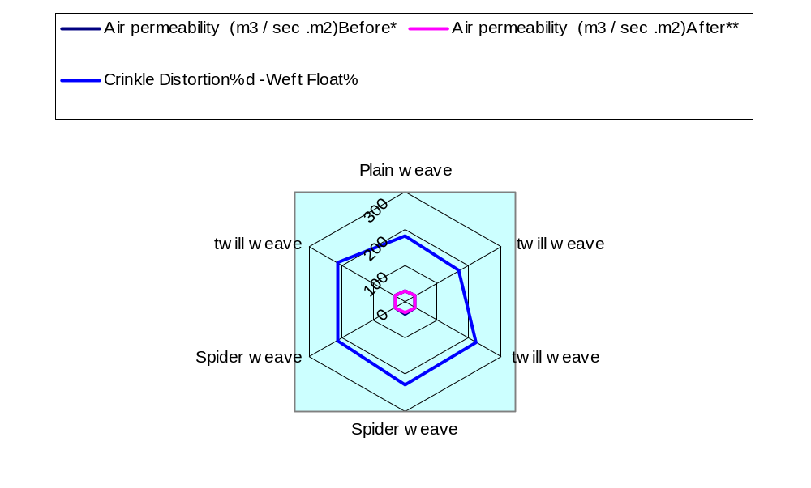
Figure 8: Relationship between Air permeability and crinkle
The Float Length: As the float cotton yarns length gets longer the freedom of the float contacts get higher. The comparisons of 1/1 plain weave to 12/14 at based twill and 48/45 spider weave in Table 2 shows a direct relationship between the locations of the free spaces assigned the direction of the float movement. Indeed, the location of the free spaces on either side of the float offered a free way of assigning the direction in which the float an in plane could crinkle. Twill has free zone on spandex right side of the top part and left side of the bottom part of the warp floats to turn crinklewise. Left hand twills have free zones located on left side of the top part and right side of the bottom part of the warp floats to let them crinkles counter crinklewise.
Shrinkage: Comparing fabric tightness (weave), plain weave showed lower shrinkage after wet processing as compared to 12/14 on based twill and 48/45 spider weave at same crinkle distortion, stretch potential. This shows that plain weave is more stable than 12/14 on based twill and 48/45 spider weave. This is because plain weave started with lower stretch potential due to tight construction and does not have enough margins for distortion. However, in both weave types, shrinkage reduced with further wet processing. It was obvious from the results that irrespective of spandex type, fabrics containing spandex do retract/expand after treatment. The % retraction needs to be determined and accounted for to get to rephrase.
4. SUMMARY AND CONCLUSIONS
Analysis and evaluation of the aesthetics distortion structure of crinkle woven fabrics give us detailed information on this literature and on the aesthetic implications of the decorative patterns and the mathematical and geometrical principles at the foundations of the arts and crafts, for that figures of crinkles become elements of design. Finishing plays an important role in the final stretch properties of fabrics containing spandex. Finishing causes the fabric constituents to relax from the stresses experienced during crinkle fabric formation. If the construction of the fabric permits, the fabric shrinks mostly as a result of the retraction of the spandex component. If a high stretch is desired, the fabric should be designed with a low to medium tightness. This relationships between the fabric stretch potential and its construction parameters for a given crinklewise of spandex type permits design of specialized products with required stretch to meet end use performance. Following observations are the outcome of this experimental research work. When fabrics are released from the weaving tensions during relaxation, depending upon the weave structure crinkles may form on the fabric surface. Distortion of the plain, twill and spider woven fabrics is dependent upon the behaviour of the floats at the relaxation state. A twill structure has free zone with spandex give the fabrics chance to be crinkling woven fabrics in twill direction. The reason is distortion , during relaxation when yarns shrinked, each float acts like in-plane lever making warp float with the neighbouring weft floats to act like the two arms of a scissor causing elongation of the main diagonal and shortening of the off diagonal making the fabric to shear. Location of the free space, assigns the direction of the float movement and as a result, the direction of the crinkles on woven fabrics. The length of the floats and free spaces between the yarns are important elements affecting the quantity of the crinkles on woven fabrics. The longer the floats and the higher the number of the free spaces in one repeat, the more freedom there will be for floats to move and as a result, the higher the crinkles on woven fabrics. Adding interlacing points if possible and accepted to the structure, could be a way to eliminate the crinkles of the woven fabric.
5. ACKNOWLEDGEMENT
The authors wish’s to express his appreciation to Mr. Jiff, The Manager of laboratory the textiles finishing College of Textiles NCSU.

6. REFERENCES
[1] Chesterland Corporation “Stretch Woven fabrics A guide to their manufacture”. Corporation, application research and service department, Published in the interest of progress and service. Multi aims of Chesterland and consumers. USA,1985, pp. 73-122.
[2]AATCC Standard Test Method, D-79-1968.
[3] American Society for Testing and Materials, Annual Book of ASTM Standards, 1989,Vol. 07.01,
[4]Chamberlain J., “Hosiery yarns and fabrics”. City of Leicester College of Technology. Leicester, UK, 1926,Vol.II, p.107.
[5]D.Riedel, International Textile Bulletin, 1986,vol32, p.17.
[6]E.R.Kaswell, “Wellington Sears Handbook of Industrial Textiles”, Wellington Sears Company Inc.
1983, p.455,
[7]Ebraheem.H.A, “Maximum sett of Woven fabrics”, Mansura Engineering Journal(MEJ), Faculty of Engineering, Mansura University ,1977,Vol, 22,No.3.September.
[8]Ghosh, T.K., Peng, H. and Banks-Lee, P., “Analysis of fabric deformation in a roll-making operation. Part II: effect of Viscoelasticity”, Textile Research Journal, 1992,Vol. 62 No. 10, pp. 669-76.
[9]Grosberg, P.(1955):"The medium and long term variations of a yarn I ",The Journal of the Textile Institute,1955,T301.
[10]ISO 5077. “Textiles- Determination of dimensional change in washing and drying”, International Organization for standardization, Geneva, Switzerland,1984
[11]J. Amirbayat and M.J. Alagha., “ A new approach to fabric Assessment”, International Journal of Clothing Science and Technology, 1995,Vol. 7, No. 1. pp. 46-54.
[12]Jelka Gersˇak, Dunja Sˇajn and Vili Bukosˇek. “A study of the relaxation phenomena in the fabrics containing elastane yarns”, International Journal of Clothing Science and Technology, 2005,Vol. 17 No. 3/4, pp. 188-199.
[13]Kavita Mathur, ElSayed ElNashar, Peter Hauser, and Abdel-Fattah M. Seyam.,"Stretch potential of Woven fabrics containing spandex" 5th International Conferences, under the title "Textile Processing: State of the Art & Future Development". 2008,Textile Research Division, Egypt.
[14]M.Rowe. , Textile Chemistry and Colorist,1978, p. 10- 207.
[15]Peirce.F.T., “Geometrical principles applicable to the design of functional fabrics”, Textile Research Journal,1947, Vol17, 123-147.
[16]Plate,D.E.,and Hepworth,K.,"Beat-up forces in weaving",PartII,J.T.I.,1973,64,T233-T249,.
[17]Sˇajn, D., Gersˇak, J. and Bukosˇek,V, “Sˇtudij odnosa med obremenitvijo in relaksacijo tkanin dodanim elastanom”, Tekstilec, 2003,Vol. 46 No 9/10, p. 274-81.
[18]Seyam,A, and El-sheikh.A., “Mechanics of Woven Fabrics, Part III: Critical Review of Weaveability limit Studies”, Textile Research Journal,1993,Vol 63,p. 371-378,.
[19]Seyam,A, and El-sheikh.A., “Mechanics of Woven Fabrics, Part I: Theoretical investigation of Weaveability limit of yarns with thickness Variation”, Textile Research Journal, 1990,Vol 63,p.389-404.
[20]Snowden.D.C., “ Construction of woven fabrics with particular reference to weaving values and sett/count/ weight calculation”, Textiles Inst. Ind .,1967,p137-140,.
[21]Vassiliadis.S., Kallivretaki A., Gurkan P. and Provatidis Ch. ,“ Fabric Hand: An Important Quality Parameter of the Textile Fabrics. 2nd Int. Conf. on Information Technology and Quality, Greece,2005

Correspondence author:
ElSayed Ahmed ElNashar, Ph.D.
Associate Professor of textiles & Apparel,
Faculty of Specific Education, Kafrelshekh University, Egypt
Cell phone: (+2) 016 9288940
Home phone: (+2) 0403608776
Work& Fax: (+2) 047 3234944
Email: Dr_elnashar@yahoo.com
Email: Dr_elnashar@hotmail.com

