Studies on some Benzopyran Derivatives with Expected Antimicrobial and Antiviral Activity

Hanaa.F.Roaiah ª, Sally.S.El-Nakkady ª, Weam.S.El-Serwy ª,

Mohamed.A.A.Ali ^{b},A.H.Abd El-Rahman ^{c}, Zeinab El-Bazza^{d}

a Natural Chemistry Products Department, National Research Center, Dokki, Cairo, Egypt
b virology Department National Research Center, Dokki, Cairo, Egypt
c Chemistry Department, Faculty of Science, Mansoura University, Egypt
d Pharmaceutical Microbiological Lab, National Center for Radiation Research and
Technology, Nasr City, Cairo, Egypt
dr_mona_zaki@yahoo.co.uk

Abstract__The naturally occurring furocoumarin (xanthotoxin) (1) yielded 3-(6-hydroxy-7-methoxy-1-benzofuran-5-yl) acrylohydrazide (2) upon treatment with hydrazine hydrate. When 2 was treated with an equimolar amount of the appropriate isothiocyanates it gave the respective N-substituted – 2 - [3 - (6 – hydroxy – 7 – methoxy – 1 – benzofuran – 5 - yl) prop – 2 -enoyl] hydrazine carbothioamide (3a-c), which when heated with sodium hydroxide, yellow mercuric oxide and phosphorus oxychloride respectively were transformed into 5-[2-(4-substituted-5-mercapto-4H-1,2,4-triazol-3-yl)vinyl]-7-methoxy-1-benzofuran-6-ol (4a-c), 5-{2-[5-(substituted amino)-1,3,4-oxadiazol-2-yl] vinyl}-7-methoxy-1-benzofuran-6-ol (5a-c), and 5-{2-[5-(substituted amino)-1,3,4-thiadiazol-2-yl] vinyl}-7-methoxy-1-benzofuran-6-ol (6a-c) respectively. The reaction of 3a with ethyl bromoacetate gave N'-(3-benzyl-4-oxo-1,3-thiazolidin-2-ylidene)-3-(6-hydroxy-7-methoxy-1-benzofuran-5-yl)acrylo hydrazide (7). When 3a,b was heated with ethyl cyanoacetate it yielded N-substituted-2-[4-(6-hydroxy-7-methoxy-1-benzofuran-5-yl)-2-imino-2H-pyran-6-yl]hydrazine-carbothioamide (8a,b) respectively. The prepared compounds were tested for their antimicrobial and antiviral activities.

1-Introduction

This work deals with the synthesis of some benzofuran derivatives derived from naturally occurring xanthotoxin for biological evaluation.

A wide variety of pharmacological properties was shown to be associated with benzofuran derivatives ^{(1, 2)}. Various thiosemicarbazides and their cyclized products e.g.triazoles, oxadiazoles, thiazolidinones and thiadiazoles are also associated with a broad spectrum of biological properties including anticonvulsant⁽³, anti-inflammatory⁽⁴⁻⁷⁾, antitumor, antiviral⁽⁸⁾, analgesic, ulcerogenic, lipid peroxidation⁽⁹⁾, antimicrobial⁽¹⁰⁾ and anti-HIV activities^{(11,12)}. The chalcones Ia-d, pyrazolinyl derivatives IIa-d, N-acetyl pyrazolinyl derivatives IIIa-d, N-phenyl pyrazolinyl derivatives IVa-d and isoxazolinyl derivatives VIa-d possess moderate activity towards the Gram +ve bacteria and yeast in a concentration of 200µg/disk compared with Chloramphenicol 10µg/disk.

Also, these compounds possess slight activity towards Gram -ve bacteria used. On the other hand, when these compounds were subjected to the U.V, light (366 nm), the activity was found to be higher than those compounds not subjected to the U.V. light ^{(13).}
.

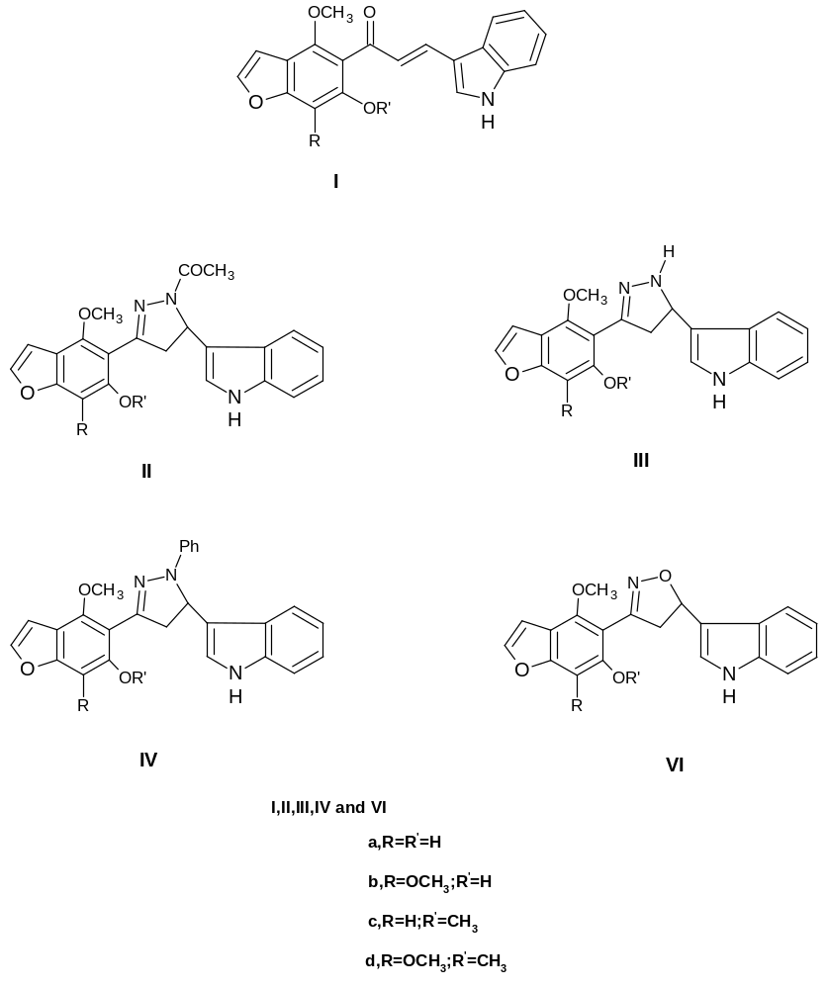

2. Results and Discussion
Xanthotoxin (1) (9-Methoxy-7H-furo [3, 2-g] chromen-7-one) yielded 3-(6-hydroxy-7-methoxy-1-benzofuran-5-yl) acrylohydrazide (2) upon treatment with hydrazine hydrate ⁽¹⁴⁾.

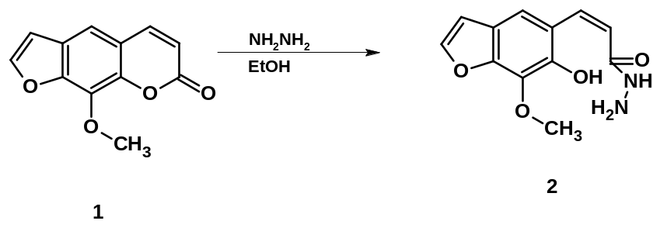

When compound 2 was treated with isothiocyanates derivatives namely, (benzyl-, ethyl- and cyclohexyl isothiocyanate), N-substituted–2-[3-(6–hydroxy–7–methoxy–1– benzofuran–5-yl) prop–2-enoyl] hydrazido carbothioamides(3a-3c) were obtained.
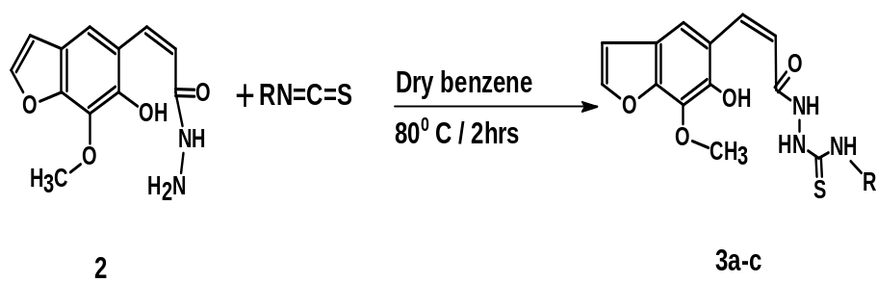

The IR spectra of compounds 3a-c showed the presence of C=S group at 3063-3225 cm⁻¹.

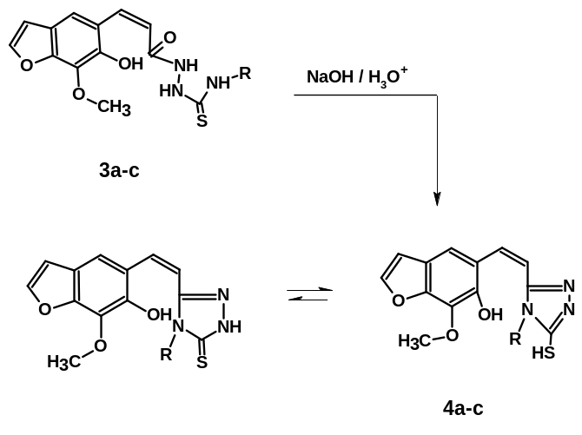 5-[2-(4-Substituted-5-mercapto-4H-1,2,4-triazol-3-yl)vinyl]-7-methoxy-1-benzofuran-6-ols(4a-4c) were formed by the cyclization of compounds 3a-c by heating in aqueous sodium hydroxide.

The H¹-NMR of compounds 4a-c confirmed the absence of the NH protons, and their IR spectra also showed the absence of the C=O and C=S groups.
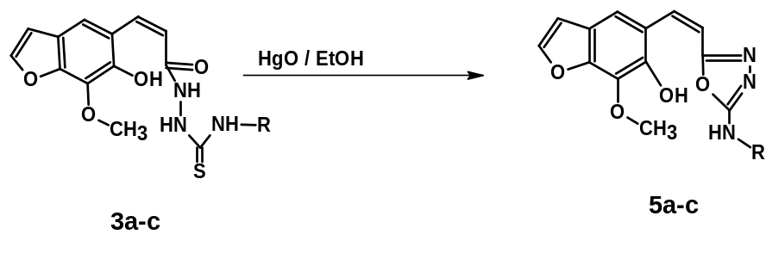On the other hand desulfurization of compounds 3a-c by yellow mercuric oxide in boiling ethanol yielded 5-{2-[5-(substituted amino)-1,3,4-oxadiazol-2-yl]vinyl}-7-methoxy-1-benzofuran-6-ols (5a-c).

-

The IR spectra of 5a-c revealed the absence of C=O and C=S absorption.
Treatment of compounds 3a-c with phosphorus oxychloride and heating yielded the corresponding 5-{2-[5 amino)-1,3,4-thiadiazol-2-yl]vinyl}-7-methoxy-1-benzofuran-6-ols (6a-c).
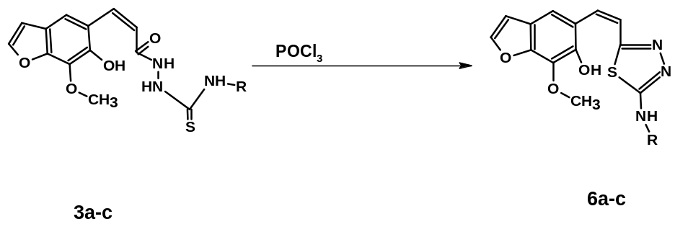

The IR spectra of 6a-c revealed the absence of C=O and C=S absorption.
The reaction of thiourea derivative 3a with ethylbromoacetate yielded N'-(3-benzyl-4-oxo-1,3-thiazolidin-2-ylidene)-3-(6-hydroxy-7-methoxy-1-benzofuran-5-yl)acrylo hydrazide (7).
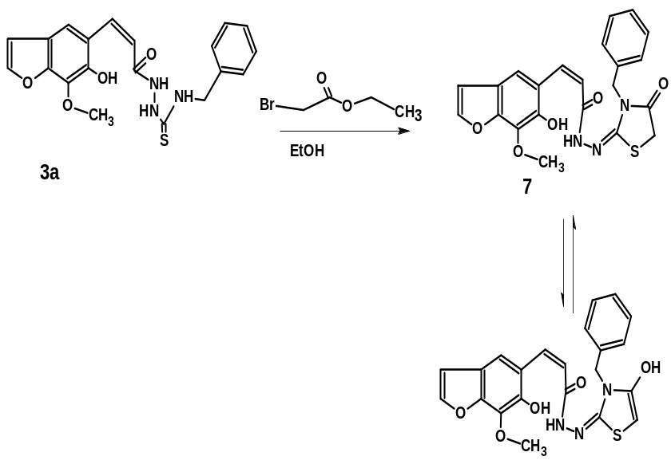

The IR spectra of 7 revealed the absence of C=S absorption.

The reaction of 3a,b with ethylcyanoacetate yielded N-substituted-2-[4-(6-hydroxy-7-methoxy-1-benzofuran-5-yl)-2-imino-2H-pyran-6-yl] hydrazinecarbothioamide (8a,b).
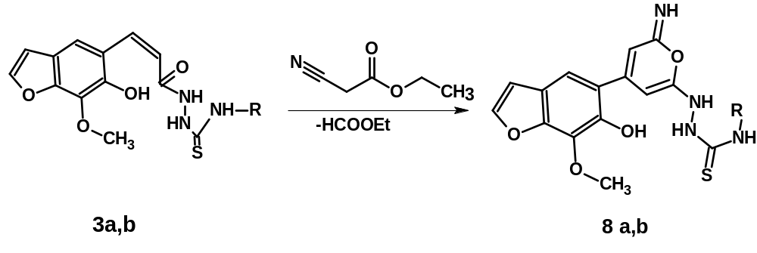
a, R=PhCH₂-
b, R=CH₃ CH₂-
c, R=C₆H₁₁-

The IR spectra of 8a,b revealed the absence of C=O absorption.

3. Biology
3.1 Antimicrobial activity test
The antimicrobial activity screening test of compounds 3(a-c),4a,4c,5b,5c,6a,6c,7, and 8a,b against G +ve, G –ve and fungi was carried out by using the disk-diffusion method with some modifications ⁽¹⁵⁾. Whatman No.1 filter paper disks (0.5 cm) were sterilized by autoclaving at 121 ⁰C for 15 min and then impregnated with the tested compounds (3 x 10⁻⁶ g.or 300 µg/disk ) (using chloroamphenical as control 300 µg/disk). The disks were placed on the surface of the cold solid medium in petri-dishes, inoculated with the tested micro-organisms, then incubated at 5⁰C for permit good diffusion and then transferred to an incubator at 37 ⁰C for 24 h for bacteria (1 and 2) and at 28⁰C for 24h for fungus (3) (cf.Table1).

3.2 Antimicrobial activity data conclusion of the data obtained in table (1)

The preliminary antimicrobial activity screening for the prepared compounds were tested using one local strain as G+ve, one local strain as G-ve bacteria and one local strain as fungus
together with chloramphenicol as control.
From the data obtained (table 1) it is clear that only compounds 3c, 5c (thiourea and oxadiazole derivatives) were found to be highly active against G+ve bacteria compared with the reference antibiotic chloramphenicol.
Compounds 3a and 8b also possess moderate activity towards G+ve bacteria while the other compounds are slightly active towards the same organism.
On the other hand, compounds 3c and 5c possess moderate activity towards G-ve bacteria compared with the control, while the other compounds possess slight activity towards the same organism.
Moreover, compounds 3a, 3b, 4c, 6c, 8a and 8b showed moderate activity towards the fungus compared with the reference, while the other compounds possess slight activity towards the same organism.
In general, only compounds 3c and 5c showed high activity towards G+ve bacteria and moderate activity towards G-ve bacteria.
N.B the activity of our target compounds, namely triazole, oxadiazole, thiadiazole, thiazolidine and pyrane derivatives will be studied in details against clinical pathogenic microorganisms and also their MIC will be published separately in the near future.

3.3 Antivirus activity
Cells and viruses
Herpes Simplex Virus type 1(HSV-1) was used for antiviral bioassay. The virus was isolated and propagated in the Virology Laboratory , Department of Water Pollution Researches, National Research Center.
African green monkey kidney cells (Vero) was used for HSV-1 propagation and bioassay. Cells were grown in minimum essential medium and supplemented by 1% antibiotic-antimycotic mixture (GIBCO-BRL), 8% fetal bovine serum (Sigma) and the pH was adjusted to (7.2-7.4) by 7.5% sodium bicarbonate solution. Cells were grown as monolayer sheets and dissociation by trypsin-versene solution (0.15% trypsin and 0.04% ethylene diamine tetraacetic acid, EDTA 2Na). The dissociated cells were subcultured in a 96-well plate to measure the cytotoxicity of the prepared compounds (Silva et al., 1997). Cytotoxicity assay were carried out for the prepared samples to determine the safe concentrations to be used for antiviral bioassay.

Plaque infectivity reduction assay (PIRA):

A 6-well plate was cultivated with Vero cell culture (105cell/ml) and incubated for 2 days at 370 C. The virus was diluted to give 107 PFU/ml final concentrations and mixed with the tested compounds at different concentrations and incubated overnight at 40• C. Growth medium was removed from the multiwell plates and virus-compound mixtures were inoculated (100µl /well). After 1h contact time, the inoculum was aspirated with 3ml of MEM and 1% agarose overlaid the cell sheets. The plates were left to solidify and then incubated at 37•C until the development of virus plaques. Cells were fixed in 10% formalin solution for 2hr, and stained with crystal violet stain. Control virus and cells were treated identically without compounds. Virus plaques were counted and the percentage of reduction was calculated (Silva et al., 1997).

Results and Discussion

Cytotoxicity was carried out to determine the non cytotoxic doses of the prepared compounds to be used for antivirus bioassay. The results showed that no toxic effects were observed for all samples at dilution > 1:8 which permit the safe use of different concentrations of the tested materials for antiviral bioassays.
The results revealed that oxadiazole carboxylic acid was of highest activity against HSV-1 than all the other tested materials. It was noticed that cyclohexyl group increased the potential of some tested compounds for anti-HSV-1 activity as shown in the case of cyclohexyl thiadiazole, cyclohexyl triazole, cyclohexyl oxadiazole as shown in fig (A,B and C , respectively) .
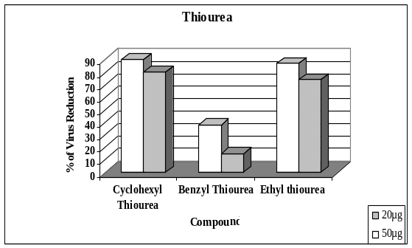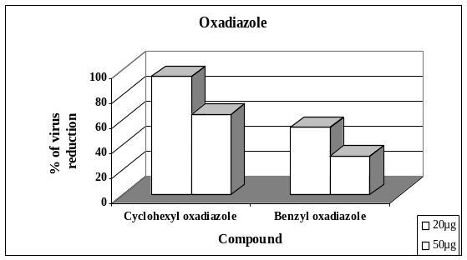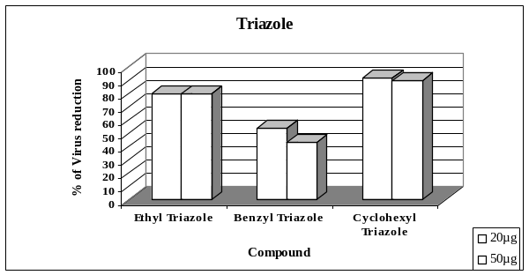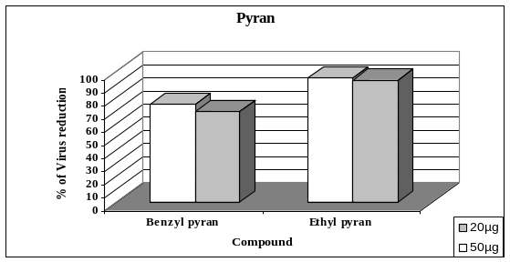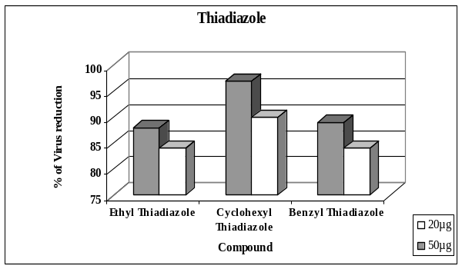
Anti-HSV 1 activity of the selected prepared compounds.
A. Thiadiazole (6a-c)
B. Thiourea (3a-c)
C. Triazole (4a-c)
D.Oxadiazole (5a,c)
E.Pyran ( 8a,b)

A
E
D
C
B

4. EXPERIMENTAL
All melting points were uncorrected. Elemental analysis was carried out in the microanalytical unit of the National Research Centre. IR spectra were recorded on a Mattson-5000 FTIR spectrometer using KBr wafer technique.¹H-NMR spectra were determined on a varian-Gemini-300 MHz. And Jeol-Ex-300 MHz NMR spectrometer using TMS as an internal standard with (chemical shift. δ = 0 ppm). Mass spectra were determined on Finnigan mat SSQ 7000 mode: EI,70Ev (Thermo Inst.Sys.Inc.,USA). The purity of the synthesized compounds was tested by thin layer chromatography (TLC), Merck plates.

4.1. Synthesis of N-substituted – 2 - [–3 -(6– hydroxy – 7 – methoxy – 1 –benzofuran – 5 - yl) prop– 2 -enoyl] hydrazine carbothioamides (3a-c).
To a suspension of 2 (0.01 mol) in dry benzene (50 ml), the appropriate isothiocyanate (0.01 mol) was added. The reaction mixture was heated at 80^{O}C with stirring for 2 hrs and then left overnight at room temperature. The solid so obtained was filtered off and crystallized from ethanol to give 3a-c(cf.Table 2).

4.2. Synthesis of 5-[2-(4-substituted-5-mercapto-4H-1, 2,4-triazol-3-yl) vinyl]-7-methoxy-1-benzofuran-6-ols (4a-c).
Compound of 3a-c (0.01mol) in sodium hydroxide (5ml, 2N) was refluxed under stirring for 10 hours. The reaction mixture was then cooled and neutralized with dilute hydrochloric acid. The precipitate thus obtained was filtered off, washed with water several times, dried and crystallized from ethanol to give 4a-c(cf.Table 2).

4.3. Synthesis of 5-{2-[5-(substituted amino)-1,3,4-oxadiazol-2-yl] vinyl}-7-methoxy-1-benzofuran-6-ols (5a-c).
Compounds of 3a-c (0.002 mol) were refluxed with excess yellow mercuric oxide (0.015 mol) in ethanol (30ml) for 4-6 hours. The reaction mixture was allowed to cool to room temperature (to allow the sedimentation of the black mercuric sulphide),filtered and mercuric sulphide was washed with ethanol.The filtrate and alcoholic washing were combined, treated with water until a permanent turbidity existed and allowed to stand overnight .The product was separated and crystallized from ethanol to give 5a-c (cf.Table 2).

4.4. Synthesis of 5-{2-[5-(substituted amino)-1,3,4-thiadiazol-2-yl] vinyl}-7-methoxy-1-benzofuran-6-ols (6a-c).
Phosphorous oxychloride (15ml) was added to the appropriate compound 3a-c (0.005 mol) and the mixture was heated under reflux for 2-4 hours. The mixture was then evaporated in vacuo and the residue was washed with dilute ammonium hydroxide solution and water, dried and crystallized from ethanol to give 6a-c(cf.Table 3).

4.5. Synthesis of N'- (3-benzyl-4-oxo-1, 3-thiazolidin-2-ylidene)-3-(6-hydroxy-7-methoxy-1-benzofuran-5-yl)acrylo hydrazide (7).
A mixture of 3a (0.01 mol), ethyl bromoacetate (0.01 mol) and anhydrous sodium acetate (0.015 mol) in absolute ethanol (30ml) was refluxed for 3h. The reaction mixture was cooled, diluted with water and allowed to stand overnight. The solid so obtained was filtered off, dried and crystallized from ethanol to give 7(cf.Table 3).

4.6. Synthesis of N-substituted-2-[4-(6-hydroxy-7-methoxy-1-benzofuran-5-yl)-2-imino-2H-pyran-6-yl]hydrazinecarbothioamides (8a,b).
A mixture of 3a,b (0.01 mol) and ethyl cyanoacetate (0.01 mol) in ethanol (30 ml) containing few drops of glacial acetic acid was refluxed for 4 hours. The precipitate that formed was filtered off, dried and crystallized from the proper solvent to give 8a,b(cf.Table 3).

Table 1 The prelininary antimicrobial screening test for the prepared compounds using chloroamphenical as control
Sample No. | Micro-organism
 | G + ve (1) | G – ve (2) | Fungi (3)
Control | ++++ | ++++ | ++++
3a | ++ | + | ++
3b | + | + | ++
3c | +++ | ++ | +
4a | + | + | +
4c | + | + | ++
5b | + | + | +
5c | +++ | ++ | +
6a | + | + | +
6c | + | + | ++
7 | + | + | +
8a | + | + | ++
8b | ++ | + | ++
Micro-organisms:
1-Bacillus Subtilies (G + ve)
2- Escherichia Coli (G – ve)
3-Aspergillus Niger (Fungus)

The inhibition zones were measured in the following manner:
Inhibition zone +++= highly active ( > 12 mm)
Inhibition zone ++= moderately active (9-12 mm)
Inhibition zone += slightly active (6-9 mm)
Inhibition zone - = non sensitive (0.5 mm)
Table 2.Physical and spectral data of the newly synthesized compounds (3a-c)-(5a,b).

MS (M⁺) | IR(ν ,cm⁻¹) and ¹H-NMR (DMSO-d₆) | %Analysis Calcd/(Found) |  |  | Molecular formula (M.wt) | Mp (⁰C)  Yield(%) | Compound no.
 | IR(ν ,cm⁻¹) and ¹H-NMR (DMSO-d₆) | N | H | C | Molecular formula (M.wt) | Mp (⁰C)  Yield(%) | Compound no.
397 | IR: 1335 (C=S), 3063-3255 (3NH), 3343 (OH). ¹H-NMR: 3.99 (s, 3H,OCH₃), 4.72 (d, 2H,CH₂Ph) , 7.25 (d, 1H furan H-3, J_{H.H}= 2.3 H_{Z}), 7.87 (d, 1H furan H-2, J_{H.H}= 2.3 H_{Z}) , 7.31-7.36 (m, 8H,aromatic protons+2H olefinic protons), 7.41- 7.82 (3br.s, 3H,3NH). | 60.44  60.34 | 4.82  4.72 | 10.57  10.42 | C₂₀H₁₉ N₃O₄S  (397.449) | 198-200 (95) | 3a
335 | IR: 1305(C=S),3128-3204 (3NH), 3250(OH). ¹H-NMR: 1.08 (t,3H,CH₃),3.50 (m,2H,CH₂), 7.79-7.82 (3br.s,3H,3 NH), 9.06 (br.s,1H,OH). | 53.72  53.65 | 5.11  5.05 | 12.53  12.46 | C₁₅H₁₇ N₃O₄S  (335.379) | >300 (85) | 3b
389 | IR: 1341(C=S),3138-3013 (3NH) and 3243 cm⁻¹ (OH). ¹H-NMR: 3.98 (s,3H,OCH₃), 1.27-2.21 (m,10H of cyclohexyl) , 4.07 (m,1H of cyclohexyl), 6.82 and 7.75 (2d,2H furan H-3,H-2,J_{H.H}=2.3Hz),7.80-7.82(3br.s,3H,3NH), 6.83 and 6.99 (2d,2H olefinc protons ),9.13 (br.s,1H,OH), | 58.59  58.43 | 5.95  5.88 | 10.79  10.68 | C₁₉H₂₃ N₃O₄S  (389.470) | 217-220 (85) | 3c
379 | IR: 1619(C=N),3238(OH). ¹H-NMR: 3.98 (s, 3H,OCH₃), 7.25 (d, 1H furan H-3, J_{H.H}= 2.3 Hz), 7.88 (d, 1H furan H-2, J_{H.H}= 2.3 Hz), 7.29-7.33 (m, 5H,aromatic protons and 2H olefinic protons), 12.75 (s, 1H,SH). | 63.31  63.20 | 4.52  4.46 | 11.07  11.00 | C₂₀H₁₇ N₃O₃S  (379.433) | >300 (95) | 4a
317 | IR: 1630(C=N),3238(OH) . ¹H-NMR: δ1.02(t,3H,CH₃),2.50(q,2H,CH₂),3.92(s,3H,OCH₃),6.8-7.81 (m,5H,aromatic protons + olefinic protons ), 12.6 (br.s, 1H, OH) , 13.4(s,1H,SH). | 56.77  56.67 | 4.76  4.65 | 13.24  13.11 | C₁₅H₁₅ N₃O₃S  (317.364) | 205-210 (98) | 4b
371 | IR: 1636(C=N),3347(OH). ¹H-NMR: 3.3(m,1H,cyclohexyl),1.03-1.77 (m,10H,cyclohexyl ), the OH signal gave one D₂O exchangeable signal at δ9.14. | 61.44  61.32 | 5.70  5.65 | 11.31  11.21 | C₁₉H₂₁ N₃O₃S  (371.454) | 170-174 (98) | 4c
363 | IR: 1670(C=N), 3323(NH), 3343(OH). ¹H-NMR: | 66.11  66.03 | 4.72  4.61 | 11.56  11.46 | C₂₀H₁₇ N₃O₄  (363.367) | 196-201 (60) | 5a
301 | IR: 1623(C=N),3349 (NH) , 3396(OH). | 59.79  59.68 | 5.02  4.96 | 13.95  13.82 | C₁₅H₁₅ N₃O₄  (301.297) | 214-216 (65) | 5b
355 | IR: 1656(C=N),3267 (NH) , 3304(OH). | 64.21  64.10 | 5.96  5.87 | 11.82  11.74 | C₁₉H₂₁ N₃O₄  (355.388) | 208-212 (60) | 5c

Table 3.Physical and spectral data of the newly synthesized compounds (6a-c),7,and (8a,b).

MS (M⁺) | IR(ν ,cm⁻¹) and ¹H-NMR (DMSO-d₆) | %Analysis Calcd/(Found) |  |  | Molecular formula (M.wt) | Mp (⁰C)  Yield(%) | Compound no.
 | IR(ν ,cm⁻¹) and ¹H-NMR (DMSO-d₆) | N | H | C | Molecular formula (M.wt) | Mp (⁰C)  Yield(%) | Compound no.
379 | IR: 1624(C=N),3217 (NH) , 3434(OH). ¹H-NMR: 3.94 (d,2H,CH₂Ph), 3.99 (s,3H,OCH₃),7.31-7.72 (m,5H,aromatic protons and 2H olefinc protons),7.26 (d,1H furan H-3,J_{H.H}= 2.3 Hz),7.85 (d,1H furan H-2,J_{H.H}= 2.3Hz),8.00(br.s,1H,NH),9.12 (br.s,1H,OH). | 63.31  63.26 | 4.52  4.43 | 11.07  10.95 | C₂₀H₁₇ N₃O₃ S  (379.433) | 185-190 (78) | 6a
317 | IR: 1622(C=N),3140 (NH) , 3387(OH). ¹H-NMR: 1.11 (t,3H,CH₃), 2.49 (m,2H,CH₂) , 4.00 (s,3H,OCH₃), 6.84-7.84 (m,3H,aromatic protons +2H olefinic protons). | 56.77  56.67 | 4.76  4.67 | 13.24  13.16 | C₁₅H₁₅ N₃O₃ S  (317.364) | >300 (60) | 6b
371 | IR: 1634(C=N),3188 (NH) , 3241(OH). ¹H-NMR: 1.22-1.9(m,10H,cyclohexyl),3.43 (m,1H,cyclohexyl),3.99 (s,3H,OCH₃),6.5-7.9 (m,5H,aromatic protons + olefinic protons). | 61.44  61.39 | 5.70  5.65 | 11.31  11.21 | C₁₉H₂₁ N₃O₃ S  (371.454) | 185-191 (65) | 6c
437 | IR: 1609 (C=N),1712 (C=O), 3031(NH). ¹H-NMR: 4.79 (s,2H,CH₂Ph),7.25-7.38 (m,8H,aromatic protons+2H olefinic protons). | 60.40  60.29 | 4.38  4.21 | 9.61  9.52 | C₂₂ H₁₉ N₃ O₅ S  (437.470) | 224-229 (75) | 7
436 | IR:1353 (NC=S), 3028-3253 (NH).¹H-NMR:4.7 (d,2H,CH₂Ph) ,5.7-8.6 and 9.8 (br.s,4H,4NH),9.5(br.s,1H,OH),7.0-7.6 (m,8H,aromatic protons + 1H olefinic proton ). | 60.54  60.61 | 4.62  4.75 | 12.84  12.92 | C₂₂ H₂₀ N₄ O₄ S  (436.485) | 192-199 (75) | 8a
374 | IR: 1368 (NC=S), 3019-3280 (NH).¹H-NMR:1.21 (t,3H,CH₃) ,3.46 (q,2H,CH₂), 6.8-7.87 (m,3H aromatic protons + 1H olefinic proton),9.06-9.11 (4br.s,4H,4NH). | 54.53  54.61 | 4.85  4.75 | 14.96  14.82 | C₁₇ H₁₈ N₄ O₄ S  (374.415) | 209-213 (75) | 8b

References
1-Hayakawa,I.; Shioya,R.; Agatsuma,T.; Furukawa,H; and Sugano,Y.; Bioorganic & Medicinal Chemistry Letters, 2004 , 14, 3411-3414.
2- Masubuchi,M.; Ebiike,H.; Kawasaki,K.; Sogabe,S.; Morikami,K.; Shiratori,Y.; Tsujii,S.; Fujii,T.; Sakata,K.; Hayase.M.; et al, Bioorganic & Medicinal Chemistry, 2003,11, 4463-4478.
3- Almasirad,A.; Tabatabai,S.A.; Faizi,M.; Kebriaeezadeh,A.; Mehrabi,N.; Dalvandi,A.; and Shafiee,A.; Bioorganic & Medicinal Chemistry Letters, in Press, 2004.
4- Burbuliene,M.M.; Jakubkiene,V.; Mekuskiene,G.; Udrenaite, E.; Smicius,R.; and Vainilavicius,P.; II Farmaco, 2004,59, 767-774.
5- Jakubkiene,V.; Burbuliene,M.M.; Mekugkiene,G.; Udrenaite,E.; Gaidelis,P.; and Vainilavieius,P.;II Farmaco, 2003,58, 323-328.
6- Cristina L.A.; Renata ,L. ; Antonio, L.F.;Faria,V.R.; Wanderley,A.G.; Afiatpour, P.;Camelo,E.; Ximenes,P.A.; Srivastava,R.M.; Oliveira,C.F.; Medeiros,M.V.; Antunes,E.; and Brondani,D.J.;II Farmaco, 2000,55, 719-724.
7- Sawhney,S.N.; and Sharma,P.K.; Bioorganic& Medicinal Chemistry Letters, 1992,3,1551-1554.
8- AI-Soud,Y.A.; AI-Dweri,M.N.; and AI-Masoudi,N.A.; II Farmaco, 2004,59, 775-783.
9- Amir,M.; and Shikha,K.; European Journal of Medicinal Chemistry, 2004,39, 535-545.
10- Sahin,G.; Palaska,E.; Ekizoglu ,M.;and Ozalp,M.; II Farmaco, 2002,57, 539-542.
11- EI-Emam,A.A.; AI-Deeb,O.A.; AI-Omar,M.; and Lebrnaim,J.;Bioorganic & Medicinal Chemistry, 2004,12, 5107-5113.
12- Takayama,H.; Shirakawa, S.; Kitajima,M.; Aimi,N.; Yamaguchi,K.; Hanasaki,Y.; Ide,T.; Katsuura,K.; Fujiwara,M.; ljichi,K.; et al.Bioorganic & Medicinal Chemistry Letters, 1996, 6, 1993-1996.
13- El-Shihi,T.H.; Abdel Latif,N.A.;and El-Sawy, E.R.;Egypt.J.Chem., 2005,48,365-376
14-Brokke, M.E.; Christensen, B.E.; J.Org.Chem., 1958,23,589.
15-Abou-Zeid,A.A.;Abdel-Hamid,M.M.; and Shehata,Y.M.;Zeitschrift für Alig.Microbiology; 1976,16(9),337.


