Chlorophyll-a dynamics in relation to environmental parameters in a tropical lagoon

¹P. C. Onuoha, ²D.I. Nwankwo and ³Vyverman, W.
¹Department of Fisheries and Marine Biology, Federal College of Fisheries and Marine Technology, Bar-beach Victoria Island, Lagos Nigeria
E-mail- hydro_vision@yahoo.com
²Department of Marine Sciences University of Lagos, Akoka, Lagos, Nigeria

³Protistology and Aquatic Ecology Research Laboratory, University of Ghent, Belgium

Abstract: The chlorophyll-a dynamics and environmental factors of the Ologe lagoon, Lagos were investigated for 2 years (Feb., 2002 – Jan., 2004). The environmental indices reflected seasonal changes related to rainfall distributive pattern and tidal seawater incursion. Air temperature (27-34 ⁰C), surface water temperature (25-32ºC), transparency (24-76cm), total dissolved solids (48-294mg/l), salinity (0-0.5‰), conductivity (83-631µS/cm), pH (5.8-8.1), total alkalinity (42-162mg/l), biochemical oxygen demand (0-28mg/l), chemical oxygen demand (6-39mg/l), total hardness (62-342mg/l), cations, and heavy metals recorded increasing values in the dry season than the wet months, while dissolved oxygen (7-12.7mg/l), total suspended solids (7-378mg/l), nitrate-nitrogen (0.02-1.02mg/l), phosphate-phosphorus (0.03-1.79mg/l) and silicate (2.05-9.54mg/l) had higher values in the wet season than the dry season. Estimation of phytoplankton biomass by chlorophyll-a concentration ranged from 0.1 to 64.5ug/l with mean value of 16.99ug/l. Values for chlorophyll-a were higher in the dry than wet season for the lagoon. Analysis, using Pearson correlation co-efficient recorded positive relationship between chlorophyll-a values and air temperature, surface water temperature, salinity, conductivity, total dissolved solids, pH, transparency, biochemical oxygen demand, chemical oxygen demand, alkalinity, total hardness and cations. Analysis using ANOVA showed significant differences in the sample means of physico-chemical parameters of effluent discharge station (OL4) and the other stations within the lagoon at 5% level of probability. Recorded chlorophyll-a values placed the Ologe lagoon between the mesotrophic and eutrophic status. It is suggested that increasing tidal influence associated with reduction in rain events may have encouraged elevated salinities and created conditions for the development of more algal cells, hence higher chlorophyll a records.
Keywords: Chlorophyll-a, environmental factors, mesotrophic, eutrophic, Ologe.

Introduction
Lagoons are ecologically and economically important aquatic ecosystems in South-western Nigeria. They provide natural food resources rich in protein which includes an array of fish and fisheries. They are also important in water transportation, energy generation, exploitation and exploration of some mineral resources including sand (FAO, 1969; Kirk and Lauder, 2000; Onyema et al., 2003, 2007; Chukwu and Nwankwo, 2004; Onyema, 2008a). Lagoons also inadvertently serve as sinks for the disposal of both domestic, municipal and industrial wastes in the region. There are nine lagoons in South-western Nigeria namely: Yewa, Ologe, Badagry, Iyagbe, Lagos, Kuramo, Epe, Lekki and Mahin lagoons from the west to the east (FAO, 1969, Webb, 1958a; Nwankwo, 2004b; Onyema, 2008).

Furthermore, chlorophyll a is an essential plant and concentrations of it could be used to reflect algal biomass and hence, level of primary production. Chlorophyll a can be an effective measure of trophic status (Lee, 1999). However, elevated chlorophyll a concentrations often indicate poor water quality and low levels often suggest good conditions (Ogamba et al., 2004). According to Lee (1999), higher phytoplankton biomass would directly reflect in higher level of chlorophyll a in such regions method to determine the amount of plant materials present in a water sample is to filter out the phytoplankton, count the cells and multiply the number counted by the average mass per individual cell from a sample (Sverdrup et. al., 2006).

The immense ecological significance of phytoplankton diversity studies especially in relation to aquatic trophic relationships cannot be understated (Smith, 1950; Lee, 1999; Nwankwo, 1984, 2004a). Coastal areas are generally more productive than the open oceans because rivers and land run-offs supply nutrients along coasts and adjoining estuarine systems. With regard to the annual rates of global primary production and productivity, Lagos offshore falls under the high productivity category (= 300gC/m) (Sverdrup el al., 2006).

Determination of primary production in the Lagos

Lagoon has primarily been by biomass estimation using cells number of phytoplankton (Nwankwo, 2004). With regard to chlorophyll a in Nigeria, there exist a report by Kadiri (1993) on the Ipkoba reservoir in Benin and another by Ogamba et al., (2004) on chlorophyll a levels and variations in the Niger Delta region. Hence studies in Nigeria suing chlorophyll a method are limited.

At present, there is no report on any of the nine lagoons of South-western Nigeria with regard to the chlorophyll a method of estimation. The aim of this study was to investigate the seasonality in chlorophyll a concentration and relate findings to environmental factors in the Ologe lagoon.

Material and Methods
Description of Study Site
The Ologe lagoon (Fig 1) is located in Lagos State, Nigeria and is one of the nine lagoons in South-western Nigeria (Webb, 1958; Nwankwo, 2004b). It is pressumbaly the smallest of the lagoons in South Western Nigeria with a surface area of 9.4km², and lies at the distal end of Badagry creek between longitudes 6° 26’N to 6° 30’N and latitudes 3° 01’E to 3° 07’E. The main body of the lagoon lies within Badagry Local Government Area and it opens up to the Atlantic ocean via the Lagos Harbour and Dahomey in the Republic of Benin. The major source of water are River Owo with a source in a town called Toto Owo where River Ore and Illo form a confluent with River Oponu in Ogun State (Akanni, 1992). Seventeen stations were chosen for sampling within the lagoon. The lagoon is shallow at most points and is open all year round via the Lagos habour to the sea (Hill and Webb, 1958; Sandison, 1966; Sandison and Hill, 1966). Like all parts of South-western Nigeria, the Ologe lagoon is exposed to two distinct seasons namely the wet (May – October) and the dry (November – April) (Nwankwo, 2004b). Like all parts of South-western Nigeria, the Ologe lagoon is exposed to two distinct seasons namely the wet (May – October) and the dry season (November – April) (Nwankwo, 2004b; Sandison and Hill, 1966). The harmmattan, a short season of dry, dusty North-East Trade winds experienced sometimes between November and January in the region reducing visibility and lowering assemblages is the common macrofloral assemblages especially in areas with reduced anthropogenic influence. The lagoon deposits are varied, and are reflected in the pattern and type of vegetation in the region. Most parts of the Ologe lagoon are colonized by recognizable riparian dense swamp rainforest community dominated by raphia palms especially Raphia hookeri, Elaeis guineensis, Acrotiscum aureum and Cocos nucifera (Akinsoji et al., 2002).Very few mangrove communities are recognizable around the Badagry creek end. Notable fauna of the area includes amphipods, Oligochaetes, few polychaetes, isopods, barnacles, oysters, periwinkle, nematodes, fiddler crabs, crabs, among others (Sandison and Hill, 1966; Onyema, 2008b).
Collection of samples
Collection of water samples
Twelve sampling stations were selected to cover the lagoon area and for the collection of sample. Table 1 shows the G.P.S location, names and number of sampling stations. Monthly surface water sample was collected for twenty-four consecutive months for physico-chemical characteristics analysis using 500ml plastic containers with screw caps. Collection of samples from the stations was always between 10 and 15hr each time. Water samples were collected just a few centimeters below the water surface at each of the twelve stations. The plastic containers was then labeled appropriately and transported to the laboratory immediately after collection for further analysis. Water samples for dissolved oxygen was collected also in 50cl bottles and fixed on site with white and black ampoules.

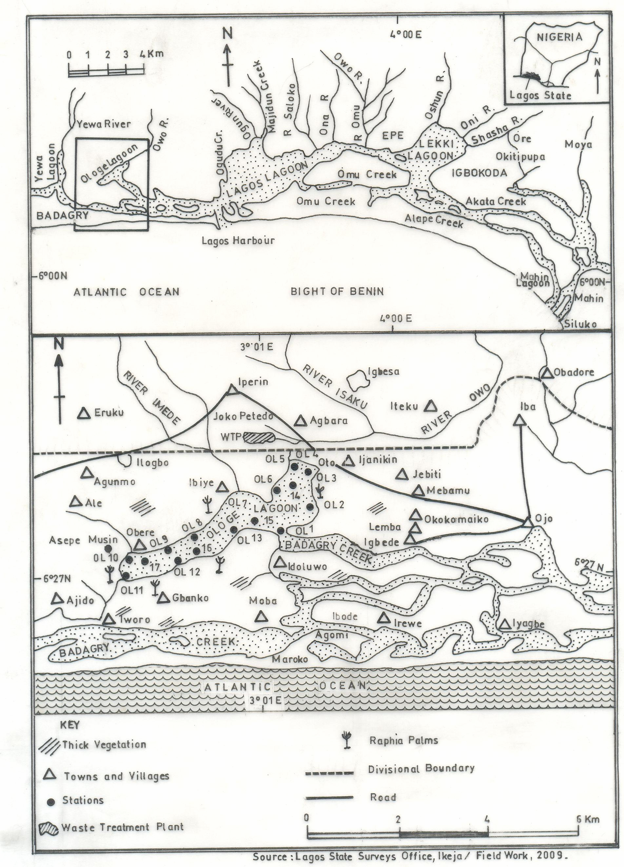

Fig. 1: Parts of Ologe lagoon Showing Sampling Stations.

Table 1: G.P.S. locations and station names of sampled areas in the Ologe lagoon
Station No. | Station name | G.P.S. locations
Station OL1 | Idolowu | Latitude 6º28’.3 N, Longitude 3º05’.3 E
Station OL2 | Between Idolowu and Otto-jetty | Latitude 6º28’.6 N, Longitude 3º05’.5 E
Station OL3 | Otto-jetty | Latitude 6º29’.0 N, Longitude 3º06’.0 E
Station OL4 | Point of effluent discharge | Latitude 6 º29’.5 N, Longitude 3 º06’.0 E
Station 0L5 | Confluence of Owo River and Ologe lagoon | Latitude 6º30’.0 N, Longitude 3 º06’.1 E
Station OL6 | Between station 5 and Ibiye | Latitude 6 º29’.3 N, Longitude 3 º06’.0 E
Station OL7 | Ibiye | Latitude 6 º29’.0 N, Longitude 3 º05’.6 E
Station OL8 | Between Ibiye and Obele | Latitude 6 º29’.2 N, Longitude 3 º06’.9 E
Station OL9 | Obele | Latitude 6 º28’.2 N, Longitude 3 º05’.7 E
Station OL10 | Asepe Mushin | Latitude 6 º28’.6 N, Longitude 3 º06’.0 E
Station OL11 | Gbanko | Latitude 6 º28’.0 N, Longitude 3 º05’.8 E
Station OL14 | Centre of Ologe lagoon between otto-jetty and station 6 | Latitude 6o ,30’.5 N Longitude 3o 06’.4 E
Station OL15 | Centre of Ologe lagoon between Ibiye and Idolowu | Latitude 6o ,30’.2 N Longitude 3o 06’.6 E
Station OL16 | Centre of Ologe lagoon between Obele and Ajido | Latitude 6o ,29’.5 N Longitude 3o 06’.0 E
Station OL17 | Centre of Ologe lagoon between Asepe Mushin and Gbanko | Latitude 6o ,28’.7 N Longitude 3o 06’.7 E

Table 2: Summary of environmental factors and method/device used for their estimation.
Parameter/Unit Method/Device Reference
1. Air temperature (º C) Horiba U-10
2. Water temperature (º C) Horiba U-10
3. Transparency (cm) Secchi disc method Onyema 2008
4. Depth (cm) Graduated pole Brown 1998
5. Rainfall (mm) Acquired from NIMET, Oshodi,
Lagos
6. Total Dissolved Solids (mgL⁻¹) Cole Palmer TDS meter
7. Total Suspended Solids (mgL⁻¹) Gravimetric method APHA(1998)
8. Total hardness (mgL⁻¹) Titrimetric method APHA(1998)
9. pH Electrometric / Cole Parmer Testr3
10. Conductivity (µS/cm) Philip PW9505 Conductivity meter
11. Salinity (%_{o}) HANNA Instrument APHA(1998)
12. Alkalinity (mgL⁻¹) Titration method APHA(1998)
13. Dissolved oxygen (mgL⁻¹) Titration method APHA(1998)
14. Biological oxygen demand (mgL⁻¹) Incubation and Titration APHA(1998)
15. Chemical oxygen demand (mgL⁻¹) Titration method APHA(1998)
16. Nitrate – nitrogen (mgL⁻¹) Colorimetric method APHA(1998)
17. Phosphate – phosphorus (mgL⁻¹) Colorimetric method APHA(1998)
18. Silica (mgL⁻¹) Colorimetric (DR2010) APHA(1998)
19. Sodium (mgl-1) Flame Photometer APHA(1998)
20. Potassium (mgl-1) Flame Photometer APHA(1998)
21. Calcium (mgL⁻¹) Titrimetric method APHA(1998)
22. Magnesium (mgL⁻¹) Titrimetric method APHA(1998)
23. Copper (mgL⁻¹) Atomic Absorption Perkin Elmer
Spectrophotometer Application
Perkin Elmer 5000 AAS (2002)
24. Iron (mgL⁻¹) Atomic absorption Perkin Elmer
Spectrophotometer Application
Perkin Elmer 5000 AAS (2002)
25. Zinc (mgL⁻¹) Atomic Absorption Perkin Elmer
Spectrophotometer Application
Perkin Elmer 5000 AAS (2002)
26 Chromium (mgl-1) Atomic Absorption Perkin Elmer
Spectrophotometer Application
Perkin Elmer 5000 AAS (2002)
27. Chlorophyll a (µg/l) Colorimetric Method APHA(1998)

The Pearson correlation Co-efficient matrix (Ogeibu, 2005) for the relationship between the different environmental parameters and chlorophyll a were obtained using SPSS 4.0.

Results
The minimum and maximum values obtained for the estimates of environmental factors, their means and standard deviation are presents in Table 3. Also in Table 3 is whether each parameter recorded higher values in the wet or dry season for the two (2) years of study. Fig. 2 showed seasonal variations in some environmental factors at four selected stations each at the Ologe lagoon from Feb., 2002 to Jan., 2004. Stations represented were selected based on their importance as confluence points and areas exposed to possible anthropogenic stresses or not.

Table 3: A summary of the minimum, maximum and mean / standard deviation estimate values for environmental factors from the Ologe lagoon (February, 2002 – December, 2004).
 | Parameter/ Unit | Minimum  value | Maximum value | Mean value ± S.D. | Higher values reported in t  In the---
1 | Air temperature (oC) | 27 | 34 | 31.10 ± 0.22 | Dry season
2 | Water temperature (oC) | 25.2 | 31.8 | 29.01 ± 0.47 | Dry season
3 | Transparency (cm) | 24 | 76 | 51.54 ± 5.65 | Dry season
4 | Depth (m) | 3.2 | 7 | 4.4 | Wet season
5 | Total Dissolved Solids (mgl-1) | 48 | 294 | 139.23 ± 17.89 | Dry season
6 | Total Suspended Solids (mgl-1) | 7 | 378 | 184.36 ± 14.90 | Wet season
7 | Rainfall (mm) | 0.6 | 383 | 137.37 | Wet season
8 | Total hardness (mgl-1) | 62 | 342 | 146.38 ± 26.52 | Dry season
9 | pH | 5.8 | 8.1 | 6.92 ± 0.14 | Dry season
10 | Conductivity (µS/cm) | 83 | 621 | 256.59 ± 36.65 | Dry season
11 | Salinity (‰) | 0.0 | 0.5 | 0.10 ± 0.03 | Dry season
12 | Alkalinity (mgl-1) | 42 | 162 | 100.20 ± 9.37 | Dry season
13 | Dissolved oxygen (mgl-1) | 7 | 12.7 | 9.08 ± 0.42 | Wet season
14 | Biological oxygen demand (mgl-1) | 0 | 28 | 13.11 ± 1.79 | Dry season
15 | Chemical oxygen demand (mgl-1) | 6 | 39 | 21.34 ± 2.52 | Dry season
16 | Nitrate – nitrogen (mgl-1) | 0.02 | 1.02 | 0.44 ± 0.08 | Wet season
17 | Phosphate – phosphorus (mgl-1) | 0.03 | 1.79 | 0.80 ± 0.10 | Wet season
18 | Silica (mgl-1) | 2.05 | 9.54 | 5.07 ± 0.45 | Wet season
19 | Sodium (mgl-1) | 2.6 | 22.7 | 30.82 ± 6.13 | Dry season
20 | Potassium (mgl-1) | 0.1 | 7.6 | 8.71 ± 1.78 | Dry season
21 | Calcium (mgl-1) | 34 | 227 | 91.27 ± 17.89 | Dry season
22 | Magnesium (mgl-1) | 0.01 | 7.6 | 2.64 ± 0.62 | Dry season
23 | Copper (mgl-1) | 0.02 | 0.06 | 0.03 ± 0.001 | Dry season
24 | Iron (mgl-1) | 0.12 | 0.99 | 0.35 ± 0.04 | Dry season
25 | Zinc (mgl-1) | 0.002 | 0.03 | 0.01 ± 0.001 | Dry season
26 | Chromium (mgl-1) | 0.001 | 0.04 | 0.02 ± 0.002 | Dry season
27 | Chlorophyll – a (µg/L) | 0.1 | 64.5 | 16.99 ± 7.83 | Dry season

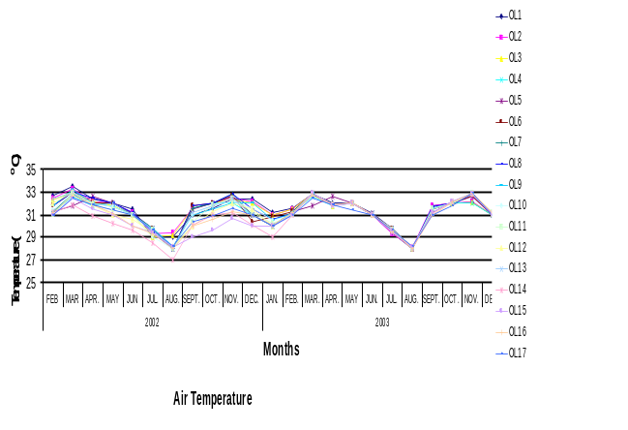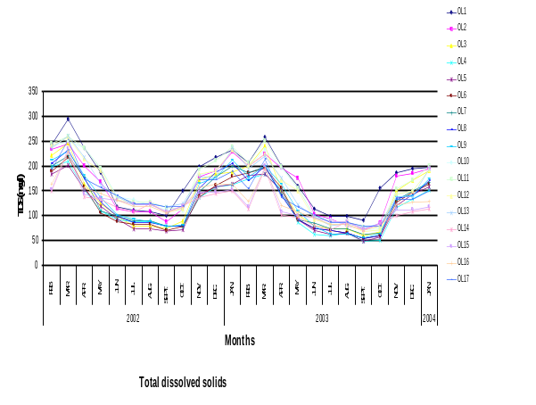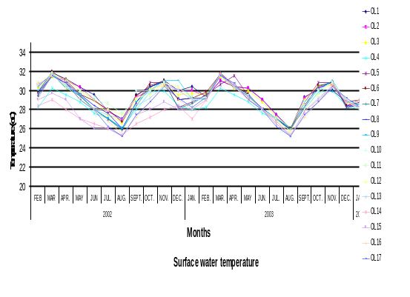

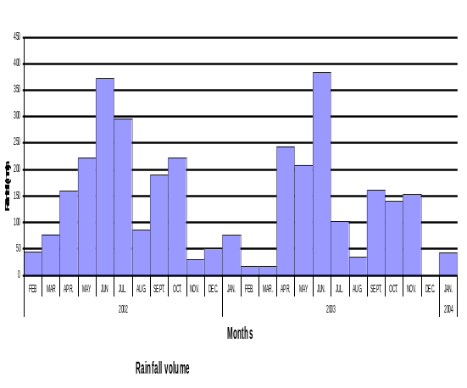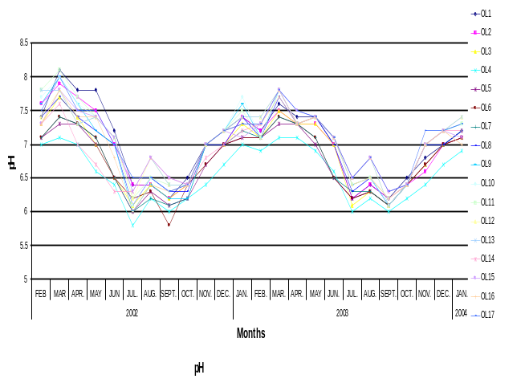
Fig. 2: Seasonal variations in some environmental factors at the Ologe lagoon, Lagos (Feb.2002-Jan.2004).

Air temperature values ranged between 27ºC to 33.5ºC among all the sampled stations within the study period. The highest air temperature (33.5ºC) was recorded at station OL1 (Idolowu) in March 2002, while the lowest was recorded at station OL14 (center of lagoon between Otto-Ijaniki and OL6) in August the same year. The lowest surface water temperature estimated was 25.2ºC (August, 2002), the highest value obtained was 31.8ºC (March, 2002. The highest transparency value (76cm) was recorded at station OL8 (between Ibiye and Obele) in March 2002, while the lowest values (24cm) was recorded at stations OL16 and OLI0 (Asepe Mushin) in the months of August and September 2003. Total dissolved solids ranged between 48 to 294mg/l, with the lowest value recorded in station OL5 (confluence between Owo River and Ologe lagoon) in September 2003. The highest total dissolved solids value (294mg/l) value was recorded at station OL1 (Idolowu) in March 2002. Total suspended solids valued ranged between 10 to 378mg/l,10 (OL3-Otto jetty in March 2003) and 378mg/l (OL10-Asepe Mushin in September 2003). Rainfall volumes showed both monthly changes and varied from one year to the next. In the first year the highest rainfall volume was recorded: highest rainfall volume (372.1mm) was recorded in June 2002 and the lowest rainfall volume (41mm) was in February 2002 . In the second year the highest rainfall as in highest rainfall volume (383mm) was recorded in July 2004 and the least (0.6mm) was in December 2003.
Hydrogen ion concentration (pH) values ranged between 5.8 (station OL4-Owo River point effluent discharge in the month of July 2002) to 8.16 (station OL11 in the month of March 2002). throughout the sampling period. Whereas the lowest conductivity estimated was 83μS/cm and recorded in OL5 (confluence between Owo River and ologe lagoon) in September 2003, the highest value obtained was621μS/cm recorded in station OL11 (Gbanko) in March 2002,

Salinity values ranged between 0.00 (station OL4 (point of effluent discharge), and 0.5 %_{o} (at station OL11 (Gbanko) in March, 2002). Alkalinity values were between 42 (station OL4 -Owo river- point of effluent discharge in September 2003) to 162mg/l (station OL1 (Idolowu) in April 2002) .

Dissolved Oxygen values ranged between 7 (station OL6 in March 2003) to 12.7mg/l (station OL14 -centre of Ologe lagoon between Otto-Ijaniki and OL6 in the month of June 2002). Biological Oxygen Demand values ranged between 3 (stations OL12 (Ajido) and OL13 (between Ajido and Idolowu) in September and October 2003 respectively) to 28mg/l (station OL3 (Otto jetty) in April 2002). Nitrate-nitrogen values were between (0.01 station OL4 (Owo river- point of effluent discharge) in January 2003) to 1.02mg/l (station OL3 (Otto jetty) in June 2003). Phosphate-phosphorus recorded between 0.03 (station OL17 in the month of March 2002) to 1.79mg/l (station OL10 in the month of June 2003). Silica values fell between 2.05 (station OL15 (between Ibiye and Idolowu) in March 2002) and 9.54mg/l (OL11 (Gbanko) in the month of May 2003). Calcium levels were between 34mg/l (station OL6 and OL8 (between Ibiye and Obele) in September and October, 2003 respectively) to 228mg/l (station OL1 (Idolowu) in April 2002). Magnesium estimates were between 10(at station OL8 (between Ibiye and Obele) in September 2003) and 76mg/l(station OL1 (Idolowu) in the month of April 2002). Copper values was between 23.1(station OL8 (between Ibiye and Obele) in July 2003) to 56.9μg/l(station OL11 (Gbanko) in the month of March 2002 ).Iron levels ranged between106(station OL17 in the month of September 2002) and 987μg/l(station OL4 (point of effluent discharge) in the month of March 2002) Zinc values ranged between 2.62 station OL7 (Ibiye) in August 2003) and 30.88μg/l(station OL4 (Owo river end receiving effluent) in the month of March 2002).

Fig 3 showed the spatio-temporal variations in chlorophyll-a values at the different stations in the Ologe lagoon from Feb., 2002 to Jan., 2004. Chlorophyll-a values ranged between 0.1 to 64.5ug/l. The highest concentration of chlorophyll-a (64.5μg/l) was recorded at station OL1 (Idolowu) in the month of December 2002 while the lowest value (0.1μg/l) was observed at station OL4 (point of effluent discharge) and OL5 (confluence between Owo River and Ologe lagoon) in the month of June 2003. Mean values for this parameter were comparatively higher during the dry season than the wet season among all sampling stations during the study period.

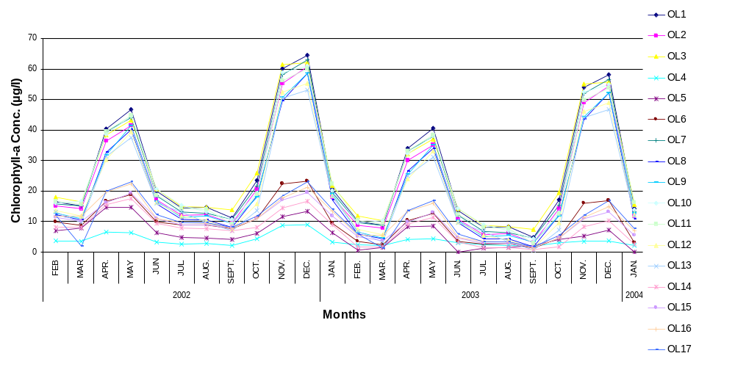
Fig 3: Spatio-temporal variations in Chlorophyll-a concentrations at the different stations in the Ologe lagoon, (Feb., 2002 – Jan., 2004

Analysis with correlation co-efficient matrix (table 4), showed that chlorophyll-a concentration had positive relationship with the following parameters; air temperature, water temperature, chemical oxygen demand, chemical oxygen demand , pH, salinity, conductivity, alkalinity, Nitrate-nitrogen, Phosphate-phosphorous, silicate, total dissolved solids, transparency, total hardness, calcium, potassium, sodium, magnesium, copper, iron, chromium and zinc, while negative association were observed with dissolved oxygen and total suspended solids.

Table (4): Pearson Correlation Co-efficient Matrix of Environmental Characteristics at Ologe Lagoon, Lagos (Feb.2002-Jan.2004)
 | AIR TEMP | WATER TEMP | DO | COD | BOD | PH | SALINITY | CONDUCTIVITY | ALKALINITY | NO3-N | PO4-P | SIO2 | TDS | TSS | TS | TRANSPARENCY | TOTAL HARDNES | CHLOROPHYLL-a | Ca | K | Na | Mg | Cu | Fe | Cr | Zn
AIR TEMP | 1
WATER TEMP | 0,95 | 1
DO | -0,36 | -0,46 | 1
COD | 0,39 | 0,52 | -0,71 | 1
BOD | 0,33 | 0,50 | -0,42 | 0,91 | 1
PH | 0,51 | 0,64 | -0,75 | 0,91 | 0,84 | 1
SALINITY | 0,51 | 0,69 | -0,72 | 0,79 | 0,74 | 0,87 | 1
CONDUCTIVITY | 0,50 | 0,68 | -0,74 | 0,81 | 0,76 | 0,90 | 0,99 | 1
ALKALINITY | 0,42 | 0,59 | -0,30 | 0,78 | 0,93 | 0,77 | 0,67 | 0,68 | 1
NO3-N | -0,30 | -0,51 | 0,37 | -0,54 | -0,63 | -0,58 | -0,83 | -0,79 | -0,54 | 1
PO4-P | -0,45 | -0,60 | 0,78 | -0,61 | -0,60 | -0,71 | -0,89 | -0,86 | -0,54 | 0,98 | 1
SIO2 | -0,08 | -0,26 | -0,02 | -0,08 | -0,28 | -0,19 | -0,55 | -0,51 | -0,31 | 0,76 | 0,75 | 1
TDS | 0,46 | 0,66 | -0,58 | 0,79 | 0,84 | 0,88 | 0,96 | 0,97 | 0,81 | -0,83 | -0,86 | -0,59 | 1
TSS | -0,51 | -0,70 | 0,73 | -0,83 | -0,79 | -0,91 | -0,97 | -0,98 | -0,75 | 0,77 | 0,86 | 0,50 | -0,97 | 1
TS | -0,52 | -0,69 | 0,82 | -0,82 | -0,70 | -0,89 | -0,93 | -0,94 | -0,67 | 0,68 | 0,84 | 0,39 | -0,89 | 0,98 | 1
TRANSPARENCY | 0,52 | 0,70 | -0,59 | 0,73 | 0,75 | 0,87 | 0,93 | 0,93 | 0,77 | -0,75 | -0,82 | -0,58 | 0,96 | -0,96 | -0,92 | 1
TOTAL HARDNES | 0,40 | 0,57 | -0,42 | 0,88 | 0,95 | 0,76 | 0,69 | 0,69 | 0,90 | -0,59 | -0,54 | -0,19 | 0,75 | -0,71 | -0,65 | 0,64 | 1
CHLOROPHYLL-a | 0,36 | 0,38 | -0,11 | 0,15 | 0,24 | 0,32 | 0,18 | 0,20 | 0,48 | 0,08 | 0,04 | 0,07 | 0,29 | -0,29 | -0,28 | 0,34 | 0,21 | 1
Ca | 0,41 | 0,56 | -0,52 | 0,92 | 0,93 | 0,78 | 0,70 | 0,70 | 0,86 | -0,57 | -0,52 | -0,13 | 0,73 | -0,73 | -0,69 | 0,63 | 0,99 | 0,17 | 1
K | 0,35 | 0,52 | -0,25 | 0,80 | 0,95 | 0,69 | 0,63 | 0,63 | 0,94 | -0,61 | -0,52 | -0,28 | 0,74 | -0,67 | -0,56 | 0,64 | 0,97 | 0,25 | 0,93 | 1
Na | 0,39 | 0,55 | -0,44 | 0,89 | 0,95 | 0,75 | 0,68 | 0,68 | 0,89 | -0,59 | -0,52 | -0,18 | 0,74 | -0,71 | -0,65 | 0,63 | 0,99 | 0,18 | 0,99 | 0,97 | 1
Mg | 0,42 | 0,57 | -0,51 | 0,92 | 0,94 | 0,79 | 0,69 | 0,70 | 0,87 | -0,55 | -0,51 | -0,11 | 0,73 | -0,73 | -0,68 | 0,63 | 0,99 | 0,20 | 1,00 | 0,94 | 0,99 | 1
Cu | 0,53 | 0,70 | -0,71 | 0,93 | 0,88 | 0,91 | 0,91 | 0,91 | 0,79 | -0,76 | -0,80 | -0,32 | 0,90 | -0,92 | -0,90 | 0,85 | 0,88 | 0,14 | 0,90 | 0,81 | 0,88 | 0,9 | 1
Fe | 0,47 | 0,63 | -0,69 | 0,92 | 0,86 | 0,87 | 0,91 | 0,91 | 0,72 | -0,79 | -0,81 | -0,36 | 0,88 | -0,89 | -0,85 | 0,81 | 0,85 | 0,01 | 0,88 | 0,79 | 0,86 | 0,87 | 0,98 | 1
Cr | 0,42 | 0,61 | -0,68 | 0,88 | 0,85 | 0,87 | 0,95 | 0,95 | 0,74 | -0,86 | -0,90 | -0,49 | 0,94 | -0,95 | -0,90 | 0,89 | 0,80 | 0,09 | 0,81 | 0,75 | 0,80 | 0,8 | 0,97 | 0,97 | 1
Zn | 0,50 | 0,70 | -0,62 | 0,78 | 0,79 | 0,84 | 0,98 | 0,97 | 0,76 | -0,84 | -0,88 | -0,62 | 0,98 | -0,97 | -0,92 | 0,94 | 0,75 | 0,25 | 0,74 | 0,72 | 0,74 | 0,7 | 0,91 | 0,90 | 0,95 | 1

Discussion
The characteristics of environmental factors from this study shows clearly that the Ologe lagoon experiences environmental gradients likened to a tropical estuarine aquatic environments from year to year (Hill and Webb, 1958; Webb, 1960; Sandison and Hill, 1966; Kjerfve, 1994; Kirk and Lauder, 2000). Furthermore environmental factors of the lagoon exhibited seasonal changes that were closely related to the distributive pattern of rainfall of the region. For instance during the wet season, reduced levels for air and water temperatures, transparency, salinity, pH, total dissolved solids, conductivity, chloride, total hardness, sulphate, calcium, magnesium, total dissolved solids and alkalinity were recorded. Conversely, in the dry season the values for these parameters increased. Reduced rain events and its associated input of floodwaters from rivers, creeks, adjoining wetlands and the effect of tidal seawater incursion probably lead to this trend of environmental gradients. Reduced phytoplankton densities as reflected in chlorophyll a values in the wet season may be linked to the low water clarity which reduces the amount of light getting to planktonic algal component for photosynthesis. Higher chlorophyll a values recorded in the dry season is a pointer to improved water clarity at this time which probably allowed greater light penetration. According to Suzuki et al. (2002), low chlorophyll a values reflecting limited phytoplankton growth in an investigation of a Mexican lagoon were associated to dark water which reduced light penetration into the lagoon considerably.
Pearson correlation co-efficient showed positive correlation between chlorophyll a values, salinity, total dissolved solids, alkalinity, pH, conductivity, and total hardness values among others. The flushing of planktonic algal forms towards the sea through Badagry creek during the rains by flood waters and hence dilution, could also account for the low chlorophyll a values (phytoplankton densities) recorded at such times. The range of chlorophyll a values for the Ologe lagoon was between o.1 and 55μg/l i.e between the mesotrophic and eutrophic productivity status (Suzuki et al., 2002, APHA, 1998). Furthermore, Ogamba et al., (2004) reported a chlorophyll a range of 0.15 – 37.4μg/l for the wet season and 0.10 and 40.28μg/l for the dry season in the Elechi creek in the Niger delta. Kadiri (1993) also reported a range of 4.20 – 35.20 mgm-3 for chlorophyll a for the Ikpoba reservoir in Benin. Kadiri (1993) reported on the seasonal changes in the chlorophyll a situation of a shallow reservoir in Benin, Nigeria.

Higher cloud cover situations attributed to the rainy season have been noted to impair chlorophyll a estimates (Kadiri, 1993) and phytoplankton biomass (Nwankwo, 1988) in some parts of the country. On the other hand, increases in insolation usually noted in the dry season likely encourage higher productivity, as recorded for this study. Furthermore, Onyema et al. (2003, 2007), are of the view that higher insolation, increased hydrological stability and marine situation are important encouraging factors for primary production in the Lagos lagoon. According to Kadiri (1993) seasonal fluctuation in abundance of phytoplankton is influenced by changes in the physical and chemical properties of the water which themselves can be dependent on rainfall. Similarly, rainfall and salinity are known to regulate the occurrence and distribution of biota in the Lagos lagoon and its associated creeks (Nwankwo and Onyema, 2003; Nwankwo, 2004).

Besides the ample availability of nutrients in this region, values for chlorophyll a were comparatively low especially in the peak of wet season which likely indicated limited phytoplankton production. Similarly, Dissolved oxygen levels throughout the period of study were high, though comparatively higher in the wet season than the dry season as result heavy influx of freshwater from adjoing rivers and creeks and lower temperature. It is possible that higher primary productivity which resulted in higher chlorophyll a values during the dry season, did not revealed a similar trend in dissolved oxygen values, as a result of masking of high dissolved oxygen by higher biochemical oxygen demand and higher temperature during this period . It could therefore be inferred that variations in chlorophyll-a values from this study were largely determined by the trend and continuum of environmental characteristics of the lagoon which varies seasonally.

Correspondence to:
Dr Onuoha Chuks Paul
Department of Fisheries and Marine Biology, Federal College of Fisheries and Marine Technology, Bar-beach Victoria Island, Lagos Nigeria
Mobile Phone: 234-8023011048
E-mail- hydro_vision@yahoo.com

References.
American Public Health Association. (1998): Standard Methods for the Examination of Water and
Waste Water. 20th ed. APHA New York. 1270pp.
Akinsoji, A., John, A. and Adekanye, M. (2002): Aquatic macrophytes of three selected sites in Lagos,
Southwest Nigeria. Journal of Science, Technology Research and Development. 2(1): 9 – 15.
Brown, C.A. (1998): Distribution and population dynamics of an estuarine population of Aloidis trigona Hinds (Bivalvia). Acta. Hydrobiol. 40(4): 227 – 237.
Brown, C.A. and Oyenekan, J.A. (1998). Temporal variability in the structure of benthic macrofauna communities of the Lagos lagoon and harbour, Nigeria. Pol. Arch. Hydrobiol. 45(1): 45 – 54.
Chukwu, L. O. and Nwankwo, D. I. (2004): The impact of land based pollution on the hydro-chemistry and macrobenthic community of a tropical West African Creek. The Ekologia. 2 (1-2): 1 – 9.
F.A.O. (1969): Fisheries Survey in the Western and Mid-Western Regions of Nigeria. FAO/Sf: 74/NIR 6. 142pp.
Kjerfve, B. (Ed.) 1994: Coastal lagoon processes. Elsevier Oceanography Series 60. Elsevier, Amsterdam. 577pp.
Kirk, R.M. and Lauder, G.A. (2000): Significant coastal lagoon systems in the South Island, New Zealand. Coastal processes and lagoon mouth closure. Science for conservation.146: 47 p.
Kadiri, M.O. (1999): Phytoplankton distribution in some coastal waters of Nigeria. Nigeria Journal of Botany.12 (1): 51 – 62.
Lee, R.E. (1999): Phycology. Cambridge University Press, New York. 614pp.
Nwankwo, D.I. (1984): Seasonal changes of phytoplankton of Lagos lagoon and the adjacent sea in relation to environmental factors. Ph.D. Thesis, University of Lagos. 447pp.
Nwankwo, D.I. (2004b). The Microalgae: Our indispensable allies in aquatic monitoring and
biodiversity sustainability. University of Lagos Press. Inaugural lecture seris. 44pp.
Ogamba, E.N. Chindah, A.C., Ekweozor, I.K.E. and Onwuteaka, J.N. (2004): Water quality of phytoplankton distribution in Elechi creek complex of the Niger delta. Journal of Nigerian Environmental Society. 2(2): 121 – 130.
Ogbeibu, A.E. (2005): Biostatistics: A practical approach to reseach and data handling. Mindex
Publishing Company limited, Benin city, Nigeria.264pp.
Onyema, I.C. (2008a): Phytoplankton biomass and diversity at the Iyagbe lagoon Lagos, Nigeria.
University of Lagos, Akoka. Department of Marine Sciences. 266pp
Onyema, I.C. (2008b): A checklist of phytoplankton species of the Iyagbe lagoon, Lagos. Journal of Fisheries and Aquatic Sciences. 3(3): 167 – 175.
Onyema, I.C. and Nwankwo, D.I. (2006): The epipelic assemblage of a polluted estuarine creek in
Lagos, Nigeria. Pollution Research. 25 (3): 459 – 468.
Onyema, I.C., Otudeko, O.G. and Nwankwo, D.I. (2003): The distribution and composition of plankton around a sewage disposal site at Iddo, Nigeria. Journal of Scientific Research Development.7: 11-26.
.Onyema, 1.C., Okpara, C.U., Ogbebor, C.I. Otudeko, O. and Nwankwo, D.I. (2007): Comparative
studies of the water chemistry characteristics and temporal plankton variations at two polluted sites along the Lagos lagoon, Nigeria. Ecology, Environment and Conservation. 13: 1 – 12.
Sandison, E.E. (1966). The effect of salinity fluctuation on the life of Balanus pallidus strusburi (Darwin) in Lagos Habour, Nigeria. Journal of Animal Ecology. 35: 365 – 378.
Sandison, E.E. and Hill, M.B. (1966): The distribution of Balanus pallidus Strusburi (Darwin), Gryphaea gasar (Adanson) Dautzenbergi, Mercierella enigmatica farvel and Hydroides uncinata (Philippi) in relation to salinity in Lagos Harbour and adjacent creek. Journal of Animal Ecology. 38: 235-258.
Suzuki, M.S., Figueiredo, R.O., Castro, S.C., Silva, C.F., Pereira, E.A., Silva, J.A. and Aragon, G.T. (2002): Sand bar opening in a castal lagoon (Iquipari) in the Northern region of Rio De Janeiro state: Hydrological and hydrochemical changes. Braz. J. Biol., 62 (1): 51 – 62.
Sverdrup, K. a., Duxbury, A. B., and Duxbury, A. C. (2006): Fundamentals of Oceanography 5th ed.
New York: McGraw Hill Companies, Inc. 342. pp.
Webb, J.E. (1958a): The Ecology of Lagos lagoon. 1: The lagoons of the Guinea Coast. Philosophical Transaction Royal Society London. Ser B: 241-283.
Webb, J.E. (1958b): The life history of Branchiostoma nigeriense Webb. Philosophical Transaction Royal Society London. Ser B:335-354
Webb, J.E. (1960): Biology in the tropics. Nature. London. 188(4151): 617 - 619.
Webb, J.E. and Hill, M.B. (1958): On the Reactions of Branchiostoma nigerence Webb to its environment. Philosophical Transactions of the Royal Society of London. Ser B. 241: 355-391.
9/2/2008

