ACID WASHING OF “ZEOLITE A”: PERFORMANCE ASSESSMENT AND OPTIMIZATION

Heba A. Hani⁽¹⁾, Shadia R. Tewfik⁽¹⁾, Mohamed H. Sorour⁽¹⁾, Nabil Abdel Monem⁽²⁾
⁽¹⁾Chemical Engineering and Pilot Plant Department, National Research Center, Dokki, Cairo, Egypt
⁽²⁾Chemical Engineering Department, Faculty of Engineering, Cairo University, Giza, Egypt
Email:shadiatewfik@yahoo.com
Abstract

Zeolite A has been developed, characterized and tested for the removal of chromium (III) from solutions. To facilitate the industrial manufacture of zeolite A, numerous experimental trials and testing procedures have been undertaken to develop prediction methodology for the synthesis of zeolite A with specified characteristics. However, conditioning of the prepared zeolite to the required pH and purity necessitated extensive washing cycles and time. In this paper an approach has been developed, through modeling and optimization techniques, to predict the range of operating parameters governing the washing of zeolite A using oxalic acid and elucidate the mechanism governing the acid washing process in a batch stirred tank reactor. Several washing parameters have been addressed comprising acid gram equivalent, liquid to solid ratios, temperature and stirring speed. It is thus possible through this prediction methodology to define the conditions required for minimum washing costs and high chromium (III) uptake. Determination of the effectiveness factor indicates that the chemical reaction controls the washing rate. The results of this paper indicate that the amount of water required for washing decreased from 310 m³ to 20 m³ per ton zeolite A using oxalic acid, consequently the washing cost decreased by about 22%. The results of optimization indicate that the acid washed zeolite A was able to adsorb 179 mg Cr³⁺/g as compared to 184 mg Cr³⁺/g for the conventionally washed zeolite A.

Key words: zeolite A, washing, prediction, optimization, chromium

1. Introduction

Zeolite A has been in environmental practice for decades as an effective tool for the removal of heavy metals. [1-5 ] With the rapid increase in demand, synthetic routes to zeolites synthesis have been widely explored [6-13] with the aim of setting cost effective approach for the preparation of tailored zeolite. [14-19] According to the conventional manufacturing processes, zeolite A is synthesized in an aqueous environment in presence of NaOH. For the structure of zeolite A to be stable and to be handled safely in several applications such as detergents and adsorbents for heavy metals, etc…, the excess alkalinity should be minimized or eliminated. [20-22]
According to the reported experience, this operation is normally performed by washing with demineralized water in a filter press or centrifuge until almost complete removal of NaOH.[23-25] There are many disadvantages of this procedure, for example, the excessive amount of wash water used and the intensive energy requirements in the filtration and/ or centrifugation of the wash water which increase the cost of this separation process. Further, it is difficult to reach a pH value < 9.5 even by using excessive amounts of washing water. The recovery or treatment of large amounts of washing water represents another disadvantage. Moreover, after drying, aggregate powders having low apparent density, which are difficult to be handled, are obtained [20].
To improve these short comings several approaches have been reported. Prepared zeolite was separated from the mother liquor, without or by partial washing followed by neutralization of the residual NaOH which impregnates the cake by a suitable acid. This solution presents practical difficulties due to the extreme instability of the zeolite in a strong acid environment, with possibilities of dealumination and structure degradation. [20,22]
Acid conditioning has been attempted by different workers. N.G. Vasilev, et.al, used HCl acid treatment of zeolites NaX, NaY, mordenite Na(NaM), and natural aluminosilicate clinoptilolite (NaK). The results of this research confirm that during zeolite treatment by hydrochloric acid there is destruction of the aluminum-oxygen tetrahedra to yield aluminum ions and to form silanol groups. [22]
Sulphuric acid washing has been described in a Japanese patent[26]. The inventors concluded that this process requests substantially critical working conditions. Neutralization has been performed using a suitable fluidizer and sulphuric acid at a concentration greater than 70%. This process did not give rise to significant alterations in the stability of the neutralized zeolite A.
Moreover, the use of tridecyl benzene sulphonic acid has proved to be very expensive, due to the very large amount of the acid requested for the neutralization step.[27]
In this paper a modified cost effective acid washing method has been developed for neutralization of zeolite A with significant reduction of wash water and complexation and precipitation removal mechanisms of chromium removal associated with highly alkaline zeolite A. [28]
Oxalic acid has been chosen being an organic weak acid to avoid the strong acidity and severity of acid treatment on zeolite structure. The formed soluble sodium oxalate salt is easily separated with the wash solution. In addition, sodium oxalate is considered as a good dispersant for silicates in solution which aids strongly in the homogeneity and the efficiency of acid washing at all zeolite washed sites. This avoids localization and accumulation of highly acidic sites which may cause structure damage.[20,22
This paper also addresses the development of an approach for the prediction of optimum zeolite A washing conditions required to fulfill high chromium uptake and minimum washing cost based on a model developed from the experimental data followed by optimization. Physical interpretation of the washing data is introduced through diffusion with chemical reaction models and calculation of Thiele modulus.[29,30]

2. Methodology

2.1 Materials
Synthesis materials comprise aluminum hydroxide (Panareac Quimicasa), sodium meta silicate (Arabic Laboratory Equipment Co. GPR), sodium hydroxide (Modern Lab) and oxalic acid dihydrate (POch S.A). Zeolite A has been synthesized following the predicted synthesis conditions and the starting molar ratios as described in previous work. [31] Briefly, the synthesis gel has been prepared by addition of the silicate solution to the aluminate solution at 65ºC, and mixing for 1 hr at 500 rpm with seeding by a previously prepared zeolite of about 7.5 wt%, followed by crystallization for 2 hr at 95ºC and 250 rpm.

2.2 Washing
Even though solids’ washing was achieved by traditional cake washing and displacement techniques, this work introduces a new technique for washing, which is applied in a batch stirred tank reactor. A certain weight of zeolite cake has been placed in oxalic acid solution of varying composition expressed as acid gram equivalent AGE (0.8-1.2). One AGE was determined by using 4.6 ml of 1N oxalic acid dihydrate per gram of zeolite A. The liquid to solid ratio (water ratio WR) was varied in the range (20-120). WR is defined as the water volume (ml) used to wash one gram zeolite A. The mixture was mixed using a mechanical stirrer (VELP Scientifica DLS) with stirring speed varying from 50 to 500 rpm and at temperature ranging of (22 – 60) ºC. After the specified washing time (2 hr), the solution has been separated by a centrifuge (Flyng Pharma Apparate TDL-5A). The samples were then dried and sieved.

2.3 Chromium adsorption
The adsorbent (0.1 g), with particle size <75 microns, was left in contact with 100 ml of the chromium sulphate solutions of 1000 ppm with an initial pH value of about 3. The experiments were carried out at room temperature for 1 hour under constant shaking. The filtered solution was then analyzed to determine the final chromium concentration using an atomic absorption flame spectrometer (GBC Avanta). The adsorption capacity is expressed as the amount of ions adsorbed per unit mass of adsorbent

2.4 Characterization
The chemical formula, phases formed, have been characterized by X-ray diffraction analysis (XRD) using a computer controlled X-ray diffractometer (made by Diano Corporation, USA) of a measuring range (2θ) from -20º to +150º. Target X-ray tube operated at 45 kV and 6 mA. The prepared samples have been also analyzed by X-ray fluorescence analysis (XRF) using AXIOS, WD-XRF Sequential Spectrophotometer (Panalytical, 2005) for determination of the Si/Al molar ratio. The FTIR spectra of washed zeolite samples was recorded using FTIR spectrophotometer (FT/IR-6100 type A) between 400-1600 cm-1). Zeolite particle size and morphology have been determined using Scanning Electron Microscope (SEM) images Model JEOL: JXA-840A Electron Probe Micro-analyzer coupled with Energy Dispersive Analysis by X-ray (EDEX). All samples were gold coated prior to measurement. The particle size distribution was determined with LASER scattering particle size distribution analyzer (Horiba LA 950). Zeta potential has been used to characterize the zeolite used at various pH conditions. It was measured using a laser zetameter, Malvern instruments, (Zeta sizer 2000).

2.5 Theoretical analysis

2.5.1 Theoretical models & Optimization
The experimental results have been theoretically analyzed assuming diffusion with chemical reaction mechanism. It is assumed that the occurring reaction was a first order neutralization reaction between the sodium hydroxide which has been entrapped and the added oxalic acid. Calculation of the reaction rate constant and effective diffusion coefficients were necessary to estimate the value of Thiele modulus and effectiveness factor [29]. The rate equation for a reversible first order reaction could be written as follows:
r 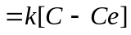 (1)
Where r is expressed as (mol/sec. g zeolite), k represents the first order reaction rate constant (cm3/sec. g zeolite), C and Ce represent the hydrogen ion concentration at different times and at equilibrium respectively (mol/cm³). The reaction rate constant was determined by parameter estimation using the first order reaction rate equation by firstly performing numerical integration of the rate equation for an initial assumption of the rate constant using the method of Runga-Kutta-Fehlberg [32]. The square of the difference between the calculated and the actual acid concentrations in the range of variation of time is then used as the objective function to calculate an improved value of the rate constant using Marquardt algorithm [33]. This procedure is iteratively repeated using tailored software until the value of the rate constant that provides acceptable error between the calculated and measured acid concentration is obtained. The diffusion coefficient, De (m²/sec), can be estimated by the Wilke–Chang equation [34,35]

De = 7.4E-15 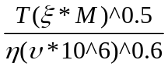 (2)
Where T is the washing temperature (K), ζ represents the association factor of solvent (water), M represents the solvent’s molecular weight, υ represents the solute (sodium hydroxide) molar volume (m³/mol) and η represent the solvent dynamic viscosity (Pa sec). Thiele modulus was then calculated using the following equation:
Φ = 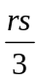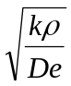 (3)
Where Φ is the dimensionless Thiele type modulus for spherical pellet, rs represents zeolite pellet diameter (m), ρ represents the zeolite density (g/cm³) and De is the diffusion coefficient of sodium hydroxide from the zeolite pores out to the washing solution (m²/sec). The effectiveness factor ή was then determined according to Smith. [29]

2.5.2 Empirical models formulation
Empirical models were formulated representing the effect of the different washing parameters on the final washing pH and on the chromium uptake. The experimental results have been correlated by applying relevant analysis methods, such as multiple non linear regression software and curve fitting to develop empirical models governing the washing of zeolite A. Typical software used for the purpose include Labfit (V.7.2.37) and Microsoft Excel.

2.5.3 Optimization
BOX Complex Routine [36] has been used to predict and define the optimum washing conditions required to fulfill minimum washing cost and high chromium uptake. This has been achieved through formulation of a cost objective function constrained with the formulated empirical equations relating the final washing pH and the chromium uploading to the washing conditions.
3. Results & Discussion

3.1 Characterization
3.1.1 XRD
Figure 1 represents a typical XRD chart for 3 of the prepared zeolite samples and acid washed at different conditions and a sample washed with water till pH 10.4

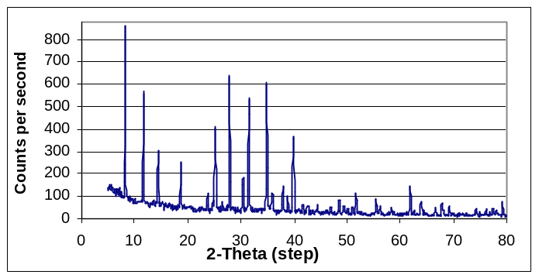
fig. 1 XRD representing four zeolite samples: the acid washed zeolite samples sample 1 (20 WR, 22ºC),sample 2 (80 WR, 60ºC), sample 3 (80 WR, 22ºC) at 1.2 AGE and 500rpm, sample 4 (water washed)

The XRD chart for the acid washed samples is typical of that of zeolite prepared via the prediction route and washed with distilled water till pH 10.4. The charts show sharp peaks of high intensity indicating highly crystalline and pure zeolite A with the following composition and characteristics: Product name: Na2O. Al2O3. 2SiO2. 4.5(H2O)—Sodium aluminum silicate hydrate (Zeolite LTA), molecular weight: 2191.06System: cubic with unit cell parameter a=24.61[37]
This indicates that the acid washed zeolite samples retains the intact zeolite A structure and the identified chemical structure as that of the samples washed with water until pH 10.4

3.1.2 XRF
XRF was also used to emphasize the performed zeolite structure. It resulted in Si/Al ratio of almost 1 for all the acid washed and the conventionally water washed samples respectively, which agrees with the XRD identified Si/Al molar ratio.
3.1.3. Inrfa red spectrometry
Figure 2 displays the FTIR spectra of the washed zeolite samples between (400-1300 cm⁻¹) [6,37]. The IR spectra shows the structure sensitive bands, as follows: asymmetric stretch 995 cm⁻¹, symmetric stretch 600 cm⁻¹, double rings D4R 550 cm⁻¹ which is characteristic of zeolite A [28,37] and T-O bend 464 cm⁻¹ . The presented bands are typical for all washed zeolite A samples, which indicate that the zeolite structure remains intact even after acid washing.

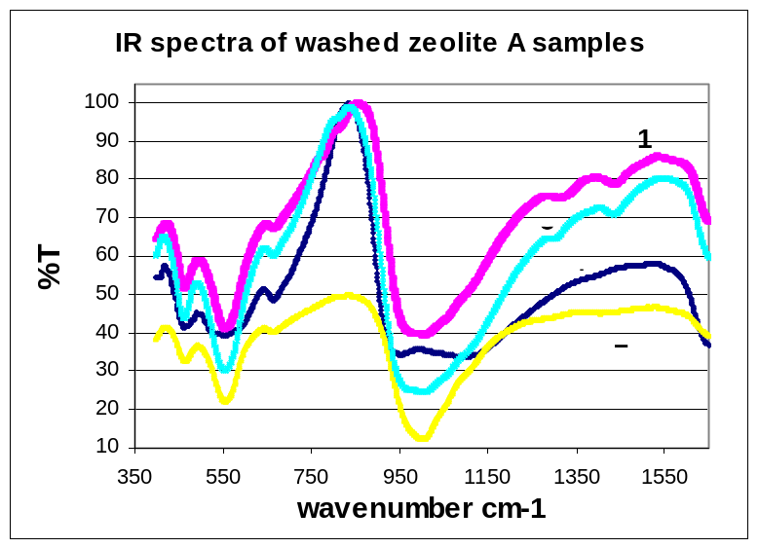

fig. 2 IR spectra of washed zeolite samples: acid washed (1-3) and water washed (4)

3.1.4 SEM
The synthesized zeolite samples have been characterized by (SEM) as shown in fig.3 as typical for the washed samples at 1.2 AGE and 500 rpm (a, b, c) and (d) for water washed zeolite sample at RT
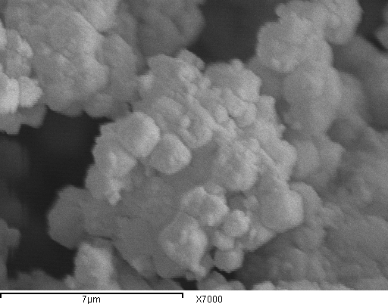
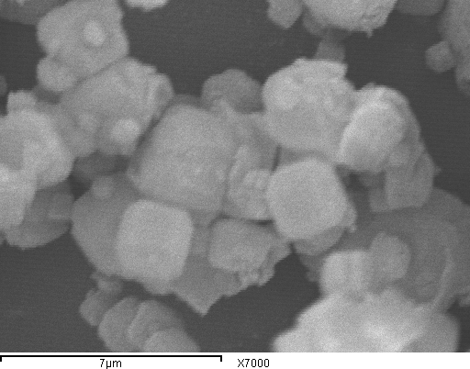
a) sample 1 (20 WR, 22ºC) b) sample 2 (80 WR, 60ºC)
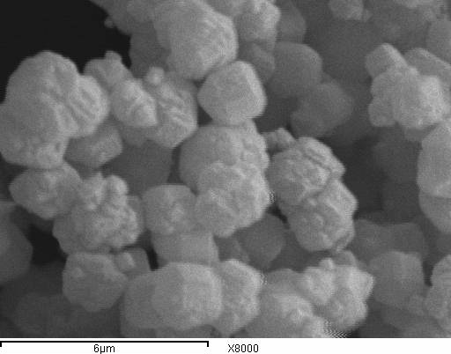
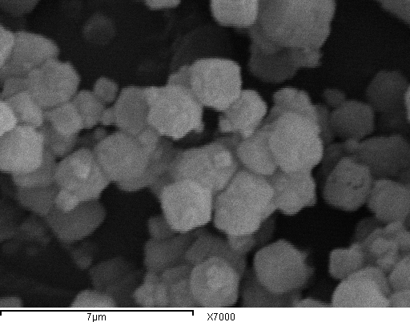
c) sample 3 (80 WR, 22ºC) d) sample 4 (not acid washed)
fig. 3 SEM of the acid washed zeolite samples (a),(b),( c), and water washed sample (d)
The SEM figures show that the highly crystalline small zeolite agglomerates formed have the size from a minimum of 0.2 to a maximum of 2 microns as compared to literature [4, 23]. This indicates that the acid washed zeolite samples retain the same surface morphology. It is clear that sample (1) has a wide particle size distribution, while the other samples have a narrow distribution.

3.1.5 Laser particle size analysis
The following table represents the particle size distribution for all the zeolite washed samples. It is clear that sample (1) has a wide particle size distribution. Also, sample 2 has narrower particle size distribution as indicated in the SEM.

Sample | Mode size (μm) | Size range (μm)
1 | 10.1 | 0.9-101.5
2 | 4.5 | 1.2-13.2
3 | 10.1 | 1-29.1
4 | 5.5 | 1-20

Table (1) Laser particle size analysis of the washed zeolite samples

3.1.6 Zeta potential
The zeta potential for the zeolite sample washed at 60ºC, 80 WR, 500 rpm and 1.2 AGE, and the zeolite sample conventionally washed is manifested in figure (4). The point of zero charge (PZC) is almost the same (at pH 5.4) for both zeolite samples.
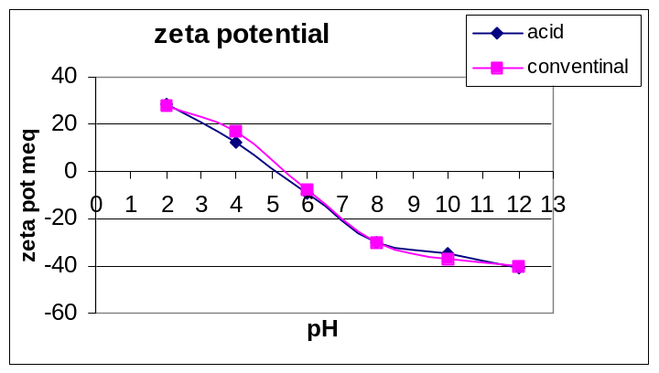

Fig4: Zeta potential measurement
of zeolite washed samples

3.2 Effect of washing parameters on pH
3.2.1 Time dependence of solution pH at different acid concentrations

Time dependence of solution pH at different acid concentrations along the 2 hours washing period is represented in the following figures as typical for all the other parameters.
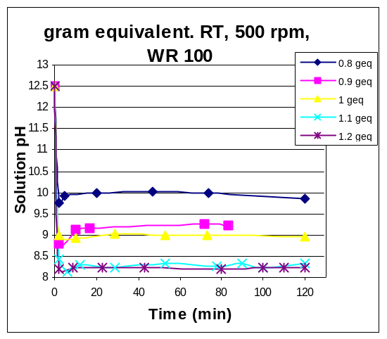
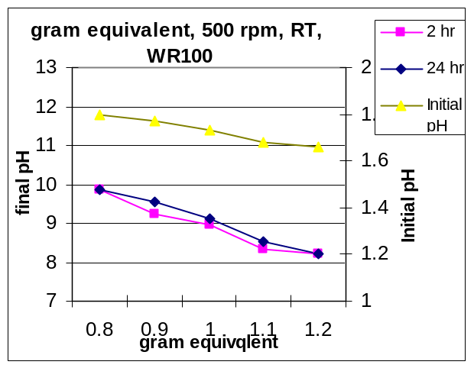
fig.5: Time dependence of solution pH at fig.6: Effect of acid gram equivalent
different acid gram equivalents at room on the final washing pH 2, 24 hr
temperature, 500 rpm and 100 WR

A sharp fall in pH is observed after the first (5-10) minutes. A typical trend was also observed in the time dependence of solution pH relations at different water ratios, temperature and rpm. indicating rather rapid neutralization of entrained alkalinity with oxalic acid. It is assumed that the accessible alkali under the prevailing conditions has almost been entirely neutralized since minimal pH change has been observed after 24 hr as shown in figure 6.

3.2.2 Effect of water ratio
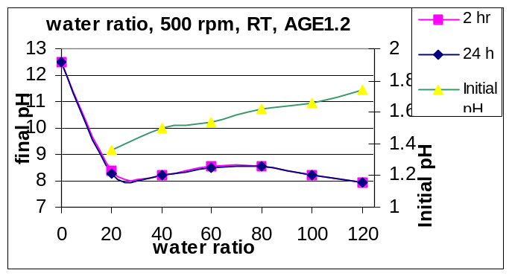

fig.7: Effect water ratio on the final washing pH after 2, 24 hr

Effect of water ratio (WR) on the final solution pH after 2 and 24 hr is shown in figure (7). Inspection of the data shown in figure 7 reveals the almost insignificant change of the final pH for water ratio more than 20. These findings would help reducing the water ratio used to minimum.

3.2.3 Effect of temperature

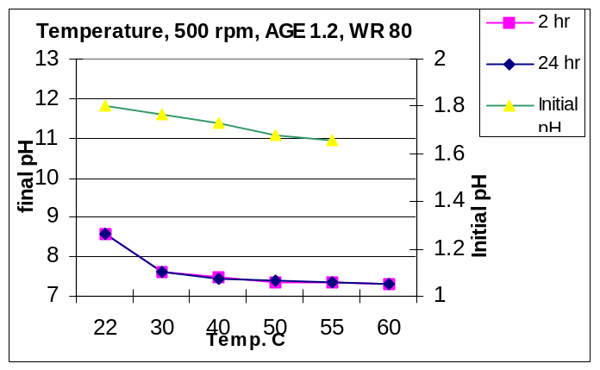

fig.8: Effect temperature on the final washing pH after 2, 24 hr.

Effect of temperature on the final solution pH after 2 and 24 hr is shown in figure (8). Increasing the temperature of the acid washing solution reveals 2 distinct zones. The first is related to sharp linear decrease of pH up to 30ºC. The second zone (segment) manifests moderate linear decrease of pH up to 60ºC, the immediate implication of these results is that most of the unreacted alkali is neutralized in the moderate temperature zone (20-30ºC). While the remainder is neutralized between 30-60ºC. Thus, in industrial practices using washing solution of temperature 30ºC is suffice to bring the final washing pH (after 2 hr) from 8.5 to about 7.6. These findings also enable thorough monitoring of the final zeolite pH through simple, but, cost effective tools such as acid concentration, water ratio and temperature.

3.2.4 Effect of stirring speed
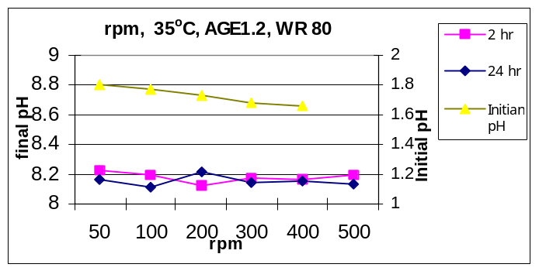

fig.9: Effect stirring speed on the final washing pH after 2, 24 hr.

Effect of stirring rpm on the final solution pH after 2 and 24 hr is shown in figure (9).The final pH is almost constant with the variation in the rpm after 2 and 24 hr, which confirms as will be shown later, that the neutralization reaction is not diffusion controlled.

3.3 Performance analysis
Acid washed zeolite samples have been tested for the chromium removal. The following figures show the results of the adsorption tests for zeolites subjected to acid wash under the specified conditions.
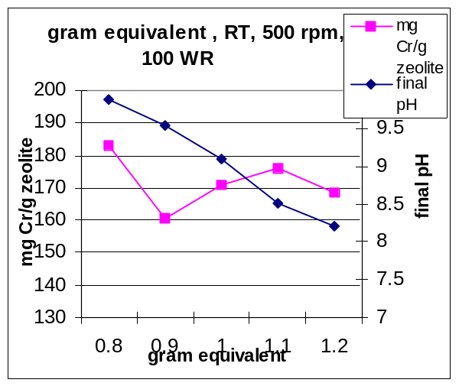
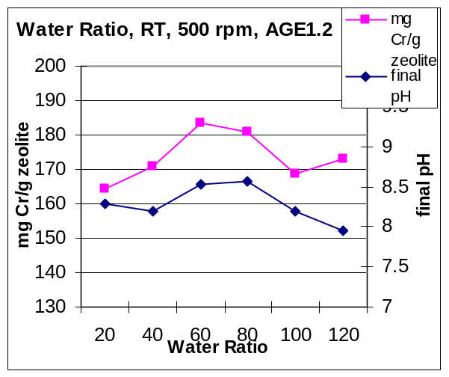
a) b)
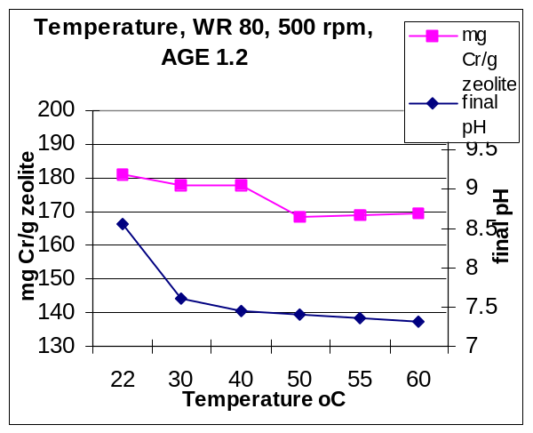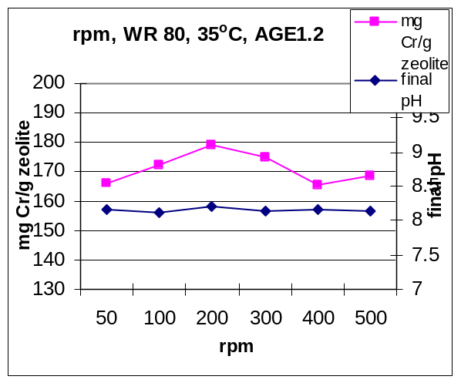
c) d)

fig.10: Chromium adsorption on acid washed zeolites: a) effect of acid gram equivalent, b) effect of water ratio, c) temperature dependence and d) influence of rpm

Figure 10a manifests a rapid fall of chromium loading from 0.8 to 0.9 AGE followed by almost restoration of a high loading capacity in the range of 0.9 to 1.2 AGE The first segment reflects the effect of pH on the surface of zeolite which decreases the extent of complexation mechanism. Further decrease of pH leads to probable improvement of access to zeolite pores and cavities with subsequent improvement of loading capacity. The value of 1.2 AGE was been chosen to be the appropriate acid gram equivalent one.
Figure 10b manifests an increase of chromium loading from 165 mg/g at 20 WR to 183 mg/g at 60 WR. The chromium loading then decreases to 181 mg/g at 80 WR. The value of 80 WR has been chosen to be the most appropriate water ratio. The impact of water ratio is related to simultaneous pH changes and dilution effect. The minor inaccuracies associated with the sensitivity of measurements should be ruled out taking into consideration the narrow range of chromium loading variation (183-170 mg/g).
Figure 10c manifests the decrease of chromium loading from 25ºC to 50ºC by 7% then it remains almost constant till 60ºC. This may be compared with the final pH curve, since the final pH shows moderate to minor decrease above 30oC. Temperature accelerates the alkali neutralization rate which increases the acid washing efficiency. The 7% decrease in the value of chromium loading may be considered minor indicating the limited effect of temperature on the washing process. The value of 35ºC has been chosen to be the most appropriate washing temperature.
Figure 10d manifests the sharp increase of chromium loading from 166 mg/g at 50 rpm to 179 mg/g at 200 rpm followed by sharp decrease in the chromium loading for higher rpm. This may be attributed to increasing the ion mobility and homogeneity in mixed solutions up to 200. By increasing the rpm higher than 200 rpm, adsorption and desorption take place simultaneously reducing the over all chromium uptake. The corresponding final washing pH remains almost constant indicating the negligible effect of stirring on the final washing pH.
The following figure represents the over all effect of the final pH along the washing study on the chromium loading
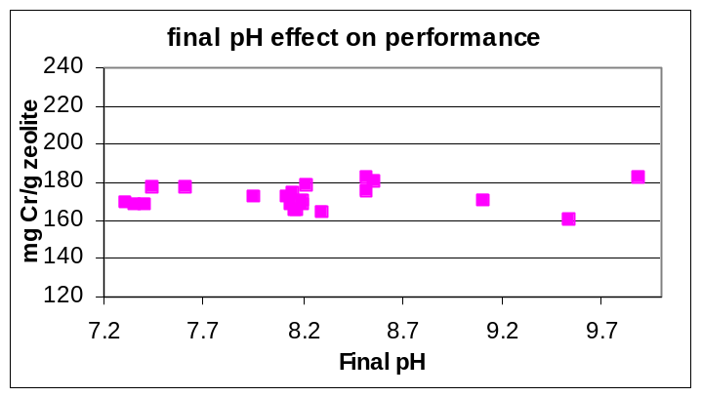

Fig 11: Effect of the final washing pH on the chromium adsorption capacity along the entire washing region

Figure 11 represents the variations of the chromium loading corresponding to the final equilibrium washing pH. The highest reported value of chromium loading was recorded at final pH value of 9.88. The effect of pH on the Cr(III) adsorption is quite complicated as mentioned by [38]. It was mentioned that the chromium hydroxide is low up to pH 6 then it increases and then decreases again by increasing the pH more than 12. In this study it is worth mentioning that the starting pH of adsorption bulk solution was 3 and it ended at about 4.5-5, which eliminated the complexation precipitation removal mechanism. On the other hand, the actual pH inside the zeolite pores was that of the final washing pH resulting in different forms of chromium complexes other than in bulk solution and enhancing the complexation precipitation removal mechanism inside the pores. Sample (4), which was washed using distilled water till pH 10.4 recorded 184 mg Cr/g zeolite adsorption capacity.

3.4 Diffusion with chemical reaction
Applying the washing process using 1.2 acid gram equivalent, water ratio of 80, 500 rpm stirring speed and 25ºC temperature; the diffusion with chemical reaction concept was applied. The hydrogen ion concentration has been varied from 0.95E-13 to 2.7E-12 mol/cm³ starting from 1min reaction time up to 34 min.. The parameters in the previous equations (1-3) were calculated considering the spherical zeolite pellet as a spherical catalyst pellet. The results are shown in the table (2).
The results manifest that the effectiveness factor is considered 1 [29]. Which indicates that the rate for the whole zeolite pellet is the same as the rate if all of the surface were available to reactant; i.e., the rate at the center is the same as the rate at the outer surface, consequently the entire surface is considered fully effective and the intraparticle diffusion resistance is minimum.
Thus the intraparticle mass transport has no effect and the chemical reaction controls the washing rate. This indicates that the effect of the mixing speed on the washing process is limited for values above 200 rpm. This result was emphasized experimentally as demonstrated in figure (10d).

Parameter |  | Value
I. Input
T | Temperature (K) | 298
M | Water molecular weight (g/mol) | 18
ζ | Water association factor | 2.6
υ | Solute molar volume (m³/mol) | 20 E-06
rs | Zeolite pellet diameter (m) | 2 E-06
ρ | Zeolite hydrated density (g/cm³) | 2
II. Calculated
k | Reaction rate constant ((cm3/sec. g zeolite) | 5.12 E-04
De | Diffusion coefficient (m2/sec) | 2.5 E-09
Φ | Thiele modulus | 4.3 E-04
ή | Effectiveness factor | 1
Table (2) Thiele modulus & effectiveness factor values

3.5 Empirical Modeling and optimization

Data analysis has resulted into the formulation of the following empirical equations governing the relationship between the final washing pH, chromium loading and the washing operating conditions and the with R² ranging from 0.9 to 1,

pH_{F} = (1.8637 – 0.9643 AGE – 0.0626 WR – 0.25 T – 0.0649 S ) ^{0.5} (4)

L = 30.18 pH_{F}⁵ - 1283.47 pH_{F} ⁴ + 21771.52 pH_{F}³ - 184166.19 pH_{F}² + 776905.33 pH_{F}
- 1307394.33 (5)

BOX COMPLEX routine has been adopted to find the values of the washing conditions that would minimize the washing process costs while maintaining high zeolite chromium loading. This has been achieved through formulation of a cost objective function, equation (6), constrained by equation (4) starting with the pH_{F} value corresponding to maximum loading calculated from equation (5). Consequently, equations (4) have been used to calculate other parameters using the defined optimum for the independent variables. The objective function is expressed based on the oxalic acid price of 0.2 USD/kg, water price of 0.2 USD/m³, and 0.08 USD/kWh:

C = 0.059 AGE + 2E-05 WR +(4.3E-04 AGE+ 9E-06 WR) (T-20) (6)

Results are presented in table (3)
Table (3) Predicted Washing Variables
Parameter |  | Range of Validity | Predicted Value
pH_{F} | Final washing pH | (7.31-9.88) | 9.87
AGE | Oxalic acid gram equivalent/ g zeolite | (0.8-1.2) | 0.8
WR | Water ratio ml/ g zeolite | (20-120) | 20
T | Washing temperature (ºC) | (22-60) | 22
S | Stirring rpm | (50-500) | 50
L | Chromium loading mg Cr/g zeolite | (160.6-183) | 178.9
C | Washing cost USD/ kg zeolite |  | 0.048
CT | Washing cost USD/ ton zeolite |  | 48

Table (3) indicates that the oxalic acid demand is about 200 kg/ ton zeolite and the wash water demand was 20 m³/ ton zeolite. Consequently, 48 USD are needed for acid washing of one ton zeolite to a final pH of 9.88. On the other hand 62 USD, represent the price of water only (310 m³/ ton zeolite), for washing of one ton zeolite with water to a pH of 10.4. The net savings are considered to be about 14 USD per ton of zeolite, in addition to other technical benefits as discussed in the previous sections.

4. Conclusions

Zeolite A washed by oxalic acid has been characterized by XRD, XRF, FTIR, SEM, laser particle size analysis and zeta potential measurements. Further, the adsorption capacity of chromium has been assessed The results indicate that the proposed acid washing scheme retained the intact zeolite structure and surface morphology and also high chromium loading as compared to zeolite washed with distilled water. The complexation effect decreased by 14%. The intraparticle mass transport has no effect and the chemical reaction controls the washing rate. This indicates that the effect of the mixing speed on the washing process could be considered negligible above 200 rpm. Based on the adopted optimization procedure, the amount of water required for washing has been decreased from about 310 m³/ ton zeolite to reach pH value of 10.4 to about 20 m³/ ton zeolite with the proposed acid washing scheme to reach pH value range of 9.87. This results in the decrease of the cost & energy requirements of washing process. Consequently the net savings in washing cost has also decreased by about 22% as compared to the conventional zeolite washing conditions. In addition, the formulated rational scheme has proved to be a powerful tool for the prediction of optimum zeolite A washing conditions to fulfil minimum washing cost and high chromium loading.

References

- Barros M.A.S.D., P.A. Arroyo, E.F. Sousa-Aguiar, C.R.G. Tavares, "Thermodynamics of the Exchange Process between K+, Ca2+ and Cr3+ in Zeolite NaA", Adsorption, 10 (2004) 227-235
- Barros Maria Angelica Simoes Dornellas, Andreia Soares Zola, Pedro Augusto Arroyo, Eduardo Falabella Sousa-Aguiar, Celia Regina Granhen Tavares, "Equilibrium and Dynamic Ion Exchange Studies of Cr3+ on Zeolites NaA and NaX", Maringa, 24 (2002) 1619-1625.
- El-Kamash A.M., A.A. Zaki, M. Abed El Geleel, "Modeling Batch Kinetics and Thermodynamics of Zinc and Cadmium Ions Removal from Waste Solutions using Synthetic Zeolite A", Journal of Hazardous Materials B127, (2005) 211-220
- Hui K.S., C.Y.H. Chao, S.C. Kot, "Removal of Mixed Heavy Metal Ions in Wastewater by Zeolite 4A and Residual Products from Recycled Coal Fly Ash", Journal of Hazardous Materials B127 (2005) 89-101
- Biskup Biserka and Boris Subotic, “Removal of Heavy-Metal Ions from Solution by Means of Zeolites. II. Thermodynamics of the Exchange Processes Between Zinc and Lead Ions from Solutions and Sodium Ions from Zeolite A”, Separation Science and Technology, 35 (2000) 311-2326.
- Alfaro S., C. Rodriguez, M.A. Valenzuela, P. Bosch, "Aging Time Effect on the Synthesis of Small Crystal LTA Zeolites in the absence of Organic Template", Materials Letters 61 (2007) 4555-4653
- Bosnar Sanja, Tatjana Antonic-Jelic, Josip Bronic, Ivan Krznaric, Boris Subotic, "Influence of Anions on the Kinetics of Zeolite A Crystallization: a Population Balance Analysis", Journal of Crystal Growth, 267 (2004) 270-282
- Caputo D., B. De Gennaro, B. Liguori, F.Testa, L. Carotenuto, C. Piccolo, "A Preliminary Investigation on Kinetics of Zeolite A Crystallization Using Optical Diagnostica", Materials Chemistry and Physics, 66 (2000) 120-125
- Fan Wei, Florian Meneau, Wim Bras, Masaru Ogura, Gopinathan Sankar, Tatsuya Okubo, "Effects of Silicon Sources on the Formation of Nanosized LTA: An In Situ Small Angle X-Ray Scattering Wide Angle X-Ray Scattering Study", Microporous and Mesoporous Materials, 101 (2007) 134-141
- Kuanchertchoo N., S. Kulprathipanja, P. Aungkavattana, D. Atong, K. Hemra, T. Rirksomboon, and S. Wongkasemjit, "Preparation of Uniform Nano-Sized NaA Zeolite Using Siltrane and Alumatrane Precursors", Applied Organometallic Chemistry, 20 (2006) 775-783.
- Marui Yukiko, Ryousuke Irie, Hiroshi Takiyama, Hirohisa Uchida, Masakuni Matsuoka, "Analysis of Nucleation of Zeolite A from Clear Solutions", Journal of Crystal Growth 237 (2002) 2148-2152
- Kraznaric Ivan, Tatjana Antonin, Josip Bronic, Boris Subotic, Robert W. Thompson, “ Influence of Silica Sources on the Chemical Composition of Aluminosilicate hydrogels and the results of Their Hydrothermal Treatment”, Croatica chemica cacaa 76 (2003) 7-17.
- Cundy Colin S., Paul A. Cox, "The Hydrothermal Synthesis of Zeolites: Precursors, Intermediates and Reaction Mechanism", Microporous and Mesoporous Materials, 82 (2005) 1-78
- Caruthers J.M., J.A. Lauterbach, K.T. Thomson, V. Venkatasubramanian, C.M. Snively, A. Bhan, S. Katare, G. Oskarsdottir, "Catalyst Design: Knowledge Extraction from High-Througput Experimentation", Journal of Catalysis, 216 (2003) 98-109
- Chudasama Chintansinh, Jince Sebastian, Raksh V. Jasra, "Pore-Size Engineering of Zeolite A for the Size/Shape Selective Molecular Separation", Industrial Chemistry Research, 44 (2005) 1780-1786
- Sheikh Ahmed Y., Alan G. Jones, "Population Balance Modeling of Particle Formation during the Chemical Synthesis of Zeolite Crystals: Assessment of Hydrothermal Precipitation Kinetics", Zeolites, 16 (1996) 164-172
- Tatlier Melkon, H. Kerem Cigizoglu, Ayse Erdem-Senatalar, "Artificial Neural Network Methods for the Estimation of zeolite Molar Compositions thet form from Different Reaction Mixtures", Computers and Chemical Engineering, 30 (2005) 137-146
- Laurlus O., S.Mintova, T. Bein, “ Environmental syntheses of nanosized zeolites with high yield and monomodal particle size distribution”, Microporous and Mesoporous Materials 96 (2006) 405-412.
- Lu Baowang , Youzou Yakushi, Yasunori Oumi, Keiji Itabashi, Tsuneji Sano, “ Control of crystal size of high-silica mordenite by quenching in the course of crystallization process”, Microporous and Mesoporous Materials 95 (2006) 141-145.
- United States Patent, Pt. No.4732880 (1988).
- US Patent No. 4,260,495 (1981)
- Vasilev N. G., A. A. Mel'nikov, I. V. Matyash, A. S. Litovchenko, and A. M. Kalinichenko., “Effect of acid treatment on the stability of aluminum-oxygen tetrahedra in zeolites.”, Theoretical and experimental chemistry, 18 (1983) 580-583
- United States Patent, Pt. No 6641796 (2000)
- Rakoczy Ranier A., Yvonne Traa, "Nanocrystalline Zeolite A: Synthesis, Ion Exchange and Dealumination", Microporous and Mesoporous Materials, 60 (2003) 69-78
- United States Patent, Pt. No 4173622 (1979)
- Japanese patent No. 80/27818
- French patent No. 2.499.123
- Basaldella, Elena I., Patricia G. Vazquez, Fabiano Iucolano, Domenico Caputo, " Chromium Removal from Water using LTA Zeolites: Effect of pH", Journal of Colloid and Interface Science, 313 (2007) 574-578
- Smith J.M., “Chemical engineering kinetics”, 2nd edition, McGraw-Hill Kogakusha 1970
- Szuiewicz Miroslaw, Roman Petrus, “ Approximate model for diffusion in a porous pellet and an effectiveness factor”, Chemical engineering science, shorter communication, 59(2004) 479-483
- Hani Heba A., Shadia R. Tewfik, Mohamed H. Sorour, Nabil Abdel Monem. “Prediction and verification of the conditions governing the synthesis of tailored zeolite a for heavy metals removal”, EuroAsian chemico-tecnological jourmal, 11 (2009) to appear
- Erwin Fehlberg (1969), “Low-order classical Runge-Kutta formulas with step size control and their application to some heat transfer problems” . NASA Technical Report 315. as quoted in http://math.fullerton.edu/mathews/n2003/RungeKuttaFehlbergMod.html
- Donald Marquardt (1963). "An Algorithm for Least-Squares Estimation of Nonlinear Parameters". SIAM Journal on Applied Mathematics 11: 431–441. doi:10.1137/0111030.
- Perry Robert H., “Perry’s chemical engineers’ handbook”, Seventh edition (1997), McGraw-Hill
- Li Jun, Xiaohui Hu, Yuzhong Su, Qingbiao Li, “ Modeling of a packed-bed electrochemical reactor for producing glyoxylic acid from oxalic acid” Chemical engineering science 62 (2007) 6784-6793
- BOX, M., "A New Method of Constrained Optimization and Comparison with Other Methods", Computer J., 8 (1965) 42-52
- Breck, Donald W., " Zeolite Molecular Sieves"Wiley, 1973
- Remoundaki Emmanouela, Artin Hatzikioseyian and Marios Tsezos, “A systematic study of chromium solubility in the presence of organic matter: consequences for the treatment of chromium-containing wastewater”, Journal of chemical technology and biotechnology 82 (2007) 802–808

