Theory of dimensions

Ayman kamel abd elsattar

Microbiology Department, National Research Center, Cairo, Egypt

Aymankamel91@yahoo.com

In brief:
The Principles:
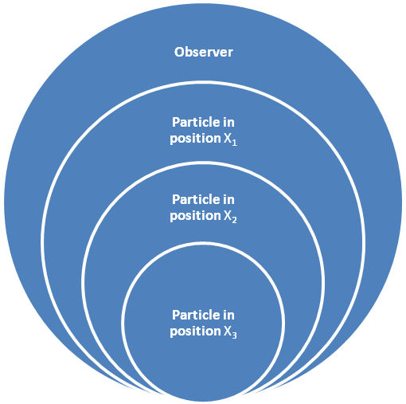
- All particles have different physical properties as the spatial dimension for each particle to the observer (the law of static particles).
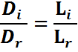
Where is Virtual dimension & is the real dimension & is imagine particle length and is real particle length.

- Each particle moving bow to each other, but with a different degree of curvature depending on the speed for a moving particle after spatial (the law of moving particles).
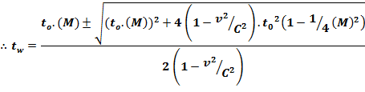
Where is the time recorded by the observer moving & is The time recorded by the static observer & is Constant curve equals 0.3131655288 & is particle velocity and is light velocity.

- Measured the speed of light is not the truth and all other particles, and carrying a light qualities and wave-particle.
In fact, there is no theory of wavelengths in the universe, but apparently us is curvature of moving particles.
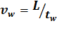 & 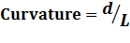
Where is the real velocity of particle & is The real distance traveled by a moving particle & is The unreal distance traveled by a moving particle.

- Explain the force of gravitation and produce new formula for explain it and determined the value of it and magnetic force.
Where is gravitation force & is the moving particle force & is the static particle force.

*New description for Energy:
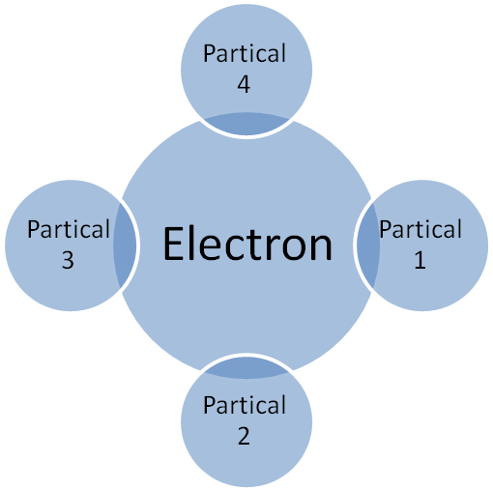
When it hits a particle of light emanating from the electron occurs a temporary cookie between these particles of light and electron excited electron getter particles of light and moving vibrating movement of the lower power level to the higher and soon to disintegrate the particles with the passive electron and exit in the form of a specific wavelength appears to us is in fact curvature of particles appear in the liberal and the curved shape waveform according to their degree bowing shows us a different wavelength, according to the speed of the particle.

