TRUE MEANING OF E=MC² AND MOMENTUM OF EMITTED HAWKING RADIATION

Author: Manjunath R

Address:

Email: manjunathr1988@yahoo.in

Abstract:

Keywords:

True meaning of E=MC²:-
Conversion of energy into mass and its vice versa is beautifully explained by Einstein’s famous equation E=MC²,here C is not just the velocity of a certain phenomenon—namely the propagation of electromagnetic radiation (light)—but rather a fundamental feature of the way space and time are unified as space time. The equation implies conversion of energy into mass and its vice versa accounts the unification of space and time. In other words in presence of mass there is unification of space and time .In absence of mass ,space and time behave as two separate factors. The space, time ,mass are different concepts in physics and these concepts are brought to gather in one equation. Moreover the question arises in human mind the need of unification of space and time in conversion of energy into mass and its vice versa .

Power of the emitted hawking radiation from the evaporating black hole of mass ’M ’ is given by
P= ħC⁶/15360 π G²M²…………………………….(1)
Let us divide the above equation by M and then multiply by 3 we get
3 P/M= ħC⁶/5120 π G²M³……………………..…(2)
Evaporation time of black hole is given by
Tev = 5120 π G²M³/ ħC⁴…………………………..(3)
Thus (2) becomes
3 P/M= C²/ Tev……………………………………(4)
The power of emitted hawking radiation is also given by
P=hf ²…………………………………………..(5)
Thus (4)becomes
3( hf) f / M= C²/ Tev…………………………………(6)
By the equivalence of Einstein ‘s mass energy law and planck ‘s law we get
hf=mC²
Thus (6) becomes
3(mC²) f=M C²/ Tev…………………………….(7)
f=M / 3m Tev………………………….……(8)
As frequency of emitted Hawking radiation is given by
f=C/λ
Thus (8) becomes
m C/λ =M / 3 Tev………………..……(9)
Momentum of emitted Hawking radiation is given by
p=mC
Thus (9) becomes
p /λ =M / 3 Tev …………………………..(10)
Wavelength of emitted Hawking radiation is given by
λ=h/p
Let us divide the above equation by p we get
p /λ = h/p²
Thus (10) becomes
p² = hM / 3 Tev………………..…….(11)

p = [hM / 3 Tev]^{1/2}
Poynting–Robertson force -:
Power of radiation can be given by P=hf^2 i.e P= (hf)c/ λ (1)
Force exerted by radiation can be given by F=hf/ λ
Proof for F=hf/ λ :

Determination of the Photon Force and Pressure
Reissig, Sergej
The 35th Meeting of the Division of Atomic, Molecular and Optical Physics, May 25-29, 2004, Tuscon, AZ. MEETING ID: DAMOP04, abstract #D1.102
In [1] the formula for the practical determination of the power of a light particle was derived: P = hf^2 (W) (1). For the praxis it is very usefully to define the forces and pressure of the electromagnetic or high temperature heat radiation. The use of the impulse equation F = fracdPdt = fracd(mc)dt (2) together with the Einstein formula for E = mc^2 leads to the following relationship: F = frac1cfracd(mc^2 )dt = frac1cfracdEdt (3) In [1] was shown: - fracdEdt = P (4). With the use the eq. (1), (3), (4) the force value could be finally determinated: | F | = frachf^2 c or | F | = frachcλ ^2 = fracEλ [N]. The pressure of the photon could be calculated with using of the force value and effective area: p = fracFA [Pa]. References 1. About the calculation of the photon power. S. Reissig, APS four corners meeting, Arizona, 2003 -www.eps.org/aps/meet/4CF03/baps/abs/S150020.html
E=F λ

According to Planck’s theory of radiation
Energy associated with radiation can be given by
E=hf
Thus the equation E=F λ becomes F=hf/ λ
Then the equation (1) becomes P=FC (2)
Here P= Power of radiation, F= Force exerted by radiation ,C= speed of light in vacuum , h = Planck’s constant ,
f = Frequency of radiation , λ = wavelength of radiation .
Consider a dust grain orbiting the sun in the solar system . Newton's law of universal gravitation states that “Every massive particle in the universe attracts every other massive particle with a force which is directly proportional to the product of their masses and inversely proportional to the square of the distance between them “.
Gravitational force of sun experienced by the dust grains orbiting the sun can be given by
F= GM m /r² (3) Here F = Gravitational force between the sun and dust grain, G = Universal gravitational constant , M = Mass of the sun, m = Mass of the dust grain, r = Distance between the Sun and dust grain(orbital radius of dust grain).
Centrifugal force is an outward force associated with curved motion, that is, rotation about some (possibly not stationary) center. Centrifugal force is one of several so-called pseudo-forces (also known as inertial forces). Centrifugal force acts on dust grain to prevent the collapse of dust grain towards the sun can be given by
F = mv² /r (4) Here F = centrifugal force , m = Mass of the dustgrain , r= Distance between the Sun and dust grain(orbital radius of dust grain) , v= velocity of dust grain .
By the comparison of (3) and (4) we get
r= GM /v² (5) Here Ms= Mass of the sun, r = Distance between the Sun and dust grain(orbital radius of dust grain), v= velocity of dust grain, G = Universal gravitational constant .
Solar radiation causes a dust grain in the solar system to slowly spiral inward. The drag is essentially a component of radiation pressure tangential to the grain's motion. The first description of this effect, given by Poynting in 1903. The grain of dust circling the Sun (panel (a) of the figure), the Sun's radiation appears to be coming from a slightly forward direction (aberration of light). Therefore the absorption of this radiation leads to a force with a component against the direction of movement. (The angle of aberration is extremely small since the radiation is moving at the speed of light while the dust grain is moving many orders of magnitude slower than that.)

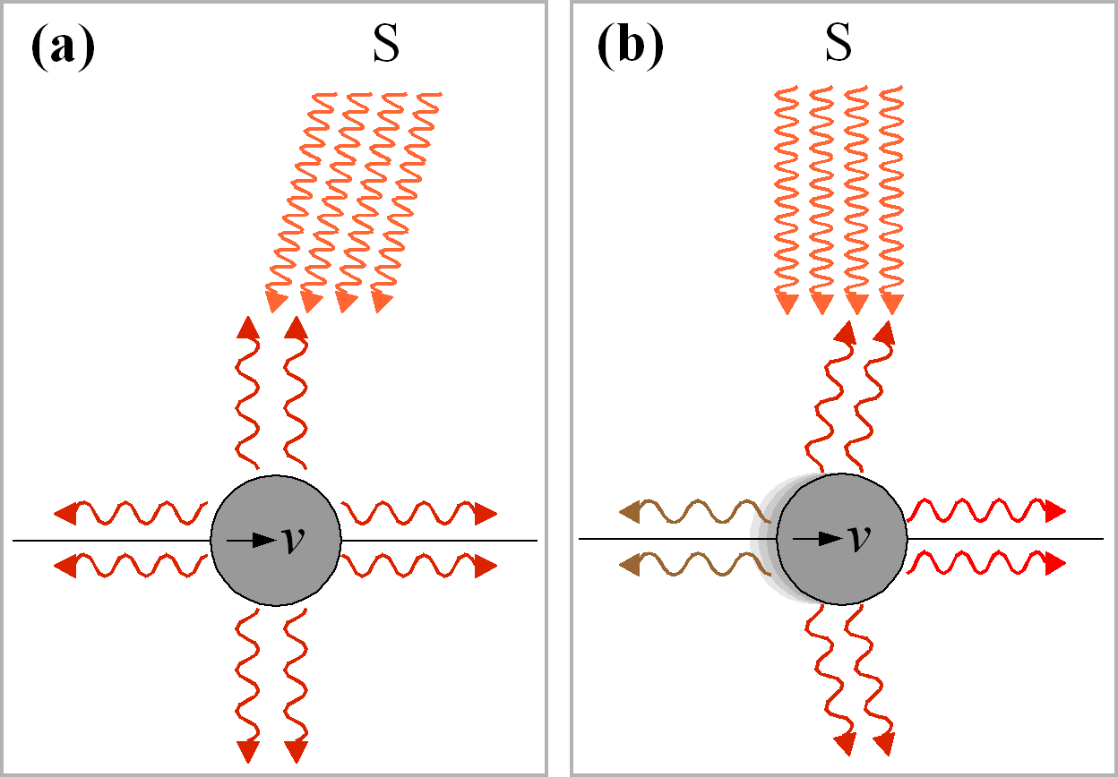

The Poynting–Robertson drag can be understood as an effective force opposite the direction of the dust grain's orbital motion, leading to a drop in the grain's angular momentum. It should be mentioned that while the dust grain thus spirals slowly into the Sun, its orbital speed increases continuously.
Poynting–Robertson force can be given by
FPR = Pv/C² (6) Here P is the power of the incoming solar radiation, v is the grain's velocity, C is the speed of light in vaccum, and R isthe dust grain's orbital radius , FPR = Poynting–Robertson force .
From (1) we know that power of incoming solar radiation can be denoted by P=FC
Then the equation (6) becomes FPR = (FC )v/C²
FPR = (Fv) / C (7) Here FPR = Poynting–Robertson force , F= Force exerted by solar radiation , v is the grain's velocity , C is the speed of light in vaccum .
Squaring the equation (7) we get
FPR ²= F² *(v/ C) ² (8)
From (5) we have r= GM /v² i.e v²= GM / r
Thus the equation (8) becomes FPR ²= F² *(v²/C ²)
FPR²= F² *(GM /rC²) .
The Schwarzschild radius (sometimes historically referred to as the gravitational radius) is a characteristic radius associated with every quantity of mass. Gravitational radius of the sun can be given by
R g =2 GM /C² (9)
From (9) the equation FPR ²= F² *(GM /rC²) can be written as
FPR ²=( F²* Rg) /2R (10)
FPR = F * (Rg /2r ) ^{1/2} (11)
Here FPR = Poynting–Robertson force , F= Force exerted by solar radiation , Rg= gravitational radius of sun, C is the speed of light in vaccum , r is the dust grain's orbital radius .

^{References:}

