List of Figures

Fig. (1): Transverse section of aorta of control rat showing normal histological structure of the tunica intima (I), media (M) and adventitia (A). (H & E.X 160)
Fig. (2): Transverse section of aorta of hyperlipidemic rat showing perivascular hemorrhage (H). (H&E X 40).
Fig. (3): Transverse section of aorta of hyperlipidemic rat showing vaculation in the cells of tunica media (arrow). (H & E X 160
Fig. (4): Transverse section of aorta of Escherichia coli (10⁷CFU/ rat, i.p) treated rat showing focal desquamation of the endothelial cells lining the intima (arrow) with hyalinization in the tunica media (M). (H & E X 160
Fig.(5): Transverse section of aorta of hyperlipidemic and Escherichia coli (10⁷CFU/ rat, i.p) treated rat showing the perivascular hemorrhage (H). (H & E X 160).
Fig. (6): Transverse section of aorta of hyperlipidemic and Escherichia coli (10⁷CFU/ rat, i.p) treated rat showing oedema in the adventitia (A) (H & E X 64).

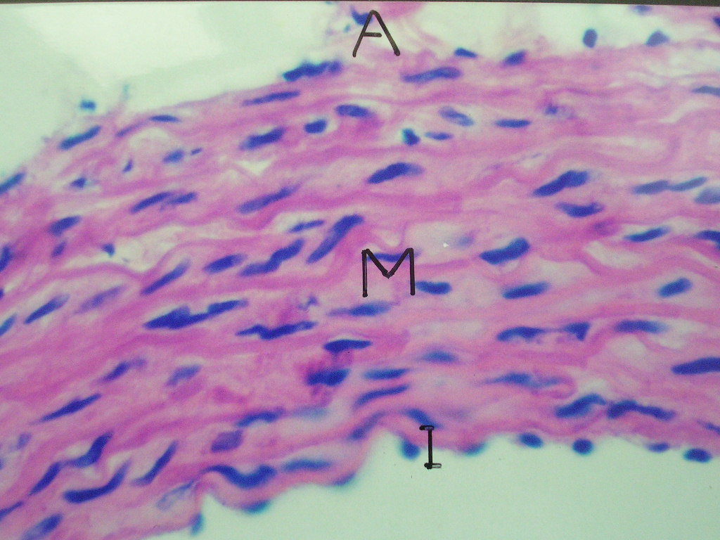
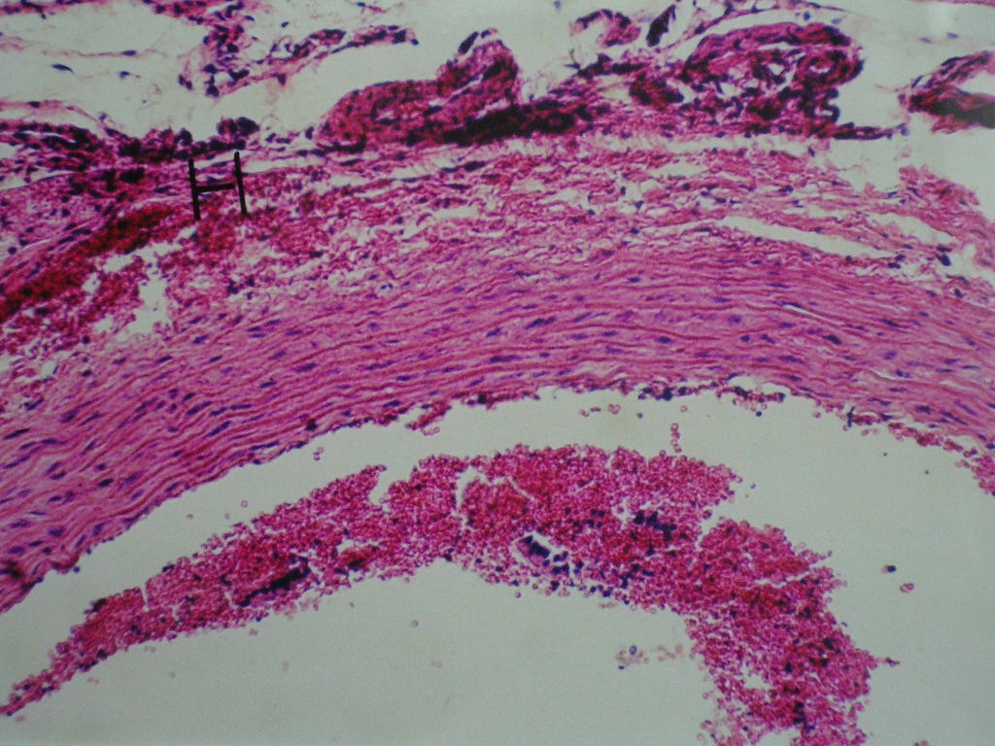
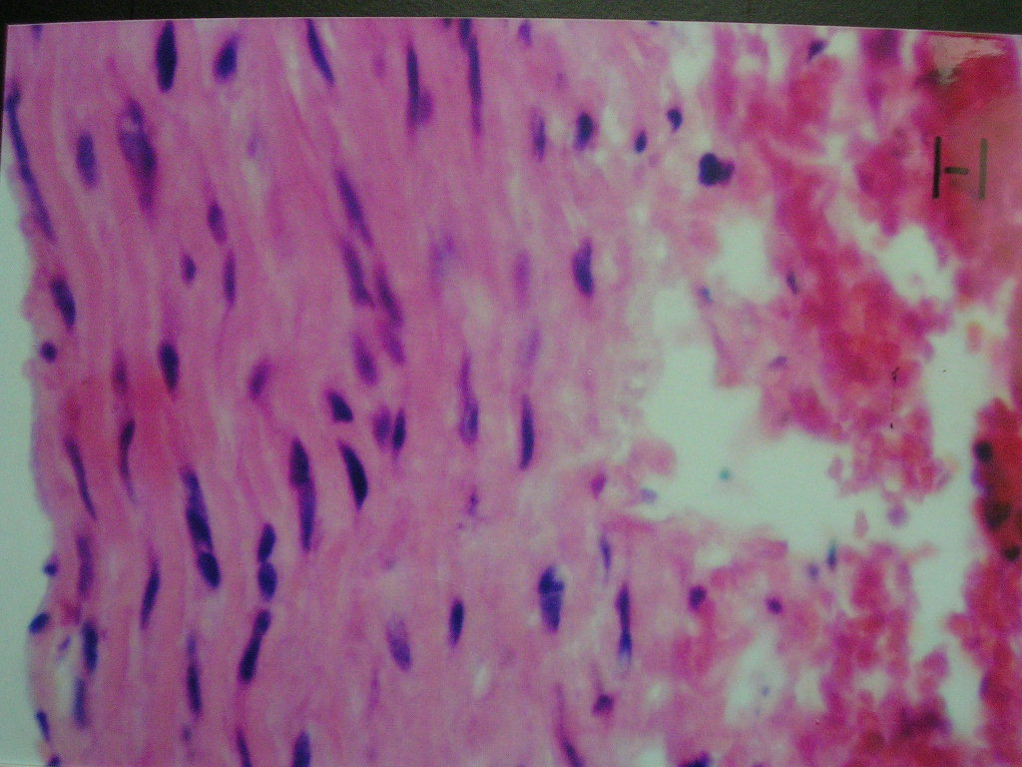
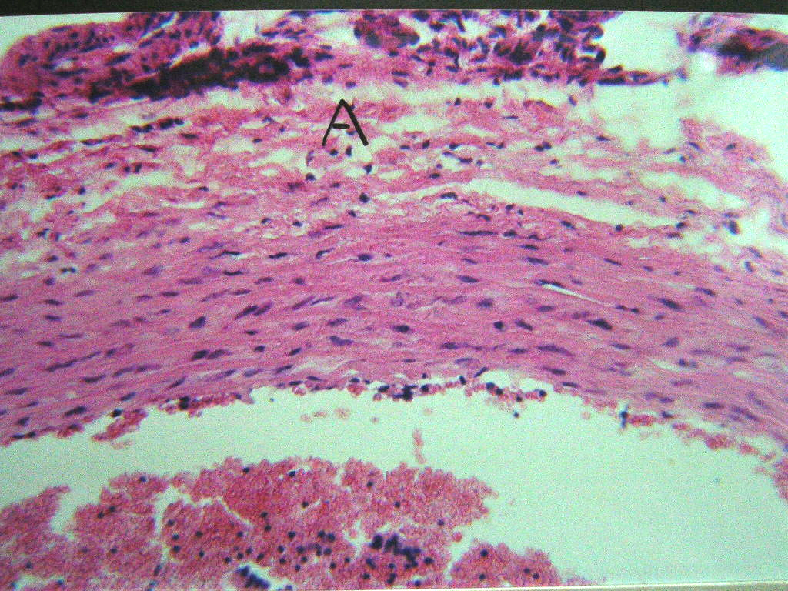
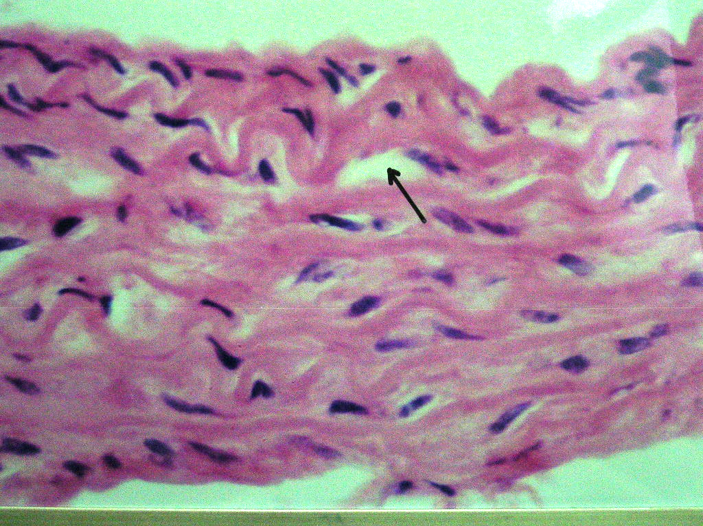
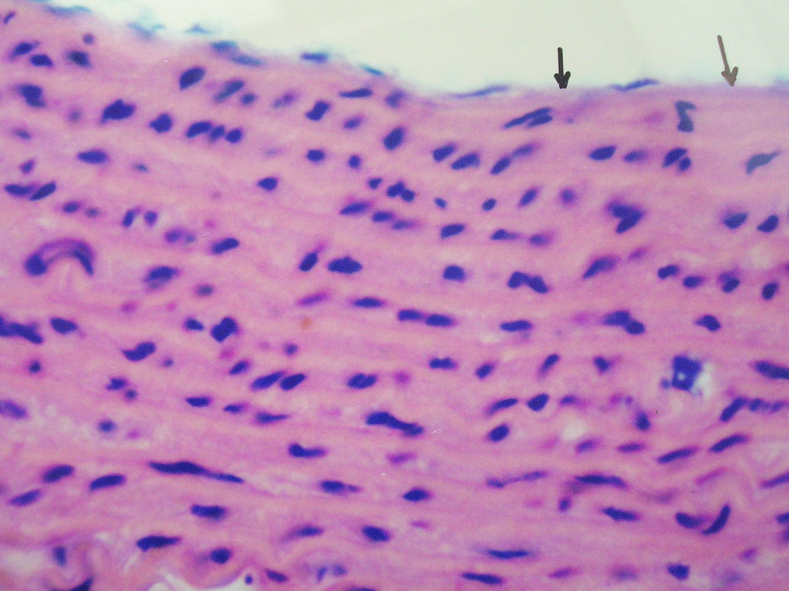
1
2
3
5
6
4

