STUDIES ON THE UTILIZATION OF ONLY FLY ASH IN RECLAMATION OF COAL MINE SPOILS: A CASE STUDY

Arvind Kumar Rai¹, Biswajit Paul², Gurdeep Singh³
Research Scholar¹, Assistant Professor², Professor & Head³
Department of Environmental Science & Engg
Indian School of Mines, Dhanbad, Jharkhand
arvind_dese@rediffmail.com

ABSTRACT
Indian coal being high in ash content of about 35- 45%. In the process of thermal power generation the country is producing high amount of fly ash. Due to high volume of fly ash generation in the thermal power plant, it creates a serious problem of disposal in relation to environmental problems. But fly ash contains many nutrients for plant growth. It has also shown to correct increase the nutrient uptake by crops grown in earthen pot. The present paper discusses the utilization of fly ash of Bokaro thermal power station in reclamation of coal mine spoils. Cymbopogon flexuous has been selected for this research work.

Key Words: Fly ash, Bulk density, Available phosphorus, Reclamation.

INTRODUCTION

Power is generated from different sources like thermal power, nuclear power and power from fossil fuel and other non conventional resources. Energy generation through thermal power plants is very normal now days. This produces very large amount of fly ash all over the world The coal used in India generally low grade high ash content coal. The power grade coal in our country is mostly mined by opencast method. At present more than 50% of the energy requirement in our country is met by coal based thermal power stations. The use of low grade high ash content coal for the power generation results in huge amount of coal ash production. These residues are generally disposed off in the form of slurry to nearby ash ponds. Ash is a residue resulting from combustion of coal in Thermal power plants. About 80% of total ash is finely divided form which is carried away with flue gases and is collected by Electrostatic precipitator. This is called dry fly ash or hopper ash. The 20% of the ash gets collected at the bottom of the boiler and is commonly known as Bottom ash. When fly ash and bottom ash is carried to storage pond in the form water slurry and deposited, it is known as pond ash.

Fly ash contains many nutrients for plant growth. It has been shown to correct nutrient deficiency or increase nutrient uptake by crops. Fly ash amendments in soil have resulted in increased plant production (Adriano et al 1980). Klein and Russell, 1973 have been shown that soils and plants around a coal burning power plant were enriched in some trace metals caused by fall out fly ash from stack of the power plant. Several studies indicates that wider potentials of Fly ash to increase the productivity and convert the problematic soils into agricultural land or revegetation of many plants (Ram et al, 2006). Indian Fly ash is mostly rich in available major and secondary nutrients, where weathered Fly ash has more organic content (Kandahar et al, 1993). Coal ash contains various trace elements, where B, Cd, Pb, Mo, Ni, Se and Zn are present in higher concentration than soil (Ram et al., 2005). These elements are beneficial for many crops.

MATERIALS AND METHODS

Study area

Bokaro thermal power station (BTPS) is located between 23⁰38’4’’ to 23⁰40’8’’ N latitude and 8608’E longitude at S – E part of the state Jharkhand. The region belongs to lower Gondwana period with late Permian sequence of Barakar series formed at about 215 million years ago (Singh, 1997). The sampling locations are shown in Fig.1.
Bokaro thermal power station of Damodar valley is situated in the state of Jharkhand. It is situated about 35 km from Bokaro steel city. BTPS on the banks of a tributary (Konar) which is about 3 Km away from Damodar rivers. The power generation capacity of BTPS is about 610 MW (Prasad, B.2004).The BTPS is the first low grade coal burning power plant constructed by DVC. The plant is divided into two parts: Plant A and Plant B. The first unit was put in service on Feb 21, 1953. Power generated at BTPS is utilized by TISCO, IISCO, railways for traction and rural and urban distribution.

Sample collection

Fly ash sample from BTPS were collected from the hoppers of Electro static precipitators (ESP) in plastic bags of two Kg labelled properly and are mixed repeatedly to represent one single composite sample and subsequently used for physical and some chemical characterization as per standard procedure of Indian Agricultural Research Institute (IARI), New Delhi. Soil pH and conductivity were determined using pH meter and conductivity meter. Moisture percentage was determined by gravimetric method (Saxena. 1989). Soil texture was determined as per international pipette method. Percentage of available nitrogen, available phosphorus and potassium were determined using, Kjeldhal apparatus, Olsen / Bray method and flame photometer respectively (Gosh et al., 1983). Ten gram of fly ash material was extracted with 20 ml solution of 0.005 M DTPA adjusted to pH 7.3 then filtrate was analysed for trace metals using an atomic absorption spectro – photometer.
Fly ash is a very fine powder and tends to travel far in the air. It is the residue of combustion of coal and comprises a wide range of inorganic particles, low to medium bulk density, high surface area and sandy silt to silt loam texture. Fly ash occurs as very fine spherical particles, having diameter in the range from few microns to 100 microns. Chemically, Fly ash is Ferro - aluminosilicate mineral with major elements like Si, Al, and Fe together with significant amount of Ca, Mg, K, P, and S. Fly ash may often contain trace amounts of some heavy toxic metals like Molybdenum, Mercury, Selenium, and Cadmium etc. The chemical composition of ash is influenced to a greater extent by the geological and geographical factors related to coal deposit, the combustion conditions, and the removal efficiencies of the control devices (Sarkar et al., 2005). Mainly the nature of mineral matter and organic constituents in coal determine the chemical composition of the resulting ash during combustion (Guijan et al., 2004).

Lemon grasses (Cymbopogon flexuous) were selected as experimental work in pot. It is a stem less perennial grass, found wild in southern states of India. It is grown mainly on poor marginal soils or wastelands.

RESULTS AND DISCUSSION
Results of various physical parameters conducted in the Environment Science & Engg laboratory on the fly ash samples are given in the Table 1, 2, 3 and 4. The results of chemical properties and growth experiment are given in Figure 2 & 3. A very brief description of discussion is presented in the following paragraph.

The physical characteristics of different parameters of fly ash with respect to pH, Electrical conductivity, specific gravity, Moisture content, Water holding capacity, Bulk density and Particle size distribution are given in Table 1.
From the present study various results indicate that pH of Bokaro fly ash shows slightly acidic in nature; EC values 0.85 mmhos/cm, Specific gravity values 2.09, but specific gravity of most soils ranges from 2.60 - 2.80. It indicates that it was less than soil. Moisture content (0.31%) indicates that chances of fugitive dust emission problems in nearby areas. Water holding capacity (68.65%) of fly ash was maximum than soil. Bulk density of BTPS fly ash was low as compared to soil. The texture composition shows that percentage of sand (71.14) is highest followed by silt (28.86) and clay (1.00).
From the Figure 2, it could be observed that available nitrogen, available phosphorus, available potassium and available sulphur were lowest in fly ash samples than soil.
From the Table 2, it could be observed that trace metals such as Fe and Co was fairly high in the ash sample. The values obtained in the study showed that in ash samples the concentration of trace metals may not cause any serious environmental problems. From the Table 3, it could be observed that major cations (Ca⁺ & Mg ⁺) was generally high in the ash sample of BTPS. Similar results were observed by Tewary et al., 2002 on the different crops such as pea and wheat on same concentrations.

One important peculiarity noted in this study that Lemon grass has increased up to 20% amended soil. A large amount of fly ash beyond 20 % a significant growth reduction is noted in pot. Similar results were reported by Singh et al., 1996 that toxic effects have been reported above these concentrations. It has been found that in Table 2, that nutrient uptake such as N, P and K by Lemon grass plant is higher at 20% of fly ash such as 0.38, 0.23, 0.28 g/ pot respectively.

CONCLUSIONS

On the basis of the several properties as well as growth experiment with pea with respect to suitable concentration of the fly ash the following conclusions can be drawn.

This fly ash can be generally used to increase the moisture content of the surrounding land. Fly ash also improves the soil conditions and water holding capacity. The minerals present in Fly ash like Potassium, Boron, Calcium, Zinc improves the fertility of land.
BTPS has shown very high concentration of plant nutrients to support crops growth. It can be observed that fly ash of BTPS is not a waste material but it can rather help amending other mining waste lands. Growth experiment with pea amended with suitable concentration of fly ash in an earthen pot showed beneficial effects up to 20% on dry weight basis. So, it can be concluded that fly ash of BTPS can be used in the management of Vegetational programmed as well as Agricultural production. This fly ash can be used for reclamation of acidic soil. Fly ash on application to acidic soil in several areas increased the yields of different crops. These increases were caused by increased plant nutrient availability Ca ²⁺ and Mg ^{2+.}in the sample of ash. It is also noted that utilisation of fly ash of BTPS is always a better practices in reclamation of acidic soil than its disposal.

REFERENCES

Adriano, D.C; Elseewi, A. A; Chang, A.C. and Straughan, I. Utilization and disposal of fly ash and other coal residues in Terrestrial Ecosystems. A Review. J. Environment Quality. 1980.
Klein, D.H. and Russell, P. Heavy metal fallout around a power plant. Environ Sci.Technol. 7 -357, 1973.

Ram, L.C., Srivastava N.K, Tripathy, R.C., Jha S.K, Sinha A.K., Singh, G. and Manmohan V. Management of mine spoil for crop productivity with lignite fly ash and biological amendments, J. of Environmental Management, 79(2), 173 -187, 2006.

Kkandkar, U.R., Gangwar, M.S., Srivastava, P.C and Singh, M. Edaphological characteristics of unweathered and weathered fly ashes from Gondwana and lignite coal, Environment pollution,1993.

Ram, L.C. and Srivastava, N.K. Prospects of sustainable Bulk Use of fly ash in agro forestry. The Second International Congress of Chemistry and Environment, 24 -26 Dec, ICCE, Indore. Pp 327 – 334, 2005.

Singh, T.N. Geo-Environment of Indian Coalfields, Sharda Prakashan, Dhanbad, Jharkhand, 1997.

Prasad, B. Impact on water Environment due to Thermal Power Plants in Jharkhand: A Case study. Proceedings of NSEEME, pp 19 -20. 2004.

Saxena, M.M. Environmental analysis: Water, Soil and Air Second Edition, Agro Botanical Publishers, Bikaner. 1989.

Ghosh, A.B., Bajaj, J.C., Hassan, R and Singh, D. Laboratory manual for soil and water testing. First Edition, Soil testing lab. Division of soil science and agricultural chemistry, IARI, New Delhi. Pp 11- 22. .1983.

Sarkar, A and Rano, R. Perspective in Ash Characterisation and utilization, Workshop on Characterisation of fly ash, April 18, ISM, Dhanbad pp -50 -66. 2005.

Guijian, L., Haoyuan, Z., Liafen, G., Liugen, Z and Zicheng, P. Petrological and mineralogical characterizations and chemical composition of coal ashes from power plants in Yangzhou mining district, China, Fuel Processing Technology, 85, pp 1635 – 1646. 2004.

Singh, S.K and Tewary, B.K. Utilisation of coal combustion residues in bio reclamation of coal mine soils, Indian Journal of Env. & Eco. 6(3): 435 – 439. 2002.
Singh, A.K. Flyash – its impact on yield and trace metal uptake by crops grown in acid soils. Proceedings National Seminar on Env. and Waste Management in Metallurgical, NML, Jamshedpur, Feb 12 – 13. 1996.

Use of fly ash in agriculture and related studies. Report of FAUP, TIFAC, DST, 2005.

Arora, K.R. Soil mechanics and foundation engg. New Delhi .1992.

Lowry, H.H Chemistry of Coal utilisation, Volume 1, John Wiley and sons, Newyork.1963.

Thomas F. Edger. Coal processing and pollution control, Gulf publishing Co Houston, Texas. 1983.

Sharma, S.P., Mohan Chander. Fuel and Combustion, TMGH Publishing Co Ltd, New Delhi. 1984.

(Please Turn Over)

List of Tables

Table 1.Physical properties of BTPS fly ash.

S.No | Parameters | Values Units
1 | pH (1: 2.5) | 6.7 --
2 | Electrical conductivity | 0.85 mmhos/cm
3 | Specific gravity | 2.09 ---
 | Moisture content | 0.31
5 | Water holding capacity | 68.65 %
6 | Bulk density | 0.86 | gm/cc
7 | Particle size distribution |  | %
 | Sand | 71.14
 | Silt | 28.86
 | Clay | 1.00

Table 2.Trace metals of BTPS fly ash.

S. No | Trace metals | Values
1 | Copper | 0083.50
2 | Cobalt | 0060.21
3 | Iron | 8925.24
4 | Zinc | 0189.14
5 | Manganese | 0364.16
6 | Lead | 0045.13

Table 3. Major Cations of BTPS fly ash.

S.No | Exchangeable cations | Values (C mole kg ⁻¹)
1 | Ca²⁺ | 15.43
2 | Mg²⁺ | 9.40

Table 4. Effect of fly ash on uptake of N, P, K (g/pot) by Lemon grass (Cymbopogon flexuous)

Fly ash/ Fertilizer | Without fertilizer recommended |  |  | With fertilizer level
 | N | P | K | N | P | K
0% | 0.20 | 0.08 | 0.14 | 0.22 | 0.05 | 0.22
5% | 0.27 | 0.09 | 0.16 | 0.33 | 0.14 | 0.24
10% | 0.30 | 0.15 | 0.24 | 0.35 | 0.18 | 0.26
20% | 0.35 | 0.18 | 0.27 | 0.38 | 0.23 | 0.28
40% | 0.12 | 0.02 | 0.15 | 0.22 | 0.07 | 0.15
100% | 0.07 | 0.04 | 0.03 | 0.15 | 0.02 | 0.05

List of Figures

Figure 1. Location of BTPS in Jharkhand State.

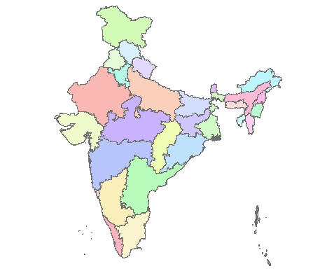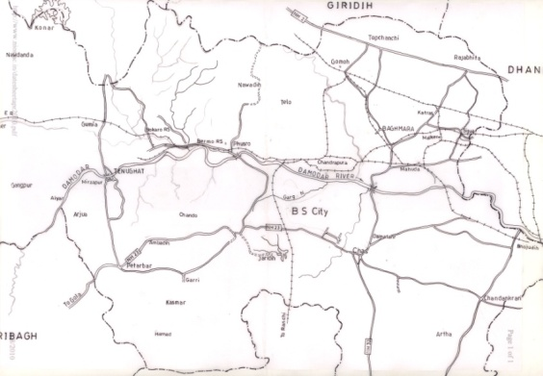
BTPS

Figure 2. Chemical Properties of BTPS fly ash

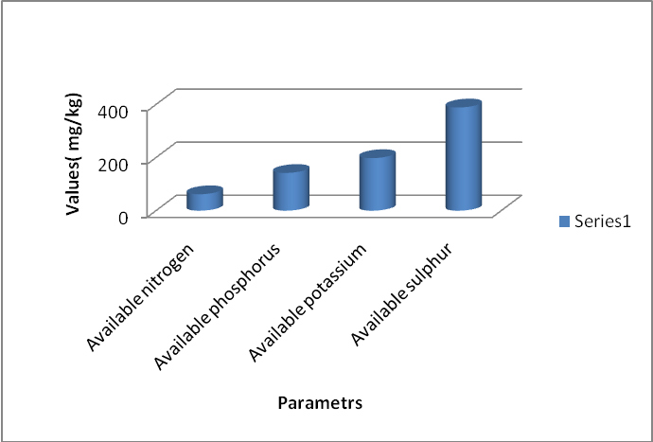

Figure 3. Effect of fly ash and fertilizer levels on dry matter yield (g/pot) of (Cymbopogon flexuous).

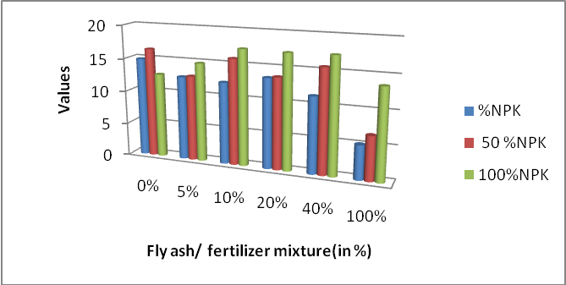

CORRESPONDENCE TO

Arvind Kumar Rai, Research Scholar.
Department of Environmental Science & Engg.
Indian School of Mines (Govt. of India)
Dhanbad, Jharkhand, India.

E - Mail: arvind_dese@rediffmail.com
Telephone No / Fax No: 0326 -2296624
Mobile No: +91 - 8051185982.

Date of sending: 11/ 03/2010

Please mail to

arvind_dese@rediffmail.com

************************************************************************

