Physico-Chemical Characterization of Sulphidation pressmud Composted pressmud and Vermicomposted pressmud.

Namita Joshi and Sonal Sharma
Department of Environmental Sciences, Kanya Gurukul Mahavidyalaya, Haridwar, Uttarakhand, India.
drnamitaenv@gmail.com

In India, Sugar industry with 400 sugar mills ranks as the second major agro-industry in the country. Pressmud a by-product of sugar-mill is produced at 30-35 Kg per ton of cane crushed. Production of sulphidation and carbonation pressmud is estimated to be 3% and 7% respectively of the quantity of cane crushed in a sugar factory following sulphidation and carbonation process respectively. Present study was undertaken to analyze the physical and chemical characteristics of raw pressmud, it’s compost prepared by using thermophillic bacteria and it’s vermicompost which is prepared by using species Eisenia foetida. while comparing physical and chemical characteristics, it was found that vermicompost have lower temperature, water holding , pH and carbon content but higher electrical conductivity, available phosphorus and moisture content as compared to raw pressmud and it’s compost.

Pressmud is soft, spongy, amorphous and dark brown white material containing sugar, fiber, and coagulated colloids including cane wax, albuminoids, inorganic salts and soil particles. It consists of 80% water and contains 0.9%- 1.5% sugar, organic matter, nitrogen, phosphorus, potassium, calcium, sulphur and coagulated colloids and other materials in varying amounts. A time when cost of chemical fertilizers is skyrocketing and not affordable by farmers, pressmud has promise as a source of plant nutrient and as a medium for raising sugarcane seedlings and as a carrier for leguminous inoculants¹. Pressmud like other organic material effect the physical, chemical and biological properties of the soil ². However, due to it’s bulky nature and wax content it usually give less benefit in the year of direct application in the fields. Composting and vermicomposting could be an alternative to the problem for promoting its use in agriculture. Present study was conducted to evaluate the physical and chemical characteristics of raw pressmud, it’s compost prepared by using thermophillic bacteria and vermicompost prepared by using earthworm species Eisenia foetida.

Materials and Methods

Composting
Sulphidation pressmud was obtained from Bidvi Sugar mill, Sharanpur, U.P, India. It was composted by using thermophillic bacteria for a time period of 60 days. This was done in order to reduce the amount of wax content and temperature of the premmud, which proved to be fatal for the earthworm species Eisenia foetida. The raw pressmud and its compost so obtained were analyzed for physical and chemical parameters.

Vermicomposting
The species Eisenia foetida were procured from Shantikunj, Hardwar,India. The pre-composted pressmud was vermicomposted using Eisenia foetida for a time period of 120 days. The temperature of the compost at the time of vermitreatment was found to be 29.7C and moisture content was 58.6%. both these parameters were suitable for the species Eissenia foetida. The physical and chemical parameters of vermicompost obtained was analyzed and compared to that of pressmud and its compost as given in Table no.1. In the present study soil was considered as control. All the physical and chemical characteristics were analyzed by following standard methods ³.

Results and Discussion

The physical and chemical parameters of control(S), Raw pressmud(PM), Composted pressmud(CPM) and Vermicomposted pressmud(VPM) are given in Table.no.1. Vermicompost is a finely divided peat like material with excellent structure, aeration, drainage and water holding capacity ⁴. It has also been documented that passage of organic material through earthworm gut significantly alters the physical structure of the material.⁵. In the present study the temperature was recorded maximum in PM(44.5±1.098). It was lowered after following composting(29.7±0.152) and vermicomposting processes(28.7±0.334).Similarly water-holding capacity of raw pressmud (78.2±1.323%)was also reduces after composting(67.0±2.499%) and vermitreatment(46.2±1.351%). But moisture content of raw pressmud significantly increases after composting. The pH of S, PM, CPM and VPM were recorded 7.32±0.053, 7.66±0.047, 6.96±0.043 and 6.54±0.062 respectively. Electrical conductivity of VPM(2.70±0.025) was observed to be higher than PM , CPM and S (1.77±0.092, 1.25±0.062 and 0.053±0.003 respectively). Sulphidation pressmud increases the electrical conductivity of clay loam soil ⁶, but decreases the electrical conductivity and sodium saturation in calcareous saline-sodic soils. The total alkalinity of PM(2.89±0.198) was recorded higher than CPM, VPM and S(1.73±0.228, 1.77±0.087 and 1.26±0.024 respectively). Total alkalinity of composted pressmud and vermicompost showed not much difference.
The content of organic carbon and available NPK increases with increasing rate of application of sulphidation pressmud . It was further estimated that carbon percentage of sulphidation pressmud ranges from 26.0% to 43.2% ⁷.Carbon content and organic matter percentage of raw pressmud decreases after composting and vermicomposting process. The optimum organic matter that a productive soil should have ranges from 3-4% and the organic matter content of compost ranges from about 35%-70%⁸.After vermitreatment available phosphorus was found to increase significantly(3.43±0.261% in VPM),graph no.2 represents the variation in available phosphorus percentage in S,PM, CPM and VPM. The phosphorus content of sulphidation pressmud as found in the present study was in the range as reported by ⁹. Sulphate percentage of PM (2.297±0.123%) was observed higher than CPM , VPM and S(0.44±0.083, 0.53±0.037 and 0.029±0.004% respectively). There was an increasment recorded in sulphate after following vermitreatment of compost. Similarly total nitrogen of CPM (1.60±0.088%) was found to be highest as compared to PM, VPM and S (1.13±0.095, 1.59±0.028 and 0.060±0.002% respectively), graph no1.But nitrate nitrogen was increased after vermicomposting of composted pressmud. Some workers stated that earthworm increases the nitrogen content due to nitrogen mineralization from organic matter in the soil because nitrification is enhanced in worm casts, the ratio of nitrate-nitrogen to ammonium-nitrogen tends to increase when earthworms are present in the soil¹⁰.

During vermicompostig most of the nutrients such as nitrate-nitrogen, ammonium-nitrogen, exchangeable phosphorus and soluble potassium, calcium and magnesium contained in the waste are changed to forms that are more readily available to plants ¹¹. On the other hand the concentration of elements was reported to be higher in compost as compared to that in the vermicompost ¹². C:N ratio was significantly decreased after composting and vermicomposting process. C:N ratio was found highest in PM (26.25) as compared to CPM , VPM and S (18.15, 8.78 and 8.16). The initial C:N ratio of the organic waste must be in the range of 25-30% in order to avoid high percentage of nitrogen volatization and fast decomposition of microbes ¹³. During composting the organic manure is decomposed by microbial activity. The organic carbon is lost as in the form of carboondioxide and total nitrogen increases as a result of carbon loss. The final nitrogen content of compost depends on the extent of decomposition ¹⁴.Some workers have also reported that C:N ratio in the casts is lower than in the parent soil from which it was derived , probably due to the mineralization of plant derived organic material during it’s passage through earthworm ¹⁵ Total sodium percentage of CPM (0.0035±0.000%) was recorded to be higher than PM, VPM and S (0.005±0.001, 0.004±0.000 and 0.002±0.000% respectively). Total potassium percentage of PM (0.037±0.003%) was observed greater than CPM and VPM (0.019±0.000 and 0.027±0.000% respectively), graph no3. It was lowered after composting but there was an increasment after following vermicomposting process. There are reports that concentration of exchangeable cations such as calcium, magnesium, sodium and potassium in worm casts is more than in the surrounding soil¹⁶. ¹⁷ found only minor differences in earthworm worked compost and compost obtained from other convectional methods. Whereas ¹⁸ considered vermicompost superior to ordinary compost in terms of it’s physical properties.

The results obtained from the experiment indicate that sulphidation pressdmud can be used as an organic manure in the fields after following composting and vermicomposting. The composting and vermicomposting processes improves the physical structure and lower the C:N of the pressmud. However chemical parameters of vermicompost were not significantly higher than the compost.

References

1. Yadav,D.V.(1992).Utilization of pressmud cakes in Indian agriculture. Indian.J.Sugarcane Technol, 7:1-16.
2. Tandon, H.L.S.(1995). In : Waste Recycling in Agriculture. Fertilizer Development Consultation Organization, New Delhi.
3. Trivedy, R.K., and Goel P.K.,(1986). In: Chemical and Biological methods for water pollution studies. Enviromedia Publication, Karad.
4. Dominguez, J., Edwards, C., and Subler, S., (1997). “A comparison of vermicomosting and composting”. Biocycle. April
5. Camp, D.M., (1980). In Compediumon Solid Waste Management by Vermicomposting. Cincinnate, OH, Municipal Environmental Research Lab, EA.
6. Yaduvanshi, N P S., Yadav, D.V., (1990). Effect of Sulphidation Pressmud and Nitrogen Fertilizer on Biomass Nitrogen Economy, Plant Composition in Sugarcane and on Soil Chemical Properties. J. Agri. Sci. 114, 259-263.
7. Tandon (1995).In :Waaste Recyling on Agriculture.Fertilizer Development Consultation Organization, New Delhi.

8. Dougherty,M., (1999). Compost utilization on the Farm. In. FIELD guide to on-farm composting. Natural Resource, Agriculture and Engineering Service (NRAES). Coperative Extention. 152 Rieley-robb Hall, Ithaca, New York 148, 53-570.

9. Borde, B.K., Kadam, J.R., Patil, N.D., (1984). Effect of pressmud cake and phosphatic fertilizer on yield and uptake of nutrient by greengram. J. Indian. Soc. Soil. SCI. 32, 516-518.
10. Ruz Jerez, E., Ball, P.R., and Tillman, R.W., (1988). The role of earthworm in nitrogen release from herbage residues. In. Jeckinson, D.S ., and Smith, K.A (EDS). Nitrogen Efficiency in Agriculture Soils (publishers unknown). pp 355-370
11. Scott, S., Edwards, C., Metzeger, J., (1998). Comparing Vermicompost and Compost. In. Biocycle J. Composting andRecycling. 39 (7) 63-66.
12, Smith, C.J., Band, W.J., and Wang, W., (1999). Waste free Vermicompost to improve agricultural soils. CSIRO Land and Water Technical Report. 23/99, July.
13. Bertoldi, M de., Vallini, G., and Pera, A.,(1984). Technical aspects of composting including modeling and microbiology. In. Gasser, J.K.R. Composting of Agricultural Wastes. Pp 27-40.
14. Crawford, J.H., (1983). Review of Composting, Process Biochem. 18, 14 –15
15. Syers, J.K., Sharpley, A.N., Keeney, D.N., (1979). Cycling of nitrogen by surface casting earthworms in a pasture ecosystem. Soil Biol Biochem. 11: 181-185.
16. Sindhi, P.H., Naik, R.L., Nazirkar, R.B, Kadam,S.K., and Khaire, V.M., (1992). Evaluation of vermicompost. Proc. National Seminar on Organic Farming. MPKV, Pune. pp 54-55
17. Pennick, and Verdannck., (1987). Coffee pulp vermicomposting treatment (Aranda, E., and Borois, I) T.Sera et al (eds). Coffee Biotechnology and Quality. 489-509. Kulwer Academic Publishers. ( Printed in the Netherlands).
18. Haimi., and Hulta.,(1987). Coffee pulp vermicomposting treatment (Aranda, E., and Borois, I) T.Sera et al (eds). Coffee Biotechnology and Quality. 489-509. Kulwer Academic Publishers. ( Printed in the Netherlands).

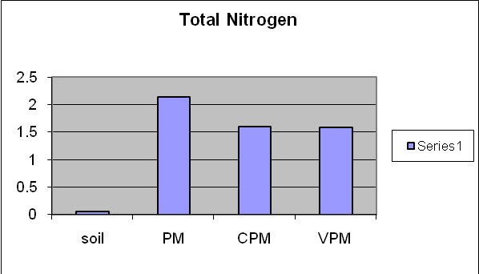
Graph no.1 .Total Nitrogen in Soil, Pressmud (PM), Composted Pressmud (CPM) and Vermicomposted Pressmud (VPM)
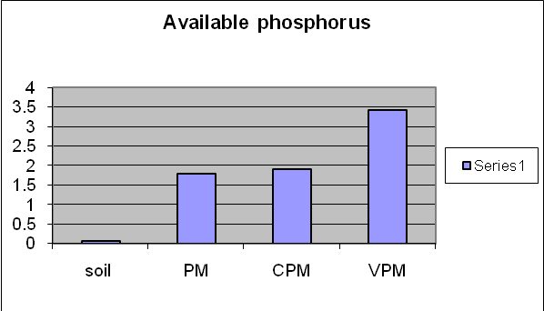
Graph no2. Available Phosphorus in Soil, Pressmud(PM), Composted Pressmud (CPM) and Vermicomposted Pressmud(VPM).
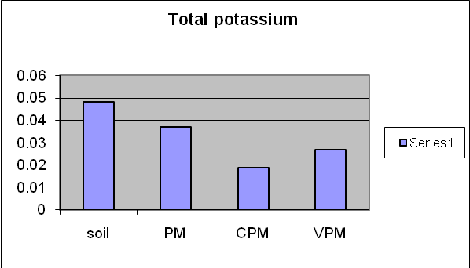
Graph no3. Total Potassiun in Soil, Pressmud(PM) , Composted Pressmud (CPM) and Vermicomposted Pressmud (VPM).

Table.1 : Values of some selected physico-chemical parameters of soil (S), pressmud (PM), composted pressmud (CPM) and vermicompost pressmud (VPM).
(The values are mean±SE of 10 observations each)
Parameters | Soil(S) | Pressmud(PM) | Composted pressmud | Vermicomposted pressmud
Temperature (ºC) | 37.3±0.494 | 44.5±1.098  p<0.01 | 29.7±0.152  p<0.01 | 28.7±0.334  p<0.01
Water holding capacity (%) | 41.5±1.893 | 78.2±1.323  p<0.01 | 67.0±2.499  p<0.01 | 46.2±1.351  p<0.01
Moisture content (%) | 9.66±0.555 | 54.9±8.993  p<0.01 | 58.6±0.567  p<0.01 | 77.3±7.068  p<0.01
pH | 7.32±0.053 | 7.66±0.047  NS | 6.96±0.043  NS | 6.54±0.062  NS
Electrical conductivity (S/cm) | 0.053±0.003 | 1.77±0.092  p<0.01 | 1.25±0.062  p<0.01 | 2.70±0.025 p<0.01
Alkalinity  (meq/100g) | 1.26±0.024 | 2.89±0.198  p<0.01 | 1.73±0.228  p<0.01 | 1.77±0.087  p<0.01
Carbon content (%) | 0.49± 0.060 | 29.67±1.058  p<0.01 | 29.05±0.372  p<0.01 | 13.97±0.641  p<0.01
Organic matter (%) | 0.86±1.000 | 51.2±1.827  NS | 50.42±0.450  NS | 24.08±1.105  NS
Available phosphorus (%) | 0.08±0.016 | 1.80±0.157  p<0.01 | 1.90±0.154  p<0.01 | 3.43±0.261  p<0.01
Sulphate (%) | 0.029±0.004 | 2.297±0.123  p<0.01 | 0.44±0.083  p<0.01 | 0.53±0.037  p<0.01
Nitrate nitrogen (%) | 0.011±0.000 | 0.271±0.044  p<0.01 | 0.76±0.141  p<0.01 | 0.898±0.108  p<0.01
Total nitrogen (%) | 0.060±0.002 | 1.13±0.095  p<0.01 | 1.60±0.088  p<0.01 | 1.59±0.028  p<0.01
Total calcium (%) | 0.032±0.002 | 0.204±0.015  NS | 0.250±0.010  NS | 0.158±0.006  NS
Total magnesium(%) | 0.077±0.006 | 0.088±0.011  NS | 0.050±0.006  NS | 0.64±0.007  NS
Total sodium (%) | 0.002±0.000 | 0.005±0.001  NS | 0.0035±0.000  NS | 0.004±0.000  NS
Total potassium (%) | 0.0058±0.000 | 0.037±0.003  NS | 0.019±0.000  NS | 0.027±0.000  NS
C:N | 8.16 | 26.25 | 18.15 | 8.78
C:P | 6.12 | 16.48 | 15.28 | 4.07
p based on (F test) indicates the level of significance of the difference between the values of control (soil) and pressmud, composted pressmud and vermicomposted pressmud.
NS- insignificant.

