Genetic variation between horse breeds using RAPD markers
Karima F. Mahrous*, Sally S. Alam and Aziza M. Hassan
Cell Biology Department, National Research Center, Dokki, Giza, Egypt

* Correspondence to:
Prof Karima F. Mahrous
Cell Biology Department, National Research Center,
El Tahrir Street, 12622 Dokki, Giza, Egypt.
E-mail: l_Fathy@yahoo.com
Fax: +202-33370931
Telephone: +20124276764

ABSTRACT
Genetic diversity is the basis for present day diversified living systems and future genetic improvement needs. Within the framework of breed conservation, genetic characterization is important in guarding breeds and is a prerequisite for managing genetic resources. The objective of the present study is to estimate the genetic diversity and phylogenetic relationships among Egyptian horse breeds (Native and Arabian) and an exotic breed (Thoroughbred) using Random Amplified Polymorphic DNA – Polymerase Chain Reaction (RAPD) technique. Initially, 25 primers were screened among all the breeds of which 14 primers amplified the genomic DNA. Four primers generated reproducible and distinct RAPD profiles and were used for further analysis. A total of 40 loci were amplified, of which 37 were found polymorphic (92.5%), useful for genetic variation study between breeds. The genetic diversity had the highest value (0.2048) in Arabian and the lowest value (0.0116) in Native breed. The genetic distance was found highest between Arabian and Thoroughbred (D=0.5442) and lowest between Native and Arabian (D=0.3280). However, genetic identity was highest (I=0.7204) between Native and Arabian and lowest (I=0.5803) between Arabian and Thoroughbred. UPGMA dendrogram based on Nei’s genetic distance grouped the investigated horse breeds genotypaes into two clusters. The first cluster includes Egyptian breeds (Native and Arabian) where as the second cluster include Thoroughbred which appeared to be most distant from the other breeds. In conclusion, these results indicated the effectiveness of RAPD in detecting polymorphism between horse populations and their applicability in population studies and establishing genetic relationships among the horse populations.

KeyWords: Genetic diversity, Horse breeds, RAPD-PCR.
INTRODUCTION
Horses have shared an intimate association with human civilization as in both historic and current societies they have fulfilled key agricultural, economic and cultural roles. Horses are members of the Equidae family. In Egypt, there are two horse breeds (Native and Arabian). The Egyptian Native horses are referred as Baladi horses. According to Mason (1996), it is a light riding animal of the Arab type found in Egypt. The herd book for the breed was formed in 1900. The Egyptian Arabian horse is one of the outstanding and most expensive horses in the world. It is also considered the most beautiful of its kinds that exist worldwide. It is an ancient breed which originated on the Arabian Peninsula (Bailey and Lear, 1994; Andrade, 1954).
Farm animal genetic diversity is required to meet current production needs in various environments, to allow sustained genetic improvement and to facilitate rapid adaptation to changing breeding objectives (Notter, 1999). Genetic diversity may be measured through genetic markers. These have been used to estimate the genetic diversity of species, breeds and populations, as well as decisions related to selection of breeds/ populations to be conserved (Zhang et al., 2006). However, breeders tend to concentrate on specific genotypes for determination of genetic diversity which combine traits of interest and may be used as progenitors in several breeding programmes in order to introduce agronomical important traits (Rahman et al., 2006). In an attempt to solve the problem of maintaining pure breeds using the observed morphological characteristics that require a lot of time and effort, the use of molecular markers in maintaining horse breeds is more suitable and less time consuming.
Many researchers employed the Random amplified polymorphic DNA markers or RAPD technique to characterize and estimate genetic distances between breeds (Williams et al., 1990; Welsh and McClelland, 1990), in the study of genetic diversity within breeds (Apostolidis et al., 2001; El-Seoudy et al., 2005; Eroglu and Arica, 2009) and in determination of gene mapping in farm animals (genetic linkage maps are now available for horse, Shiue et al.,1999).The RAPD technology has provided a quick and efficient screen for DNA sequence-based polymorphisms at a very large number of loci. The major advantage is that no prior DNA sequence information is required. The vast range of potential primers that can be used gives the technique great diagnostic power. Reproducible RAPD bands can be found by a careful selection of primers, optimization of PCR conditions for the target species and replication to ensure that only the reproducible bands are scored (Rahman et al., 2006).
RAPD markers have been used successfully in estimating genetic relatedness among various populations of sheep, cattle , goat, buffalo and chicken (Mahfouz et al., 2008; Hassan et al., 2007; Rahman et al., 2006; Abdel-Rahman and Hafez ,2007 ; Okumus and Kaya, 2005, respectively). Moreover, the effectiveness of RAPD in detecting polymorphism between horse populations and their applicability in population studies and establishing genetic relationships among horse populations has been reported by Bailey and Lear (1994), Shiue et al. (1999), Apostolidis (2001) and Egito et al. ( 2007).
The objective of this study was to use the RAPD technique to evaluate genetic diversity and relatedness within and among three horse breeds, Native, Arabian (Egyptian horses) and Thoroughbred (exotic breed). To our knowledge there is currently no information about RAPD genetic markers that detect genetic polymorphism in Egyptian horse breeds and its relation to other horse breed. Information from this work provides basic genetic knowledge that is critical for conservation and breeding programs.

MATERIALS AND METHODS
Sample Collection
Blood samples of about 10 ML were collected from 30 horse animals belonging to three different breeds, Egyptian breeds (Native and Arabian) and exotic breed (Thoroughbred). They were collected from the faculty of veterinary - Cairo University, El Zahra Station and El -Gizera club, respectively.
Genomic DNA extraction
High quality genomic DNA was extracted from blood according to the established protocol of Miller et al. (1988). Briefly, Buffy coats of nucleated cells obtained from anticoagulated blood (EDTA) were resuspended in 15 ml polypropylene centrifugation tubes with 3 ml of nuclei lysis buffer (10 mM Tris-HCl , 400 mM NaCl , 2 mM Na₂EDTA). The cell lysates were digested overnight at 37°C with 0.2 ml of 10% SDS (sodium dodecyl sulphate) and 0.5 ml of a protease K solution (1 mg protease K in 1% SDSand and 2 mM Na₂EDTA). Nucleic acid was extracted by addition of 1 ml saturated NaCl and shake vigorously for 15 sec, centrifuge at 2500 rpm for 15 min. The supernatant was transferred to another tube and 2 volumes of ice cold absolute ethanol were added and gently invert several times (until DNA precipitates). Precipitated DNA strands were removed with a plastic spatula or pipette and place in a 1.5 ml microfuge tube that contains 100-200 µl TE buffer. (10mM Tris—HCl, 1mM Na₂EDTA).
The quality of isolated genomic DNA was checked by agarose gel electrophoresis. For this purpose, well dissolved DNA samples were resolved on 0.8% agarose (w/v) gel. The concentration of the DNA and its purity were determined by spectrophotometry based on the absorbance at 260 and 280 nm, respectively. The DNA samples were adjusted to a final concentration of 50 ng\ul.
RAPD-PCR analysis
A set of 25 decamer oligonucleotide primers (Operon Technologies Inc., Alameda, Calif.: A, B and C) (Table 1) were screened using unique samples of DNA from distinct animals and breeds. Primers were designated as useful if they yielded well-amplified, distinguishable polymorphic bands. Finally four primers (OPA07, OPA09, OPA11, and OPA18) were selected and used to amplify DNA from all individuals. RAPD-PCR reactions were carried out as described by William et al. (1990). The total reaction volume of 50 ul contained100 ng genomic DNA, 200 μM (each) dNTPs, 2 μM of a random primer , 3.5 mM Mgcl₂, 0.75Uof DyNAcymeII DNA polymerase (finnezymes Oy) and 5 μl 10X DNA polymerase buffer. The PCR reactions were carried out in DNA thermocycler (Perkin-Elmer 9700) programmed with a first denaturation of 5 min at 94°C, followed by 45 cycles of 1 min denaturation at 95°C, 1 min annealing at 36°C and 2 min extension at 72°C. Final extension at 72°C for 5 min was allowed before holding the reaction at 4°C for 10 min. Reaction products were stored at 4°C prior to electrophoresis. A volume of 10 μl of each sample was mixed with 6× gel loading buffer (2 μL) (analytical grade water containing 25% ficoll, 0.25% bromophenol blue and 0.25% xylene cyanol) and used for electrophoresis on 1.2% agarose gel run at a constant voltage of 10V/cm. RAPD patterns were visualised and documented using the Gel Documentation system, Gel-Pro Analyzer (Media Cybernetics). A Φx174 DNA digested with HaeIII were used as known molecular size DNA markers.
Recording of data and Statistical analysis
The RAPD patterns were scored for the presence and absence of amplicons. In a binary matrix the presence of a band was recorded as one and the absence as zero. The scores obtained using all primers in the RAPD analysis were then combined to create a single data matrix. This was used for estimating polymorphic loci, Nei’s (1973) gene diversity (h), allele frequencies, genetic distance (D) and genetic identity (I). All calculations were carried out using the population genetic analysis software, PopGene version 1.31 (Yeh et al., 1999). Dendrogram was constructed using Unweighted Pair Group Method using Arithmetic Averages (UPGMA) based on Nei’s (1972) genetic distances.

RESULTS AND DISCUSSION
The ability to detect polymorphisms at the DNA level has led to new approaches for the genetic analysis of livestock species. The RAPD assay has the potential to make useful contributions to genetic analysis of livestock, especially in terms of relatedness among either breeds or species (Cushwa and Medrano, 1996). A major application has been to compare the genomes of closely related species in order to determine the extent of genetic divergence (Bowditch et al., 1993).
As a result of an initial RAPD analysis of pooled DNA, a total of 25 random primers (decamers) were screened, out of which 6 (OPA02, OPA12, OPA17, OPB13, OPB15 and OPC16) yielded monomorphic bands (24%), and 8 (OPA07, OPA09, OPA11, OPA18, OPB18, OPB20, OPC02 and OPC09) (32%) yielded polymorphic bands. Primers were selected based on number of polymorphic bands and amplification quality. Out of the 8 primers that produced polymorphic bands only 4 primers generated reproducible and distinct RAPD profiles and were retained to investigate polymorphism within and between individuals of all studied horse breeds (Native, Arabian and Thoroughbred). An overall of 40 loci were amplified, 37 of them were polymorphic (92.5%). In another study, Egito et al. (2007) reported that 13 out of 146 primers generated 44 polymorphic bands between different breeds of horses (Pantaneiro, Arabian and Thoroughbred). In the present study, the number of polymorphic bands per primer ranged from 2 to 15 with an average 9.25 bands/primer. The molecular size of the amplicons was in the range of 76 to 2358 bp. Bailey and Lear (1994) studying Arabian and Thoroughbred breeds found an average of 3.6 polymorphic bands/primer in a RAPD assay. Martins (1996) studying three Brazilian breeds (Lavradeiro, Crioulo and Campolina) found 2.9 bands/primer, using 29 markers. Apostolidis et al. (2001) found 10.2 bands/primer and 51 polymorphic bands in Greek horses (Thessalian, Skyros Pony, Pinia, Cretan and Andravida). Egito et al. (2007) studying the genetic variability of Pantaneiro, Arabian and Thoroughbred horses using RAPD-PCR markers found 3.38 bands/primer. Thus, the proportion of primers capable of detecting polymorphism among the breeds evaluated depends upon the genetic background of the breeds, genetic distance between the breeds and complexity of the genome (Ahlawat et al., 2004). The present study also revealed that primer OPA07 produced maximum number of bands (16), while minimum number of bands (4) was recorded in primer OPA18 in all the breeds (Table 2). It has been suggested that the sequence of primer OPA07 may occur frequently in all breeds and scored the maximum number of polymorphic bands whereas primer OPA18 was found less polymorphic within and between breeds. Sharma et al. (2001) found that RAPD technique detects sufficient polymorphism within and between breeds.
The present and earlier studies (Wei et al., 1994; Bailey and Lear, 1994; Smith et al., 1996; Egito et al., 2007) indicate that RAPD analysis requires screening of a large number of random primers in order to detect polymorphism, because the amplification from the arbitrary primers depends on the presence or absence of the corresponding primer binding sites in the genome. Hence comparatively large numbers of random primers are required to detect sufficient polymorphism to be utilized for genetic analysis. Figures 1, 2, 3 and 4 show the amplification pattern of genomic DNA of different breeds with various random decamer primers. The RAPD profile generated from these primers was utilized to estimate genetic diversity and relatedness within and among horse breeds based on the band frequency. Table (3) show the estimated allele frequencies at RAPD-encoding loci varied among breeds. The number and proportion of polymorphic bands and the values of genetic diversity in different horse breeds are shown in Table (4). The percentage of the polymorphic loci ranged from 52.5% in Arabian horses to 5 % in Native horses. According to Nei (1987) the proportion of polymorphic loci is not a good measure of genetic variation. A more appropriate measure of genetic variation is average heterozygosity or gene diversity. Higher heterozygosity values indicate broader genetic diversity. Accordingly, the estimated genetic diversity had the highest value (0.2048) in Arabian and the lowest value (0.0116) in Native. Also, Shannon’s diversity (Lewontin , 1972) was calculated to provide a relative estimate of the degree of variation within each breed. The Shannon index ranged from 0.0196 (Native) to 0.3011 (Arabian). The greatest index of genetic diversity was observed when the three breeds were considered as one (0.3026). These results are inconsistent with the findings of Egito et al. (2007), who found that the genetic diversity in Arabian breed was (0.2814). In addition they recorded greatest diversity index when the five populations of Pantaneiro horses were considered as one, but when considered separately each Pantaneiro population showed lower diversity index than that of the breed.
In the present study, the Egyptian Native breed had low genetic diversity or variation among its individuals indicating low heterozygosity. Similar results were obtained in another Egyptian Native breeds, Ali (2003) showed closer proximity in Egyptian Native sheep breeds Barki to Rahmani and Baladi (95.7 and 91.3%, respectively) that was detected by random amplified polymorphic DNA markers. Also, Abdel-Rahman and Hafez (2007) found a high genetic similarity among three Egyptian water buffalo flocks using RAPD-PCR technique. Our results also indicated that the Thoroughbred had low genic diversity index (0.0391) compared to the Arabian breed. Egito et al. (2007) reported that Thoroughbred has the lowest genic diversity index compared with Arabian and Pantaneiro horses. Also, Ouragh (2005) was studying the DNA polymorphism in Thoroughbred, Arabian and Anglo- Arabian horses in Morocco using microsatellite marker analysis. They found that heterozygosity value was lower in Thoroughbred (0.7036), but relatively high in Arabian and Anglo- Arab (0.7216 and 0.7232, respectively). Guérin et al. (1993) Observed that the lowest polymorphism information content value is found in the Thoroughbred, which confirmed the well known homogeneity of this breed (Ellegren et al., 1992), conversely Arab horse is the most heterogeneous of the all studied breeds (Thoroughbred, Sell Français, Trotteur Français). Moreover, in the study of Bowling and Clark (1985) in Thoroughbred, Arabian, Standardbred, Morgan, Quarter Horse, Paso Fino and Peruvian Paso, they observed a lower biochemical marker variation in Thoroughbred and concluded that this was due to a Stud Book that has been closed for more than 200 years, as well as intense selection for a single trait: speed in flat races.
The genetic distance (D) and genetic identity (I) among the three horse breeds are shown in Table (5). The genetic identity between the populations from the amplified patterns of four random primers was (I=0.7204) between Native and Arabian, (I=0.6460) between Thoroughbred and Native, and (I=0.5803) between Arabian and Thoroughbred. The genetic distance expresses the degree of divergence between populations. Higher values were found for the pairs formed between Arabian and Thoroughbred (D=0.5442) and the lower value found for distances between Native and Arabian (D=0.3280). The UPGMA dendrogram, based on genetic distance, was constructed to show phylogenetic relationships among the horse breeds Figure (5). The Thoroughbred appeared to be most distant from the other breeds whereas the Native and Arabian breeds were closely related with the highest genetic similarity. The close identity between the Native and Arabian breeds suggests that all the indigenous breeds are more or less comparatively similar and branched from the same line of evolutionary tree. In a study of genetic variability by microsatellites and protein polymorphisms alleles, Kelly et al. (2002) found that American horse breeds together with Barb and Arabian horses clearly formed a separate cluster from the Spanish pure-bred and Thoroughbred breeds, as shown by an UPGMA dendrogram based on Nei’s standard genetic distance.
In conclusion, the present study indicated the effectiveness of RAPD markers in detecting the polymorphism and estimating the genetic relationship within the horse breeds. Though the Egyptian horse breeds showed the least genetic distance with each other while Thoroughbred appeared to be most distant from the Egyptian breeds.
REFERANCES
Abdel-Rahman SM, Hafez EE (2007). Genetic similarity among the three Egyptian Water Buffalo flocks using RAPD-PCR and PCR-RFLP techniques. Research J of Agriculture and Biological Science. 3(5): 351-355.
Ahlawat SPS, Sunder JDr, Kundu A, Chatterjee R N, Rai RB, Kumar B, Senani S, Saha S K, Yadav S P (2004). Use of RAPD-PCR for genetic analysis of Nicobari fowl of Andamans. British Poultry Science. 45(4): 194 - 200.
Ali BA (2003). Genetic similarity among four breeds of sheep in Egypt detected by random amplified polymorphic DNA markers. Afr J Biotech. 2:194-197.
Andrade R (1954). Alrededor del Caballo Español. Ed. Sociedad de Astoria, Lisboa.
Apostolidis AP, Mamuris Z, Karkavelia E, Alifakiotis T (2001). Comparison of Greek breeds of horses using RAPD markers. J. Animal Breed. Genet. 118: 47-56.
Bailey E and Lear TL (1994). Comparison of Thoroughbred and Arabian horses using RAPD markers. Anim. Genet. 25 (Suppl. 1):105-108.
Bowditch BM, Albright A, Williams J, Braun MJ (1993). The use of RAPD markers in comparative genomes studies. Meth Enzymol. 224:294–309.
Bowling AT, CLARK RS (1985). Blood group and protein polymorphism gene frequencies for seven breeds of horses in the United States. Animal Blood Groups and Biochemical Genetics (presently Animal Genetics). 16: 93-108.
Cushwa WT, Medrano JF (1996). Applications of the random amplified polymorphic DNA (RAPD) assay for genetic analysis of livestock species. Anim Biotechnol.7:11–31.
Egito AAdo, Fuck BH, McManus C, Paiva SR, Albuquerque Mdo SM, Santos SA, Abreu UGPde, Silva JAda, Sereno FTPdeS, Mariante AdaS (2007). Genetic variability of Pantaneiro horse using RAPD-PCR markers. R. Bras. Zootec.36 (4):799-806.
Ellegren H, Andersson L, Johansson M, Sandberg K (1992). DNA fingerprinting in horses using a simple (TG) n probe and its application to population comparison. Anim Genet. 23:1-9.
El-Seoudy AA, Abdel Gawad NM, Abu-Shady AM, Abdelsalam AZE (2005). Biochemical and molecular characterization of some Egyptian goat breeds. Egypt. J. of Genetics and Cytology. 34: 63-79.
Eroglu D, Arica ŞÇ (2009). Molecular genetic analysis of three Turkish local silkworm breeds (Bursa Beyazı, Alaca and Hatay Sarısı) by RAPD-PCR method. Journal of Applied Biological Sciences. 3(2): 15-18.
Guérin G, Bertaud M, Billoud B, Mériaux JC (1993). A genetic analysis of variable no of tandem repeat (VNTR) polymorphism in horse. Gene Sel. Evol. 25: 435-445.
Hassen F, Bekele E, Ayalew W, Dessie T (2007). Genetic variability of five indigenous Ethiopian cattle breeds using RAPD markers. Afr. J Biotech. 6 (19): 2274-2279.
Kelly L, Postiglioni A, De Andrés DF, Vega-Plá JL, Gagliardi R, Biagetti R, Franco J (2002). Genetic characterisation of the Uruguayan Creole horse and analysis of relationships among horse breeds. Res .Vet. Sci., Feb.72(1): 69-73.
Lewontin RC (1972). The apportionment of human diversity. Evol Biol. 6:381-398.
Mahfouz ER, Othman OE, El Nahas SM, El Barody MAA (2008). Genetic variation between some Egyptian sheep breeds using RAPD-PCR. Research J of Cell and Molecular Biology. 2(2): 46-52.
Martins VB (1996). Técnica de diagnóstico com marcadores RAPD para uso e preservação de germoplasma eqüino. Brasília: Universidade de Brasília. pp. 44.
Mason IL (1996). A World Dictionary of Livestock Breeds. Types and Varieties, Fourth Edition, C.A.B International, pp. 273.
Miller SA, Dykes DD, Polesky HF (1988). A simple salting out procedure for extracting DNA from human nucleated cells. Nucleic Acids Res.16:1215.
Nei M (1972). Genetic distance between populations. Am. Nat.106:283–29.
Nei M (1973). Analysis of gene diversity in subdivided populations. Proc. Natl. Acad. Sci.,USA. 70: 3321-3323.
Nei M (1987). Molecular evolutionary genetics. Columbia University Press, New York.
Notter DR (1999). The importance of genetic diversity in livestock populations of the future.J Anim. Sci.77:61-69.
Okumus A, Kaya M (2005).Genetic similarity by RAPD between pure lines of chickens. J. of Biol. Sci., 5(4): 424-426.
Ouragh L (2005). DNA polymorphism of Arabian, Thoroughbred and Anglo-Arab horses in Morocco. In Applications of Gene-Based Technologies for Improving Animal Production and Health in Developing Countries, Makkar, H. P. S., and Viljoen ,G. J., (eds.), Netherlands, pp.621-629.
Rahman MA, Rahman MM, Jalil MA, Uddin SN, Rahman MM (2006). Molecular characterization of Black Bengal and Jamuna Pari goat breeds by RAPD Markers. American J. of Animal and Veterinary Sciences. 1 (2):17-22.
Sharma D, Appa Rao KB, Singh RV, Totey SM( 2001). Genetic diversity among chicken breeds estimated through randomly amplified polymorphic DNA. Anim. Biotechnol. Nov, 12(2):111-20.
Shiue Y-L, Bickell LA, Caetanoa AR, Millon LV, Clark RS, Eggleston ML, Michelmore R , Bailey E, Guerin G, Godard S, Mickelson JR, Valberg SJ, Murray JD, Bowling AT (1999). Synteny map of the horse genome comprised of 240 microsatellite and RAPD markers. Anim. Genet. 30(1): 1-9.
Smith EJ, Jones CP, Bartlett J, Nestor KE (1996). Use of randomly amplified polymorphic DNA markers for the genetic analysis of relatedness and diversity in chickens and turkeys. Poultry Science. 75:579-584.
Wei R, Dentine MR, Bitgood JJ (1994). Identification of RAPD markers in crosses between inbred lines of Rhode Island Red and White Leghorn. Proceedings, 5th World Congress on Genetics Applied to Livestock Production, University of Guelph, Guelph, Ontario, Canada, 7th to12th Augus.
Welsh J, McClelland M (1990). Fingerprinting genomes using PCR with arbitrary primers. Nucleic Acids Res. 18:7213–7218.
Williams JGK, Kubelik AR, Livak KJ, Rafalski JA, Tingey SV (1990). DNA polymorphisms amplified by arbitrary primers are useful genetic markers. Nucleic Acids Res.18: 6531–6535.
Yeh FC, Boyle T, Rongcai Y, Ye Z, Xian JM (1999). POPGENE, Version 1.31.A Microsoft window based free ware for population genetic analysis. University of Alberta, Edmonton. Canada.
Zhang L, Zhu J, Gu S, Sun Q, Zhou G, Fu C, Chen L Li D, Liu S, Yang, Z (2006). Genetic diversity of nine population of black goat (Caprahircus) in Schuan, P R China. Zoolog. Sci., 23(3):229-234.

Table 1. Sequence, operon codes and GC content of the random primers used to study variation in horse species.
GC% | Sequence  (5’- 3’) | Primers | GC% | Sequence  (5’- 3’) | Primers
60 | CCA CAG CAGT | OPB18 | 70 | TGC CGA GCTG | OPA02
60 | GGA CCC TTAC | OPB20 | 70 | GGT CCC TGAC | OPA06
70 | GTG AGG CGTC | OPC02 | 60 | GAA ACG GGTG | OPA07
60 | GGG GGT CTTT | OPC03 | 60 | GTG ACG TAGG | OPA08
70 | GAT GAC CGCC | OPC05 | 70 | GGG TAA CGCC | OPA09
60 | GAA CGG ACTC | OPC06 | 60 | GTG ATC GCAG | OPA10
70 | GTC CCG ACGA | OPC07 | 60 | CAA TCG CCGT | OPA11
70 | TGG ACC GGTG | OPC08 | 60 | TCG GCG ATAG | OPA12
70 | CTC ACC GTC C | OPC09 | 60 | TTC CGA ACCC | OPA15
60 | TGT CAT CCCC | OPC12 | 60 | GAC CGC TTGT | OPA17
60 | CAC ACT CCAG | OPC16 | 60 | AGG TGA CCGT | OPA18
60 | ACT TCG CCAC | OPC20 | 70 | TTC CCC CGCT | OPB13
 |  |  | 60 | GGA GGG TGTT | OPB15

Table 2. Total number of bands, polymorphic bands, % of polymorphic loci and their size ranges from the random primers.
Primer | Total No.  of bands | No. of polymorphic bands | % of polymorphic loci | Size range  (bp)  Max. Min.
OPA07 | 16 | 15 | 93.75 | 2358 76
OPA09 | 9 | 9 | 100 | 1227 194
OPA11 | 11 | 11 | 100 | 1416 310
OPA18 | 4 | 2 | 50 | 1050 280

Table 3. Estimation of gene frequency (Allele \ Locus) of the 37 polymorphic RAPD markers scored in three breeds, each marker is assigned by the name of the primer and its approximate size in base pairs.
Thoroughbred  Allele 0 Allele 1 |  | Arabian  Allele 0 Allele 1 |  | Native  Allele 0 Allele 1 |  | RAPD markers
0 | 1 | 0.4533 | 0.5477 | 0 | 1 | OPA07₂₃₅₈
0 | 1 | 0.2254 | 0.7746 | 0 | 1 | OPA07₁₈₇₉
0 | 1 | 0.3675 | 0.6325 | 0 | 1 | OPA07₁₄₅₉
1 | 0 | 0 | 1 | 0 | 1 | OPA07₁₃₅₃
0 | 1 | 0.2254 | 0.7746 | 0 | 1 | OPA07₁₁₃₄
0 | 1 | 0.1633 | 0.8367 | 0 | 1 | OPA07₁₀₄₆
0 | 1 | 0.1633 | 0.8367 | 0 | 1 | OPA07₉₅₅
0 | 1 | 0.2254 | 0.7746 | 0 | 1 | OPA07₇₇₁
0 | 1 | 0.2929 | 0.7071 | 0 | 1 | OPA07₅₄₂
0 | 1 | 0.6836 | 0.3162 | 0 | 1 | OPA07₄₃₈
1 | 0 | 0 | 1 | 0 | 1 | OPA07₃₉₀
0 | 1 | 0.1633 | 0.8367 | 0 | 1 | OPA07₃₀₃
1 | 0 | 0 | 1 | 0 | 1 | OPA07₂₁₉
0 | 1 | 1 | 0 | 0 | 1 | OPA07₁₇₁
0 | 1 | 1 | 0 | 0 | 1 | OPA07₇₆
0 | 1 | 0.4523 | 0.5477 | 0.1056 | 0.8944 | OPA09₁₂₂₇
0.2929 | 0.7071 | 0.1633 | 0.8367 | 0 | 1 | OPA09₁₀₆₀
0 | 1 | 1 | 0 | 0 | 1 | OPA09₈₂₅
0 | 1 | 0.5528 | 0.4472 | 0 | 1 | OPA09₇₆₆
1 | 0 | 0 | 1 | 1 | 0 | OPA09₇₄₀
1 | 0 | 0.4523 | 0.5477 | 0 | 1 | OPA09₅₆₉
1 | 0 | 0 | 1 | 0 | 1 | OPA09₃₆₉
0 | 1 | 0 | 1 | 0.1633 | 0.8367 | OPA09₃₄₈
1 | 0 | 0 | 1 | 0 | 1 | OPA09₁₉₄
0.1056 | 0.8944 | 0 | 1 | 0 | 1 | OPA11₁₄₁₆
0 | 1 | 1 | 0 | 1 | 0 | OPA11₁₀₇₆
0 | 1 | 0 | 1 | 1 | 0 | OPA11₉₃₆
0.1056 | 0.8944 | 0 | 1 | 0 | 1 | OPA11₉₀₃
0 | 1 | 0.4523 | 0.5477 | 0 | 1 | OPA11₇₈₅
0 | 1 | 0.1056 | 0.8944 | 0.1056 | 0.8944 | OPA11₆₆₇
0 | 1 | 0.1056 | 0.8944 | 1 | 0 | OPA11₅₆₉
1 | 0 | 0.6838 | 0.3162 | 1 | 0 | OPA11₄₆₅
1 | 0 | 0 | 1 | 0 | 1 | OPA11₃₈₇
0 | 1 | 0 | 1 | 1 | 0 | OPA11₃₆₉
0 | 1 | 0.4523 | 0.5477 | 1 | 0 | OPA11₃₁₀
0.5528 | 0.4472 | 1 | 0 | 0 | 1 | OPA18₁₀₅₀
0.3675 | 0.6325 | 0.5528 | 0.4472 | 1 | 0 | OPA18₂₈₀

Table 4. Genetic diversity in investigated horse breeds based on RAPD markers.
Horse breeds | No. of polymorphic loci | % of polymorphic loci | Genetic diversity Nei’s  (1973) | Shannon’s diversity  (Lewontin 1972)
Native | 2 | 5 | 0.0116 | 0.0196
Arabian | 21 | 52.5 | 0.2048 | 0.3011
Thoroughbred | 4 | 10 | 0.0391 | 0.0572
All | 37 | 92.5 | 0.3026 | 0.4557

Table 5. Genetic identity (above diagonal) and genetic distance (below diagonal) between the investigated horse breeds (Nei's 1972).
Breeds | Native | Arabian | Thoroughbred
Native | **** | 0.7204 | 0.6460
Arabian | 0.3280 | **** | 0.5803
Thoroughbred | 0.4370 | 0.5442 | ****

Figure legends
Figure 1. Random amplified polymorphic DNA (RAPD) profile generated by primer OPA07 in individual horses of different breeds, a: Native, b: Arabian, c: Thoroughbred, Lane M = molecular marker (Φx174 DNA HaeIII digest).
Figure 2. Random amplified polymorphic DNA (RAPD) profile generated by primer OPA09 in individual horses of different breeds, a: Native, b: Arabian, c: Thoroughbred, Lane M = molecular marker (Φx174 DNA HaeIII digest).
Figure 3. Random amplified polymorphic DNA (RAPD) profile generated by primer OPA011 in individual horses of different breeds, a: Native, b: Arabian, c: Thoroughbred, Lane M = molecular marker (Φx174 DNA HaeIII digest).
Figure 4. Random amplified polymorphic DNA (RAPD) profile generated by primer OPA18 in individual horses of different breeds, Lane1-5: Arabian, Lane 6-10: Thoroughbred, Lane11-15: Native, Lane M = molecular marker (Φx174 DNA HaeIII digest).
Figure 5. UPGMA dendrogram of three horse breeds, based on Nei’s (1972) genetic distance.

Figure 1

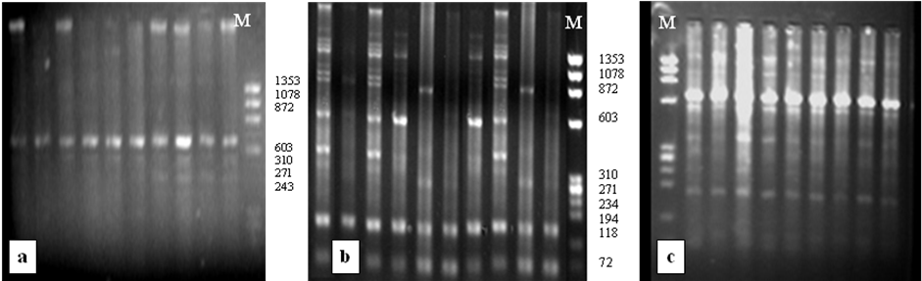

Figure 2

1353 1078 872 603

310 271
234 194

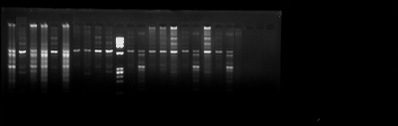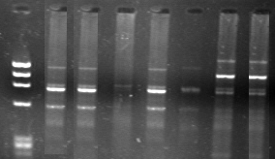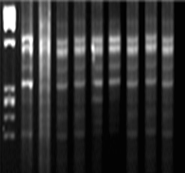
a

1353 1078 872
603

310 271 234 194

M
M

1353 1078 872
603

310 271 234 194

M
b
c

Figure 3.

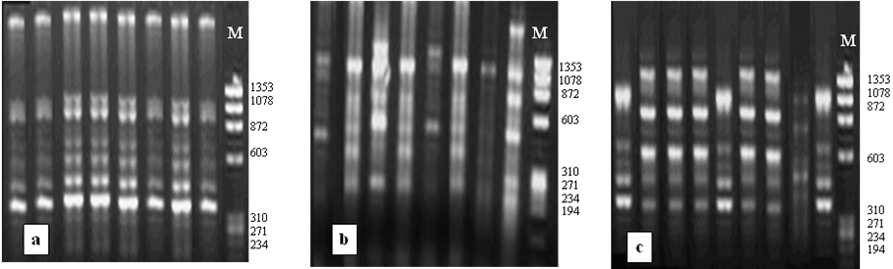

Figure 4.
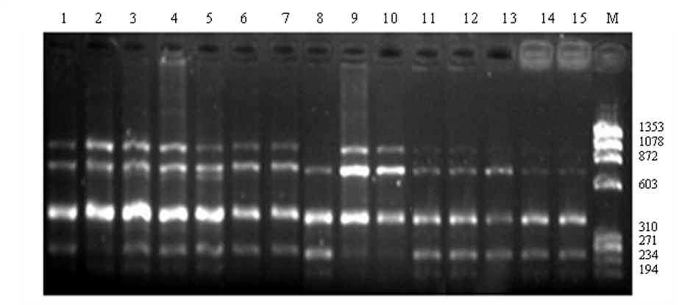

Figure 5.
0.7 0.6 0.5 0.4 0.3 0.2 0.1 0.0

…….….....................................Arabian
………………………………………………….
..…………................................... Native

….…........................................................................Thoroughbred

