Subsurface Geophysical Estimation of Sand Volume in Ogudu
Sandfilled area Lagos, Nigeria.

Adeoti Lukumon*, Oyedele K. Festus* and Adegbola R. Bolaji**
*Department of Geosciences University of Lagos, Lagos Nigeria
**Department of Physics, Lagos State University, Lagos Nigeria.
lukuade@yahoo.com, kayodeunilag@yahoo.com

Abstract
Surface geophysical survey was carried out using Electrical resistivity and induced polarization methods to estimate volume of sand deposits for the purpose of development/exploitation via dredging in Agboyi area of Lagos State .The study area was divided into square, rectangular, triangular and trapezoidal cells before conducting the geophysical survey. A total of 125 Vertical electrical sounding (VES) data were collected using Schlumberger electrode configuration with an electrode spacing varying between 100 and 400m. Five wells were also drilled for the collection of soil samples with a view to mapping the litho-logical variations of the subsurface strata. The combination of Vertical electrical sounding (VES) data, Induced Polarization (IP) data and well log data were used in inferring the litho-logical units of each geo-electric layer within the study area. The geo-electric sections delineate three to five subsurface layers, which include sand, sandy clay/ clayed sand, and clay. The 2-D and 3-D Isopach maps show the distribution of sand with thickness ranging between 0.5m and 7.0m.The volume of sand within each cell was calculated and the results were summed to give a total volume of 165596.5712m³ of sand as against 1.5million m³ projected. Hence, the analysis shows that the study area is devoid of enough sands for the purpose of development/exploitation via dredging.

Keywords: Vertical Electrical sounding (VES); Geoelectric Section; Lithological

1. Introduction
Lagos state is one of the heartbeats of economic activities in Nigeria because of the presence of many industries, ports (air and sea), etc. The population of the state is now becoming explosive that many people could not afford decent accommodation while those that could afford pay exorbitantly. Thus, congestion makes suitable sites to become very scarce in urban areas. This now informed the study of some abundant areas in coastal part via geophysical methods in order to quantify the volume of sand for reclamation purposes.

Geophysical methods are often used in site investigation to determine the overburden thicknesses and map subsurface conditions prior to excavation and construction. Electrical resistivity and seismic exploration methods are the most common techniques used for this purpose (Kurthenecker 1934; Moore 1952; Drake 1962; Early and Dyer 1964; Burton 1976; kearey and Brooks 1984; Olorunfemi and Meshida 1987). There are many methods of electrical surveying, some make of naturally occurring fields within the Earth while others require the introduction of artificially generated currents into ground. These comprise the spontaneous of self-potential (SP) method, induced polarization (IP) method and electrical resistivity methods. Although more labour intensive, the electrical resistivity method is more viable for deep subsurface investigation (Reynolds, 1997). Electrical resistivity method is routinely used in engineering and hydrogeological investigations to investigate the shallow subsurface geology.

The study was carried out at Agboyi village which is considered to be one of the Islands in the coastal part of Lagos. About 1.5million m³ of sand was envisaged for reclaiming part of the area by the proponents. The Electrical resistivity and induced polarization methods were employed because VES gives low resistivity values for both saline sand and clay but in contrast, induced polarization method differentiate both i.e, saline sand typifies low induced polarization (poor chargeability) while clay depicts high induced polarization (medium to high chargeability). In view of the nature of the geology of the study area, the combination of both methods in delineating the subsurface could not be overemphasized.

2- Site and Geology
The area of study (Figure 1) is an Island with a swampy terrain having daily rising and falling of tides. It is accessible by road from Oworonsoki-Ojota axis expressway and from Ojota via the overhead bridge. A canoe is required to get to the site because of a canal which traverses the area and empties into the lagoon. Some of the visible activities include fishing, sand dredging and transportation via canoe. The geology of the study area can be described broadly as a sedimentary basin, which thickens from North to South (Down dip) and from East to West. The littoral and lagoon deposits of recent sediments underlie the study area. The area shares the geologic characteristics of coastal environments in Nigeria which include the presence of clays, shale deposits, sandstones and pebbles. Hence, the study area is characterized by unconsolidated sands, clays and mud with a varying proportion of vegetable matter, along the coastal areas while the alluvial consist of the coarse, clayey, unsorted sands with clay lenses and occasional beds.

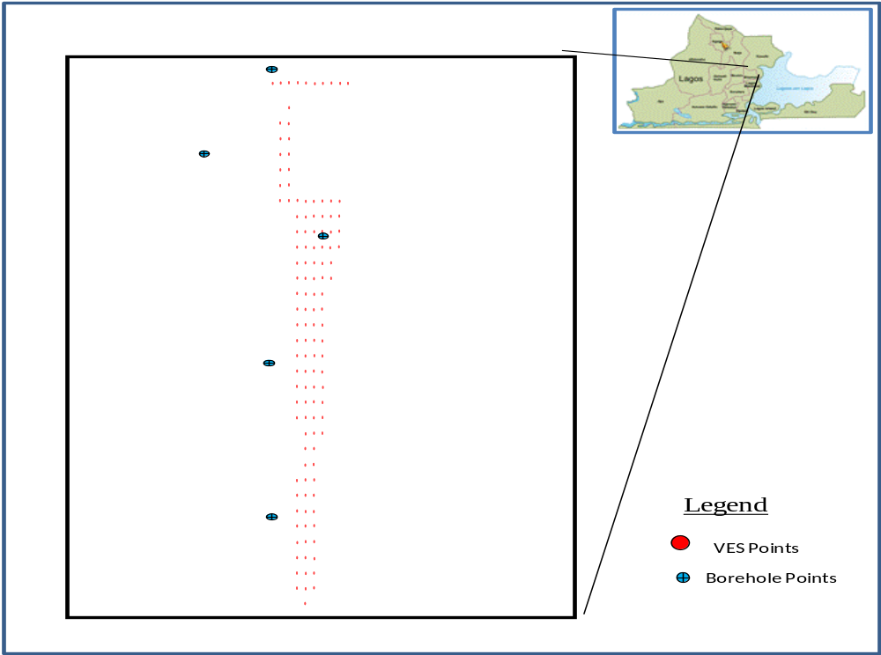

Figure 1: Base Map of Study Area

3-Data Acquisition
The study area was divided into square, rectangular, triangular and trapezoidal cells and geo referenced by Garmin Etrex model Global Positioning System (GPS) handset with a view to determining the longitude, latitude and elevation of the VES locations (figure 1). ABEM Terrameter SAS 1000 and PASI Tarrameter were used for the data acquisition. A total of 125 Vertical electrical sounding (VES) data were collected using the Schlumberger electrode array with electrode spread (AB) varying from 2.0m to a maximum of 400m. The electrical chargeability and resistivity measurements were taken simultaneously. The essential idea behind the vertical sounding used in this study area assume conductivity variation with depth only, is such that as the resistance between the current and potential electrode is increased, the current filament passing across the potential electrode carries a current fraction that has returned to the surface after reaching increasing deeper depth (Telford et. al., 1976). Five wells were also drilled for the purpose of correlation with sounding results.

4-Results and Discussion
Sounding curves were interpreted qualitatively and quantitatively. The qualitative interpretation involved evaluation of curves for estimation of volume of sand deposit in the studied area. Quantitative interpretation of the curves involves partial curve matching using two layer Schlumberger master curves and the auxiliary K, Q, A and H curves. Outputs were modelled using computer iterations. WinGLink software was utilized for the iterations. The results of qualitative interpretation of 125 VES data are characterized by HA, QHA, QH and KH curves. The results of the cuttings from the five wells drilled revealed the subsurface strata as sand, clay, clayed sand and sandy clay at various depths (Table 2).
Samples of the resistivity and IP curves are respectively shown in Figures 2 & 3. One of geoelectric sections beneath the VES is shown in Figures 4. Summary of some of the interpreted VES data is presented in Table 1. 2-D Isopach Map (Fig. 5), 3-D Isopach Map in South-Eastern View (Fig.6), and Isopach Map in North-Western View (Fig.7) are presented. The estimated volume of sand within each cell is shown Table 3.

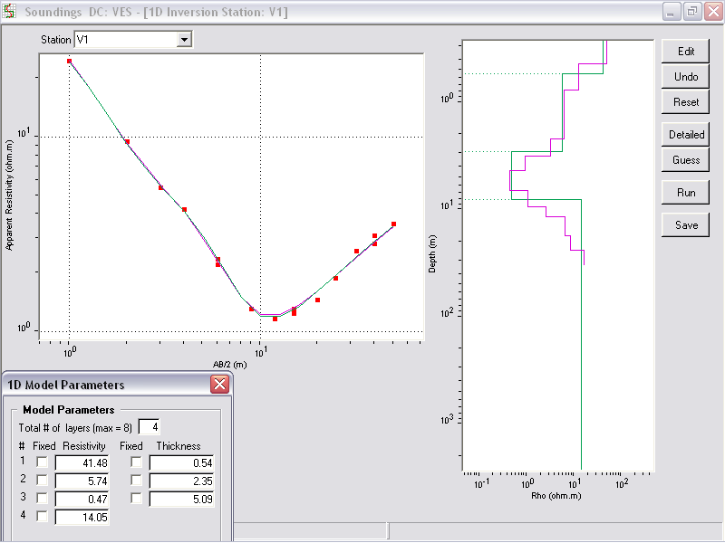
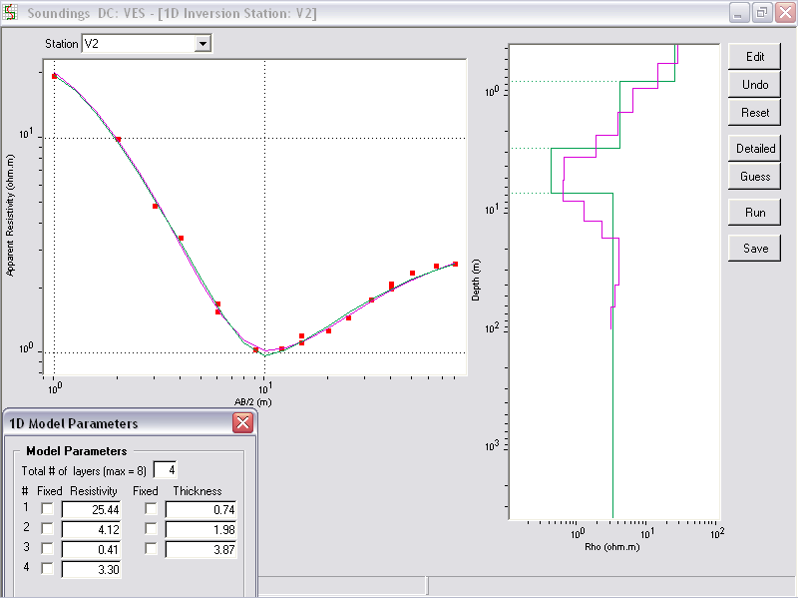
Figure: 2 Sample of resistivity field curves

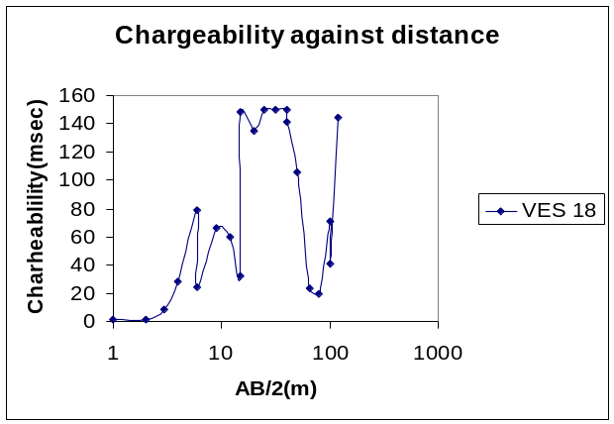

Fig: 3 Sample of chargeability field curves

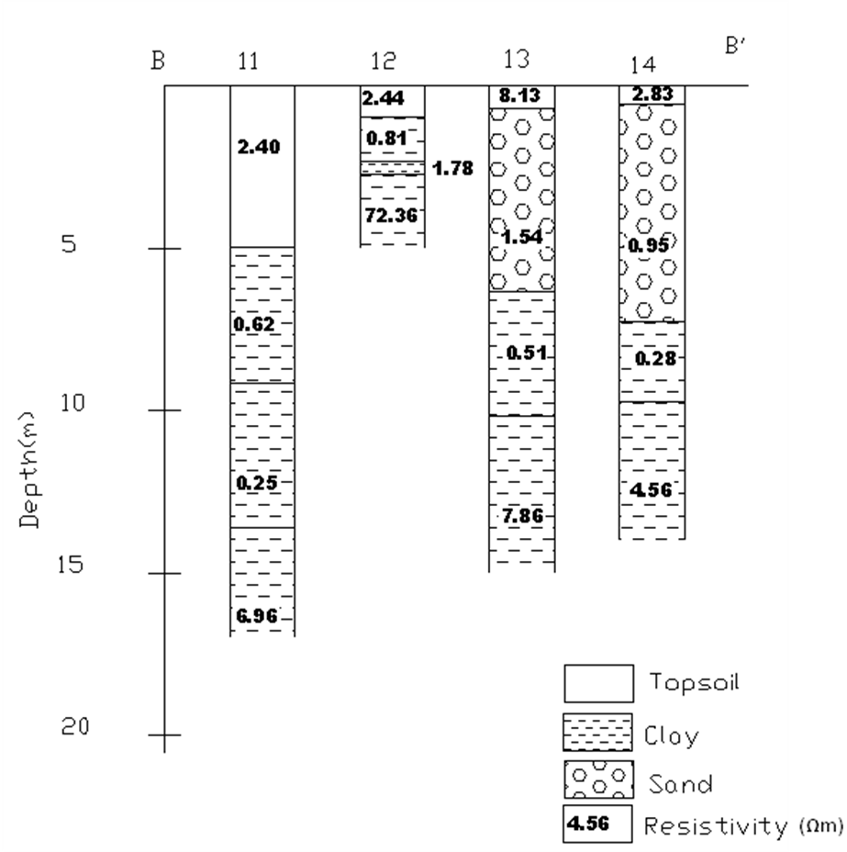
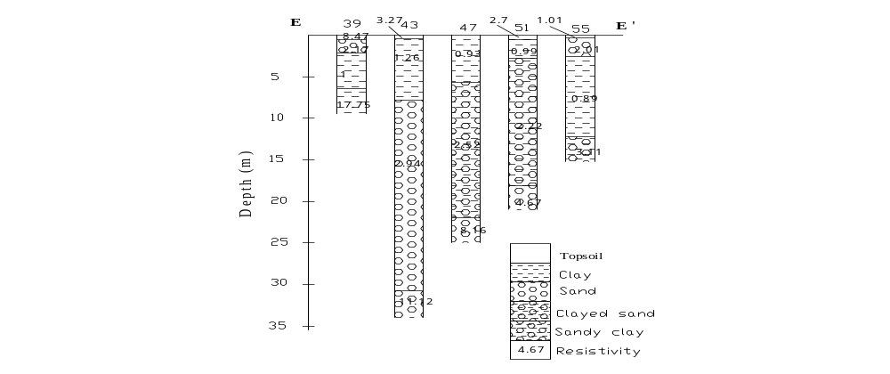
Fig 4 : Sample of Geo-electric sections Along traverses BB’ and EE’

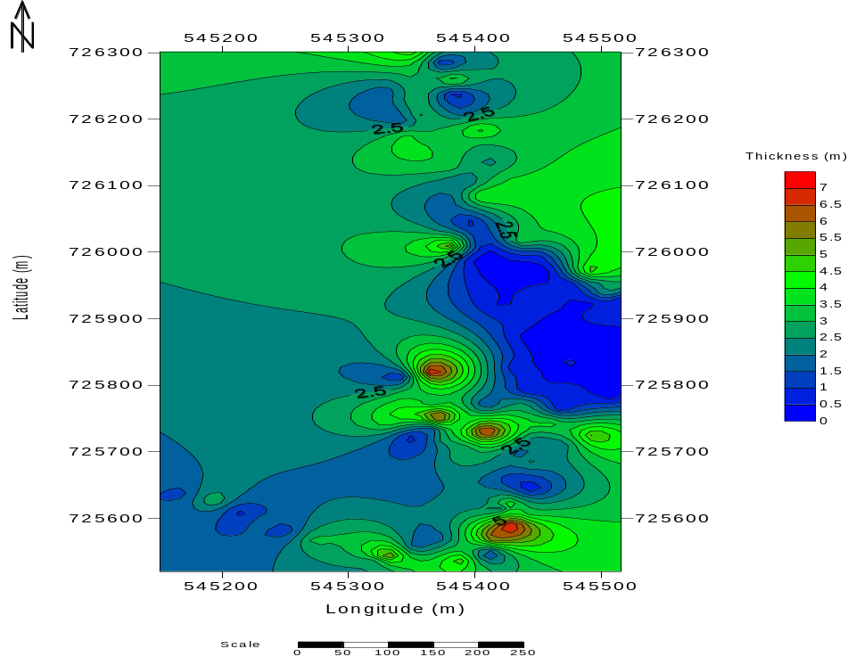

Figure 5: 2D Isopach Map of Agboyi-Ogudu, Lagos State

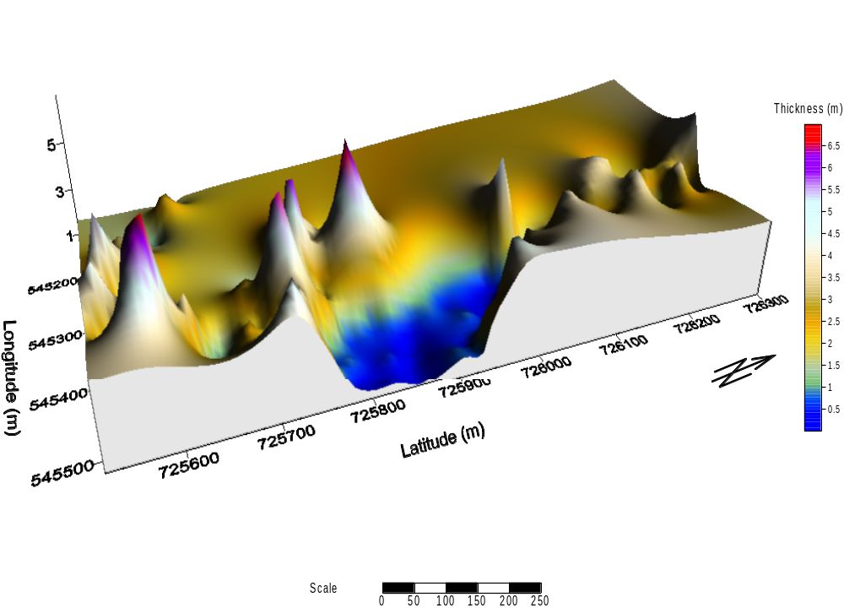
Figure 6: 3D Isopach Map (South-Eastern View) of Agboyi-Ogudu, Lagos State.

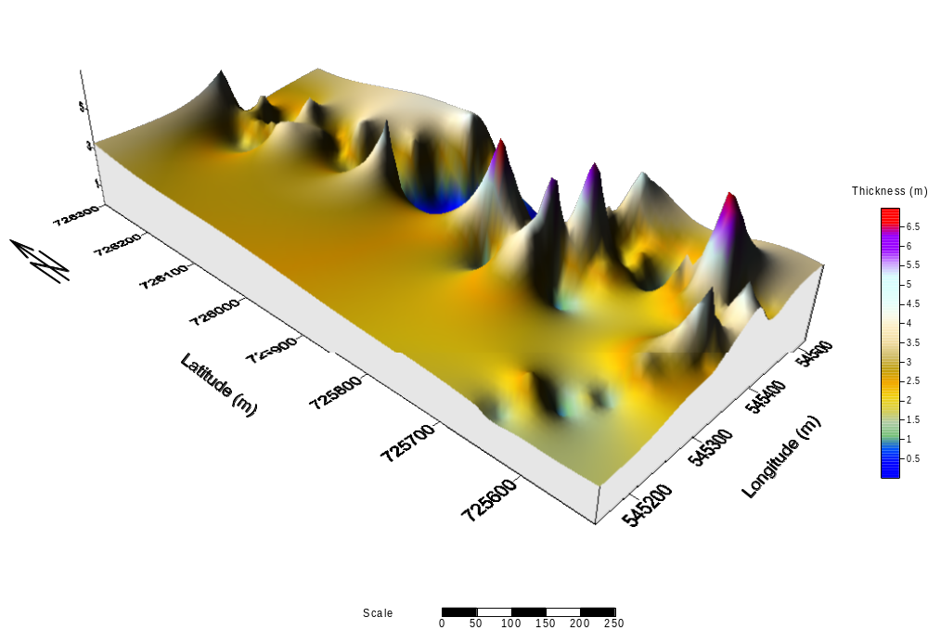

Figure 7: Isopach Map (North-Western View) of Agboyi-Ogudu, Lagos State.

Table 1. True Resistivity and Horizon Depths.
VES Number | Number of Layers | Resistivity(Ωm) | Thickness(m) | Depth(m) | Lithology
1 | 1 | 36.16 | 0.54 | 0.54 | Topsoil (Sand)
 | 2 | 7.85 | 2.55 | 3.09 | Sand
 | 3 | 0.16 | 5.09 | 8.18 | Clay
 | 4 | 5.63 | --- | --- | Clay
2 | 1 | 25.44 | 0.74 | 0.74 | Topsoil (Sand)
 | 2 | 4.12 | 1.98 | 2.73 | Sand
 | 3 | 0.41 | 3.87 | 6.59 | Clay
 | 4 | 3.30 | --- | --- | Clay
3 | 1 | 41.48 | 0.62 | 0.62 | Topsoil (Sand)
 | 2 | 5.74 | 2.19 | 2.81 | Sand
 | 3 | 0.47 | 14.75 | 17.56 | Clay
 | 4 | 14.05 | --- | --- | Clay
4 | 1 | 204.54 | 0.47 | 0.47 | Topsoil (Sand)
 | 2 | 5.15 | 2.79 | 3.26 | Sand
 | 3 | 0.88 | 14.37 | 17.63 | Clay
 | 4 | 29.16 | --- | --- | Clay
5 | 1 | 95.83 | 0.57 | 0.57 | Topsoil (Sand)
 | 2 | 3.63 | 0.53 | 1.10 | Sand
 | 3 | 1.46 | 18.52 | 19.62 | Clay
 | 4 | 4.10 | --- | --- | Clay
6 | 1 | 74.37 | 0.47 | 0.47 | Topsoil (Sand)
 | 2 | 5.02 | 1.39 | 1.86 | Sand
 | 3 | 1.26 | 3.76 | 5.62 | Clay
 | 4 | 8.35 | --- | --- | Clay
7 | 1 | 190.9 | 0.43 | 0.43 | Topsoil (Sand)
 | 2 | 84.81 | 0.29 | 0.72 | Sand
 | 3 | 4.95 | 2.97 | 3.69 | Sand
 | 4 | 9.53 | 14.20 | 17.89 | Clay
 | 5 | 5.20 | --- | --- | Clay
8 | 1 | 28.04 | 0.58 | 0.58 | Topsoil (Sand)
 | 2 | 3.36 | 2.54 | 3.12 | Sand
 | 3 | 1.19 | 11.22 | 14.34 | Clay
 | 4 | 9.69 |  |  | Clay
9 | 1 | 5.73 | 1.26 | 1.26 | Topsoil (Sand)
 | 2 | 0.91 | 3.24 | 4.50 | Sand
 | 3 | 1.52 | 15.94 | 20.44 | Clay
 | 4 | 2.16 | --- | --- | Clay

Table 2: Borehole log

Sample | Depth(m) | Lithology
1 | 0 – 0.15 | Brownish Clay (with plant roots)
2 | 0.15 – 1.50 | Brownish- grey clay
3 | 2.25 - 3.0 | Medium to coarse grained sand(light grey)
4 | 3.50 – 4.25 | Fine sandy clay (light grey)
5 | 4.50 – 5.25 | Fine - medium sandy clay (compacted)
6 | 5.25 – 6.0 | Dark grey clay
7 | 6.0 – 6.75 | Dark grey clay
8 | 6.75 – 7.5 | Dark grey clay
9 | 7.50 – 8.25 | Dark grey clay
10 | 8.25 – 9.00 | Dark grey clay
11 | 9.0 – 9.75 | Dark grey clay (compact)
12 | 9.75 – 10.25 | Dark grey clay (compact)
13 | 10.25 – 11.00 | Dark grey clay (compact)
14 | 11.00 – 11.75 | Dark grey clay (compact)
15 | 12.00 – 12.55 | Dark grey clay (compact)
16 | 12.55 – 13.25 | Dark grey clay (compact)
17 | 13.50 – 14.25 | Dark grey clay (compact)

6 – Geoelectric Sections

The well log data of the borehole drilled, induced polarization and VES data were used to infer geoelectric layers. These were later used to draw the geoelectric sections AA’, BB’, CC’, DD’, EE’, FF’, GG’, HH’, II’, JJ’, KK’ and LL’. The layer resistivities and thicknesses indicate four to five subsurface layers. The topsoil is made up of sand, clay and clayed sand. The sand has resistivity values which vary from 0.53 to 90.60 ohm-m with layer thickness 0.2-7.25m. The clay shows resistivity contrast 0.93-9.13ohm-m with layer thickness between 0.23m and 6.00m while clayey sand has thickness and resistivity value of 1.59m and 2.16 ohm-m respectively.

Sand, clay and sandy clay constitute the second geoelectric layer. The sand has layer thickness and resistivities values that vary from 0.34-5.67m and 0.98-120.34 ohm-m respectively. The clay has resistivity values that range from 0.6-1130ohm-m and thickness values that vary between 0.73-7.89m. The resistivities in sandy clay vary from 0.35 to 1.55ohm-m with earth thickness 0.74-6.99m.

The third horizon is symptomatic of clay, sandy clay, and sand. The clay has resistivity values between 0.16 and 28.73ohm-m while its thickness varies from 0.15 to 17.43m. In some of the VES data, thickness could not be determined because the current terminated within this layer. Clayeysand/sandy clay region have 1.71-21.30m layer thickness with resistivity values ranging from 0.71ohm-m to certained because the current terminated within this region. The sand exhibits resistivity values 0.59-96.44ohm-m and its thickness falls between 3.89 and 3.19m.

Table 3: Estimation of volume of sand within each cell

VES Points | Average Thickness(m | Area(m²) | Volume(m³)
1,2,3,4,5 | 2.5560 | 3283.2428 | 8391.9686
6,7,8,9,10 | 1.7440 | 4530.8750 | 7901.8460
1,2,17 | 2.9000 | 1025.3820 | 2973.6078
11,12,18,19 | 2.3450 | 2060.8662 | 4832.7312
12,13,19,20 | 2.8225 | 1333.5017 | 3763.8085
13,14,20,21 | 4.7775 | 1333.5017 | 6370.8044
14,15,21,22 | 4.5225 | 1333.5017 | 6030.7614
15,16,22,23 | 2.6225 | 1575.9565 | 4132.9459
24,25,39,40 | 1.9300 | 947.0893 | 1827.8823
25,26,40,41 | 2.2100 | 694.5321 | 1534.9159
26,27,41,42 | 3.3900 | 694.5321 | 2354.4638
27,28,42,43 | 3.0025 | 694.5321 | 2085.3326
28,29,43,44 | 1.0525 | 694.5321 | 730.9950
29,30,44,45 | 0.4650 | 694.5321 | 322.9574
30,31,45,46 | 0.3950 | 694.5321 | 274.3402
31,32,46,47 | 0.2450 | 694.5321 | 170.1604
32,33,47,48 | 0.1625 | 694.5321 | 112.8615
33,34,48,49 | 0.5775 | 694.5321 | 401.0923
34,35,49,50 | 0.6375 | 694.5321 | 442.7642
35,36,50,51 | 1.0650 | 694.5321 | 739.6767
36,37,51,52 | 1.5525 | 694.5321 | 1078.2611
37,38,52,53 | 2.1575 | 694.5321 | 1498.4530
38,53,54,55 | 2.9550 | 719.7827 | 2126.9579
39,40,56,57 | 2.4000 | 947.0893 | 2273.0143
40,41,57,58 | 3.4800 | 625.0000 | 2175.0000
41,42,58,59 | 4.1825 | 625.0000 | 2614.0625
42,43,59,60 | 2.5575 | 625.0000 | 1598.4375
43,44,60,61 | 1.1050 | 625.0000 | 690.6250
44,45,61,62 | 0.6050 | 625.0000 | 378.1250
45,46,62,63 | 0.4950 | 625.0000 | 309.3750
46,47,63,64 | 0.2450 | 625.0000 | 153.1250
47,48,64,65 | 0.1800 | 625.0000 | 112.5000
48,49,65,66 | 0.5150 | 625.0000 | 321.8750
49,50,66,67 | 0.6375 | 625.0000 | 398.4375
50,51,67,68 | 0.5125 | 625.0000 | 320.3125
51,52,68,69 | 0.3850 | 625.0000 | 240.6250
52,53,69,70 | 0.5100 | 625.0000 | 318.7500
53,54,70,71 | 1.2875 | 625.0000 | 804.6875
54,55,71,72 | 1.8400 | 625.0000 | 1150.0000
56,57,73,74 | 2.5150 | 947.0893 | 2381.9296
57,58,74,75 | 4.0450 | 625.0000 | 2528.1250
58,59,75,76 | 3.8700 | 625.0000 | 2418.7500
59,60,76,77 | 2.3300 | 625.0000 | 1456.2500
60,61,77,78 | 1.5575 | 625.0000 | 973.4375
61,62,78,79 | 0.7250 | 1055.6889 | 765.3745
62,63,79,80 | 0.7000 | 1055.6889 | 738.9822
63,64,80,81 | 0.5350 | 1055.6889 | 564.7936
64,65,81,82 | 0.4500 | 1055.6889 | 475.0600
65,66,82,83 | 0.5600 | 1055.6889 | 591.1858

VES Points | Average Thickness(m) | Area(m²) | Volume(m³)
66,67,83,84 | 0.6225 | 1055.6889 | 657.1663
67,68,84,85 | 0.5625 | 1055.6889 | 593.8250
68,69,85,86 | 0.4325 | 1055.6889 | 456.5854
69,70,86,87 | 1.7150 | 1055.6889 | 1810.5065
70,71,87,88 | 2.3375 | 1055.6889 | 2467.6728
71,72,88 | 1.3833 | 544.4569 | 753.1654
73,74,89,90 | 1.6425 | 947.0893 | 1555.5942
74,75,90,91 | 3.6725 | 625.0000 | 2295.3125
75,76,91,92 | 3.7175 | 625.0000 | 2323.4375
76,77,92,93 | 2.5175 | 625.0000 | 1573.4375
77,78,93,94 | 3.5475 | 625.0000 | 2217.1875
89,90,95,96 | 2.5425 | 1414.3200 | 3595.9086
90,91,96,97 | 4.0475 | 889.0011 | 3598.2320
91,92,97,98 | 3.5600 | 889.0011 | 3164.8439
92,93,94,98 | 3.7325 | 1181.9269 | 4411.5422
99,107,108 | 3.1933 | 1212.2743 | 3871.1959
99,100,108,109 | 2.7375 | 889.0011 | 2433.6405
100,101,109,110 | 2.9750 | 889.0011 | 2644.7783
101,102,110,111 | 3.3950 | 889.0011 | 3018.1587
102,103,111,112 | 3.0100 | 889.0011 | 2675.8933
103,104,112,113 | 2.9725 | 889.0011 | 2642.5558
104,105,113,114 | 2.6750 | 889.0011 | 2378.0779
105,106,114,115 | 1.8950 | 889.0011 | 1684.6571
107,108,117,118 | 2.5425 | 1288.0414 | 3274.8453
108,109,118,119 | 2.7000 | 944.5637 | 2550.3220
109,110,119,120 | 3.4750 | 944.5637 | 3282.3589
110,111,120,121 | 3.4850 | 944.5637 | 3291.8045
111,112,121,122 | 2.8625 | 944.5637 | 2703.8136
112,113,122,123 | 2.3750 | 625.0000 | 1484.3750
113,114,123,124 | 2.3750 | 944.5637 | 2243.3388
114,115,124,125 | 2.6550 | 944.5637 | 2507.8166
106,115,125,116 | 2.9075 | 1575.9565 | 4582.0935
Total |  |  | 165596.5712

The fourth substratum layer denotes clay, sandy clay/clayed sand and sand. The clay, sandy clay/clayedsand and sand have resistivity values that vary from 1.18-28.81ohm-m, 3.11-89.64ohm-m, and 2.13-31.30ohm-m respectively. The layer thicknesses could not be determined because the current terminated within those zones except in some parts of clay region where VES 8 and VES 20 have layer thicknesses of between 7.38 and 17.89m.
The fifth identified layer is diagnostic sections AA’, CC’, DD’, and FF’. The resistivity values in clay vary from 0.11-25.64ohm-m while those in clayey sand/sandy clay ranging between 4.78 and 5.92ohm-m. Their earth thickness could not be determined because the current terminated within these horizons. 97.59ohm-m in some of the VES. Also, the earth thickness of some VES could not be as

7- Isopach Maps
The 2-D Isopach map in Figure 5 shows the distribution of the sand in the area investigated with thickness ranging from 0.5 to almost 7.0m. The 3-D Isopach map along South-Eastern view of the study area (Figure 6) shows the distribution of the trough and peak of the sand. The thickness of the sand ranges from 0.5m to almost7.0m. The 3-D Isopach map along the North-Western view of the area investigated shows the distribution of the trough and peak of the sand with thickness between 0.5m and almost 7.0m (Figure 7).
The analysis of both 2-D and 3-D Isopach maps show that the sand thickness varies from 0.5m to almost 7.0m.

8-Volume of sand
The study area was divided into square, rectangular, triangular and trapezoidal cells. The volume of sand within each cell was calculated as shown in Table 3.

9-Conclnusion
A geophysical investigation via Electrical resistivity and Induced Polarisation methods has been undertaken at Ogudu sand filled area in Agboyi Local Council, Lagos State with the aim of estimating the volume of sand for exploitation/development via dredging. The combination of Vertical electrical sounding (VES) data, Induced Polarization (IP) data and well log data was used in inferring the lithological information of each geoelectric layer within the study area. The geoelectric sections delineate three to five geoelectric layers, which include sand, sandy clay, clayed sand, and clay. The 2-D and 3-D Isopach maps show the distribution of sand with thickness ranging between 0.5m and 7.0m. The study area was divided into square, rectangular, triangular and trapezoidal cells. The volume of sand within each cell was calculated. Hence, these results were summed to give a total volume of 165,596.5712m³ of sand.

References
Adeyemi, P. A (1972). Sedimentology of Lagos lagoon, Unpublished special BSc thesis,Obafemi Awolowo University,Ife-Ife, Osun State, Nigeria

Burton, A.N (1976). The use of geophysical methods in engineering geology, Part 1: Seismic techniques, Ground Engineering
Drake, C.L (1976). Geophysics and engineering, Geophysics 27: 193-197
Durotoye, A.B (1975). Quaternary sediments in Nigeria. In: Kogbe CA (ed) Geology of Nigeria. Elizabeth Press, Lagos, pp 431-451

Early, K.R, Dyer, K.R. (1964). The use of resistivity survey in foundation site underlain by Karst dolomite Geotechnique 14: 341-348

Emery, K.O.E, Uchupi, J.P, Brown, C, Mascle, J. (1975). Continental margin off Western 59: Africa-Angola to Sierria
Leone. America Association of Petroleum Geologist, Bulletin 2209-2265

Ghost, D.P (1971). Inverse filter coefficients for the computation of
apparent resistivity standard curves for a

horizontal stratified earth. Geophysical Prospecting19:749-775.

Halstead, L.B (1971). The shoreline of lake Kainji, a preliminary survey, Journal of Mining Geology 6: 1-22

Jones, G.P.A (1960). Sedimentary study of the Ngalda gravels, Bauchi province, N E Jones Nigeria, Record of Geological survey, Nigeria, 29-40

Hockey, E.D (1964). The geology of part of south-western Nigeria. Geological survey, Nigeria Bulletin 31: 1-101.

Keary, P. Brooks, M. (1984) An introduction to geophysical exploration. Blackwell Scientific Publication, Oxford, pp198-217

