ENVIRONMENTAL STUDIES ON THE MUDSKIPPERS IN THE INTERTIDAL
ZONE OF KUWAIT BAY
Bahija E. Al-Behbehani* & Hussain M. A. Ebrahim
*Science Department, College of Basic Education, PAAET, Kuwait
2-College of Health Sciences, PAAET, Kuwait
bshm7000@yahoo.com

Abstract: This work deals with monitoring mudskippers in their natural environment (intertidal zone) along the Kuwait Bay muddy shores in the State of Kuwait. This is to provide information is concerning the environmental factors effecting mudskipper diversity in Kuwait Bay. Kuwait Bay is a large mud-flat with a fascinating associated fauna of mud-skippers and crabs provide rewarding feeding-grounds for many birds. A number of fifty mudskipper samples are collected during the hot summer season (July and August) of the year 2009 and examined for parasites and to evaluate the different environmental factors controlling the biodiversity in this marine environment. The results of the present study indicate the abundance of the mudskippers allover the intertidal mud flat of the Bay and the total absence of either external and/or internal parasites in the mudskipper tissues and organs. Mudskippers are found to be completely amphibious fish that are adapted to live in the intertidal environment. Mudskippers are very active when they are outside the water, feeding and interacting with one another. The mud in the Kuwait Bay environment is very good for burrowing in, since the particles are very sticky, unlike sand. Often, the mudskipper form mixed colonies with digging crabs (Fiddler crabs-Caidae). Specific physiological and behavioural changes in bioindicators are used to detect changes in environmental health, so Mudskippers can be considered as bioindicators of marine pollution in Kuwait Bay, this needs further studies. [Nature and Science. xx; x (x): xx-xx]. (ISSN: 1545-0740).
Key words: Mudskippers, Intertidal Zone, Kuwait Bay

1. Introduction
Mudskippers are members of the subfamily Oxudercinae (tribe Periophthalmini, Murdy, 1989), within the family Gobiidae (Gobies). They are completely amphibious fish that can use their pectoral fins to "walk" on land (Swanson, and Gibb, 2004; Harris, 1960). Being amphibious, they are uniquely adapted to intertidal habitats, unlike most fish in such habitats which survive the retreat of the tide by hiding under wet seaweed or in tidal pools. Mudskippers are quite active when they are out of water, feeding and interacting with one another. Mudskippers constitute a group of 25 air-breathing species in four genera (Periophthalmodon, Periophthalmus, Boleophthalmus and Scartelaos) that are the most derived and the most amphibious of the ten genera of the teleost subfamily Oxudercinae (Gobiidae: Murdy, 1989; Clayton, 1993; Graham, 1997; Aguilar, 2000). These fishes spend extensive periods of time out of water and have numerous physiological, morphological and behavioral specializations for amphibious life (Gordon et al., 1969; Clayton, 1993; Graham, 1997; Lee and Graham, 2002). These fishes present a range of peculiar behavioural and physiological adaptations to an amphibious lifestyle. These include: Anatomical and behavioural adaptations that allow them to move effectively on land as well as in the water (Harris, 1960). As their name implies these fish use their fins to move around in a series of skips. They can also flip their muscular body to catapult themselves up to 2 feet (60 cm) into the air (Piper, 2007) .They have ability to breathe through their skin and the lining of their mouth (the mucosa) and throat (the pharynx). This is only possible when the mudskipper is wet, limiting mudskippers to humid habitats and requiring that they keep themselves moist. This mode of breathing, similar to that employed by amphibians, is known as cutaneous air breathing (Graham, 1997). Another important adaptation that aids breathing while out of water is their enlarged gill chambers, where they retain a bubble of air. These large gill chambers close tightly when the fish is above water, keeping the gills moist, and allowing them to function. They supply oxygen for respiration also while on land (Graham, 1997). Digging of deep burrows in soft sediments that allow the fish to thermo regulate (Tytler and Vaughan, 1983), avoid marine predators during the high tide when the fish and burrow are submerged (Sasekumar et al.. 1994) and for laying their eggs (Brillet, 1969).
Even when their burrow is submerged, mudskippers maintain an air pocket inside it, which allows them to breathe in conditions of very low oxygen concentration (Ishimatsu et al., 1998; Ishimatsu et al., 2000; Lee et al., 2005). Eighteen species of the genus Periophthalmus have been described (Larson and Takita, 2004; Jaafar et al., 2009; Jaafar and Larson, 2008). Periophthalmus argentilineatus grows to a length of about 9.5 cm and is it feeds on small prey such as small crabs and other arthropods (Milward, 1974). Another species, Periophthalmus barbarus, is the only oxudercine goby that inhabits the coastal areas of western Africa (Murdy, 1989).
Mudskipper colonies are reported from the Bay of Kuwait in the Arabian Gulf area. Each fish digs his own deep burrow where it hides from disturbances and during the high tide. Under certain conditions, the single fishes (most probably Boleophthalmus boddarti) build polygonal territories of a size of about one meter, surrounded by dams, defended against rivals, and large enough to provide food (Microphytobenthos) (Höpner, 1999). Often, the mudskipper form mixed colonies with digging crabs (Fiddler crabs -Ucaidae). Sayer and Davenport (1991) stated that amphibious behaviour in fish has resulted in the colonization and eventual domination by vertebrates of the terrestrial habitat. It is generally proposed that aquatic hypoxia, owing to metabolic oxygen consumption and organic decay, was the most important selective force in the evolution of air-breathing vertebrates (Randall et al., 1981). There is evidently scope for detailed examination of emersion in a number of amphibious fishes, testing a matrix of environmental and biotic stimuli, in an attempt to determine in more detail the reasons for such behaviour (Sayer and Davenport, 1991). Tytler and Vaughan (1983) reported that the annual range of body temperatures (14–35°C) of emergent mudskippers are substantially less than that of air temperatures (10–42°C) as a result of behavioural thermoregulation. Body temperatures generally match those of wet mud, which can be 7°C lower than air shade temperatures.
Colombini et al. (1996) stated that activity patterns and zonation of the mudskippers were directly influenced by the synodic and tidal cycles and depended more on environmental factors such as air temperature and relative humidity than on the diel light cycle.
Chen et al. (2007) reported that the mudskipper, Boleophthalmus pectinirostris forms a territory during the cold season to keep a pool of water that encourages diatom growth and enables the fish to engage in surface activity. Mudskippers have eyes at the top of the head for an all-round view, while their mouth faces downwards to feed on the mud surface. Their pectoral fins are used like crutches to crawl over mud. Mudskippers are a carnivorous opportunist feeder. Mudskippers dig deep burrows to escape predators and raise their young. They maintain an air pocket in their burrows to breathe. Even when their burrow is submerged, mudskippers are seen to maintain an air pocket inside it, which allows them to breathe in conditions of very low oxygen concentration (Ishimatsu et al., 1998; Ishimatsu et al., 2000; Lee et al., 2005). Ishimatsu et al. (1998) reported that mudskipper fishes can maintain their metabolism while they are confined in mudflat burrows filled with oxygen-depleted water, and their eggs, which are deposited in the burrows, can develop under severely hypoxic conditions. During the mating season, the males become much more active, and their colors become more intense. Jaafar et al. (2006) recorded the mudskipper, Periophthalmus walailakae from Singapore. This species most closely resembles Pn. schlosseri but with only one row of teeth on the upper jaw, scales on the isthmus, and a different upper lip and jaw morphology. The authors (ibid) added that contrary to an earlier report, scales are present on the snout, intertidal, and isthmus of Ps. walailakae. The two species can also be distinguished by size, external morphology, and body color patterns. As stated by Harris (1961), these fishes present a range of peculiar behavioral and physiological adaptations to an amphibious lifestyle. He (ibid) reported that these include anatomical and behavioral adaptations that allow them to move effectively on land as well as in the water. Piper (2007) reported that they can also flip their muscular body to jump up to 60 cm in the air. They have ability to breathe through their skin and the lining of their mouth and throat .This is only possible when the mudskipper body is wet, limiting mudskippers to humid habitats and requiring that they keep themselves moist. This mode of breathing, similar to that employed by amphibians, is known as "cutaneous air breathing" (Graham, 1997). Another important adaptation that aids breathing while out of water is their enlarged gill chambers, where they retain a bubble of air. These large gill chambers close tightly when the fish is above water, keeping the gills moist, and allowing them to function. They supply oxygen for respiration also while on land (Graham, 1997). As reported in the study of Tytler and Vaughan (1983) diggings of deep burrows in soft sediments that allow the fish to thermo- regulate avoid marine predators during the high tide when the fish and burrow are submerged (Sasekumar, et al., 1994) and for laying their eggs (Brillet, 1969). Periophthalmus argentilineatus is one of the most widespread and well-known species. It can be found in mangrove ecosystems and mudflats of East Africa and Madagascar east through the Sundarbans of Bengal, South East Asia to Northern Australia, Southeast China and Southern Japan, up to Samoa and Tonga Islands .Another species, Periophthalmus barbarus, is the only oxudercine goby that inhabits the coastal areas of Western Africa (Murdy, 1989). Both of these amphibious habits are completely unsuited for normal fish tanks. Clayton (1987), Clayton and Vaughan (1988) and Clayton and Wright (1989) stated that the proximate mechanisms of territorial behaviour in Boleophthalmus boddarti, an amphibious gobiid mudskipper that builds and maintains polygonal mud-walled territories provide a good example of the elastic disc concept of territories. Clayton and Wright (1989) stated that at high population densities, the amphibious and herbivorous mudskipper Boleophthalmus boddarti construct mud walls around their territories as a means of reducing aggression between neighbours. The authors (ibid) stated there were no significant differences in diatom density between territorial and non-territorial areas or between grazed and non-grazed areas within territories. They concluded that the mud walls are considered to play a secondary, indirect role in maintaining populations of diatoms within territories. The mudflats are subject to intense bioturbation, and that for the Arabian Gulf area, mudskipper colonies are reported from the Bay of Kuwait. Each fish digs his own deep burrow where it hides from disturbances and during high tide (Höpner, 1999). Under certain conditions, the single fishes build polygonal territories of a size of about one meter, surrounded by dams, defended against rivals, and large enough to provide food (Microphytobenthos). This scenery is rare even in Kuwait Bay and difficult to be accessed; it is widespread on lower situated mudflats of the Khowre Musa area where it covers many km2. Even in the higher situated zone, mudskippers contribute decisively to the bioturbation power but do not form territories. Often, they form mixed colonies with digging crabs, e.g. Fiddler crabs (Ucaidae). In Kuwait, Clayton and Wells (1994) distinguished four main species of mudskippers around the mudflats of Kuwait Bay and the Northern coast of Kuwait. The authors stated that the mudskippers are also separated into zones. The mudskipper found on the high shore is called Periophthalmus, a carnivorous mudskipper up to 15 centimeters long which feeds on little crabs at low tide .Periophthalmus' eyes are well-adapted to vision in air, and when he's lying waiting for his prey only his eyes stick up out of the muddy water. In order to keep his eyes wet, Periophthalmus has little cups underneath the eyes and when he blinks, the eyes roll down into his skull and get remoistened by the water held in these little cups.
Slightly further down the shore the second species of mudskipper, called Boleophthalmus is the largest, measuring up to 25 cm and, like larger animals, is an herbivore. Boleophthalmus can be easily recognized by their feeding action, a side-to-side head movement that collects the fine surface film of diatoms and algae on which they feed. Even in the hot summer, this species of mudskipper can remain active for several minutes at a time out of water, and it can be recognized by its characteristic mode of locomotion. The pelvic fins have moved forward and fused together to form a little cup which he uses as a sort of crutch to balance on. His very strong and well-muscled pectoral fins have moved down the body and are, allowing him to swing along on them, using the life between the tides rear fin as a stabilizer. Boleophthalmus build and maintain these polygonal walled territories by carrying mouthfuls of mud from their burrows and depositing them on their walls. As far as is known, this population in Sulaibikhat Bay is unique throughout the Indo-Pacific area (Clayton and Wells, 1994). Boleophthalmus stays always within its mud walls, which enclose an area rather like a pasture that has enough food for each individual to survive. Inside each walled com- pound, Boleophthalmus digs a burrow up to one and a half metres deep. The burrow may be anywhere in the territory, maybe right beside the wall (Clayton and Wells, 1994).
The mud is very good for burrowing in, since the particles are very sticky, unlike sand. In all except the very softest ooze, burrows will last for quite a long time. Some burrows have a little chimney sticking up above the surface, others have small water-filled pools beside the openings, and the reason for these variations is unknown (Clayton and Wells, 1994). Boleophthalmus is very quick to dive into his burrow, and constantly alert to danger. If they suspect a predator is around, Boleophthalmus will merely raise his bulbous eyes above the surface of the mud to check out the situation, ducking down again at the slightest sign of trouble.
Clayton and Wells (1994) reported that all mudskippers are sexually monomorphic, which means that the males and females look exactly alike. However, during the breeding season, which extends from March until late August, the males go through an elaborate display that advertises their sex quite unmistakably. After hatching, the larvae swim off with the tide and spend some time simply floating around with the other types of plankton. Then they turn into very miniature mudskippers and return to the mudflats where they congregate in the soft mud areas. Here, as stated by Clayton and Wells (1994), they will remain until they reach maturity and manage to gain a territory of their own. Out of thousands of eggs, predators such as crabs will take the vast majority of larvae and only a handful will survive. The large xanthid crab, with its dark-tipped claws, feeds on mudskipper larvae. Clayton and Wells (1994) stated that the last two species of mudskippers found in Kuwait are both found much further out and so are much harder to observe. They are also much less amphibious than their inshore cousins and spend their time in permanently wet mud. The authors (ibid) stated that the larger of the two is called Scartelaos, and, although he is about as long as Boleophthalmus, is much thinner. Clayton and Wells (1994) reported that the final species of mudskipper is called Apocryptes and is much smaller than any of the others. Since both Scartelaos and Apocryptes inhabit areas of oozing wet mud, it is impossible for them to build burrows, so they hide from predators by simply squirming down into the soft mud out of sight.
Clayton and Snowden (2000) observed the surface activity of the carnivorous mudskipper Periophthalmus waltoni Koumans 1941 was on mudflat in Sulaibikhat Bay, a muddy shore embayment in Kuwait Bay, at the north-western head of the Arabian Gulf. They reported that Each adult fish had a home range of between 2-3 m2 in which were located the main and subsidiary burrows, the main one simply being the most frequently used. The burrows were of two types such that the entrance was either a double- turreted one (the ‘Y’ shaped burrow) or was in a water-filled, saucer-like depression. While some fish had a single burrow system of either type, oth- utilise between two and six different ones. During the period of observation no other P. waltoni were seen to use them.
Mhaisen and Al-Maliki (1996) stated that the mudskipper Periophthalmus waltoni (Perciformes: Gobiidae) in the Khor Al-Zubair estuary (Iraq) are infected with Myxobolus pfeifferi (Sporozoa), Diplozoon sp. (Monogenea) and Neoechinorhynchus sp. (Acanthocephala). The State of Kuwait occupies approximately 17,800 km² of the Northwestern part of the Arabian Gulf, between 28º30’ and 30º05’N, and 46º33’ and 48º30’E. It comprises the mainland and nine offshore islands. Kuwait’s climate is characterized by hot summers and mild winters. Temperature extremes are high, with means during the warmest and coolest months ranging between 46.2ºC and 6.9ºC. Winter brings occasional frost. Rainfall is minimal, not exceeding 115 mm/year, but evaporation is very high, averaging 14.1 mm/d. The relative humidity is low, and strong, dry and hot, Northwesterly winds prevail during summer, particularly in June and July (Al Nafisi et al., 2009).
"Kuwait bay" is considered as one of the characterized features of the Kuwaiti marine environment, which is an elliptically shaped bay that protrudes from the Arabian Gulf in Westward direction at its Northwestern corner. Kuwait Bay is of a moderate size (850 km²) with an average water depth of 5 m and a maximum depth of 20 m at the entrance (Al-Ghadban, 2004). The Northern shoreline is a pristine shore and in contrast, the Southern part the bay hosts urban activities, major ports such as Shuwaikh and Doha Ports and three major power and desalination plants (Doha East, Doha West and Subiya). The Bay of Kuwait presents a unique ecosystem and a significant nursery ground for many fishes and shrimp species (Al-Yamani et al., 2004). Although biological and ecological data on the marine biota of the region is limited, with some coastal areas receiving more attention than others at least four critical marine habitats, coral reefs, intertidal marshes, mangrove and sea grass beds, and kept forest, have been recognized in the region (Price et. al., 1993).
In recent years, increased developmental activities and misuse of native vegetation have greatly degraded the coastal environment and marine ecosystems. In addition, harsh weather conditions have accelerated the disappearance of vegetation cover in both inland and coastal areas. A forestation of intertidal zones with mangrove plants is considered a viable option to improve coastal environment and enrich marine biodiversity. Mangrove plantations also protect the coastline from strong currents and support the accumulation of sediments and organic matter in the intertidal zones. These changes would improve the quality of mudflats and promote the survival and growth of marine fauna (Sbandar et al., 20; Emabi, 1993; Ogino, 1993; Al Nafisi et a., 2009). The coastal zone of Kuwait, depending on the sediment nature and morphology, is classified into two main parts: Northern muddy province and Southern rocky/sible for them to build burrows, so they hide from predators by simply squirming down into the soft mud out of sight.
Clayton and Snowden (2000) observed the surface activity of the carnivorous mudskipper Periophthalmus waltoni Koumans 1941 was on mudflatal and growth of marine fauna (Sbandar et al., 20; Emabi, 1993; Ogino, 1993; Al Nafisi et a., 2009). The coastal zone of Kuwait, depending on the sediment nature and morphology, is classified into two main parts: Northern muddy province and Southern rocky/sandy part. These parts are subdivided into several zones (Abou-Seida and Al-Sarawi, 1990). The bay supports a thriving fishing industry and contains a site of an aquaculture facility of 80 net pen cages with a production of roughly 500 – 600 metric tons ole and normal values for this region of the world. Kuwait Bay is an exposed area and stressed as a result of the extensive man-made activities, such as dredging, indiscriminate solid and liquid waste disposal and over fishing. Al-Bakri et al., (1985) have concluded that the alteration of the coastal zone has resulted in more impact to the ecosystem compared to the harsh environmental condition. The environmental condition of the coastal area became more critical as a result of the war-related activities (Al-Ghadban et al., 1992).
El-Sammak et al., (2005) compared the levels of heavy metals in bottom sediments of Kuwait Bay and Sulaibikhat embayment with the reported values of Dubai, Greek and Canada and highlighted higher values of cadmium and nickel. Al-Majed et al. (2004) identified certain concentration of methyl mercury in the embayment and attributed such concentration due to the power plant and also due to the pervious industrial outfall and also due to the shipping activities and the discharged into the area from the emergency outlets. Al-Ghadban et al. (1994) reported higher values of total organic carbon content (more than 3%) in the area. Coastal pollution has been increasing significantly over the recent years and found expanding environmental problems in many developing countries. The discharges of industrial wastes have resulted in high metal concentrations in the local marine environment, especially in the coastal sediments (Saad et al., 1981; Mance, 1987; Ni et al., 2005). Al-Sarawi et al. (2002) reported high levels of metal discharges from power, thermal, desalination and water treatment plants and leakage from oil wells in Kuwait marine environment Glibert et al. (2004) stated that the bay supports a thriving fishing industry and contains a site of an aquaculture facility of 80 net pen cages with a production of roughly 500 – 600 metric tons of sea bream (Sparus auratus L.) per year. Mudskipper, Periophthalmus waltoni is distributed in the northern region of Kuwait Bay’s tidal mudflats. They are the prey for many predators and thus, it is essential to evaluate the bioaccumulation of metals toxicants in this fish. The gills, skin and food are the main routes of accumulation of metals by fish (Hein et al., 1993; Ni et al., 2005). The objectives of the present study were to study the ecological behavior of the mudskippers and to determine the relationships between the gobies fish behavior and the Kuwait Bay’s mudflats habitat.

2. Materials and methods
The studied Mudskippers in the present study are monitored along the Kuwait Bay shores (Fig. 1) during the very hot summer season, near delivery hospital, Shuwaikh area, Kuwait Governorate. They are particularly abundant in the muddy shore. However, a number of fifty mudskipper samples are collected randomly to be examined for parasites.
Field observations:
The procedure followed for monitoring the mud skippers is described by Clayton and Wells (1994), that comprises using a sheet of plywood or a big stone to help to distribute our weights more evenly across the mud, as a surface crust of dried mud may seem quite hard, but if it cracks one, and one will sink right down into the soft ooze below. But if one chooses the right type of shore he should be able to observe the mudskippers from the safety of dry land.
Fifty specimens of the amphibious gobies (2.17œ5.20 cm standard length (SL); 0.16œ2.70 g body wet weight) were collected using hand-nets during low tides in Kuwait Bay. Species are abundant and successfully surviving in the mud flat pool during low tides. The caught specimens were placed in small plastic containers, and kept alive in aerated sea- water prior to further studies in the College laboratory. Taxonomic identification and confirmation of the species were based on description given in Clayton and Wells (1994). The amphibious goby was identified as Periophthalmus sp.
Laboratory observations:
Collected specimens were examined for infestation with external parasites, and then dissected for detecting internal parasites in the body cavity and all other organs.
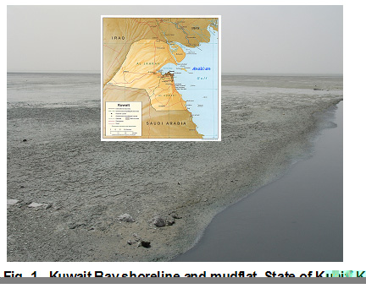

Results and Discussion
The Mudskippers observed in the present study appear to be quite active when they are out of water, feeding and interacting with each other (Fig. 2). The results of the present work are presented in the following items:
1- Description and habitat
In the present study, the mudskipper that are found in and around the mudflats of Kuwait Bay, are amphibious fishes that are called mudskippers. The results agree with those of Clayton and Wells (1994), who are separated the mudskippers into zones. The high shore mudskippers are called Periophthalmus, which are carnivorous mudskippers up to 15 centimeters long and feeds on little crabs at low tide. The genus Periophthalmus is by far the most diverse and widespread genus of mudskippers that contains eighteen described species (Larson and Takita, 2004).
They are uniquely adapted to intertidal habitats, unlike most fish in such habitats, which survive the retreat of the tide by hiding in tidal pools. Mudskippers need to live in habitats that are hot and humid in order to breathe, where air and water temperature range from 75 to 86 °F and humidity from 60 to 80 %. Mudskippers are only active when the temperature is above 55 °F. This result agrees with the results of Clayton and Well (1994).
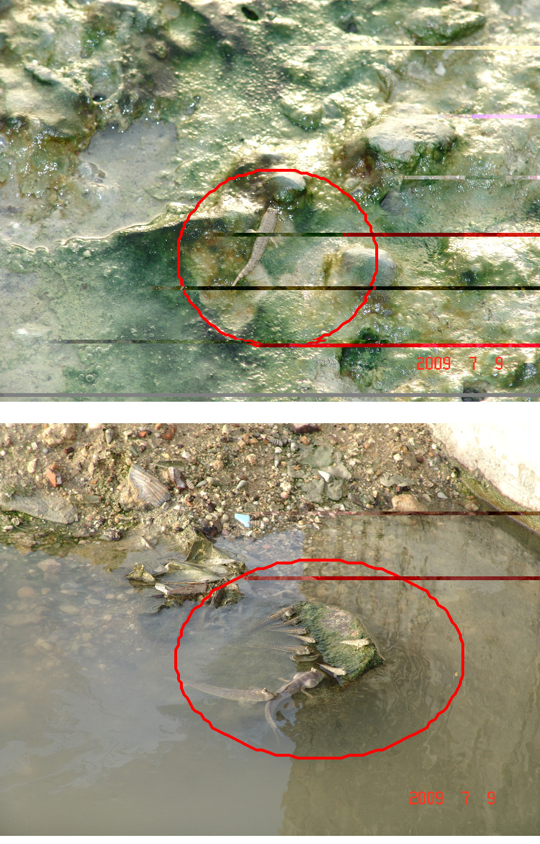
Figs. 2A &2B. The observed Mudskippers appear to be quite active when they are out of water.

Other adaptation of mudskippers to life on land is their huge goggly eyes at the top of their heads for an all-round view, while their mouth faces downwards to feed on the mud surface. These eyes sit on stalks while the rest of their bodies remain safely underwater. Unlike other fishes, mudskippers prefer to swim with their heads above water, their eyes giving them a good 360-degree view. To keep their eyes moist when they are on land, the eyes can be retracted to dip them into water that collects at the bottom of the eye socket. Mudskippers are probably the only fish with movable eyelids (Fig. 3). The pectoral fins of the mudskippers are used like crutches to crawl over mud.
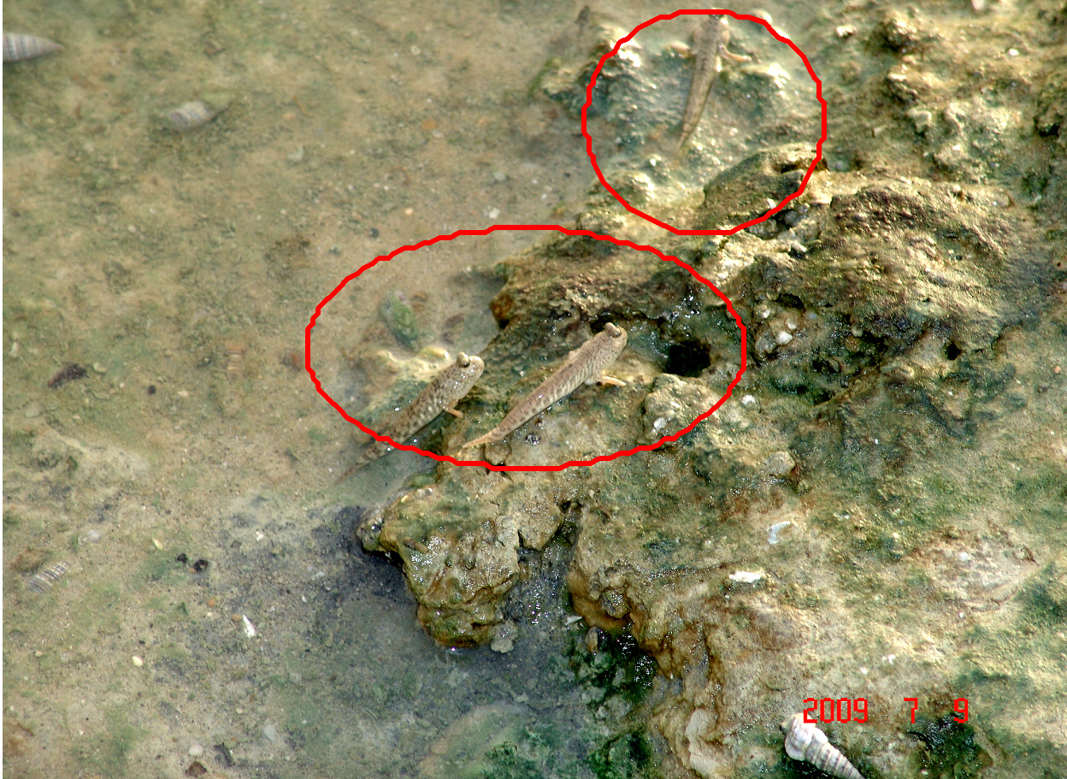
Fig. 3. Mudskippers are probably the only fish with huge eyes for an all-over view.
2- Territorial behaviour
Mudskippers are noticed to dig deep burrows to escape predators and raise their young. They maintain an air pocket in their burrows to breathe. Chen et al. (2007) reported that the mudskipper, Boleophthalmus pectinirostris, maintained territories in farming ponds during the cold season between November and February. Two types of territory are found, one is surrounded by mud-walls, and the other is without mud-walls. Both types of territory are entirely covered by shallow water (Fig. 4).

Fig. 4. Walled territories.
The area of walled territories was significantly bigger than that of non-walled ones. The nearest neighbour's distance of walled territories was significantly shorter than that of non-walled territories. This description is detected in the present study.
Fish surface activity occurred between 1200 and 1500 hours at which time the territorial water temperature reached a maximum, being significantly higher than that of the air, mud surface or deep burrow. The territorial sediments exhibited a significantly greater benthic micro- algal biomass as compared to the non-territorial sediments. The present study indicates that B. pectinirostris forms a territory a pool of water that encourages diatom growth and enables the fish to engage in surface activity (Fig. 4).
Clayton (1987), Clayton and Vaughan (1988) and Clayton and Wright (1989) stated that the proximate mechanisms of territorial behaviour in Boleophthalmus boddarti, an amphibious gobiid mudskipper that builds and maintains polygonal mud-walled territories provides a good example of the elastic disc concept of territories. The occurrence of wall building is density dependent and a contiguous mosaic of territories is only produced at high fish densities. Wall removal and replacement experiments show that the mud-wall acts as a visual barrier and reduces aggression between neighboring territorial fish.
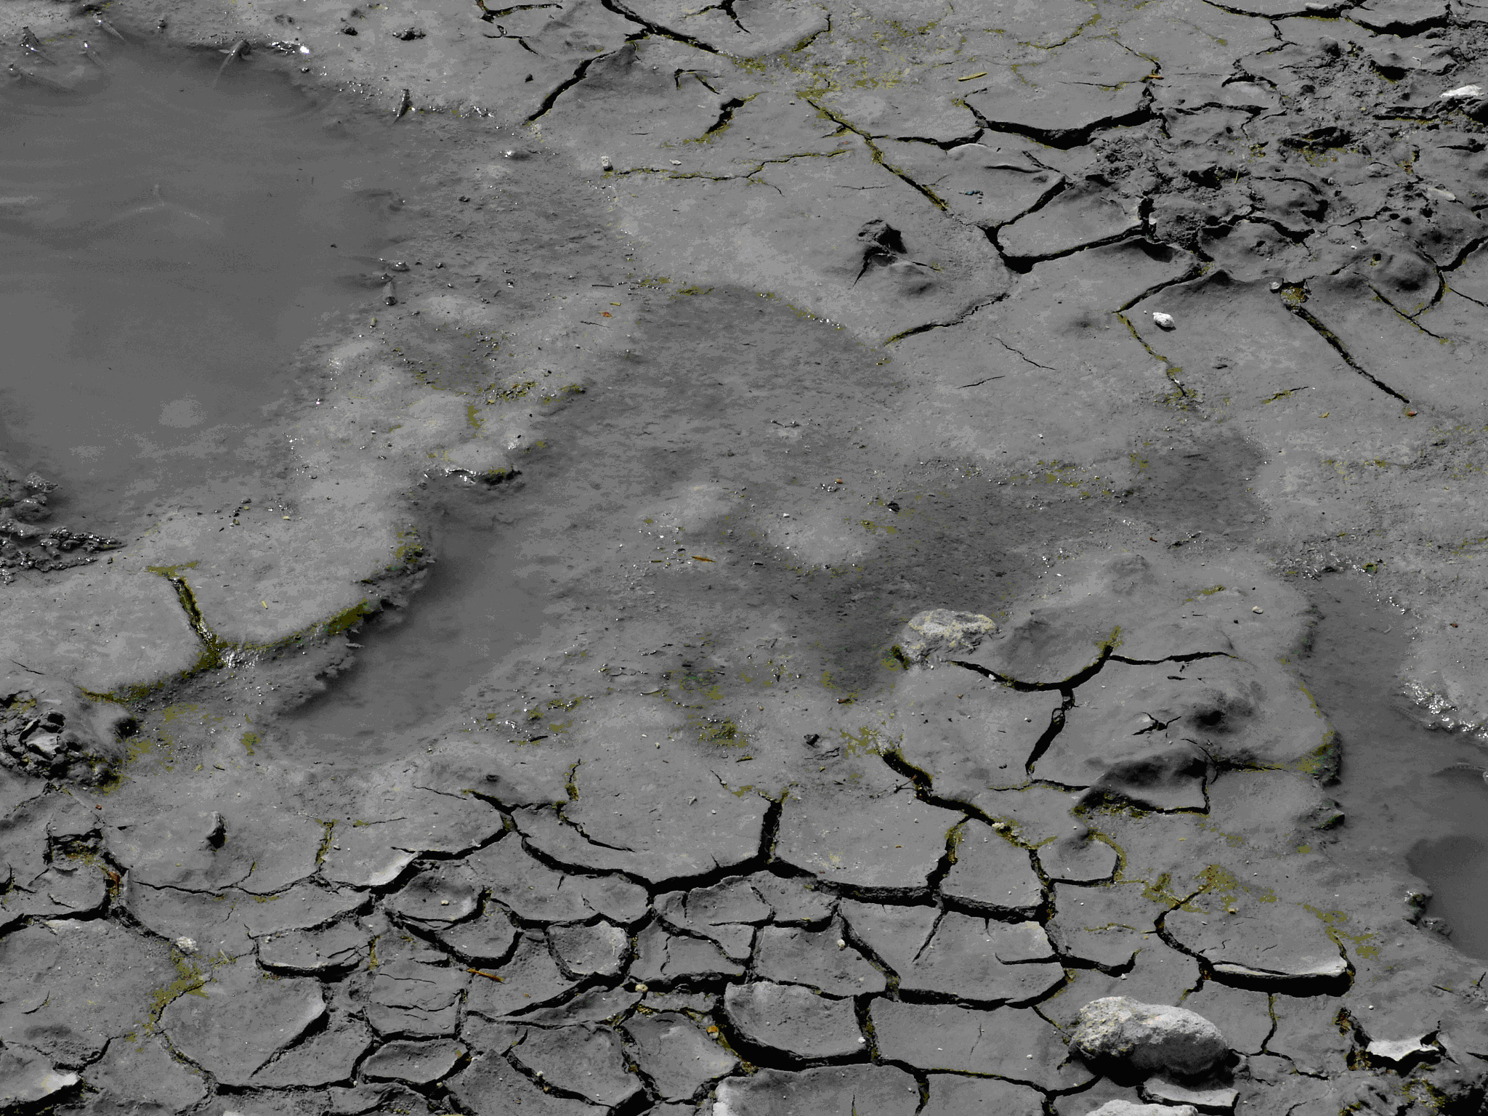
Clayton and Wright (1989) stated that at high population densities, the amphibious and herbivorous mudskipper Boleophthalmus boddarti construct mud walls around their territories as a means of reducing aggression between neighbours. Because of the walls, territories contain pools of water and exposed mud slopes. Whilst the density of benthic diatom prey was highly variable, the highest was found on the exposed mud slopes and the lowest on the boundary walls. Fish grazed mainly on the mud slopes. No significant differences were found in diatom density between territorial and non-territorial areas or between grazed and non-grazed areas within territories. The variation of the diatom density, however, was reduced within territories. The mud walls play an indirect role in maintaining populations of diatoms within territories.
Höpner(1999) reported that the mudflats are subject to intense bioturbation, and that for the Arabian Gulf area, mudskipper colonies are reported from the Bay of Kuwait. Each fish digs his own deep burrow where it hides from disturbances and during high tide. The author (ibid) stated that under certain conditions, the single fishes (most probably Boleophthalmus boddarti) build polygonal territories of a size of about one meter, surrounded by dams, defended against rivals, and large enough to provide food(microphytobenthos). Clayton and Wells (1994) stated that while this scenery is rare even in Kuwait Bay and difficult to be accessed, it is widespread on lower situated mudflats of the Khowr-e Musa area where it covers many km2. Even in the higher situated zone, mudskippers contribute decisively to the bioturbation power but do not form territories. Often, they form mixed colonies with digging crabs (Ucaidae). This result agrees with the results of the present study.
Boleophthalmus build and maintain these polygonal walled territories by carrying mouthfuls of mud from their burrows and depositing them on their walls. As far as is known, this population in Sulaibikhat Bay is unique throughout the Indo-Pacific area (Clayton and Wells, 1994)!
Although they are found all over Kuwait Bay, the most interesting population of Boleophthalmus can be seen in Sulaibikhat Bay where they construct and maintain and elaborate and continuous network of polygonal walled territories (see Fig. 3 and 4). Most of these territories are five-sided with an average area of 1.69 square metres. The ones with only four sides tend to be smaller, while those with six or seven sides are a little bigger. These territories are unusual in that each is occupied by a single fish of either sex.
Boleophthalmus stays always within its mud walls which enclose an area that has enough food for each individual to survive. They build the walls with mud from their burrows which they carry up in their mouths and spit out onto the section in need of repair. If part of the wall is destroyed, they will work hard to repair it within a matter of hours during low tide. The best time to see these walled territories is at low tide when the sun is low in the sky. If there is a mild winter, some of the walls will last for more than a year .Inside each walled compound, Boleophthalmus digs a burrow up to one and a half metres deep. The burrow may be anywhere in the territory, maybe right beside the wall (Clayton and Wells, 1994).
Young Boleophthalmus don't have their own territories, due to lack of suitable space. Instead, they are forced to live in areas where the mud is too soft for either walls or burrows, burying themselves in soft ooze whenever a predator threatens. Obviously, this is not as safe as a nice deep burrow, so the young mudskippers are live between the tides constantly on the lookout for a vacant territory and constantly trespass both in order to feed and to investigate the chances of finding an empty lot.
Naturally, the owners do not take kindly to this and will chase the intruder out, into a neighboring territory, where upon the neighbours will take up the pursuit and a splendid chain reaction of indignant outrage will follow the poor trespasser all the way back to the soft muddy area where belongs.. The main factor in ensuring a constant supply of vacant territories is predation and this is especially prevalent during the spring when the weather is cold and the fish are rather sluggish as a result. Shore birds are their worst enemies.
Clayton and Wells (1994) stated that most of the fish found in the intertidal zone come there at high tide to feed. However, to see the fish, which have best adapted to the amphibious life between the tides we have to go to the third main coastal region of Kuwait: the mudflats. Even when their burrow is submerged, mudskippers are seen to maintain an air pocket inside it, which allows them to breathe in conditions of very low oxygen concentration. This result accommodates with the results of (Ishimatsu et al., 1998; Ishimatsu et al., 2000; Lee et al., 2005).
Clayton and Wells (1994) observed mudskippers dig deep burrows to escape predators and raise their young and that they maintain an air pocket in their burrows to breathe. During the mating season, the male's colors become more intense, and they become much more active. They (ibid) stated that males leap and flip in the air and even stand on their tails, all to attract the females. The male becomes more aggressive forward other males with biting and raising its dorsal fins. If the female is attracted to the male, she does her own mating ritual with distinctive movements. She then goes into the male's burrow where she lays her eggs in a special part of the burrow the male builds her. The males then fertilize the eggs and takes over responsibility for the eggs. The above descriptions are noticed in the present study. These fishes present a range of peculiar behavioral and physiological adaptations to an amphibious lifestyle. He reported that these include: Anatomical and behavioral adaptations that allow them to move effectively on land as well as in the water (Harris, 1961). They can also flip their muscular body to catapult themselves up to 60 cm into the air. This observation is noticed in the present study (Piper, 2007).
Another important adaptation that helps the mudskippers to breath while they are out of water is their gill chambers, where they keep a bubble of air. These large gill chambers close tightly when the mudskipper is above the water, allowing the gills to be kept moist, and make them work. They supply oxygen for respiration also while the gobies are on the land (Graham, 1997).
As reported in the study of Tytler and Vaughan (1983), digging of deep burrows in soft sediments that allow the fish to thermoregulate , avoid marine predators during the high tide when the fish and burrow are submerged (Sasekumar et al., 1994) and for laying their eggs (Brillet,1969).
Tytler and Vaughan (1983) stated that in winter, mudskippers avoid low surface temperatures by remaining in their burrows, in the present study, no mudskippers were detected during winter months. In summer, body temperatures are kept lower than ambient by selecting areas where evaporative cooling is high. Body temperatures generally match those of wet mud, which can be 7°C lower than air shade temperatures.
Chen et al. (2007) stated that the mudskipper Boleophthalmus pectinirostris maintained territories in farming ponds during the cold season between November and February.
The present study results accommodate with the above observations.

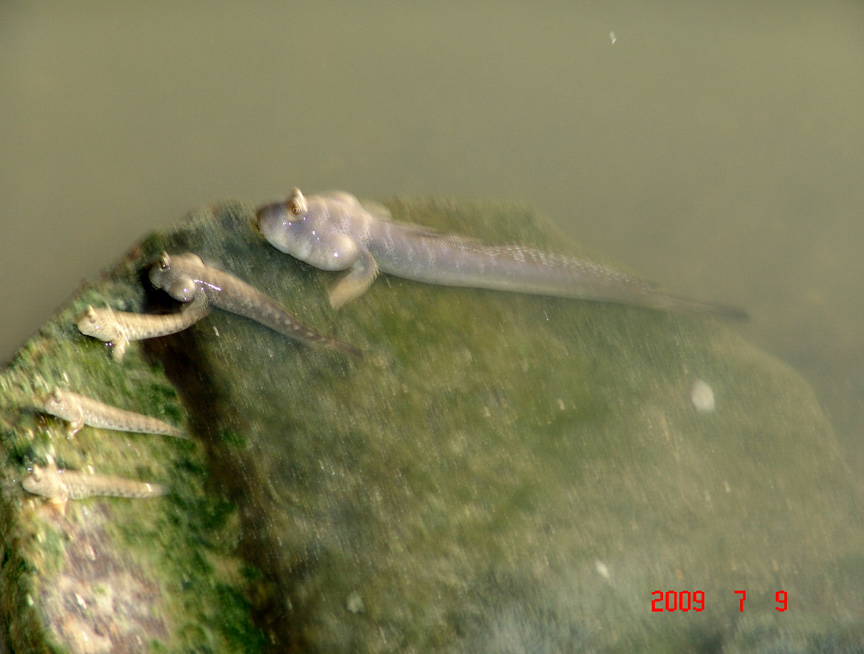
Fig. 5. Periophthalmus' eyes are well-adapted to see in air and out of the muddy water.
Periophthalmus' eyes are well-adapted to see in air, and when they are lying in wait for their preys only their eyes stick up out of the muddy water (Fig. 5). In order to keep their eyes wet, Periophthalmus have little cups underneath their eyes and when they blinks, the eyes roll down into their skull and get remoistened by the water held in these little cups. Even in the heat of summer, this species of mudskipper can remain active for several minutes at a time out of water. They are seen periodically rolling on their sides to help to keep their skins wet.
Every five minutes or so, Periophthalmus will dash back to its burrow to cool off and refresh itself. This species of mudskipper can be recognized by its characteristic way of locomotion. It lifts his tail, and then arches his back. It has two sets of paired fins, pectorals near his chest, and pelvic fins at the hips. The pelvic fins have moved forward and fused together to form a little cup, which is used as a sort of crutch to balance on. This description agrees with the results of the present study.
Periophthalmus, was observed sitting on the mudflats splashing water over his body with his pectoral fins for about several minutes before moving back to his burrow. This agrees with the description of Clayton and Wells (1994). These burrows are quite remarkable; they are y -shaped, with two entrances and are more than a meter deep in order to get down to permanent water level. The mud is suitable habitat for burrowing in, since the particles are very sticky, unlike sand. In all except the very softest ooze, burrows will last for quite a long time (Clayton and Wells, 1994).
3- Feeding
Periophthalmus needs to be out of water to feed and it needs to keep his skin wet, it can absorbs oxygen through its skin as well as through its gills. Some times, it will fill its mouth with water to help him to survive for a longer time out side the water (Fig. 6), since the inside of its mouth has lots of tiny blood vessels that absorb oxygen. However, this water isn't 'essential; the mudskipper loses it anyway when it eats his prey (Clayton and Wells, 1994).
Ishimatsu et al., (1998) reported that mudskipper fishes can maintain their metabolism while they are confined in mudflat burrows filled with oxygen-depleted water, and their eggs, deposited in the burrows, can develop under severely hypoxic conditions.
Their feeding action, a side-to-side head movement that collects the fine surface film of diatoms and algae on which they feed can easily recognize Boleophthalmus. Terns are another ménage to the mudskipper that they catch by flying along about three to five metres up, then dive-bombing their prey with their bayonet-like beaks. Sea gulls use a craftier approach, skimming very low, just above the mud walls and trying to catch the Boleophthalmus unawares.
But, Boleophthalmus like all the other mudskippers, is very quick to dive into his burrow, and constantly alert to danger. If they suspect a predator is around, Boleophthalmus will merely raise his bulbous eyes above the surface of the mud to check out the situation.
4- Infection of the mudskippers with parasites: External examination and dissection of 50 samples of the mudskipper collected from the studied area indicates no parasitic infections.
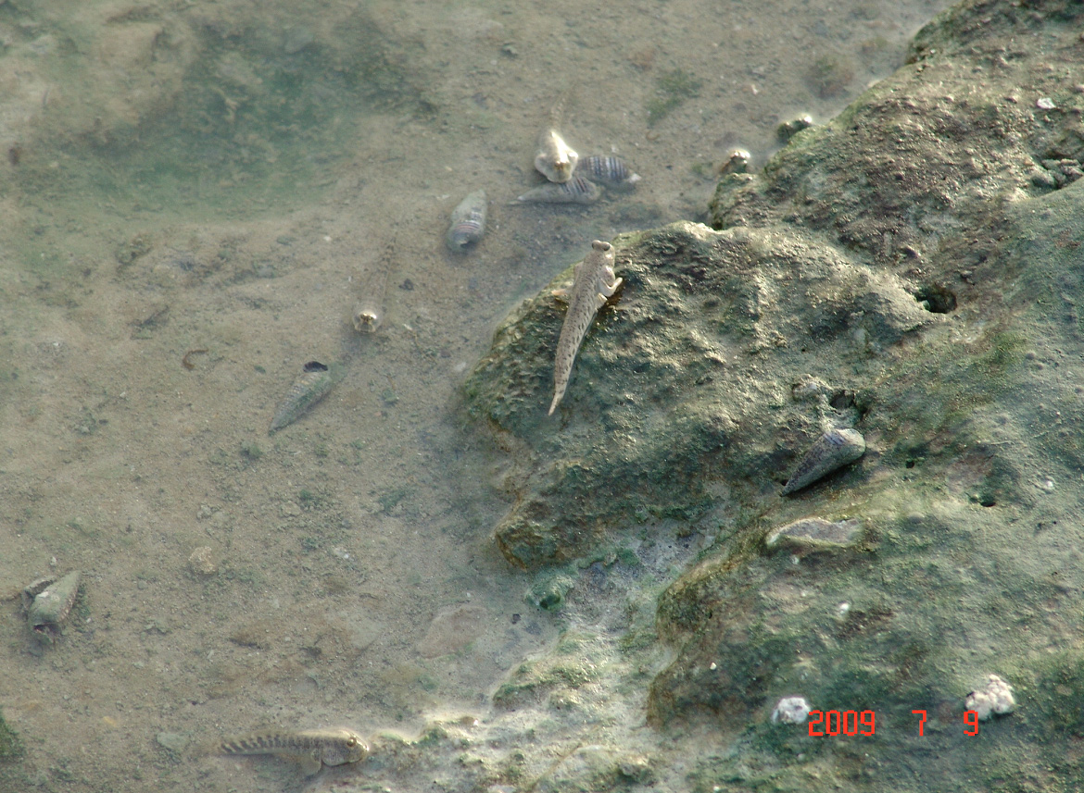
Fig. 6. The mudskipper needs to be out of water to feed and keep his skin wet.

CONCLUSIONS
Mudskippers have been monitored in the intertidal zone along the Kuwait Bay muddy shores during the very hot summer season of the year 2009. However, a number of fifty random mudskipper samples are examined externally and internally for parasites. These examinations are to evaluate the different factors controlling the biodiversity in that area. The results indicate the abundance of the Mudskippers allover the muddy flat of the Bay and the total absence of either external and/or internal parasites in the mudskipper.
A forestation of intertidal zones with mangrove plantations is viable options to improve coastal environment and enrich marine biodiversity. These factors also protect the coastline from strong currents and support the accumulation of sediments and organic matter in the intertidal zones. These changes would improve the quality of mudflats and promote the survival and growth of intertidal zone fauna.
The results indicated, also, that mudskippers are free from parasitic infection. However, important results concerning the controlling the parasitic infection of mudskippers is needed.
The above findings deduce that the mudskippers caught from Kuwait bay tidal mud flats have the capability to live in the Kuwait Bay, although the studies reported the toxicity by metals and the trace metals in the habitat
RECOMMENDATION
Further environmental studies on the Bay area and its fauna are recommended to evaluate the probable reasons of absence of either external and/or internal parasites in the mudskipper. Also, toxicological investigations that use the gobies as bioindicator are recommended

References
- Abou-Seida M.M, Al-Sarawi M. Utilization and management of the coastal areas in Kuwait. Coastal Management, 1990; 18:385-401.
- Aguilar NM. Comparative physiology of air-breathing gobies. PhD dissertation, University of California, San Diego, USA; 2000.
- Al-Bakri D, Foda M, Behbehani M, Khalaf F, Shublaq W, El-Sayed M, Al-Sheikh ., Kittaheh W, Khuribet A, Al-Kadi A. The Environmental Assessment of the Intertidal Zone of Kuwait. Kuwait Institute for Scientific Research, Report No. KISR 1687, Kuwait; 1985.
- Al-Ghadban AN. Assessment of Suspended Sediment in Kuwait Bay Using Land sat and Spot Images. Kuwait Journal of Science and Engineering, 2004; 31(2): 155-172.
- Al-Ghadban AN, Salman AS, Al-Nafisi R. Environmental Damage Assessment of War Activities to Coastline of Kuwait. Kuwait Institute for Scientific Research, Report No. KISR 4033, Kuwait; 1992.
- Al-Ghadban AN, Al-Ajmi D. Integrated Impact Assessment of Proposed Al-Muharrami and Bin Abdulla Mohammad. Resources management of mangroves in the Arid Environment in the Sultanate of Oman. M. Sc. Thesis, University of New castle, United Kingdom; 1993.
- Al-Ghadban AN, Abdali F, Jacob P. Total Organic Carbon in the Sediments of the Arabian Gulf and Needs for Productivity Investigation. Marine Pollution Bulletin, 1992; 28: 356-362.
- Al-Majid N, Bu Tayban, Preston M. The Distribution and Inventory of Total and Methyl Mercury in Kuwait Bay, Marine Pollution Bulletin, 2004; 49: 930-937.
- Al-Nafisi RS, Al-Ghadban A, Gharib I, Bhat NR. Positive Impacts of Mangrove Plantations on Kuwait's Coastal Environment. European Journal of Scientific Research, 2009; 26 (4): 510-521.
- Al-Sarawi A, Massoud MS, Khader SR, Bu- Olayan, AH. Recent trace metals in coastal waters of Sulaibhikhat Bay, Kuwait. Technology, 2002; 8: 27-38.
- Al-Yamani F, Bishop J, Ramadan E, Al-Husaini M, Al-Ghadban A. Oceanographic atlas of Kuwait's waters. Kuwait Institute for Scientific Research/ Environmental Public Authority, Kuwait; 2004.
- Brillet C. "Etude du comportement constructeur des Poisson amphibies Periophthalmidae". Terre et la Vie, 1969; 23 (4): 496–520.
- Chen S, Hong W, Zhang Q, Su Y. Why does the mudskipper Boleophthalmus pectinirostris form territories in farming ponds? Journal of the Marine Biological Association of the United Kingdom, 2007; 87: 615–619.
- Clayton DA. Why Mudskippers Build Walls. Behaviour, 1987; 102 (3-4): 185-195.
- Clayton DA. Mudskippers. Oceanogr. Mar. Biol. Annu. Rev., 1993; 31: 507-577
- Clayton D.A. and Wright JM. Mud-walled territories and feeding behaviour of Boleophthalmus boddarti (Pisces: Gobiidae) on the Mudflats of Kuwait. Journal of Ethology, 1989; 7 (2): 91-95.
- Clayton DA, Vaughan TC. Ethogram of Boleophthalmus boddarti (Pallas), a mudskipper found on the mudflats of Kuwait – Journal of the University of Kuwait (Sciences), 1988; 15 (1): 115–138.
- Clayton DA, Wells K. Discovering Kuwait's wildlife. Fahad Al Marzouq Printing and Publishing, Kuwait; 1994.
- Clayton DA, Snowden R. Surface activity in the mudskipper, Periophthalmus waltoni Koumans 1941 in relation to prey activity and environmental factors. Tropical Zoology, 2000; 13: 239:249.
- Colombini I, Berti R, Ercolini A, Nocita A, Chelazzi L. Environmental factors influencing the zonation and activity patterns of a population of eriophthalmus sobrinus Eggert in a Kenyan mangrove. Journal of Experimental Marine Biology and Ecology, 1995; 27:135-149.
- Dames A, Moore S. Studies for Subiya area, Kuwait Bay and development of electrical network. Ministry of Electricity and Water, Report No. MEW/CP/PGP-1113-90/81, Government of Kuwait, 1983.
- El-Sammak A, Karam QE, Bu Shaiba A. Preliminary Assessment of the Geological and Water Environments in Kuwait Bay: Identification of Hot-Spot Areas. Kuwait Institute for Scientific Research, Report No. KISR 7665, Kuwait, 2005.
- Glibert et al., 2004. (cited from Al-Nafisi, R. S., A. Al-Ghadban, Ismail Gharib and N. R. Bhat .2009).
- Gordon MS, Boetius I, Evans DH, McCarthy R, Oglesby LC. Aspects of the physiology of terrestrial life in amphibious fishes I: the mudskipper, Periophthalmus sobrinus. J. Exp. Biol., 1969; 50: 141-149.
- Graham JB. Air–breathing Fishes. Evolution, Diversity and Adaptation. San Diego California: Academic Press, 1997.
- Höpner T. (Intertidal Treasure Khowre Mussa–Unraised .Tidal Flats in Iran- Wadden Sea Newsletter–1 University of Oldenburg, FRG and S. M. Kazem Maraschi, University of Ahwaz, Iran), 1999.
- Harris VA. On the locomotion of the mudskipper Periophthalmus koelreuteri (Pallas): Gobiidae". Proceedings of the Zoological Society of London, 1960; 134: 107–135.
- Harris VA. On the locomotion of the mudskipper Periophthalmus koelreuteri (Pallas): Gobiidae". Proceedings of the Zoological Society of London, 1961; 134: 107–135.
- Hein duPreez H, vanRensburg E, vanVuren JH. Preliminary laboratory investigation of the bio- concentration of zinc and iron in selected tissues of the banded Tilapia, Tilapia sparrmanii (Cichlidae).Bulletin of Environment Contamination and Toxicology, 1993; 50: 674-681
- Ishimatsu A, Hishida Y, Takita T, Kanda T, Oikawa S, Takeda T, Khoo KH. "Mudskipper Store Air in Their Burrows". Nature, 1998; 391: 237–238.
- Ishimatsu A, Takeda T, Kanda T, Oikawa S, Khoo KH. "Burrow environment of mudskippers in Malaysia". Journal of Bioscience, 2000; 11 (1, 2): 17–28.
- Jaafar Z, Lim KP, Chou LM. Taxonomical and morphological notes on two species of mudskippers, Periophthalmus walailakae and Periophthalmodon schlosseri (Teleostei: Gobiidae) from Singapore. Zoological Science, 2006; 23: 1043–1047.
- Jaafar Z, Larson HL. A new species of mudskipper, Periophthalmus takita (Teleostei: Gobiidae: Oxudercinae), from Australia, with a key to the genus". Zoological Science, 2008; 25: 946–952.
- Jaafar Z, Perrig M, Chou LM. Periophthalmus variabilis (Teleostei: Gobiidae: Oxudercinae), a valid species of mudskipper, and a re-diagnosis of Periophthalmus novemradiatus". Zoological Science, 2009; 26: 309–314
- Larson HK, Takita T. "Two new species of Periophthalmus (Teleostei: Gobiidae: Oxudercinae) from northern Australia, and a rediagnosis of Periophthalmus novaeguineaensis". The Beagle, Records of the Museums and Art Galleries of the Northern Territory, 2004; 20: 175–185.
- Lee HJ, Graham JB. Their game is mud. Nat. Hist., 2002; 9/02: 42-47.
- Lee HJ, Martinez CA, Hertzberg KJ, Hamilton AL, Graham JB. Burrow air phase maintenance and respiration by the mudskipper Scartelaos histophorus (Gobiidae: Oxudercinae)". The Journal of Experimental Biology, 2005; 208: 169–177.
- Mhaisen FT, Al-Maliki NS. Parasites, diseases and food of the dark-blotched Mudskipper Periophthalmus waltoni (Perciformes: Gobiidae) in the Khor Al-Zubair estuary (Iraq). Zoology in the Middle East., 1996; 13 :85-87.
- Mance G. Pollution threats of heavy metals in aquatic environments. Elsevier Applied Science. London, 1987; 363 pp
- Milward NE. Studies on the taxonomy, ecology and physiology of Queensland mudskippers (unpubl. Ph D. dissertation ed.). Univ. Of Queensland, Brisbane, Australia, 1974.
- Murdy EO. A Taxonomic Revision and Cladistic Analysis of the Oxudercine Gobies (Gobiidae: Oxudercinae)". Records of the Australian Museum Suppl., 1989; 11: 1–93.
- Ni IH, Chan SM, Wang WX. Influences of salinity on the biokinetics of Cd, Se, and Zn in the intertidal mudskipper Periophthalmus cantonensis. Chemosphere, 2005; 61: 1607-1617
- Randall DJ, Cameron JN, Daxboeck C, Smatresk NJ. Aspects of bimodal gas exchange in the bowﬁn Amiacalva L. (Actinopterygii: Amiiformes). Respir. Physiol., 1981; 43,339–348.
- Piper R. Extraordinary Animals: An Encyclopedia of Curious and Unusual Animals, Greenwood Press, 2007.
- Price A, Sheppard C, Ropert C. The Gulf: its biological setting. Marine Pollution Bulletin, 1993; 27: 9-15.
- Saad MA, Ezzat AA, El-Rayis OA, Hatez H. Occurrence and distribution of chemical pollutants in Lake Mariut, Egypt II Heavy metals. Water Air and Soil Pollution, 1981; 16: 401-407.
- Samhan W, Shublaq W, Gopalkrishnan TC, Ghobria F. Study of the coastal zone of Kuwait for aquaculture purposes (EES-73). Kuwait Institute for Scientific Research, Report No. KISR 2053, Kuwait, 1986.
- Sasekumar A, Chong VC, Lim KH, Singh HR. "The Fish Community of Matang Mangrove Waters, Malaysia". Proceedings, Third ASEAN-Australia Symposium on Living Coastal Resources. Research papers: Vol. 2: 457-464, Bangkok, Thailand: Chula longhorn University, 1994.
- Sayer MD, Davenport J. Amphibious fish: why do they leave water? Reviews in Fish Biology and Fisheries, 1991; 1:159-181.
- Sbandar AS, Alhazeem H, Alsaffer AH. Mangrove replanting Scheme in Kuwait: An Evaluation and advantages. In: Mangrove Ecosystems: Natural Distribution. Biology and Management (eds). Kuwait Institute for Scientific Research. 2001; 219- 234.
- Swanson BO, Gibb AC. "Kinematics of aquatic and terrestrial escape responses in mudskippers." The Journal of Experimental Biology, 2004; 207: 4037-4044.
- Tytler P, Vaughan T. Thermal ecology of the mudskippers, Periophthalmus koelreuteri (Pallas) and Boleophthalmus boddarti (Pallas) of Kuwait Bay. J. Fish Biol., 1983; 23:327–337.

