Calculated linear regression equations of motion K⁺ & Na⁺ ions and compare moving process these elements in corn roots

Tayeb Saki Nejad^{1*}, Abdolmahdi Bakhshande², Ashraf jazayeri³
1- Assistant Professor Department of Agronomy Physiology, Islamic Azad University, Ahvaz branch
2- Professor Department of Physiology, Ramin Agriculture University
3- Assistant Professor Department of biology, Shahid Chamran University
*Corresponding Arthur: Tayebsaki1350@yahoo.com

Abstract: This research in research farm of Islamic Azad University, branch Ahvaz Iran in the years 2006 and 2007 were performed. Research measuring 3 different depths in the roots of corn: (A = 0 - 20, B = 20 - 40, C = 40 - 60 Cm). Root sampling method of trench digging Tuesday soil depth and applied water stress in different period of plant growing split plot design with 4 replications of was. Linear regression equation of potassium movement in the depth of process A, y =-0.506X +2.38 showed severe discharge and transfer element potassium in various quantities have been irrigated. In other words, imposing severe water stress, ion transfer and discharge was more that equation slope (m =- 0.506) trend Go shows the discharge and transfer. Linear regression equation in the depth of B, with y = 0. 268x +1.79 indicates that the process of gathering more ions that transfer of this phenomenon in the top of this element from the lower root (the depth of C) to the top and the absorption of these elements is water stress conditions. Depth c element assembly process is very much needed due to plant water stress conditions, this element set is osmotic pressure, ion transfer process of gathering and deep C and B and C, especially in the height of the highest accumulation process and the accumulation of sodium ions was the transfer process in both the height and depth A very small majority of sodium absorption in the root C accumulation in deep to find and apply severe water stress increased the accumulation of positive slope of regression line equation y = 0.09x-. 005, that showed increased sodium.

Key Words: Linear regression equation, K⁺ & Na⁺, corn root

1. Introduction
Process of potassium absorption in the early stages of growth, compared with dry matter accumulation is very severe, so that the potash deficiency, young corn plants show it. At the beginning stage of milky Game maximum absorption of potassium in plant and at maturity occurs when grain, ²/₃ potash in the leaves and ¹/₃ the grain has been stored. Potassium absorption before seed formation hundred percent and fully carried out and compared with the elements nitrogen and phosphorus, potash plant gathering process, 30 days earlier reaches its maximum value, thus attracting a few weeks before potassium plant stops, almost equivalent amount of potassium uptake in plant nitrogen uptake has been reported. Gomez and Bltrans (1992) reported that water stress absorption of potassium and other elements of the preferred maize under drought stress conditions are lots of absorption.
Sinha (1992) announced that potassium absorption process and stores the plants like wheat and corn increased water stress and cause more resistance against plant water deficit is.
Yang (2002) experiment that was conducted in China, was declared the first drought conditions, the amount of potassium absorbed 2-3 times under optimum conditions is increased, Secondly, the

presence of potassium ions, water stress and its effect on assembly process dry matter, leaf area index and plant height can be adjusted because of this phenomenon by increasing the ability or increase photosynthesis and enzyme activities measured carbon Robisco and reinforcing materials and as were synthesis.
Various reports such as Prmachandra (1992), Liker (1999), Keying (2001) in the process of potassium uptake under drought stress conditions confirms to the following:
1 - potassium uptake mechanisms, moving mass (which very limited amount of potassium, the plant is absorption), contact ion root (the amount you absorb this method is low) and soil distribution of ions through ion distance K⁺, 6 mm, twice the distance of phosphorus 3 mm player is, is. Thus the process of water absorption of phosphorus deficiency due to motor radius less than the element potassium, the increasingly impaired.
2 - cause increased potassium uptake under drought stress conditions, active ion uptake mechanisms has been reported that plant, to increase resistance to drought, unlike the release phenomenon, with only energy K⁺ concentration in roots and some to enhance the body, or increase potassium absorption, causing a positive effect on photosynthesis, growth and leaf area index, enhance ATP synthesis and NADPH, increased synthesis of chlorophyll b and a, increase speed to fertilizer materials in grain yield, more protein synthesis and composition Polymeric set arm and closed aperture, the aperture increased, the reduction of transpiration and the most important issue when tensions increased absorption of water, the water and create conditions suitable internal osmotic pressure through the set and transpiration is also reduced.
3 - due to more absorption of potassium under drought stress conditions than other elements, more drying and long consecutive dry and semi-arid areas, the release of K⁺ between the layers of clay and potassium ion concentration in soil increases the This phenomenon will attract more potassium. Porter (1991) in tests in Indiana, conducted Prdova University, reported that increased corn by product dry potassium years 4800 Kg, in normal years and 900 Kg rain 5400 Kg in ha respectively, and announced that the conditions potassium absorption process for increasing drought resistance of plant water deficit conditions, the intensity of their shows more.
Lvov (1963) declared that whatever amount of potassium absorption in tassel emergence time increases, the value of this plant to increase product shows.
Soya hang (1999), when water stress at flowering stage or potassium uptake by the roots is increased or transfer of this element leaves bottom leaves are done in high water potential part to reduce air and water to find more Parties can move limbs.
Mashner (1971) and Lour (1953), patterns for Na ⁺ ion accumulation and switching instead of sodium by potassium species of plant design and presented four models, which are defined, summary, all models are presented:
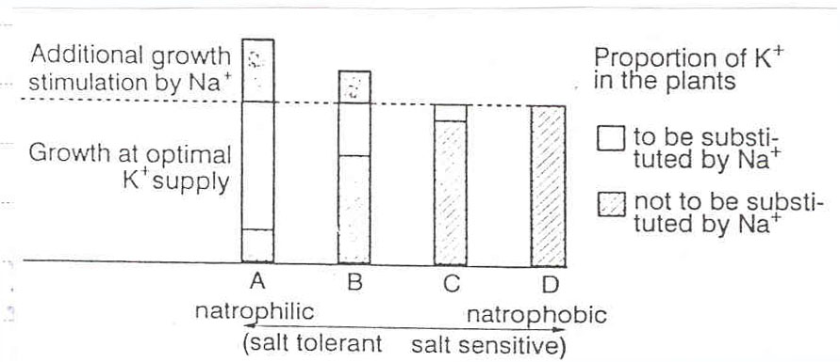

Figure 1: Evaluation of different models of accumulation and Na ⁺ ions instead of switching it with K⁺ ions in different plant species.

Model A: the pattern of sodium accumulation, plant needs, and Na⁺ ions can completely replace the potassium is increased growth, such as: sugar beet.
Model B: plant uptake of sodium but could not quite done, instead switching to K⁺ ions, minor amount of growth by Na⁺ ions are seen, such as: cabbage, cotton, chickpea, cotton, wheat and spinach.
Model C: the plant amount of Na⁺ ions, which attract the low K ⁺ ion, is replaced, such as: barley, rice, oats, tomatoes, potatoes and Ryegrass.
Model D: instead of switching by the Na⁺& K⁺ ions are seen by the sodium and growth of these plants is conceptual, such as: corn, rye, soybean, bean farm and Timothy.
Green etal (1980), Figodver and colleagues (1987-89), the study of plant resistance to ion system Na⁺, the phenomenon of transfer of value to this element was raised aerial organs and declared that the resistant plants such as sugar beet, transmission from the root to shoot, and a strong addition to filling this vacuum transfer ion K⁺ deficiency in aerial organs, reducing the element concentration in roots and reduce toxicity, but in plants such as beans and corn absorption, sodium ions in roots and transport remained the aerial organs is very minor, however, this plant caused toxicity, especially root and disorder in the root task creates. (Figure2)
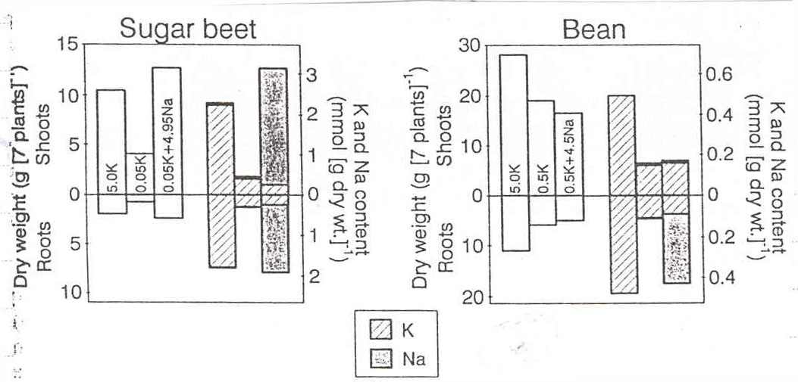

Figure 2: dry weight and amount of potassium in resistant species (beet sugar) and sensitive (beans) in different concentrations of potassium and sodium (concentration mmol as shown in columns).
Johnson (1989), reaction weight C₃ and C₄ plants in the treatments without the sodium ions were studied, they were told that the ions in the presence of Na⁺, accumulation of dry matter per plant increased C₄ plants, which acid concentration because followers Mesophyll cells of these plants is increased more CO₂ is absorbed, but the change in C3 plants dry matter was not reported by the Na⁺ ion, although this experiment, C₃ and C₄ plants relatively resistant Na⁺ ion was used (Figure 3).
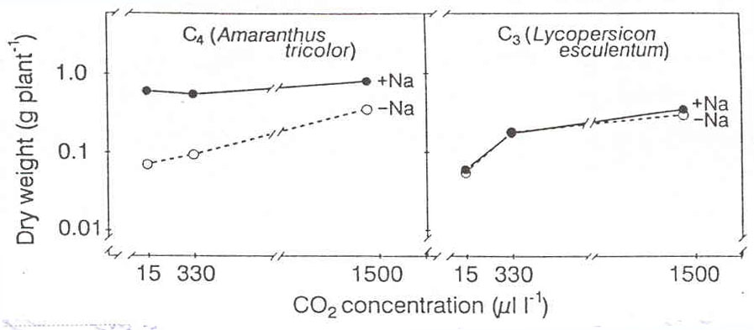

Figure 3: a) reaction C₃ and C₄ plants growing supply and increased Na⁺ ions absorb CO₂
b) the process of Na⁺ ion absorption in corn and followers, Base on Johnson etal (1989).
When enough K⁺ ions and is accessible, the condition and the amount of potassium ions is soil moisture, the corn results full of K ⁺ uptake and K⁺ by switching instead of sodium is very minor and insignificant, but the absence of potassium and low moisture content, amount of Na⁺ ions and absorption of higher salinity, which have been in corn shows, comparing hydrated ion size K⁺= 0.331 Na⁺= 0.358 nm, absorption of K⁺ ions in sufficient moisture and optimal concentration of potassium, is more evident, salinity conditions, Na⁺ uptake by K⁺ ratio is limited in the amount Vacuoles low to moderate salinity (up to 200 mmol) is higher and the intensity of the high salinity decreases, the reason This replacement of Na⁺ ions instead of K⁺ ions are. Stem less than what is illustrated in the way of resistance mechanisms of Na⁺ ion uptake and transfer of low sodium are aerial organs that may be due to multiple layers is endodermis, the radial wall cells, the six funds its four faces and caspariaen strip ring that acts as a selective and contribution to the movement Simplest increases, what contribution increases than decreases plant resistance is the New salt (Table 1) but other resistance mechanisms such as leaf and root out salt, ion times in shoot organs and reduced transpiration in this regard has been reported.
Table 1: Evaluation of resistance against three species of plant in different concentrations of Na ⁺ environment
plant | Na in soil  (%) | Na in phloem (%)
Atriplex | 200 | 8
Barley | 100 | 4
Rice | 100 | 5

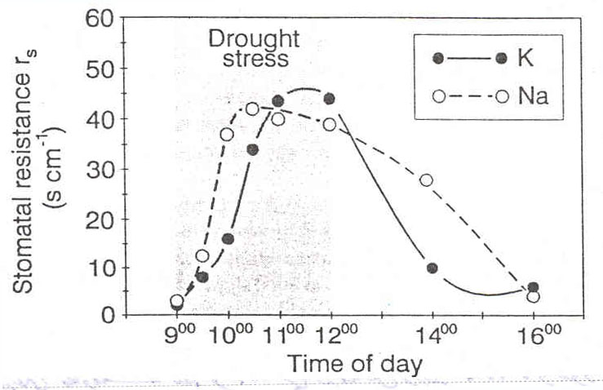 Separation process of two K⁺ and Na⁺ ions that a very large period was unknown, the peptides are the various circular and especially Alinomisin Game 1 in comparison with sodium potassium absorption and carry more, to Solvay that this phenomenon also in plants and animal cells is the same report, the resolution of various types of plants are not the same, for example sugar beet amount of sodium absorption and corn will contrast with very little power is to absorb sodium. The solution in a concentration of young corn plant food, 50 times more potassium than sodium absorption and transport are much detail this time to shoot is very weak and this phenomenon because the ions accumulated in the secondary roots of the Na⁺ ion Vonda raw wood quickly receive. Mashner (1982), announced during the water shortage, sodium balance in the water system by the plant is used to set the aperture, with a sudden decrease in water, with the receiving aperture ion compared with Na⁺ ions released K⁺, much faster are closed in this experiment with two treatments, the process of closing speed and the aperture was performed, which quickly closed treatment " B ", the presence of ions Na⁺, were faster.

Figure 4: Effect of ions Na⁺ & K⁺ on the aperture closure under drought stress conditions.

Material and methods
Research in Islamic Azad University research farm in southwest and 3 kilometers away from the city of Ahwaz split plot design in randomized complete block design : 1- Main treatments: drought stress levels ( I₀= no stress and control, I₁= mild stress, I₂= sever stress, I₃= high sever stress ) and 2- sub-plots: phases of plant growth (S₁= vegetable, S₂= reproductive, S₃= maturation) with four replications in two years 2006 and 2007 were performed before planting by the drill samples, 10 samples of 30-0 and 60-30 cm depth soil was prepared, the method of pressure plates, parts of farm field capacity (FC) and permanent wilting point (PWP), which respectively FC =24.7 and PWP =14.7 percent was measured, the apparent density of soil by the method of cylindrical liquid measure, equal to, respectively, and Pa=1.3 G/cm³ was , that these three parameters, FC, PWP and Pa during the experiment were considered fixed. Determine soil moisture content by weight as a method of sampling once every 2 days were used with this method, moisture by weight () and due to be fixed cylinder size drill (V) samples, percentage volumetric soil moisture () was calculated using these two components, the amount of inflow to each plot (plot Game as closed and exit the water were built) were calculated from the following formula:
V: is equal to amount of water necessary for each irrigation
: equals to volume moisture percentage
: equals to weight moisture percentage
P_{a}: equals to apparent weight of soil. (G/cm3)
Fc: Field capacity points
PWP: permanent wilting point.
A: equals to experimental plate level (cm²)
E: equals to irrigation efficiency
D_{s}: equals to depth of root penetration (used tranche excavation) by installing parshal folum and meter we measured the amount of water entered into each part of land.
With the installation and also Flume Parshal exposure meter of water, the amounts of water input to each control plot were applied. And nutrient analysis to determine root depth of 3 soil sampling was done as follows:
A = 0 - 20, B = 20 - 40, C = 40 - 60 Cm soil depth
The method of the three deep trench excavation soil sampling to determine nutrient potassium and sodium in plant, potassium and sodium measured root photometer method was performed. Estimated amount of sodium for some samples, the device atomic absorption photometer was used.
3. Results
3.1. Potassium: The study of accumulation and transport in root at different depths showed that the irrigation cycle, developmental phases, and their interaction as well as replication effects at 1% level on percentage of potassium in root were significant. The Duncan test also showed that the more stress increase the more potassium accumulate in the root, so that the highest accumulation percentage was seen in treatment I₃ (the most severe water stress) with 2.71ppm and under non stress condition the root took the lowest potassium. The trend of potassium accumulation in three sampling depths represented the greatest potassium in C depth at control treatment and with application of different water stresses, especially in the most severe stressed treatment, the potassium accumulation in both C and A depths increased. The reason is possibly related to high uptake of this ion in severe stress at C depth and also its transport trend at A depth (Table 2, Figure 5).

Table 2: equations linear regression moves process of nutritional elements in various amount of irrigation in root length
Depth(Cm) | potassium | sodium
A = 0-20 | Y= -0.506x+2.38 | Y=-0.505x+2.38
B = 20-40 | Y= 0.268x+1.79 | Y=0.118x-0.015
C = 40-60 | Y= 0.3x+1.85 | Y=0.09x-0.005

Figure 5: Effect drought stress on linear regression equations of motion K⁺ ion.

The review nutrient movement equations in Table 2 and the notes following review are to better understand the problem:
1- Values more positive slope (m line) increased more linear an equation in the root element provides.
2- Negative slope values (m line) equations of linear transfer and discharge process plant element offers and what this number is smaller element of the evacuation process more parts. (Slope line in the table is presented with the following line)
The Duncan test presented the growth periods of three mean groups in a two-year-experiment in which S₂ treatment showed the highest potassium accumulation percentage.
3.2. Sodium: The effect of irrigation cycle, growth stages, and their interaction as well as replication effect on sodium accumulation at different depths was not significant (Table 5).
By increasing the stress the sodium accumulation increases in root. The highest accumulation was in I3 treatment with 0.64 ppm and non stress treatment with 0.12ppm was the lowest. The study of accumulation trend of sodium in three sampling depths showed that the highest accumulation was at C depth and when different stress levels were applied the highest accumulation was observed only in B depth. The sodium was accumulated at lower parts of root and the preventative state was seen in relation to its transport into A depth. Duncan test showed that this ion accumulation at S₂ treatment through three different mean groups was the highest (Table 2, Figure 6).

Figure 6: Effect drought stress on linear regression equations of motion Na⁺ ion.

Discussion
Process of absorption capacity, such as single elements of K⁺ & Na⁺ polyvalent ions is easier done. Cautions potassium and sodium, respectively, have different absorption process, which attracted many first and second absorption and energy spend less and work release phenomenon is absorbed. But these two elements in the process of moving the plant root quite "are different. Potassium equation (Y= 0.3x+1.85) above quickly reaches the root, but the sodium in the equation (Y=0.09x-0.005) gathering to root tip. The cause of this phenomenon causes following:
1 - hydrated caution radius smaller than the potassium caution is sodium, potassium, so much quicker than moving element is sodium.
2 - Proteins absorb and conduct Valynomisin more of potassium caution, and they are to prevent absorption of sodium ions.
3 – Layers endodermis prevent movement of sodium ion radius are large hydrated potassium ion radius but less easily hydrated layers are endodermis password.
Discharge process in the range 20-40 potassium ion sodium ion is much higher. Slope line equations of these two elements confirm this issue. Slope 0.26 line potassium ion movement and sodium ion motion equation line slope is 0.11. The numbers indicate the process of gathering and movement of the root elements are much larger numbers and everything are in the process of gathering further element is the element from the root tip moves toward more.
Smith (2003) stated that the trend of nutritional element accumulation in root is proportional to that of aerial organs and by decreasing of root development radius resulting from any factor, there is significant reduction in both phosphorus and nitrogen. On the other hand, by exerting mild stress, the nitrogen accumulation is slightly increased, for this reason, the accumulation of free amine amino acid like praline as well as root osmotic pressure decrease and consequently entering some water into root by which some nitrogen is absorbed.
Sobarno (2001) believed that the reason of phosphorus uptake decrease can be attributed to small movement radius of nitrogen which almost is half of movement radius of potassium.
Sormitov (2003) said that in ¹/₃ time of moisture elasticity in one time and in three times the phosphorus uptake is decreased 100 percent, 80 percent and 50 percent respectively. By increasing the soil moisture elasticity, water layers between root and soil particles is getting thinner and the route of ion become longer. By applying different water, the accumulation of single capacitated sodium and potassium elements was increased.
According to smith (2003) the accumulation of these elements for decreasing root osmotic potential and enter of more water under stress condition indeed regulate the osmotic pressure. The highest trend of accumulation all the four elements was seen in plant generative growing treatment and water stress exerted the greatest damage to accumulation trend the element. The trend of potassium accumulation during initial growth stages is very severe compared to accumulation of dry matter. The maximum potassium uptake is taken place when the grain begins to get milky and before grain formation the accumulation is completed.
The transport of potassium in to root was completely obvious which in 0-20 cm showed the highest potassium accumulation and it represent the transport trend toward tip of root.
Smith and zobel (2003) stated it is because of large movement radius and needed plant.
Sinha (1992) reported that the uptake potassium trend and its storage in plants like maize and wheat is increased during water stress and contribute to high resistance against water deficit. The mechanism of potassium uptake, mass movement, contact of root with ion and ion dissemination by soil which is the distance of ion K⁺, 6 mm two times of 3 mm. Therefore, due to smaller movement radial of phosphorus than the potassium, the phosphorus uptake trend is disordered by water deficit.
Sony et al (2001) have reported the reason of increased potassium uptake under drought stress can be attributed to active uptake mechanism of this ion by which the plant in order to promote its resistance to drought, increases the potassium concentration in root and other organs through energy consumption. The other reason is attributed to extended drought and wet periods in the dried and semi-dried regions which it causes potassium release through day layers.
The trend of transport and accumulation of sodium in root showed that the highest accumulation is at tip of root and its transport to upward of root was very limited during water stress. At this point, the prevention of endodermic layer of sodium penetration to aerial organs of maize is proposed by David (1995).
Zhiang (2002) stated that a great deal of plant energy during drought stress is consuming for osmotic pressure regulation, twisting the leaf and increasing of stomata resistance.

Acknowledgements
President of research the Islamic Azad University, Ahvaz branch, Dr. Zarin Abadi

Corresponding Author
Dr. Tayeb Saki Nejad
Department of agriculture
Islamic Azad University, Ahvaz Branch, Iran
00989166129260
Reference
- Food and Agriculture Organization. 1983. Integrating crops and livestock in West Africa. FAO Animal Production Paper No. 41, FAO, Rome. 112 pp.
- Food and Agriculture Organization. 1986. Production Year Book Vol. 40. FAO, Rome.
- Giesbrecht, J. 1969. Effect of population and row spacing on the performance of four corn (Zea mays L) hybrids. Agro. J. 61: 439-441.
- Gonske, R.G. and Keeney, D.R. 1969. Effect of fertilization nitrogen variety and maturity on dry-matter yield of corn grown for silage. Agro. J. 61: 72-75.
- Goering, H.K. and Van Soest, P.J. 1970. Forage fiber analysis (apparatus, reagents, procedures and some applications). Agriculture Handbook No. 379. US Dept. of Agriculture, Washington, D.C. 20 pp.
- Hacker, J.B. and Manson, D.J. 1981. The digestibility of plant parts. CAB Herb. Abstr. 51 (9): 459-482.
- Jenik, Jan and Nall, J.B. 1976. Plant communities of the Accra plains, Ghana. Folia Geobot. Phytotax, Praha 11: 163-212.
- Loomis, R.S. and Gerakis, P.A. 1975. Productivity in agricultural ecosystems. In: J.P. Cooper (ed.), Photosynthesis and productivity in different environments. IBP-3, Comb. Univ. Press, Cambridge. pp. 145-172.
- Lutz, J.A.; Camper, H.M. and Jones, G.D. 1971. Row spacing and population effects on corn yields. Agro. J. 63: 12-14.
- McLeod, M.N. and Minson, D.J. 1974. Differences in carbohydrate fractions between Lolium perenne and two tropical grasses of similar dry-matter digestibility. J. Agric. Sci. (Camb.) 82: 449-454.
- Menken, U. ter and El-Harith, E.A. 1985. Feeding farm animals on unused resources in the tropics and sub-tropics. Anim. Res. and Dev. 22: 116-127.
- Minson, D.J. and McLeod, M.N. 1972. The in vitro technique: Its modifications for estimating digestibility of large numbers of tropical pasture samples. C.S.I.R.O., Div. of Trop. Past. Tech. Pap. No. 8. CSIRO, Melbourne, Australia. 15 pp.
- Perry, L.J. 1974. Crop residues grazed by cattle. Farm Ranch and Home Quarterly 21(3):21-22. Inst. Agric. and Resources, Univ. Nebraska, Lincoln.
- Powell, M. 1985. Contribution of fractionated crop residues grazed by cattle. Farm Ranch and Home Quarterly 21(3):21-22. Institute of Agriculture and National Resources, University of Nebraska, Lincoln.
- Qureshi, A.W. 1986. Recent trends in livestock development in Africa and the Middle East. In: Nuclear and related techniques for animals in harsh environment. IAEA Proceedings (IAEA-SR-115/1). pp. 17-37.
- Raymond, W.F. 1969. Nutritive value of forage crops. Adv. in Agro. 21: 1-108.
- Reed, J.D.; Tedla, A. and Jutzi, S. 1986. Large differences in digestibility of crop residues from sorghum varieties. ILCA Newsletter 5(1): 56. ILCA, Addis Ababa, Ethiopia.
- Wareing, P. and Patrick, J. 1975. Source-sink relationship and partition of assimilates in the plant. In: J.P. Cooper (ed.), Photosynthesis and productivity in different environments. IBP-3, Camb. Univ. Press, Cambridge. pp. 481-499.
- Weber, D.W.; Vetter, R.L. and Gray, U. 1970. Grazing corn harvest refuses by beef cows. J. Anim. Sci. 31: 1030 Abs. No. 80.
- Westselaar, R. and Farquhar, A.D. 1980. Nitrogen losses from tops of plants. Adv. in Agro. 33: 263-302.
- Animal & Plant Health Inspection Service (APHIS): Biotechnology Regulatory Services. Corn webpage [Online]. USDA. Available at http://www.aphis.usda.gov/brs/corn.html (verified 26 July 2004).
- Barnes, R.F., M.E. Heath, D.S. Metcalfe. 1973. Forages: The Science of Grasslands Agriculture, Third Edition. Iowa State University Press. Ames, IA. 41:439-440.
- Barnes, R.F., M. Collins, K.J. Moore, C.J. Nelson. 2003. Forages: An Introduction to Grassland Agriculture. Iowa State Press. Ames, Iowa.
- FAO Grassland Index [Online]. Zea mays L. Available at http://www.fao.org/ag/AGP/AGPC/doc/Gbase/DATA/PF000342.HTM (verified 23 July 2004).
- Jacques, D. 2002. The identification of certain native and naturalized grasses by their vegetative characters. Canadian Agriculture Library (CAL) [Online]. Available at http://www.agr.gc.ca/cal/epub/762e/762_toc_e.html (verified 12 July 2004).
- Lauer, J. 2003. Keys to Higher Corn Forage Yields. University of Wisconsin. Madison, WI. Available at http://www.uwex.edu/ces/forage/wfc/proceedings2003/cornsilageyields.htm (verified 23 July 2004).
- USDA, NRCS. 2004. The PLANTS Database, Version 3.5 [Online]. National Plant Data Center, Baton Rouge, LA. Available at http://plants.usda.gov/cgi_bin/plant_profile.cgi?symbol=ZEMA (verified 12 July 2004).
- Gillespie, R. (2002). Dating the first Australians. Radiocarbon 44:455-472
Cheese man, John M. Mechanisms of Salinity Tolerance in Plants. Plant Physiol. 1988 Jul; 87(3):547–550.
- French, Jorgen. Strudel, Ernst. Axial and Radial Hydraulic Resistance to Roots of Maize (Zea mays L.). Plant Physiol. 1989 Oct; 91(2):719–726.
- Husked, Dieter. Strudel, Ernst. Zimmermann, Ulrich. Pressure Probe Technique for Measuring Water Relations of Cells in Higher Plants. Plant Physiol. 1978 Feb; 61(2):158–163.
- Lynch, Jonathan. Cramer, Grant R.; Läuchli, André. Salinity Reduces Membrane-Associated Calcium in Corn Root Protoplasts. Plant Physiol. 1987 Feb; 83(2):390–394.
- Radin, John W.; Matthews, Mark A. Water Transport Properties of Cortical Cells in Roots of Nitrogen- and Phosphorus-Deficient Cotton Seedlings. Plant Physiol. 1989 Jan; 89(1):264–268.
- Strudel, Ernst. Oren, Ram. Schulze, Ernst-Detlef. Water Transport in Maize Roots: Measurement of Hydraulic Conductivity, Solute Permeability, and of Reflection Coefficients of Excised Roots Using the Root Pressure Probe. Plant Physiol. 1987 Aug; 84(4):1220–1232.
- Zhu, Guo Li.; Strudel, Ernst. Water Transport across Maize Roots: Simultaneous Measurement of Flows at the Cell and Root Level by Double Pressure Probe Technique. Plant Physiol. 1991 Jan; 95(1):305–315.
- Zidan, Ibrahim. Azaizeh, Hassan. Neumann, Peter M. Does Salinity Reduce Growth in Maize Root Epidermal Cells by Inhibiting Their Capacity for Cell Wall Acidification? Plant Physiol. 1990 May; 93(1):7–11.
- Smith, L. (1980), The Aboriginal Population of Australia, Australian National University Press, Canberra
- Tats, C. (1999). AIATSIS Research Discussion Papers No 8, Australian Institute of Aboriginal and Torres Strait Islander Studies,
- CanberraWindschuttle K. (2001). The Fabrication of Aboriginal History], the New Criterion Vol. 20, No. 1, September 20.
- Bean, C. Ed. (1941). [http://www.awm.gov.au/histories/ww1/1/index.asp Volume I - The Story of Anzac: the first phase], First World War Official Histories 11th Edition. Australian Electoral Commission (2000). [http://www.aec.gov.au/_content/when/referendums/1999_report/index.htm 1999 Referendum Reports and Statistics]
- Parliamentary Library (1997). [http://www.aph.gov.au/library/pubs/rn/1997-98/98rn25.htm The Reserve Powers of the Governor-General]
- Australian Government. (2005). [http://www.budget.gov.au/ Budget 2005-2006] Department of the Environment and Heritage. [http://www.deh.gov.au/biodiversity/about-biodiversity.html About Biodiversity]
- Macfarlane (1998).[http://www.rba.gov.au/PublicationsAndResearch/Bulletin/bu_oct98/bu_1098_2.pdf Australian Monetary Policy in the Last Quarter of the Twentieth Century]. Reserve Bank of Australia Bulletin, October
- Parham (2002). [http://www.pc.gov.au/research/confproc/mrrag/mrrag.pdf Microeconomic reforms and the revival in Australia’s growth in productivity and living standards]. Conference of Economists, Adelaide, 1 October
Australian Bureau of Statistics. Labor Force Australia. Cat#6202
Australian Bureau of Statistics. [http://www.abs.gov.au/ausstats/abs@.nsf/94713ad445ff1425ca25682000192af2/1a79e7ae231704f8ca256f720082feb9!OpenDocument Year Book Australia 2005]
- Department of Foreign Affairs and Trade (2003). Advancing the National Interest, [http://www.dfat.gov.au/ani/appendix_one.pdf Appendix 1]
- Australian Bureau of Statistics. 2001 Census, [http://www.abs.gov.au/ausstats/abs@census.nsf/ddc9b4f92657325cca256c3e000bdbaf/7dd97c937216e32fca256bbe008371f0!OpenDocument A Snapshot of Australia]
- Department of Immigration, Multicultural and Indigenous Affairs. (2005). [http://www.immi.gov.au/facts/06evolution.htm The Evolution of Australia's Multicultural Policy]
Parliament of Australia, Senate (2005). [http://www.aph.gov.au/Senate/committee/legcon_ctte/expats03/ Inquiry into Australian Expatriates]
[http://www.ncls.org.au/default.aspx?docid=2250&track=82083 NCLS releases latest estimates of church attendance], National Church Life Survey, Media release, 28 February 2004
Australian Film Commission. What are Australians Watching?, [http://www.afc.gov.au/gtp/freetv.html Free-to-Air, 1999-2004 TV]
Australian Bureau of Statistics, [http://www.abs.gov.au/Ausstats/abs@.nsf/0/68180154bf128d91ca2569d000164365?OpenDocument Population Growth - Australia’s Population Growth]

