Joint magnetic and seismic interpretation; Determining depth and orientation of volcanic rock in the Qikou depression, China

S. Morris Cooper , Liu Tianyou
Institute of Geophysics and Geomatics
China University of geosciences
Wuhan, China

Email: smorriscpr@gmail.com

Abstract
Identification of volcanic rocks is important in both the oil and gas industry since they may serve as either hindrance or source rocks. Their exploration in deep layer, especially when judging their geological properties, is usually difficult, even for 3-D seismic method. However, these special geological bodies vary distinctly in density, susceptibility and resistivity, which laid a foundation for adopting comprehensive geophysical prospecting techniques to solving this kind of problems. In this paper we use integrated geophysics method to construct a 2.5d inverse model of an igneous rock in the Qikou depresson, eastern China. The model was constrained by a seismic straitigraphic model based on reflection coefficient and well data. The combination of seismic and magnetic data for the inversion of volcanic rocks produces a much clearer understanding as to the orientation of said rocks as demonstrated in this paper.

Key words: Reflection coefficient, seismic data, magnetic data, modeling, Qikou depression

1.0 Introduction

The earth and its content have long been concerns to mankind. Man has tried to unravel its complexity and delve into its origin via various methods. The subsurface has been of a particular concern to earth scientists, who seek to x-ray it using diverse means, some for the purpose of simply having adequate knowledge and prevent disaster while others do it for exploration purpose.

With advances in technology and the need to have a clearer picture of the subsurface and its contents, earth scientists have deemed it necessary to utilize the properties associated with its interior. These geophysical properties which vary from one substance to another include resistivity, conductivity, susceptibility, and density.

Existing geophysics exploration methods (magnetic, gravity, seismic and electromagnetic) are based on the geophysical properties of the subsurface. However, these methods are limited in scope since each one of them is only applicable to one of these properties at a time. For example, the seismic method is related to the thickness and density of a substance since it deals with the velocity of waves in a given material. The exploration of special geological bodies in deep layer, especially when judging their geological properties, is usually difficult, even for 3-D seismic method. However, these special geological bodies vary distinctly in density, susceptibility and resistivity, which laid a foundation for adopting comprehensive geophysical prospecting techniques to solve this kind of problems (Yang et al. 2005).

Integration of seismic and non-seismic methods in the exploration for hydrocarbons is not a new concept. Potential field information has, for several decades, been successfully used to address the problem of defining the salt/sediment boundary, where even the best quality 3-D seismic data task does not meet the challenges (Nafe & Drake 1957, Gardner 1974). Similarly, the combination of gravity and magnetic information, have complimented seismic data in the interpretation of basin basement character and structure. Data from these two methods have been used in a wide range of tasks; from definition of the tectonic setting of the sedimentary basin, to detailed mapping of the character of the basement in conjunction with information from seismic data.

The combination of two or more geophysics methods in studying the subsurface was first introduced in earlier 70s and continues today. These combinations eliminate unnecessary models and reduce ambiguity thereby narrowing down to specifics based on the properties exhibited. There is an ever present need to reduce risk and save time, resources and energy where exploration is concerned. With the advent of new technologies and improvements in existing methods, integrated geophysics methods remain the way forward for the industries and comprehensive study of the substructures.

In this paper, using the concept of velocity and density coefficient, we combine seismic and aeromagnetic data to model volcanic rock and the strata of the subsurface in the qikou area of the Dagang oilfield.

1.1 Study Area

Qikou depression is located in the south of Tianjin, Huanghua, north of Changzhou City, east to the Bohai Bay area. Qikou depression is the largest of the Huanghua depressions with a regional tertiary sediment thickness of about 9km and a tick, big and wide source rooks (Anon, 1987). It covers an area characteristic of resource exploration of about 3900km². It is a petroliferous Cenozoic basin and has apparent geometrical and kinematic similarities with the other Meso-Cenozoic extensional basins located along the eastern margin of the Eurasian Plate (Nabelek et al, 1987 and Xu, 1997). Previous studies have suggested that the Bohai Basin of which Qikou is a part is a typical extensional basin and has two tectonic evolution phases, rifting during the Paleogene period and thermal subsiding since Neogene’s (Allen et al, 1997, Ye et al, 1985) This area is replete with complex fault system and plutonic rocks as a result of tectonic activities characteristic of eastern china (Liu et al, 2004). Several of the well drilled bottomed on such rock with a thickness of about 200m. Because the Cenozoic sediments above the basalt do not contain hydrocarbon reserve, the exploration in this area focuses mainly on identifying sediments below basalt and evaluating its thickness. As seismic alone fail to adequately image the basalt structure due to its complex lithology, facies and content, the present work is an attempt to address the problem using a joint seismic magnetic inversion constrained by well data.

2.0 Material and Method

2.1 Seismic data
A 3d seismic data was acquired from the qikou depression along with well two logs. A cross section (taken between two wells) of the data revealed faults and complex strata (fig 1).
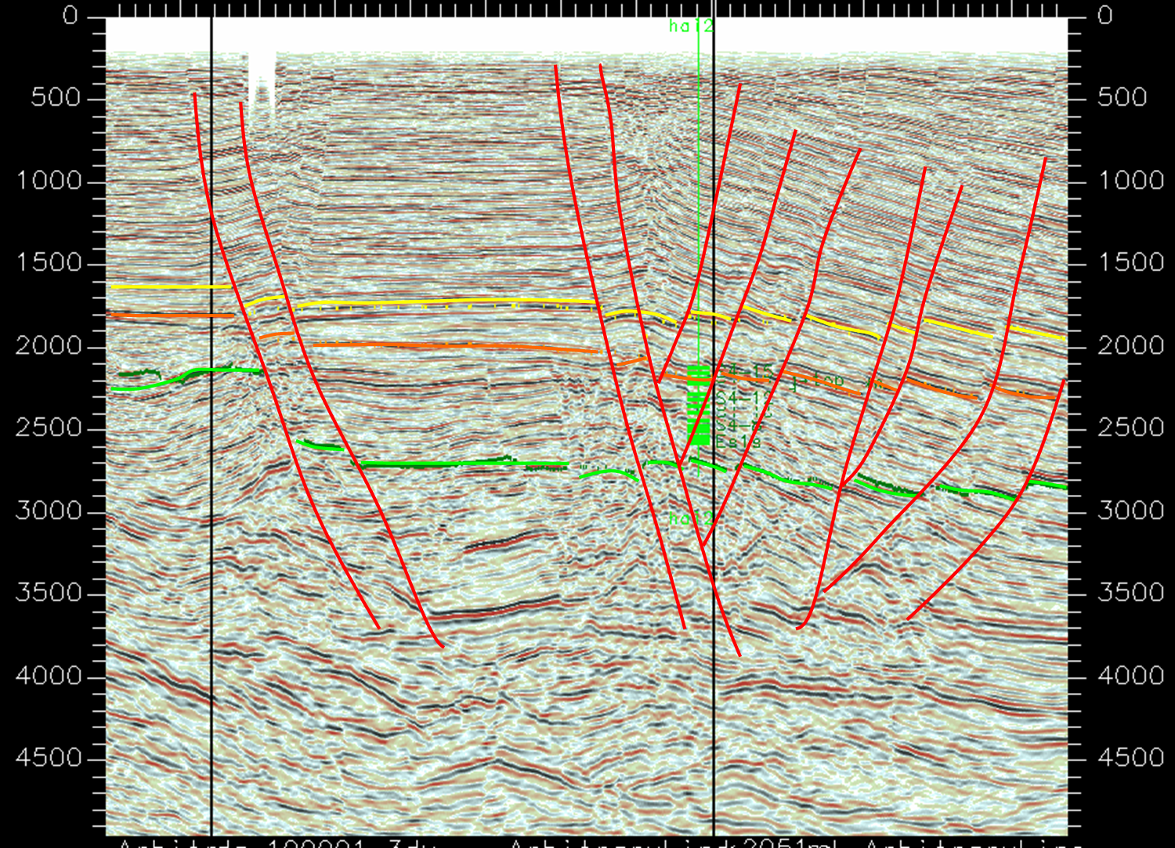
Figure 1: Seismic line of the of he Qikou depression including the positions of two wells. The red vertical lines are inferred faults and the horizontal color lines are horizons or strata

2.2 Magnetic data
An aeromagnetic map (fig. 2) of the area indicates region of high and low amplitudes. The high amplitudes are caused probably by igneous rocks of various susceptibilities. The low amplitudes are most likely due to sedimentary rocks and other nonmagnetic sources. Generally, magnetic highs arise from igneous and crystalline basement rocks, whereas lows arise from felsic igneous, sedimentary, or altered basement rocks. Igneous outcrops not associated with high-amplitude magnetic anomalies might be thin or contain low concentrations of primary magnetic minerals, or lost them due to alteration.
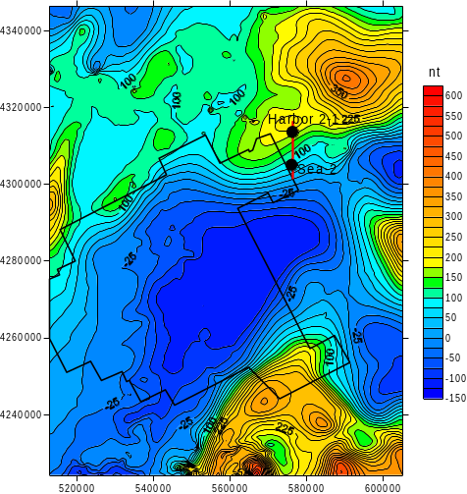
Figure 2: Aeromagnetic map of Dagang and it surrounding. The red vertical line is the position of the profile passing through the wells Harbor2-1 and Sea -2.

2.3 Logging constrained layer velocity inversion

This is generally based on the change in the rate in lithology; therefore, the speed parameter in seismic exploration is very important. The use of the reflection coefficient sequence stratigraphic interval in seismic lithologic inversion is an important means and methods. The basic principle is: Consider two distinct homogeneous layers with one lying on top of the other. The speed of waves in the first is V_{n} and its density is ρ_{n}, the next layer has speed V_{n +1} and density ρ_{n +1} respectively. The reflection coefficient (Aki and Richards,) between the two layers is givens as:
(1)
In practice due to inadequate information or very small change in the density for a given region, the density is ignored and equation (1) reduces to:
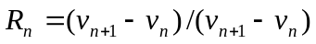 (2)
The above equation (2) can be expressed in terms of V_{n+1} as:
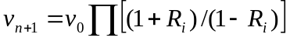 (3)
Where R_{i} is for the first i_{th} layer interface coefficient and V₀ is the initial velocity. From (3) we see that the reflection coefficient (R1, R2, R3…Rn) is recursive changing with change in velocity of successive layers. From equation (3) we were able to with the availability of sonic log data construct an initial velocity model considering all seismic signatures.

The seismic signature of a geological interface represents lateral variations in the vertical positioning of a reflection (event) across a seismic profile. These variations are due to “real” subsurface structure and/or velocity-generated, time-structural relief or both. “Real” subsurface structure can be the result of primary depositional patterns, postdepositional deformation (faulting, folding, uplift, diapirism), erosion, salt dissolution, ifferential compaction, etc. Velocity-generated time-structural relief is due to lateral variations in the average velocity of the sedimentary section overlying the reflector of interest, and can be caused by lateral facies variations and lateral variation in the thickness of individual sedimentary layers (Anderson et al, 1995). These are taken into consideration when modeling is carried out.

The modeling is assisted by visualization technology which plays an important role in displaying, describing and understanding the surface and subsurface geological phenomena. The process is such that a stratigraphic structural interpretation of a seismic line is use as reasonable initial model followed by a 2.5d computer-human interaction model based on well logged data. The third set of 2.5d model is based on potential field data constrained by well log and the seismic models. In our case we used a magnetic data to model volcanic rock in the Qikou depression.

3.0 Result and discussion

3.1 Velocity inversion

Due to the apparent velocity difference between different rock layers, it is possible to use velocity calculation for analysis of igneous rock. From the acoustic logging the velocity of different rocks in the area of study is as follows: Qikou Sag Tertiary basalt is generally 4500-5500m/s, Low porosity basalt is 4000m/s, diabase has a velocity between 5500-6500m/s, for tuff it is 2500-3500m/s, sand and shale ranges from 3000-3500m/s. This velocity difference provides favorable conditions for the application layer identification technology for volcanic rocks. An initial model of the subsurface strata as inferred from the seismic profile based on velocity analysis is shown below (fig.3).

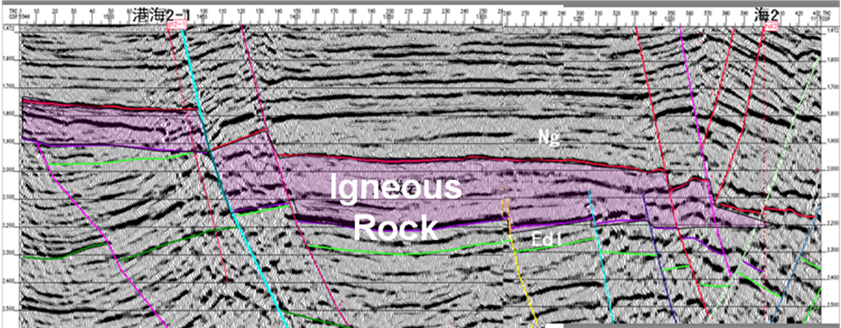
Figure 3: interpretation of the seismic line showing three strata and igneous rockwith locations of faults.
The purple shaded area shows a layer of igneous rock and horizontal color lines or marks indicate horizons while vertical lines show fault pattern. In this initial reasoning, we assume three distinct strata with an igneous rock as the center of the three. This is similar to the inverse forward 2.5D model (fig 4) constrained by sonic log data and the use of reflection coefficient. The reflection seismic signature of a subsurface body includes all features in recorded reflection seismic data that can be confidently attributed to the presence of that body. Geophysical signatures in reflection seismic sections have two basic components: time-structural relief and character variations. The seismic signature of a subsurface body is usually best defined through forward modeling.

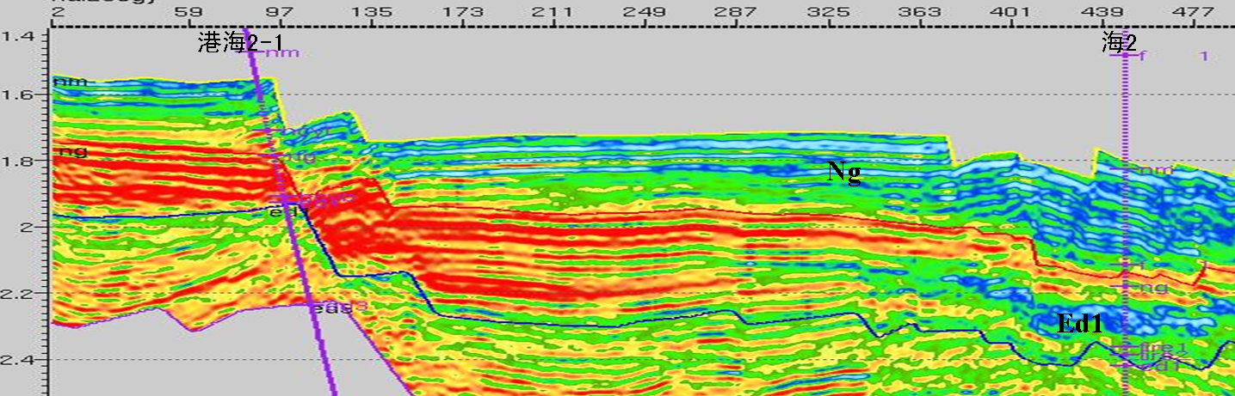

Figure 4: A model of the seismic profile showing regions of low and high densities. The positions of welss are indicated by purple vertical lines. On the left is Harbor 2-1 and on the right is sea2.

The vertical purple lines are positions of well while the deep red horizontal lines indicate region with high speed and density. The upper strata based on this model composed mainly deposits of Miocene era and that below the volcanic rock is mostly those of Oligocene. This model based on refection coefficient does not fully give us the orientation (size and shape) of the igneous rock but one can clearly demarcate the various strata or horizons.

3.2 Magnetic Inversion
To visualize the approximate position of the volcanic rock magnetic data is use taking a profile of the area of interest. The profile is then use to construct model (fig. 5).

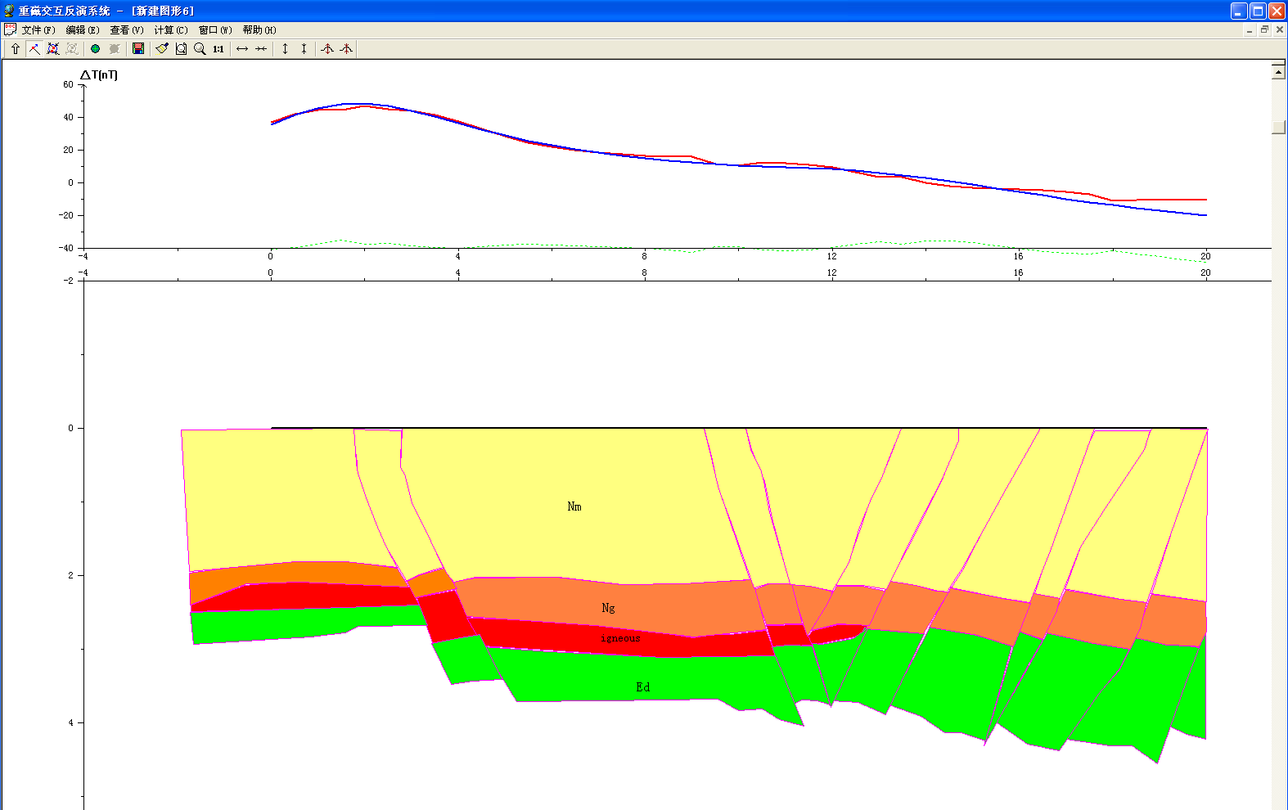
Figure 5: An inverse model of the magnetic profile. The blue curve is the observed anomaly and the red is the calculated. The red potion is the shape of the inferred igneous rock. The first strata is Pliocene (Mn), second Ng is Miocene and Ed is Oligocene all of which are Cenozoic. The vertical lines are faults as inferred from the seismic profile.

The inverse model is constrained by well log and seismic data as well as initial model based on seismic interpretation and reflection coefficient respectively. The model shows three different strata and a slap of igneous rock. The three strata consist material of the Cenozoic era namely Pliocene, Miocene and Oligocene from top to bottom respectively. Tertiary sedimentary strata magnetic susceptibility is approximately (0-50) × 10-5SI; magnetic susceptibility of igneous rocks is about 1500 × 10 ⁻⁵SI. The average thickness of the igneous rock is about 500m.

4.0 Conclusion

We have shown that a joint seismic –magnetic inversion constrained with well log produces a clearer understanding (size and depth) of volcanic rocks in a hydrocarbon prone region where the source rocks are found below such mass volcanic rocks. The thickness of the rock is calculated at 500m and it susceptibility is 1500x10⁻⁵SI. The straitigraphy was also distantly demarcated with the aid of well data. This reduces exploration risk and help to identify areas for posible drilling and locating source rocks.

References

- Allen, M., Macdonald, D., Zhao, X. et al., 1997. Early Cenozoic two-phase extension and late Cenozoic thermal subsidence and inversion of the Bohai Basin, northern China, Marine and Petroleum Geology, 1997, 14(7-8): 951－972.
- Aki, K., Richards, P.G., 1980. Quantitative Seismology, Freeman and Co., New York
- Anderson, N. L., D. E. Hedke, and R. W. Knapp, 1995. Forward seismic modeling - applications and utility: Geophysical atlas of selected oil and gas fields in Kansas, Kansas Geological Survey Bulletin 237, 28-33.

- Anon., 1987. Dagang Oilfield. In: Petroleum Geology of China, volume 4. Petroleum Industry Press, 1987. Beijing.

- Gardner, G. H. E, Gardner, L. W & Gregory, A. R. (1974): Formation velocity and density - the diagnostic basis for stratigraphic traps. - Geophysics, 39, 770-780.
- Liu, M., Cui, X., Liu, F., 2004. Cenozoic rifting and volcanism in eastern China: a mantle dynamic link to the Indo-Asian collision? Tectonophysics, 2004, 393(1-4): 29－42.
- Nabelek, J., Chen, W., Ye, H., 1987. The Tangshan earthquake sequence and its implications for the evolution of the North China Basin, Journal of Geophysical Research 1987,92(12):12615 - 12628
- Nafe, J. E. & Drake, C. L. (1957): Variation with depth in shallow and deep water marine sediments of porosity, density, and the velocities of compression and shear waves. - Geophysics, 22, 523-552.
- Xu, J., 1997. Similarities between Cenozoic basins of different magnitudes in East Asia continental margin, Experimenal Petroleum Geology (in Chinese), 1997, 19(4): 297－304.
- Yang Zhanjun and Wei Yan, 2005. The gravity & seismic data jointed formation separation technique for deep structure study, 75th meeting of Society of Exploration Geophysicists
- Ye, H., Shedlock, K., Hellinger, S. et al., 1985. The North China Basin: an example of a Cenozoic Rifted interaplate basin, Tectonics, 1985, 4(2): 153－169.

Igneous Rock

