Analysis of Land use change in Siby, Mali, 1986-1999: A Remote Sensing approach.
Lansine Kalifa Keitaª* Liqin Zhang^{b}
Department of Land Resources Management, China University of Geosciences,
Wuhan 430074, Hubei, P.R. China.
lansinekeita73@yahoo.fr
Abstract:
Land-use change is the main component of regional environmental change, while protected areas represent a direct land use policy to prevent its potentially negative effects on biodiversity and environmental services. In this paper，it gave a detailed introduction about the classification process of land use in Siby in Mali using remote sensing and GIS softwares such as Envi 4.3 and ArcGIS 9.3 two Landsat TM images (1986 and 1999) of Siby were used for the study. After being geometric corrected subset and enhanced, the images were classified into 5 classes: urban area, Farmland, Water, Forest, and Grassland, using the supervised maximum likelihood classifier. The results show that urban land expanded by 77.01 ha (0.0769%), whilst there were reductions in the other classes such grassland -46. 21 ha(-0.0461%) ,forest -96.27 ha (-0.0961%). The implication of this unprecedented growth in urban land is the resulting environmental and ecological problems associated with unplanned urban growth and development such as loose of grassland, deforestation and increased of farmland (Peter H. Verburg et al, 2008). In this paper attention will be given, firstly, to what is meant by land-use planning. Secondly, a new phenomenon in land-use planning, that is or can be of great meaning for the creation of a more sustainable countryside, is reviewed: the use of spatial concepts as a starting point of new land-use plans. Thirdly, how these concepts can be applied in land-use planning in order to achieve the ultimate goal of ‘sustainable rural systems’, is discussed. Growing human populations exert increasing pressure (Tomlin .C.D, 1990) on the landscape as demands multiply for resources such as food, water, wood, soil.

Key Words: Remote Sensing, classification, Land use change, Siby

INTRODUCTION
Land use practices generally develop over a long period under different environmental, political, demographic, and social conditions (Wilkie.D.S.et al 1996). These conditions often vary and have a direct impact on land use and land cover .The interaction of nature and society and their implications on land use and land cover is a very complex phenomenon that encompasses a wide range of social and natural processes. ‘‘Land-use planning is the systematic assessment of land and water potential, alternatives for land-use and economic and social conditions in order to select and adapt the best land-use options’’ (Mathieu Bouchard and David Pothier, 2008). This definition embraces the systematic approach of possibilities for different land-uses in the future, and also the felt need for changes and the willingness to execute the plan. All present land-use planning is caught up between two seemingly contradictory dimensions: ecological conservation and economic existence. Both dimensions are, in some way or another, related to sustainability. The first dimension refers, at present, strongly to conservation: to conserve the natural resources: clear water, air and soils; to preserve plants and animals (biodiversity; gene sources); etc. In many cases it even goes further than just conservation: it seeks a re-creation of lost values. Examples are the creation of nature areas out of farmland or reforestation of pieces of land.

The creation of a more sustainable countryside has become a very important item across the world. Several methods, approaches and policies can be applied and agencies, interests groups etc. can become active in this regard. Land-use planning, as one of these activities, is challenged to play an active role in obtaining sustainable rural systems. Informed decision on the management of natural resources requires an understanding of the complex dynamics of socio-economic and biophysical factors Since the Rio Earth Summit in 1992; many studies have concentrated on environmental issues in the tropics, which have positively influenced national environmental policies (Hubert N. van Lier, 1998,). However, environmental degradation continues to be a major ecological concern in tropical countries, where population growth and food production exert increased pressure on the ecological system. Accelerated urban growth is usually associated with, and driven by population concentration in an area. The extent of urbanization or its growth drives changes in land use /cover pattern. Land use and land cover changes may have adverse impacts on the ecology of an area, especially its hydro-geomorphology and vegetation. As a result, regional land use and Land cover change has become one of the global hot topics of research.
This work concerns land use change in Siby, a rural community in The Republic of Mali, using two satellite images (1986 and 1999) .The main aim is to show how, urban land area, farmland, Grassland, water, and forest in Siby have changed between the time period 1986 and 1999. The combination of population growth, limited expansion of arable land, and the growing need for land for non-agricultural purposes, increases the pressure on grassland competition for the available space. Land derives its interest from the vegetation and crops that can be grown on it. Land cover and land use are, however, dynamic, and are affected both by natural phenomena, such as climatic events and natural disasters, and by human activities, although the impact of the latter has mainly been felt in recent centuries (Kelly, B.A.et al, 2007). Generally speaking, arable land is extending at the expense of forest and pasture on global average. Non-agricultural uses, including those for urban and industrial infrastructure, are continuously on the rise. Land use/cover change is the change of land surface caused by human activity and climate change on land use. It is one of the main ideas in global change research and is important in regional ecology construction (Li X. B.Chen et al, 2003).Change of land use types and land use structure is the main direct reason for that change and it is guidable for regional land plan to analyze this change.

Thus, monitoring land use dynamics is essential to tune management strategies that enable a balance between production and conservation. For the assessment of the land use/cover changes, remote sensing data play a major role with their ability to provide quantitative information on the spatial dynamics of land cover from different time periods. This technique contributes greatly to a global understanding of environmental processes, but analysis
at the local scale is more complicated. Finer scale studies in the Siby commune
MATERIALS AND METHODS
Overview of Mali) Mali is a vast country with an area of 1,241,238 km² Located in the hinterland in the heart of West Africa, (Fig 2) Mali shares over 7,000 km border with 7 neighboring countries, namely Algeria in the north, Niger and Burkina Faso to the east, Ivory Coast and Guinea - Conakry to the south, Senegal and Mauritania in the west Mali hinges between North Africa and Arab-Berber-Saharan black Africa. Since 1992 Mali has embarked on an extensive process of decentralization and deconcentration, which marks the irreversible commitment of national authorities to empower people to manage their own development.
(This process has helped reshape the administrative landscape of Mali into 703 municipalities (of which 607 are rural and 96 urban), 49 Circles, 8 regions and 1 district (Bamako). According to the 1998 Population and Housing Census (RGPH) the total resident population of Mali was estimated at 9.810 million, of which 50.5% are women and 49.5% men. Life expectancy at birth was recorded as 60.5 years for the entire population, with 62.2 years for women and 58.8 years for men. Young people under 15 years accounted for 46.3% in 1998. The population is growing at an average annual rate of 2.2%.

Study area:

This research was conducted in Siby (Fig 2: A and B) Siby is a rural municipality in Mali. It is located in the Circle of Kati in the Koulikoro Region, 50 km from Mali's capital, Bamako It lies on Latitude:.12°23’N, and along longitude: 8°20 ‘W. Its Elevation is 1226ft.above sea level. The municipality of Siby has a population of 20,287 inhabitants (2004) (Table: 2).It covers a surface of 1001.25km² .

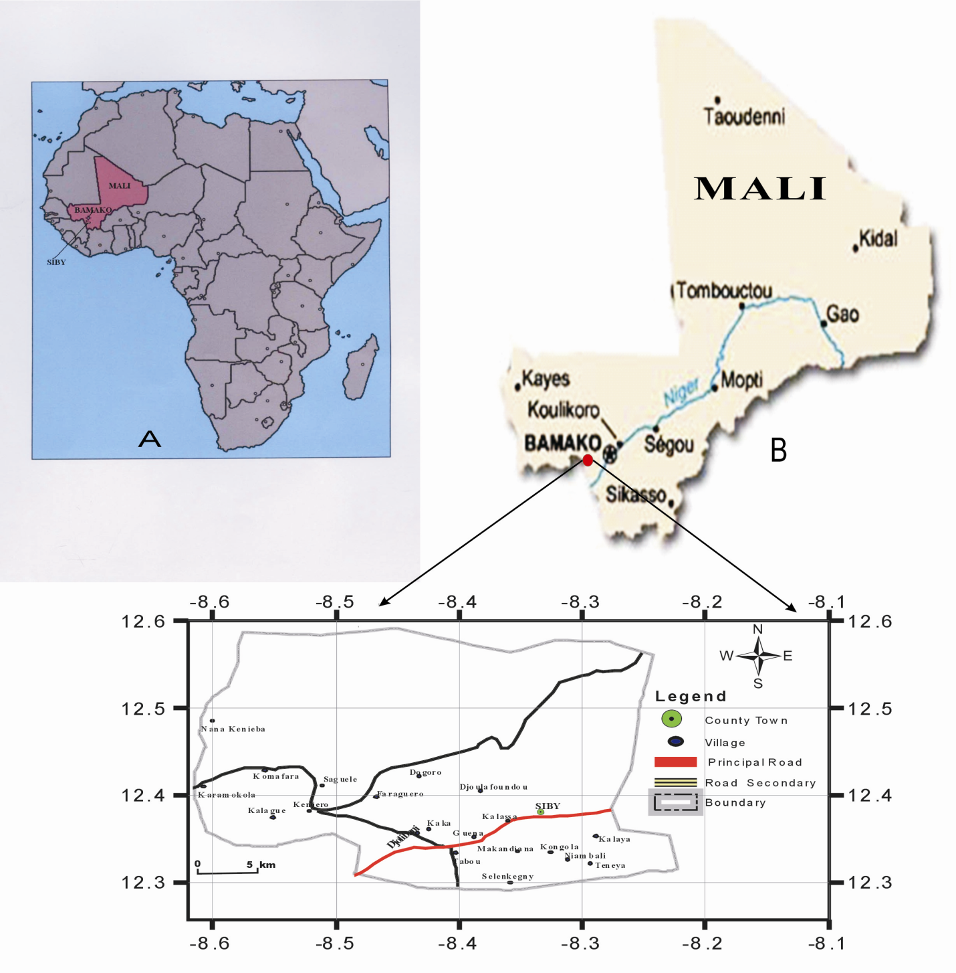Fig2 A: Location of Mali in Africa: B, Location of Siby in Mali,C Siby Map physical

The village of Siby is sub-divided into five quarters, all located on the plain at the side of the Mandingoes Mountains. The climate is characterized by its sudano-sahelian type, with a long dry season (September-May), divided into a cool period from November to February and warm period from March to June. The rainy season extends from June to September or mid October. As a tropical climate, it is characterized by a dry season characterized by warm and tropical air masses known as the harmattan, and by a rainy season controlled by continental tropical air masses monsoon at times of low sun .In this study, two Landsat TM images (December 14, 1986 and October 25, 1999) of Siby (wrs path 199, row 52) are used for analysis. The quality of images is good. Remote Sensing is the main research method while GIS is the auxiliary method (Soulemane Paré, et al .2008) .The figure below shows the main processes involved in image processing and analysis of results. Land-use planning has been described in many ways. A simple and short description is that it consists activities that: (1) determine future land-uses; (2.) improve the area properties and (3). Organize the management of the new situation. (A) ‘Physical planning’ is related to studies and policies aimed at deciding what type of land-use activity should take place and where. In this sense it distributes the often scarce space between several potential users, with the optimization of the land-uses as a main objective. Many developed and developing countries have policies and projects resulting in this type of land-use planning. (B) ‘Land redevelopment’ refers to the actual changing of the land-uses and the improvement of the physical conditions for the planned land-uses. In most cases, this type of land-use planning follows physical planning. It is responsible to carry through the planned land-uses as determined in physical planning and often to improve the physical conditions for the planned land-uses. (C).
‘Land management’ refers to new methods of how to manage lands by mankind. For the rural countryside it mainly focuses on farm practices, forest management and nature management. The intensity of the use, especially in farming and to a certain degree also in forestry, has a tremendous long-term effect on the abiotic (soil, water, air. as) well as on the biotic factors. In Siby The farming system is characterized by traditional subsistence farming and cultivation of cash crops as well as intensive fuel wood extractions and ranching.

Image of 1999 (TM)
Image of 1986 (TM)
The Pre-processing of RS Image
Geometric correction

Image subset

Enhancement processing

RS Image Classification (Maximum Likelihood method)

Establish the classification signature
Do the accuracy assessment of classification
Do the post-classification processing
Perform the supervised classification
Develop the interpretation mark
Set up the classification system

Overlap the images, and determine the transition matrix of land use change

Analysis of land use change
Analysis of annual change (%) 1986-1999
Analysis of annual change (ha) 1986-1999
Analysis of change percent (%) 1986-1999
Analysis of change (ha) 1986-1999

Fig1: The process of project

The integrated use of satellite remote sensing and GIS has been proven to be a powerful and cost effective approach for assessment of desertification or land degradation in this arid ecosystem. Reliable and up-to-date information on the recent changes in land cover dynamic can help provide necessary base information for the documentation of land degradation and desertification changes trend in this area. Standard image enhancements, classifications, and change detection techniques were applied to determine changes between the available images. Remote sensing and Geographic Information Systems (GIS) are providing new tools for advanced ecosystem management. The collection of remotely sensed data facilitates the analyses of earth-system function, patterning, and change at local, regional, and global scales over time. Such data also provide a vital link between intensive, localized ecological research and the regional, national, and international conservation and management of biological diversity (Wilkie and Finn, 1996. Due to increasing changes of land-use, mainly by human activities, detection of such changes, assessment of their trends and analysis of the recent land cover dynamics through the integration of remote sensing and GIS provide base information for documenting of land degradation and trend of desertification changes in Siby.
Change detection: The biophysical data of Siby map with villages were obtained through the change detection analysis of remote sensing imagery. We have worked on the followings data: Data type, landsat TM Datum: WGS84 coordinate system Type UTM zone 29 N, Number of bands: 3, Number of lines 1296 respectively for (1986 and 1999. This was because some of the land use types observed during field work was a result of change. Therefore, areas that did not change throughout the study period were identified on the images and used for accuracy assessment. Google Earth (especially the parts of the Siby commune that are overlaid with large-scale aerial photos images) was employed as reference data for the assessment of the classification and accuracy. Supervised classifications using Maximum Likelihood method was performed on the images. Five land use change classes were used. These include urban area,
Farmland, Water, Forest and Grassland, points of all classes are higher than 1000 (Fig4). Since there are some influential factors, such as mixed pixel and phenomenon of same spectrum on different targets, some small spots were produced .Rejection of the small spot was done by the RS and GIS software. The mapping was done using GIS tools in ArcGIS 9.3 .In addition correction was also done by visual interpretation. The accuracy of the two classified images was testified with a stratified random sampling method, and the overall accuracy reached. Sometime it is important to calculate changes of variable values over time (Table 2). Changes can be expressed as an absolute change or a percent change, as an average annual absolute change, or as an average annual absolute change, or as an average annual percent change. Let us use (x_{t}) to represent the value in beginning year and (t_{t+n}) for the ending year. The period between the beginning and ending year is n year. Also, let us use G_{a} for the absolute change, G_{p} for the percent change,g_{a} for the average annual absolute change. The formulas to calculate the three changes are expressed as:
Ga= x_{t+n} - x_{t} (1)
Gp=G_{a} / x_{t} = (x_{t+n} - x_{t}) / x_{t} (2)
g_{a}= G_{a} / n = (xt_{+n}- x_{t}) / n (3)

RESULTS AND DISCUSSIONS

The results of the two classified images for 1986 and 1999 are presented in (Fig3-4) respectively. Change detection is the process of identifying differences in the state of an object or phenomenon by observing it at different times. Change detection is an important process in monitoring and managing natural resources and urban development because it provides quantitative analysis of the spatial distribution of the population of interest. Land use type dynamic for Siby district, 1986 -1999 is shown in (Table 1). As expected, urban area increased throughout the study period of 1986 -1999.It increased by 1,001. 25 ha (1%) between 1986 and 1999, from 15,018.75 ha (15%) to 16,020 ha (16%), respectively. One thing is apparent, that the annual change percent increase of urban area during the 1986-1999 period (about 0.07%) 77.01 ha. This increase in urban area could be attributed to loss of grassland, population growth. Information on the effects of increasing farmland area for the development of rural areas is essential for policy makers involved. With agricultural policy and rural development Farmland, annual change is 318. 86 ha (0.3384%) (Table1) in 1986 -1999 farmland area was 28,936.12 ha (28.90%) to 33,081.3 ha (-33.04%) respectively. The main reason of increase farmland is the growth of population in Siby 1986 to 1999.(Table 2 ) total percent change growth 1986 (-54.25% ), 1998 (24.39) and 1999 (25 %). Climate change is a major challenge for humanity. The population size and population growth have significantly negative impacts on water quality.
Water saw a relatively large declined of -19, 25 ha (-0, 05%), respectively, from 8,010 ha (8%) to 7,759.68 ha (7, 75%) during 1986 -1999 period .Cultivated land refers to the farmland used for growing crops, including cultivated land newly developed ,reclaimed and consolide land fallow land ,formed in rotation land for forage and crops with fruit trees . The period under review is that before the creation of communes, when decentralization in Mali began from 1998 to 1999 (15,150 and 18,846 inhabitant respectively) (Table 2) 41,654 inhabitant in 1987 .However, more recent changes in land use are dominated by losses of forest land. Forest lost -1.25 ha (-96.27%).This loss of forest land in combination with the trend towards a much higher demand for agricultural products for a growing and wealthier population, has resulted in a discussion about the long-term capacity of the population of Siby to feed itself, and the consequences for the global food market if Siby district would not be able to feed its own population. There are 2 large forests in the commune that of Wanda and the Keniébaoulé part of which extends over the common Néguéla. The forest is mainly composed of woody and herbaceous formations. The forest or savanna woodland and savanna tree or shrubs are the main plant. There are also some gallery forests along rivers. Deforestation has been used to describe changes in many different ecosystems .It is generally defined as loss of forest cover or forested land. With regards to grassland area (Table 1), decline -46.21 ha (-0.0461%), main reason farmland increasing.
Water is essential for maintaining an adequate food supply and a quality environment for the human population, plants, animals, and microbes on the earth. Per capita food supplies (cereal grains) have been decreasing for nearly 20 years (declined 17%), in part because of shortages of freshwater, cropland, and the concurrent increase in human numbers (Danny Redo et al, 2008). Shortages in food supplies have in part contributed to more than 3 billion malnourished people in the world (Hubert N. Van Lier, 1998). The land use types and pattern changes that were affected by extremely frequent human activity is one of influencing factors. The decrease in forest area reflects the policy of allowing agricultural lands. The most fundamental obstacle to progress in understanding and predicting human impacts on terrestrial ecosystems lies in the lack of a comprehensive and integrative theory of human environment relationships, which can be applied to explain empirical observations and predict new results.
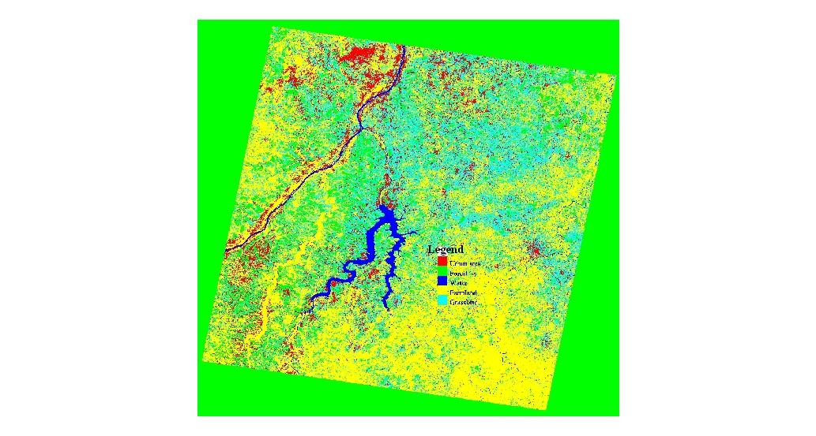

Fig 3. The classification of TM 1986 in Siby

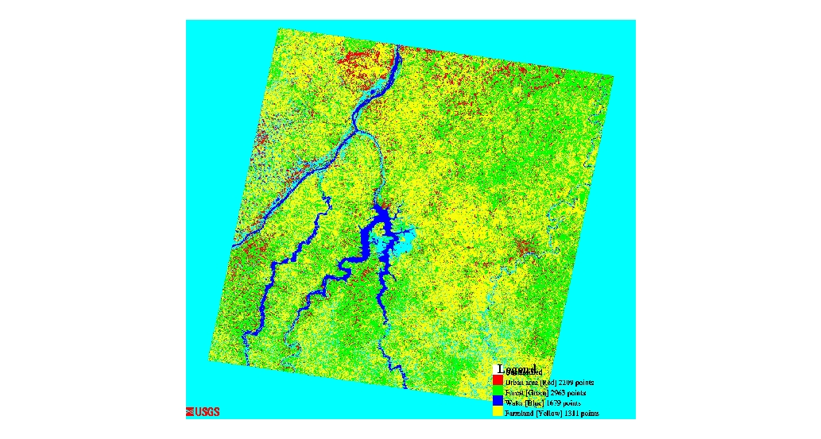

Fig 4. The classification of TM 1999 with points in Siby

In Siby the timber and bamboo gives rise to an intense activity as the PACT (Programme d’Appui aux Collectivités Territoriales) in at least 80% of the villages of the commune. Thus the annual production amounted in 2005 to 20,000 cubic meters of wood, 10,000 quintals of coal, 10,000 beams mpan 1000. Forests have been subjected for decades to intense exploitation from these operators. Under the Domestic Energy Strategy launched in Mali in 1996, the Fuel Cell Ligneous established rural markets of timber to supply major urban centers (Bamako) wood and coal .Increase in population, destructions of environmental resources, environmental pollution, introduction of various forms of land use planning are the various issues threatening the environment today(Gordon N.D Mc Machon et al 1992 ) . This paper has argued that more attention should be given to the actual land use and land functions and linkages between these.
A better understanding of the interactions between land cover, use and function and methods to map and quantify land use and land function will also benefit our ability to properly model land changes. The fact that land function cannot always be observed directly will, however, continue to limit our capabilities to base our analysis on land use and land function directly. A proper representation of land function will always require additional data beyond land cover observations which, in many cases, can only be achieved at local scales of analysis. Recent studies have indicated that the mapping of land functions based on proxies provides options to actually map and quantify land functions. The increasing attention for multifunctionality of the land necessitates the development of methods and tools to map and quantify the different functions across the landscape. Land cover based methods are clearly insufficient when multiple functions are considered. Straightforward analysis of land cover change impacts on multifunctionality ignores the emergence of land functions from land system interactions and is therefore mostly inadequate. Multifunctionality is not only important in densely populated areas with high claims on land resources. Also other areas have multiple functionalities that are important for functioning of the land system, e.g. in terms of providing regulating services such as water retention or carbon sequestration.
Although more attention for land use characterization will certainly improve our understanding of the land system, a further characterization of land functions is needed, given the importance of goods and services that are not directly related to the specific intend of the land management.
Increase in urbanization is recently becoming a global phenomenon instigating various environmental problems Over the years, man’s interaction with his environment have been recognized as a major force shaping the biosphere, mostly, its landscape. Human actions rather than natural phenomena are the source of most contemporary changes in the state and flow of the biosphere (Jessica Milligan et al 2009). The results also demonstrate the difficulties in distinguishing features. Certain thematic classes generated confusion and resultant misclassification, indicating that further research is warranted in identifying improved methods for separating these classes .The human vulnerability and implications of these negative changes on livelihoods of communities require proper and serious attention.

1986 1999 Change in 1986 -1999
Land Use Type Area ha % Area ha % Area ha % Annual change ha Annual change %
Urban area 15,018.75 15 16,020 16 1,001.25 1 77.01 0.0769
Farmland 28,936.12 28.90 33,081.3 33.04 4,145.18 4.14 318.86 0.3384
Water 8,010 08 7,759.68 07.75 - 250.32 - 0.75 - 19.25 - 0.0576
Forest 14,017.5 14 12,765.93 12.75 - 1,251.57 - 1.25 - 96.27 - 0.0961
Grassland 34,142.62 34.10 33,541.87 33.5 - 600.75 - 0.6 - 46.21 - 0.0461

Table 1. Statistic of land use type and statistic on the change of Land use in Siby from 1986 to 1999. (Unit: hectares)

Years | Observed population  inhabitant | Total absolute change growth (TACG) | Average annual absolute change (AAAC) | Total percent change growth (TPCG)
1987 | 41,654 | -22,808 | -1900 | -54.75
1998 | 15,150 | 3,696 | 308 | 24.39
1999 | 18,846 | 18,846 | 1570 | 25
Table 2.Demographic analysis
Note: year 1987 is before the creation of commune

CONCLUSION
This study exploits the possibility of Remote Sensing and Geographical Information Systems (GIS) techniques in the drive towards sustainable environmental development with particular respect to urban expansion, vegetation loss and also on the exploitation of other environmental natural resources. Land use change is the single most important factor influencing the conservation of natural environments. Patterns of land-use change can be broadly classified into two main categories: 1) expansion of the agriculture frontier, which is a major driver of deforestation and destruction of natural habitats, and 2) ecosystems recovery associated with intensification of land use on marginal agriculture lands is associated with population growth and urbanization in Siby. Our analysis show that the analysis of land-use change provides important additional information to classic gap analysis, and that these trends should be used to prioritize conservation efforts. The challenge to move the focus of land change science from land cover to land use and land function requires the development of new data, methods and an even further integration of the disciplines involved in land science research. The progress of the land change community to develop new data, methods and models within the past decade indicates the innovative capacity of the community we are therefore optimistic that the land change community will be capable to meet the challenges identified in this paper.

ACKNOWLEDGEMENT

China Scholarship Council and China University of Geosciences supported this study. The author wishes to thank Associate Professor Liqin Zhang in Land Resources Management, China University of Geosciences (Wuhan) for this supervision and everyone who helped in one way or another.

Corresponding Author: lansinekeita73@yahoo.fr
of Land Resources Management China University of Geosciences

Phone: +86 (67885956) ,Cellular: +86(15997484873)

REFERENCES

[1]Danny Redo, J.O. Joby Bass, Andrew
C. Millington , 2008, Journal Applied Geography ,Forest dynamics and the importance of place in western Honduras. xxx :120,doi:10.1016/j.apgeog.2008.07.007,www.elsevier.com/locate/apgeog
[2]Hubert N. van Lier, 1998, Journal .Landscape
and Urban Planning .The role of land
use planning in sustainable rural systems, Landscape and Urban Planning 41: 83–91
PII S0169-2046_ 97. 00061-3
linkinghub.elsevier.com/retrieve/pii/S0169204697000613
[3] Gordon,N.D., McMachon ,T.A.,Finlayon
B.L,. 1992. Stream Hydrology: An
Introduction for Ecologists. John Wiley and Sons LTD., Baffins Lane, Chichester, west Sussex, England, ISBN 0-471-95505-1, Pages 285-286 doi:10.1016/0022-1694(95)90042-X169(1995), (http://www.sciencedirect.com/science?_ob
[4]Jessica Milligan, Tim O’Riordan,
Sophie A. Nicholson-Cole*, Andrew R.Watkinson,2009,JournalLandUse Policy .Nature conservation for future sustainable shorelines: Lessons from seeking to involve the public, Land Use Policy 26: 203213.doi:10.1016/j.landusepol.2008.01.004 www.elsevier.com/locate/landusepol
[5]KELLY, B. A. 2007. Impact of
agroforestry practices on the flowering
phenology of Vitellaria paradoxa in parklands in southern Mali. Agroforestry systems, vol 71, no 1, p. 67-75. Journal SEARCH WILEYINTERSCIENCE,DOI 10.1111/j.1365-294X.2004.02144.x I , www.springerlink.com/index/7247H62V10037QV0.pdf.
[6] Li X.B., Chen Y.H., Shi P.J., 2003.
Detecting Vegetation Fractional Coverage of
Typical Steppe in Northern China Based on Multi-scale Remotely Sensed Data. Acta Botanica Sinica, Journal of Arid Environments, Volume 72, Pages 974-985,
doi:10.1016/j.jaridenv.2007.11.014,(6),(linkinghub.elsevier.com/retrieve/pii/S01401963070032
[7]Mathieu Bouchard and
David Pothier,2008,Journalecological
modeling, Simulatio nsofthe effectsofchanges in mean fire return intervals on balsam fir abundance, and implications for spruce budwormoutbreaks,218 :207218 ,doi:10.1016/j.ecolmodel.2008.07.001www.elsevier.com/locate/ecolmdel
[8]Peter H. Verburg, Jeannette van
de Steeg ,A.Veldkamp and Louise Willemen ,2008, Journal of Environmental Management, from land cover change to land function dynamics: A major challenge to improve land characterization, 90: 1327–1335doi:10.1016/j.jenvman.2008.08.005, www.elsevier.com/locate/jenvman
[9]SouleymaneParéPatrice,Savadogo,Tigabu,
JeanMarieOuadbaPerChristerOde´n.2008LanduseanalysisfromspatialandfielddatacaptureinSouthernBurkinaFaso,WestAfrica,pp277285doi:10.1016/j.agee.2008.04.009,ScienceDirectlinkinghub ,.elsevier.com/retrieve/pii/S0140196307003278
[10]Tomlin,CD,1990.GeographicInformation system
Englewood Cliffs, NJ: Prentice Hall. Rural Communities. The Guelph Seminar Series. The Arkleton Trust and Univ. of Guelph, pp. 53–63.Oxford University Press Inc. New York, NY, USA, ISBN: 0-19-511831-6, Doi 10.1145/258319.258358,5(2),portal.acm.org/citation.cfm?id=778250
[11]Wilkie,D.S.;Finn,J.T.1996
.Remotesensing imagery for natural resources monitoring: publication Company: Columbia Univer guide for first-time users. New York: Columbia University Press.295p.www.forestencyclopedia.net/c/c13262

Submission date: 20/02/ 2010

